Human Resource- training, education and skill development

1. Rupak Mahapatra,Bsc (maritime science),marine engineering and reserch institute, indian maritime university,mumbai campus, coolrupak1997@gmail.com
2.Rahul Kumar Gupta,Bsc(maritime science),marine engineering and research institute,indian maritime unversity,mumbai campus, rhgupta.09@gmail.com
3. Mukul Dongre. Bsc(maritime science), marine engineering and research institute, indian maritime university, mumbai campus, mukuldongre33@gmail.com

ABSTRACT
The primary goal of each organization is to maximize the profits, take the larger share of the market or to provide the best service possible. In order to implement this goal, organizations must have unique resources, i.e. – human resources. Effective management of human resources is an important factor in achieving the goals and benefits of an organization, individual and society. No less important is the acquired qualifications and competencies of the employees. There are cases when the lack of competencies encourages the employers to seek for certain alternatives: either exchange young specialists into experienced ones or invest in them time and money. Additional investments are expensive for the companies, especially in the areas where quick orientation in the current situation is required (eg. Transport sector). Therefore, a qualified transport specialist is a great asset of the company instruction include traffic code or laws and vehicle operation. Typically, instruction will warn of dangerous conditions in driving such as road conditions, driver impairments, and hazardous weather.
- SKILL DEVELOPMENT
Human personals in roadways mode of transport need special skill development courses. Various new technologies such as GPS, METROLOGICAL DATA, SETCOPS, SLEEP ALERT, ACCIDENT ALERT SYSTEM needs adaptable workers. These skills development courses will not only reduce time and fuel consumptions but also save money and boost the roadway mode of transport in India.
- TRAINING
The training will involve virtual classrooms and stimulator test to detect the real life situations and test the workers ability to handle those situations.
AIRWAYS
- EDUCATION
To become a pilot you need a bachelor's degree in aircraft operations, aviation, aeronautical engineering, or a related field. A strong grasp of knowledge regarding the operations of machinery and flight controls should be well kept.
- SKILL DEVELOPMENT
Airways need professional skills that involve air traffic control and airspace design planning, emergency response personnel at airports, a diversity of technical engineering jobs from aircraft and engine design to component production.

- TRAINING
The training will involve flight simulator courses, cockpit procedure trainer and apart from professional subjects, a perfect blend of linguistics, knowledge and hospitality is almost required.
WATERWAYS
- EDUCATION
Maritime sector rather than sticking to traditional engine and deck courses must come up with the polyvalent i.e. dual degree course (maritime science in India) that provides the same manpower with the knowledge of both engines and deck.
- SKILL DEVELOPMENT
Human personals in this sector should have high command over the linguistics, firefighting and calamities at sea or abroad
- TRAINING
Paramilitary training accompanied through various stimulators of both engine and deck would make the right polyvalent officer out of the cadets.

KEYWORDS
INTRODUCTION
ROADWAYS
AIRWAYS
WATERWAYS

INTRODUCTION
Transport is an important part of India's economy but it is poor in comparison with international standards. Since the economic liberalization of the 1990s, infrastructure development has progressed rapidly; today there is a variety of modes of transport by land, water and air. However, India's relatively low GDP per capita has meant that access to transport has not been uniform.
Despite ongoing improvements in the sector, several aspects of transportation are still riddled with problems due to outdated infrastructure and lack of investment in less economically active parts of the country. The demand for transport infrastructure and services has been rising by around 10% a year^{[1]} with the current infrastructure being unable to meet these growing demands.
Transportation can be broadly divided into:
- Roadways
- Airways
- Waterways

Human resources are the people who make up the workforce of an organization, business sector or economy. The low contribution of the transport sector in the GDP of India can be attributed to the presence of uneducated and unskilled workers.
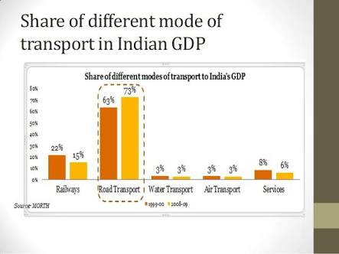
The transport sector of India owes its poor development due to the following problems faced due to rise in untrained workers:
- The presence of uneducated and unskilled manpower in roadways causes an increase in the number of accidents due to lack of knowledge regarding traffic and safety rules.
- The operational cost in transport sector seems to be in a hike just because the human resources have been traditionally predesigned to do a single work.
- The lack of skill and training regarding the use GPS, metrological data lead to a huge delay in transportation of good, higher consumption of fuel and can cause fatal accidents too.
- The human personal in maritime sector are slowed down due to language barriers.
- Long duty free and payless vacations cause to be a hindrance for joining of talented manpower.
- Improvement in engineering, fuel, aircraft productivity has an impact on labour i.e. man power. This causes fierce competition and decreases number of human personnel.
- The irregularities in job and salaries results in sharp decline in the airline industries.
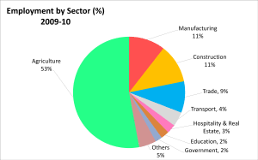
The aforesaid problem tends to affect the transport sector very badly and the only panacea is EDUCATION, TRAINING AND SKILL DEVELOPMENT OF HUMAN RESOURCES IN THE TRANSPORT SECTOR.
ROADWAYS
- EDUCATION

- Driver's education is a formal class or program that prepares a new driver to obtain a learner's permit or driver's license. The formal class program may also prepare existing license holders for an overseas license conversion or medical assessment driving test or refresher course. It may take place in a classroom, in a vehicle, online, or a combination of the above. Topics of instruction include traffic code or laws and vehicle operation. Typically, instruction will warn of dangerous conditions in driving such as road conditions, driver impairments, and hazardous weather. Instructional videos may also be shown, demonstrating proper driving strategies and the consequences for not observing the rules.
An online driving education is one of the most affordable and convenient ways to acquire driving education. Many driver's education courses are available online.^{[4]} It is up to the relevant government authority to accept any such programs as meeting their requirements.

- Roadway transport rather than employing an ignoramus on a low pay scale should make it mandatory that all its employees must have passed 10 class examinations. this would make the workers literate enough to understand basics of transportation such as;
- Transportation cost i.e. charges or wages per hour or at any scale suitable for both the worker and the hiring person.
- Basic operating cost relating to working of machinery.
- Basic managerial skills to handle other aspect of transportation business.

- To keep the previously hired workers or the experienced and aged persons on work. The government must introduce an adult education scheme based only for specific reason of road transport.

- Benefits of educating the human resources available for road transport

- Roadways comprise of around 60- 70% of uneducated and unskilled labours. Educating these masses would provide a building block towards a 100% literate country.
- Sharpe decline in the number drunk and drive accidents or due to the noncompliance of traffic rules.
- Decrease in rate of corrupt practices.
- Shorter and efficient route development that will lead to saving of time and money.
- Ease in availability of quick payments and faster transportation.

- SKILL DEVELOPMENT
Human resources in roadway mode of transport need a varied number of skills to ameliorate the transport business and make it safe and easy. Skill development means mainly learning, experimenting and implying new and innovative technologies and ideas. In the current era the upcoming of new technologies has made it easy for the workers to assimilate the happenings around them and use it for the transport sector.
Various skill developments that are required for human resources for roadways transport are :
- GPS tracking and route planning.
GPS tracking systems nowadays have turned out to be need of the hour. If your company doesn’t use a GPS tracking system then it becomes impossible for you to track your employees, the vehicles, fuel consumption, driver idling, vehicle’s speed limit and much more.
Satcop – A tracking systems supplier in India with the help of tracking systems you are able to keep track of the ways to transportation, unnecessary consumption of fuel, shortcuts for the destination, if the driver is idling somewhere or driving at a high speed. Ignoring these types of elements could increase your expenditure and consume more time as well.
There can be vehicle breakdowns through the way which are also tracked with the help of GPS vehicle tracking system. If your driver gets stuck in an area where communication is rarely possible, there’s an internal feature in the tracking systems which can help in notifying emergency to the managing person.
A GPS tracking system thus saves time & money and helps to solve the problems with fewer hassles

- Metrological data and efficient transport plans
the fourteen-year’s NHTSA data, 24% of crashes — approximately 1,511,000—on average are weather-related each year, and 7,130 people are killed and over 629,000 people are injured in weather-related crashes each year
Extreme weather has an effect on car equipment
The adverse impact of weather on cars’ performance can be detected in various aspects, such as environment temperature, battery type, whether the car is designed to manage the battery's temperature and how well the condition of the car is maintained

Skill development courses regarding the study and implementation of metrological data fitted in the transport vehicle would help the working professional as
  - Help in finding out the correct route in times of bad weather
  - Help in proper planning whether to continue the journey or not.
  - Help in proper caring of goods that could be harmed due to bad weather
  - Prevention of accidents any mishaps.

- Accident alert system

. Accident alert system main aim is to rescuing people in accidents. This is improved security systems for vehicles. This accident alert system in it detects the accident and the location of the accident occurred and sends GPS coordinates to the specified mobile, computer etc.

- Skill development programs should be manditary as such efficient skills would save the life of various workers by providing timly medical facilities.

Some Vehicle tracking System can even detect unauthorized movements of the vehicle and then alert the owner. This gives an edge over other pieces of technology for the same purpose. When the vehicle is stolen, the location data from tracking system can be used to find the location and can be informed to police for further action.
- Any activity of theft robbry and smugglimng can be easily detected by having proper skills on the system.

- . Sleep alert device

The driver alert device is a safety measure, just like a seat belt which you wear around your ear while driving. On noticing that your heads falls forward or sideways, the device rings an alarm. . If all drivers should have one of these device, accidents as a result of sleep driving could be completely eliminated.

- Government should make sleep alert device and its proper usage skills to be known to every roadway transport worker. This will save the life and the property to be transported.

- TRAINING

The training of human resources for road transport is highly essential. Training in this transport sector can be done in the following ways:
- Proper driving lessons along with real knowledge safety rules must be timly checked through stimulator test.
- Knowledge, managerial skills, test must be done through virtual classrooms to understand their knowledge in a small amount of time.
- Training must be seriously provide based on recent technologies that include GPS routing, meterological data and planning. The workers must be through with stimulator course to test their actions in real life situations.
- The transportation authority must make it mandatory for every worker to pass every training test based on new aids for safe travel.
AIRWAYS
Air transport is the second fastest method of transport. This celerity comes with higher cost and energy use. The global trend has been for increasing numbers of people to travel by air, and individually to do so with increasing frequency and over longer distances.air transport is also one of the costliest means of transportation. Air transport has a very meager amount of human resources owing to its less umber of cargo carriers and transportation orders.
However the air mode of transport too needs proper human resources that are well adapt to new studies, skills and intensive training.
EDUCATION
To become a pilot you need a bachelor's degree in aircraft operations, aviation, aeronautical engineering, or a related field. In addition, you will complete up to two months of ground training and need more than 1,500 hours of flight experience
. Finally, you'll be required to have a commercial pilot's license and may need instrument rating certification or airline transport pilot certification
Aspiring airline pilots are required to complete a certain number of hours of flight training to qualify for licensure. To obtain a commercial pilot's license, 250 hours of flight time - in addition to 1,500 hours of flight time for an airline transport pilot certificate - is required. Flight training can be completed through degree programs or through flying schools approved by the FAA. Airline pilots must also have a minimum of 40 hours of instrument flying experience in-air and through simulation. Instrument flying ratings demonstrate a pilot's ability to fly in low visibility conditions.
Consider finding personal flight instructors. Although formal training provides a basic education, it usually doesn't provide enough experience to easily succeed as an airline pilot, according to ALPA. By hiring personal instructors, you have the opportunity to acquire in-depth knowledge.
SKILL DEVELOPMENT
The skills you'll need for this career include strong communication, problem solving and observation skills, good depth perception and reaction time, and the ability to operate aircraft computer and navigation systems
Jobs in air transport cover a wide range of activities and skills.
These include:
- skilled work by technicians building and maintaining aircraft;
- a diversity of technical engineering jobs from aircraft and engine design to component production;
- air traffic control and airspace design planning;
- logistics for airlines and airports;
- complex information technology systems on board aircraft and in areas such as baggage handling systems design;
- service industry support jobs such as chefs in catering companies;
- creative positions in design and marketing;
- customer services occupations in airline ticketing, check-in, cabin crew and retail;
- manual labour on airfields;
- air traffic controllers and pilots;
- emergency response personnel at airports; and
- leadership, management and executive roles.
Flight attendants require good customer service skills. On-the-job training programs cover situational awareness, distraction management, conflict resolution and other hospitality topics.
Attendants who are bilingual and have college experience may have better opportunities.
TRAINING
Acquire Flight Experience
Aspiring airline pilots are required to complete a certain number of hours of flight training to qualify for licensure. To obtain a commercial pilot's license, 250 hours of flight time - in addition to 1,500 hours of flight time for an airline transport pilot certificate - is required. Flight training can be completed through degree programs or through flying schools approved by the FAA. Airline pilots must also have a minimum of 40 hours of instrument flying experience in-air and through simulation. Instrument flying ratings demonstrate a pilot's ability to fly in low visibility conditions.
. Although formal training provides a basic education, it usually doesn't provide enough experience to easily succeed as an airline pilot, according to ALPA.
A flight simulator is a device that artificially re-creates aircraft flight and the environment in which it flies, for pilot training, design, or other purposes. It includes replicating the equations that govern how aircraft fly, how they react to applications of flight controls, the effects of other aircraft systems, and how the aircraft reacts to external factors such as air density, turbulence, wind shear, cloud, precipitation, etc. Flight simulation is used for a variety of reasons, including flight training (mainly of pilots), the design and development of the aircraft itself, and research into aircraft characteristics and control handling qualities
Training for pilots
Several different devices are utilized in modern flight training. Cockpit Procedures Trainer (CPT) are used to practice basic cockpit procedures, such as processing emergency checklists, and for cockpit familiarization. Certain aircraft systems may or may not be simulated. The aerodynamic model is usually extremely generic if present at all
WATERWAYS
Water transport is the cheapest and the oldest mode of transport. It operates on a natural track and hence does not require huge capital investment in the construction and maintenance of its track except in case of canals. The cost of operation of water transport is also very less. It has the largest carrying capacity and is most suitable for carrying bulky goods over long distances. It has played a very significant role in bringing different parts of the world closer and is indispensable to foreign trade.
A Modern ship consists of a host of complex and sophisticated machinery like large diesel engines, boilers, steam engines, steam turbines, gas turbines, alternators, pumps, crosses, winches, compressors, refrigeration & air-conditioning plants etc. The role of the Marine engineer is to perform the task of operating and maintaining these machinery safely and efficiently which requires a high degree of skill and expertise.
The maritime sector owing to its wide spread routes in trade needs highly skilled, educated and trained professional to work at sea.
EDUCATION
Merchant navy has its education system dating back to centuries old. Currently to be a merchant navy officer you have to undergo education in one of the sides i.e. engine or deck . In this current scenario when technology seems to outdate conventional means. Its need of the hour to bring forth a new way of education” polyvalent degree or dual degree”.
Polyvalent course or dual degree is a new concept of training to produce a technical officer having combine knowledge of nautical and engine field. Considering the need of multi skills officer as future need of the international shipping industry and to make Indian seafarers more versatile with unified training . the DG of SHIPPING approved to start the polyvalent course called BSC (MARITIME SCINCE) in MERI, MUMBAI. A cadet who wishes to be certified polyvalent officer has to undertake 3 years BSC ( MARITIME SCIENCE) degree course and attend 18 months onboard training program.
The cadet of BSC (maritime science) they are eligible for exemption from part A examination of MEO CL-4 certificate of competency as well as exempted from the foundation course and written examination for second mate certificate of competency.
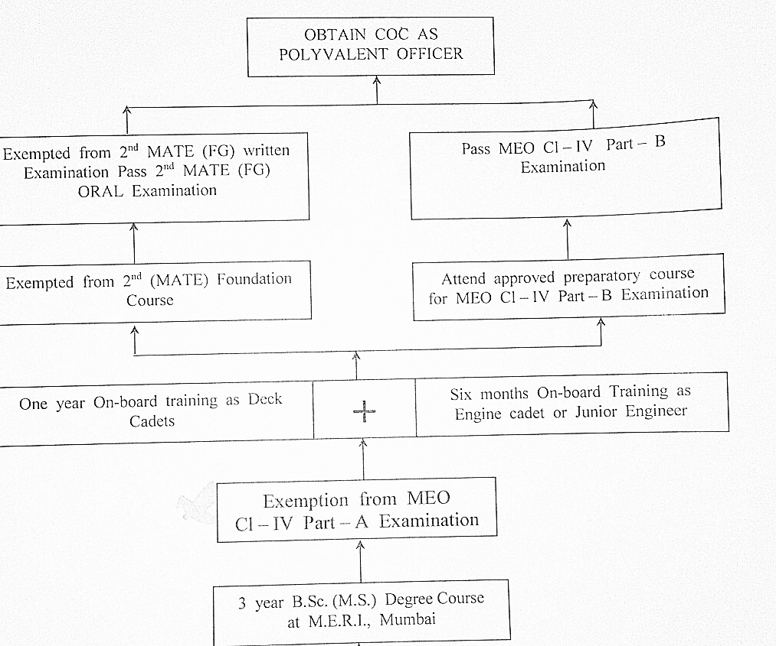

SKILL DEVELOPMENT
Mariners are known for their robust yet ignited minds. The human resources in merchant navy should be highly skilled as their lives are keen to change depending upon the sea.
The skills as required to a mariner is discussed as;
- Leadership skills- the working personals must have a good leadership quality to lead the entire seas in rough seas
.
- Management abilities- often it is the master of the ship that determines the work profile, things to buy at the next port and ship handling. Thus management ability should be taught to the cadets from very beginning.

- Safety at sea- skill development courses must be made mandatory for everyone to safe guard the life’s at sea.

- Skills regarding the handling of official work such as data ,accounts must be taught as it would help them in the port.

- New technology to break language barriers :

A new device called Pilot could make that dream (mostly) a reality. In the context of a wearable, that means you’ll probably need an always-on data connection, which itself means you’ll need a subscription and a hefty power supply to keep the connection going all day. Pilot gets around this by wirelessly accessing your cell phone’s processor to do the work locally; prior on-phone translation services have been imperfect, but Pilot claims to have reached true real-time speeds. Consumer-level wearable real-time translation could be one of the most disruptive technologies in recent memory, breaking down old cultural barriers, accelerating globalization.
Skill development courses to be organized regarding the use of such new technology that could possibly break the linguist problem in marine field.
TRAINING
The training of human resources available for water transport must undergo the following trainings:
- Para military training : this would make a cadet disciplined and fit for the turbulent seas.
- Cadets must complete training at specified ports and dockyards to make themselves adapt for working condition of the ships.
- Stumilator courses- various stumilator courses both for the engine side and the deck side can be availed by these professionals that would determine their action as per the real life situation.
- Training for emergencies- the human resources available for maritime sector should be well trained to act in emergencies such as fire fighting and man over board or abandon ship.

CONCLUSION
Human resources play vital role in the upliftment of any transport sector. If human resources are properly utilized then it would be quite beneficial to the country’s GDP. Human resources irrespective of their work profile must be educated, skilled and trained.

ACKNOWLEDGEMENT
I would like to thank Mr. A.N.S NETI sir for helping us out in this paper with his valuable advice and suggestions.
I would like to thank our institute incharge Mr. Md Shaji for being a constant critic and helping us even in a busy schedule.
I would like to thank my seniors and my batch mates for their support.
THANK YOU

REFERENCES

- www.nnva.gov
- www.collegeguard.com
- The times of India
- Wikipedia
- Google

