Goltens’ In-Situ Crankshaft Annealing Process and Procedures

The information provided in this document is intended to provide an overview of Goltens’ capabilities and experience as well as the precautions and process followed while undertaking in-situ annealing of damaged crankshafts. More detailed guidelines for execution are contained in Goltens’ internal work procedures. This information is intended to be supplemental and not replace the contents of any proposal or services contract between Goltens and the customer.

Goltens’ Experience and Qualifications:

As an addition to Goltens’ in-situ crankshaft machining capabilities, Goltens has refined the process for annealing crankshafts and other shafting and can do this successfully in-place as well as in our workshops around the world. A deep understanding of the metallurgy, expansion characteristics and safety precautions has been developed and refined over the years into a safe, repeatable, highly controlled process.

Our experience demonstrates that excessive hardness can be successfully reduced or removed and that minor finish grinding/cutting can restore the machinery to service with significantly less loss of shaft diameter as well as the avoidance of costly shaft/equipment removal and the purchase of a replacement crankshaft.

Sample List of Crankshafts that Goltens has successfully annealed:
- BERGEN BRM - DEUTZ 12M640 - MAN B&W 16U28LH-4
- GMT 420.12 - MIRRLEES 16KV MAJOR MK II - MAK 453
- MIRRLEES K8 MAJOR - MAK 551 - MITSUBISHI MHI 16KU
- MAK 6M453 - NIIGATA 16V32 CLX - MAK 6M552C
- NIIGATA 32CX - MAK 8M19 - PIELSTICK 12VPC2
- MAK 8M32 - PIELSTICK 14VPC4 - MAN B&W 10V52/55A
- PIELSTICK PC2 - MAN B&W 12V52/55 - ROLLS ROYCE B-TYPE GAS
- MAN B&W 14V40/45A - SKL VDS 26/20 - MAN B&W 16V40/54
- STORK WERKSPOOR 280/8 - MAN B&W 23/30 - STORK WERKSPOOR 6TM 410
- MAN B&W 28/33 - STORK WERKSPOOR 8TM620 - MAN B&W 28LH
- SULZER 12ZV40/48 - MAN B&W 40/54A - SULZER 16ZAV40S
- MAN B&W 7L40/45 - SULZER AL 25/30 - MAN B&W 8L23/30
- SULZER ZA40 - MAN B&W 8L32/40 - WARTSILA 18V46B
- MAN B&W 9L 40/54 - WARTSILA 4R32 - MAN B&W 9L28/32
- WARTSILA 9R32

Goltens standard procedures

- Pre Machining Crankshaft Inspection: the requirement to perform annealing is generally discovered as part of a standard crankshaft inspection/machining job. As part of these jobs, Goltens undertakes a standard set of inspections prior to undertaking repairs. These inspections include:
  - Diameter Assessment on the damaged crankpin
  - Preliminary Hardness Test – completed if journal surface is clear of foreign material
  - Preliminary Magnaflux (Crack test) – completed if journal is clear of foreign material - to determine if there are surface cracks in the journal surface and how significant the damage is.
  - Run Out measurement - It is of upmost importance that the crankshaft is fully inspected for any signs of bend, before the heat treatment is started. And this must be checked again after the heat treatment is completed. The run out / straightness is checked using a dial gauge mounted on the bedplate frame, and the crankshaft is turned using the turning gear.

- Secondary Magnaflux Inspection (post machining to clean journal surface) – in order to complete a thorough evaluation of the journal condition, the journal is machined in-situ to base crankshaft material using Goltens’ specialized machining tooling. Foreign material, such as bearing babbitt, interferes with measurement and masks potential issues. Goltens repeats this process until the journal is clear of cracks.

- Hardness Mapping – once the journal surface is clear of all cracks, a thorough evaluation of the journal’s hardness is completed and this is mapped for reference during the repair process. A recommendation is then made, based upon the extent of the hardness and the amount of material allowed to be removed from the journal without affecting rated output, as to whether to attempt to machine away the hardness or to pursue repair via annealing. In the case where annealing is required, the following steps and considerations apply.

- Annealing Temperature Determination:
  - Prior to undertaking the annealing procedure, the material composition of the shaft and the maker’s tempering / annealing temperatures during manufacturing of the crankshaft are determined to avoid exceeding the original tempering temperature.
  - Normally, this temperature is found to be around 650 °C and the max holding temperature would be set in between 600 °C up to maximum 630 °C.
  - If no info is available from the maker or class, as to what temperature has been used for heat treatment during manufacturing of the crankshaft. The heat treatment max holding temperature is set never to exceed 600 °C.

- Pre-annealing Set Up requirements:
  - Journal surface must be free of all cracks – as noted previously.
  - Removal of adjacent main bearings (upper and lower shell to be removed)
  - Removal of counter weights on damaged unit and the adjacent 2 units
  - Removal of damaged connecting rod(s) and the connecting rods on adjacent crankpins
  - Removal of thrust bearings – this will allow the shaft to expand axially to avoid any bending in the shaft or pressure on the block
  - Removal of the crankshaft oil plugs – to allow for proper cleaning of the oil channels after heat treatment.
  - In some cases the coupling, flywheel, damper have to be removed, this is due to weight, expansion and position of the crankpin requiring heat treatment
  - Dial gauges are placed in various positions to monitor the movement and expansion of the crankshaft during heat treatment.
  - The engine must be inspected to ensure that sufficient space is available for axial movement of the shaft in the engine block due to expansion of the shaft during heat treatment.

- Annealing Process Execution:
  - The heating is done using ceramic mats that are mounted around the damaged crankpin; under the heating mats we have mounted thermocouple sensors. These sensors are used to control the heating up process, holding time, and finally the cooling down time during the heat treatment process.
  - The computer will be programmed to heat up the crankpin with 40°C per hour until it reaches the defined annealing temperature
  - The annealing temperature will be held for predetermined holding time but may be adjusted depending on the circumstance and severity of damage encountered. It should be noted that a longer holding time will result in an increased elongation and should therefore be checked if available prior to commencing the job
  - After the annealing temperature has been held for the defined period the crankpin will be allowed to cool in a tightly controlled manner at a rate of 40°C per hour until the crankpin reaches 150°C at which time the insulation will be removed and the pin will be allowed to cool normally.

- Post-annealing Procedure:
  - Journal Machining – after annealing, the journal is machined until the scaling that has developed in the annealing process is removed and clean journal material is reached. Normally a minimum of 0.50mm is required to remove the scale and reach clean metal.
  - Magnaflux – crack testing is once again performed to verify that there are no cracks present in the journal surface
  - Hardness – hardness testing is conducted to determine the post annealing hardness levels and verify that they are within the established tolerances. In the event that excessive hardness is still present, the annealing process may be repeated.
  - Run Out - The run out / straightness is again checked using a dial gauge consistent with the pre-annealing run out check. A bend in a crankshaft often occurs after a bearing failure on a crankpin. This bend is caused by the by the same material changes / movement that caused the material hardness to increase. So after annealing, when the hardness introducing the bend has been removed, the crankshaft will often have a run out that is less than what was found before the heat treatment. In some cases there can still be a run out that is out of maker’s specifications. In the event of residual run out outside of tolerances the following is pursued after the annealed crankpin journal is polished to finish:
  - Straightening before machining
    - In Situ Machining of Adjacent Main Journals – by using Goltens’ highly specialized tooling to machine the main journals to the next available undersize the remaining bend in the crankshaft will be removed. After machining the crankshaft will have the correct centre line and the crankshaft will have a run out within recommended tolerances. This machining is done from a fixed point, where the crankshaft is turning and the machining tool is fixed to the bedplate. When machining from a fixed point with the crankshaft turning, any bend or high spot in a shaft will be removed in the crankshaft. It is in principal the same procedure when machining a crankshaft in a crankshaft grinding machine in a workshop.
    - If the crankshaft is too small or there is limited space for our tools, the crankshaft has to be removed from the engine and sent to our crankshaft grinding machine in our workshop.
  - Finish Machining and Super Polishing/honing of annealed journal – after all inspections are completed satisfactorily; the journal is machined to the finish undersize and then polished.
  - Polishing of adjacent main journals - The adjacent main journals may have to be honed/super polished, as there will sometimes be some discolouring on the running surfaces as a result of the annealing on the crankpin.
Below are some pictures of previous jobs completed at various stages in the process:

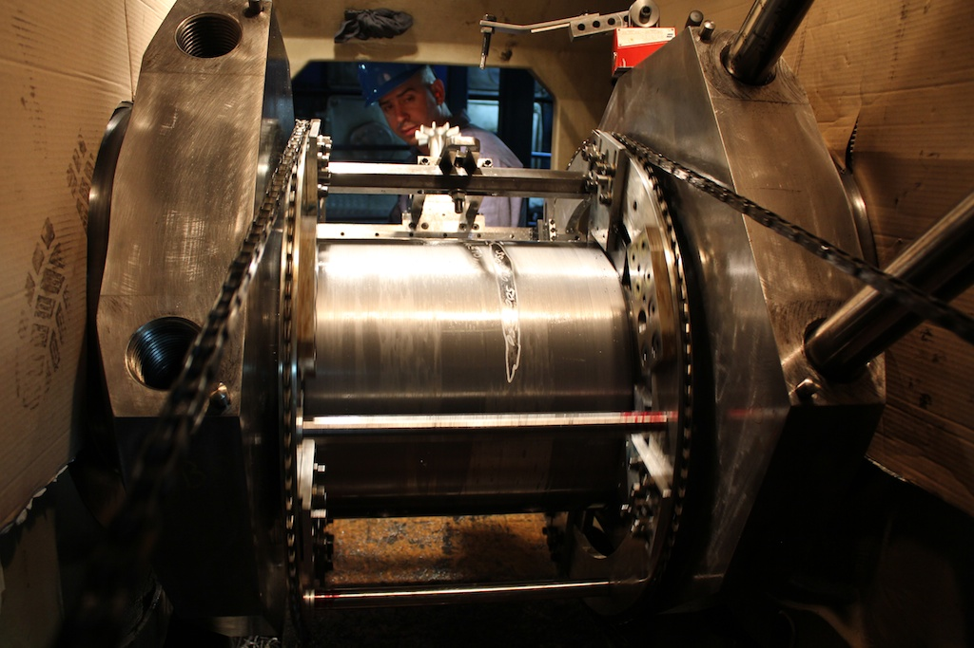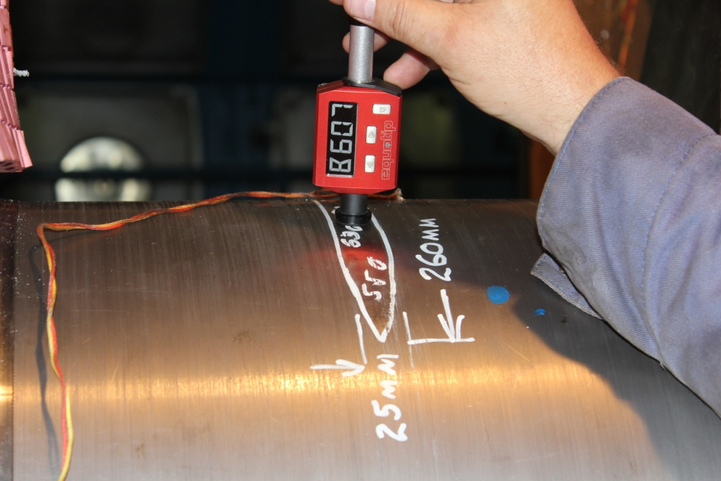
Machining cracks from journal surface – pre annealing Measuring Hardness post machining of cracks from Journal Surface

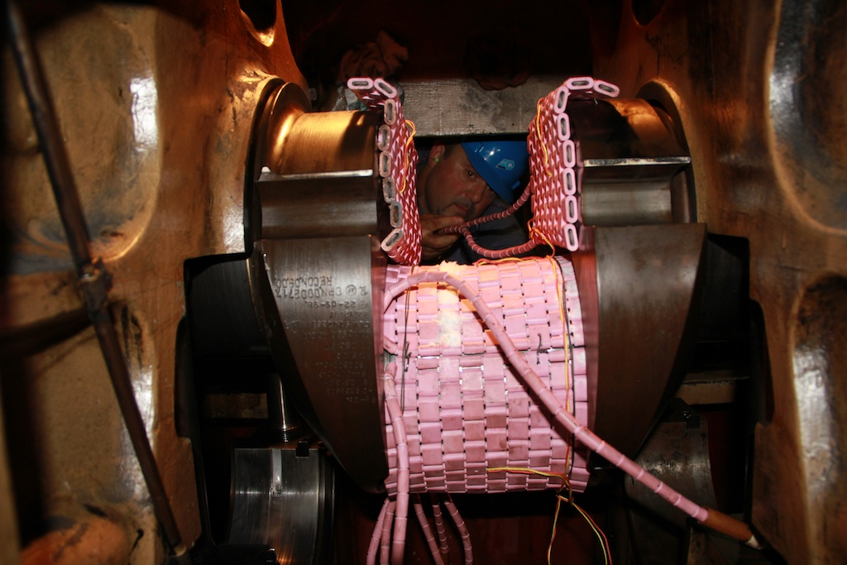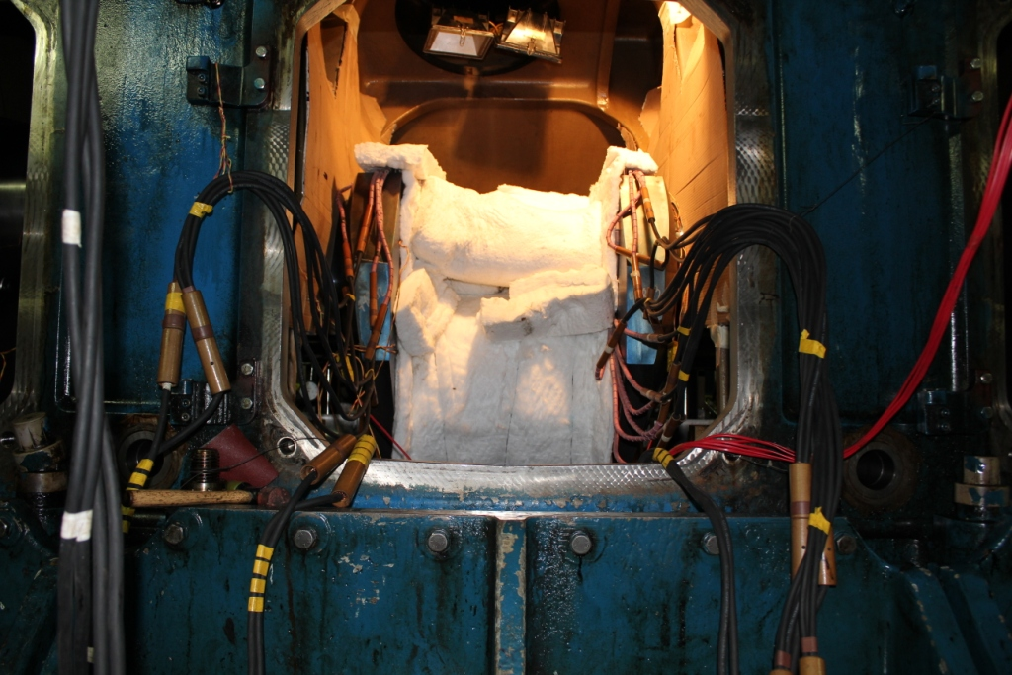
Heating blankets mounted with sensors for temperature control and First layer Insulation in progress to ensure minimum heat loss
monitoring
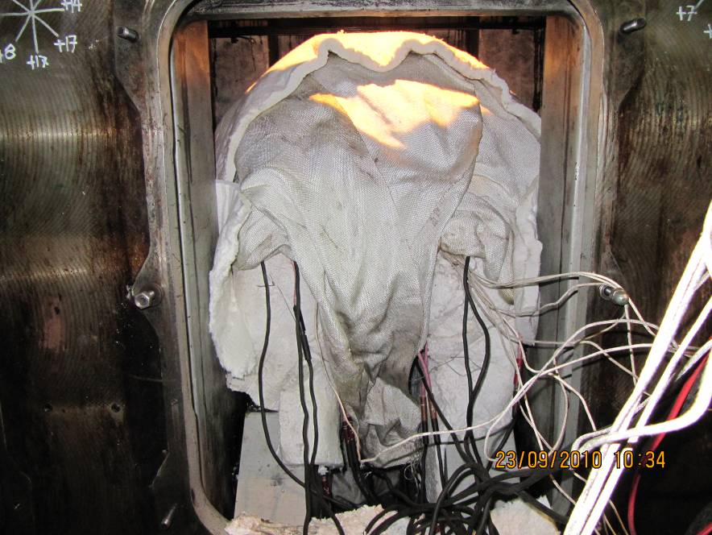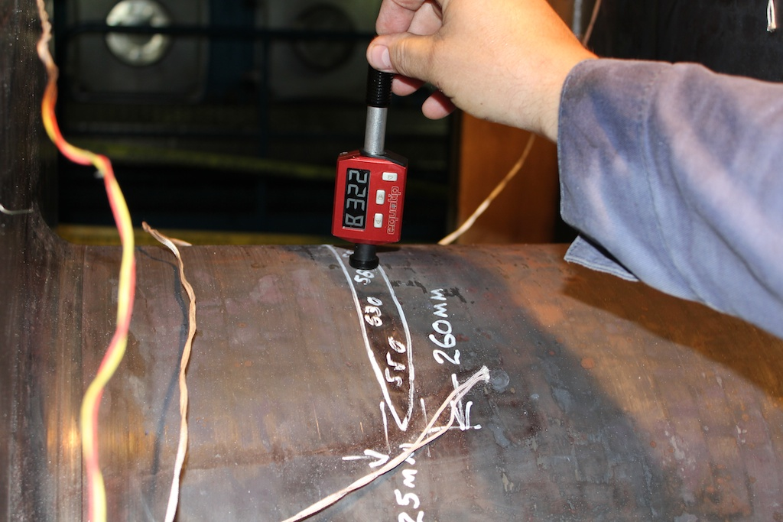
Heat treatment in progress onboard a vessel, where the crankpin is Measuring hardness on crankpin post annealing
fully insulated. This a main engine crankshaft with diameter 500 mm.

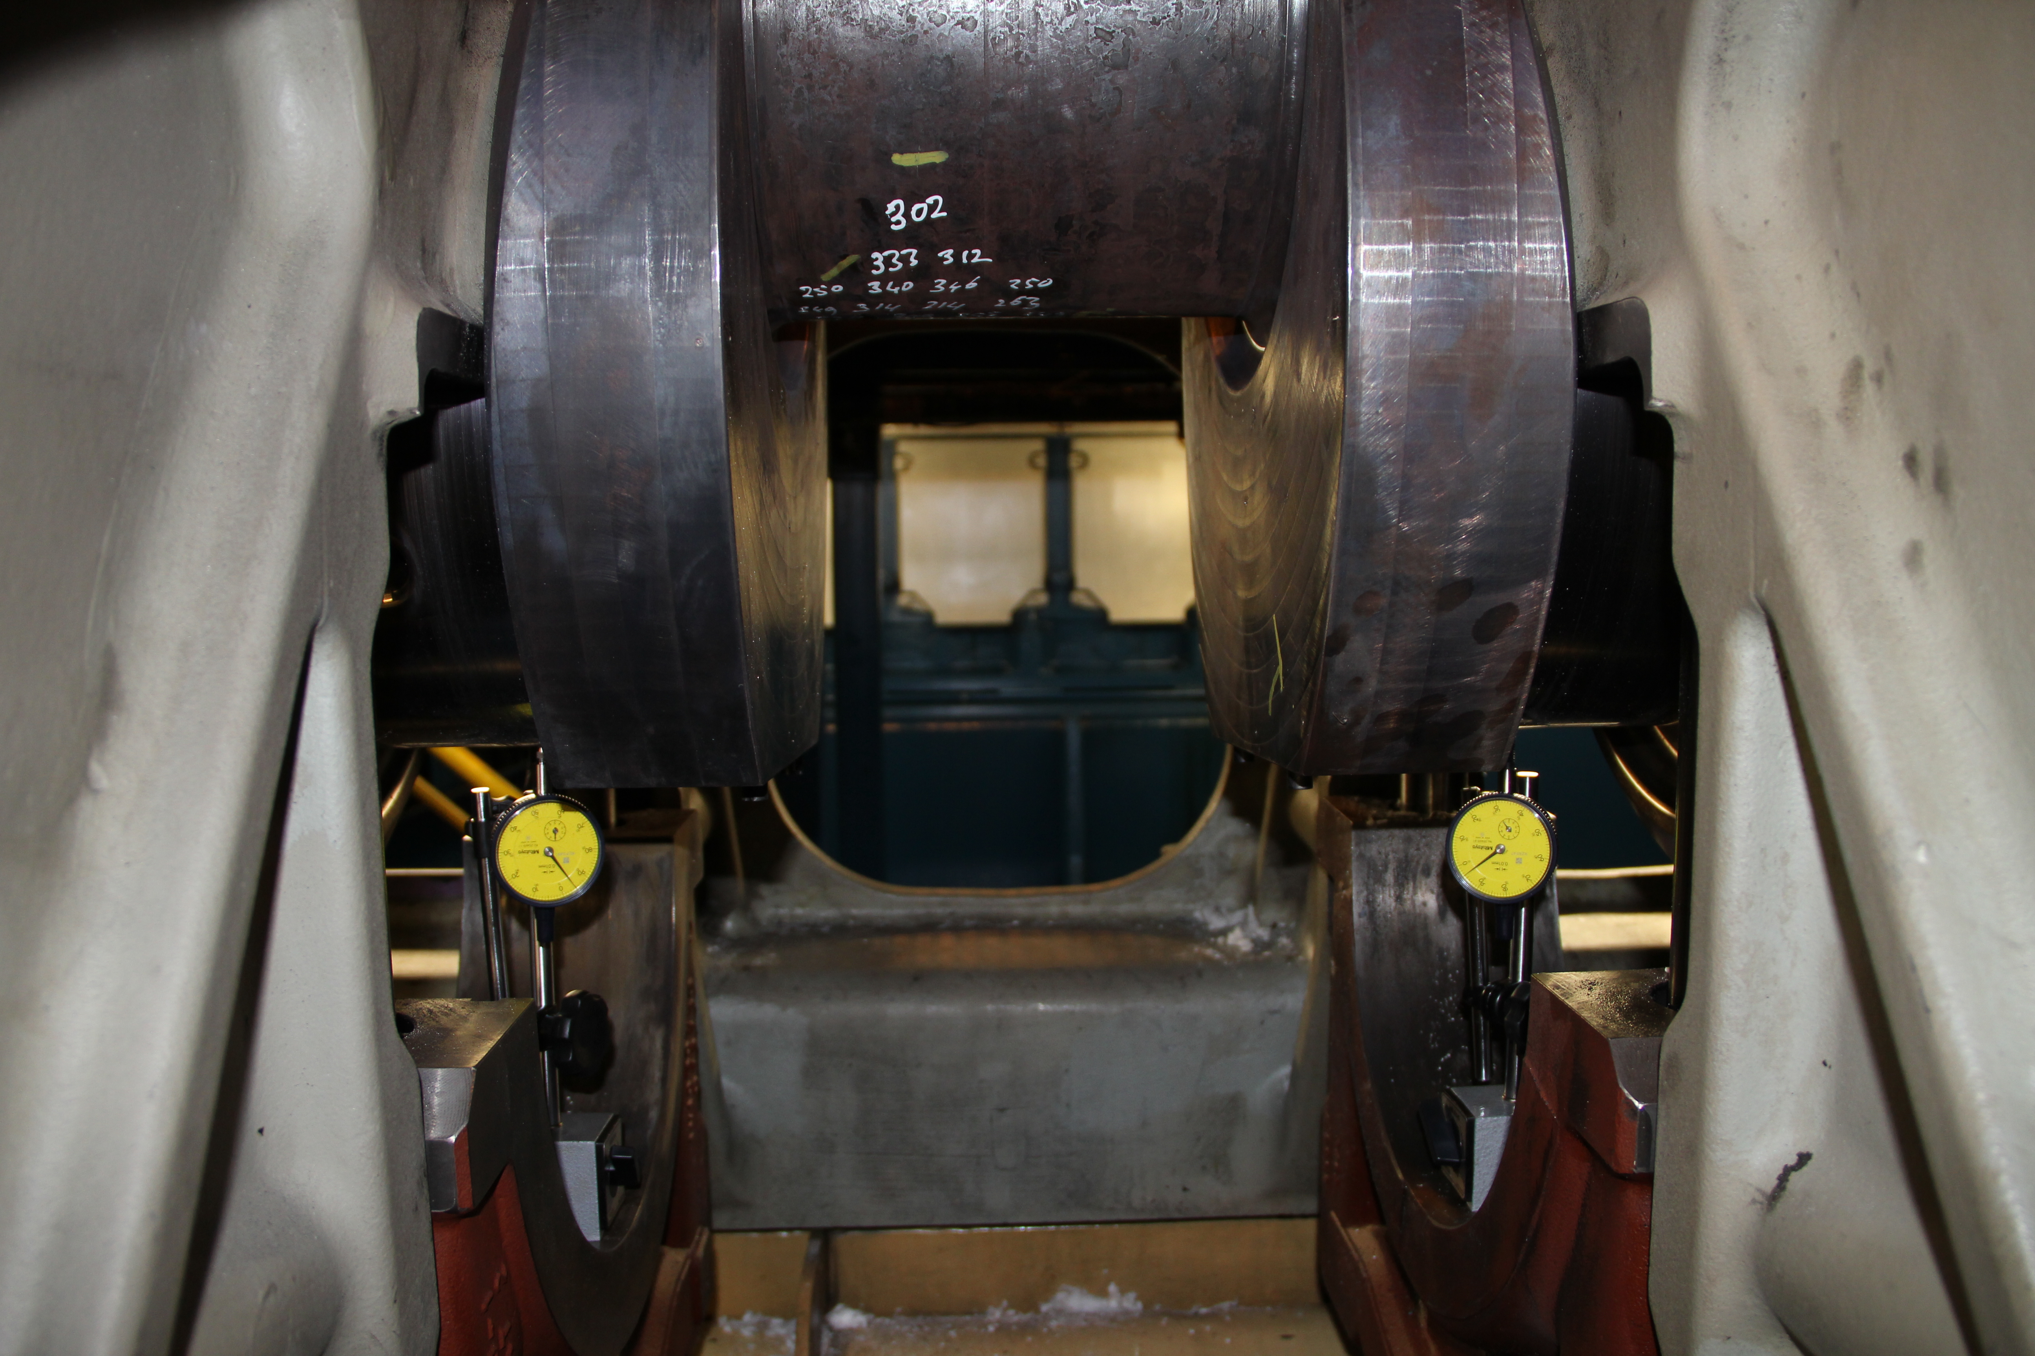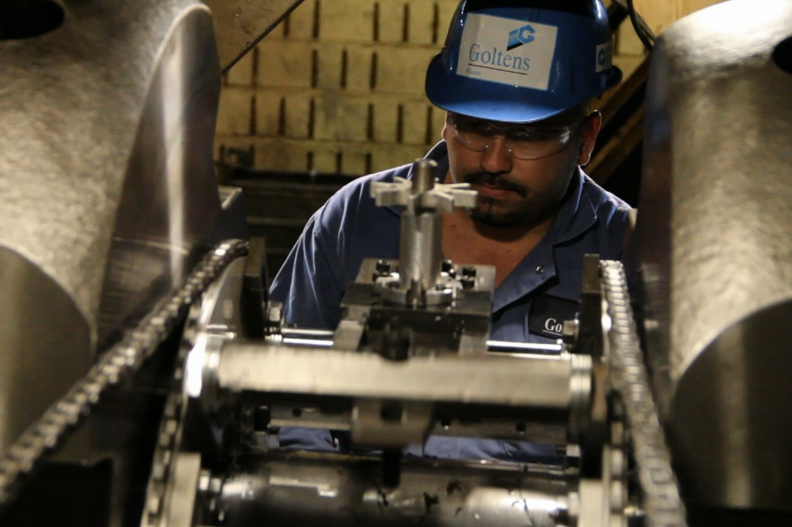
Measuring Run Out post annealing Finish Machining of crankpin

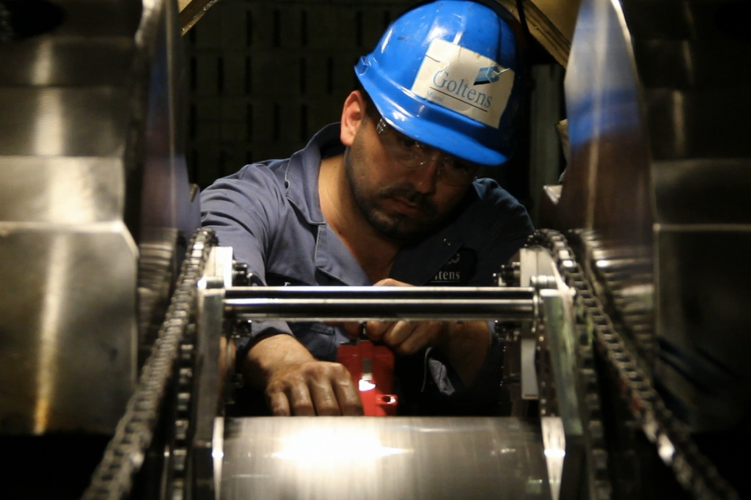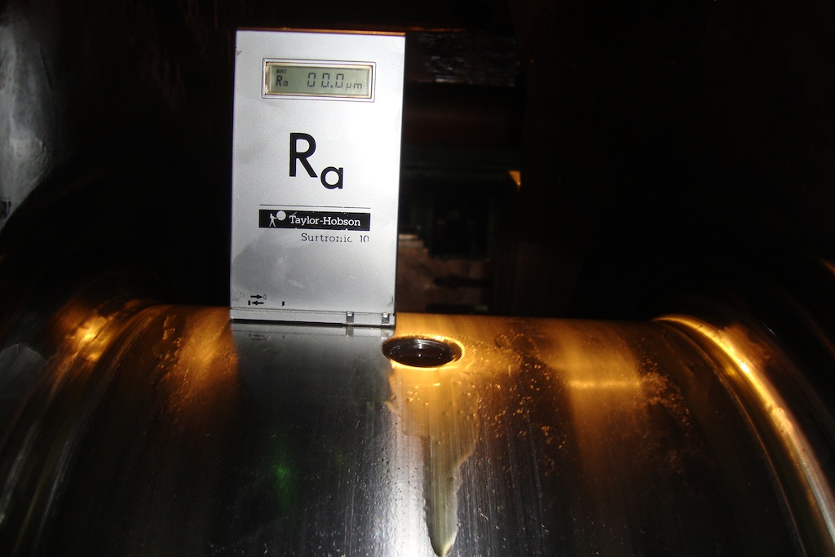
Honing/Super Polishing of Crankpin Final measurement of Surface Roughness

