SAIL SYNERGY 2K17
Theme: - New Techniques and Advancement in Fire Fighting.
Title: - On Board ship Fire Extinguishing using suitable Fire Extinguishing Equipments

Cdt. Avishek Ankit (Main Author), 2nd Year B.Tech ME, Tolani Maritime Institute, Pune.
Cdt. Kewal J. Gohel (Co- Author), 2nd Year B.Tech ME, Tolani Maritime Institute, Pune.

1] Abstract:-
Basically FIRE FIGHTING is the action or process of extinguishing fires as a person’s job. The practice of dealing with problem as they arise rather than planning strategically to avoid them. Therefore I am trying to put innovative ideas on how to deal with fire effectively. These include:-
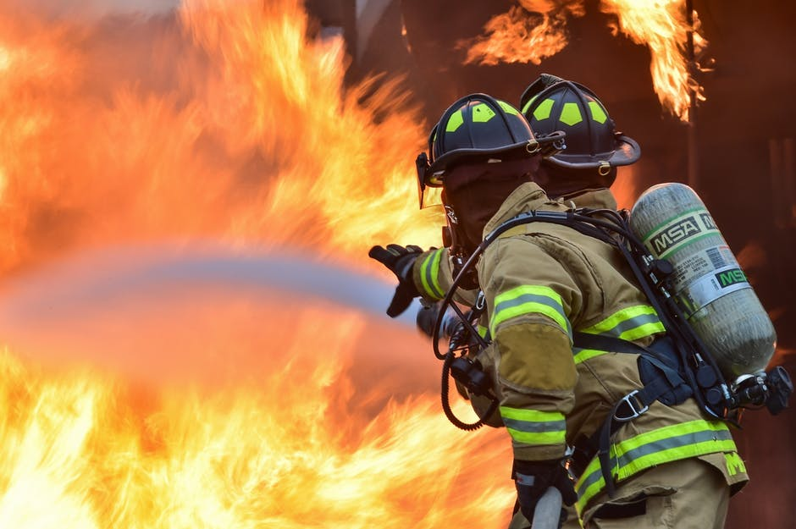
1] Integrated Voice Evacuation and Messaging System:-It will alert the occupants with a pre-recorded message when a fire breaks out. It will give voice instructions for ship’s crew, customized to their particular location in relation to fire and how to escape it.
2] Water Mist System: - It is a typical sprinkler system which works on the flow of water. Instead of the large water droplets, Water Mist System sends out a mist that smothers a fire, since the droplets are smaller, the Mist system creates more of them. The large surface areas of droplets convert water to steam faster.
3] Sonic Fire Extinguishers:-This apparatus is also called as wave extinguisher and works by using ACOUSTIC WAVES to suppress the flame. The extinguisher only emits sound, making it ideal to use around equipment and personnel.
4] Fire extinguishing grenades:-These are hand blown colored round glass bottles usually be filled with salt water. During a fire, the filled glass bottles will be thrown into the blaze wherein the thin glass would easily shatter releasing its contents and trying to kill out the fire.

2] Keywords
Integrated Voice Evacuation and Messaging System= IVEMS
Extinguisher= Ext
Evacuation Plans= EP
Fire Fighting=FF

3] Introduction:-

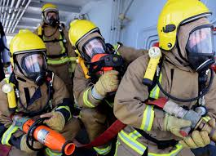
Fire On board ship is one of the most serious risks for life and property as well as the surrounding environment. A ship is evidently subjected to the same risks with regard to fire as a civil or industrial land culture. On board ship these there are tons of liquid fuels, electrical equipment, air conditioning plants, engines, boilers, stores of flammable material and crew accommodation areas (kitchens, mess room, lounge cabins). To all this we must add the load, which the vessel carries, which includes a high % of solid or liquid goods, that are either flammable or at least combustible and often of a dangerous nature. On passenger Ships, the load consists of accommodation and entertainment facilities for the passengers and in Ferries of a large garage for motor vehicles, offshore rigs and tanker storage ships are essentially oil plants.
A ship however by its very nature, is bound to spend the greatest part of its working life at sea, where in the event of a fire, difficulties related to meteorological, and Maritime environment co-exist with the need to cope with the emergency in conditions of limited space and without the possibility of immediate assistance in terms of personnel and facilities to combat the fire and to assist the casualties who may be burned, poisoned or traumatized.
Thus a fire On board ship during navigation represents an extremely high risk situation which may cause physical harm or death to passengers and loss of the ship and considerable damage to its structures and equipments. Furthermore when the ship is carrying Mineral Oil from the ship’s fuel or the cargo are spilt into the sea. Therefore, advancement in FF is very necessary and certain more systems should be installed On board ship. Some of these include:-

1] IVEMS 2] Water Mist System 3] Sonic Fire Extinguishers 4] Fire extinguishing grenades

4. MAJOR CAUSES OF FIRE ACCIDENTS ON BOARD SHIP ARE:-

SR NO. | CATEGORY | RATE | DESCRIPTION
1 | Human error | 88% | Ignorance and negligence [unsafe practises, lack of foresight, attitude etc.]
2 | Mechanical failure | 10% | Human factor to a certain extent
3 | Act of god | 2% | Weather, lightening etc.

5] Integrated Voice Evacuation and Messaging System
(Dependable, Innovative and Intelligent)
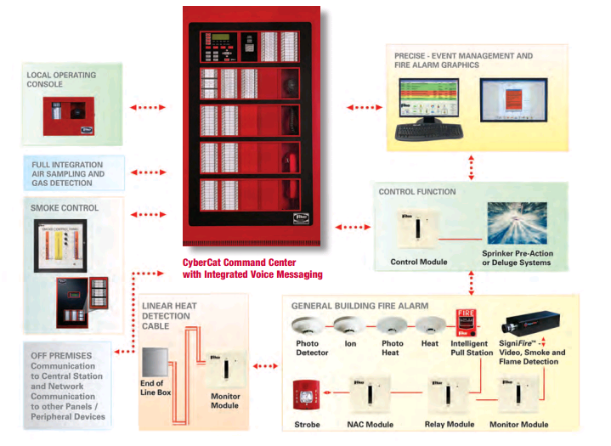
Really! Not all fire safety technologies are built to fight fire but some protect the people from the fire. It will alert the occupants of ship with pre-recorded message when a fire breaks out. It is a concept of ‘distributed intelligence’ which gives voice instructions to occupants, customized to their particular location, in relation to fire and how to escape it. Fire evacuation plans and other safety information play over speakers so the crew can respond appropriately. The system responds in a fraction of second. It can be programmed so specific alerts, either instructions or tones played during fires in various parts of ship. It can be sensed with fire elements (heat, smoke and flame) in a fraction of second.
It is often more effective, faster and safer means of evacuating or messaging occupants in an emergency. It is designed for distributed intelligence and ultimate survivability. Fully integrated into Cyber cat lines of intelligent fire alarm panels, this modular voice evacuation system and the benefits of voice messaging to any size of applications. Crew members will receive a clear and concise instructions pertaining to their specific location, proximity to the situation and emergency strategy- all delivered at the same time.

5.1 Features of IVEMS are:-
- Built-in Microphone
- Addressable fire fighter phone
- Live paging with Microphone
- Customization of recorded messages, configuration at each amplifier
- Additional distributed amplifiers can be added throughout the protected premises
- Local operating consoles available with and without remote display units
- Line-level input available to activate emergency communication system
5.1.1 Significant amplifier feature include:-
- 50 watt rated output per amplifier
- Speaker circuits operated 25 vrms
- Integrated class A or B synchronised NAC
- Integrated back up amplifier
- Up to 16 to 30-sec audio messages stored in each amplifier
- Integrated power supply
- 4 individually programmable class A or B speaker circuit

5.2 Integrated flexibility in voice applications:-

This seamless combination of fire alarm and voice messaging simplifies operation, installation and configuration of the entire system
1] Built-in Redundancy:-
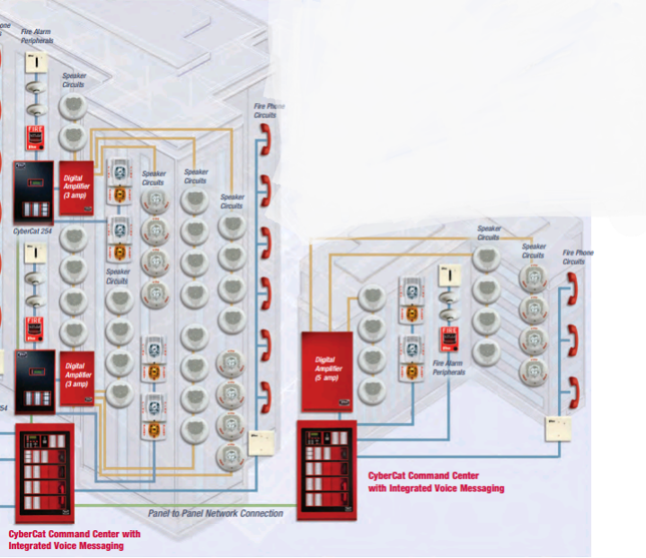
A back-up is integrated into each amplifier for increased survivability and significant risk reduction, all without the need for any additional equipment, that translates into extra protection without an increase in equipment cost and a faster, easier installation.
Integrated Voice Evacuation and Messaging System
2] Fully digital:-
Digitally based, voice messages are clear and distinct without outside interference, virtually eliminated. In addition messages are easily customised for versatility in life safety communication.
3] Fault Tolerant System Architecture:-
As with systems, reliability is a corner stone of the integrated voice messaging system designed with multiple levels of fault protection, the system continues to operate effectively, even if one of the component fails for any reason.
The system offers live paging throughout the facility or messaging from pre-recorded audio files at each amplifier. This prevents system with wider bandwidth limitations, significantly increasing the survivability if the systems. It also eliminates the need for a centralized audio bank for an additional cost savings.
4] Virtually unlimited messages:-
Each amplifiers messages are customisable. Amplifier operates independently, allowing foe all amplifiers to play the same or unique message simultaneously throughout the system.

5.3 Working of IVEMS
When smoke, fire and other threats affects lives, reaction time is critical. That’s why these systems are designed to respond faster than the other equipment requires, by eliminating polling delays and interference. Information is delivered simultaneously from intelligent sensors to the alarm panel and other devices within the system. Therefore, it responds within fraction of a second.

6. Water Mist System:-
The term ‘water mist’ refer to fire water sprays in which 99% of the volume of the spray is in drops with diameters less than 1000 microns. The use of water mist fire suppression, compared to use of gaseous agents and conventional sprinkler systems has demonstrated the following advantages, which include:-
- No toxic and asphyxiation problem
- No environmental problems
- Low system cost
- Limited no water damage
- High efficiency is suppressing certain fires
In order to identify future developments and efficient improvements for water mist suppression system, there is a need to review the progress that has been made on water mist technology over the past few years. This paper, as a first step provides the review of the fundamental research in the water mist fire systems, including mechanisms of extinguishment, spray characteristics methods of generating water mist and some factors that influence performance of water mist such as the enclosure effect and dynamic mixing. Recent studies on the use of computer modelling for the development of water mist systems are also reviewed and discussed

6.1 Extinguishing mechanisms:-
Water as favourable physical properties for suppression. Its high heat capacity (4.2J/gK)
And latent heat of vaporisation (2442J/g) can absorb significant quantity of heat from flame and fuels. Water also expand 1700 times, when it evaporates to steam which results in the dilution of the surrounding oxygen and fuel vapours. With the formation of fine droplets, the effectiveness of water in fire suppression is further increased due to significant increase in surface area of water that is available for heat absorption and evaporation.
Water mist in fire suppression, however does not behave like a true gaseous agent. When water is injected into a compartment, not all the sprays that are formed are directly involved in fire suppression. They are partitioned into a no. of fractions:-
- Droplets that penetrate the fire plane, or otherwise reach the burning surface under the fire plume to inhibit pyrolysis by cooling and the resultant steam that dilutes the available oxygen.
- Droplets that are blown away reaching the fire.
- Droplets that impact on the walls, floor and ceiling of compartment and cool them, if they are hot, or otherwise run-off to waste.
- Droplets that vaporize to steam while traversing the compartment and contribute to the cooling of fire plume, hot gases, compartment and other surfaces.
- Droplets that pre-wet adjacent combustibles to prevent fire spread.

Finally, Extinguishing Mechanisms Classified as:-
- Primary Mechanisms:-
- Heat Extraction:-
- Cooling of fire plume
- Wetting/Cooling of the fuel surface
- Displacement:-
- Displacement of Oxygen
- Dilution of fuel vapour.
- Secondary Mechanisms:-
- Radiation attenuation
- Kinetic Effects

  - Factors that affect water mist performance:-

- Water mist characteristics:-
The effectiveness of a water mist system is supressing a fire is directly related to the spray.
Characteristics produced by the Nozzles:-
The important parameters include:-
- Mean flow Rate per unit area in the fire region
- Direct of application
- Distribution of flow rate in and about the fire area
- Droplet size and distribution
- Entrained air velocity
- Droplet velocity relative to Entrained air, flame velocity and fuel types.

- Droplet size distribution:-
It refers to the range of droplet size contained in representative samples of a spray or mist cloud measured at specific locations (amount of water spray in unit volume or unit area)

- Flux Density:-
It will reduce the compartment temperature but will have little effect or oxygen concentrations in the compartment.

- Spray Momentum:-
It refers to the spray mass, spray velocity and its direction relative to fire plumps. It determines not only whether the water droplets can penetrate into the flame or reach the fuel surface but determines the rate entrainment rate of surrounding air into fire plumps.

- Enclosure Effects:-
It is mainly dependent on the fire size in relation to compartment size.

- Dynamic mixing:-
The degree of dynamic mixing in the compartment created by water mist discharge is determined by spray characteristics (e.g. Spray momentum, velocity), the nozzle characteristics (pressure, cone angle), the spacing of nozzles, the configuration in compartment etc.
  - Methods of generating water mist:-

1. Impingement nozzles
2. Pressure jet nozzles
3. Twin fluid nozzles

6.4 Computer modelling of water mist fire system
1. The concentration of water vapour for effective diluting is also obtained by the application of computer models.
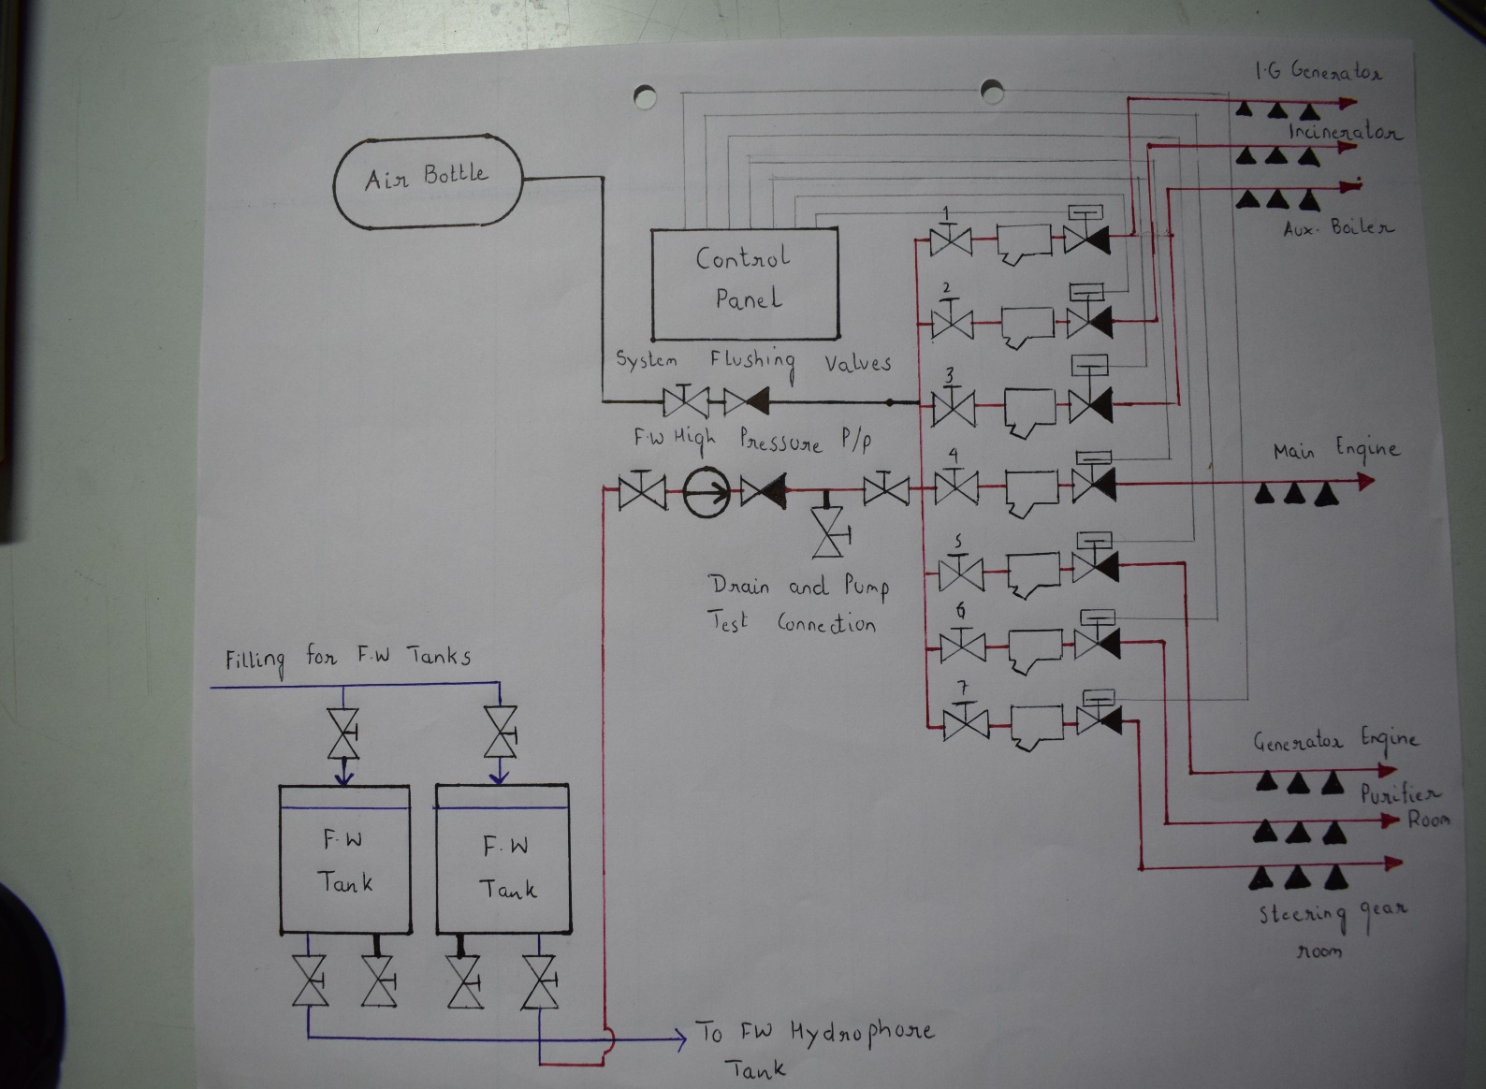
2. CFD models can be used to trace the extinguishing processes. It can provide detailed information on the physical interaction between fires and water mist, the fire speed, the distribution of spray droplets in compartment and the mass and heat transfer between the fire and sprays
On board ship water mist system line diagram.

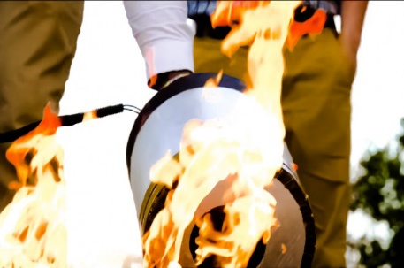
7. Sonic Fire Extinguishers:-
This apparatus is also called as wave extinguisher and works by using Acoustic wave to suppress the flame. The extinguisher only emits sound, making it ideal to use around equipment and personnel. Essentially from my point of view, the vibrations of music work to separate the air from the fuel, causing the material to burn out.

Working Mechanism:-

FILTER
AMPLIFICATION
BLOCK
OUTPUT
SPEAKER
SIGNAL
GENERATOR

This device should be installed in successive corners of bridge, accommodation of ships and must generate a sonic boom sound at particular period of time without intervention of human.

8] Fire Extinguishing Grenade
These are hand blown colored round glass bottles usually be filled with salt water. During a fire, the filled glass bottles will be thrown into the blaze wherein the thin glass would easily shatter releasing its contents and trying to kill out the fire.

8.1. Working Mechanism:-
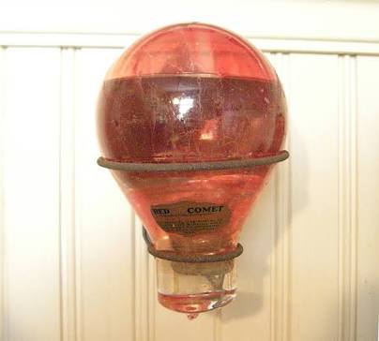
When the fire breaks out, heating up to 90 degree Celsius maximum temperature, the components of the chemical liquid burst the special glass of the container and the fire extinguishing liquid is sprinkled into the fire through the flame. It forms coating on the surface of the material for a short time when dissolves and by this way, the fire extinguishes.
It is an environment friendly automatic fire Extinguisher based on liquid. It has excellent extinguishing ability with perfect effectiveness and compact execution opens a new area in fire extinguishing.

8.2. Details about Fire Extinguishing Grenades
Total weight (approx.) | 1030 gram
Net weight (available)) | 830 gram
Material Quantity | 600 cm³
Dimensions | 80 x 280 mm
Type of glass | Safety glass
Extinguishing material used | Liquid inside the ampoule transform mainly form when heated
Extinguishing method | It’s a combination of fast elimination of oxygen from the burning surface and producing a protective film that prevails further
Environmental Safety | Absolutely environment friendly, harmless to human and animals
Protecting coverage area | 8 m³

9. Conclusion:-
This paper presents the effective measures to fight out the herculean problem which could be a major setback to the property as well as the surrounding environment, and most importantly the precious life of the seafarers.
In this paper, a few ideas have been put forth that can be, with the aid of Science and Technology, brought into existence to kill the fire effectively. Also, herein are discussed a couple of systems that have already been developed and the possible modifications that can be brought in these developed systems. It is the life of the seafarers that is of utmost importance to run a vessel and deliver goods as well as services from one corner if the globe to the other. So, the FF techniques should be updated to ensure safety of life followed by safety of property and environment.

10. Acknowledgement:-
We also extend our sincere thanks to our worthy Mentors Prof. Mr. Arun O. Mahajan and Cdt. Milind Basson for their guidance and support and for putting their precious time and efforts for the successful completion of the paper.
11. References:-
1] Fire prevention and FF hand-out provided for Modular Courses by TMI institute.
2] www.slideshare.net
3] Fire Fighting _quora.html
4] http://wikipedia.org
5] News article on FF
http://www.thehindu.com/today’s:paper/FFcases

