Smart Shoes
Energy Harvesting Through Piezoelectric Effect

Sudhanshu Sagar, Tolani Maritime Institute, Induri, Pune, India, suddzsagar017@gmail.com
Snehadri Banik, Tolani Maritime Institute, Induri, Pune, India, banik.snehadritmi@gmail.com

Abstract-In a world where technology advances every fortnight, the demand for alternative sources of energy is ever-increasing. The alternative sources of energy need to be renewable, sustainable and a clean source of energy at the same time. Batteries require charging, replacement and other maintenance efforts. For example, in the applications such as villages, border areas, forests, hilly areas, where generally remote controlled devices are used, continuous charging of the micro-cells is not possible by conventional charging methods. So, some alternative methods need to be developed to keep the batteries full time charged and to avoid the need of any consumable external energy source to charge the batteries. To resolve such problems, Energy harvesting technique is proposed as the best alternative. There exists variety of energy harvesting techniques but mechanical energy harvesting happens to be the most prominent. This technique utilizes piezoelectric components where deformations produced by different means are directly converted to electrical charge via piezoelectric effect, this was discovered by the Curie brothers’ in 1880.
Every day thousands, hundreds of thousands, even millions of footsteps land each second; be it a common man, a soldier or even a mariner for instance. Each footstep creates a great amount of force, force that is equivalent to our own body weight. There is a fact that an average human being takes seven thousand steps a day. It is possible to harvest electricity from our footsteps; all with the help of piezoelectric effect. A piezoelectric power harvester mounted inside a shoe can generate electrical energy large enough to charge a wide array of devices. This project deals with application of piezoelectric crystals put into the shoes which can be used to charge batteries.
Subsequently the electrical energy can be regulated or stored for further use. The proposed work in this research recommends Piezoelectricity as an alternate energy source. The motive is to obtain a pollution-free energy source and to utilize and optimize the energy being wasted.
Keywords- Piezoelectricity, piezoelectric effect, piezoelectric cells, PZT, MOSFET, transducers, sonar, macroscopic polarisation, integrated circuit.

- INTRODUCTION
At present, electricity has become a lifeline for human population. Its demand is increasing day by

day. Modern technology needs a huge amount of electrical power for its various operations.
Electricity production is the single largest source of pollution in the whole world. At one hand, rising concern about the gap between demand and supply of electricity for masses has highlighted the exploration of alternate sources of energy and its sustainable use. On the other hand, human population all over the world and hence energy demand is increasing day by day linearly. Accordingly, it is an objective of the present invention to provide a method of electrical power generation from this ever increasing human population that does not negatively impact the environment. This technology is based on a principle called the piezoelectric effect, in which certain materials have the ability to build up an electrical charge from having pressure and strain applied to them. Piezoelectricity refers to the ability of some materials to generate an electric potential in response to applied pressure. Harvesting of energy which means energy is already available, but is going to waste if not utilized. Embedded piezoelectric material can provide the magic of converting pressure exerted by the moving people into electric current. Thousands, hundreds of thousands, even millions of footsteps land each second. Each footstep creates a great amount of force, force that is equivalent to our own body weight. There is a fact that an average human being takes seven thousand steps a day.
- A Brief History of Piezoelectricity
The name “piezo” derives from the Greek, meaning “to press”; in more modern terminology, we say that the effect intermingles electric and elastic phenomena. Discovered by Curie brothers, the piezoelectricity rapidly grew as a new ﬁeld of research in the last quarter of the nineteenth century. In 1880, Pierre and Jacques Curie found that in certain materials such as zinc blende, topaz, and quartz, mechanical stresses were accompanied by macroscopic polarization and hence the production of electric surface charges. The following year, Lippmann, from thermodynamic considerations, predicted the converse effect: an imposed voltage produces mechanical deformations or strains the material. The piezoelectric effect remained a curiosity until the early 1920’s when its presence in quartz was utilized to realize crystal resonators for the stabilization of oscillators, thereby launching the ﬁeld of frequency control. With the introduction of quartz control, timekeeping moved from the sun and stars to small, man-made sources that exceeded astronomy based references in stability. Piezoelectric materials are among these ‘invisible’ materials that are widespread around us, although they are unknown to the public at large. Mobile phones, automotive electronics, medical technology, and industrial systems are only a few areas where piezoelectric components are indispensable. Echoes to capture the image of an unborn baby in a womb make use of piezoelectricity. Even in a parking sensor at the back of our car, piezoelectric material is present.
The piezoelectric effect describes the relation between a mechanical stress and an electric voltage in solids. It is reversible in nature. The following are the classifications of piezoelectricity:
- Direct piezoelectric effect: The direct piezoelectric effect is that these materials, when subjected to direct effect mechanical stress, generate an electric charge proportional to that stress.
- Inverse piezoelectric effect: The inverse piezoelectric effect is that these materials become strained when an electric ﬁeld inverse effect is applied, the strain again being proportional to the applied ﬁeld. Clever use of piezoelectric materials enables the realization of a wide variety of technical functions.
Piezoelectric energy can be harvested by converting mechanical vibrations into an electrical charge, or by placing a material under significant strain through heavy pressure. These harvesters generate electricity based on the amount of force used in compressing or deforming a material, as well as the amount and type of deformation on the material’s crystal structure and the speed or frequency of compressions or vibrations to the material. The potential for piezoelectric energy harvesting is therefore much greater than alternative energy harvesting technologies, with the components capable of delivering up to 70 per cent of their charge.

- Applications of Piezoelectric Effect
The advent of the man-made piezoelectric materials widened the ﬁeld of applications and devices based on piezoelectricity are used in sonar, hydrophone, microphones, piezo-ignition systems, accelerometers and ultrasonic transducers. The discovery of a strong piezoelectric effect in polyvinylidene ﬂuoride (PVDF) polymer, by Kawai in 1969, further added many applications where properties such as mechanical ﬂexibility are desired. Today, piezoelectric applications include smart materials for vibration control, aerospace and astronautical applications of ﬂexible surfaces and structures, sensors for robotic applications, and novel applications for vibration reduction in sports equipment (tennis racquets and snowboards). Recently, the newer and rapidly burgeoning areas of utilization are the non-volatile memory and the integral incorporation of mechanical actuation and sensing microstructures (e.g. POSFET devices) into electronic chips.
Sonar as a successful application of a piezoelectric material stimulated others to discover new piezoelectric materials and to develop new devices. An eye-catching example is the use of Rochelle salt as a single crystal needle in the pick-up part of early electronic phonographs, starting in 1935. Around 1950 Rochelle salt was replaced by piezoelectric ceramics, and in turn they were replaced by magnetic car- piezoelectric ceramics ridges in the 1970’s. From then, it took about ten years before compact disc players massively replaced phonographs.

- STUDY OF PIEZO MATERIALS
Piezoelectric ceramics belong to the group of ferroelectric materials. Ferroelectric materials are crystals which are polar without an electric field being applied. The piezoelectric effect is common in piezo ceramics like PbTiO3, PbZrO3, PVDF and PZT. The main component of the project is the piezoelectric material. The proper choice of the piezo material is of prime importance. For this, an analysis on the 2 most commonly available piezoelectric material - PZT and PVDF, to determine the most suitable material was done. The criterion for selection was better output voltage for various pressures applied. In order to understand the output corresponding to the various forces applied, the V-I characteristics of each material namely, PZT and PVDF were plotted. For this the Piezo transducer material under test is placed on a Piezo force sensor. Voltmeters are connected across both of them for measuring voltages and an ammeter is connected to measure the current. As varying forces are applied on the Piezo material, different voltage readings corresponding to the force is displayed. For each such voltage reading across the force sensor, various voltage and current readings of the Piezo test material are noted.
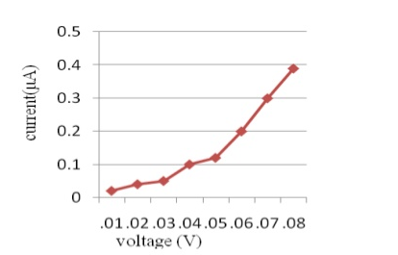
Fig. 1: V-I Graph of PVDF materials

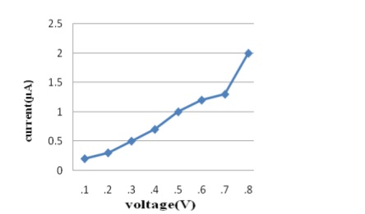
Fig. 2: Graph of PZT material

The voltage from PZT is around 2 V where as that of PVDF is around 0.4V. We can thus conclude that better output is obtained from the PZT than the PVDF.
- STUDY OF CONNECTIONS
Next is to determine the kind of connection that gives appreciable voltage and current necessary, three PZT are connected in series. Fig .3: PZT in series connection A force sensor and voltmeter is connected to this series combination. As varying forces are applied on this connection, corresponding voltages are noted. Also the voltage generated across the series connection and the current is measured. Similarly, the connections are done for parallel and series-parallel connections are done and the graphs are as in figures 3 and 4. Fig 4: V-I graph of parallel and series connection Fig 5: V-I graph of parallel and series combination.
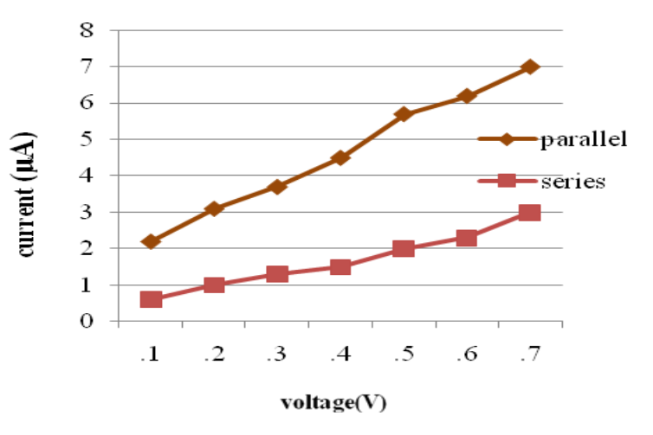
Fig. 3: V-I graph of parallel and series connection

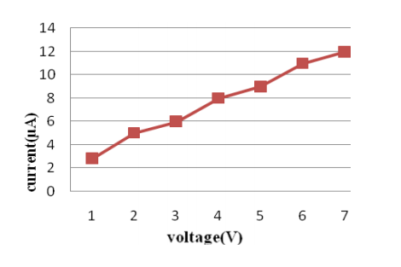
Fig. 4: V-I graph of parallel and series combination
It can be seen from the graph that the voltage from a series connection is good but the current obtained is poor, whereas the current from a parallel connection is good but the voltage is poor. But this problem is rectified in a series- parallel connection where a good voltage as well as current can be obtained.

- METHODOLOGY
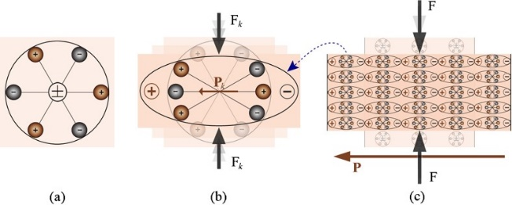
Fig. 4: Piezoelectric effect explained with a simple molecular model: (a) An unperturbed molecule with no piezoelectric polarization (though prior electric polarization may exist); (b) The molecule subjected to an external force (F_{k}), resulting in to polarization (P_{k}) as indicated; (c) The polarizing effect on the surface when piezoelectric material is subjected to an external force.
The piezoelectric effect, explained with a simple molecular model shown in Fig. 4, is the generation of an electric charge as a result of a force exerted on the material. Before subjecting the material to an external stress the centres of the negative and positive charges of each molecule coincide—resulting into an electrically neutral molecule as indicated in Fig. 4 (a). However, in presence of an external mechanical stress the internal reticular can be deformed, thus causing the separation of the positive and negative centres of the molecule and generating little dipoles as indicated in Fig. 4 (b). As a result, the opposite facing poles inside the material cancel each other and fixed charges appear on the surface. This is illustrated in Fig. 4 (c). That is to say, the material is polarized and the effect called direct piezoelectric effect. This polarization generates an electric field that can be used to transform the mechanical energy, used in the material’s deformation, into electrical energy.
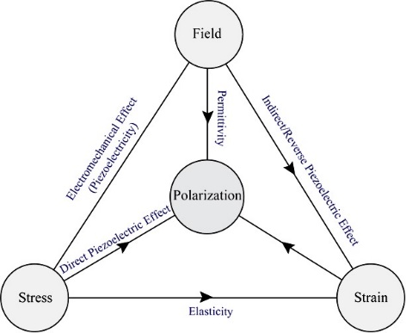

Fig. 5: Piezoelectricity—an intermingling of electric and elastic phenomena

- PIEZOELECTRIC MATERIALS
The commonly used piezoelectric materials are:
- Natural Occurring
- Cane Sugar
- Collagen
- Topaz
- DNA
- Rochelle salt
- Tendon
- Quartz
- Tourmaline

- Manmade Crystals
- Gallium orthophosphate (GaPO₄)
- Langasite (La₃Ga₅SiO₁₄)

- Manmade Ceramics
- Barium titanate (BaTiO₃)
- Barium titanate was the first piezoelectric ceramic discovered.
- Lead zicromate Titanate
- Lithium niobate (LiNbO₃)

- ANALYSIS DONE ON THE SMART SHOE
People whose weight varied from 40kg to 75 kg were made to walk wearing the smart shoe to test the voltage generating capacity of the Piezo tile. Maximum voltage is generated when maximum weight/force is applied.

- WORKING
The piezoelectric material converts the pressure applied to it into electrical energy. The source of pressure from the weight of the people walking over, the energy is transmitted through the feet onto the soles of the shoe. The output of the piezoelectric material is not a steady one. So a bridge circuit is used to convert this variable voltage into a linear one. Again an AC ripple filter is used to filter out any further fluctuations in the output. The output dc voltage is then stored in a rechargeable battery. As the power output from a single piezo-film is extremely low, combination of few Piezo films was investigated. Two possible connections were tested - parallel and series connections. The parallel connection did not show significant increase in the voltage output. With series connection, additional piezo-film results in increased of voltage output but not in linear proportion. So here a combination of both parallel and series connection is employed. From battery provisions are provided to connect dc load. An inverter is connected to battery to provide provision to connect AC load. The voltage produced across the tile can be seen in a LCD for test purposes. For this purpose, microcontroller PIC16F873A is used. The PIC16F873A features 128 bytes of EEPROM data memory, self-programming, an ICD, 2 Comparators, 5 channels of 10-bit Analog-to-Digital (A/D) converter, the synchronous serial port can be configured as either 3-wire Serial Peripheral Interface (SPI™) or the 2-wire Inter-Integrated Circuit (I²C™) bus and a Universal Asynchronous Receiver Transmitter (USART).

Fig. 6: Microcontroller PIC16F873A
The microcontroller uses a crystal oscillator for its operation. The output of the microcontroller is then given to the LCD which then displays the voltage levels. The inverter used in this circuit uses the IC CD4047. It is used to convert the DC voltage stored in the battery to AC voltage. IC CD4047 produces two pulse trains phase shifted by 180°. These pulse trains are used to switch transistors configured in common emitter mode producing pulse trains of 12V, which is capable of switching a MOSFET. The sources of the two MOSFETs used in the inverter circuit. The EMF generated by a piezoelectric crystal of such dimension is not enough to charge such devices. So, MOSFET (metal oxide semiconductor field effect). MOSFET is a device which converts low voltage to higher voltage with an intelligent IC (Integrated Circuits). This high voltage generated will be enough to charge a 3.71 V smartphone batteries, and other electronic gadgets.

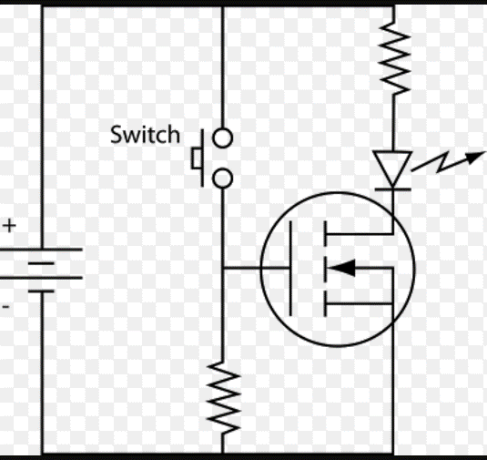
Fig 5: MOSFET-circuit diagram

- DISCUSSIONS

This projects gives us a brief idea about how piezoelectric effect can be used in our daily life to generate voltage, in other words electricity which can be used to charge devices such as smartphones, flashlights or iPod. A million footsteps land each second, even though the voltage generated in each step might be minute, but on an average a human takes around thousand steps a day, so if we take the summation of all the ‘minute voltage’, it can act as a power brank. This might seem to be an impossible task; but can act as a power bank and more importantly a sustainable source of energy.
Piezoelectric crystals when put into shoes can generate voltage large enough which can be used to charge certain devices such as mobile phones and mp3 players. The EMF generated can also be stored for later use. The EMF generated by a piezoelectric crystal of such dimension is not enough to charge such devices. So, MOSFET (metal oxide semiconductor field effect). MOSFET is a device which converts low voltage to higher voltage with an intelligent IC (Integrated Circuits). This high voltage generated will be enough to charge a 3.71 V smartphone batteries, and other electronic gadgets.

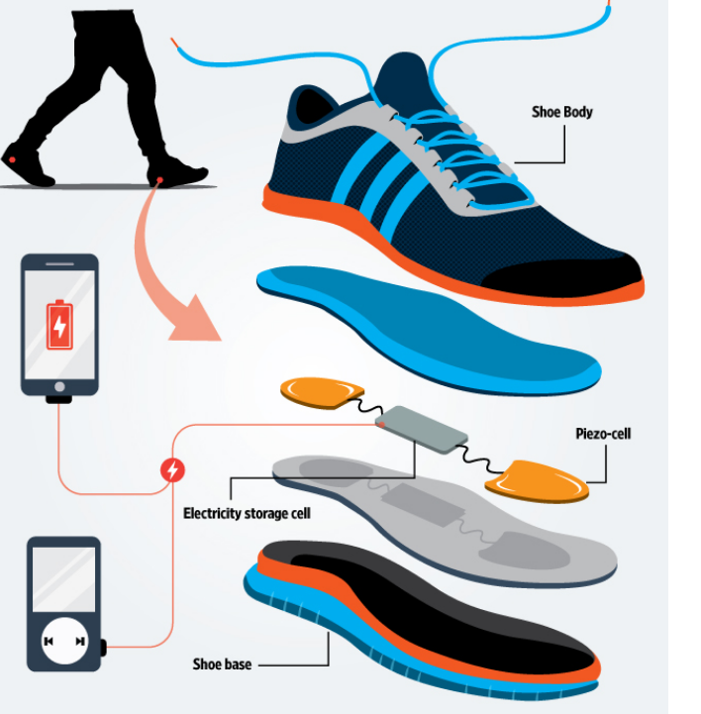

Fig 6: General representation of smart shoes

- CONCLUSION

We conclude that piezoelectric effect in daily life will not only help in generating power but also will act as a sustainable source of energy for the upcoming generations till we find an alternate environment friendly and renewable source of energy.
Also, by comparison it was found that series- parallel combination connection is more suitable. The weight applied on the tile and corresponding voltage generated is studied and they are found to have linear relation. It is especially suited for implementation in crowded areas. This can be used in street lighting without use of long power lines. It can also be used as charging ports, lighting of pavement side buildings.
Piezoelectricity is a “green energy” source which when applied at its peak potential can be a source of hope who live in darkness.

- ACKNOWLEDGMENT

We would like to thank Tolani Maritime Institute, Induri for providing us with an opportunity to do a research project on “Smart Shoes: Energy Harvesting through Piezoelectric Effect”.
We wish to express our sincere gratitude to Prof. Arun O. Mahajan, Prof. Sanjay Dabadgaonkar, Prof. Puja Achawat and Prof. Nilima C. Joshi for their constant guidance and encouragement in carrying out this research project.

- BIBLIOGRAPHY

- R.S.Dahiya, M. Valle Robotic Tactile Sensing, © Springer Science + Business Media Dordrecht 2013
- P. Dineva et al., Dynamic Fracture of Piezoelectric Materials, © Springer International Publishing Switzerland 2014
- A.K. Sawhney, A Course in Electrical Measurements and Instrumentations, © Dhanpat Rai & Company
- Electricity from Footsteps, S.S.Taliyan, B.B. Biswas, R.K. Patil and G. P. Srivastava, Reactor Control Division, Electronics & Instrumentation Group And T.K. Basu IPR, Gandhinagar.
- Design Study of Piezoelectric Energy- Harvesting Devices for Generation of Higher Electrical Power Using a Coupled Piezoelectric-Circuit Finite Element Method IEEE Transactions on Ultrasonic’s, Ferroelectrics, and Frequency Control, vol. 57, no. 2, February 2010.

