Safeguarding of merchant ships using electricity
Sairam Betamcherla , Tolani Maritime Institution
Marine engineering 1st year
E-mail:saisreekala115@gmail.com

1. Abstract
This paper deals with conceptual study of electrification of guard rails of the ship to make it pirate proof and joining of the cargo containers with electromagnetic base to make it safe trip for the cargo ships in rough weather. This method saves lives of many aspiring mariners from the grip of piracy and life threatening situations that costs a lot to their family and the company. These technologies and designs have not only the potential to be very sustainable in the long term use but also are cost efficient as compared to traditional methods of fighting piracy.

2. Keywords
Electrification ,guard rails, pirate proof , electro magnetization of containers, no life risk, cost efficient.

3. Introduction
According to the Ministry of Shipping, around 95% of India’s trading by volume and 70% by value is done through maritime transport. This transportation of goods involves huge running cost and their safety is of utmost priority. So far it appears that no security system has been developed that is 100%effective in this context, coming up against well organized well equipped and armed attackers. However, ship owners and operators nevertheless had to implement whatever measures are available to detect and deter piracy of their vessels and cargos. This includes use of many modern technologies such as LRAD (long range acoustic device) ,water cannons which stopped the piracy in the last few years and the main role is that of the countries navy's which is ready to help 24/7/365.The use of electric fences can reduce the problem very effectively and helpful for the safety of the ship as well as the people on board.
4. Recent incidents of piracy
On 13 March 2017, the Aris 13, was hijacked by pirates in two skiffs a few miles off alula the northernmost town of Somalia in Puntland . It was the first hijacking of a large commercial vessel since 2012. The ship was taking oil from Djibouti to the Somali capital, Mogadishu. The Aris 13 was boarded by about two dozen armed men, who immediately turned off its tracking system after a distress call was sent from the ship. They then anchored her off Alula. On Thursday 16 March an intense gunfight started between the pirates and the Punt land Maritime Police Force, followed by intense negotiations between the marine force, local clan elders and the pirates, effectively ending the hijacking later that day. The crew was released unharmed. This accident can be effectively prevented with the below mentioned solution.
5. Electrification of guard rails
Electrification: The act of electrifying, or the state of being charged with electricity.
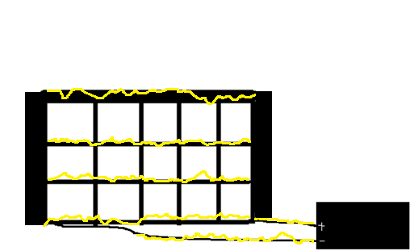
Building process
Electric railing system could be used to repel unauthorized persons from gaining access to the deck of a ship. The system would be similar to that of the 5-strand wire outrigger used on the top of perimeter fencing. The Electric rail would be attached to the foot-well of the deck which would make climbing aboard from below without touching the Electric rail impossible – they would have to climb up, out and over without touching the Electric rail.
Safety measures
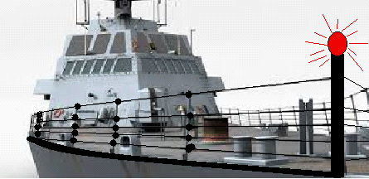
The red light here indicates the grill is electrified but from long distance it looks like just all other warning signals. This prevents the crew from coming in contact while the guard rail is in switched on condition. While the pirates are not aware of the electric guard rails try to climb on to the ships deck will be electrified with 0.25 A of nonfatal electric current that doesn’t kill them but immobilizes them for a particular time period , this gives the captain and its crew enough time to assess the situation and act according to it to make the ship , cargo safe .
Circuit diagram of the electrical guard rail
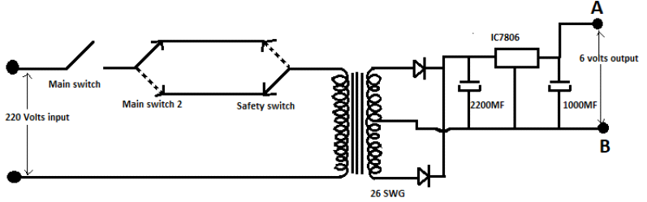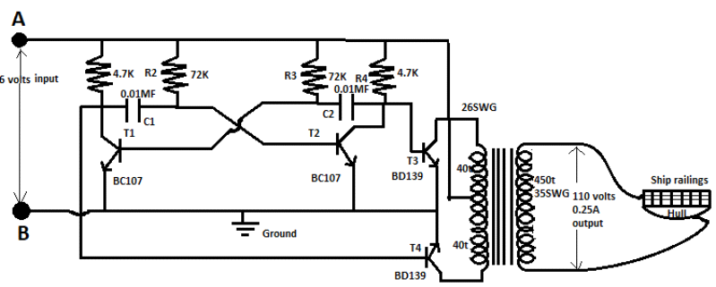
The above circuit is a astable multivibrator that changes 6V DC to AC output that oscillates continuously between its two unstable states without the aid of external triggering. The time period of each states are determined by Resistor Capacitor ( RC ) time and in this the 220 volts present on the ship is stepped down to 6 volts through a step down transformer and converted to DC voltage and then a IC 7806 is used as a switch that activates in case extra current flow through the circuit .in the astable multivibrator 2 power transistors(BD139) and 2 npn transistors (BC107)are used for conversion of 6 volt Dc to AC with continuous switching on and off of the transistor.Secondry is designed to have 6-0-6V primary and 110V 250 milli amperes in secondary .Primary winding 80 turns (40 +40)26 SWG secondary winding 450 turns of 35SWG.
Emergency situation
In case of emergency situation there will be an alarm and all the crew will be alerted to go to their respective muster stations and when the captain is sure that no crew is missing then the current in rails is switched on and in case a crew member by mistake comes in contact to the grill there will be a kill switch in a unpredictable place and the crew needed to switch it off but in case of fault this kill switch activates itself it can be manually overridden from the deck and engine room switches.
The outcome of this solution
Getting electrified and immobilization of the person for few minutes /seconds. This works on the principle of stun guns.

Advantages as compared to conventional methods
- Cost efficient
- No life risk
- More durable
- Hard to detect for pirates
- 100% effective
- Easy to install
- Suitable for all weather types
Working on an example
As an example let’s take a ship name maersk Alabama whose length is 145 m long and 290 mts of safe railing it was attacked by pirates of Somalia when travelling to Mombasa and its captain Mr. Philips acts to his extreme intelligence and saves it at last but in this, once the pirates are on the ship the captain is help less if this security was on this ship it would not be possible for the pirates to get on and hijack this ship. When they are wet with water thrown by the water cannonsAnd will be electrified even if they wear rubber gloves and shoes. 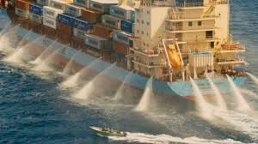

ELECTROMAGNETIC CONTAINER
Containers have a lot of uses these days and without them we cannot imagine our day to day life running smoothly and they are available in different sizes for different purposes .They are used to transport goods starting from small wrist watches to cars , cranes etc. They are to be most carefully secured but the accidents happen due to one or the another reason.
Accidents related to falling of containers into sea
Now and then we here the cases of containers falling into the sea , loss of millions worth cargo etc .This happens due to the carelessness shown by crew for lashing and tightening the support cables everyday . This accidents happen mainly when the seas are rough .But this can be prevented by the following suggestion/idea that would save millions worth cargo easily.
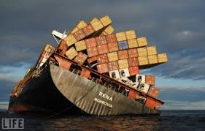
Stastical data
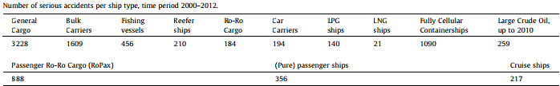
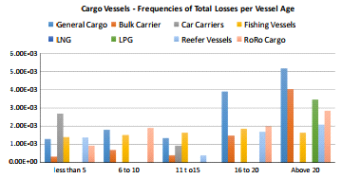
From the above it is statically proven that cargo ships get damaged more due to capsizing.

Electro magnetization of containers
Now and then we here the cases of containers falling into the sea , loss of millions worth cargo etc .This happens due to the carelessness shown by crew for lashing and tightening the support cables everyday . These accidents happen mainly when the seas are rough .But this can be prevented by the following suggestion/idea that would save millions worth cargo easily.
Working Principle
It works on the simple of magnetization of a iron core when it is surrounded with electric wiring.
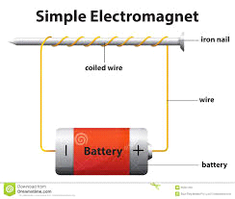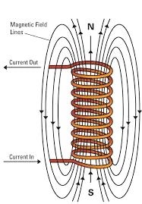

Explanation with a sketch
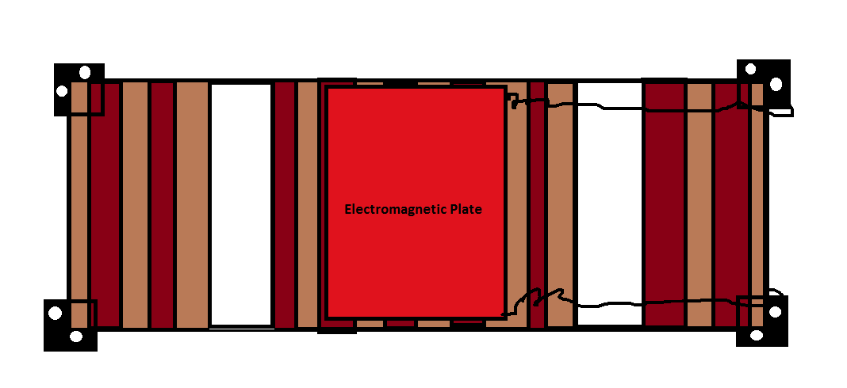
The base has a length of 25 meters and height of 15 meters and the electromagnet should be placed in 1/3 length of the container powered by the system that is used to power a refrigerating container on board .

How this works
When the weather detoriates in a sea voyage the electromagnets are switched on as a backup plan for safety .when this is switched on the magnet holds the below container with its magnetic power and makes it stiff and prevents it from shifting or tilting with the rolling and pitching of seas

Internal features of electromagnetic container
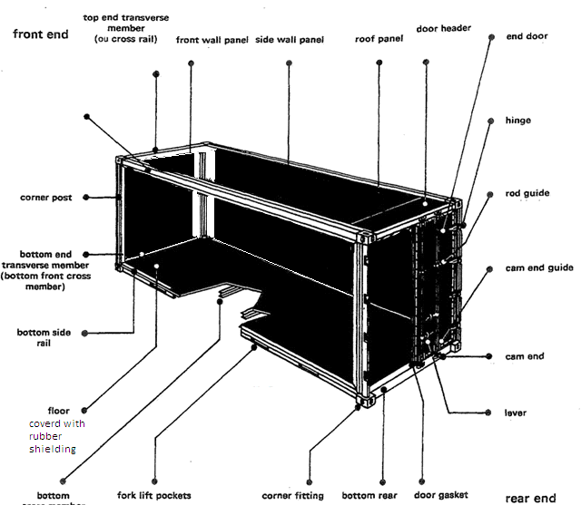

Containers that are electrified
Containers that are electrified will not slip over and fall in any situation

Advantages:
- The ship becomes 100% safe
- No life risk
- No money loss
- The cargos total security
Conclusion:
Through the above mentioned ideas if inappropriate needed to be sharpen more for perfection .through these we can save millions of worth cargo and lives of the crew members on the ship which is more worth that it cannot be compared with anything .thanking u all for giving me this opportunity to express my ideas in such a prestigious stage.

Acknowledgements:
The completion of this undertaking could have not be possible without the participation and assistance of so many people whose names may not at all enumerated .Their contributions are appreciated and gratefully acknowledged.
To my parents, friends, well-wishers and others who in one way or the other shared support either morally, financially, and physically, thank you . Above all to the great almighty thank you
Bibliography:
- Imo website
- Google
- Reference books from library
Lloyds MIU handbook of maritime security
- Lecturers
- Friends
- Mentors
- Captain Phillips movie
- www.slideshare.net
- https://www.google.co.in/search?q=astable+multivibrator+&oq=astable+multivibrator+&gs_l=psy-ab.3..0i67k1j0l3.957.2364.0.2989.9.9.0.0.0.0.100.834.8j1.9.0....0...1.1.64.psy-ab..0.9.833.dYdQUGyWKuQ
- https://en.wikipedia.org/wiki/Pirates_of_the_Sea
- https://www.google.co.in/search?q=electromagnet&oq=electro+mag&gs_l=psy-ab.1.0.0i10k1l4.1241.4179.0.6819.11.9.0.0.0.0.334.1289.3-4.4.0....0...1.1.64.psy-ab..7.4.1287...0j0i67k1j0i131k1.1ny-gO9aY8A

Thank you

