

THE GREAT EASTERN INSTITUTE OF MARITIME STUDIES (LONAVALA)

PAPER PRESENTATION ON

“WORLD TECHNICAL VISION 2040 - THINK WILD”

FOR

TRANSTECH -2014

SUBMITTED BY:

- Cdt. SUDHAKAR SINGH (201309GME32)
- Cdt. VIPUL SHARMA (201309GME37)
- Cdt. VIVEK SRIRAJ TADALA (201309GME38)

ABSTRACT
The operating environment of the future is likely to be dramatically different from today. The objective for the vision 2040 is to implement aggressive improvements in energy efficiency in new ship designs, retrofitting and operations and to show a way towards a better future – for our own success and for wider society, with sustainable shipping serving a genuinely sustainable economy.
INTRODUCTION
Vision 2040 for a sustainable shipping industry
• Changing to a diverse mix of energy sources, using resources more efficiently and responsibly, and dramatically reducing greenhouse gas intensity.
• Providing safe, healthy and secure work environments so that people want to work in shipping, where they can enjoy rewarding careers and achieve their full potential.
• Earning the reputation of being a trusted and responsible partner in the communities we live, work and operate
.• Developing financial solutions that reward sustainable performance and enable large-scale uptake of innovation, technology, design and operational efficiencies.
• Transparency and accountability drive performance improvements and enable better, sustainable business decision-making.
• Proactively contributing to the responsible governance of the oceans.

We cannot wait until 2040 to become sustainable; we need to act today. We will need to:
• Pioneer/implement aggressive improvements in energy efficiency in new ship designs, retrofitting and operations.
• Actively seek renewable and other energy sources to encourage a step-change in shipping’s energy portfolio.
• To achieve significantly reduced greenhouse gas intensity.
• Implement systems to trace and increase accountability of ship building materials and their sources, with the ultimate aim of having end-to-end responsibility and accountability for these materials.
Motivation for implementing new technologies :-

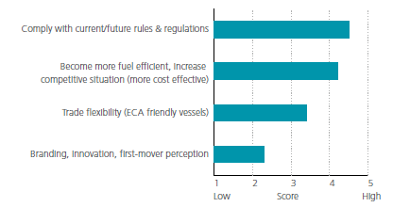

Barriers to implementing new technologies :-

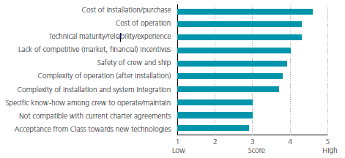
The different types of propulsion methods used at present :-
Across the marine industry, we are witnessing a paradigm shift in operations and thinking. There are many and varied reasons for this change – they include increases in the cost of marine fuels and continued globalisation, as well as environmental regulation and an increase in stakeholder expectations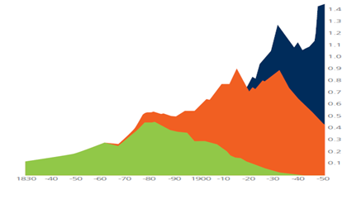
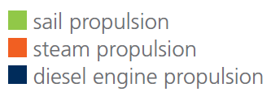

What will tomorrow’s sustainable vessel look like and how will it differ from other vessels?
There are ways in which we can help drive and develop the key technologies which will shape the green ships of the future.
- Research
Ship design will focus on reuse and recycling, materials, hull design, propulsion and fuels, and these are the areas on which our research is focused.

- Human factors
People are widely accepted as the greatest source of operational risk to modern ships – fatigue, poor leadership, lack of experience and poor maintenance are just a few of the ways that the human element can impact on operations.
Therefore, to make a business more sustainable, it needs a well-trained, well-motivated and effective workforce.

- Influencing legislation, promoting environmental protection
Of course, the vessel of the future won’t be possible without legislation to guide its development and enforce compliance.

TECHNOLOGY AND ENERGY EFFICIENCY METHODS THAT COULD BE USED IN THE FUTURE
Shipping will have to adopt new technologies over the next decade in order to be able to adapt to upcoming regulations and market pressure.
- Ballast water treatment technologies
The technology used will depend on the vessel type, trading pattern, vessel size and design. However, all ballast water management technologies involve a filtration process which separates particles from the water flow using membranes and hydro cyclones.

The filtration measures are usually easy to install and maintain, and are often necessary to save sensitive components down the line.
However, the process does create pressure drops and a reduction in flow rate.

The filtration process is followed by mechanical/ physical processes or active substances.
The mechanical/physical processes can include cavitations, UV lighting, heat, vacuum, oxygen stripping or acoustic treatment.

- Water injection (HAM/WIF)
Water injection (HAM/WIF) is an approach in which water is added through saturation
of the scavenge air, as direct water injection or as emulsified water in the fuel.

This is an effective way of reducing NOx emissions, although there is some concern that it may affect the engine’s thermal efficiency and cause fuel consumption to increase.
The amount of NOx removed will depend on the amount of water injected: while emission reductions of up to 50% have been observed, emissions have typically been reduced by less than 30 percent.

- Road to “Emission Zero”

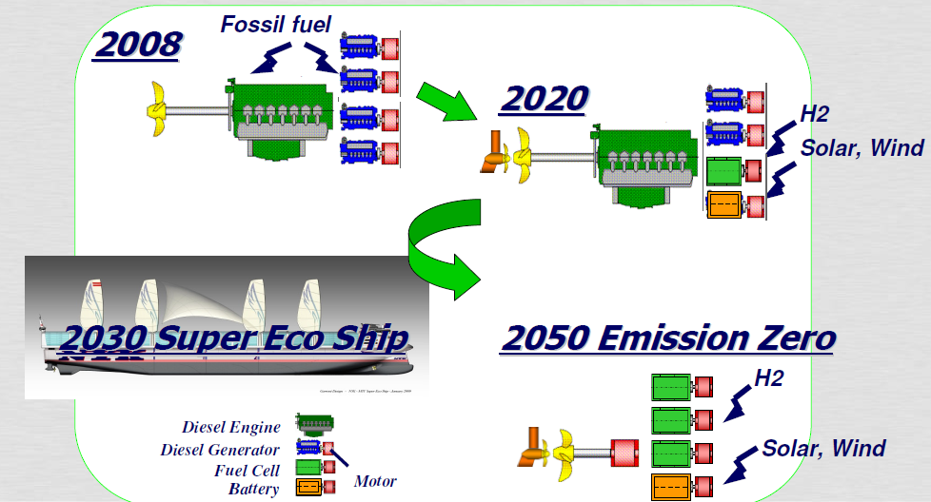

- Reduction in ship resistance
Reduction in ship resistance seems to be an area in which interest is only increasing in importance.
This includes air cavity systems, which will impact on frictional resistance, and the use of lighter materials to reduce the lightweight of the ship.

- Liquefied natural gas
In the past few years, LNG has become a more popular fuel for shipping.
LNG has to be stored in cryogenic tanks which require much more space than traditional fuel oil tanks. This may reduce the cargo capacity, depending on the type of vessel and the potential to have an adequate and safe location for the LNG tanks on board.
LNG is assumed to be available at a competitive cost, but the future price level is highly uncertain.

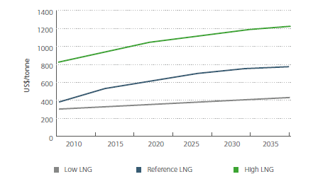
LNG price projections 2010-2035 (real terms).

GREEN SHIP OF THE FUTURE

Low carbon shipping Propulsion technologies:
– Propeller and system efficiencies
– Hydrogen fuel cells
– Nuclear power
– Battery-powered ships, gas-fuelled
ships and onshore power supplies
– Fuels based on renewable energy such
as bio-fuels.

Designs for ship recycling
A few of these projects are outlined here.
- Design for ship recycling
- Low carbon shipping
- Propulsion technologies
- Nuclear power
- Bio-fuels
Impact of environmental protection futures up to 2040 :
Among the additional environmental features fitted to the UASC vessels in order to obtain the environmental protection notation are:
– An electronically controlled main engine in accordance with MARPOL Annex VI NOx requirements
– Segregated low-sulphur bunker tanks
– A refrigerant leak detection system to continuously monitor leakage
– Operational features to minimize the translocation of organisms in ballast water.

ANNEX VI AND THE FUTURE SHIP DESIGN –
The impact of exhaust emission controls
Those ships currently subject to the NOX controls have generally been fitted with certified engines, while for ships currently subject to SOX controls (which really means ships operating within the existing North Sea and Baltic SOX Emission Control Areas (SECAs)), compliance has been achieved through the bunkering and use of fuel oils manufactured to meet the initial 1.5% sulphur limit.

The Annex’s global fuel oil sulphur limit of 4.5% has not really been a factor; the IMO’s fuel oil sulphur monitoring programme (which has been running since 1999) shows that, even before Annex VI came into force in 2005, fuel oil sulphur content as bunkered never exceeded 4.5% by more than a fraction of one per cent – a situation which is continuing to date. Taking into account the various factors (only some of which are known or at least reasonably predictable) – ship construction date; known and likely trading areas; the establishment of further ECAs.
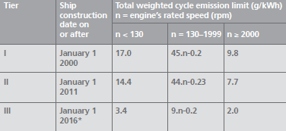

IMPROVEMENTS IN RECYCLING CONVENTION AND THEIR IMPACT ON ENVIRONMENT AS WE MOVE TOWARDS 2020

Life before the recycling Convention
Today, most ship scrapping takes place in South Asia – mainly in India, Bangladesh and Pakistan where demand is high for steel scrap. Some 95-98% of a ship’s lightweight is recycled.

So based on trends in the world economy and transport demand, marine regulations and technology, we have described four possible development paths as we move towards 2020, Scenarios A to D.

Scenario A (“Full steam ahead”): High economic growth; high fuel prices;
little regulatory or stakeholder pressure on the environment

Scenario B (“Knowing the ropes”): High economic growth; LNG prices low
and decoupled from oil prices; high regulatory and stakeholder pressure on the
environment

Scenario C (“Sink or swim”): Low economic growth; low fuel prices in general
but high demand keeps the marine gas oil (MGO) prices up; high regulatory and
stakeholder pressure on the environment

Scenario D (“In the doldrums”): Low economic growth; LNG prices decoupled
from oil prices; low regulatory or stakeholder pressure on the environment

This study has identified key findings leading up to 2020. The key findings from simulation model are: -

Finding 1: More than 1 in 10 new buildings in the next 8 years will be delivered with gas
fuelled engines.

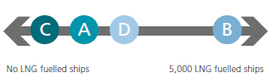

Finding 2: In 2020, the demand for marine distillates could be as high as 200-250 million
tonnes annually.
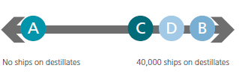

Finding 5: Ballast water treatment systems will be installed on at least half of the world fleet.

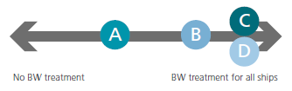
The vision to be fulfilled in 2040 , must start implementing from 2020 itself.
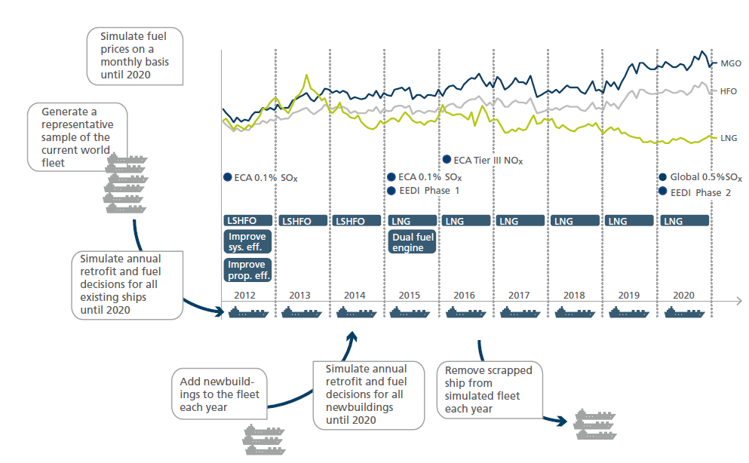

What would be the result of implementing the above technologies?

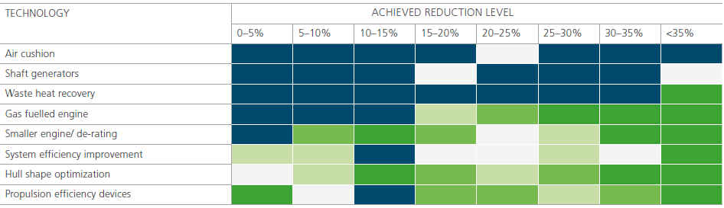

The colours indicate technologies implemented to achieve that reduction, where green is very likely and blue is unlikely.

BEYOND 2040 !
As this report has analysed technology uptake through 2020, we conclude this document with some
thoughts on technology adaptation beyond a 2020 perspective.

Innovation and adoption of new solutions
The low energy ship
"Multifunctional ship types and or technological advances in drag reduction, propulsion, and materials herald new ship concepts"
- Air bubble lubrication: Uncertainties in the physical mechanisms, and the scaling and technical feasibility of this system, need to be solved by 2020. Negative interaction between bubbles and the propeller must be addressed.
The green-fueled ship
Implementation of technologies like LNG, biofuel, wind or nuclear face significant technical and economic challenges, and the time frame ranges from a few years for LNG to decades for nuclear.
- Natural gas: Changes in CO2 emissions range from a 20% cut to a net increase. Newbuild costs are on average 10-20% higher than diesel ships. Within 10 years, a considerable share of new ships (particularly short-sea) will use gas fuel.
The electric ship
"Supply vessels and ferries with high fluctuations in power demand are the most suitable candidates..."
- Hybrid ships: By 2020, these will mix conventional and superconducting motors and generators, fuel cells and batteries, first to service, passenger and small cargo ships. For larger ships, probably only as auxiliary power.
The digital ship
"While some e-Navigation technologies are presently in use by front runners in shipping, by 2020 the majority of the fleet will have followed."
- ECDIS: A key e-Navigation technology, coupling to non-navigation systems could extend its potential to port scheduling and customs clearance. Competence on ECDIS will be vital.
The arctic ship
"Increased demand for seaborne trade in the Arctic will lead to the introduction of larger vessels that require novel icebreaking services."
- Novel icebreakers: Over the next decade, oblique icebreakers (sideways operation in heavy ice)are expected to be widely adopted for Arctic operations.
References:
  - www.forumforthefuture.org/project/sustainable-shipping-initiative/overview
  - DNV, Maritime Fuel Price and Uptake Projections to 2035: DNV Research & Innovation, 2012.
  - IEA/OECD, 2000: Experience curves for energy technology policy, 2000.
  - IHS Fairplay, World Fleet Database, 2012.
  - North European LNG Infrastructure Project, 2011, A feasibility study for an LNG filling station
infrastructure and test of recommendations.
  - OECD website: www.oecd.org, 2012.
Acknowledgment:
I wish to express my sincere gratitude to Mr. Ajoy Chatterjee, Principal & Head, Capt. Philip John, Vice Principal, & Mr. R. K. Joshi, Course In charge of GME XXV Batch, GEIMS, Lonavala, for providing us the inputs and support to present this Technical Paper Presentation on “World Technical vision 2040 – THINK WILD”.I sincerely thank our Soft Skills Trainer, Mrs. Meena R.S. for giving us the guidance and encouragement needed to complete this project successfully. I also thank the organizers of TRANSTECH -14, to provide us the platform to exhibit our views and knowledge, on the theme selected for the competition.

Place: Lonavala Date: 10 January, 2014

