Contribution of transport sector towards Make in India
Challenges in design and manufacturing
- Ayush Raj Chauhan, C.V. Raman College of Engineering, Bhubaneswar, ayushrajsingh13@gmail.com
- Pramish Kumar, C.V. Raman College of Engineering, Bhubaneswar, pramishroy007@gmail.com
- Shubham Singh, C.V. Raman College of Engineering, Bhubaneswar, shubhambhadoria77@gmail.com

Abstract
Design and Manufacturing sector of a country plays a major role in the growth of economy. The lacklustre performance of the transport sector of India is a cause of great concern when compared with other economies of the world. With the launch of “Make in India” campaign there is not only rise in hope and the optimism in the domestic and foreign investors is also building up. But the target is very far taking into consideration the present factors. There are huge obstacles that need to be overcome like simplifying stringent laws and regulations, introducing transparency in system, building best infrastructure, reforming labour laws, improving labour skill, go green and clean, etc.
Keywords
- Challenge
- Manufacturing
- Design
- Transport
- Make in India

Introduction
India is one of the fastest growing countries in the world and needs to maintain its growth momentum in a sustainable manner to improve its overall standard of living and reduce poverty. Investment environment surveys like ease of doing business in India repeatedly show that limited and low quality of manufacturing facilities act as a major impediment to business growth in India. In this context, the present study analysis the current status and issues related to India’s transport infrastructure mainly roads and highways, railways, airports, sea-ports and inland waterways. Remember after independence, today India has become the biggest market open for entire world due to globalisation & commercialisation.
In our daily lives, we all have seen products, machineries, other electronic appliances varying from small infrared remote controls to plasma and L.E.D televisions, from smartphones to laptops & servers are made in China, Korea, Japan, America, & other European countries.
Make in India is a vision initiative focused on expanding manufacturing & attracting foreign direct investment, foster innovations, & enhance skills; the government hopes to use manufacturing to create jobs & stimulate overall economic activity by boosting the contribution of transport sector to GDP.
Indian manufacturing practices are labour –intensive. Our thought about purchase is more or less “cost-centric” about technology rather than value conscious. From years our mindset has been conservative and little bit traditional towards technology research and development, consequently, our market has been pre-dominated by foreign companies thereby relying on them.
Yet there is more to manufacturing than building things. Manufacturing is the production of physical goods, while Design involves the way in which people construct products, devise business processes & think about service delivery for society as a whole. Conceived in such a manner, ‘design’ is vital part of economic development , system operations & overall quality of life. Relying upon the principles of creativity, functionality & user-friendliness, design creates tremendous opportunities to create jobs, boost small & medium- sized enterprises and improve trade balances between import & export.
There are lot of social, economical, financial, educational issues prevailing in the Indian mainland which effectively are hindrances to Make in India. Much more business & organisational setups and governmental policies & their obsolete laws have put us on back drop in design & manufacturing.
Now in India, many of us have learned to conduct R&D in highly resource-constrained environments and have found ways to use locally appropriate technology for development purpose. Frugal innovation responds to limitations in resources (financial, material, institutional), & using a range of methods, turns these constraints into an advantage, through optimising the use of resources in development, production, and delivery, or by leveraging them in new ways and reducing the complexity. Frugal engineering result in economical (lower-cost) products & services.
Challenges in Manufacturing
- Transport manufacturing infrastructure & development - Inadequate and inefficient public transport infrastructure facilities; Road, Rail & port congestion.
- Lack of Resources – Inadequacy in Capital investment (finance), lack of natural resources (raw material), organisation minus and personnel surplus.
- Transparency- According to transparency international in 2015 India was ranked 76th out of 168 countries in corruption perceptions index. The largest contributors to corruption are bribing and bureaucracy, entitlement programs and social spending schemes enacted by the Indian government.
- Ease of doing business - Ease of doing business is the major obstacle to the growth of the manufacturing sector. The World Bank’s “Ease of doing Business 2016” report has ranked India at 130th out of 189 countries in ease of doing business, was 142nd in 2015. 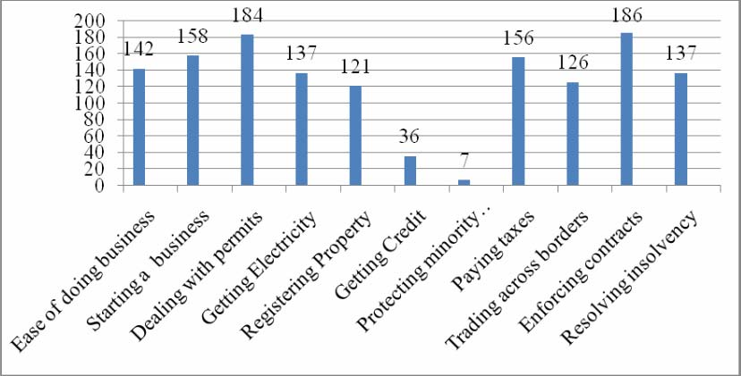 Ranking of India on the overall ease of doing business, 2015. The “ease of doing business” covers ease in starting a business, enforcing contracts, registering property, gaining access to electricity, paying taxes, etc. The easier and simple process gives a country a good rank. More the complex and time consuming process, poorer is the rank given. It is a matter of great concern that more than two decades have passed since the commencement of economic reforms and still India lags behind in providing business encouraging environment and the other facilities as are provided by other countries of the world. It requires 1420 days to enforce a contract in India as compared to 527 days in OECD nations. Construction permits are also a costly pursuit. In the exports section also, getting approvals require long time and huge cost.
- Illicit trade – Crores of money is lost, discouraging the growth of manufacturing sector.
- Inefficient supply chain network – An array of external factors affect supply chain networks, including market volatility and skewed demand patterns, infrastructure and transportation bottlenecks, and poor structuring of supply chain networks to optimize on sales. This is why many Western companies use their Indian plants to serve the domestic market & shy away from integrating them into their global networks.
- Land acquisition – The single biggest constraint to infrastructure development in the nation is Land acquisition. With the increasing pressure on land due to urbanisation, rapid economic development, industrialization, increasing infrastructure requirements, etc. Especially in fast growing economy like India, the acquisition of land by the government has increased. In India , there are a rising number of protests against compulsory acquisition of land for construction of manufacturing units such as Tata`s Nano car in Singur , W.B., in which 997 acres of agricultural land was acquired to setup a factory for one of the cheapest cars in Asia and so the project was subsequently shifted to Gujarat. For developing special economic zones such as Nandigram or construction of large dams like Sardar Sarovar Dams on the river Narmada, which led to a cancellation of grant by World Bank due to protests under the argument that the tribal population was getting displaced under unfair conditions. Land acquisition is a lengthy and cumbersome. It is one of the main reasons for delay of the projects. About 70 % of the industrial projects got delayed due to it. 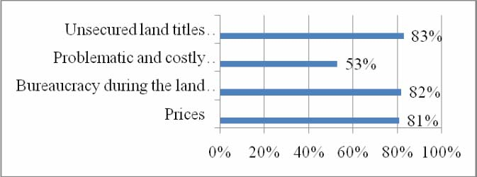
Causes of difficulty in acquiring land (% of respondents).
- Intensive dependence on Labour – is due to low cost of labour in India. It becomes problem when manufacturers depend solely on labour arbitrage to gain competitive advantage rather than concentrating on quality and productivity.
- Labour laws - India’s labour regulations are among world`s most stringent and complex, and over time have limited the growth of the formal manufacturing sector. The present labour laws favour the employees and protect employment and also a big tool in the hands of trade unions to raise their bargaining power giving a way to go for capital intensive methods in the organised sector. This adversely affects the expansion of employment and generating jobs. There are more than 200 laws regarding conditions of employment, social security, health, safety, welfare, trade unions, industrial and labour disputes, etc but are still ineffective. From year 2004-05 to 2011-12, the rate of employment growth was just 0.5% with contrast to 2.8% during 1999 to 2005. The Industrial Disputes Act 1947, Section 9A requires (an industry with at least 50 workers), worker’s consent to modify job description or move workers from one plant to another. It further requires at least 21 days in notice before modifying wages, hours of work, rest intervals, and leave and chapter V-B of the same act with employees more than 100, requires industrial firms to obtain prior government permission to lay-off or retrench one or more workers. Another problem is lost relevance of most of the labour regulations in the present day.
- Manpower skills, Training & Education (Human Resource Development) – The countries with high skilled labour can do much better than others, but the situation in India is very gloomy with huge skill gaps. Although India has improved a lot in education and vocational training, but its competitors are much ahead in this area. As per the report named “Higher education in India: Vision 2032” by FICCI and Ernst&Young, 75% IT graduates are deemed ‘unemployable’, 55% in manufacturing. Further in India only 3.5 million workers are undergoing skills courses a year.As per NAAC the quality of higher education is 90% of the universities and 70% is below par.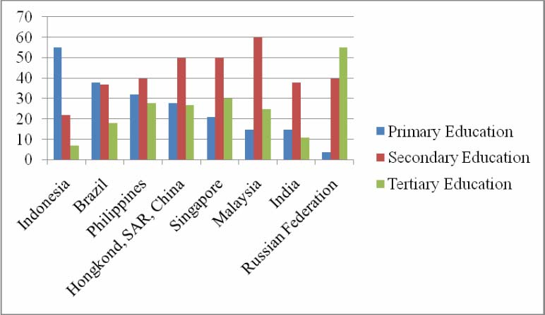
- Labour Force Education (% of total).
- Business environment – Sustenance of Business, Accessible, Logistics support and cost of doing business.
- Taxation policies – High taxes, taxes on various levels, in various forms like duty, cess, customs, etc.
- Environmental clearance – Environment clearances have added layers of complexity for infrastructure development. Non-governmental organisation(NGOs) in India add to the delay by holding up projects by filing writ petitions. Environmental clearances, infrastructure shortfalls and land acquisition problems continue to be key concerns for industries and corporate wanting to invest in infrastructure development projects. Off-late, the environmental ministry has been under tremendous pressure from infrastructure ministries and also other industries demanding that the clearance process be made simpler and more industry-friendly.
- Serviceability, Quality, Profitability, Agility.
- Cleaner & safer transport - Transport emissions & air quality. Greenhouse gas (GHG) emissions. India is still following BS IV as against EURO 6 implemented in European countries, which is equivalent to BS VI norms. Mitigating ‘End of Life’ policy. Compliance with international safety standards. Mandatory crash tests.
- Exports – It play a major role in the growth of manufacturing sector, but the share of India in global merchandise exports has been very low as compared to other countries like it rose from 0.5 % in 1990 to 1% in 2006 and 1.8% in 2013. The major reasons behind the declining manufacturing exports are the slow rate of growth of the transport sector, the small share of hi-tech exports, etc.

Status of Design in India
Patenting is integral to design because it involves how products are put together. The latest patent and industrial design data from the government indicates that 4,388 patents were granted in India in 2013. These are miniscule numbers compared to global data from World Intellectual Property Organization (WIPO) for the United States of America (U.S.) which is a global leader in innovation and China which is rapidly expanding its own rate of innovation.
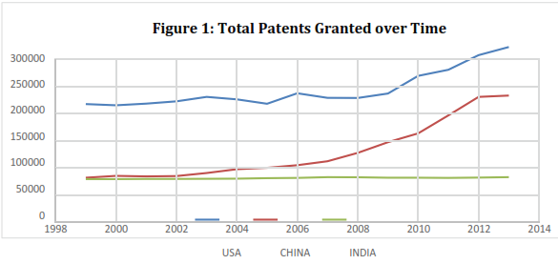
The numbers don’t look very different when examining industrial designs registered in India during the same period. India registered 5,077 industrial designs. Innovation is one of the major factors that drive growth in an economy and India has a lot of ground to cover if it is to compete in the global space of innovation.
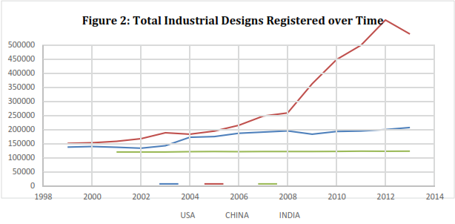

Challenges in Design
Among the broad economic factors that affect design economy in India, higher education, digital connectivity, R&D and technology innovations have been identified as the most important.
- Higher education and training- India’s rate of higher education enrolment at 18 percent is below the 26 percent in China and 36 percent in Brazil. Globally, about 27 percent of the young adult population is enrolled in colleges or universities. This includes graduation and qualification in scientific, engineering, technical, architectural, planning and designing studies. Moreover he or she should be efficient in computer skills and its operation e.g. Auto-CAD, Auto-CAM. Having employees with advanced skills is vital for the design economy. Designers need university graduates with training in computer graphics, industrial design, and data visualization.
- Digital Connectivity- Digital usage remains low in India. Around 213 million people or 18 percent of the population has access to the Internet. For digital and mobile usage to rise, though, there needs to be greater progress on digital connectivity. A survey in India found that “68 percent of mobile Internet users experience session failure and lengthy loading times while outdoors and 63 percent face quality and reliability issues indoors”. This limits the quality of the user experience and makes it difficult to take full advantage of the technology. The fastest growing information technology sector has created the high demand for digital services in India.
- R&D and Technology Innovation - The World Economic Forum’s Global Competitiveness Report 2015–16 puts India at the 42nd place among countries worldwide in terms of innovation capacity. India is strong among the BRICs in terms of the availability of scientists and engineers, but lags on other parameters such as university-industry R&D collaboration and patents granted per head. Our total R&D spending is around 1 % of the GDP. The manufacturing R&D growth story in India has often centred on cost-effectiveness due to labour arbitrage. The stress has been on driving process efficiencies for cost reduction to compete globally.

Transport Sector in India.
Transportation mix in India heavily skewed toward roads, while water transport remains underutilized (2014).
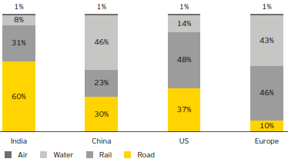
Globalizing trade is exerting pressure on India’s existing infrastructure. Thus, investment in developing railway, road & highway, shipping & port network, aviation and hinterland connectivity is imperative for the growth of the manufacturing sector in India.

Challenges in Roadways.
India has the world’s second-largest road network (4.7 million km), with highways constituting only 1.7 % of this network and the densest amongst countries of similar size. However, our roads are capacity constrained (road congestion repercussions), slow, unsafe, environment unfriendly, not maintained or non- maintainable, and patchily administered. India needs to increase the number of expressways, national & state highways. The bigger hurdles on this front timeliness in awarding contracts , difficulties in acquiring land, securing environmental clearances, and persistent shortages in construction capacity. In rural areas the road connectivity is not up to the standards. However, talking about the hinterland connectivity, the road infrastructure is non-existent in hard to reach terrains of north-eastern region and other isolated areas like borders, L.O.C.’s and L.A.C.`s . Heavy truck Manufacturers like Tata, Mahindra and Ashok Leyland are Indian private sector companies. Foreign company Scania is going to manufacture heavy trucks in India.
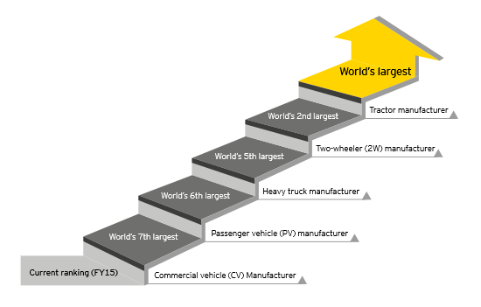Vehicle manufacturer ranking of India in financial year 2015

Challenges in Railways
Indian railways is the third largest railway network in the world under a single management, which is spread across 64,600 km. It has suffered revenue losses from the absence of a comprehensive framework for capacity expansion over the last 60 years. The expenditure on railways as a percentage of total transport sector expenditure has declined considerably over last two decades. Downgraded diesel engine locomotives and established electrical locomotives, wagons and tracks need to be upgraded. On an average the speed of train used for transportation of minerals and goods is 60-80 kmph which is very slower than other countries like China, Japan, France, Italy and U.S.A. having a bullet speed of more than 300 kmph. A programme for raising speed to 160-200 kmph on selected existing route tracks should be undertaken, till the time the High Speed Railway(HSR) projects are found commercially justified or operationally required to cater to the country`s growth. Through Make in India, foreign manufacturers Alstom are going to provide diesel and general electrical locomotives to Indian railway.

Challenges in Airways
The past 20 years have brought dramatic changes to Indian Civil Aviation. New airlines are inaugurating new routes, both domestically and internationally. But the problems that aviation sector is facing are high operational costs, high cost of aviation turbine fuel, high service tax and other charges, shortage of maintenance facilities, competition from foreign airlines and congestion at airports. Our 1% of transportation is held by airways, which is similar to all other countries. Although our nation`s defence equipments are transported through heavy-lift helicopters and transport aircraft, thereby we rely on foreign companies for our needs like Lockheed Martin and Boeing. Airbus & Co. had setup its manufacturing unit to build aeroplanes for civil purpose.

Challenges in Seaways and Inland Waterways
India is the 16th largest maritime country in the world, with a coastline of about 7,517 km. Shipping is the cheapest and safest transportation for trade, commerce and logistics in the world. Major ports in India have congested traffic of both merchant ships and navy combat ships. Inadequate and improper dredging and container handling facilities, inefficient and non-optimal deployment of port equipment, lack of coordination between port authorities and shipping companies has led to low productivity. Lack of design and manufacturing capabilities of shipyard, lack of strong private sector and commercial ship building industry, sub-optimal hinterland connectivity, absence of strong ancillary industries for merchant shipbuilding industries has held us back. The government PSU’s like Kochi shipyard limited, HGRE, Mazagon dock limited, Hindustan shipyard limited, etc. are more into building naval ships, and that too slow. Similarly, inland waterways transport (IWT) in India is suffering from these problems mainly because of the apathy & negligence of the governments over the years towards the protection of the rivers and their utilization for transportation where rivers are a lot season and nature dependant.

Results
In 1980’s India was on its peak in manufacturing sector contributing to economic growth and development, unfortunately we failed to be at par with the economic growth of other countries. Hence the already established transport infrastructure of pre-independence era became obsolete, which needed a revival regularly by modernisation and advanced upgradation seeking future load on the pre-existing system. Now, Make in India can make a difference, by which we can cope up with the pace of the big economies and democracies of the earth. Globally, innovations have lead to inventions and so are same here back in our nation also, but in today’s India, inventions outside lead to innovations inside, this is frugal India. This proves that we are well-formed minds but not well-educated minds. Our literacy rates are lower than many developed & developing nations, but still at present day condition, at the age of 12 going schools, the rate is 95% much higher than others in world. So we can hope the largest better skilled and young talent pool under process, will be ready in upcoming years, if the % rate do not decline by increasing age of 18 and above which is strictly meant for higher education and training. Increase Competitiveness of India’s manufacturing sector. Its time to move beyond cost-effectiveness; differentiate through R&D and innovation. R&D and innovation in manufacturing need to focus on rapid technology adoption, which is also critical to the success of “Make in India”. This will allow Indian companies to move up the manufacturing value chain and become leading global providers for product design and intellectual property, while navigating through production complexity and supply chain challenges. Foreign Direct investments have increased drastically. FDI`s in manufacturing sector during the first half of 2015 witnessed a 221% increase as compared to the first half of 2014 with US$ 24.8 billion Equity. Manufacturing’s share of FDI raised to 80% and FDI projects raised by 22%. Our government`s and PM`s assertion and increasing influence being used in Global summits, is enhancing India`s opportunities of technology sharing and transfer for the first time.
Conclusion
Today design and manufacturing development in India is most crucial to continue high and sustainable growth. The major issues in design and manufacturing are R&D, technology innovations, digital connectivity, education and training skills, lack of resources, transport infrastructure development, land acquisition, environmental clearances, illicit trade, taxation policies, labour laws etc. The conditions of India’s design and manufacturing sector have been slowly improving. According to a survey, a leading 32% of international investors ranked India as the most attractive market, while 60% placed the country among top three investment destinations. Respondents believe that ongoing economic reforms are increasing opportunities for them to develop their companies profitably in India.

Acknowledgement
This technical paper was a work of motivation by our Prime Minister Narendra Modi’s Make in India initiative campaign, and was partially supported by the reports and journals published by world think tanks; national surveys carried out by government; global indices.

References
en.wikipedia.org
www.makeinindia.com
World Bank’s “Ease of doing Business 2016” report,
“Higher education in India: Vision 2032” report by FICCI and Ernst & Young,
Global data from World Intellectual Property Organization (WIPO),
A.T. Kearney Analysis,
Indian Transport Report by National Transport Development Policy Committee,
International Journal of Commerce, Business and Management (IJCBM),
EPCA (Environment Protection and Conservation Authority) Reports,
Global Competitiveness Reports by World Economic Forum: www.weforum.org

