
G.K.M. COLLGE OF ENGINEERING AND TECHNOLOGY

DEPARTMENT OF MARINE ENGINEERING

“WATER JET PROPULSION SYSTEM”

Prepared by
Cdt.R.Ramamoorthy
Cdt.M.Thamizh Thendral
Cdt.V.Sowri Rajan

Mail ID:cadetramamoorthy@gmail.com PH.NO:9524320203 ramam58@gmail.com 9566242699.

NOTE: Video will be showed at the time of oral presentation.

ABSTRACT
Waterjet propulsion is the most successful and efficient method of propulsion for high-speed applications. The advantages are not only higher efficiency, but also lower vessel resistance due to the absence of underwater appendages like shafts, rudders and shaftstruts. Waterjets are usually used to power ships with design speeds of 30 knots or more such as high-speed ferries, luxury yachts, fast patrol boats and naval support vessels, including catamarans and trimarans. They are also used in vessels such as naval landing craft which perform special duties in shallow water.
Waterjet propulsion has many advantages over other forms of marine propulsion, such as stern drives, outboard motors, shafted propellers and surface drives. These advantages include Excellent manoeuvrability, high efficiency, low drag and shallow draught, low maintenance, smooth and quiet, total safety, Maximum engine life, simplicity, easy installation, precise steering control etc..,

KEYWORDS
Hydrofoil Backflush
Jetavator Cavitation
Headwinds Fabrication

INTRODUCTION
As a source of propulsion, waterjets have a number of advantages over propellers. They can absorb high levels of input power in units with small dimensions, the steering systems are integrated into the waterjet assembly, avoiding the need for rudders, and the absence of shaft lines and struts substantially reduces hull resistance at high speeds. The powerful flow of water leaving the jet nozzle at all vessel speeds also means that ships powered by waterjets have excellent manoeuvrability.
Waterjets normally have a lifetime of 25 years. Maintenance needs are strongly dependent on both the duties a vessel performs and local conditions. As they play critical roles in jet efficiency, both the stator bowl and the stator blade profiles must remain in the best possible condition. Rather than aluminium abrasion-resistant stainless steel is used for these components, minimises maintenance requirements and avoids performance degradation.

WATERJET HISTORY

The waterjet propulsion system was probably invented almost four centuries ago by David Ramseye. In 1630, he stated in English Patent No.50 that he was able “to make Boates, Shippes and Barges to goe against Stronge Winde and Tyd”. Three decades later in 1661, English patent No.132 was granted to Thomas Toogood and James Hayes for their invention of Forceing Water by Bellowes [...] together with a particular way of Forceing water through the Bottome or Sides of Shipps belowe the Surface or Toppe of the Water, which may be of siguler Use and Ease in Navagacon. While there is no doubt that this concept was based on a waterjet, they did not develop a working prototype. It was also not a high-speed device, and the competition consisted of modified Archimedes screws. Both this invention and subsequent developments in waterjet technology up until the 1980s is described in detail by Roy.

The extensive developments in high-speed vessels can in part be contributed to the application of waterjet propulsion systems. The stern-mounted waterjets in current use are based on the principles used in products built by the Italian manufacturer Riva Calzoni in 1932. In the 1950s, US Navy hydrofoil applications boosted their use, and this in turn led to the famous Boeing jetfoil (a passenger-carrying version was launched in 1974) being powered by waterjet propulsors. The use of waterjets in commercial applications, however, only really started to grow after 1980. Figure (below) provides a historical view of events leading to current waterjet technology, with the basic development being driven by technology developed in Europe and applications involving high-speed vessels.

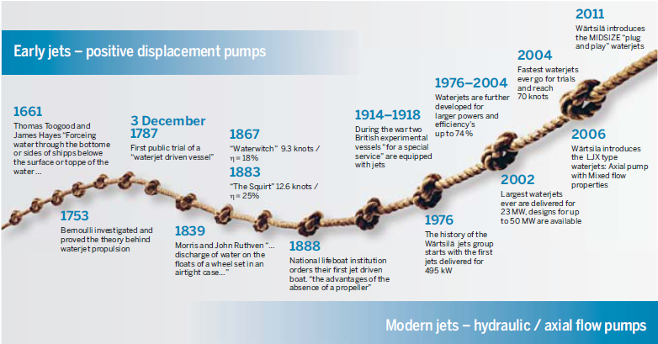
HISTORICAL DEVELOPMENT OF WATERJET PROPULSION SYSTEM
During the first decade of the 21st century, the diameter of waterjet units has increased to well above two metres with installed powers of up to 25 MW per unit. High-speed luxury motor yachts can now achieve speeds that are well above 65 knots (almost 120 km/hour). Waterjets can now in fact be considered a form of propulsion capable of operating successfully in sectors where conventional propellers are normally used. Improvements in pump technology have increased overall levels of efficiency, and the range of applications supported is a lot wider.
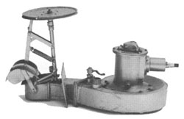
1954
A slight modification to expel the jet stream above the waterline proved the turning point in marine jet propulsion, increasing speed to 17mph and eliminating all underwater appendages.This first type of unit was named "Quinnat" and consisted of a vertical shaft centrifugal unit, driven through a right angle gearbox.

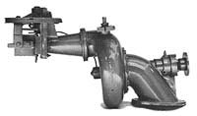
1956
The first batch of "Rainbow" jet units were produced. A small direct drive centrifugal type of unit, the Rainbow gave a good performance in a suitable light craft, without the noise of a gearbox. About 100 were manufactured and marketed in New Zealand.

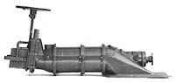
1957
This year saw the birth of the "Chinook" unit. A twin impeller axial-flowturbine, the Chinook was far more efficient with its straight-throughflow and two-stage pressure build up. Following this came the three-stage Chinook unit which increased performance further.

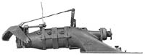
1963

The "Colorado" series of jet units was a completely new, greatly simplified design which halved the cost of the unit. This series was developed into a full range of one, two and three stage units driving a widerange of boats from river-runabouts to off-shore racing craft.

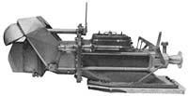
1970

This year saw the introduction of the "Work Jets" - larger, heavy duty units designed for diesel commercial vessels, large launches etc. The WorkJets were the forerunners to today's Hamilton HM Series of larger waterjets.

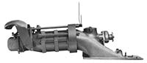
1973

The 750 series of jet units evolved a standardised method of installation in hulls, regardless of the number of stages. This gave more cockpit space in the boat and employed modern controls and engines. Preceeded by the 740 jet unit (Colorado pump with 750 intake) and followed by 770 series jet units

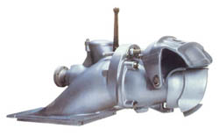
1975
First 'commercial' waterjet, Model 1031, introduced. Large diameter, single stage unit.

1991

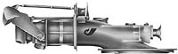
HS Series waterjets, for 50-65 knot craft, is introduced. These were multi-stage waterjet units designed for high-speed light commercial craft with power inputs up to 1,600kW.

WATERJET COMPONENTS AND OPERATING PRINCIPLE

Waterjet propulsion systems consist of an inlet duct which guides water into the pump, an engine-driven impeller to raise the water pressure, guide vanes which support the impeller shaft and also reduce rotational losses, and a jetavator which directs the stream of water emerging from the pump to steer the vessel. The thrust resulting from the ejection of water by the pump is transmitted to the vessel through an inboard thrust bearing. The arrangement of these components in Wärtsila LJX waterjet assemblies is shown in Figure 1.

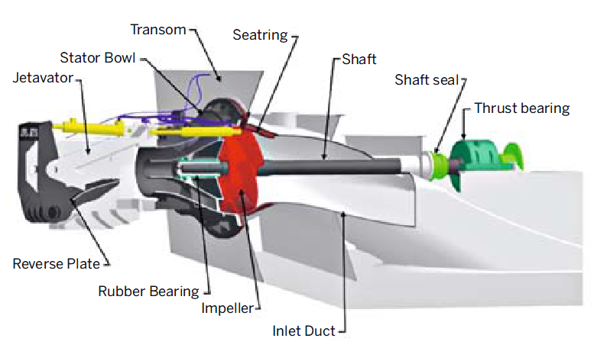

Fig.1:WATERJET COMPONENTS

Figure 2 is a simplified diagram of the inlet duct and pump sections showing the impeller, stator bowl and nozzle. Waterjet units are normally mounted on a vessel’s transom. The stator bowl is specially designed to regulate water flow so that the pump and jet system can operate under optimum conditions. The acceleration of the mass of water flowing through the system results in a thrust force on the vessel:

THRUST=MASS FLOW*(V_{J}-V_{I})

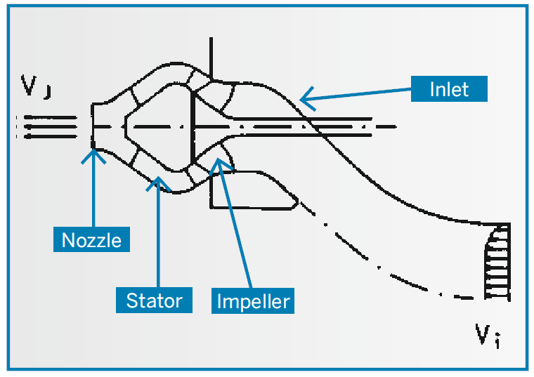

Fig 2:CROSS SECTION OF A WATERJET INLET DUCT AND PUMP SECTION

TYPES OF PUMP

Historically, pumps are classified by their specific speed, a number which is basically a ratio between flow through the pump and the delivered pressure. Typical pump outlet sections are shown in Figure 3.

Centrifugal pumps (shown on the left in Figure 3) convert a horizontal flow of water into a radial flow, deliver a relatively high pressure at small flows and have a low specific speed. In configurations with higher specific speeds, liquid flow through the pump becomes axial with larger flows being delivered at lower pressures.

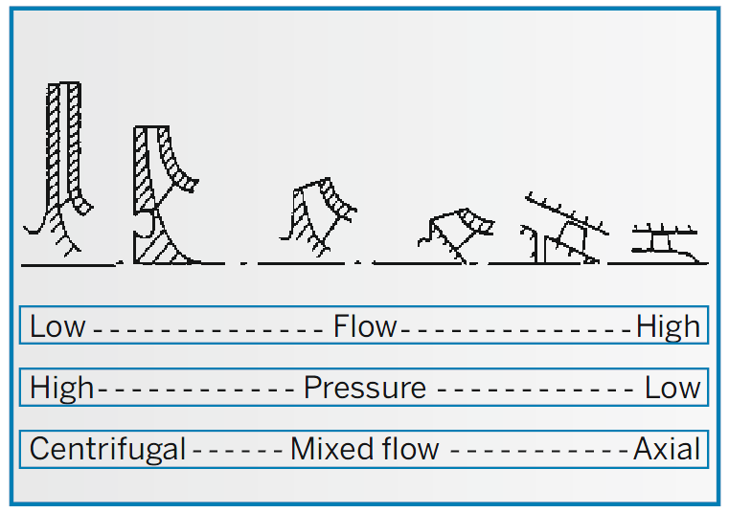

Fig 3:PUMP OUTLET SECTIONS

The manner in which pump construction changes with specific speed is also shown schematically in Figure 3. In the axial-flow pumps on the right, the flow of water follows the line of the pump shaft. Power curves for different pump designs have different slopes and are shown in Figure 4.

The slope of the power curve indicates the extent to which the delivered power will be affected by changes in the pump’s working point. This is an important aspect of performance when operating high-speed vessels. While the power absorption of an axial pump changes significantly with a change in flow, power absorption in a mixed-flow pump is relatively insensitive to changes in flow rates.

The power absorption curve for a typical FPP is also shown in Figure 4. As propellers operate at higher specific speeds than the axial pumps in waterjet assemblies, the slope of their power curves is even steeper. This in turn means that a relatively small change in flow results in a relatively large change in the level of power absorbed.

A detailed analysis of waterjet systems reveals that the pump best suited for vessels operating between moderate (25+ knots) and high speeds (up to 60-70 knots) is of the so-called “mixed flow” type.

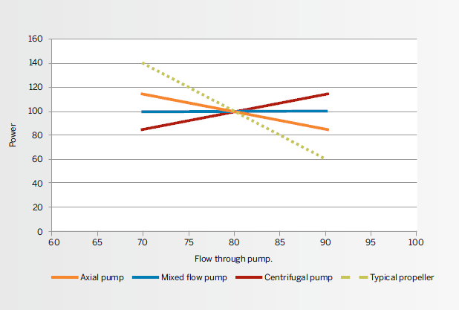
Fig 4: Power curves for different pump types. The dotted line is the power curve for a fixed-pitch propeller (FPP).

Land-based pumps usually feature robust forms of construction and have relatively large diameters, which means they are heavy and unsuitable for use in propulsion systems. Also, the space available in a vessel’s transom for installation is normally quite restricted, especially in vessels with high levels of installed power, and there is often the need to install a deck or swimming platform above external components of the waterjet assembly.New waterjet pump therefore offers the benefits of an axial pump design but has the required mixed-flow hydraulic properties, and maximum assembly diameters have been reduced significantly. The resulting propulsion solutions are also lighter and more cost-effective.

COMPARISON WITH FPP SOLUTIONS

It is important to avoid confusing the behaviour of waterjet impellers with that of fixed-pitch propellers (FPP). As a propeller is located in the stream of water that passes around the vessel’s hull, the effect of anything that reduces ship speed, such as headwinds or fouling of the hull, has an immediate impact on the propeller. If the propeller speed is maintained, the power demanded from the engines will increase, with the risk that they will be overloaded. For this reason, propellers are not designed for 100% MCR (maximum continuous rating) but for lower levels of power output, usually around 85% MCR.

As the impeller of a waterjet is not located in the water stream surrounding the hull, external factors that influence ship speed have only a small influence on flow through the pump. Together with the relatively flat power curve (Figure 4), power demand from the vessel’s engines hardly changes. For this reason, the design of waterjet impellers is always based on 100% MCR.

STEERING AND REVERSING DESIGN
Waterjets, while having a good performance when sailing a straight course, loose thrust when a steering action is initiated. Three factors are responsible for this. First, the flow is deviated from the normal ahead direction to create a transverse component in order to develop a steering force. This lowers the flow in the ahead direction and therewith the propulsive thrust.
Second, when the flow leaving the jet hits the steering Sleeve, part of the flow is flushed back and not contributing to forward thrust.
Finally, during steering the back pressure in the nozzle area, normally equal to ambient pressure, will increase due to the hydraulic losses in the steering sleeve. This will cause a lower flow through the jet and again will result in a reduction of propulsive thrust.
While all factors combined are not so dramatic that propulsive thrust will collapse, there are ways to improve the performance. The transverse component is required to create a steering force and cannot be influenced but the back flush and hydraulic losses can and were therefore addressed in the design process.
The current series of steering sleeves for the larger waterjets have a square cross section in which the water of the pump is expelled through a circular nozzle. Inside the steering sleeve a reverse plate is mounted through which the flow through the sleeve can be reversed, see figure 5.
Figure 5: Steering sleeve with reverse plate for large (9100 kW) waterjet units mounted on a catamaran.

When activated during a steering action the flow hitting the side walls of the steering sleeve is partly flushed back, see figure 6.
Figure 6: Flow hitting an inclined wall creates a backflush.

SUITABLE FOR BOTH LOW SPEED AND HIGH SPEED APPLICATIONS
Waterjets are mainly used for high-speed vessels because at speeds higher than 25-30 knots, the amount of power required to propel the ship is lower than for other types of propulsor. Rudders and conventional shaftlines can add as much as 10-14% to the bare hull resistance, while a waterjet propulsion solution entails no such effect.
Even though waterjets are the preferred propulsor for most high-speed ships being built today, they can also be successfully used in low-speed applications. Most cases involve situations where propellers would be considered vulnerable if a vessel is mostly sailing in shallow water, but fast patrol boats have also been converted from propeller propulsion to waterjet solutions to avoid situations in which their propellers are fouled by nets thrown overboard by smugglers or other vessels they are pursuing.
INLET DESIGN
Duct inlets are important components in waterjet installations. Power losses in the inlet section total 6-8%, and both the inlet design and its construction are critical. The correct balance has to be found between avoiding flow separation at the ramp and cavitation on the top of the cutwater, while minimising losses and creating a proper flow field for the impeller (see Figure 7).

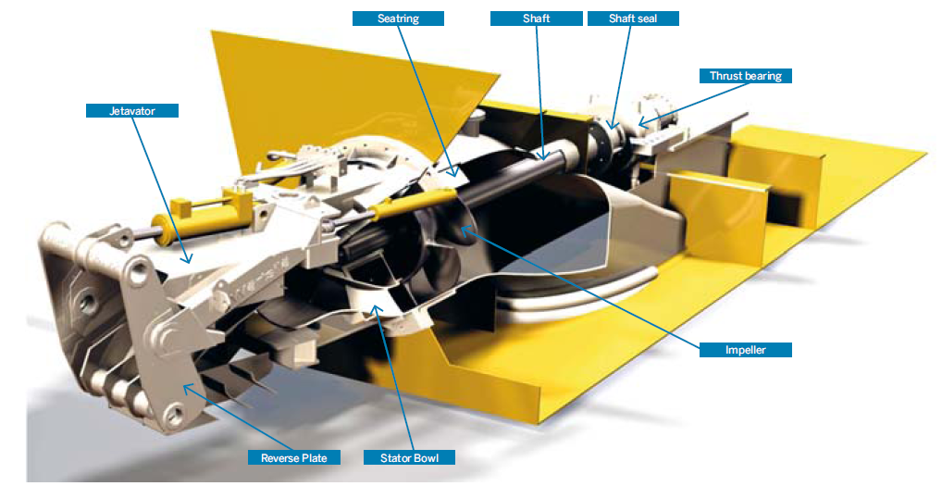
Fig 7:AXIAL FLOW WATERJET

MATERIAL
The main construction materials of waterjet units are aluminium and stainless steel. Stainless steel is used for all power transmitting parts (shafting and impeller). Pump seat and stator are also made out of stainless steel. These parts, being close to the impeller, are exposed to relatively high fluctuating pressures and hence design for fatigue is of importance.
Stainless steel has better fatigue properties than aluminium and is therefore more suitable for these components. Duplex type 2205 is normally preferred above type 316 stainless steel. This material has better PRE values (important for corrosion) and higher mechanical properties.
As a standard the inlet is made out of aluminium plate compatible with the material of the ship’s hull. Strength and corrosion properties are better than those of cast material and with the construction designed to be suitable for welded fabrication it is the better choice. The steering sleeve, being of a more complicated geometry, is made out of marine grade cast aluminium.

GALVANIC DESIGN
Dissimilar materials in seawater will be at a different galvanic potential. If they are electrically connected a current will flow between the materials. This can lead to galvanic corrosion in which the less noble material is sacrificed.
The choice was made to use sacrificial anodes instead of an impressed current system, the reason being that impressed current systems require active maintenance from the user, something which is not always the case as experience has shown.
The cathodic protection scheme not only helps to protect the aluminium parts of the jet but also protects the stainless steel against pitting and crevice corrosion and attacks from Sulphite Reducing Bacteria, SRB.
This is a problem occasionally encountered on waterjets, see figure 8. Such biofilms can locally cause a very acid environment resulting in an extremely rapid acid attack on the stainless steel surfaces.
Figure 8: Example of corrosion caused by Sulphite Reducing Bacteria on a duplex stainless steel impeller of a waterjet.
APPLICATIONS FOR WATERJET
Waterjets are used in a broad range of applications, from small sports boats up to the largest megayachts and high-speed ferries. They are used by both commercial concerns and by government departments.
Types of vessel in which waterjets are used include:
- vessels with a high power density (large installed power in a relatively small ship).
- shallow-draft vessels such as landing craft.
- high-speed vessels (30 knots+).
- hybrid propulsion vessels which combine good performance at low speeds with high (temporary) maximum speeds.
- vessels used in life-saving operations.

High-speed vessels often feature high levels of installed power and high power densities. Compared to an equivalent FPP solution, a waterjet propulsion solution is smaller and requires much less space, both inside and underneath the vessel. While a 5 MW propeller would typically have a diameter of 3.5 m, the diameter of an equivalent waterjet would be some 0.9 m. Currently, the largest power source connected to a 2180 waterjet (diameter 2.18 metres) is a gas turbine capable of delivering an extraordinary 26 MW.
Shallow-draft vessels such as landing craft often employ waterjet propulsion solutions. Not only does the absence of rudders and propellers under the vessel avoid the problem of colliding with the sea bottom, the integrated steering and reversing assembly, an integral part of the waterjet assembly, offers excellent manoeuvrability in shallow water.
The most common reason for using waterjets is to achieve high vessel operating speeds. Compared to conventional propeller solutions, the high internal dynamic pressure in a waterjet results in the propulsion system having a much higher efficiency at high speeds, with cavitation only setting at a much later stage. Waterjet efficiencies can be as high as 75% and speeds of up to 80 knots are possible. At such high speeds, conventional propeller solutions would suffer severe loss of thrust because of massive levels of cavitation.
WATERJET ADVANTAGES
Waterjet propulsion has many advantages over other forms of marine propulsion, such as stern drives, outboard motors, shafted propellers and surface drives. These advantages include...

Excellent Manoeuvrability
- Precise steering control at all boat speeds
- "Zero Speed" steering effect provides 360° thrusting ability for docking and holding stationary.
- Sideways movement possible with multiple jet installations.
- High efficiency astern thrust with "power-braking" ability at speed
High Efficiency
- Propulsive coefficients as good or higher than the best propeller systems achievable at medium to high planing speeds
- Flexibility when using multiple waterjets may allow operators to continue to operate efficiently on fewer drives

Low Drag and Shallow Draught
- Absence of underwater appendages reduces hull resistance
- Shallow draught - the waterjet intake is flush with hull bottom to allow access to shallow water areas and beach landings with no risk of damage to the drive

Low Maintenance
- No protruding propulsion gear eliminates impact damage or snags
- Minimum downtime and simple maintenance routines

Smooth and Quiet
- No hull vibration, no torque effect and no high speed cavitation gives maximum comfort levels on board
- Low underwater acoustic signature

Total Safety
- No exposed propeller for complete safety around people in the water and marine life

Maximum Engine Life
- Jet unit impeller is finely matched to engine power
- Power absorption is the same regardless of boat speed
- No possibility of engine overload under any conditions

Simplicity
- Single packaged module
- No heavy and expensive gearbox required for many installations. Simple driveline from engine to jet coupling

Easy installation
- Complete factory tested package, ready to bolt in
- No difficult engine alignment problems

Superior Cavitation Resistance
- Pump design offers up to 25% more thrust than other waterjets between 0 and 20 knots. Manoeuvrability at low speeds and acceleration to high speeds are superior.
CONCLUSION
Special attention was given to the steering and reversing performance. A new type of steering sleeve was designed. The design requires less hydraulic power for the actuators and has a greater efficiency in both steering as reversing.
The midsize waterjet packages offer shipowners and operators a number of unique features. These include an improved steering response, inboard hydraulic systems that remove the necessity to conduct outboard maintenance on sensitive hydraulic hoses, a simpler hydraulic power pack and thrust bearing lubrication set for reduced maintenance and greater reliability, and a high-performance pump design with a proven track record.

AcKNOWLEDGEMENTS
The authors are grateful to Professor P. Sateesh Kumar, Chief Engineer, Head of the Department of Marine Engineering and Professor P.S.Sridhar, Chief Engineer, GKM College of Engineering and Technology, for providing us help and support for preparing this paper. The authors would also like to thank the organizers of “TRANSTECH 13” for providing us the opportunity to present this paper.
REFERENCES
1. Verbeek, R: ‘Waterjet forces and transom flange design’, RINA Symposium on waterjet propulsion, 1994
2. van Esch B.P.M, Bulten N.W.H: ‘Hydrodynamic forces on the impeller of a waterjet propulsion system’, Conference on modelling fluid flow, Budapest Hungary, 2006.
3. Cheng Li, van Esch B.P.M: ‘Blade interaction forces in a mixed-flow pump with vaned diffuser’, Proceedings FEDSM 2009, 2009.
4. DNV, Classification notes, No. 30.8
5. ECCS-Technical Committee 2: ‘European Recommendations for Aluminium Alloy Structures Fatigue Design’, Report no.68, 1992.
6. Ship Structure Committee 2000: ‘Fatigue of Aluminium Structural Weldments’, 2000.
7. Boyer H.E: ‘Atlas of fatigue curves’, American Society of Metal, 1986.
8. Alexander, K: ‘Corrosion resistance of aluminium and stainless steel in waterjets’, Fast Ferry Conference, Singapore, 1997.
9. Heselmans, J.J.M: ‘Cathodic protection design for a waterjet’, Consultancy report for Wärtsilä, 2010.
10. Heselmans, J.J.M: ‘Performance of stainless steel in marine applications’, Stainless steel world, December 2006.

