2014 TN 104

INLAND WATERWAYS:

Hybrid Ferry

Ajay Khatri Id : 201437TN104
B.TECH NAUTICAL TECHNOLOGY
TOLANI MARITIME INSTITUTE
INDURI, PUNE, INDIA
ajaykhatri.12@gmail.com

Abstract:

Ferry generating its own power (using solar power) , hence 40% less fuel consumption.
(Can also use wind energy by building a wind tunnel around the ferry)
For inland transportation in river Ganga (Allahabad to Varanasi*) *proposed
A ship connecting two pilgrim places (Allahabad and Varanasi) , using Solar power in conjunction with diesel oil to generate electricity as to fed azipods in order to propel the ship. Additionally smoke filters attached on the funnel with further aid with reduction of air pollution. Also, anti-grounding feature to be added taking in consideration the nature of seabed and shallow water. Hence environment is given prime importance.
Key features:
- Environment Friendly (uses solar power)
- 40% less fuel consumption
- Anti-Grounding feature
- Quick maneuverability ( No rudder used )
- Inland transportation
- Tourism
- Aid to traffic

- Environment Friendly : Uses clean fuel and harness energy (solar energy)
(Energy can also be generated using wind turbines on the hull by making a wind tunnel , taking care of hydrodynamics)
- 40% less fuel consumption: Uses solar power as fuel to run the engine. A full solar
field is to be setup which will harness sufficient energy to run the electric motors
- Anti-Grounding feature: Uses ultrasonic waves to scan sea bed ahead of bow.
- Quick maneuverability: No rudder is used. Propeller itself turns hence no chance of
rudder failure. Hence able to overcome limitations of rudder

Introduction:
The Ganges is the most sacred river to Hindus. It is also a lifeline to millions of Indians who live along its course and depend on it for their daily needs. It is worshipped as the goddess Ganga in Hinduism. It has also been important historically, with many former provincial or imperial capital (such as Pataliputra, Kannauj, Kara, Kashi, Patna,Bhagalpur, Murshidabad, Baharampur, Kampilya, and Kolkata) located on its banks. The bulk of the traffic on the Ganga is not made up of large ships carrying industrial cargo such as ores and machinery, but of smaller boats belonging to people who have been using the river for many generations. In the 18th century, most boats carried salt and sand with a few others carrying cotton and other goods. Today, sand and timber make up the bulk of the cargo being transported. Excavation of sand from the river banks for sale to the construction industry is common along the Allahabad-Varanasi stretch. While this is largely mechanised with JCBs doing the heavy digging, the design of the boats used for this purpose has not changed over centuries. Most villagers who live by the banks of the river also own small boats.
Hence inland waterways in India needs to be promoted. There is a great need to empower tourism in inland waterways.

The Concept:
To design a passenger ferry generating its own power (using solar power) , hence 40% less fuel consumption contributing to less pollution. This will connect two pilgrim places (Allahabad and Varanasi) , and will use Solar power in conjunction with diesel oil to generate electricity as to feed azipods in order to propel it. Moreover various advanced equipments are used in order to make it Environment Friendly. This passenger ferry will be equipped with all luxuries and safety in the prime concern for the passengers.
For inland transportation in river Ganga (Allahabad to Varanasi*) *proposed

Scope:
Cities: Allahabad to Varansi
Can be used around the year except rainy season as :
- River gets flooded.
- Very less tourist visit the place during rainy season.
- No or minimum sunlight.

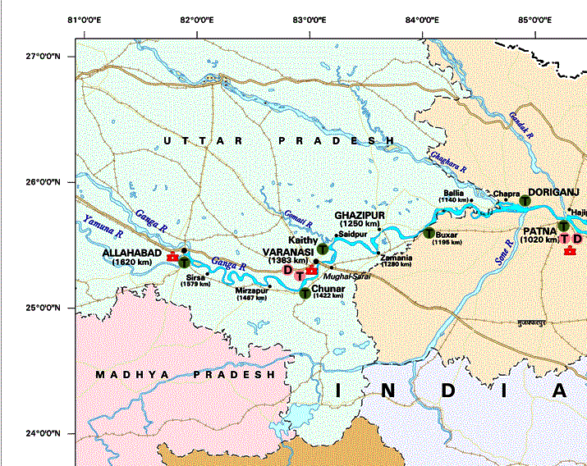

Working:
This will use combination of power sources to generate electricity to run the azipods.

What are Azipods?
In the traditional azimuth thrusters such as Z-drive and L-drive thrusters, the propeller is driven by an electric motor or a diesel engine inside the ship's hull. The propeller is coupled to the prime mover with shafts and bevel gears that allow rotating the propeller about a vertical axis. In the Azipod unit, the electric motor is mounted inside the propulsion unit and the propeller is connected directly to the motor shaft. Electric power for the propulsion motor is conducted through slip rings that let the Azipod unit rotate 360 degrees about the vertical axis. Because Azipod units utilize fixed-pitch propellers, power is always fed through a variable-frequency drive or cycloconverter that allows speed and direction control of the propulsion motors.
The pod's propeller usually faces forward because in this pulling (or tractor) configuration the propeller is more efficient due to operation in undisturbed flow. Because it can rotate around its mount axis, the pod can apply its thrust in any direction. Azimuth thrusters allow ships to be more manoeuvrable and enable them to travel backward nearly as efficiently as they can travel forward. In order to get the most out of it, shiphandling training on simulators and manned models is required.
The podded design typically achieved a 9% better fuel efficiency than the conventional propulsion system when it was first installed in the 1990s. Improvements to the conventional design have shrunk the gap to 6%-8%, but on the other hand the hydrodynamic flow around the Azipod has been improved by fin retrofits and a dynamic computer optimization of the respective operating angles of the pods in multipod installations, yielding overall efficiency improvements now in the range of 18%.

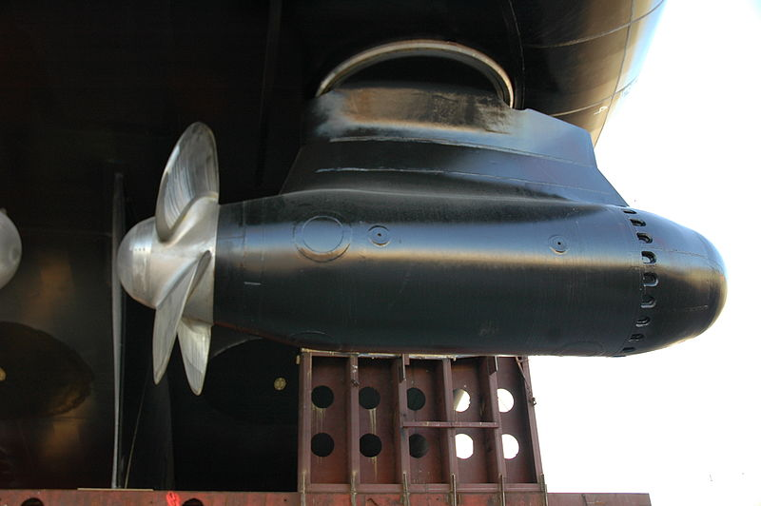

Key features:
- Environment Friendly
- Anti-Grounding feature
- Quick maneuverability ( No rudder used )
- Inland transportation
- Tourism
- Aid to traffic

- Environment Friendly:
Geology:
Allahabad is popularly known as one of the holy places of Kumbh fair or Kumbh Mela or Kumbh fair. Which occurs in every six and twelve years. Another attractions of Allahabad is the Sangam or confluence of three holiest rivers in Hindu mythology , namely river Ganga, Yamuna and mythical Saraswati. As soon as you reach through the Ghats of Varanasi or Kashi. You will witness the Varansi's older traditions and its Gnages Ghats that complement the concept of divinity. Ghats of Ganges are the holiest spot in Varanasi. You can see pilgrims flocking the place to take holy dip in the divine river Ganges. There are numerous temples seen on the bank of the Ganges in Varanasi. Some of the prominent and famous Ghats are Dasaswamedh Ghat, Manikaranika Ghat, Harischandra Ghat, Kabir Ghat and Assi Ghat.
But pollution is the main concern in the river as well in the city. Pollution of the Ganges the largest river in India, poses significant threats to human health and the larger environment. Severely polluted with human waste and industrial contaminants, the river provides water to about 40% of India's population across 11 states, serving an estimated population of 500 million people or more, more than any other river in the world.
According to a CPCB data-based report, "Varanasi Chokes", presented jointly by IndiaSpend, Centre for Environment and Energy Development (CEED) and Care4Air here at a workshop on Monday, Varanasi and Allahabad both had zero good-air quality days in year 2016. Moreover, Varanasi and Allahabad had not a single good-air quality day out of the 227 and 263 days monitored respectively.
Hence air pollution is major cause of concern in both the places.
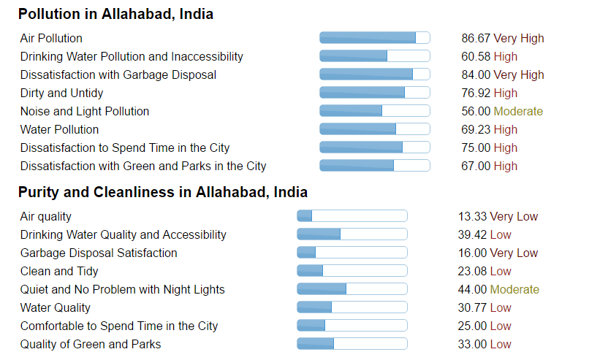
*Report : TOI, November 2016
So there comes a need for eco friendly transport.

Power Sources:
Solar hybrid power systems are hybrid power systems that combine solar power from a photovoltaic system with another power generating energy source. A common type is a photovoltaic diesel hybrid system, combining photovoltaics (PV) and diesel generators, or diesel gensets, as PV has hardly any marginal cost and is treated with priority on the grid. The diesel gensets are used to constantly fill in the gap between the present load and the actual generated power by the PV system.
As solar energy is fluctuating, and the generation capacity of the diesel genesets is limited to a certain range, it is often a viable option to include battery storage in order to optimize solar's contribution to the overall generation of the hybrid system.
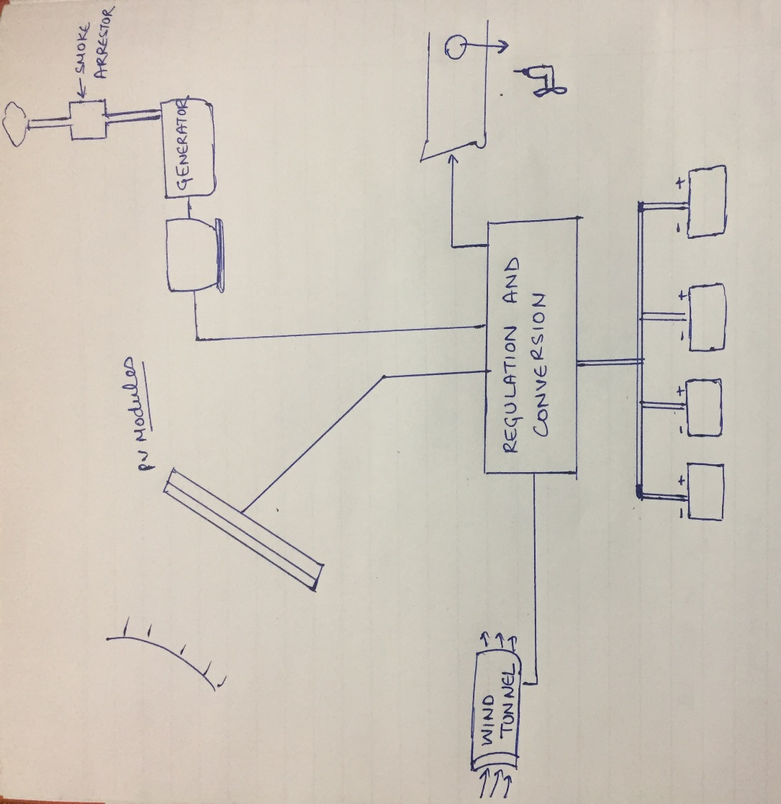
To Azipods
Moreover the smoke(NOX,SOX) from diesel generator will be caught by smoke filters, leading to release of clean air into atmosphere.

- Anti – Grounding Feature:
Uses ultrasonic waves to scan sea bed ahead of bow. Ultrasonic transmitter (attached at bow at a particular angle) will transmit pulses ahead of bow which will enable us to calculate depths well ahead bow.

Working:
Transducer attached will transit pulses ahead of bow, hence by calculating time of echo to reach the transducer distance of the hypotenuse will be known.
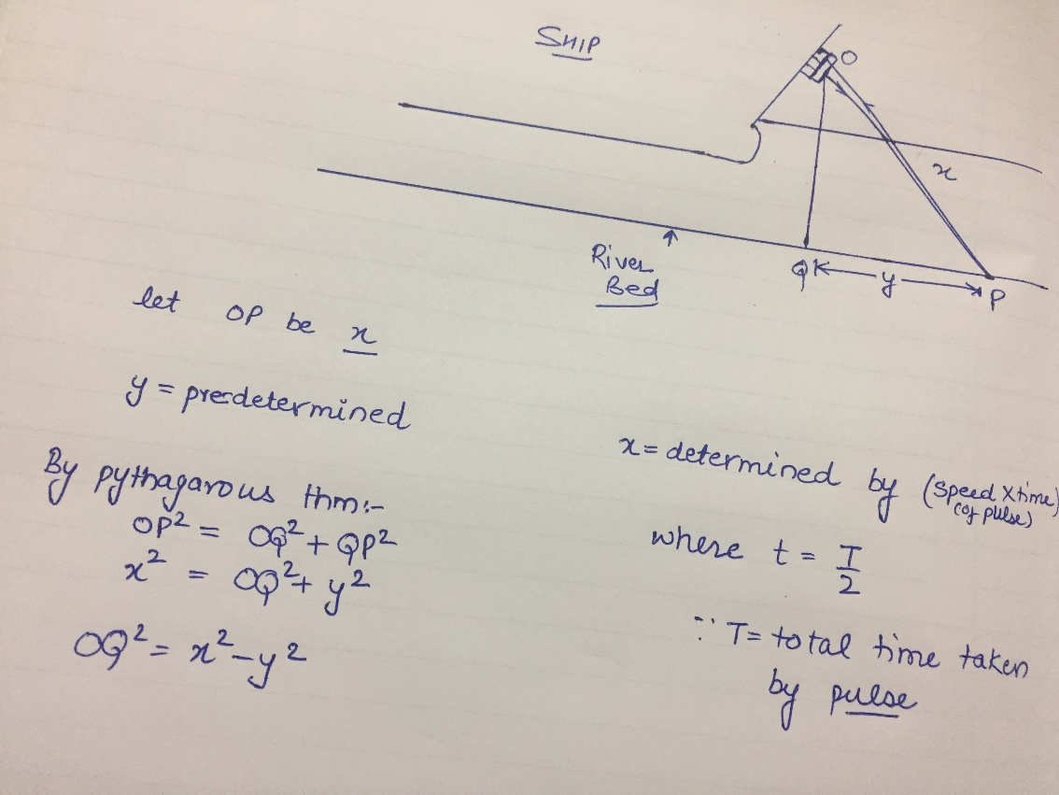

- Quick maneuverability ( No rudder used ): As Azipod is used , so rudder is no longer required. Hence no limitations due to rudder leading to easy and quick maneuverability.

From Allahabad to Varanasi:
Natural condition of river (on-site)
Depth- 2-2.5 m
Number of bridges : 30
Average height of bridges: 20 m
Restricted places: Ghats such as Dasaswamedh Gaht, Manikaranika Ghat, Harischandra Ghat, Kabir Ghat and Assi Ghat.
Months of sunshine: Seven
Average sunshine (in hours) per day : 6 hours
Budget: Approx. 20 lac* (with machinery, battery, solar panel)
*wind tunnel,accomodation not included

Conclusion:
India needs to improve its tourism industry. India is considered as “country of gods” Moreover tourism can be well benefitted by collaboration with these pilgrimage tours. This ferry designed takes care of everything including environment, safety, fuel consumption and luxury. This can easily fit into the government budget and may soon become an earning hand for the government.

