AUTOMATED PLANNING AND CONTROL
ARTIFICIAL INTELLIGENCE

Siddhant Kumar Srivastava,
B. Tech Marine Engineering,
Tolani Maritime Institute, Pune.
sidna.0243@gmail.com

Abstract
Last few decades have seen a massive technical development in the field of robotics. Now, robots are used in every possible field to reduce the human efforts. But the robots still require some input to perform the required task and that is where artificial intelligence gets its cue.
Although the development of artificial intelligence has taken place to some extent, there is still need to better the interface. The specific requirements of planning in robotics, as compared with other application domains of planning, are mainly the need to handle:
- online input from sensors and communication channels;
- heterogeneous partial models of the environment and of the robot, as well as noisy and partial knowledge of the state from information acquired through sensors and communication channels; and
- direct integration of planning with acting, sensing, and learning.
These very demanding requirements advocate for addressing planning in robotics through domain-specific representations and techniques. Indeed, when planning is integrated within a robot, it usually takes several forms and is implemented throughout different systems. Among these various forms of robot planning, there is in particular path and motion planning, perception planning, navigation planning, manipulation planning, and domain-independent planning.

Keywords: Robotics, Online Input, Sensors and Communication Channels, Heterogeneous Partial Models, Direct Integration of Planning.

1.0 INTRODUCTION
It is an abstract, explicit deliberate process that chooses and organises action by anticipating their expected outcomes. This deliberation aims at achieving as best as possible some pre-stated objectives. Automated planning is an area of Artificial Intelligence (AI) that studies this deliberation process completely. Planning is also needed when the adaptation of actions is constrained, for example, by a critical environment involving high risk or high cost, by a joint activity with someone else or by an activity to be synchronised with an active system.
One motivation for Automated Planning is very practical: designing information processing tools that give access to affordable and efficient planning resources. That operation may involve a large number of actors and the deployment of a communication and transportation infrastructure. Also, planning is an important aspect of rational behaviour if one purpose of the AI is to grasp the computational aspect of intelligence, then we can say that planning is the reasoning side of acting which is in truth a key element in such a purpose.
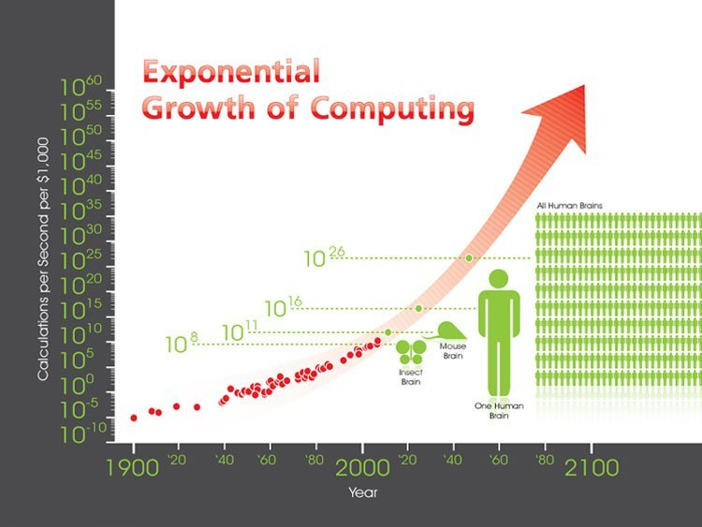
Figure: Growth in computing in the past century

2.0 CONCEPTUAL MODEL FOR PLANNING
A conceptual model is a simple theoretical device for describing the main elements of a problem. It can depart significantly from the computational concerns and algorithmic approaches for solving that problem.
As planning is concerned with choosing and organising actions for changing the state of the system, a conceptual model requires a general model for dynamic system.
A conceptual model requires a state transition system for it to work upon. A state transition system is used to describe is used to describe a relation between discreet systems. It consists of states and transitions between the states. Formally, a transition system is a set of states and state transitions represented as a set of an s and an arrow respectively.{s,→}
Formally, a state-transition system is a 4-truple given as
∑= (S,A,E,γ)
Where,
S = a finite or recursively enumerable set of states
A = a finite or recursively enumerable set of actions
E = a finite or recursively enumerable set of events
γ = S x A x E → 2^{s} is a state-transition system.
It may be represented as a directed graph whose nodes are the states in ‘S’.
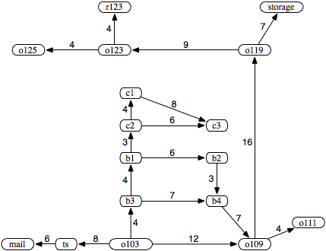 Fig.: A directed graph for arc costs of a delivery robot domain

Where a directed graph is an entity used to define the state transition system where:
- Nodes are equivalent of the states and
- Edges are equivalent of state transitions (s→s’)

3.0 TYPES OF PLANNING
Planning has had a very long history before it has been extensively employed in the artificial intelligent systems. On a wider scale, it can be categorised as under:
- Classical Planning
- Neoclassical Planning
- Planning with Time and Resources
- Planning under Uncertainty

3.1 Classical Planning

Classical planning refers generically to planning for restricted state-transition systems. There are several motivations for studying classical planning problems. As usual in science when one is facing a very complex problem, it is very useful to make restrictive assumptions in order to work out well-founded models and approaches. Classical planning is now a well-formalized and well-characterized problem. It is important, to have a good understanding of its representations and properties. Though, classical planning opened the way to algorithms and techniques that scale up reasonably well, there was still an issue to representing states, actions and the state transition system, about which I will be discussing in a few moments, such that they do not explicitly enumerate them. Without such a representation, it was not possible to develop a domain independent approach to planning.
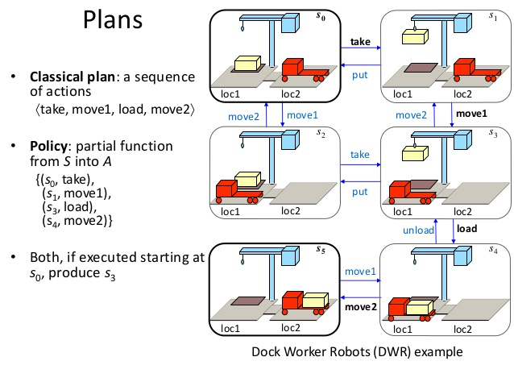

3.2 Neoclassical Planning

Neoclassical planning, like classical planning, is also concerned with restricted state transition systems. However, when the classical planning appeared to be stalled for its expressiveness and complexity, neoclassical techniques led to a revival of research on classical planning. These techniques brought a new search space and several new algorithms that directly allowed a significant increase in the size of classical planning.
The main difference between the classical and neoclassical planning system was that in classical planning, every node of the search space was a partial plan, i.e. a partially ordered set of actions on a planned space whereas in neoclassical planning technique, every node of the search space could be viewed as a set of several partial plans. This set is either explicit or implicit in the data structures that make a search node.

3.3 Planning with Time and Resources

The conceptual model for planning was mainly a general model for a dynamic system. With time and resources, the dynamics are represented as a sequence of states; actions and events are instantaneous state transitions; the planning goals are not constrained in time. In fact, they act according to the time constraints
This restricted model is quite useful for studying the logics and computational aspects of planning with simple state-transition operators.
A better model of an action should not account only for the ongoing set of sequences but should also consider the other actions that may prevail at that time of execution. Such a model should the effects of an action throughout its duration and the delayed effects after the action has finished.

3.4 Planning Under Uncertainty

Classical and Neoclassical planning provided with the skeleton for automated computing and control strategies via the relation between the states and transitions I between, there was still a requirement to fix the problem of spontaneous decision making processes. For a state transition system to work efficiently, the states, actions and events should be linked properly so that the systems function efficiently. Markov’s Decision Making process has given a theory for the same towards making it proper and efficient, the work on which is still in progress.

4.0 MARKOV’S DECISION MAKING PROCESS

Planning based on Markov Decision Processes (MDPs) is designed to deal with Non-determinism, probabilities, partial observability, and extended goals. It's key idea is to represent the planning problem as an optimization problem. MDPs provide a mathematical framework for modelling decision making in situations where the outcomes are partly random and partly under the control of the system which here is the decision maker. More precisely, MDP is a discrete time stochastic control process. Meaning to say that at any point of time, the process is in some state or the other. The decision maker can choose an action from any of these states that would be available then. The process then responds at the next time step by randomly moving into a new state and giving the required output to the processor.
    - Components
      - States ‘s’
      - Actions ‘a’
        - Each state ‘s’ has actions A(s) available from it.
      - Transition model P(s^{I}|s,a)
        - Markov’s assumption: the probability of going to ‘s^{I}’ from s depends only on s and a and not on any other past actions and states.
      - Reward function R(s)
    - The Solution
      - Policy ∏(s): mapping from states to actions.

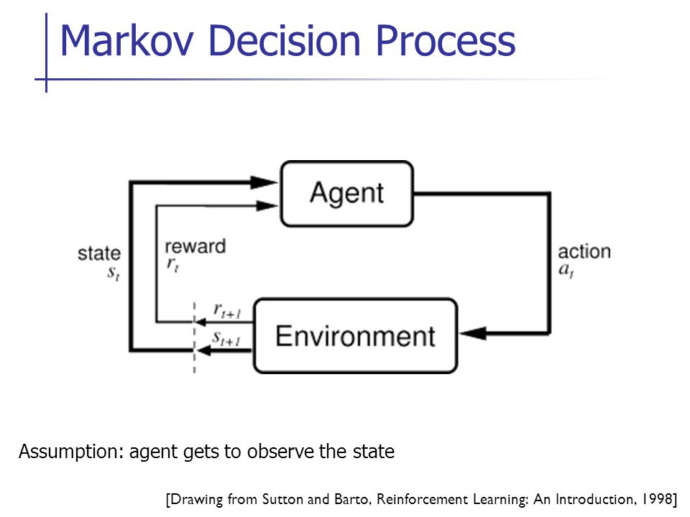

5.0 CONTROL

When a device is designed to perform without the need of conscious human inputs for correction, it is called automatic control. Automatic control systems were first developed over 2,000 years ago, an example being the ancient Ktesibios's water clock in Egypt. Since then, many automatic control devices have been used over the centuries, older ones often being open-loop and more recent ones often being closed.
There is an altogether a separate branch that deals with the controlling operations in any mechanism. That branch is known as control engineering and has developed rapidly in the last couple of decades.
For any device to function in an autonomous manner, it must require some sort of input from the surroundings. This task is accomplished via. Sensors that collect information from the environment. This collected data has to be processed before a plan of action can be chalked out by the system assessing it. This is done through the control loops.
The control loops can be classified into two broad categories:
- Inner-control loops
- Outer-control loops
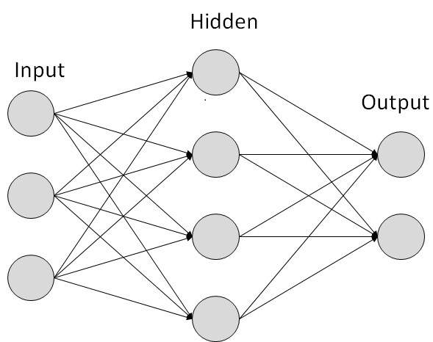
Figure: Skeleton for a control loop system
5.1 Inner-control loops

Inner control loops are similar to autonomic nervous systems in animals. They tend to be control systems that act largely unconsciously to do things.

This system is also the primary mechanism in controlling the fight-or-flight responses first described by Walter Cannon (1929 & 1932). The autonomic nervous system has two branches: the sympathetic nervous system and the parasympathetic nervous system. The sympathetic nervous system is a quick response mobilizing system, and the parasympathetic is a more slowly activated dampening system.

5.2 Outer-control loops

Where inner control loops are similar to autonomic nervous systems in animals, outer control loops are similar to their brains. That is, they tend to be more conscious and less automatically predictable.
A variety of activities that do not require too much of depth in concept like the movement and communication but require a sense of justification fall under this category.

6.0 OBJECTIVES

What we want to do is to define some desirable property P, then we ought in the principle that provably possesses the property P.
Three main choices for P are:
- Perfect Rationality: Such an agent acts at every instant to maximize its expected utility, given the information it has taken in from the surroundings.
- Calculative Rationality: Such an agent eventually returns what would have been the rational choice at the beginning of the deliberation. Such a property is interesting to exhibit in a system because it constitutes an “in-principle” capacity to do the right thing.
- Bounded Optimality: Such an agent behaves as well as given its computational resources. This means, the expected utility of the agent for a bounded optimal agent is at least as high as the expected utility of any other agent program running on the same machine.
Although the three are equally competent and self-sufficient to form an independent AI system, it would rather be if Bounded Optimality was to be given the priority with Perfect Rationality and Calculated Rationality assisting it to form an optimal environment to sense, organise and act in a given situation.
7.0 APPLICATIONS
7.1 Smart Robots

Computers have already taken over most of the human related working in the limited conditions. But the basic objective here is to create such a programme that can take in information from whatever surrounding that it is in and act accordingly, the basic idea of automated planning and control as was being discussed. Just like the humans have five most important sense organs, the robots can be installed with surrounding sensitive sensors to take in input. Now artificial intelligence has been the life and beat of this discussion and here also it has a part to play. The sensors that will take in the input from the surrounding will be connected with this system of artificial intelligence where in it will analyse and put the situation into the respective category of state-transition system and act according to the data present in any one of the sets or a combination of them.
Some robots have the ability to learn in a limited capacity, for example the Massachusetts Institute of Technology’s Artificial Intelligence lab has created a robot called ‘KISMET’ which can interact socially. It recognises the human’s body language and voice inflection and responds appropriately. KISMET’s creators are interested in how humans and babies interact, based only on the tone of speech and visual cue.
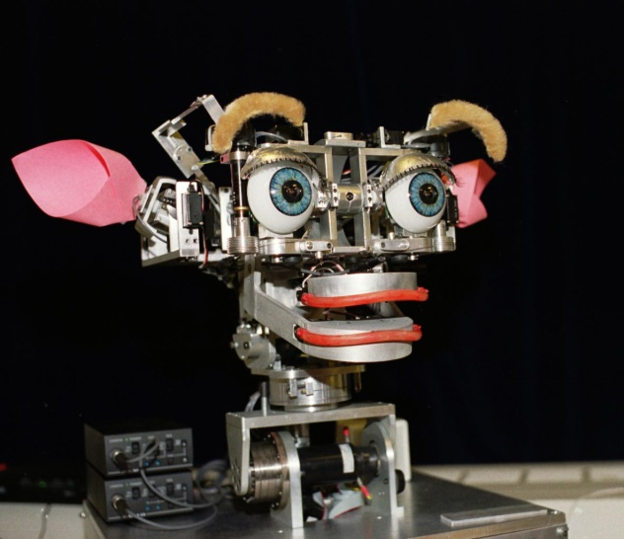
Figure: ‘KISMET’ Artificial Intelligence powered robot designed
By the Massachusetts Institute of Technology’s Artificial Intelligence lab

7.2 Dock worker robots

A container is a large metallic cell of a standard size that can be conveniently piled on docks and loaded on ships, trains, and cargo planes. It is intended to allow safe transportation of some freight from a shipping point to a destination point. A significant part of the shipment cost lies in the transition phase between two transportation media, e.g., when a container has to be moved between two ships, or from a ship to a train or a truck, usually via some storage area. The high cost of these trans-shipment operations explains the motivation of their automatization. Several sites, such as the Rotterdam Harbour, already perform trans-shipment operations with Automated Ground Vehicles (AGVs). These AGVs are mostly tele-operated. They require fixed navigation equipment and a site specifically designed to suit their human-controlled operations. The objective is to turn the tele-operated AGVs into self-operated AGVs.
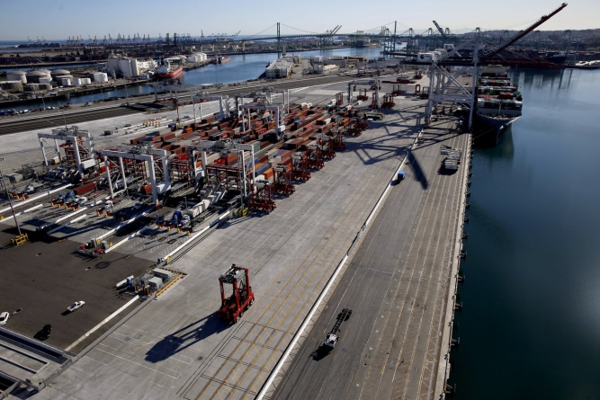
Figure: Dock using the Dock Worker Robots
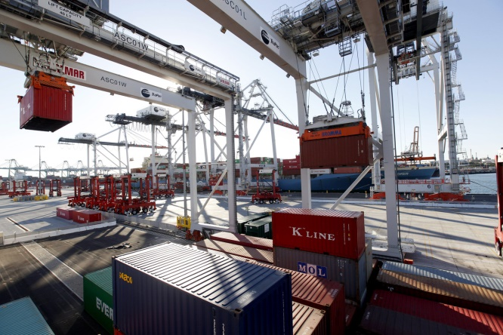
Figure: Dock using the Dock Worker Robots

7.3 Martha project

The planning and the execution control of a trans-shipment task are managed in the Martha project at several levels. At the highest level, the mission allocation is performed incrementally by a centralized planner that allocates to each robot the container transportation jobs it has to perform. It views the robots as resources and container transportation tasks as jobs to be allocated to available robots. It can handle priorities and cost estimates of jobs, as well as a fairly flexible model of the uncertainty of the specified tasks, e.g., the uncertainty of the arrival time of the ships to be handled. The planner works incrementally, taking into account newly specified transportation tasks with respect to the running ones; it is able to modify part of the already allocated missions whose execution has not started yet.
Figure: Dock work environment as described under
The Martha Project

7.4 Autonomous Vehicles

An autonomous car is a vehicle that is capable of sensing its environment and navigating without human input. Autonomous cars use a variety of techniques to detect their surroundings, such as radar, laser light, GPS, odometry, and computer vision. Advanced control systems interpret sensory information to identify appropriate navigation paths, as well as obstacles and relevant signage. Autonomous cars have control systems that are capable of analysing sensory data to distinguish between different cars on the road, which is very useful in planning a path to the desired destination.
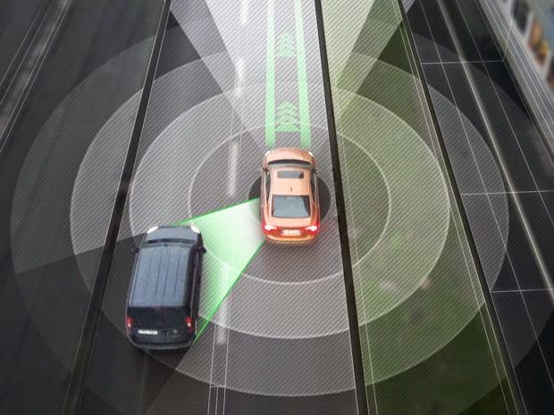
Figure: Working of an autonomous vehicle by collection of information
from the surrounding

8.0 CONCLUSION

Artificial Intelligence is a boon for every sector that we are working into. We cannot even imagine how immensely useful it can prove to be to the human kind in researches, discoveries, inventions, explorations and what not. The integrated system installed can help to intake the input from the surroundings via the sensors and plan and arrange it according to the intelligent program especially designed for the purpose and thus draw out a suitable reaction to the environment.
If only successful techniques can be developed such that the processor can categorise and decipher various situations that it will face in any task, the levels of success that will be achieved will be beyond the expectations.
The examples have already been set with the invention of ‘KISMET’ the AI based talking robot which has the capability to talk to any person just like a human, taking into consideration the body language and voice inflection.
Also, the Dock Worker Robots and The Martha Project have brought forward the plan of independent working of the artificial intelligence program as and when they are required.
So, there are more number of things that are left to be explored and discovered that we have only guessed at. These AI powered robots can be used to get information from the places that are, as of now, out of the human boundaries. Definitely these systems can help bring out the mysteries unexplored and solve the most important question in life, our existence.

9. REFERENCES

- http://open.ed.ac.uk/artificial-intelligence-planning/, Introduction, week 1, video 1.1.
- http://open.ed.ac.uk/artificial-intelligence-planning/,Conceptual Model for Planning, week 1, video 1.2.
- Malik Ghalib, Dana Nau,Paolo Traverso, State transition Systems, Automated Planning theory and theory and practice, Chapter 2.1
- Stuart J. Russel, Peter Norvig, Artificial Intelligence A Modern Approach,Objectives,Chapter 27.2
- Dan w. Patterson, Control Strategies, Artificial Intelligence and Expert System, Chapter 9.
- http://www.controleng.com/single-article/artificial-intelligence-for-control-engineering/1284e9173857dba3c4fa632978e2209f.html, Control Systems.
- Malik Ghalib, Dana Nau,Paolo Traverso,Dock Worker Robots, Automated Planning theory and theory and practice, Chapter 20.4
- Malik Ghalib, Dana Nau,Paolo Traverso,The Martha Project, Automated Planning theory and theory and practice, Chapter 20.4
- http://www.rand.org/pubs/research_reports/RR443-2.html#page-content, Autonomous Vehicles.

