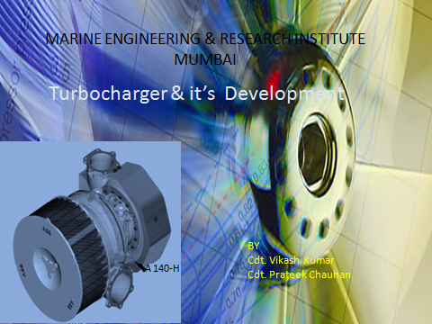

ACKNOWLEDGEMENT

We feel great pleasure to express our heartful gratitude & thankful to our guide Shri A.N.S. Neti and all faculty members of MERI for their invaluable and helpful counsel rendered throughout the project.
We also extend our gratitude to our Deputy Director Shri Rajeev Prakash for providing all the facilities to carry out the practical work in this institute. We take this opportunity to thank him.
We also would like to thank TOLANI MARITIME INSTITUTE for providing us this golden opportunity for showcasing our talent.

Contents
- Introduction
Consequent development of engines

- Turbocharger

- Turbocharger designers

  - ABB
    - TPS
    - TPL
    - TPL91 – B
    - A100 Series
    - WHR (Waste Heat Recovery ) System

  - MAN
    - TCA
    - TCA88 – 25
    - TCR
    - TCR22
    - VTA ( Variable Turbine Area ) Technology
    - TCS – PGT (Turbo Compound System with Power Turbine & Generator).
  - Napier

- Future trends in turbocharging.

  - Miller cycle
  - 2-Stage Turbocharger

- Conclusion

- Bibliography

- Introduction

Man`s desire to move propelled him to search for wheel. Since man thought about making that wheel integrated to fulfill his transportation needs and movement of his goods. Innovations in transportation are a dynamic process and from that day new inventions are coming on and on.
The advent of diesel engine has brought exponential growth in transportation. Engine – engine can be defined as a self moving contraception that with the help of shaft and rotor allows the driven machinery to move alongside it.
Engines are of two types:-
- Internal combustion engine
- External combustion engine
In this paper we are concerned with mainly marine engines, which are preferably I.C. engine.

Internal combustion engine: -
Any type of machine that obtains mechanical energy directly from the expenditure of the chemical energy of fuel burned in a combustion chamber.
Consequent development of engines:-

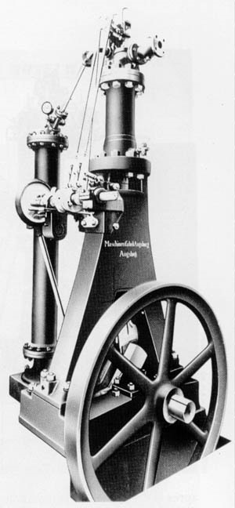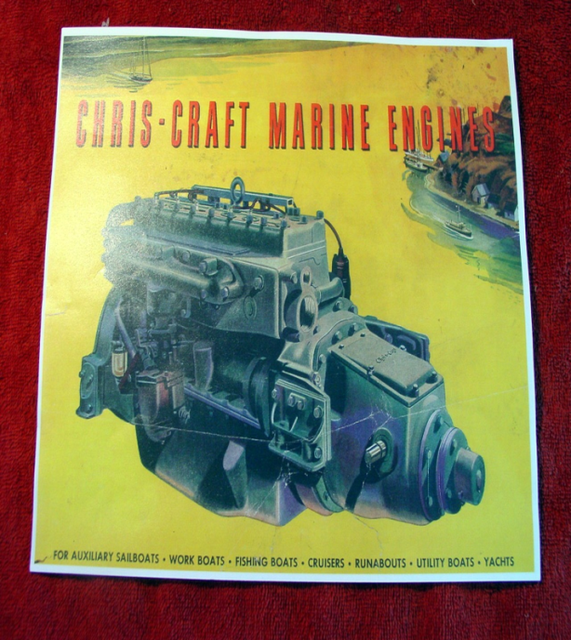
Rudolf engine 1950’s diesel engine
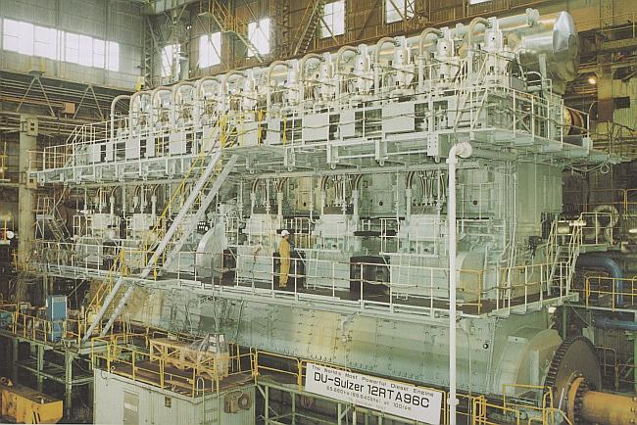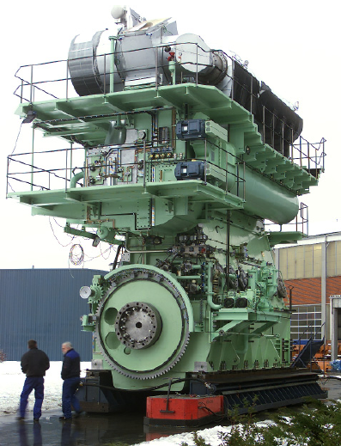
14 Cylinder RT- Flex 96C, 2300 tonnes, MAN’s ME Engine
power output of 84.42 MW (114 800bhp).
Modern Engine

Optimisation in every parts of the engine is being tried to increase it ‘efficiencies, such as:-

- Development of Piston and combustion chamber – OROS Geometry, High piston top land.
- Development in fuel systems – common rail system(CR system).
- Development of Lubricating system – Swirl injection system.
- Other ancillary developments – computer control system(CoCoS system) etc.....
- Major player in the development:- Turbocharger( vital components that can increase engine power by more than 300%).

- Turbocharger

For Combustion of a fuel, an adequate quantity of air is required. For a Turbocharger system capacity should be sufficient to ensure that the air demand is met when the turbocharger is not at its optimum.

The turbocharger was the brainchild of inventor Alfred Büchi, who was awarded a German patent for the idea of using exhaust-gas energy to drive a turbine sitting on the same rotating shaft as a compressor wheel, which increase engine efficiency by about 40%.

Cross-section of Brown Boveri type VTR501 turbocharger

The diesel engine exhaust gases enter through the water-cooled gas inlet casing (50), expand in the nozzle ring (30) and supply energy to the shaft (20) by flowing through the blading (21). The gases exhaust to the open air through the gas outlet casing (60), which is also water cooled, and the exhaust piping. The charge air enters the compressor through an inlet stub (82) or through the silencer filter (80). It is then compressed in the inducer and the impeller (25), flows through the diffuser (28) and is fed to the engine via the pressure stubs on the compressor casing (74).
- Turbocharger Designers

3.1 Asian Brown Broveri (ABB)

3.1.1 TPS series-
ABB Turbo Systems addressed the market in the mid-1990s with the TPS series, designed to serve four-stroke engines with outputs from 500 kW to 3200 kW per turbocharger.
The TPS models are divided into the following three types according to the size of compressors: version D (TPS-D), E (TPS-E) and F (TPS-F).
Each TPS models consist of a mixed flow turbine and centrifugal compressor. The TPS models use the centre support bearing systems and are small size turbochargers. TPS-D and TPS-E turbocharger are available with two completely different compressor stages to ensure the full range of pressure ratios, while TPS-F series is introduced in 2001.

Bird's eye view of the TPS turbocharger

Main features:-
Compressors

The compressor is made by machining forged aluminium. In addition, it uses splitter blades with a backward-type outlet to achieve higher efficiency, higher volume flow rates, and a larger operational area. The TPS-D supports pressure ratios up to about 4.2 and the TPS-E, high-pressure ratios up to about 4.7. The TPS-F supports large volume flow rates and even high-pressure ratios up to about 4.7.
Peak efficiencies of more than 84 per cent are obtainable.

Volume flow rate ranges and pressure ratios of the TPS-D, TPS-E, and TPS-F

Turbine

A mixed flow turbine equipped with a nozzle was developed to address pulse-turbocharging, 4-stroke engines. In addition, a turbine nozzle that has an anti-erosion coating on it can be applied to engines that use low quality fuel. Furthermore, a cleaning nozzle specifically for water cleaning was optimized to achieve effective turbine cleaning. Turbine development included the ability to operate at gas temperatures of up to 750⁰ C and yield a long lifetime on heavy fuel operation and under extreme load conditions.

Scrool casing & nozzle ring

A new scroll casing and nozzle ring were designed using proven inverse calculation methods that ensure losses are kept very low and turbine blading is not too strongly excited.

Bearings
Sliding bearing with a taper land type is used, which is fixed on the stationary portion. This structure provides a compact design that has a longitudinal length of 1 563 mm. Turbocharger bearings must deliver a good load-carrying capability with respect to both static and dynamic forces, good stability and minimal mechanical losses from a cost-effective design fostering modest maintenance. The TPS turbocharger bearings are lubricated directly from the engine lube oil system.

3.1.2 TPL Series:-

A completely new generation turbocharger from ABB Turbo Systems— the TPL series—was launched in 1996 to meet the demands of the highest output low and medium speed engines..

Each TPL model consists of an axial turbine and a centrifugal compressor, along with a bearing placed between the compressor and turbine: The TPL models use a centre-support bearing system and are large-size turbochargers. The TPL models are divided into the following two types according to the types of applicable engines: Versions A (TPL-A) and B (TPL-B). Now TPL-A is being supplemented by TPL-C ; the advanced 4- stroke power back series.

Bird's eye view of the TPL-A turbocharger Bird's eye view of the TPL-B turbocharger

TPL-A model addresses demands from 4- stroke engines delivering 1250 KW to 1800KW per turbocharger, while outputs from 5000KW to 25 000KW per turbocharger are served by TPL- B variant designed primarily for large, modern two-stroke marine diesel engines introduced in 1999.

As we are mainly concerned with recent innovations in turbocharging ,here is an overlook on the features & benefits of TPL-B series turbocharger. TPL-B series is acting as a platform for all the recent benchmarks achieved by ABB, from the TPL- 91B designed for the largest and most powerful diesel engines to the A100 series unfolding a totally new idea of single stage, high efficiency, high pressure turbo charging.

TPL-B

The features and benefits of TPL- B are as:-

Features Benefits

Axial turbine with wide-chord blading | • High efficiency
Internal plain bearings, lubricated by engine lube oil | • High efficiency
Large-diameter radial compressor with backswept blades | Wide compressor map for optimized matching in all applications
Free-floating axial bearing disc; radial bearing bushes with squeeze oil damper | High availability and reliability; increased TBO
Free-floating axial bearing disc; radial bearing bushes with squeeze oil damper | Easy to service; work in confined spaces possible
No water-cooling | No water connections; no corrosion problems
Turbine and compressor cleaning integrated | Cleaning at high and low loads possible
Improved air filter silencer | Low noise emissions
Modular design
Variable positioning of casings and flanges

Main Features:-
Compressors
The compressor is made by machining forged aluminium; it is now made as a one-piece unit instead of the two-piece unit used for the VTR turbochargers. In addition, it uses splitter blades where shorter and longer blades are arranged alternately and a backward-type outlet to achieve higher efficiency, higher volume flow rates, and a larger operational area.

Turbine

The TPL-B models are often installed on 2-stroke engines, which use constant pressure turbocharging systems that provide exhaust pulses smaller than those of 4-stroke engines. Turbine blades without a lacing wire are employed to improve the turbine efficiency. In addition, turbine blades fewer than those of the TPL-A models (wide-code blades) are used to provide durability against the vibration of the turbine blades.

To prevent turbine performance from degrading through exhaust stains accumulated on the turbine components, a cleaning nozzle was incorporated in the casing, facilitating turbine cleaning.

Bearings

TPL models employ sliding bearings. As the journal bearing to support the radial direction load, a semi-floating bearing with the inner radius arranged with three arcs is used. The non-rotating, semi-floating bearings are not fixed in the casing, but float in an oil-filled radial gap that acts as an oil damper.
By providing a very small gap between the casing and rim of the bearing, instead of firmly fixing the bearing, and inserting lubricant into this gap, the damping of the rotor vibration is adjusted. Lubricant also flows into the gap between the rotor and the inner radius of the bearing, and when the rotor rotates, the oil film floats the rotor inside the bearing.

Structure of the TPL bearing

3.1.3 TPL 91-B.

The TPL 91-B model which supplemented the TPL 73,77,80, and 85B models is designed for the largest & most powerful 2- stroke diesel engine having air flow of 55.7m³/s, a shaft power of 10 450KW and weight of 14.5 tonnes. Having a engine applications range from 20 000KW to 28 000KW per turbocharger & a compressor pressure ratio upto 4.5.

TPL 91-B Turbocharger

3.1.4 A100 series

ABB’s latest series – The A100 has been developed for meeting the IMO – II regulations while eliminating or limiting bsfc penalties and to achieve compressor pressure ratios of up to 5.8 at full load.

Single stage, high efficiency, high pressure A100 series is a benefit for everybody:-
For the end user:- lower fuel consumption
For the engine builder:- higher power density
For the environment:- less NO_{X} and SO_{x}

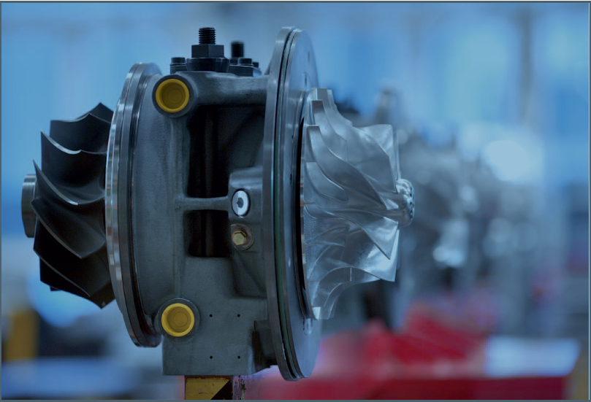
A140-H

The A100 radial turbochargers have been designed with similar dimensios and frame sizes to the well- established TPS series. A100-M/H is designed for medium and high speed engines having pressure ratios up to 5.8 and efficiency 68%. A100-L for medium-bore low speed 2- stroke engine offering pressure ratio up to 4.7 and 75% eficiency.

New high pressures diffusers and compressure blading are developed in addition to the innovative wheel cooling to ensure the full load pressures ratios up about 5.8 with aluminium wheels. A140 first frame in A100-M/H series having entirely new compressor stages can achieve 80% efficiency.It is being followed by A135 and again A145 & A130 wil follow
A135.

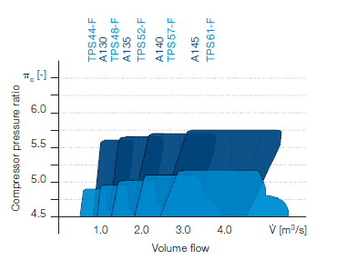
Pressure ratio vs volume flow range for A100 radial turbochargers at full load.
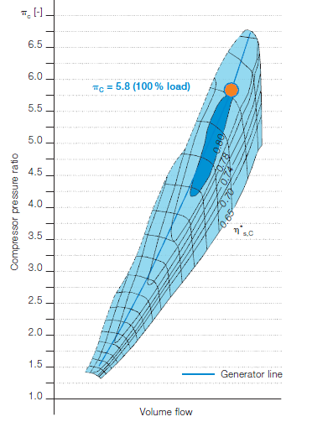

Compressor map(A140)

3.1.5 Waste Heat Recovery (WHR) systems

Due to the high efficiencies of the modern turbochargers, it is now possible to divet the surplus exhaust gas before the turbochargers and feed it to small turbocharger turbines-the power turbine- which use the energy in the gas to produce mechanical or electrical power.

The full energy potential of the waste heat can be recovered by additionally using the steam produced in the boiler after the turbochargers to drive a steam turbine.The combined power and steam turbine unit will supply electricity to the onboard grid or provide additional power to the main engine via a shaft motor/generator.It delivers additional out-put amounting to about 10% “free of charge”fuel and emission savings.
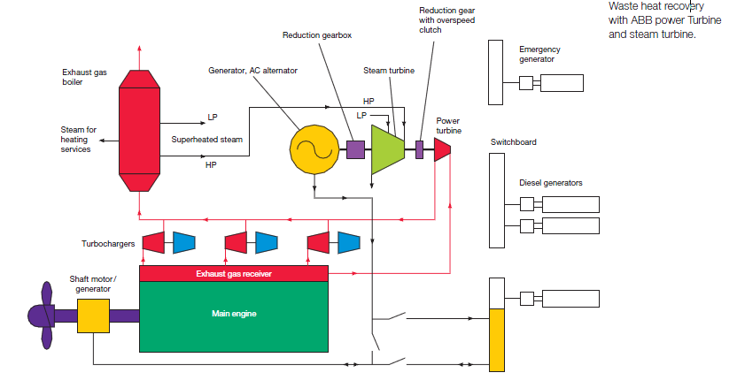

3.2 MAN
MAN’s latest high efficiency turbochargers are available in two forms – the TCA (axial) and TCR (radial). Introduction of a new axial turbocharger generation – the TCA series –in 2001 and the introduction of the new radial TCR series in 2004 were ideally timed to assist engines from MAN Diesel meet tightening emissions legislation, including the International Maritime Organisation IMO Tier II limits for oxides of nitrogen (NOx).
MAN claims that by running at speeds in excess of 70 000rpm the current high-pressure ratio units are capable of boosting engine output by over 300%.

3.2.1 TCA
The new series of TCA turbochargers are available in 2 stroke and 4 stroke versions for diesel, dual fuel and gas engines. They have been developed to provide a robust and reliable platform for engine applications ranging from 2,500 kW up to 35,400 kW output per turbocharger. Integral design combined with advanced materials has improved turbocharger efficiency, simplified installation on the engine, and has extended times between overhauls. Using fewer parts than any other generation has reduced maintenance and service times, which ensures lower life cycle costs.

Uncooled casings integrated air seal,oil piping and venting
systems

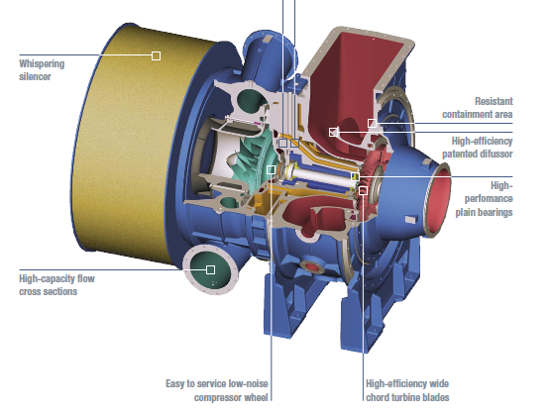

Features Benefits
Turbine
Newly developed wide-chord turbine blades without damping wire | Increases efficiency
New turbine nozzle ring | Extended life-time
New optimised turbine outlet diffusor | Increases efficiency
New optimised turbine inlet casing

Bearings
Reduced shaft diameter | Minimises mechanical losses
High performance thrust bearings | Minimises mechanical losses
Floating journal bearing bushes | Optimises damping behaviour

Compressors
Newly developed compressor wheel | Reduces noise emission. Increased efficiency and optimisation of the engines operating line
Newly developed compressor volute
New compressor diffusor vanes

Easy Maintenance
Thrust bearing inspection without shaft removal | Reduces service time
Compressor wheel change | Basic tooling without dismantling compressor casing
Easy replacement of turbine blades | Reduces service time
Optional monitoring system

Extended Parts Life-time
Floating journal bearings
Floating thrust bearing disk
Cast nozzle rings
Turbine blades
Compressor wheel
Optional titanium compressor wheel

Designs Features
Air cooled casings | No corrosion
Integrated emergency and post | Safe operation
lubrication tank
Lubrication by engine lube oil system
Integrated oil piping and oil venting system
Integrated sealing air supply
Reduced number of parts
Integrated burst protection | Safe operation

Turbine
All components of the TCA turbocharger have been optimised with regard to flow control and stress reduction by means of modern 3D CFD and FEM calculations. The result is a turbine with very stiff and high-wear resistant wide-chord blades, which are supported in the turbine disc by means of a ‘fir tree foot’. A damping wire is therefore no longer necessary, which makes maintenance work easier and improves efficiency.

Bearings
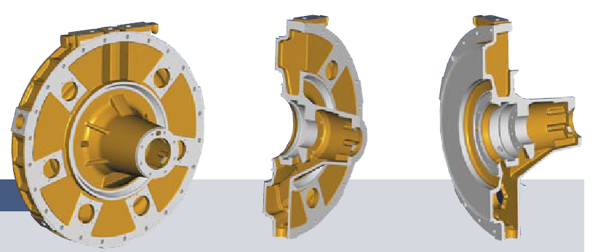
Internal radial bearings with floating bushes and a separate thrust bearing with a follow-up floating disc.The advanced design provides higher safety margins. Low circumferential speeds of the bearing bushes minimises friction losses which contributes to a higher total efficiency. The expected service life of the bearing body is up to 50,000 hours.

Compressors
The compressor wheel operates at a circumferential speed well over 500 m/s which results in very high centrifugal forces. A titanium compressor wheel suitable for use in very high pressure conditions has been developed specifically for the TCA series, utilising advanced 3D CFD and FEM calculations. Noise is considerably reduced. A new type of force and form locking compressor wheel attachment on the turbine shaft permits assembly and dis-assembly of the compressor wheel, without having to use an unwieldy hydraulic tool.

Nozzle Ring

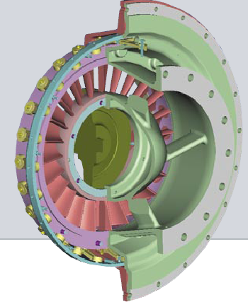

TCA nozzle rings are manufactured from highly resistant materials which ensure The adjustable nozzle ring permits optimum adaptation of the ‘flow cross section’ to the corresponding load condition of the engine and therefore reduces both fuel consumption and pollutant emissionss a long service life.

Whispering Silencer

The newly developed radial silencer is able to reduce noise emissions down to a value of well under 105 db. The shape of the radially arranged damping segments provides optimum flow conditions and contributes to total turbocharger efficiency. The filter matting over the circumference of the silencer can easily be removed and cleaned when required.

Casings

The uncooled casings of the TCA series are designed in accordance with the ‘pipeless engine’ principle. All supply pipes are fully integrated within the casing. Only one oil supply and discharge pipe has to be connected externally. Newly developed one and two socket compressor spirals and diffusers permit optimum matching of the turbocharger.
In order to permit optimum mounting to the engine all casings can be installed and turned in steps of 15°. to the engine .

3.2.2 TCA88-25

TCA88-25 latest and largest in the series, is an uprated vresion of TCA88-20. A revised compressor design with new wheel geometry increases volume flow by 16% from 50.4m³/s to 58.6m³/s per terbocharger. The maximum supercharged engine output per turbocharger has risen from 23 400KW for the TCA88-20 to 27 300KW for the TCA88-25 with efficiencies well above 72%.
As a result, only three TCA88-25 are now required to supercharge the 12K98ME-C two – stroke engine, the most powerful in MAN’s range.

3.2.3 TCR

Like it’s TCA cousin, the TCR is completely designed using a 3D-CAD system. 3D-CAD system simplifies and reduces development work by integrating software tools during the CFD(flow) and FEA(strength) analysis. These findings allow the optimisation of the material used for the turbocharger so as to combine maximum strength with the lowest possible weight and compact design.

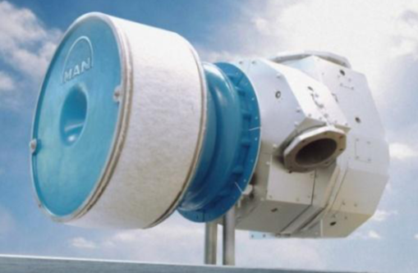
TCR radial turbocharger

The radial-flow TCR is designed for medium speed engines and larger high speed units, and is also claimed to be suitable for many smaller low speed two- stroke engines. It is intended for use with residual and distillate fuel oils and gas fuels.

The new TCR series has a compressor pressure ratio of 4.7 and is capable of 5.2 when built as a special version. Aimed specifically at the medium and high speed diesel and gas markets. Six different models are able to cover a wide range of outputs from 400 to 6000KW.
The TCR series will replace the NR series, which is in production for last 50 years.

Main features

Turbine

The flow calculations create a shape of turbine with both high efficiency and wide application range. Therefore it provides optimum values in part load and full load operation and is suitable for both constant and pulse pressure turbo charging.

Compressor

- The flow and strength analysis resulted in a new design of compressor wheel, which permits higher efficiency, quicker response behaviour during acceleration and, therefore low emissions from the complete system.
- The compressor wheel is screwed onto the shaft via a special retainer, which ensures precise centring.
- This design permits, among other things, a reduction of the hub size and therefore, an increase in airflow rate.
- An integrated washing system permits compressor wheel cleaning during operation.

Bearing

The axial rotor support bearing is located between the two radial bearings, permits minimisation of the bearing space requirements.

Sealing system

- The sealing system is designed to be as compact as possible and with no sealing air requirement.

- The piston ring gasket, combined with a labyrinth seal, is tested and proved to provide optimum sealing capacity, both in operation and at standstill.

Casing

- One piece cast aluminium casing benefits from FEA optimised.
- Optimisation of the gas inlet casing, via the nozzle ring to the turbine outlet casing, can be obtained in various mounting variants.
- An optional variable nozzle ring permits turbocharger adaptation to most load conditions.

3.2.4 TCR22

TCR22, largest radial turbocharger currently available has been successfully trialled on a 6S35MC two- stroke engine rated 4 440KW at 173 rpm. It demonstrated high efficiencies over the engine’s entire load range. In particular, part load operation showed a marked improvement.

This has resulted in the introduction of the TCR22-21and TCR-25 tailored specifically to two- stroke applications, and able to handle engines up to 6400KW. The new units feature an enlarged compressor wheel design, oil supply characteristics offering extended time delay for slow-down alarm,simpler installation, and a high capacity turbine wheel.

3.2.5 Variable Turbine Area (VTA) technology

The latest TCA and TCR turbochargers with VTA “Variable Turbine Area” employ a system of adjustable vanes upstream of the turbocharger turbine that allow the amount of air compressed by the compressor wheel to be flexibly varied. The so-called charge air can thus be more precisely matched to the quantity of fuel injected and hence combustion optimised at all the engine’s operating speeds and loads.

VTA’s variability exactly matches flexibility of MAN Diesel’s electronically controlled fuel-injection systems, e.g. common rail, and allows fuel consumption and related emissions to be minimised while the engine’s ability to respond to load changes is greatly improved.

With our VTA technology, by contrast, the quality/efficiency of power produced by the engine can be optimised towards the amount of power needed by the ship. Ensuring efficient combustion of the fuel in this way further reduces fuel consumption and ensures compliance with emission limits.

3.2.6 TCS- PGT
(Turbo Compound System with Power Turbine and Generator)

Current engines need only about 61% turbocharger efficiency, whereas modern turbochargers offer 68% to 70% efficiency.
One possibility that has become apparent with the latest generation of high-efficiency turbocharger is the diversion of more exhaust gas to power turbine- based recovery systems.
MAN Diesel’s turbocharger division proposes it’s TES (Thermal Efficiency Systems) range of efficiency – enhancing proposals.

With the TCS-PGT (Turbo Compound System with Power Turbine and Generator):-

- 5% of additional power can be extracted from the main engine exhaust gases
- This power can be supplied as 50Hz or 60Hz electrical energy which is fed to the vessel’s onboard power grid.
- Depending upon the size of the engine installed, this can delivered a maximum of 4700KW extra energy.
- When the system is installed alongside current high efficiency turbochargers, payback periods of 3 to 5 years are anticipated- may be shorter if fuel cost continues to rise.
- Having TCS-PGT System in operation, it is often not necessary to run auxiliary gensets, saving on fuel and maintenance; particularly as planned maintenance on the auxiliaries can then be carried out with the vessel underway

The system is highly recommended for applications where the main engines have rated outputs above 20,000 KW and where onboard electrical demand is more than 10% of main engine power.

How does it work?

A power turbine is inserted into the exhaust gas system parallel to the engine turbochargers. The turbine drives an electrical generator via a reduction gear box, and it receives up to 13%
of the exhaust gas flow, diverted from the main engine exhaust gas receiver.

Other designer

  - Napier

Napier’s 7 series is intended for medium speed engines running on heavy fuel and gas, aimed at marine, power generation and rail engines in the power range of 2 MW to 6.5MW per turbocharger. Its latest 8 series offers pressure ratio of up to 5.2,an extended power range up to 10.5 MW. 70% efficiency is said to be achieved.

- Future trends in turbocharging

Aim of Turbocharger development:

1. Higher Scavenge Air Pressure
2. Higher Turbocharger Efficiency
3. Compact dimensions and competitive price

Trend of engine BMEP with respect to turbocharger overall efficiency and pressure ratio

Today’s engines operate at BMEP up to 19.5 bar, with turbocharger efficiencies of just over 68 per cent and pressure ratios up to 3.95. If the engine BMEP would be increased to 21 bar then the turbocharger efficiency would need to be raised to 70 per cent and pressure ratio to about 4.2.
The reason for this relationship between turbocharger performance and engine BMEP is because a higher BMEP requires a higher pressure ratio to keep the air excess ratio at the same level. At the same time turbocharger efficiency must also be increased to keep the air mass flow and cylinder mass purity at desired values.

In the case of four-stroke engines, turbocharger speed is a significant criterion because of the need to obtain higher pressure ratios. Turbocharger speed is not a major limiting factor for two-stroke engines

4.1. Miller cycle

Higher turbocharger pressure ratios with the miller/Atkinson process in diesel engines, is key to reducing NOx emissions.
In miller cycle, the combustion air is compressed by the turbocharger to a higher pressure than that needed to fill the cylinder for the desired air /fuel ratio. On 4 –stroke engines, miller cycle involves closing the inlet valve early to allow the incoming air to expand and cool and thus eliminate the combustion temperature peaks responsible for the majority of NOx formation.

Working principle standard – Miller timing
Simulated pV- and TV-diagram

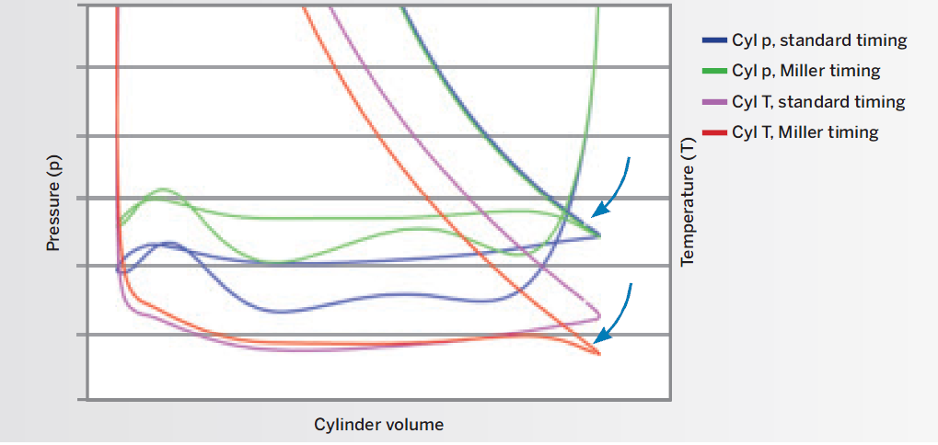

Miller cycle vs. standard diesel cycle

On low speed, 2-stroke engines the same effect is achieved by reduction of compression volume, increasing scavenging air pressure and late closing of the exhaust valve, in some cases combined with optimisation of the fuel system.
The high pressure turbocharging ensures that an equivalent amount of air enters the cylinder, thus leaving engine power, torque and response unaffected, due to as a lower temperature at the beginning of the cycle.
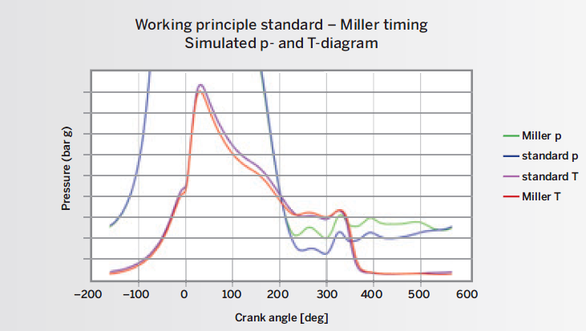

Miller cycle vs. standard diesel cycle; high-pressure

4.2 2-stage turbocharger

The 2-stage turbocharger seems to be a only viable option in respect to meet the future emissions regulation limits of International Maritime Organisation (IMO) Tier III regulations and to have greater pressure ratio great than 5.8 (recently achieved by ABB’S A100 series).

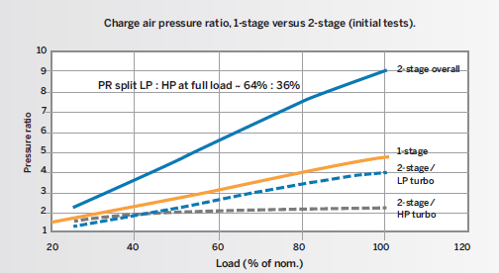

Charge air pressure ratios with initial specifications.

Single stage turbocharger distinguishes itself by simplicity and cost effectiveness, but
reaches certain limits at higher pressure ratios. Two-stage turbocharging allows mechanically less charged turbochargers and the increase of the full load efficiency, advantages that go at the expense of part load behaviour and the increase of the complexity of the supercharging system.

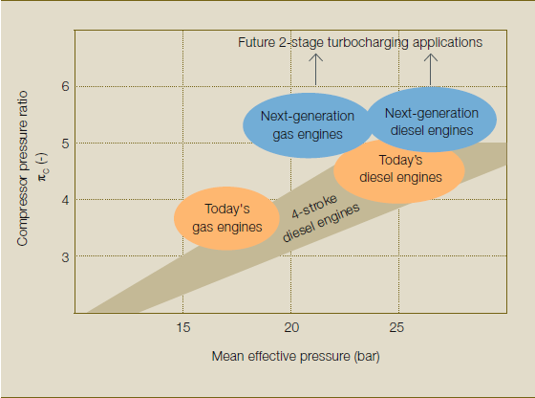

Trends in the turbocharging of modern high-speed engines

As long as the pressure ratio is no more than 6, then a single stage system looks like the optimum, though this means a large turbocharger with limited efficiency and flexibility. As pressure ratio above 8 is desired, then 2-stage turbocharging along with Miller /Atkinson cycle looks like the best practical answer.

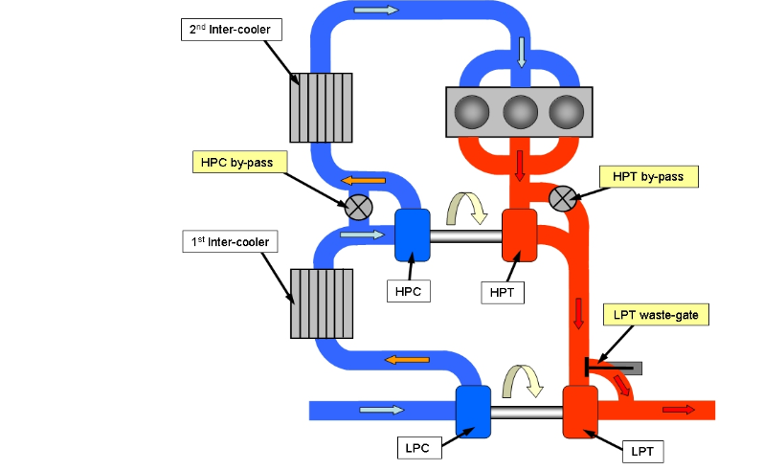

2-Stage turbocharger engine scheme of diesel engine with three highlighted main boost control elements.

Three main control elements were chosen for boosting system
– Hight pressure turbine by-pass (HPT by-pass)
– Low pressure turbine waste-gate (LPT waste-gate)
– Hight pressure compressor by-pass (HPC by-pass)

HPT by-pass is in principle the most important actuator. Ideally it could control engine alone without any other control elements help. It decreases the boosting pressure within high pressure stage and so controls whole system. LPT waste-gate is the second in importance sequence. It decreases the LP turbocharger speed and avoids its over-speeding. HPC by-pass enables complete by-passing of HP stage together with HPT by-pass. In other words said it is able to “switch off” the high pressure stage. This usually happens at high engine speed when the HPC is too small for extensive mass flow.

With the help of Miller cycle the high pressure 2-stage turbocharging ensures that an equivalent amount of air enters the cylinder, thus leaving engine power, torque and response unaffected, due to as a lower temperature at the beginning of the cycle.

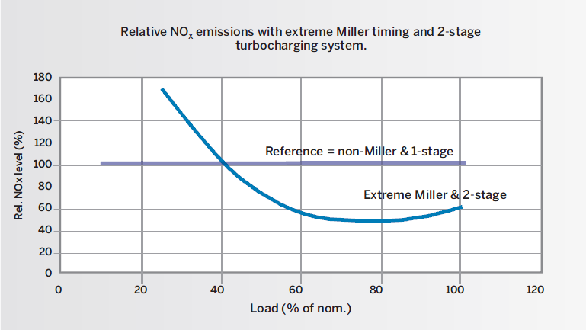

Relative NOX emissions with extreme Miller timing and 2-stage TC (initial specifications).

The lower start combustion temperature enable Miller cycle of varying intensity to eliminate the combustion temperature peaks responsible for the majority of NOx formation. By cooling the combustion process using a Miller cycle, NOX emissions can be efficiently reduced. This demands high boost pressures, which can be achieved with a 2-stage turbo charging (TC) system. Thus, these two technologies form an optimum combination.

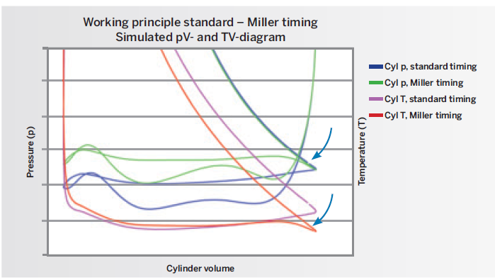

Miller cycle vs. standard diesel cycle

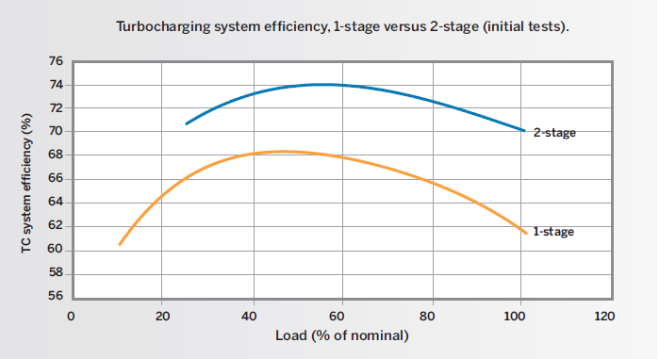

Turbocharging system efficiency with initial specifications

2-stage turbocharging believes to offer enormous potential for engine builder and users in providing more freedom to reach the full potential of current and future engines. MAN participating in the European Hercules project, with a test assembly comprising a TCR 22 as a first-stage turbocharger and a TCR20 for the second. This has achieved compression efficiency better than 90% and peak efficiency close to 80% of the overall turbocharger efficiency at pressure ratios of around 6. Better results are anticipated in future with modifications employed.

- CONCLUSIONS

Primary objectives in the design and development of turbocharger are to comply with fuel prices rising day by day and to meet the higher stringent legislations of International Maritime Organisation (IMO) Tier II and Tier III. The future aspects of the turbocharging are going to be focused on green shipping and will strive for high efficiency, high reliability, maintaining larger over-haul periods, etc. The proven technical advancement of the variable turbine area geometry, two-stage turbocharging with optimized Miller cycle will set the bench mark in the future innovations.

The developments have been a continuous process and researches are busy making turbochargers optimising engine are perfection personified and thus we conclude by saying

“Optimum design is yet to be achieved”

- Bibliography

1 .Pounder’s Marine Diesel Engine and gas turbines
2. D.A Taylor
3. Marine Engineer’s Review
4. MAN B&W manual
5. ABB manual
6. Motorship magazine.
7. Google search engine

