IMPACT OF ADVANCED TECHNOLOGY ON HUMAN LIFE
AUTHOR: Shreeya Sawale
Mechanical engineering (second year)
MKSSS'S Cummins College for Women, Pune

ABSTRACT: Technology is invading every area of our personal and professional lives. My purpose for this presentation is to highlight the overview of do's and don'ts of impact of advanced technology on mankind. Technological development has provided human history with a kind of directionality. This paper sketches the Technological advancements which have shown substantial growth concerned with each and every field of humanity whether it be the communication systems, astronomy, nuclear powers, medical fields, automobiles, electronic devices of daily usage or the computers.

- KEYWORDS: Advanced technology, Communication, Nuclear technology, Globalization , Industrialisation.

INTRODUCTION
Technology: The application of tools and methods. Since the "beginning" we have been using technology to adapt to the environment and make our lives much easier. The technology referred to in the question is about today's gadgets such as tablets, cell phones, computers, etc... With the power of these technologies rising, the only way for advanced technology to invade our freedom is if you allow it to. Most people use computers to help them think AND work, while others allow the technology to be their lives and take away their freedoms. Without things like the Internet, students would look for newspaper articles and books on the certain subject they research. Now, using a quick internet search, they find the subject they need with the click of a button, being more efficient in working. Adapting to find easier solutions is in our nature.
RELATION OF TECHNOLOGY WITH HUMANITY
The origin of science lies in the evolution of the human brain, and the intrinsic sense of curiosity in human beings to explore, to know, and to understand nature and the world around. Historically, the origins of science go back to the beginning of civilized existence. From its earliest days, science has been embedded in society, there has been a continuous learning process in society as a whole, based on day to day experiences and this can become the body of the knowledge from which applications and understanding have grown.
Sir Francis Bacon wrote: "Human knowledge and human power are coextensive. Nature can only be ruled by being obeyed. POSITIVE SIDE OF THE IMPACT
Technology runs in the veins of society. It is the fuel that drives our lives. It is an integral part of daily life.
- Automation of Processes in the Industry and the Household
- Technology has automated many of the critical processes in the industry as well as the household. Imagine the amount of labor that must have been involved in industrial processes when the concept of automation did not exist. Electronic gadgets have entered homes of the common man to rescue him from the boredom of daily chores. Imagine the amount of time people must be spending doing household chores during the time there were no machines and household appliances. It's better not imagined. Today's is the age of robotics. Machines can learn, adopt new things and perform tasks with near-human efficiency.
- Changed Modes of Transport
The automobile industry and technology are interwoven. Time has witnessed this industry evolve from mechanical scooters to automated aircraft. Animals were the only modes of transport in the olden days. Technology was the driving force behind the creation and design of the modern-day automobiles. Bicycles evolved into scooters and sports bikes. The idea of having four-wheeled modes of transport gave rise to the creation of cars. Modes of air and water transport came up, thanks to technology.
- Reduced Risk to Human Life
Machines have automated many crucial industrial processes. Machines are now taking up mundane jobs that were once done by human workers. Technology has evolved to an extent where machines can perform tasks that are not feasible for man, either because they are risky or life-threatening or because they are beyond human capacity. The use of advanced technologies like robotics and artificial intelligence has proven to be helpful in life-risking endeavors like mining and space exploration.
- Data Management and Information Retrieval
Computer technology, needless to say, has changed the face of the world. Computers can store, organize and manage huge amounts of data. They can process large amounts of information. Computers have given rise to the software industry, one of the most progressive industries of the world. The Internet that seeded from computer networking concepts is the most effective communication platform and the largest information base existing today.
- Impact on the Entertainment and Advertising Industries
The Internet has brought a positive change to the entertainment and advertising industries. Over the Internet, advertisements can reach the masses within seconds. Internet advertisements have changed equations of the advertising industry. Branding on the Internet is much more effective that other forms of product promotion. The entertainment media has progressed because of advancements in technology. Movies, songs, games are a few clicks away. People have begun using the Internet to watch and download movies, listen to music, play games and entertain themselves. Thanks to handy, mobile and user-friendly devices, all this has become really easy.
- Communication Redefined
Cellular communication has revolutionized the communication industry. The conventional telephone, also a piece of technology, was one of the earliest technological developments in communication. Mobile phones have broadened the horizons of communication by enabling convenient long-distance calling and mobile use. Letters have taken a backseat and emails and cell phone messages have become the easiest means to connect. Owing to developments in technology, communication is wireless. Social networking is another defining factor here. It has given an all new dimension to communication, entertainment and recreation.
- Satellite Technology
Satellite communication is an important facet of technology. Satellite TV and satellite radio have eased the broadcasting of events across the globe. How else do you think could matches and concerts be broadcasted live? Not just TV and radio, even communication to ships and airplanes wouldn't have been possible if not for satellite communication. Even your hand-held devices wouldn't be of use, if not for radio communication.
  - NEGATIVE SIDE OF THE IMPACT

- Technology advancement has made humans so lazy, technology users are so dependent on new advance tech tools, this laziness has resulted into less innovation, it has increased on health risks because technology users exercise less.
- Nevertheless some people argue that science can destroy mankind. E.g.; Robots will be built to clone humans, robots will take over the world, the first genetically cloned human brain will be implanted in a robot which will enable to feel human emotions, and maybe even create some kind of robotic offspring. One thing I would also like to state is technology is only created by our minds, with our imaginations. Without imaginations, no technology would have been created.
- On the minus side there is weaponry which is the inseparable issue of the new technologies. Nevertheless, weapon engineering propels and provides a huge advance. Rivalry between the countries may also be ascribed to technological advancements, as the countries compete for the development of new warfare techniques and equipment’s. On the other hand while many people live in horrible conditions and famine governments spend a lot of money on developing weapon industry. Is it the right way? Maybe the modern technology should either stop or prevent social disproportions.
- It has affected the environment because of the increase pollution which has affected the Ozone layers which has resulted into global warming.
- Use technology now a days...Instead of talking to other people.. They prefer to stay at home and play or do face book in their PC chat through phones or listen music through air phone....Many people think that they can't do anything without their phones or say that their life is boring without technology.
TECHNOLOGICAL ADVANCEMENT
Present scenario
Another prominent technological innovation that well represents our humanity today is the Internet. The Internet is the worldwide, publicly accessible network of interconnected computer networks that transmit data between themselves. The Internet allows for us to, in some ways make the world smaller.
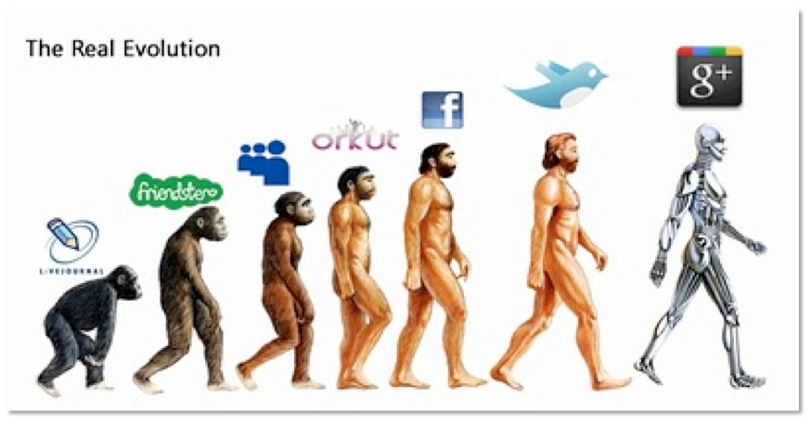

Internet Technology
Another prominent technological innovation that well represents our humanity today is the Internet. The Internet is the worldwide, publicly accessible network of interconnected computer networks that transmit data between themselves.
The Internet allows for us to, in some ways make the world smaller.
In 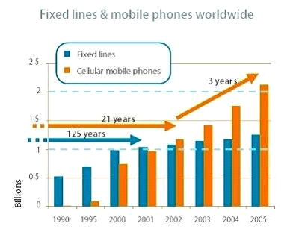
Nuclear Technology
It has many vital applications in modern society, the most prominent of which are nuclear weapons, nuclear medicine, and nuclear power. The most controversial of these is, without a doubt, nuclear weapons.
When you look at the usage of nuclear technology, you must look at the situation from the viewpoint of human society as a whole, and not from a standpoint of an individual. Even in the area of peaceful uses of nuclear energy, there are great concerns about nuclear accidents, damage from nuclear radiation and the question of safe disposal of radioactive wastes.
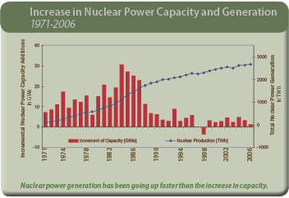

Agriculture Technology
In agriculture, improvements have been effected so far on a gradual basis. For example, in animal husbandry, one has gone from selection and crossing, to artificial insemination, and embryo transplant technologies none of these have given rise to fears. But genetic engineering arouses fears because one moves across species boundaries. Multiplications and mutations can develop and progress rapidly in biological systems. Risk assessment is much more difficult and uncertain, compared to physical engineering systems. In biology, one also deals with systems interactions, such as in ecology, those are complex. It is, therefore, important to continuously monitor what is happening in the field, using the very same powerful techniques of biotechnology.
Medical Technology
Perhaps one of the most vital technological advances in our society today is in the field of human medicine and health sciences. This field deals with the maintenance, prolongment , and restoration of human health through the study, diagnosis, treatment, and prevention of disease and injury.
Today, modern medicine is practiced within a well-developed framework of health-care infrastructure. Research in the field of medicine has allowed for the development of many new treatments, drugs, medicines, and solutions that have allowed for the dramatic prolongment of the human lifespan. Today, with the influence of medicine, the lifespan of the average human is only increasing. Medicine in today’s world provides the most vital of all services; it ensures the survival of the humanity as a whole.
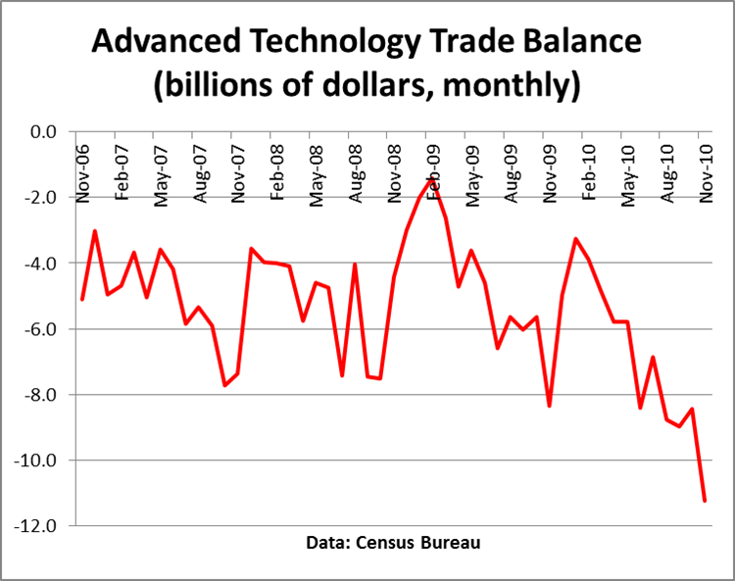
AKNOWLEDGEMENT: This research paper is made possible through the help and support from everyone, including: parents, teachers, family, friends, and in essence, all sentient beings. Especially, please allow me to dedicate my acknowledgment of gratitude toward the following significant advisors .First and foremost, I would like to thank Mr A.M. Rajurkar sir, for his most support and encouragement. He kindly read my paper and offered invaluable detailed advices on grammar, organization, and the theme of the paper. Finally, I sincerely thank to my parents, family, and friends, who provide the advice and financial support. The product of this paper would not be possible without all of them.
APPENDIX: Science and Technology will continue to advance rapidly as we move into the next millennium. What is important is to ensure that these advances benefit humanity as a whole. Technology has several positive effects on today's world like making life more convenient and providing huge entertainment storage; however it can affects people's health and interaction negatively. Though we can’t deny the endowments that the current era of advancement has provides us with, but like any other thing, we cannot deny the fact that there is always two sides to everything: Good and Bad.

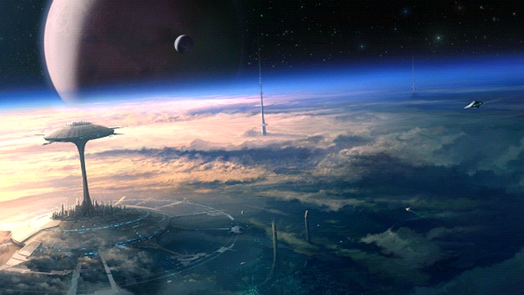
REFERENCES:
- Alexander Roberts Todd, Problems of the technological society, publisher: Ghana publishing Corporation for university of Ghana, 1973.
- Donald P. Lauda and Robert D. Ryan, Advancing technology its impact on society, Editors: Donald P. Lauda and Robert D. Ryan, publishers: W.C.Brown Co. 1971.
- Information on sciencedirect.com - https://www.google.com/url?sa=t&rct=j&q=&esrc=s&source=web&cd=1&ved=0CCoQFjAA&url=http%3A%2F%2Fwww.sciencedirect.com%2F&ei=cnXfUo2vLoPBrAef7IHQCw&usg=AFQjCNH96s-J4QGd04OEk_NaX8VlFAR2uw&bvm=bv.59568121,d.bmk&cad=rjt

Research and Advanced Technology for Digital Libraries: 7th ...
- http://books.google.com/books?id=x0e8V7d2LroC&pg=PA499&dq=reference+for+impact+of+advanced+technology&hl=en&sa=X&ei=3HXfUrDlA4bUrQf3joDQAg&ved=0CEUQ6AEwBQ.

