PORTS IN INDIA- PAST, PRESENT AND FUTURE

Siddhant Kumar Srivastava
B.Tech Marine Engineering,
Tolani Maritime Institute,
Pune – 410507.
sidna.0243@gmail.com

Sandesh Sinha
B.Tech Marine Engineering,
Tolani Maritime Institute,
Pune – 410507.
sandeshsinha005@gmail.com

Abstract

India is the sixteenth largest maritime country in the world, with a coastline of about 7,517 km. It has 12 major and 200 notified minor and intermediate ports out of which 64 are handling the export and import operations. Cargo traffic, which recorded 1,052 Million Metric Tonnes (MMT) in 2015, is expected to reach 1,758 MMT by 2017. The Indian ports and shipping industry plays a vital role in sustaining growth in the country’s trade and commerce.
The government has played an important role in the development of port and its facilities. It has allowed Foreign Direct Investment (FDI) of up to 100 per cent on the ports under the automatic route for port and harbour construction and maintenance projects. It has also facilitated a 10-year tax holiday to enterprises that develop, maintain and operate ports, inland waterways and inland ports. After the launch of the Make In India policy, 118 projects involving investment of USD 7.73 billion have been approved in last four years. USD 2.69 billion invested in last three years in Ports & Shipping sector alone.
The future of the ports in India appears to be bright as it is one of the major countries that has been a vital part to the Maritime and Shipping industries. In light of this, Eight new ports are expected to come up in the near future, three of which have already been announced by the Finance Minister. Also, the SagarMala project, one of the objectives of which is the establishment of logistics hubs and establishment of industries as well as manufacturing centres to be served through ports in domestic and international trade, aims at creating job opportunities to aid the development of the nation as a whole.

Keywords: Million Metric Tonnes(MMT), Foreign Direct Investment(FDI), Make In India Policy, Route of Port and Harbour Construction and Maintenance, SagarMala Project.

- Introduction

India has been one of the most important points of sea trade in the entire South Asian region since the start of shipping industry. Its peninsular location made it apt for trade though marine routes which led to establishment of many ports during very early times.
Infrastructure plays a very important role in the economic progress of the nation. No country can think of economic progress & development without the development of efficient infrastructure. Especially in age of globalisation where international goods & commodities are to be transported from one country to the other, efficient infrastructure is the key to the success. Taking into consideration the flow of international goods, international cargo traffic is mainly carried through two modes of transport, by air & sea. 90% of the international cargo is transported through ships.

- Past
Maritime trade and commerce in India dates back to the early Indus valley civilization where the trades used to take place between the other existing civilizations like the Mesopotamian civilization. The trades have paced up ever since and the maritime sector was of utmost importance during the Mughal Rule and also during the British Rule in India. During the British rule, the port facilities started to develop due to the increased demand of export of raw materials from the country England where the materials were processed and cast out into goods and were supplied to other countries out of which India was also one of the importers. 6 major ports were developed during that time which include the ports in Bombay, Calcutta, Madras, Gujrat, Mangalore and Karachi with around 50 non major ports. Today, that number has grown up to more than 200 plus ports with 12 currently active ports. This has made India one of the leading markets as far as the maritime trade and commerce is concerned.
The current policies are focussed more on the automatization of major ports and the Prime Minister’s dream of the Sagarmala Project.
- Present

Cargo traffic handled by India’s major ports increased 5.56 per cent year-on-year to 113.63 million tonnes (MT) during April-May 2017. In terms of composition of cargo traffic, iron ore traffic volume rose 33.28 per cent to 9.96 MT, coking coal grew 12.67 per cent to 9.30 MT, and Fertiliser traffic went up 20.09 per cent to 1 MT during the period.
The country’s major ports handled a combined traffic volume of 647.43 million tonnes during 2016-17, registering an annual growth rate of 6.79 per cent, as against a growth of 4.32 per cent in FY 2015 -16. The major ports recorded the highest ever capacity addition of 100.37 MT in 2016-17, thereby raising the total capacity to 1065 MT per annum, as against a capacity of 965.36 MT per annum in 2015-16.
The government has taken several measures to improve operational efficiency through mechanisation, deepening the draft and speedy evacuations. The major ports have outperformed private ports for the second consecutive year by registering a growth 6.79 per cent in 2016-17, whereas the private ports recorded a traffic growth rate of 4 per cent
The Department of Industrial Policy and Promotion (DIPP), Ministry of Commerce and Industry, reported that the Indian ports sector received FDI worth US$ 1.64 billion between April 2000 and March 2017.

The Indian Minister for Shipping, Road Transport and Highways, Mr Nitin Gadkari, announced a massive investment in India’s ports and roads sector, which is likely to help boost the country’s economy. The Indian government plans to develop 10 coastal economic regions as part of plans to revive the country’s Sagarmala (string of ports) project.
The zones would be converted into manufacturing hubs, supported by port modernisation projects, and could span 300–500 km of the coastline. The government is also looking to develop the inland waterway sector as an alternative to road and rail routes to transport goods to the nation’s ports and hopes to attract private investment in the sector.
- Indian shipping companies are expected to gain from the surge in country's iron ore exports to China, and as a result shipping firms are increasing the number of their large sized vessels deployed on the India-China route.
- Reliance Defence and Engineering Ltd (RDEL) has signed a contract with the Ministry of Defence for the design and construction of 14 fast patrol vessels (FPVs) for the Indian Coast Guard, at a cost of Rs 916 crore (US$ 137.4 million).
- Tata Steel has signed an agreement to purchase 51 per cent stake in Creative Port Development (CPDPL), which has a concession agreement with the Odisha government to develop a 10 million-tonnes-per-annum (mtpa) Subarnarekha port at Chamukh village in Balasore district of Odisha.
3.1 Performance of Major Ports

The twelve major ports in India handled more than 55% of the maritime cargo traffic of the country in 2014-15. Traffic handled at the major ports has been increasing over the years in tandem with the economic activity and volume of trade turnover. The total traffic handled by the major ports has recorded nearly threefold increase from 195.9 million tonnes in 1994-95 to 581.34 million tonnes in 2014-15. Cargo handling capacity at major ports has also risen with traffic. The capacity which was placed at 174.0 million tonnes at the end of 1994-95 has increased to a level of 871.52 million tonnes at the end of 2014-15. The capacity addition and the productivity improvements achieved by the major ports coupled with growing participation of Private Sector in cargo handling have had a favourable impact on efficiency of cargo handling operations at India’s major ports. The capacity utilization which was 112.6 % in 1994-95, remained above 100% thereafter till 1999-2000.
3.1.1 Major Ports: cargo traffic in terms of overseas and coastal traffic
The overseas and coastal cargo handled during 2014-15 by major ports was of the order of 461.87 million tonnes and 119.47 million tonnes respectively. The Overseas Cargo traffic increased by 4.8% in 2014-15. The Coastal cargo traffic growth was 4.2% in 2014-15 over 2013-14. Amongst the major ports, Kandla Port accounted for the highest share of 15.9% in the total cargo traffic at all major ports during 2014-15 followed by Paradip, J. L. Nehru, Mumbai, Vishakhapatnam, Chennai, NMPT, Chidambaranar and Kamarajar. The cargo traffic at Haldia Dock Complex, Cochin, Kolkata Dock System (KDS) and Mormugao had a share of less than 5% each during the same period. The Cargo traffic at all the Ports was overwhelmingly outward oriented with overseas cargo accounting for the larger share in the total cargo handled at the port.
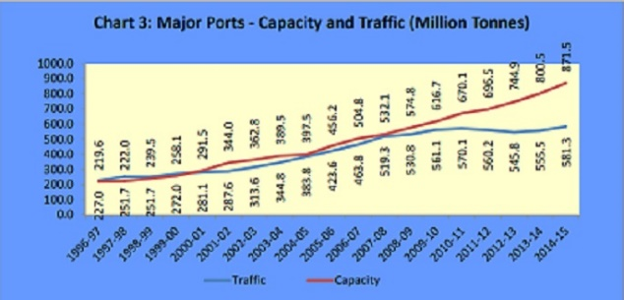
Fig 3.1.1 Capacity and traffic at major ports
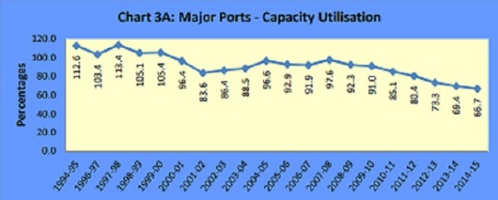
Fig. 3.1.2 Capacity Utilization at major ports

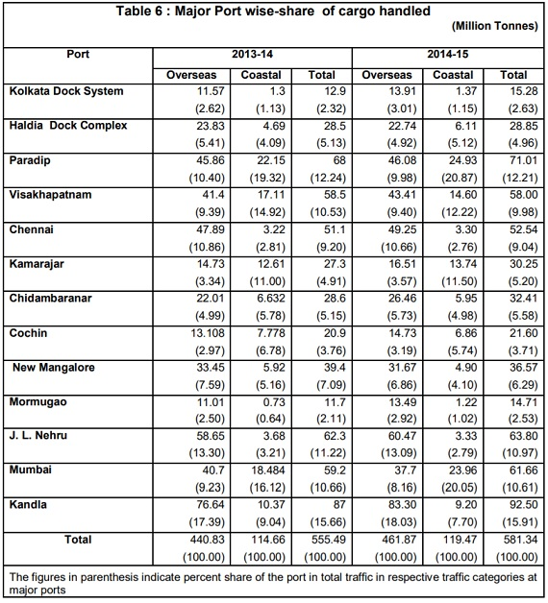
3.1.2 Container Traffic
Containerization started in India in 1973 in a limited way with the creation of interim container handling facilities at Mumbai and Cochin Ports. Since then, container traffic has steadily increased over the years, in tune with the increasing use of containers in international trade. Container traffic has experienced about seven fold increase from 1.05 million Twenty Feet Equivalent Units (TEUs) (13.08 million tonnes) in 1993-94 to 7.9 million TEUs (119.4 million tonnes) in 2014-15. Over the same period non-containerized cargo grew from 166 million tonnes to 461.89 million tonnes i.e. about three fold increases.
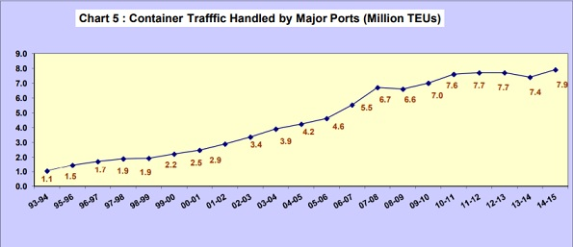
Fig 3.2.1 Container Traffic at major ports

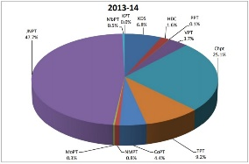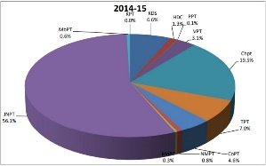
Fig 3.2.2 Comparison between the container traffic in the years 2013-14 and 2014-15 at major ports
Fig 3.2.3 Legends
3.2 Performance of non-Major Ports
There are 205 non-major ports situated along the peninsula coast-line and sea-islands. These ports are located in Gujarat (46), Maharashtra (48), Goa (5), Daman & Diu (2), Karnataka (9), Kerala (17), Lakshdweep (10), Tamilnadu (16), Puducherry (3), Andhra Pradesh (12), Orissa (13), West Bengal (1) and Andaman & Nicobar Island (23). Out of these 205 Non-major ports, only some ports are well developed and provide all-weather berthing facilities for cargo handling. In 2014-15, only 70 Non-major Ports were reported to have handled cargo traffic.
3.2.1 Cargo Traffic Handled
The effectiveness of non-major ports in meeting the growing volume of cargo traffic in the backdrop of saturation of existing capacities at the major ports cannot be overlooked. Recognizing the importance of non-major ports, maritime states have launched initiatives for their development, through the participation of private sector. This has led to significant growth in the cargo traffic handled by the non-major ports in the past few years. Non-major ports in India collectively handled 470.89 million tonnes of traffic during the year 2014-15 as compared to 416.97 million tonnes of cargo handled in 2013-14. The year-on-year growth in traffic in 2014-15 was 12.9% as compared to 7.5% in 2013-14. At a disaggregated level, the overseas cargo traffic increased by 11.8% in 2014-15 compared to an increase of 11.2% recorded in 2013-14. Coastal cargo traffic increased by 13.9% in 2014-15 compared to an increase of 15.1 % in 2013-14.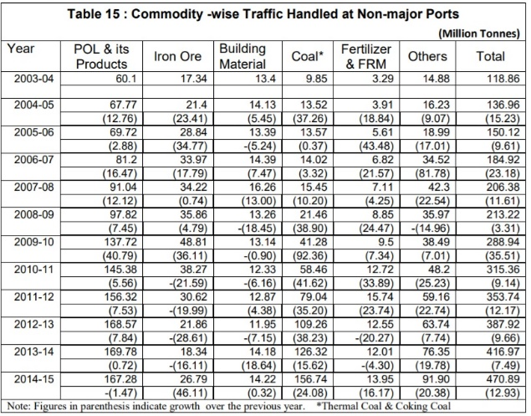
3.2.2 Maritime State-wise traffic
The overall increase of 12.93% in cargo handled at non-major ports during 2014-15 was mainly driven by traffic growth in Gujarat, Andhra Pradesh and Maharashtra, Though the Cargo handled at the non major ports in Tamil Nadu and others have witnessed negative growth of 4.7%, and 0.8% respectively, the impact on the total traffic handled by Non-Major Ports is not significant due to low share of these States in the total traffic handled during the year.
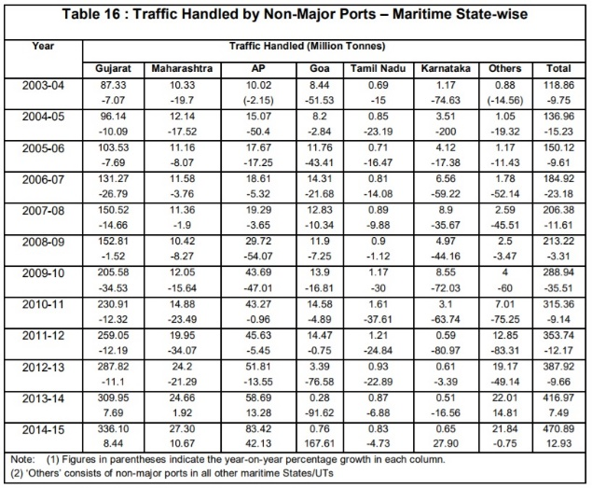
- Future

Increasing investments and cargo traffic point towards a healthy outlook for the Indian ports sector. Providers of services such as operation and maintenance (O&M), pilotage and harbouring and marine assets such as barges and dredgers are benefiting from these investments.

The capacity addition at ports is expected to grow at a CAGR of 5-6 per cent till 2022, thereby adding 275-325 MT of capacity.

Under the Sagarmala Programme, the government has envisioned a total of 189 projects for modernisation of ports involving an investment of Rs 1.42 trillion (US$ 22 billion by the year 2035.

Ministry of Shipping has set a target capacity of over 3,130 MMT by 2020, which would be driven by participation from the private sector. Non-major ports are expected to generate over 50 per cent of this capacity.

- The Ministry of Shipping, Government of India, has announced plans to execute 199 residual maritime projects worth Rs 800,000 crore (US$ 124 billion) over the next two years, via government funding.
- Mr Narendra Modi, Prime Minister of India, has launched several projects of Kandla Port Trust, including Dr Babasaheb Ambedkar Convention Centre, 14th and 16th General Cargo Berth and Interchange-cum-ROB at Kutch Salt Junction among others.
- The Union Cabinet has approved the proposal of Ministry of Shipping to replace the 'Major Port Trusts Act, 1963' by the 'Major Port Authorities Bill, 2016', which will empower major ports to perform with greater efficiency by having full autonomy in decision making and by modernising the institutional structure of major ports.
- The Ministry of Shipping plans to undertake development of 37 national waterways (NWs), out of the 111 NWs declared under the National Waterways Act 2016, in the next three years, which would have positive impact on reduction of overall logistics cost.
- The Union Cabinet has approved a new productivity-linked reward (PLR) scheme for 37,870 Port and Dock workers in all the Major Port Trusts for the years 2015-16 to 2017-18 at an annual cost of Rs 49.58 crore (US$ 7.4 million).
- Mr Nitin Gadkari, Minister for Road Transport and Highways and Shipping, has stated that India would like to collaborate with Germany for projects worth Rs 1 trillion (US$ 15 billion), aimed at enhancing port rail connectivity and identifying environment-friendly technology for scrapping of old vehicles.
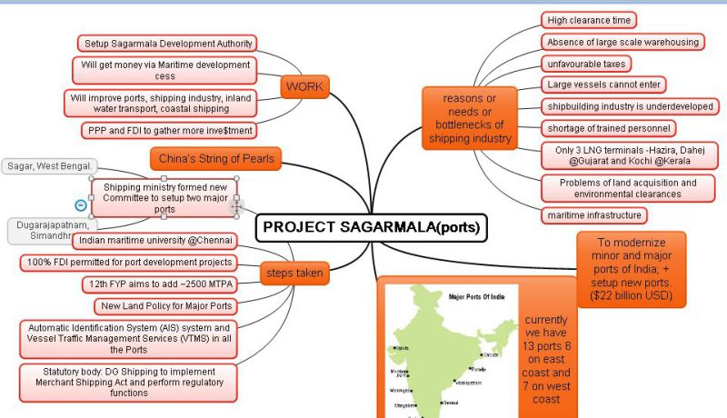
Fig 4.1 Sagarmala Project
- Conclusion
The paper concludes the brief of the Maritime Industry in India and the various functional major ports alongside the mention of non-major ports. The Maritime Agenda mainly highlights the development driven path that this sector has embarked upon, beginning 2010. The major ports in India and their organisation is handled mainly by the central government and non- major ports come under the state government, subject to legislation of those listed in the concurrent as well as the state list. The current scenario in the port sector highlights the growing trend of public- private partnerhsips and the expansion of the port sector inorder to meet the escalating export-import market. India hosted the Indian Maritime Summit from the 14-16th of April 2016, with the intention of furthering the development at a faster pace that would be beneficial for trade and commerce of industries as well as the maritime sector itself. The market for logistics and service providers is marked by competition that is driving the productivity of the sector. The competition within the ports in India and abroad is seen as a pivotal factor in making the sector at par with international standards. The advancement of the ports are crucial to India in order to elevate it’s international trade transactions. The improvement of the inland waterway system will aptly contribute to this port advancement. Though the Indian ports are not as advanced when compared with their counterparts in the global market, it stands at an advantage with regard to the increasing domestic demand. Thus making investments in Indian ports in sync with the market trend could be beneficial in the coming years.
- References

- http://www.aivp.org/wp-content/uploads/2016/06/suresh_trishala_indian_maritime_industry.pdf basic port statistics of india 2014-15
- https://www.mptgoa.com/wp-content/uploads/2016/06/port-statistics-2014-15.pdf insights into the indian maritime industry and ports in india.
- https://www.ibef.org/industry/ports-india-shipping.aspx
- https://www.mptgoa.com/wp-content/uploads/2016/06/port-statistics-2014-15.pdf

