THE GREAT EASTERN INSTITUTE OF
MARITIME STUDIES
(LONAVALA)

PAPER PRESENTATION
ON
FUEL CELL AS AN ALTERNATE FOR
MARINE PROPULSION
PREPARED
FOR
TRANSTECH-13
INNOVATION IN TRANSPORTATION
BY
Cdt. Kiran Kumar Gowda B.S
Cdt. Vikas Sahoo
GME 201208 – 22 BATCH
ABSTRACT
Hydrogen gas fuel and fuel cell technology was considered as an alternate substitution for the use instead of cheap, heavy fuel oils with high levels of impurities and other diesel fractions, as even this may emit more than necessary due to a lack of exhaust after treatment. Hydrogen fuel-cell powered ships effectively run on batteries powered by hydrogen instead of conventional non-renewable resources. The fuel cell converts the hydrogen supplied and oxygen in air into water, and in the process it produces electricity. As long as hydrogen and oxygen keep flowing into the fuel cell, it never goes dead.
Hydrogen fuel cells have potential for reducing harmful emissions (only depending on how the hydrogen is produced), and will decrease the International shipping’s dependence on heavy oil & other fossil fuels. The disadvantage: in order to put hydrogen-powered ships in use more profoundly at sea is that we must change not only our present propulsion technology. But, our entire fuel supply and fuel distribution system.
There are two ways to make hydrogen fuel, one clean, one not so clean. Electrolyzing water—splitting the hydrogen from the oxygen—produces no direct emissions, but the process requires more energy than it produces. Hydrogen also comes from partly burning methane gas and reacting it with steam, which separates the resulting gas into oxygen and hydrogen. In other words, in order to produce “clean” hydrogen fuel you need to start with fossil fuels (coal or natural gas), which come with the same old climate-compromising problems.
“The critical question is how can we produce hydrogen in efficient ways that also produce low emissions & support Healthy air pollution free shipping with linking Technologies such as fuel cells?”

FUEL CELLS
Fuel cell is an electrochemical device or a cell that converts energy from a fuel into electrical energy. Sir William Robert groove, Is the pioneer of these technology of fuel cell based on his general theory of conversion of energy at 1839.Such fuel cells are usually stacked together and used for the greater power generation and to pull up the greater loads.
Electricity is generated from the reaction between a fuel supply and an oxidizing agent. The reactants flow into the cell, and the reaction products flow out of it, while the electrolyte remains within it. Fuel cells can operate continuously as long as the necessary reactant and oxidant flows are maintained as in the case of any other electrochemical process.
COMPONENTS OF THE FUEL CELL
- Anode
- Cathode
- Anode catalyst –usually made of platinum powder
- Cathode catalyst- usually made of nickel
- Electrolyte & basic circuit connectors
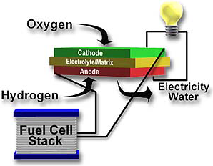

A BLOCK DIAGRAM OF THE UNIT FUEL CELL
Many combinations of fuels and oxidants are possible. A hydrogen fuel cell uses hydrogen as its fuel and Oxygen (usually from air) as its oxidant. Other fuels include Hydrocarbons and Alcohols other oxidants include chlorine and chlorine dioxide. Hydrogen fuel cells are the once which are mostly topic of discussion and the once which have been chosen for the improvisation as the oxidant used in it is usually air and is readily available. Though there are few constraints regarding the production of the hydrogen.

WORKING OF THE HYDROGEN FUEL CELLS
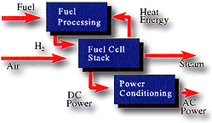
- Hydrogen flows into the fuel cell and through the porous anode.
- The anode’s catalyst separates the hydrogen atoms into protons and electrons.
- The electrons flow to the electrical circuit, generating electrical power.
- The protons flow through the electrolyte to the cathode.
- Oxygen flows into the fuel cell to the cathode and the cathode catalyst combines protons, electrons, and oxygen’s to form water (as its only emission).
- Along the process the flow of electrons is achieved/generation of electricity.
Case Example of a ship whose main propulsion has been powered by similar technology:
FutureShip, a subsidiary of Germanischer Lloyd, has developed a concept for Scandlines (below) that uses fuel cells as the primary source of propulsion: 8.3 MW fuel cells draw fuel from 140 m3 hydrogen tanks, sufficient for a passage of 48 hours at 17 knots.

ADVANTAGES OF THE FUEL CELL IN MARINE:
 | FUEL | EFFECIENCY
CURRENT STATUS
Steam turbine with reheat steam (1450 psig, 150 F) | Residual | 32-36
Low-speed diesel | Residual | 39-41
FUTURE CONVENTIONAL
Steam turbine with heat pressure, high heat temperature reheat (2,400 psig, 1,050 F ) | Residual | 35-39
Adiabatic diesel | Diesel | 49
Naval Academy heat balance engine | Diesel | 43
Heavy-duty gas turbine, Combines cycle | Residual | 36-40
Closed-cycle combustion turbine | Residual | 40-41
FUEL CELLS
Phosphoric acid | Naphtha | 41
Molten carbonate | Distillate | 50
Alkaline | Hydrogen | 60

Comparison of different Marine Power plants

IMPROVED EFFICIENCY
The direct electrochemical conversion of fuel energy to electricity in fuel cells provides fewer sources of loss than in combustion engines. At optimal load, the best fuel cell stacks have an electric efficiency of 50-55 %, giving a fuel to electric efficiency of 45-50 % when internal consumption is included.
These values are slightly higher than the typical values of fuel to electric efficiency for state-of-the-art marine diesel generators, which are just above 40 %. New gas engines claim to achieve efficiencies greater than 45 %.
For part load operation, where combustion engines have lower efficiencies and emissions of local pollutants are higher, fuel cell power packs generally maintain or even increase their efficiency.
Losses in the electrochemical conversion process generate heat that is recoverable. Depending on the type of fuel cell technology, the amount and quality of exhaust from fuel cell stacks are high compared with combustion engines. Thermal integration with steam turbines or some form of a Rankin cycle (i.e., converting heat into work) can thus increase the electric efficiency significantly.

REDUCED EMISSIONS TO AIR
CO₂ emissions lead to global warming. By using fuels such as liquid natural gas (LNG) or methanol that have less carbon content than conventional ship fuels, these emissions can be reduced.

CO and CH₄ emissions can occur from some fuel cells depending on the choice of fuel, but are significantly lower than for combustion engines running on LNG. However, when hydrogen is used as fuel, no carbon compounds are emitted.

PM, NO_{X}, and SO_{X} emissions from ships can result in severe consequences to human health and the environment (e.g. Corbett et al. 2007; Eide et al. 2012). In the long-term, the potential uptake of fuel cells on board could contribute to reducing these consequences.

NO_{X} is formed by combustion at high temperatures, a process that does not occur in fuel cells, and thus NO_{X} emissions from fuel cells are negligible.

As sulphur must be removed from the fuel before it is supplied to the fuel cell, SO_{x} emissions are eliminated. PM is not emitted from fuel cells, as the fuel cannot contain heavy hydrocarbons.

OTHER ADVANTAGES

Use of a fuel cell power plant instead of a combustion engine will reduce noise and vibrations due to less moving parts improving comfort for crew and passengers.

Fewer moving parts also lead to a reduction in maintenance requirements during operation compared with combustion engines as this have less moving parts and less alignment and dynamic balance of the machineries to be maintained.

Reduced plant size and flexibility in laying it out: when limited space is required for fuel and gas processing, can easily be installed in independent modules. This makes the total installation less vulnerable to single failures and, in principle, the modules could be placed in several different locations around the ship.

Together with lower vibrations and noise, modularity makes the engine room location less critical.

CHALLENGES IN ADOPTING THIS TECHNOLOGY

Despite potential benefits, the marine market is not in itself large enough to drive fuel cell technology developments. Hence, it cannot be expected that fuel cells will penetrate marine markets before they become firmly established in the commercial utility sector, and shipbuilders will need to use and adapt products developed first either for the power industry or for DOD. In addition, cost advantages to onsite shore users due to large-scale production may not accrue to the marine industry.

- High cost of platinum and other catalysts that are used in the manufacture of the F.C systems which results in very high first costs of plant installation making it very difficult to compete with conventional systems.
- startup time, especially in some of the systems like PAFCs;
- High reformer cost, especially in small systems where fuel compound supplied at the time of processing reforms itself into the hydrogen;
- carbon monoxide intolerance of electrodes;
- high cost of membranes ( especially for in the case of solid polymer electrolyte fuel cells);
- low efficiency of the oxygen electrode;
- deterioration of the cost/performance ratio in small systems; and
- Need to replace cells periodically.
- Most importantly due to the major concerns of economical production and distribution and safe storage of hydrogen.

PROTON EXCHANGE MEMBRANE FUEL CELL (PEMFC)
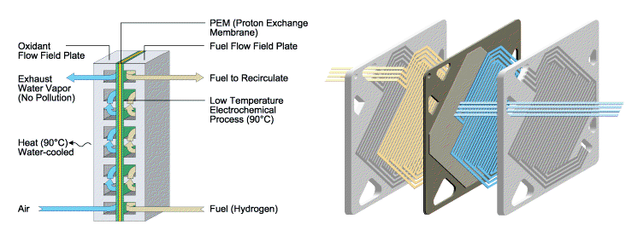
- Fuelled by hydrogen is the most widespread and developed fuel cell technology.
- Operates on hydrogen, and this needs to be of high quality as impurities will damage the membranes.
- A modified version of PEMFC is High temperature PEM (HTPEM) with a novel membrane that can withstand temperatures up to 200°C, which enable a simpler balance of plant, because the needs for cooling, water management, and purification are reduced compared with PEMFC.
- Have excellent dynamic capabilities, and electric efficiencies of around 40 % have been demonstrated.
- Produced in smaller units, up to 100 kW, and are thus suited for distributed power supply.
- Typical applications are cars, stationary power generation, small scale power sources, and combined heat and power systems.
- HTPEM fuel cell units consist of independent modules, typically 5-15 kW, with small built-in reformer units.
- The modules can easily be assembled into larger power packs, and up to 1 MW has been suggested.
- These technologies are significantly more compact than the high temperature technologies.

SOME OF THE METHODS TO IMPROVISE FUEL CELL
TECHNOLOGY:

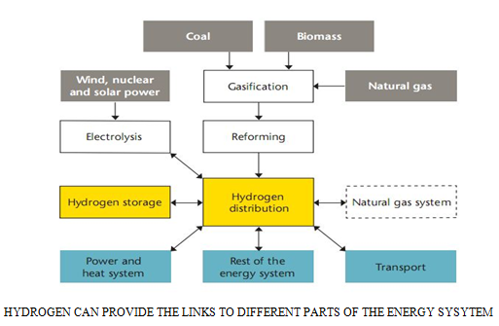

  - To ensure the Hydrogen fuel produced is actually produced based on renewable energy sources such as WINDFARM DRIVE TECHNOLOGY, SOLAR CONCENTRATORS PV CELL TECHNOLOGY, OCEAN THERMAL ENERGY CONVERSION TECHNOLOGY or SAFE & CONTROLLED nuclear power plant technology etc. can be used based on the port and its nearby areas geographical location, and develop the required bunkering infrastructures: Hydrogen Station and Hydrogen mega reservoirs to facilitate re-fueling of the ships which run on the Hydrogen fuel cell technology. Hydrogen fuel cells are one such technology that helps us to do it and increase the flexibility and robustness of the whole energy system by providing the way to store energy (w.r.t energy buffer principle) for longer period of time.

Hydrogen Bunkering Layout At Sea
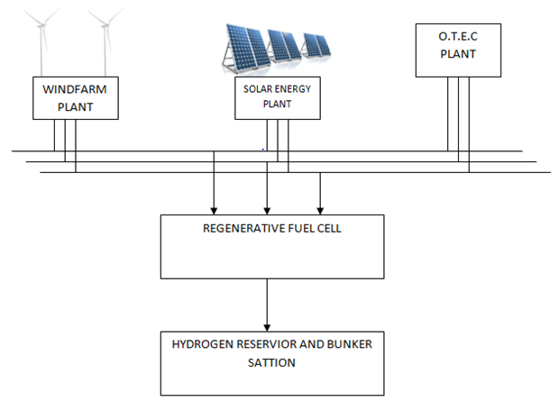

It could also pave the way for the larger scale use of intermittent sources of renewable energy, such as solar, wind and wave power and help us in building the required hydrogen bunkering system for the same as shown below:

  - The transport and distribution of Hydrogen issue that doesn’t always get the attention it deserves. The use of large amounts of Hydrogen worldwide will require a comprehensive and very costly infrastructure. This can be developed in a long time perspective. To keep costs at a reasonable level, this infrastructure will have to be used at close to full capacity, making the smooth transition to hydrogen an important challenge for society and Industry. Some of the advanced countries like Germany, Denmark, Japan and other European countries have already have such technology of producing the hydrogen by electrolysis renewably from the state of art “WINDFARM DRIVE TECHNOLOGY” And other countries like china have projected plans to come with such technology.

  - Similar in the case of the hydrogen fuel once the initial implementations are made the substantially & comparatively the costs would come down as the fossil prices reach the peak value with increase in the demand.

  - Based on the Energy Buffering Principle the several stacks of fuel cells can be put into reverse mode and used to generate the hydrogen by building a plant in certain regional places where the renewable energy resources are high. And hydrogen thus produced can be used for different end use.
  - Also we can go for the system of the co-generation wherever possible in order to utilize the loss of heat from the power plant of the vehicles. This would help the system to boost up efficiency level of any fuel cell from 45% to 75-70%.
  - We should come with advancements of developing a cheap and feasible conventional transport system that are based on this technology in order to stay competitive with conventional transport fuels and systems. And make the system more user-friendly. As Conventional internal combustion engines cost $25-$35/kW; a fuel cell system would need to cost $30/kW to be competitive
  - And improvise on the safety of the systems which is the basic and an important concern such as in the case of storing and distributing the hydrogen fuel. And come with advancements such as a fuel with cryogenic freezing, or using the materials for the cylinders with nano-pores or coming with any such special materials etc.

BASIC LAYOUT OF HOW THE FUEL CELL TECHNOLOGY WOULD WORK WITH RENEWABLE ELECTROLYSIS:-
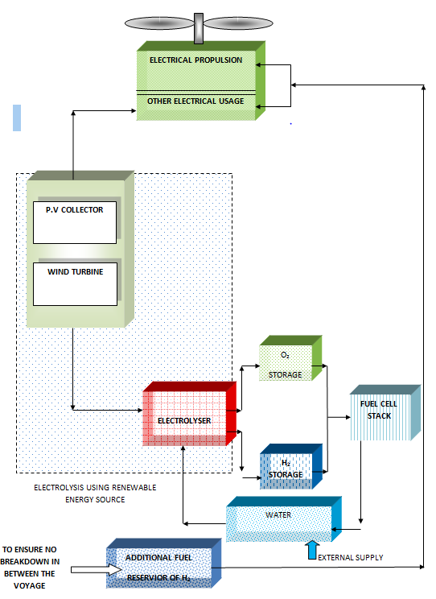
Some Of The Ships That Are Already Running Such Technology With Slight Variation In The Propulsion Plant Are:

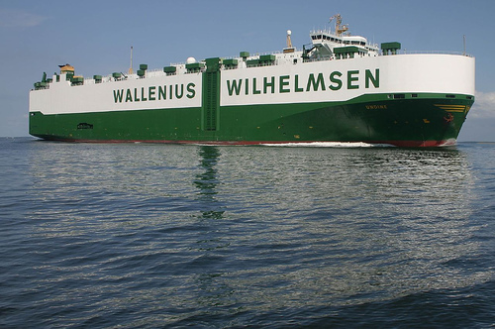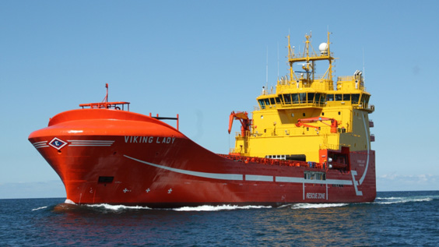

MV UNDINE VIKING LADY

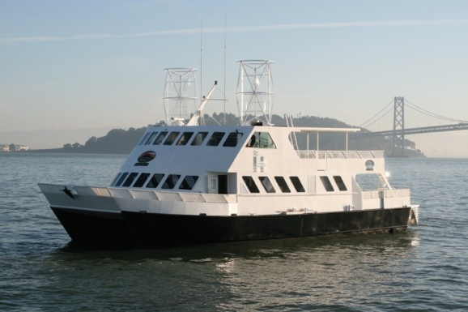

HORNBLOWER HYBRID SCANDLINES
CONCLUSION:
- Promising technology to be in par with stringent emission control norms and decrease dependency on the Heavy oils and other fossil fuels.
- Most viable for niche market use in the near future for larger ocean going vessels too.
- Has potential for widespread marketplace acceptance if we can build an effective and efficient renewable bunkering infrastructures and hydrogen stations. And required bunkering infrastructure has to be built for the shipping Industry like the automobile industry having a “Hydrogen Stations & Hydrogen Highways” concept being developed in few places of Germany, Hawaii, and Iceland e.t.c
- Also this would be widely bought in practice with better manufacturing techniques both to improvise on the quality of the fuel cell to enhance its life and also to reduce the first cost of same.
- It will help us in reducing the maintenance factors in the conventional systems and improve the safety features of the crew and passengers.
- The technology to keep the future secured, with regards to conservation of the environment and decrease dependency on the extinguishing fossil fuels.
- Fuel cell are commercially available today in some markets, as number of small ferries and boats, where their unique benefits bring special value, but for wide spread acceptance and penetration into market of this early products require government incentives to make them affordable to be competitive to the cost to power capacities of the marine propulsion engines.
- Full collaboration between government and private industry, including a substantial public investment support is required for further research and development, demonstration and pilot programs, early commercial purchases, incentives for early adopters, and removal of market barriers to be achieved.

REFERENCE:
  - Wikipedia -www.wikipedia.com

  - WWW.FUELCELL.ORG - Robert Rose

  - Hydrogen and the law- Bill Vincent

  - Non-Conventional Energy Sources by G.D. RAI

  - Automotive research journal Fuel Cells & Vehicular Technology by Dr. John Heywood, professor of mechanical engineering, Massachusetts Institute of Technology and director of the Sloan Automotive Research Laboratory.

