Contributions of Transport Sector towards “Make in India”
ICT (Information & Communication Technology) innovations for Transport sector

1.Samuel Masihi , masihisamuel@gmail.com
2.Amanjot Singh singhamanjot5551@gmail.com
3. Robbie Rathi rathirobbie@gmail.com

Abstract:
Information technology has become an essential part of the rapid and accurate transfer and processing of enormous volumes of data processed in international transport firms and port organizations in the maritime sector. The proper management of systems, which process this information and communicate it to those who manage port operations related to ships is vital for efficient transport. This explains why container-tracking systems are given high priority among operational computer applications in ports. The importance of information technology and its role in improving the operational systems in cargo handling is improving. New innovations in the communication technology for ships have taken shipping to new heights. A huge amount of focus is given to information and communication technology which in turn provides us with automation in navigational equipments. With the efficient use of ICT in maritime sector, we will have better coordination which will lead to greater safety of ships as well as humans onboard ships and improved and better trade options across the globe.
Keywords: container-tracking, port operations, automation, safety

Introduction
Working together and in coordination with each other is important for smooth functioning of any industry. Information exchange system is one way of doing that. Through effective communication between various entities of an industry, there is a flow of knowledge which prevents stagnation from seeping in. It is no surprise that information exchange in maritime industry happens to be just as important. Some experts believe that importance of information exchange somehow becomes even greater due to the global implications of information. In marine industry, this can be done through several ways. Moreover, there have also been information exchange events like GMISS (the Global Maritime Information Sharing Symposium) which aims for efficient exchange of ideas. This is why an efficient information exchange system is the key to smooth functioning of entire marine industry.
Many opportunities have yet to be seized in marine traffic. For instance, information technology can enable considerable savings in fuel and costs and support streamline vessel maintenance and repairs. Remote asset management allows land-based service teams to assess the situation before extra costs are incurred. Technological innovations in navigation, weather forecasts and ice conditions are already in wide use. Furthermore, sharing vessel asset information in a cloud service enables effective fleet management of even very small freight and passenger fleets.
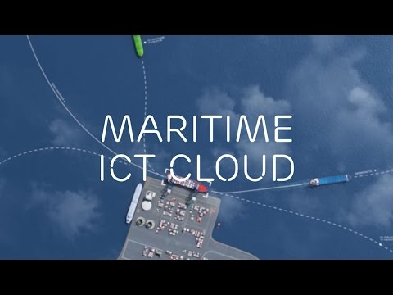

FIGURE 1. Maritime ICT Cloud

Main Work

2.1 Future Challenges :

The challenge is to create solutions for connected and automated maritime transport that address future requirements and have a significant impact across a broad range of stakeholders, ship, port and logistic operators, so as to ensure industry take-up and long-term user driven developments. The EU’s Integrated Maritime Transport Strategy opens new horizons for digital information exchange technologies; for example, the SafeSeaNet system is a core platform to contribute “upgraded EU maritime transport information management” linking other established systems such as e-Freight and e-Customs, the National Single Window, Port Community Systems, transport logistics management systems, and Galileo, as well as e-navigation developments for improved vessel safety and operation from shore-based management. In the maritime transport sector, vast amounts of data are available that could support new business opportunities to improve the logistics and ship operation. Value added services for better freight transport management could be developed for intermodal transport and data on vessel traffic and for e-navigation could improve safety, environmental performance and competitiveness. There are numerous potential advantages in better exploiting available data and the use of information and communication technologies in transport and logistics, such as improved traffic management in ports and at sea, and reduced administrative cost of regulatory compliance. The importance of smooth information flows is reflected in the development of tools to simplify access to maritime traffic and transport data. These tools are at different stages of development and implementation for waterborne transport, including inland waterways, as well as multimodal transport.

2.2 Key ICT Innovations :

There are a number of key ICT innovations that will address future maritime requirements and affect almost all aspects of connected and automated maritime transport processes: Robotics and autonomy, autonomous vehicles, simulation and optimisation, open system integration, the Internet of Things and Big Data Analytics, Cyber-physical systems, Internet of Services, Cloud computing, Augmented and virtual reality simulation, and cybersecurity. The next generation of connectivity between ship and shore will be dominated by a variety of new communication technologies, including most importantly, satellite communications. These technologies will help to reduce costs by enhancing operational efficiency, automating processes, improving safety and security, and reducing negative environmental impact. The improved maritime connectivity will have a significant effect on how the maritime industry manages information. Most ship systems, shore based support centres, ports, and integrated transport systems will be linked to the Internet. This will enable data streams from multiple sources to be combined for real-time decision making, leading to more efficient operations, as 6 well as more automated ships and guided vehicles. This will also have a positive impact on the safety of life at sea, and bring many benefits, such as reducing fuel consumption, remote condition monitoring, and more efficiently organised supply chains.

The emerging enabling ICT technologies for waterborne transport and logistics are similar to those found for multimodal transport1 and some of the emerging ICT technologies have already been used in recent EU waterborne transport and logistics related projects: Cloud computing: With the rapid development of web technologies a new concept has emerged called: “cloud computing”. In the maritime domain, the Cloud connects all maritime stakeholders with maritime information services of all kinds. This offers greater flexibility and enables both large and small companies to use the system. Wireless communication technologies: There is also an increasing use of wireless communication technologies (such as smart mobile phones, QR code, RFID and telematics tracking). As computer power is increasing exponentially and smart devices are getting more affordable and capable, this will allow people to be connected anywhere at any time. Such ubiquitous connectivity and network services enable real-time and extended visibility across the entire waterborne transport and logistics sectors, which is essential to handle increasing complexity.

2.3 Internet of Things (IoT):

Web 3.0 provides the infrastructural framework supported by a new set of languages making use of the Maritime Cloud Technology to allow intelligent, contextual decisions of the sematic Web with the IoT to connect devices to connect an informative stream of data. The IoT can support the intelligent cargo concept for sustainable global logistics operations where goods are self-context and situation aware and connected to a range of services. The IoT is also essential for increased complexity of technical systems onboard, which is a prerequisite for increased automation, remote services and autonomy. 1 Harris, I, Wang, and Y, Wang H. ICT in multimodal transport and technological trends: Unleashing potential for the future, Int. J. Production Economics, 2015.

2.4 Big Data Analytics:

The technological developments mentioned above will allow an increasing volume and detail of information to be captured from a variety of sources. These large data sets (so called “Big Data”) will need to be processed using sophisticated analytics to significantly improve the decision making. Future decision support systems for managing ship and port operations and freight logistics are expected to utilize the developments of all the technological trends identified. Bid Data Analytics will optimize operational efficiency, traffic, and transport management, and improve competitiveness.

2.5 Augmented Reality (AR):

AR technology, where interactions with the real world environment are augmented by virtual images, graphics or other data is a potential application for managing ship’s bridge operations or port resources. Future applications will connect the virtual world with reality to assist in more efficient decision making, such as navigation or improving the awareness of threats from pirates.

2.6 Robotics and Autonomy:

Systems automation, the availability of smart sensors and global networks for data transfer from ship to shore will promote remote controlled and autonomous ship operations. The development of remote-controlled and new types of robots that could be used to replace human-operators on board ships is closely linked to the development of other technologies such as sensors, Big Data analytics, and the IoT. New types of robots, called “SmartBots”, will have the ability to carry out specific tasks autonomously.

2.7 Cyber-Security:

Increased communication between systems on board a vessel, leading to ships becoming a “system of systems”, together with critical infrastructures becoming ever more interconnected, will require resilience to be built into those advanced technology networks, to reduce the risk from cyber-crime etc. Low connectivity and fragmentation within the supply chain have helped to protect shipping from cyber threats, but with a fourfold increase in the adoption of satellite communication on board vessels over 10 years, the issue is becoming much more critical. For example, if automated ports and automated guided vehicles (AGVs) were to become the dominant mode for transporting food supplies, this would pose significant risks, both in terms of supply security and the risk of introducing harmful substances in food.

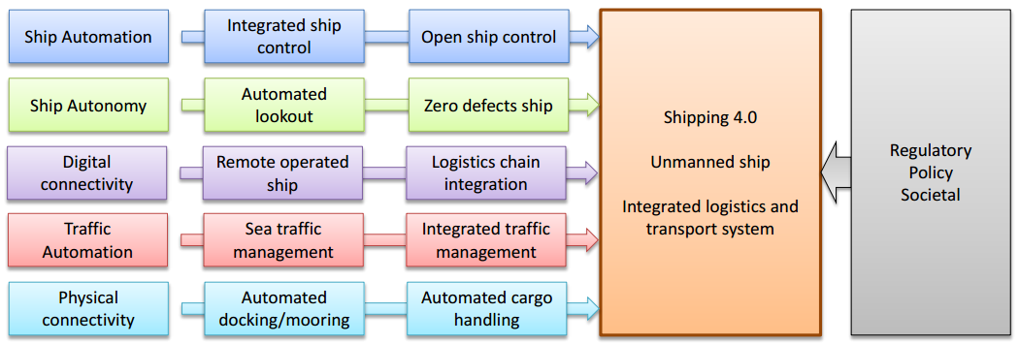

FIGURE 2. E-Maritime Framework

2.8 ICT Maritime Opportunities 2030 - Maritime Connected and Automated Transport :

Improving competitiveness, safety, and security of European shipping is a major objective of the EU Maritime Transport Strategy, which in turn shapes the requirements for upgraded maritime transport information management. Advances in ICT have created a demand for new forms of surveillance and information management systems and these are increasingly driven by policy and governance addressing safety, security, and sustainability. This is reflected in the emergence of the IMO’s e-navigation concept and the more embracing European Commission’s e-Maritime framework, established for measurable economic, social and environmental benefits. The rapid development in information and communication technologies will significantly increase digitalization in all waterborne sectors and lead to data-driven services such as optimizing energy use and fuel efficiency, vessel performance, condition monitoring, and weather routing. A higher degree of systems automation, the availability of smart sensors and global networks for data transfer between ship and shore will promote remote controlled, and semi or fully autonomous operation of assets. Interconnectivity between sea-based operations and shore-based operation centres will enable increasing support and control from the shore. This will require secure systems and operations against cyber-attacks. The requirements for maritime connected and automated transport, (which includes e-Maritime and e-navigation), to address future impacts and challenges are based on forecasted trends and trend interdependencies. These requirements took into account market intelligence, predicted societal trends and the future regulatory framework, for all waterborne sectors. The principal outcomes from these trends represent the likely demands on the maritime industry through to 2030.

The selected priority areas to address future maritime requirements for connected and automated maritime transport are as follows:

Improved port and logistics infrastructure and operations

Improved littoral management and development

Improved crew working conditions and health and safety requirements on board

Improved ship security systems/Improved protection against hacking

Greater shore based monitoring and surveillance

Continuing drive for greater energy efficiency/Better design codes and modelling

Flexible and adaptive ship operations/ Improved ship handling and survivability/ Improved vessel routing Greater ship autonomy/More autonomous ship operation

Greater integration of the logistics chain/Displacement of paper systems

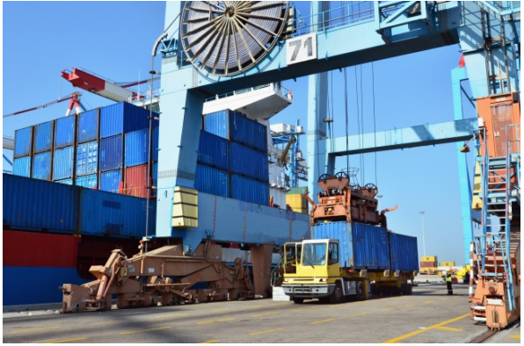

Figure 3. Port logistics

2.9 Technological developments to address maritime requirements :

The anticipated technological developments to address future maritime requirements in the selected priority areas are presented below:

Improved port and logistics infrastructure and operations

Over the next decade the ports and logistics sector will witness automation becoming more widespread and operations being increasingly directed and optimized in real-time by sensors and intelligent software, including the use of IoT, Big Data Analytics and robotics. Simulation software will be used for planning new terminals or assessing existing ones, as well as for training staff. Virtual and augmented reality will also be used for this purpose. Up to now, container ports have been slow to fully utilise the IoT, but there are many commercial opportunities present in using the IoT, with smart and connected ports moving to a more integrated solution via improved wireless infrastructure. The IoT is an important driver for the Big Data concept, making it possible to create a rich perspective on how a business actually performs.

Littoral management and development

Now that a marine and maritime policy framework has come into being at European level9 , there is an opportunity for European Territorial Co-operation (ETC) maritime cross-border programmes to investigate, as part of their situation analysis, how they can link to this framework, and so cooperate more closely. The principal policy areas with the potential for such cooperation are Integrated Maritime Policy; Marine Strategy Framework Directive; Common Fisheries Policy; Integrated Coastal Zone Management; Maritime Transport; Ports; e-Maritime; Maritime Safety; Water Framework Directive.

Improved crew working conditions and health and safety requirements on board

There is a need for an investigation of minimum manning levels for different types of ships trading on different trade routes and carrying different cargo types, to determine whether and how these need to be reviewed, and better understood for their implications to safety and efficiency. While the human role will evolve, a ship may remain fully controlled from on board, but changes will be necessary to the skillsets of crew members as systems are increasingly ruled by software and shore-based support being increased. The benefits of improved connectivity and Internet access need to be made more widely available to all seafarers.

Improved ship security systems/Improved protection against hacking

Further developments in the range and performance of Global Monitoring for Environment and Security (GMES) services will bring greater situational awareness, with faster data collection and dissemination contributing to more effective early warning systems. Increased communication between systems on board a vessel, leading to ships becoming a “system of systems”, together with critical infrastructures becoming ever more interconnected, will require resilience to be built into those advanced tech networks, to reduce the risk from cyber-crime, terrorism, etc. Low connectivity and fragmentation within the supply chain have helped to protect shipping from cyber threats, but with a fourfold increase in the adoption of satellite communication on board vessels over 10 years, the issue is becoming more important.

Greater shore based monitoring and surveillance

Remote operation of ships may be introduced for safety reasons in busy shipping lanes, to pass control of a vessel to a shore-based pilot with local knowledge, or in niche areas for other reasons. 9 Commission Green Paper: Towards a future Maritime Policy for the Union: a European vision for the oceans and seas [COM (2006) 275 final 12

Continuing drive for greater energy efficiency/Better design codes and modeling

With improvements in the speed, scale and volume of operational data that can be collected from on-board vessels, and the increasingly real-time sharing of this information between ship and shore using marine broadband services, more economical and less environmentally-harmful ship operations will become possible. The entry into force of the Monitoring, Reporting and Verification (MRV) regulation from 1 January 2018, requiring ship-owners and operators to annually monitor, report and verify fuel consumption for vessels 5,000gt or over which call at any EU port, is providing a strong motivation for technologies to facilitate compliance with these requirements. Greater possibilities for, and willingness to, share ship data with third-party technology firms will lead to improvements in ship energy efficiency. Data analytics and vessel management software will give operators better reliability and control over maintenance costs at sea and in dock, even as more sophisticated systems reduce the environmental strain caused by the sector. In the future, it will allow extended periods between dry-docking, with vessel milestones based on vessel condition, rather than according to a fixed schedule. Big data/data analytics will also permit optimized deployment of vessels on trades, seasons and regions etc., based on individual vessel performance. Real-time data collection in ports will also lead to greater efficiency and less environmentally harmful operations, as improvements are needed for the development of both smart and green port concepts.

Flexible and adaptive ship operations/ Improved ship handling and survivability/ Improved vessel routing

There will be a greater connection between maritime navigation systems in operation and their designers, offering benefits in safety, efficiency and continuous improvement of system usability.

Greater ship autonomy/More autonomous ship operation

Drone cargo ships, known colloquially as ‘ghost’ ships, are unlikely to start operations within the coming decade and an intermediate step of partially automated ships, or Smart ships, with much reduced crew levels should be expected beforehand. Smaller and more specialised craft may be deployed on a shorter time scale, e.g. for inland waterways. Courtesy of Rolls-Royce

Greater integration of the logistics chain/Displacement of paper systems

Although efforts to create and transfer title documents electronically, such as the bills of lading, they have so far met with limited success; the electronic exchange of information on cargo, crew and passengers is now advancing. Over the next five years, more on-board activities will be systemized to reduce duplication and provide single points of data entry, enabling greater on- 13 board and onshore analysis services in a real-time environment. Developments aimed at reducing the amount of paperwork officers and their crew have to undertake while at sea will accelerate, with the ultimate ambition to realize “the paperless ship”. At present, much shipping and logistics data that is generated is not being exploited beyond its narrow purpose. This situation could be addressed by harnessing the power of big data and developing real-time big data handling capabilities. In order to integrate EU maritime transport with competitive intra-European door-to-door transport services, it is imperative that an integrated ICT infrastructure is used for all modes of transport. This will require a single reference model and framework to addresses different facets of transport and logistics, such as collaboration, digitization, and security etc. However, the important issue is semantic interoperability, rather than using the same systems or standards for all transport modes. In this context it would be inappropriate for the maritime community to define its own standards in areas that relate to other transport modes as long as existing standards satisfy all the important maritime requirements.

2.10 Research Priorities for implementing ICT Maritime opportunities to 2030:
Four research priority topics for future research, development and innovation, that are needed to address the impacts and challenges for Maritime Connected and Automated Transport, and for implementing the main ICT opportunities, are indicated below:
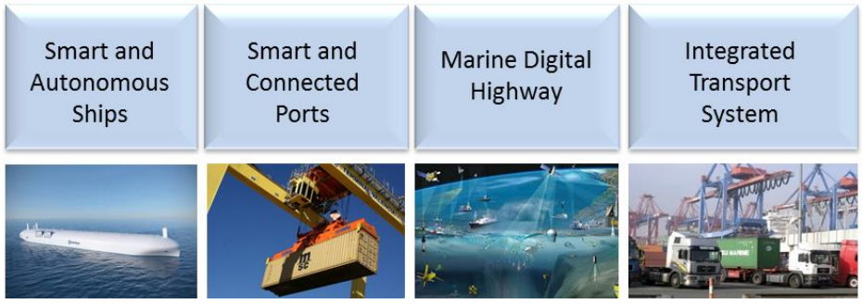

FIGURE 3. Future Development

The maritime requirements for Maritime Connected and Automated Transport needed to address the opportunities and activities identified are:
- Smart and Autonomous ships: Vessels with reduced manning levels, real-time monitoring of ship performance with automated information management and surveillance. Improved integration with shore support centres for technical operation and remote maintenance. As data networks, data management, and sensors become more vital for ship operation, these systems will need to be carefully protected from cyber security risks.
- Smart and Connected Ports: Smart ports with Digital infrastructure and ICT innovation: Robotics and automation, autonomous vehicles; the IoT and Big Data Analytics, simulation and virtual reality, and cyber security. Integration of national single windows with trade portals and port community systems: providing one entry point for all logistics, operational and administrative information.
- European Marine Digital Highway: Integration of navigation technologies with shore based data networks and centres (SafeSeaNet, (AIS, LRIT), GNSS, National Single Window, VTS, route planning etc.) with the corresponding navigational and communication facilities aboard ships to provide an 14 accurate, safe and secure “e-Navigation-based” ship traffic and transport management system for a marine digital highway.

Conclusions

The final, and probably most powerful, attribute that ICT provides to persons and organizations is intelligence (Kenney and Curry, 2001). This refers to the capability to collect, process, distribute, steer and monitor value chain processes in distributed places. In manufacturing and services, this leads to various types of reorganization of value chains for efficiency reasons, i.e. related with time, cost-effectiveness or product quality. As in the case of extensibility, sustainability of transport is not one of the goals. In some cases the outcome may be transport that is more sustainable, but in other cases it may be less sustainable transport. Sustainability of the transport sector is a major concern today for different levels of government throughout the developed economies of the world.

Acknowledgments
We have taken efforts in this project. However, it would not have been possible without the kind support and help of many individuals and the Institute. We would like to express our special gratitude to Mr. Ajoy Chatterjee, Principal and Head, GEIMS and vice principal Capt. Ravi Shankar. We would like to extend our sincere thanks to TOLANI Maritime Institute for giving us this platform to express our ideas regarding the project. We are highly indebted to Mrs. Meena Ravi Shankar, Soft Skills faculty for her guidance and constant supervision as well as for providing necessary information regarding the project & also for her support in completing the project. We would like to express my gratitude towards our parents & entire faculty of GEIMS for their kind co-operation and encouragement which helped us in completion of this project.

References
- Marine insight
- Maritime Europe Strategy Action
- The role of ICT in the logistics integration process of shipping lines
- Pietro Evangelista

List of figures
Figure number | Title
1 | Maritime ICT Cloud
2 | E-Maritime Framework
3 | Port logistics
4 | Future development

