Role of I.T. & Communication In Enhancing Education

Abstract

This paper briefly discusses the relationship between scientific education and economic development. The advances in Information and Communication Technology (ICT) have had a major positive impact on various sectors including education around the world during the last two decades, therefore, the applications of ICT tools and best ICT practices in basic and higher educational institutions in the developed world are discussed and their incorporation in the educational institutions is investigated. In addition, recommendations are made on how to improve the education onboard ship by integrating ICT within such a system.

Introduction

The development in science and technology has revolutionized the world during the last five decades and most people around the world have benefited from such development, as their quality of life has been significantly improved.
The innovation in science and technology has drastically improved the sectors of agriculture, mining, transportation, industry, commerce, telecommunications, IT, etc but a major role in marine sector. The advances in these and others sectors have had a direct impact on the quality of life of people around the world.

The objective of this paper is to explore possible ways to accelerate the applications of the best science, engineering and technology practices which will increase the chances for further development in I.T. & Communications onboard ships and will improve the quality of life of seafarers.
A major factor that can contribute to achieving such an objective is the improvement of the quality of education in subjects related to science, engineering and technology, since this will result in a more qualified and experienced workforce capable of drastically enhancing the ships and its economy development with life saving options of seafarers.

Information Technology
Information technology has become an essential part of the rapid and accurate transfer and processing of enormous volumes of data processed in international transport firms and port organizations. The proper management of systems, which process this information and Communicate it to those who manage port operations, are vital for efficient transport. This explains why container-tracking systems are given high priority among operational computer applications in ports. Investigates the importance of information technology and its role in improving the operational systems in cargo handling. A computer simulation model is developed to compare two different operational systems ± a container terminal equipped with electronic devices versus a terminal without such devices. The importance of information technology in supply-chain management is also discussed.

The importance of information technology in supply-chain
Management:

Supply-chain management can be defined as: all processes concerned with the enhancement of movement and handling of goods from point of production (supply) to point of consumption (demand).

Supply-chain management is a process responsible for development and management of the total supply system of a firm, both the internal and the external components. During the past two decades, the maritime industry has witnessed the evolution of one of the most important trends in the history of port community ± the increasingly sophisticated use of computers.
Although these devices and electronic commerce have found applications in port/transport industry, the business sector is a major beneficiary.
Electronic commerce (EC) may be defined as the use of technology to facilitate the exchange of information in commercial transactions among enterprises and individuals, enhancing growth and profitability across the supply chain (Heffernan, 1998). Based on the estimates produced by the US Government, the global free market of information technology and telecommunications via Internet is doubling every 100 days by individuals and businesses. As a transaction payment method and delivery medium, the cost-effectiveness of the Internet and EC is now disputable. In
Australia, approximately 1.5 million organizations and individuals have access to the Internet; of those, approximately 250,000 are business related. The worldwide volume of EC conducted over the Internet and its derivatives is expected to reach US$300 billion a year by the early part of the next decade. It is in the business-to-business application of EC that the Internet is beginning to transform the global supply chains of international trade. In international transportation and logistics services, the already vigorous growth in the volume of global trade is likely to be further accelerated as EC facilitates new connections of buyers and suppliers. In the Australian maritime industry, terminal operators and port/transport industry intend to develop a longer-term approach to EC to improve the efficiency of operations, aiming to enhance the
competence of their existing operational system (Cox, 1999).
Given the complexity of the supply chain, with multiple participants, there is ample opportunity to increase efficiency and reduce costs by EC, which enables integration of the increasingly tighter links in the supply chain. The efficient usage of EC in shipping and cargo distribution could provide:
- transportation management, including optimizing the choice of carriers
based on service requirements and freight rates;
- logistics management, including the tracking of containers from the port
of origin to the port of unloading in Australia, on the rail track and between origin and the final destination and flexible routing, storage and distribution as necessary;
- trade and transportation documentation, including the electronic development and transfer of shipping documents, customs clearance and other regulatory requirements;
- international trade finance; and
- Insurance.
Although this paper, as a small part of a larger study, does not cover application of the Internet in port operations, the authors acknowledge that as an inevitable future trend of this business which will further simplify the suggestions made in their current studies.

Objective of Communication in 21st Century
In the new global economy which is “powered by technology, fueled by information and driven by knowledge”, the purpose of education has taken an even more important meaning.
The current study draws, however, on a maritime-related context of communication—that of oral communication while the maritime students are still in their training and education. A study of such kind is deemed important in order to gain more understanding of English within ESP and to address future needs of these maritime students especially in relation to their oral proficiency.

IT - Reshaping Education system
- Helping Teachers in being effective in what they do
- Improving the quality and relevance of classroom instruction
- Making quantifiable and measurable progress towards improving efficiency
- IT Ways of Classroom
- Transformation of Learning Environment
How Things are Different?
- Access to variety of learning resources
- Immediacy to information (e-learning , web based learning etc.
- Any time – Collaborative - Distance learning (video-conferencing, tele-conferencing etc.)
- Multimedia approach to education
- Authentic and up to date information
- Online library
- Better accesses to children with disabilities
- Real Life Simulation
- Virtual Classrooms

Simulations (Simulators)
- Helps in putting knowledge into practice and learn.
- Gaming environment help towards innovative and collaborative approach to counter real world competition.

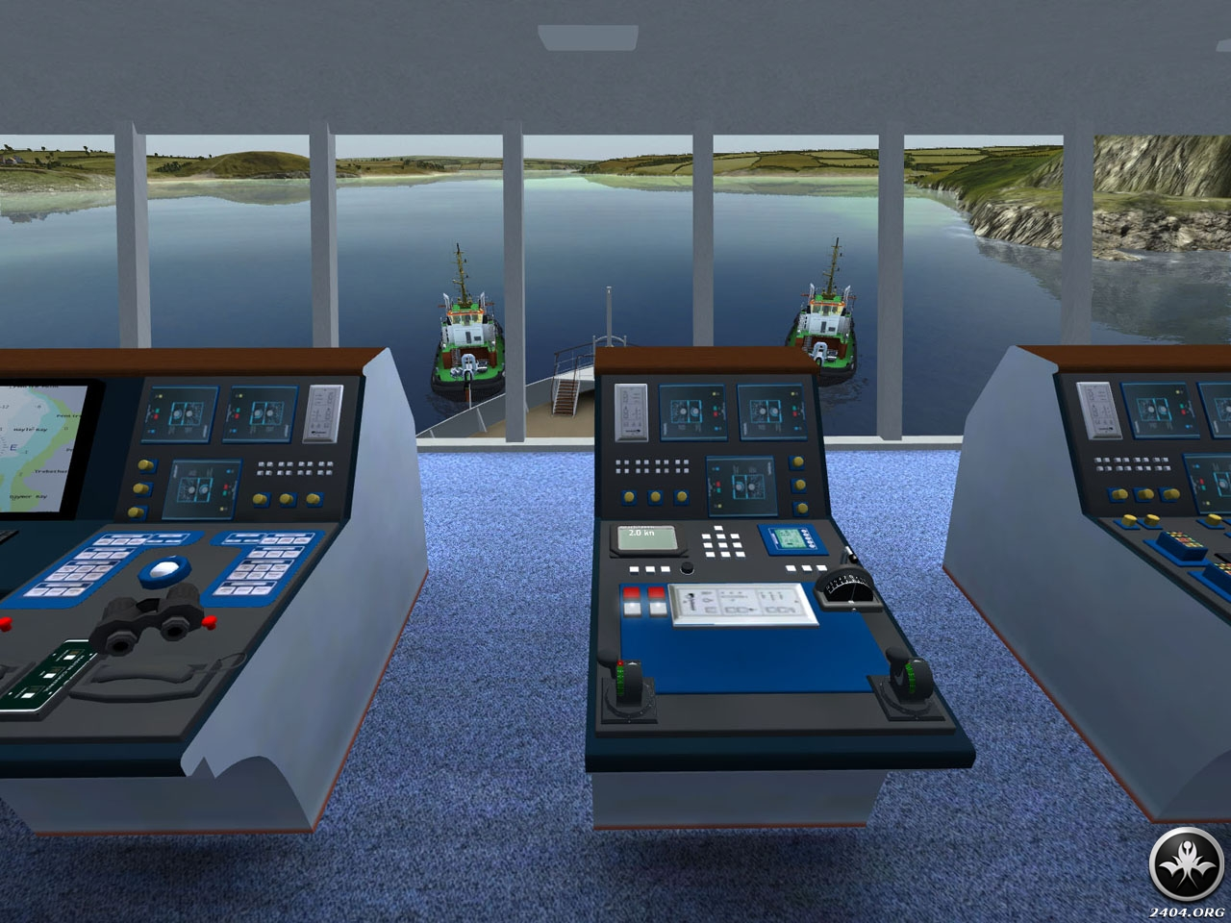

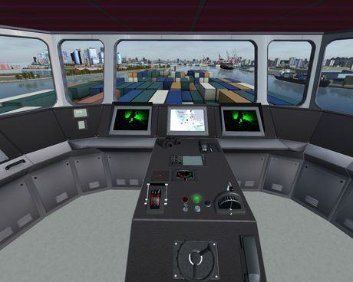

Voice recognition technology
Voice recognition technology (VRT) provides communications between the crane operator and the ground personnel. This system could be used standalone or it can be integrated with other technologies in communications between the crane operator and on quay personnel during loading and unloading of a vessel. Voice systems use pattern recognition similar to that in barcode systems. Instead of an image, the computer recognizes words in a pre-programmed vocabulary. When it is activated, crane operators speak into a microphone; the machine recognizes words or phrases and then converts them into electronic impulses for the micro- or host computer. The high-performance units operate at an accuracy rate of 99.5 per cent. One of the advantages of the system is message recording. This would assist the terminal operator in providing the final report on the position of containers loaded on to the ship. When properly
integrated, the system can assist in the automatic capture and processing of marine terminal data.
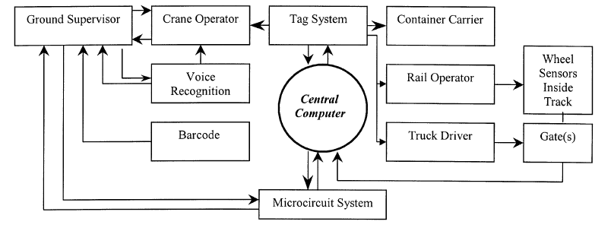
Figure 1 loosely illustrates the links between the above devices and port components where the central computer integrates the entire system. In the following section, we will simulate the effect of utilising some of these devices by comparing two port operational systems, a traditional system versus alternative case where devices are employed.

Electronic devices in container terminals
Providing reliable service to the interacting elements of the transportation chain is a major objective of any container terminal. Within a port community, the effective flow of information is considered to be an important variable. For example, in an eight-berth terminal where eight ships are berthed for loading/ unloading some 6,000 containers simultaneously, a highly sophisticated information technology is required to provide reliable and timely information
for hundreds of people within the port/transport community. Among them are freight forwarders, transport companies, rail operators, crane operators and container carriers in terminals. To carry out an effective data management, appropriate electronic devices must be used. However, despite the fact that several devices are available in the market, they are not employed in every container terminal. Whilst they can operate as individual devices in ports and outside terminals (e.g. rail track), they should be integrated to the port and transport network communications via a computer system. Only a few international ports have taken maximum advantages of the existing devices to improve their operational efficiency, minimise terminal congestion and establish a fully integrated system (World Cargo News, 1997).
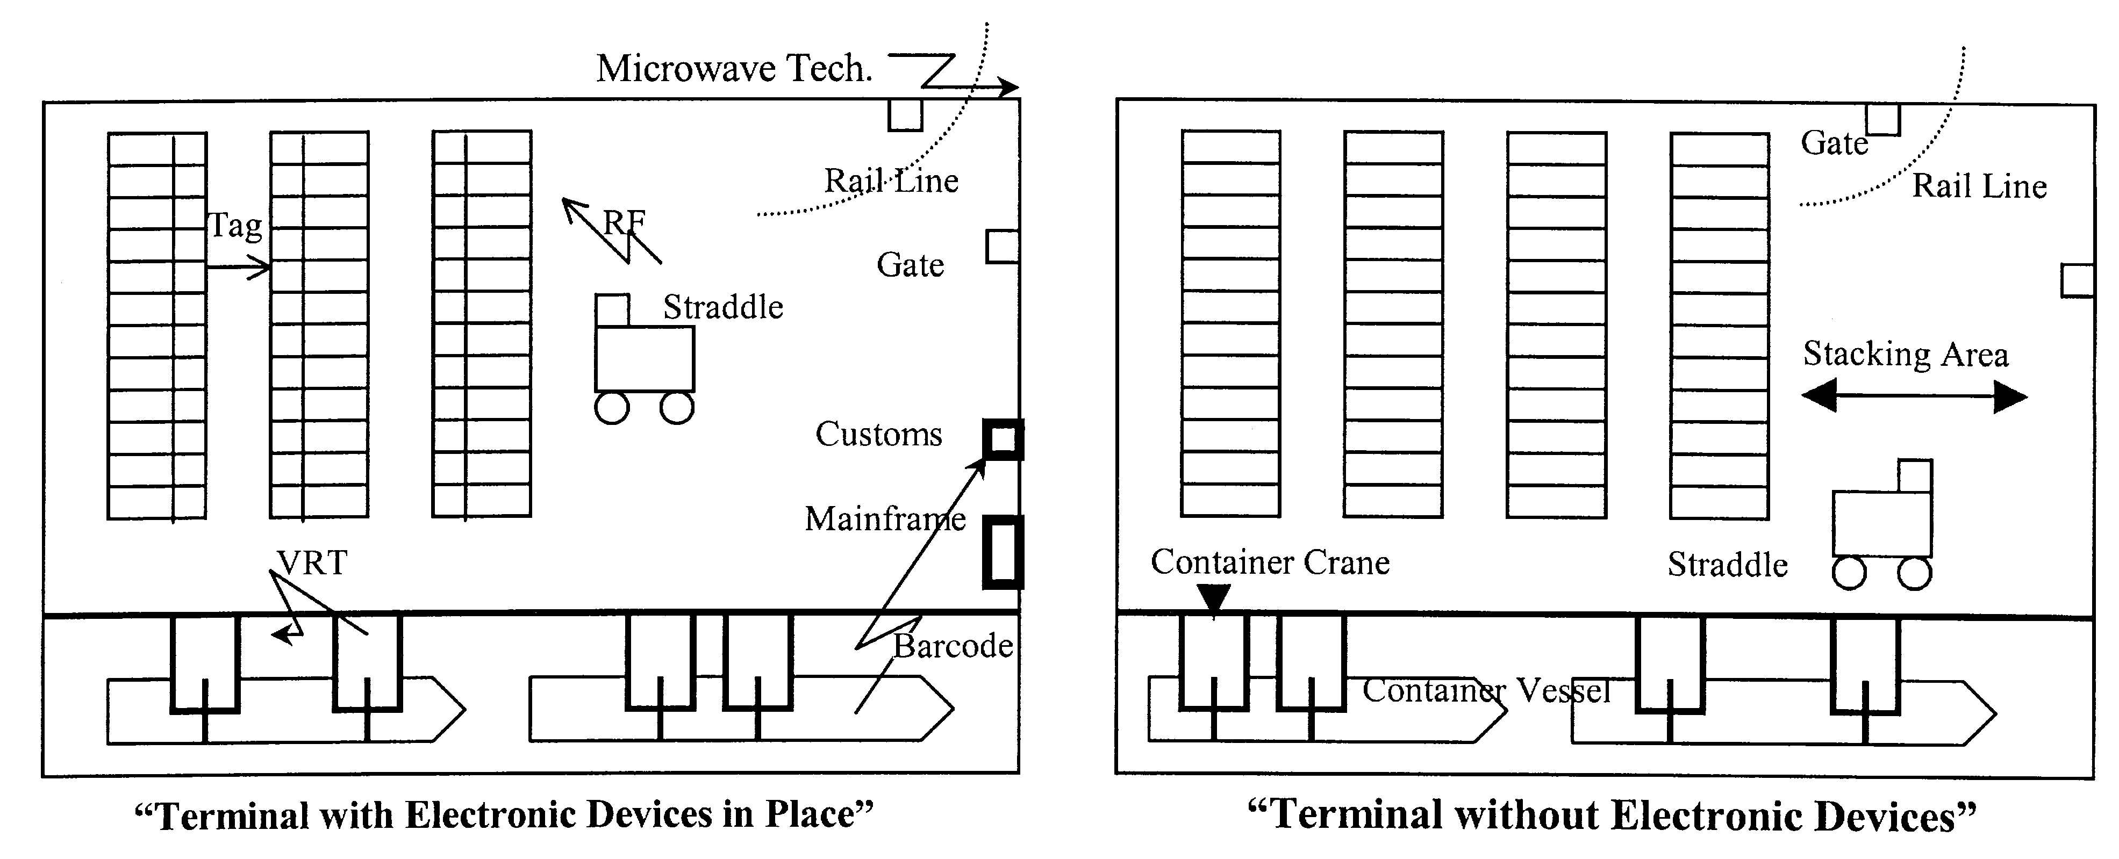

Radio frequency microcircuit system (RF)
The system was developed to identify the containers when traffic at terminals reaches the peak. It is not easy to check and control the traffic at a terminal where thousands of containers are stacked and hundreds of containers are on the move. Container carriers deliver the stacked imported containers to the quay area and the newly unloaded containers occupy their slots. The system is ideally suited for operation in a harsh and outdoor environment. Nonconductive materials such as grime, snow and rain that intrude between the interrogator and transponder do not appear to affect operation of the system. The system consists of the reader or antenna (that is buried in the pavement of the terminal to keep it free from vandalism, accident and weather) transponders (tags), an interrogator and computer interface tag. RF system offers high-speed and remote electronic identification of equipment. The heart of the system is the tag, powered either by a battery or by an RF beam from the antenna. Each tag can have a unique code that is related to the object to which the transponder is attached. The electronic components of the transponders are enclosed in rugged packages that may be as small as a credit card. One application for RF systems is in monitoring the movement of containers and their status in the terminal. This is the area that assists the terminal operator to produce prompt reports for importers/exporters and other relevant agencies. The system can also track containers entering and leaving the terminal through the gate or as they pass the scanning points in the yard.

MarTEL
MarTEL is a standardized test of maritime English language proficiency, through an interactive online learning platform. It was created under the European Union's Leonardo da Vinci (European Union programme) funding stream, in combination with the Lifelong Learning Programme, and was established in 2007.
MarTEL has three grades, with the key aim to develop a series of Maritime English language standards incorporating the International Maritime Organization's (IMO) Standard Marine Communication Phrases (SMCP) at different standards:
Shipping is an integral part of the world economy, and yet safety at sea is still not viewed as a priority. 80% of accidents at sea are in some way caused by human error and just under half of those are caused by poor levels of maritime English language.^{[1]}
The language of the sea is English and many ships, and to a lesser extent, ports, are manned by multinational crews. Hence, good communication in Maritime English is essential for creation and maintenance of effective working environments and safety of the crew, and generally safety at sea and at ports.^{[2]}
The MarTEL Project compliments the Loginovsky Report which stated that the significance of English as the working language of the international shipping industry and the overall performance and safety of the international fleet depends on the skill to apply it correctly. The Report continued that the ability of a non-native speaker to have a good command of Maritime English is very much influenced by the ability to think in it, in the frame work of the maritime profession. He concludes that to make the teaching and learning processes more effective, it is required to increase the thought activity of a seafarer using English.

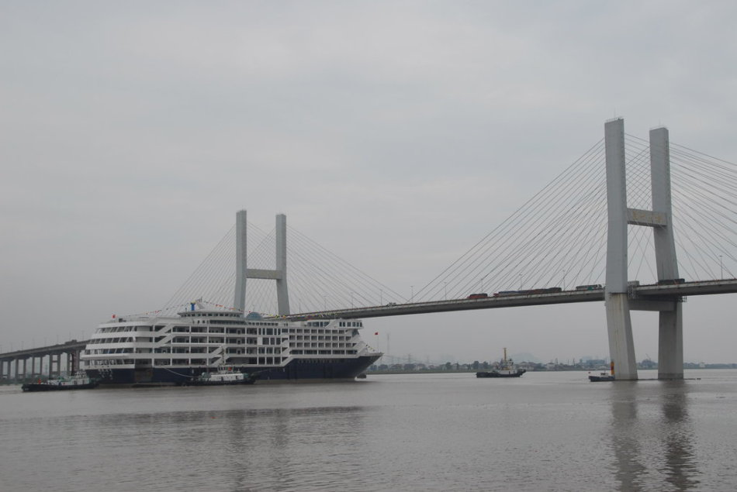
Skills needed for Workplace in Future

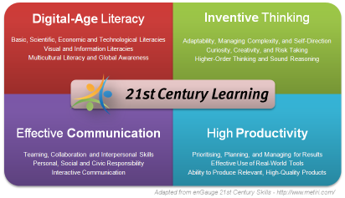

Digital Age Literacy

Functional Literacy | Ability to decipher meaning and express ideas in a range of media ; this inclides the use of images , graphics , video, charts and graphs or visual literacy
Scientific Literacy | Understanding of both the theoretical and applied aspects of both science and mathematics
Technological Literacy | Competence in the use of information and communication technologies
Information Literacy | Ability to find, evaluate and make appropriate use of information , including via the use of ICTs
Cultural Literacy | Appreciation of the diversity of cultures
Global Awareness | Understanding of how nations, corporations, communities all over the world are interrelated.

Survey : IT Presence in Education
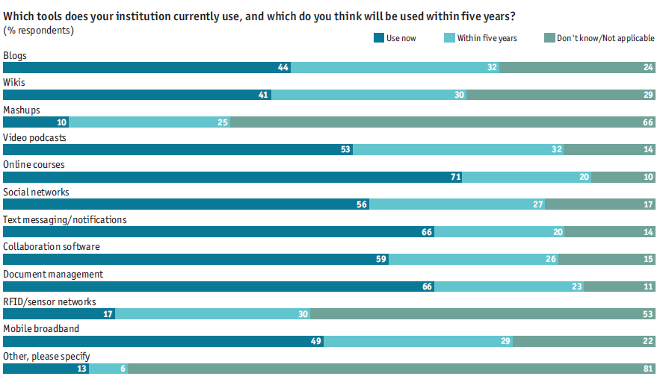

Upcoming Trends
- Cloud Computing for Education
  - Cost
  - Flexibility
  - Accessibility
- Unified Communications – Education Desktop
  - Collaborative tool for Many Applications
- VSAT-enabled virtual and interactive classrooms
  - Lost Cost Terminal to support applications in Internet Access, Video Conferencing

Conclusion
The advancement of information technology provides a wide range of options for the container terminal operator to automate its information system. Electronic devices employed in container terminals reduced the manual effort and paper flow, facilitated timely information flow and enhanced control and quality of service and decision made. The use of computer simulation has become a standard approach for evaluating design of complex cargo handling facilities. It enabled us to investigate the behavior of two different operational systems leading to significant savings derived from the implementation of electronic devices in port terminals. The importance of information technology including the Internet, in supply-chain management, facilitating the exchange of information in commercial transactions among enterprises and individuals and enhancing growth and profitability across the supply chain was also discussed.

References
- Bascombe, A. (1998), ``Stations'', Containerizations International, May, p. 39.
- Burt, D. (1996), ``Computer-based system'', Purchasing and Supply Management.
- Cox, A. (1999), Privatization and Supply Chain Management, p. 5.
- Graybeal, W.J. (1980), Concept of a System: Simulation, Principles and Methods, p. 3.
- Heffernan, R. (1998), ``Brave new `electronic' world'', Containerizations International, June, p. 57.
- Talk with an intern of Educomp
- The Economist Intelligence Unit 2012 : The Future of Higher Education
- Victoria L. Tinio : ICT in Education
- Wiki Educator
- Network Magazine
Acknowledgement:
Our Sincere thanks to Our Institute, Principal & Head , Mr. Ajoy Chatterjee, Course Coordinator, Mr. Rajeev Wad, and all our faculty to have helped us to provide us the needed knowledge to complete the project on time.
A special thanks to our Soft Skills trainer, Mrs. Meena Ravi Shankar , to have given us the protocols of presentation effectively.

