INTELLIGENT ENGINES
J Pravin Kumar(author & presenter), S Gobinath(co-author), Sri Venkateswara College of Engineering, Chennai-602105.
ABSTRACT
New regulations in the exhaust gas emissions are being brought into force time to time. This necessitates not only the machine but also the operating Marine Engineers are to be updated to meet the ever changing demand of the industry. One such development on the engine side is the computer controlled low speed marine engines, commonly known as “Intelligent Engines”. The basic development is to reduce the operating cost at the same time to provide high degree of flexibility with enhanced reliability and adopt stringent emission norms. This paper attempts to touch upon the various aspects of an “Intelligent Engines”.
NOMENCLATURE
[Symbol] [Definition]
CCU Cylinder Control Unit.
ECU Engine Control Unit.
SFOC Specific Fuel Oil Consumption.
PM Particulate Matter.
SECA Sulphur Emission Control Areas
INTRODUCTION
“Necessity is the mother of invention”.
So whenever there is a need, there born the new innovative ideas which could lift up the current status a step ahead. In marine industry, the conventional cam operated engine lags in the operational flexibility and reliability. The need for flexibility to cope with diversified emission limits and increasing demands for reliability will undoubtedly lead to comprehensive use of electronic hardware and software in marine engines. Usage of such an electronic hardware and software in the marine low speed engines lead to the development of camless engines also called “Intelligent Engines”.
BASIC CONCEPT
“An Intelligent Engine is one which will monitor its own condition according to its feedback and pre-set settings and adjust the key parameters of the engine’s performance, under various conditions without manual intervention”.
Engine performance data will be constantly monitored and compared with the defined values in the expert system, if deviations are deducted corrective actions are automatically deducted to restore the system to normal. The figure 1 shows the layout of the Intelligent engine control programme.
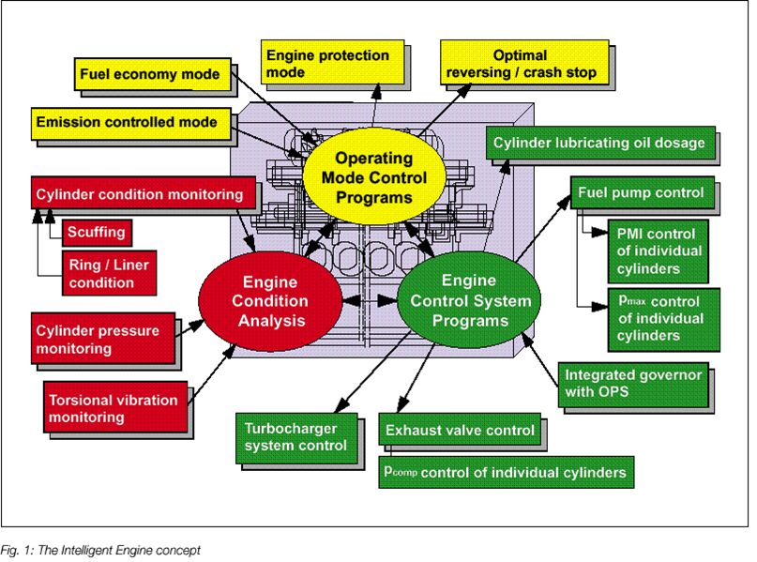
The electronic control system will contain data for optimum operation in a number of different modes such as fuel economy mode, emission control mode, reversing/crash stop mode and engine protection mode. The load limiter will protect the engine from overloading. The engine operating mode can be selected from the bridge control system or by the Intelligent engine’s own control system. The centre part shows the brain of the system. The electronic control system analyses the general engine condition and controls the operation of the engine.
Figure 1
A condition monitoring system is used to evaluate the general condition of the engine, thus monitoring its performance and keeping the operating parameters within prescribed limit. The condition monitoring system will intervene when the performance parameters shows unsatisfactory deviations.
OPERATONAL FEATURES
(i)FUEL INJECTION:
The fuel injection system consists of high pressure servo oil system which provides power supply to operate the fuel pump, accumulator to ensure fast delivery of servo oil & to avoid heavy pressure oscillations in the servo oil pipe system and NC valves to control the movement of plunger.
The figure 2 shows the electronic fuel injection system of MAN B&W engine.
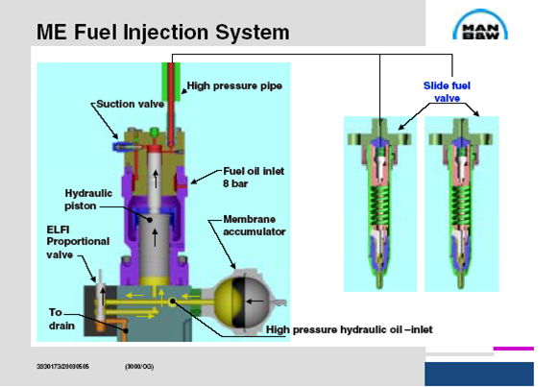
Figure 2
Before engine is started the hydraulic power system is pressurised by means of a small electrically driven high pressure pump. After starting the engine, the hydraulic system is pressurised by means of the engine driven multi piston pumps. The hydraulic power system uses engine lube oil itself with a redundancy filter to supply clean oil to hydraulic power system. The usage of engine system oil as the activating medium means that separate hydraulic oil system is not needed, thus extra tanks, coolers, supply pumps, a lot of pipings etc can be dispensed.
A High pressure lube oil pump takes suction from the main engine lube oil sump through the redundancy filter and delivers the high pressure lube oil (about 200 bar) to the common rail servo oil system. This high pressure lube oil is accumulated in the accumulator until the NC valve opens. NC opens only when the signal is received from the CCU. When the NC valve opens, the high pressure servo oil in the accumulator acts on the servo piston of the fuel injection pump and the pump delivers the fuel oil at a high pressure to the fuel injector through the injection pipes.
(ii)EXHAUST VALVE
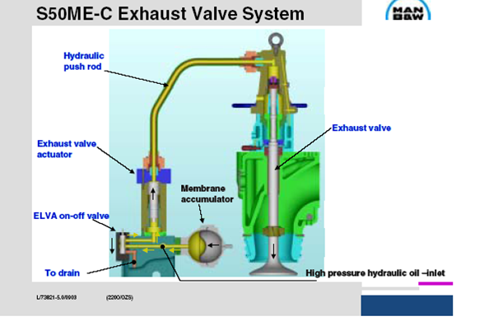
Figure 3
The exhaust valve is operated by the same servo oil system as that for the fuel injection system. The figure 3 shows the exhaust valve actuating system of an Intelligent engine. The timing of opening and closing the valve is obtained by using a fast acting on/off control valve. The high pressure servo oil is accumulated in the accumulator until the NC valve receives signal from the CCU. When the NC valve opens the high pressure servo oil acts on the servo piston of the valve pump which in turn actuates the exhaust valve actuator piston and opens the exhaust valve. The exhaust valve is closed by the standard air spring.
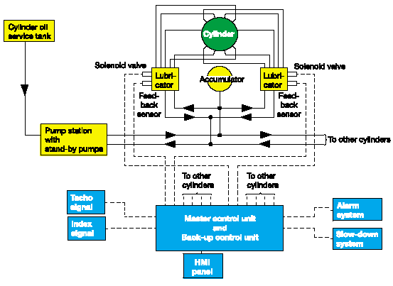
(iii)CYLINDER LUBRICATION SYSTEM
Figure 4
Intelligent engines uses an electronic system of cylinder lubrication. The figure 4 shows the electronic cylinder lubricator system fitted in the Intelligent engines. A pump station delivers lube oil to the lubricators at 45 bar pressure. The lubricators have a small piston for each lube oil quill in the cylinder liner, and the power for injecting the oil comes from the 45 bar system pressure acting on a larger common driving piston. Thus, the driving side is a conventional common rail system, whereas the injection side is a high pressure positive displacement system, thus giving equal amounts of lube oil to each quill and the best possible safety margin against clogging of single lube oil quills.
For large bore engines, each cylinder has two lubricators and an accumulator, while the small bore engines are served by one lubricator per cylinder. The pump station includes two pumps(one operating, the other on stand-by with automatic start up), a filter and cooler.
In MAN B&W ME engines, Alpha cylinder lubrication system is used in which a high pressure lubricator pump supplies oil to an injector to inject a fixed volume into the engine cylinder once in 4 revolutions. A computer control unit gets input from engine speed, load index and LCD signals. It sends an ‘ON’ signal for lubrication to the solenoid valve to control the oil injection. The computer sends an ‘OFF’ signal to the solenoid valve to allow the oil back to the return line. The feed rate is adjustable by adjusting the interval between injection i.e. every fifth and sixth revolution. This gives better utilization of expensive cylinder lube oil and reduces the consumption. This system has reduced the specific cylinder oil consumption by 0.3 g/bhp-hr and allows the cylinder oil dosage in g/bhp-hr entering thr cylinder in such a way that it is proportional to the amount of sulphur in g/bhp-hr entering the cylinder with fuel.
EMISSION CONTROL TECHNIQUE
NOx and primary PM emissions are mainly linked to the performance of the vessel engine whereas the SOx emission is related to the sulphur content in the fuel.
Figure 5
For SOx reduction, we can use low sulphur fuels and also dry/wet scrubbers for post treatment of the emission. We can also adopt pre treatment of fuel. For NOx emission control we can simply control the combustion parameters (in cylinder temperature). But there will be a slight increase in SFOC. Intelligent engine has 4 operating modes namely fuel economy mode, emission control mode, engine protection mode, crash stop/reversing mode. While entering SECA areas and special areas we can switch over from fuel economy mode to emission control mode thereby increase in SFOC is only prone to those area of voyage.
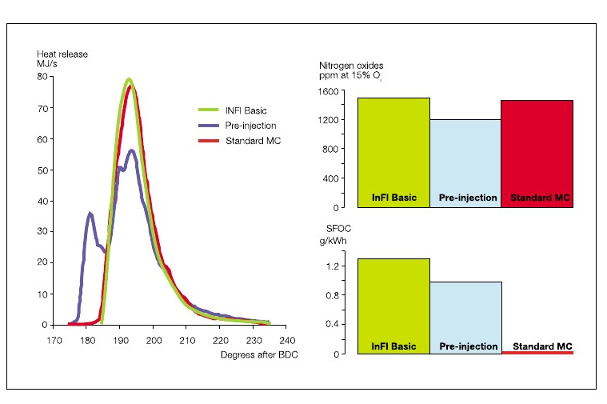
Figure 6
Further to make the environment greener, the engine manufacturers are trying in various ways, one such a project in MAN B&W is HELIOS which will reduce the emission as well as SFOC by using LNG/LPG/CNG as fuel in an electronically controlled engine. The introduction of ME-GI engines in industry is the most trending topic relating to emission control and automation.
CONTROL SYSTEM
Redundant computers connected in a network provide the control functions of the camshaft (timing and rate shaping). The Engine Control System is an integrated part of intelligent engine that brings completely new characteristics to the engine. It comprises two Engine Control Unit (ECU), a Cylinder Control System (CCU) for each cylinder, a Local Control Terminal and an interface for an external Application Control System. The ECU and CCU have both been developed as dedicated controllers optimised for the specific needs of the intelligent engine.
The Engine Control Unit controls the functions related to the overall condition of the engine. It is connected to the Plant Control System, Safety System, Supervision & Alarm System and is directly connected to the sensors and actuator. The Cylinder Control Unit (CCU) is connected to all the functional components to be controlled on each cylinder.
In the event of a failure in a controller, the system will identify the faulty unit, which is simply to be replaced with a spare. As soon as the spare is connected it will automatically be configured to the functions it is to replace, and resume operation. As both ECU and CCU are implemented in the same type of hardware, only a few identical spares are needed. If failures occur in connected equipment –sensors, actuators, wires etc – the system will locate the area of the failure and through built-in guidance and test facilities, assist the engine operating staff in the final identification of the failed component.
ADVANTAGES OF INTELLIGENT ENGINES
- Reliability of engine increases.
- Fuel and lube oil consumption cost reduces.
- Follow up of stringent air pollution emission norms.
CONCLUSION
Environmental friendliness and impeccable reliability will be the dominant development goals in the years to come. To meet these requirements at an acceptable production cost an increasing use of electronics is foreseen, and the concept of intelligent engine will be applied in marine engines of the future. This paper attempts to highlight the concept of intelligent engine.
ACKNOWLEGEMENTS
The authors wish to acknowledge in particular, the undermentioned for their valuable advice and assistance:
Prof. H R Premnath, HOD, SVCE Prof. S Krishnan, Dean(Academics), SVCE Prof. K V Sivanarayana, Dean(Students Welfare), SVCE.
The authors also wish to acknowledge MAN B&W diesel A/B, Denmark.
REFERENCES
[1] DEVEN ARANHA., ‘Marine Diesel Engines’, August 2010.
[2] POUNDER., ‘Marine Diesel Engines and Gas Turbines’, 2004.
[3] ‘The Intelligent Engine: Development Status and Prospectus’, by MAN B&W.
[4] “MAN DIESEL & TURBO” official website www.mandieselturbo.com.
AUTHORS BIOGRAPHY
J Pravin Kumar and S Gobinath are the final year students of ‘Sri Venkateswara College of Engineering’, Chennai-602105.

