LNG AS AN ALTERNATING FUEL
Author and Presenters:-
Cadet Harsh Agarwal (09345493977) harshagarwal121@yahoo.in
Address- 3526, Kalyan Ji Ka Rasta, Chandpole Bazar, Jaipur-01, Rajasthan
Cadet Shrirang Khadilkar (08489672196) khadilkar_shrirang@yahoo.co.in
Address-17, Mohite Ttownship A, Anand Nadar, Sinhagad Rd, Pune-51, Maharashtra
Co-author:-
Cadet Shahirul Asheeque (08489021749) rakib30121991@gmail.com
Address- ONGC colony, Sibsagar, Assam
NOORUL ISLAM UNIVERSITY, KANYAKUMARI
Abstract:
Propulsion does mean power and pollution, particularly when it comes to powering ships. Burning diesel and HFO (Heavy Fuel Oil) creates greenhouse gases, mainly SOx, NOx and CO2, that are emitted into the atmosphere. Propulsion systems, because they require seals and bearings to reduce friction, can also leak lube oil into the ocean when seals weaken due to harsh conditions and varying loads. These are among the issues being addressed by the International Maritime Organization (IMO) in its continuing efforts to reduce maritime pollution worldwide. The IMO’s Tier III regulations, scheduled to take effect in 2016, would require dramatic reductions in greenhouse gas emissions from ships, including a massive 80 percent in NOx when transiting designated Emission Control Areas.

We are having a good alternative to it. It is the Natural gas ( LNG).

The combustion of natural gas is much cleaner. During complete combustion, the only byproducts are carbon dioxide (a greenhouse gas) and water, both colorless. Natural gas is, in fact, a “no sulfur fuel” and can reduce NOx emissions by up to 90 percent and CO2 by up to 20 percent with little or no smoke.

Liquefied natural gas (LNG) can be used as a fuel in ships because it occupies one-six hundredth the volume of natural gas. The Price of LNG is lesser than HFO.

Keywords
Dual fuel 2 stroke engines, Complete gas 4 stroke engine, ramp up time, abatement technology, lobe bundle tank,

Introduction
This paper is an introduction to the use of Liquefied Natural Gas (LNG) as a marine transportation fuel, and specifically the advantages and challenges. Both new construction and conversion are considered. Issues of storage, safety, fueling, marine regulatory classification and commercial technology are discussed for context and background. Finally a high level look at adding LNG capability to a vessel are discussed including ‘rough order of magnitude’ (ROM) equipment costs, operating costs, and emissions reductions.
The EPA Clean Diesel program prescribes a path for the stepwise reduction of emissions from diesel engines. Nitrogen Oxides (NOx), Sulfur Oxides (SOx), and Particulate Matter (PM) emissions are regulated by the EPA. Reducing NOx with after-treatment requires the use of Selective Catalytic Reduction (SCR). This technology requires continuous consumption of aqueous urea (typically 5-10% of diesel fuel consumption) and will likely represent a significant operating expenditure for SCR equipped vessels. Using LNG as a marine fuel could allow ships to achieve similar NOx, SOx, and PM emissions and 20% lower CO2 emissions when compared to Tier 4 diesels. If the natural gas is produced from renewable sources, such as biomass, the carbon footprint can be reduced by up to 80.
LNG is created in a process called liquefaction, which in addition to liquefying the fuel it purifies it to at least 95% methane. LNG is the most energy dense form of natural gas. On an energy basis natural gas is much cheaper than oil. Oil at today’s price of $80 per barrel has a cost per energy of $47.1 per mm Watt-hr. As a comparison natural gas costs under $20.5 per mm Watt-hr. Historically this price gap is tending to widen and favors natural gas. The energy and transportation costs associated with production and delivery of LNG add cost, but LNG is still significantly cheaper than diesel.
Why LNG
Use of LNG reduces harmful emissions of NOx, SOx, CO2, and Particles. Costs, operability and maintenance are very less as compared to marine diesel engines. It removes or reduces ship owner’s taxes and other fees related to emissions. LO consumption is reduced in LNG engines due to less auxiliary machines and moving parts. LNG engines are more efficient than diesel. In LNG propelled ships all HFO installations deleted; heating system with coils, purifiers, treatment units, service and settling tanks. A simpler propulsion set installation / refurbishment. A simpler propulsion set operability and maintenance.
How LNG

LNG is a cryogenic fuel that is maintained at approximately -162°C at atmospheric pressure. The advantage of cooling and liquefying the fuel is that the volume is decreased approximately 600 times as compared to the gas. This improves the energy density significantly for LNG. As a result when compared to diesel fuel LNG has about 2/3 as much energy on a volume basis and almost 90% as much energy on a weight basis. Unfortunately, storing cryogenic (very cold) fuels requires special insulated tanks that significantly erode much of the volume and weight advantages of LNG.
LNG can be used for marine propulsion in two ways:-
- Dual fuel 2 stroke engines
- Complete gas 4 stroke engine

Dual fuel 2 stroke engine
Plant layput
Working
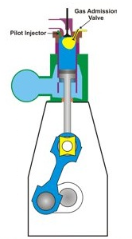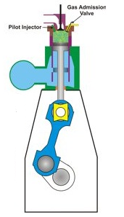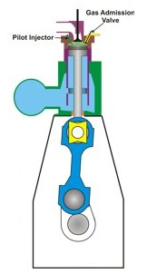
- The gas admission valve is closed and piston moves up the cylinder compressing gas-air mixture.

- The exhaust valve is closed and the gas admission valve is open. Gas at a higher pressure than cylinder pressure flows into the cylinder.

- Just before TDC a pilot injector injects a small amount of fuel oil into the cylinder which starts to burn and ignites gas-air mixture.

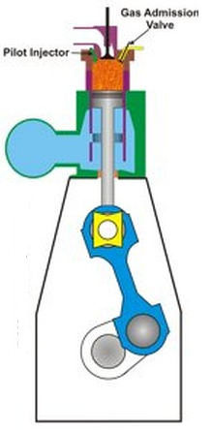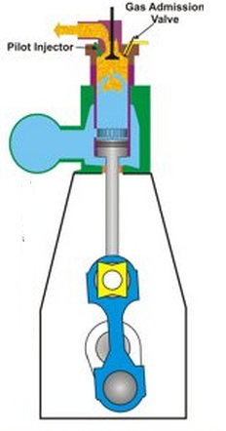
- The piston is forced down the cylinder by burning expanding gas.

- The exhaust valve open followed by scavenge ports. Air enters the cylinder pushing out the exhaust gas.

Dual fuel injection system
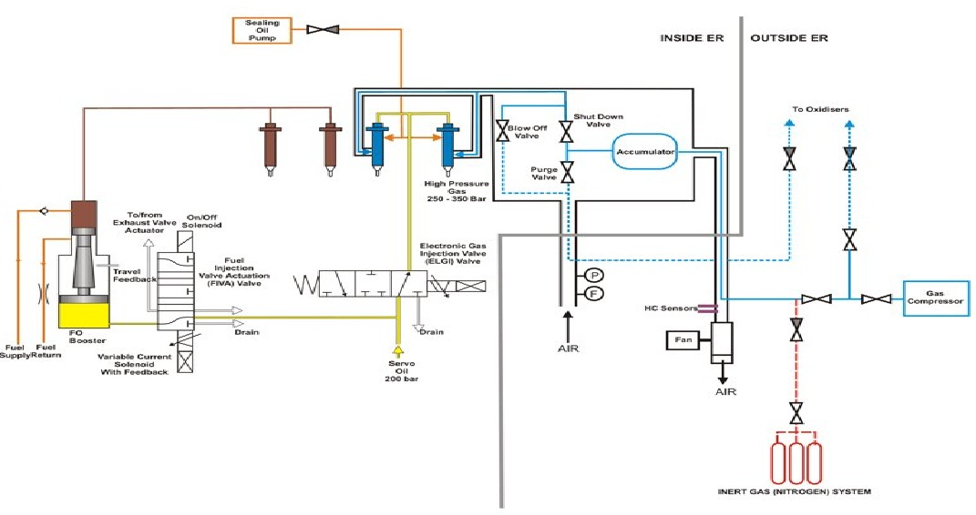
The gas is pressurized by reciprocating compressors to 250-300 bar. It is then cooled and led to the valve blocks on each cylinder. Each valve block incorporate an accumulator which has a volume corresponding to about 20 times the amount of gas injected at full load condition. The purpose of accumulator is to reduce the pressure drop during gas injection. And to monitor that small pressure drop as it forms an important part of engine safety system.
The gas supply pipes are double walled with air seal being supplied in between two pipes. Pressurized air supplied by fan is then monitored for gas leakage.
To prevent gas leakage at the injector and to lubricate moving parts the gas injectors are supplied with sealing oil which is pressurized at 25-30 bar above the gas injector pressure.
Any failure of injection of pilot fuel leading to non-combustion of the injected gas will lead to the gas supply shut off and the gas lines purged with inert gas.

Advantages
- They have built in redundancy –the fuel being used can be changed without interruption of the engine’s speed or power output.
- Application flexibility.
- Long overhaul intervals.
- Low gas feed pressure.
- Embedded automation system.
- No need for installing any exhaust abatement equipment in the exhaust pipe.
- Higher ignition energy than spark plug.
Disadvantages
- More expensive.
- Higher methane emission than spark ignited engine.
- More complex system.
- Area required is high.
Applications
- Merchant ships- 68 vessels

- Offshore- PSVs/FPSOs- 22 vessels
- Cruise and ferry- 2 vessels
- Navy vessels- Costal patrol

Complete gas 4 stroke engine

Plant layout

W orking

LNG Fuel consumption system is simple in operation and fully automatic. There are no pumps used in the system.
The Pressure Build Up Vaporizer regulates the pressure in the tank which is driving the LNG to the Fuel Vaporizer. LNG is vaporized to NG which goes to the Fuel Heater. The heater takes the NG to the temperature level required before entering the GRU-Gas Regulating Unit.

A rich gas-air mixture in a pre-combustion chamber is ignited and forms a strong ignition source for the very lean mixture in the cylinder. In the lean burn engines more air is in the cylinder than is needed for complete combustion. This reduces peak temperatures and therefore lowers NOx emissions. The electronic control system constantly monitors and optimizes operating parameters to maintain power and emissions across the operating range. The engines produce very low NOx, even at low load.

Advantages
- Exceptionally low emissions of NOx
- Eliminate Sox and particulate matter thus no abatement technology is required
- CO₂ emissions are also reduced by around 20%
- Simple engine room design, layout and fuel management
- System is neat and clean
- Optimum response at all engine loads
- Quick ramp up time
- Low lube oil consumption
- All HFO installations deleted; Heating system with coils, purifiers, treatment units, service and settling tanks.
- Reduced Fuel consumption, gas engine more efficient than diesel.
Disadvantages
- Need to reduce size and cost of LNG tanks
- Large initial investment in installation on LNG bunker stations
- Introduction of gearbox in the system is necessary
Application
- Over 500 Bergen gas engines sold for land & marine applications since 1991
- Five coastal ferries in service since 2007; annual NOx reduction per vessel equivalent to 160,000 cars – over 25,000 running hours
- Coral Methane gas carrier in service since 2009
- Recent orders for a specialist Fish Feeder and Offshore Platform Supply Vessel with gas based propulsion systems

Storage Tanks
LNG is typically stored in highly insulated tanks at low pressures, (1-5bar). Fitting these tanks on a ship or in a vehicle is quite feasible but does not compare favorably to diesel. In practice it should be expected that the volume required to store LNG will be about 1.5-2.5 more than the comparable volume of diesel. To reduce this storage volume new type of tanks are being developed called ‘Lobe-Bundle tank’ by Hyundai and approved by Japanese classification society Nippon Kaiji Kyokai (NK).
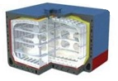The Lobe-Bundle Tank uses ring-shaped plates instead of conventional flat plates to reduce the weight of the tank and building cost significantly. The tank is built using spray-type insulation rather than panel-type insulation, substantially reducing construction time.
Hyundai Heavy’s LNG tank technology meets International Maritime Organization standards requiring high level of structural analysis and fatigue/fracture analysis for Type B independent LNG storage tanks.
Right, options showing potential location of LNG fuel tanks (in yellow) in a large container ship design.
Safety
LNG as a liquid is not flammable or explosive. As with any gas it has a flammability range. This range for LNG gas is between 5 and 15 percent when mixed with air. An explosion can only occur when the gas is in an enclosed space with air, the mixture is between 5 and 15 percent, and an ignition source is present. As with any flammable substance, proper design, regulations, and personnel training are needed to maintain a safe environment.
LNG is lighter than the air so in case of any leakage it will immediately go to uptake and leave the ship so there is no possibility for any hazard. Detection of leakage by addition of odorant
Operational Costs
Fueling with LNG can significantly offset operational costs due to the much lower cost of LNG
fuel compared with diesel. WSF currently fuels ferries with Ultra Low Sulfur Diesel and on
some vessels biodiesel. The fuel consumption estimates are 800,000 gallons of diesel per year
based on the Issaquah. To supply an equivalent quantity of energy, a volume of 1,360,000
gallons of LNG are required. However, LNG is much less expensive than diesel even after
transportation and liquefaction costs are included. The estimated yearly fuel cost savings are
summarized in Table 1.
 | Gal/yr | Cost/gal | USD/yr | Source
Issaquah Fuel Consumption | 800,000 | $2.50 | $2,000,000 | WSF provided cost per gallon
LNG Fuel Consumption | 1,360,000 | $0.83 | $1,128,800 | Vendor estimated cost per gallon
Savings per year |  |  | $871,200

Savings per year $871,200
Table 1. Fuel cost savings for adapting the 144 vehicle ferry for LNG propulsion
While the estimated savings in Table 1 are significant, the savings could be even greater if the
Vessel is built to Tier 4 requirements. If the vessel were Tier 4, which it will be if built after
2014, there may well be a cost incurred by the purchase of urea for use in an SCR system. Urea
Consumption is typically about 5-10% of the diesel volume. Even at 5% this would add a cost of
$120,000 per year at today’s urea price of $800/ton.
Operational costs for maintenance of LNG engines are reportedly lower than diesel engines,
According to the engine vendor. Since the fuel is cleaner, all equipment runs cleaner. However,
a significant amount of control and monitoring equipment is required for an LNG vessel above
what would be expected for a conventional diesel which could offset some of the savings.
Bunkering
Liquefied Natural Gas (LNG) is bunkered by pressure from land based stations, tanker trucks, coastal tankers or bunker barge 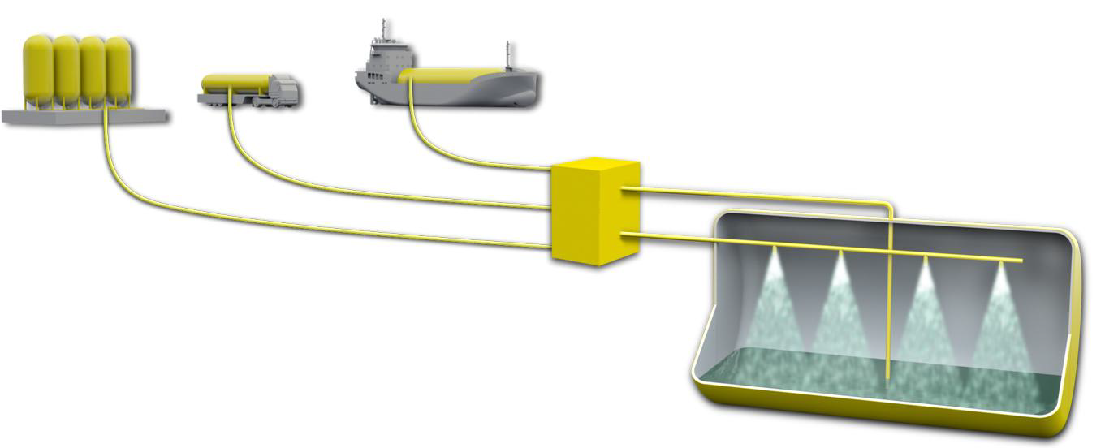
LNG Tank
Bunker station
Top filling line
Bottom top filling line

Conclusion
LNG is used today as a transportation fuel but the market is still small compared to most other alternative transportation fuels. Although LNG faces the storage disadvantage as compared to the diesel engine, it has lots and lots of advantages such as pollution control, greater efficiency, improved safety, availability of fuel, cost effective etc. Manufacturers such as Wartsila, MAN Diesel and Rolls Royce have the technology needed and have made it possible to use LNG as an alternating fuel. Thus use of LNG as an alternating fuel will be incorporated as soon as possible for the betterment in the maritime industry.

Reference

- Hyundai Heavy Develops New Independent LNG Storage Tank, Hyundai Heavy Industries Co. Ltd., Press Release, November 2012
- NATURAL GAS FOR MARINE VESSELS, U.S. MARKET OPPORTUNITIES, APRIL 2012
- Wärtsilä 2-Stroke Dual-Fuel: A Single Solution, Wärtsilä article, October 2012
- Rolls-Royce marine gas engine receives U.S. EPA approval, 4 September 2012
- Design and integrated systems for efficiency: hull design, power and propulsion systems, Geir Bjørkeli, Rolls-Royce, November 2011
- Gas technology, A special report on marine and offshore gas solutions, Lloyd’s Register Report, October 2012
- Dual-Fuel Engine Goes Walkabout, A Technical Customer Magazine of MAN Diesel & Turbo, February 2010
- Introduction to LNG as a Maritime fuel, The Good, The Bad, The Ugly Gary W. Van Tassel, Maersk line Ltd.
- MAN B&W ME-GI ENGINES. RECENT RESEARCH AND RESULTS, Lars R. JULIUSSEN, Michael J. KRYGER and Anders ANDREASEN, October 2011
- LNG Fuel Gas Systems, Hamworthy Gas Systems AS, Norway
- Operational Information,The 2 Stroke Dual Fuel Engine, MAN B&W

