
MAEER's MAHARASHTRA ACADEMY OF NAVAL EDUCATION
AND TRAINING (MANET)
GateNo.140,LoniKalbhor,Rajbaug,Pune-Solapur
Highway,Pune-412201
PRESENTS
MODERN INNOVATIVE TECHNOLOGY IN MARINE DIESEL ENGINE FOR SUSTAINABLE DEVELOPMENT
Prepared By:-
(1)Cdt. Pratik Manglani (main presenter) (2)Cdt. Alok Marval.
(Sem V)
Email–manglanirajan76@gmail.com,manglanipratik517@gmail.com,,
contact-9561920271
ABSTRACT-Today engine designers have a range of technologies to maintain a balance between fuel economy and emission reduction,As the internal combustion engine (ICE) finds its place in the market with latest design modifications in various components to improve efficiency, economy and overall performance,So modifications or latest technologies come into existence :-(1)for replacement of old techniques in order to increase engine efficiency.(2)To drastically reduce gaseous and particulate emissions (sox, nox etc) to prevent pollution from ships.(3)Reduce specific fuel consumption and engine lifecycle costs.
A)The scuderi split cycle engine solves both the breathing and thermal efficiency problems with two unique and patented concepts-1)unique valve design 2)high pressure and massive turbulence.The split cycle engine separate the 4 strokes of intake,compression,power and exhaust into 2 separate but paired cylinders,This cycle has so many advantages in comparison to conventional engine technology.(B)The introduction of Six stroke engines which is now gaining momentum is a milestone in the Engine technology. This deserves a place in the history like “Sir Rudolph Diesel’s” first engine in Augsburg.The SIX STROKE ENGINE is a type of internal combustion engine based on the 4-stroke engine but with additional complexity to make it more efficient and reduce emissions. The engine captures the heat lost from the four-stroke Otto cycle or Diesel cycle and uses it to power an additional power and exhaust stroke of the piston in the same cylinder.This paper depict about the design which use air as the working fluid for the additional power stroke.The pistons in this type of six-stroke engine go up and down three times for each injection of fuel.There are 2 power strokes:with fuel and with air/steam.(C)The hcci(homogeneous charge compression ignition) is not new technology but with advent of sophisticated computer controlled electronics it has gained serious attention in the quest for improving fuel efficiency and reduce emissions.
This paper outlines how the engine manufacturing giants takes advantage of the new technologies in its main engine designs by the combination of traditional proven technologies with enhanced electronic control.These while being both production-friendly and operationally easy to handle, savings in manpower, reduction in size, cost efficiency thereby providing sustainable development.
KEYWORDS -1) BTDC- Before top dead centre
2) ATDC- After top dead centre
3) NA-Naturally aspirated
4) RCCI- Reactivity controlled compression ignition
5).SI- Spark ignition,CI-Compression ignition
a) SCUDERI SPLIT CYCLE ENGINE -This paper emphasizes on part wise details thermodynamically, detailed working and future considerations of Scuderi split cycle engine. This Engine represents a new thermodynamic cycle that creates an unprecedented opportunity for engine manufacturers to take fuel efficiency to new levels.These engines separate the 4strokes of intake, compression, power, and exhaust into 2 separate but paired cylinders.
The 1st cylinder is used for intake and compression and 2nd for power and exhaust.A split-cycle engine is really an air compressor on one side with a combustion chamber on the other.In 1st cylinder when intake and compression is get completed we get an compressed air, this compressed air is then transferred through a crossover passage from the compression cylinder into the second cylinder, where combustion and exhaust occur.
Initial split cycles engines disadvantages-These engines appeared as early as 1914. Many configurations have since been developed; however, none has matched the efficiency or performance of conventional engines. Previous split-cycle engines have had two major disadvantages-poor volumetric efficiency and low thermal efficiency.Here poor volumetric efficiency means poor breathing.The scuderi split cycle engine solves both the breathing and thermal efficiency problems with two unique and patented concepts-1).unique valve design 2).high pressure and massive turbulence.
1). Poor volumetric efficiency (SOLVED BY unique valve design)-
The breathing problem was caused by high-pressure gas trapped in the compression cylinder.
This trapped high pressure gas needed to re-expand before another charge of air could be drawn into the compression cylinder, effectively reducing the engine’s capacity to pump air and resulting in poor volumetric efficiency.
On the compression side of this Engine, the breathing problem is solved by reducing the clearance between the piston and the cylinder head to less than 1 mm. This design requires the use of outwardly opening valves that enable the piston to move very close to the cylinder head without interference of the valves. This effectively pushes almost 100% of the compressed air from compression cylinder into crossover passage,eliminating the breathing problems associated with previous split-cycle engines.
2).Low thermal efficiency(BY Firing(ATDC)-High pressure and massive turbulence.) –
The thermal efficiency of these engines has always been significantly worse than a conventional Otto cycle engine. The primary reason:They all tried to fire like a conventional engine BTDC.In order to fire BTDC in a split-cycle engine, the compressed air, trapped in the crossover passage,is allowed to expand into the power cylinder as the power piston is in its upward stroke. By releasing the pressure of the compressed air,the work done on the air in the compression cylinder is lost. The power piston then recompresses the air in order to fire BTDC. By allowing the compressed gas in the transfer passage to expand into the power cylinder, the engine needs to perform the work of compression twice.In a conventional engine,the work of compression is done only once; consequently, it achieves much better thermal efficiency.
Firing ATDC:Although considered bad practice in conventional engine design, firing ATDC in a split-cycle arrangement eliminates the losses created by recompressing the gas. The big issue was not how to solve the thermal efficiency problem of the split-cycle engine, but rather how to fire ATDC.
High Pressure and Massive Turbulence:
In this Engine, firing ATDC is accomplished by using combination of high pressure air in transfer passage and high turbulence in the power cylinder. Because the cylinders in these Engine are independent from each other, the compression ratio in the 1st cylinder is not limited by the combustion process. A compression ratio in the order of 75:1 is obtained, with pressure in the compression cylinder equal to that of a conventional engine during combustion. The pressure in the compression cylinder and the crossover passage reach more than 50 bar on our NA engine and more than 130 bar on our turbocharged engine. This high-pressure air entering the power cylinder creates massive turbulence. The turbulence is further enhanced by keeping the valves open as long as possible during combustion. The result is rapid atomization of the air/fuel mixture, creating a fast flame speed or combustion rate faster than any previously obtained.
Turbocharged Split-Cycle Engine (High Torque, High Speed, Enormous Power, Smaller Engines):Development of this Engine is the turbocharged version. Because the crossover passage provides an opportunity to cool the intake air after it is compressed. also high resistance to knock potentially enables this Engine to boost or turbocharged to more than 2.5 bar absolute pressure.
Scuderi Split-Cycle Diesel Engine-Reduced Emissions-This Engine’s combustion process of firing ATDC has an unusual effect of reducing both soot and NOx.
Advantages of Scuderi split Cycle Design:
- One of the biggest advantages is design flexibility. Many features that require additional equipment or are just too difficult to implement in a conventional engine design are easily accomplished with this configuration. For example, supercharging can be added simply by increasing the diameter of the compression cylinder.
- Piston friction can be reduced by offsetting the compression and power cylinders.
- A Miller cycle can be achieved simply by increasing the length of the power cylinder.
- In this Engine,turbocharger can be used to recover energy from the exhaust of the engine. Pressurized air from the turbocharger is fed into the compression cylinder, reducing the amount of energy needed for compression. The net energy gain provided by the turbocharged operating mode is unique to this Engine and cannot be achieved when using conventional engine.

Scuderi Hybrid Engine- The first Hybrid System that makes sense:A-Normal Operating Mode:Because this Engine is a dedicated compressor on one side and an engine on the other, it only requires the addition of air storage tank and related controls to convert it into a hybrid system that has the ability to capture and store the energy that is normally lost during operation of the engine.
B-Regenerative Braking Mode:By turning off the power cylinder while the vehicle is still engaged with the engine,diverting the flow of compressed air to the air storage tank,the momentum of the vehicle continues turning the engine, thereby compressing air and storing it in the storage tank for later use.
C-High-Efficiency Mode: By turning off the compression cylinder and utilizing high-pressure air from the storage tank to supply the power cylinder, losses due to compression are reduced to nearly zero when operating in the high-efficiency mode.
D-Cruising Mode: High-efficiency cruising mode is achieved by sending only a portion of the compression cylinder’s charge to the power cylinder. The remainder of the charge is sent to the air storage tank for later use. Whenever the air storage tank is full, the compression cylinder shuts off, and the vehicle operates in high-efficiency mode.

Fig. A Fig. B

Fig. C Fig. D

B). Six stroke engines –
Water is freely available and in abundant quantity, if it is possible to use water to increase efficiency of engine it will be the best method to control emissions and it is also a renewable resource so it cannot deplete.
Bruce Crower created this engine concept. In the 6 stroke engine, there are 2 extra strokes that are added to the normal 4 strokes for most internal combustion engines resulting in a six stroke engine. The 5th down-stroke is called a "steam stroke" and 6th up-stroke exhausts the steam and also expels engine heat from the engine. This will give a 35% reduction in fuel consumption and reduced exhaust emissions. Lot of heat is wasted from fuel combustion in engine which reduces its efficiency. In this we find a way to harness most of the heat and increase work output along with using the heat extracted by water.
PRINCIPAL:The engine captures the heat lost from the 4stroke Otto cycle or Diesel cycle and uses it to power an additional power and exhaust stroke of the piston in the same cylinder. The pistons in this type of 6stroke engine go up and down three times for each injection of fuel. There are two power strokes: one with fuel, the other with air.In this 1st 4stroke are same as IC engines i.e. suction, compression, expansion and exhaust.Water in the combustion chamber is added after the exhaust stroke.Water has a property of expanding 1600 times the volume when converted to steam hence giving us a 2nd power stroke, this will be our 5th stroke. The 6th stroke is removing the steam from combustion chamber.6 strokes engines differentiates itself entirely, due to its thermodynamic cycle and a modified cylinder head with two supplementary chambers: combustion and an air heating chamber.
WORKING-The 1st cycle of four events is of external combustion.
- Event 1:air intake in the cylinder (dynamic event).
- Event 2:air compression in the heating chamber (dynamic event).
- Event 3:keeping air pressure in closed chamber where a maximum heat exchange occurs with the combustion chambers walls, without direct action on the crankshaft (static event).
- Event 4:expansion of the super heated air in the cylinder, work (dynamic event).
During this 4 event's cycle, the pure air never comes in direct contact with the heating source.
- The 2nd cycle of 4 events is of internal combustion.
- Event 5: re-compressions of pure heated air in the combustion chamber (dynamic event).

- Events 6: fuel injection and combustion in closed combustion chamber, without direct action on the crankshaft (static event).
- Events 7: combustion gases expanding in the cylinder, work (dynamic event).
- Event 8: combustion gases exhaust (dynamic event).
During this event’s cycle; the air comes in direct contact with the heating source.
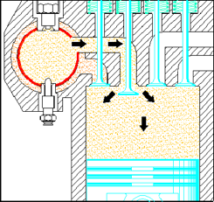
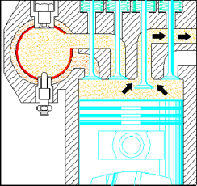
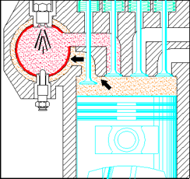
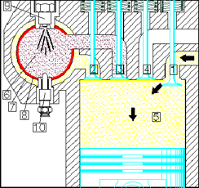
4THSTROKE(EXHAUST) 3RDSTROKE(POWER)
1ST STROKE (SUCTION)
2ND STROKE (COMPRESSION IN HEATING) CHAMBER)

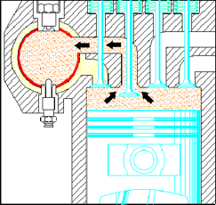
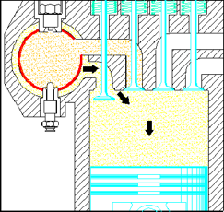
5TH STROKE(POWER) 6TH STROKES (RECOMPRESSION)

The P-V grphs shown below shows the amount of work gained in 6 stokes in comparision with 4 stroke.
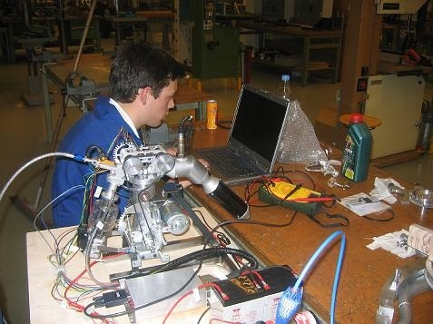
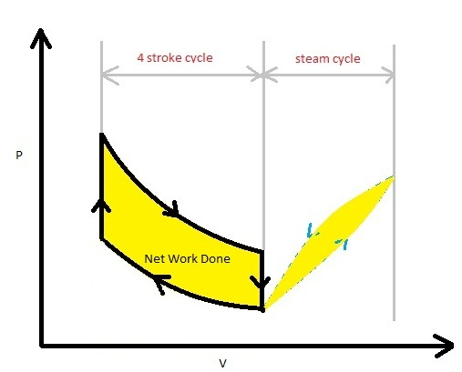
TESTS ON THE PROTOTYPE

PROTOTYPE
The air-heating chamber is isolated from the cylinder head to reduce thermal loss. In addition, since the combustion chamber is isolated from the cylinder by its valves, the moving parts, especially the piston, are not subject to any excessive stress from the very high temperatures and pressures. They are also protected from explosive combustion or auto-ignition.
To facilitate cold starts, combustion chamber is fitted with heater plug (glow plug).Injection and combustion take place in the closed combustion chamber, therefore at a constant volume. These features give plenty of time for the fuel to burn ideally, and release every potential calorie (first contribution to pollution reduction). The injection split up, with dual fuel using the SNDF system (Single Nozzle, Dual Fuel).
FACTORS CONTRIBUTING TO INCREASED THERMAL EFFICIENCY, REDUCED FUEL CONSUMPTION AND POLLUTANT EMISSIONS-
- The heat that is evacuated during the cooling of a conventional engine’s cylinder head is recovered in the 6stroke engine by the air-heating chamber surrounding the combustion chamber.
- After intake, air is compressed in the heating chamber and heated through 720° of crankshaft angle, 360° of which in closed chamber (external combustion),Better combustion and expansion of gases that take place over 540° of crankshaft rotation, 360° of which is in closed combustion chamber, and 180° for expansion.
- The glowing combustion chamber allows the optimal burning of any fuel and reduces the residues.
- Better filling of the cylinder on the intake due to the lower temperature of the cylinder walls and the piston head.
- Large reduction in cooling power. The water pump and fan outputs are reduced. Possibility to suppress the water cooler.
- Less inertia due to lightness of the moving parts.
- Lower oil temperature. With combustion taking place in a closed chamber, the high temperatures less stress the oil and the risk of dilution is reduced, even in cold starts.
- 35% reduce in fuel consumption,Emissions are low.
- The higher percentage of power strokes may allow lower working speeds, with higher torque output at lower and broader rpm ranges. Lower working speed might allow designs with greater crankshaft diameter.
COMPARISON-
 | CONVENTIONAL ENGINES |  | SIX STROKE ENGINES
1. | One power stroke in one revolution for 2 stroke engines, and in case of 4 stroke engines one power stroke in 2 revolutions. | 1. | Two power strokes in three revolutions (Additional power stroke by air).
2. | Specific Fuel Oil Consumption (SFOC) is high. | 2. | SFOC is less.
3. | Thermal efficiency is less. | 3. | Better thermal efficiency.
4. | Cylinder lub. Oil consumption is high due to direct combustion. | 4. | Cylinder lub. Oil consumption is reduced as combustion chamber is separate.
5. | Jacket cooling water system is necessary which increases the weight of the engine. | 5. | Jacket cooling water system is eliminated, so there is a drastic reduction in the weight of the engine.
6. | Water is the cooling medium, so chances of liner crack and leakage of cooling water is high due to an increased thermal gradient. | 6. | Air is the cooling medium, which is also used for producing additional power stroke.
7. | Piston & liner material are complex in construction and special alloys are used to withstand thermal and gas loads. | 7. | Piston & liner material are simple and cheaper materials are used. So the cost of the engine reduces drastically.
8. | Overall efficiency reduces due to overlapping period. | 8. | No overlapping period.
9. | Chemical, noise & air pollution (NOx, HC, CO) are frequent. | 9. | 65.2% reduction in pollution.
10. | Chances of blow past, scavenge fire & crank case explosion exists. | 10. | Chances of blow past, scavenge fire & crank case explosion are rare.
11. | Excess load acts on cams & the crank shaft. | 11 | Load on the cam & crankshaft is less.
12. | Incomplete combustion is a common problem in such engines. | 12. | Complete combustion of fuel takes place as the combustion chamber is always red hot.
13. | Chances of contamination of crankcase oil are more. | 13. | Chances of contamination of crankcase oil are less.
C) HOMOGENEOUS CHARGE COMPRESSION IGNITION (HCCI) – HCCI,is a form of internal combustion in which well-mixed fuel and oxidizer (typically air) are compressed to the point of auto-ignition.It is a hybrid of the traditional SI and CI process.It is not that much new combustion technology but with the advent of sophisticated computer controlled electronics it has gained serious attention in the quest for improving fuel efficiency and reduce emissions.
Unlike a traditional S.I engine, HCCI combustion takes place spontaneously and homogeneously without flame propagation. This eliminates heterogeneous air/fuel mixture regions. In addition, HCCI is a lean combustion process. These conditions translate to a lower local flame temperature which lower the amount of NOx produced in the process.HCCI has characteristics of 2 most popular forms of combustion used in SI engines- homogeneous charge spark ignition (gasoline engines) and stratified charge compression ignition (diesel engines). As in homogeneous charge SI engines, the fuel and oxidizer are mixed together. However, rather than using an electric discharge to ignite a portion of the mixture, the density and temperature of the mixture are raised by compression until entire mixture reacts spontaneously. Stratified charge compression ignition also relies on temperature and density increase resulting from compression, but combustion occurs at the boundary of fuel-air mixing, caused by an injection event, to initiate combustion.
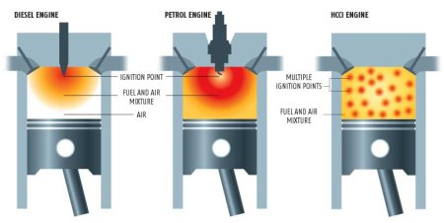
The defining characteristic of HCCI is that the ignition occurs at several places at a time which makes the fuel/air mixture burn nearly simultaneously. There is no direct initiator of combustion. This makes the process inherently challenging to control. However, with advances in microprocessors and a physical understanding of the ignition process, HCCI can be controlled to achieve gasoline engine-like emissions along with diesel engine-like efficiency. In fact, HCCI engines have been shown to achieve extremely low levels of NO_{x} emission without an after treatment catalytic converter. The unburned hydrocarbon and carbon monoxide emissions are still high (due to lower peak temperatures), as in gasoline engines, and must still be treated to meet automotive emission regulations.
Recent research has shown that the use of 2 fuels with different reactivity’s (such as gasoline and diesel) can help solve some of the difficulties of controlling HCCI and burn rates. RCCI has been demonstrated to provide highly efficient, low emissions operation over wide load and speed ranges.In an hcci engine fuel delivery control is of paramount importance in controlling the combustion process. On the intake stroke, fuel is injected into each cylinder combustion chamber via fuel injectors mounted directly in the cylinder head. Air is separately induced from intake plenum. By the end of the intake stroke, fuel and air have been fully introduced and mixed in the cylinders combustion chamber.
As the piston begins to move back up during the compression stroke, heat begins to build in the combustion chamber. When the piston reaches the end of this stroke, sufficient heat has to accumulated to cause the fuel/air mixture to spontaneously combust (no spark is necessary) and force the piston down for the power stroke.Unlike conventional SI(and even diesels),the combustion process is a lean, low temperature and flame less release of energy across the entire combustion chamber. The entire fuel mixture is burned simultaneously producing equivalent power, but using much less fuel and releasing far fewer emission in the process.At the end of the power stroke, the piston reverse direction again and initiates the exhaust stroke, but before all of the exhaust gases can be evacuated, the exhaust valves close early, trapping some of the latent combustion heat. This heat is preserved, and a small quantity of fuel is injected into the combustion chamber for a pre-charge (to control combustion temperatures and emissions) before the next stroke begins.
Merits -1).Lean combustion returns 15percent increase in fuel efficiency over a conventional SI engine.2)Cleaner combustion and lower emissions than a conventional SI engines. Fuel is burned quicker and at lower temperatures, reducing heat energy loss compared to conventional SI engines
References – (Internet)-1.http://www.researchandmarkets.com/reports/328321/
2. http://www.ScuderiEngine.com
3. http://en.wikipedia.org/wiki/six_stroke_engine.
4.www.google.com. Etc

