Indian Maritime Foundation
Paper Presentation

Title: Climate Change and its impact on
Marine Biodiversity and Global
Security

Presented By: Tolani Maritime Institute
Induri, Pune

Cdt. Abhishek Goswami (201537TN106)
Cdt. Gautam Kumar Mishra (201537TN126)
ABSTRACT
We know that human activities are releasing gigatonnes of carbon to the Earth's atmosphere annually. Direct consequences of cumulative post-industrial emissions include increasing global temperature, perturbed regional weather patterns, rising sea levels, acidifying oceans, changed nutrient loads and altered ocean circulation. These and other physical consequences are affecting marine biological processes from genes to ecosystems, over scales from rock pools to ocean basins, impacting ecosystem services and threatening human food security. The rates of physical change are unprecedented in some cases.
Given the essential roles that oceans play in planetary function and provision of human sustenance, the grand challenge is to intervene before more tipping points are passed and marine ecosystems follow less-buffered terrestrial systems further down a spiral of decline.
This report gives a detailed description about present-day climate change, setting it in context with historical change, considers consequences of climate change for marine biological processes now and in to the future, and discusses contributions that marine systems could play in mitigating the impacts of global climate change.
Also the report focuses on the threats that the global climate change will inflicton the global security issues especially when it comes to human and food security which further give rise to threats interdependent on them(you can name all those threats that you’ve mention in your report).
CLIMATE CHANGE AND ITS IMPACT ON MARINE BIODIVERSITY AND GLOBAL SECURITY

T
his June, the world's oceans reached 17 degrees Celsius, their highest average temperature since record keeping for these data began in the 19th century. A rise of 1.4°C to 5.8°C was predicted by the Intergovernmental Panel on Climate Change. This makes the Climate change a knockout punch for the species under the stress of overfishing and habitat loss.
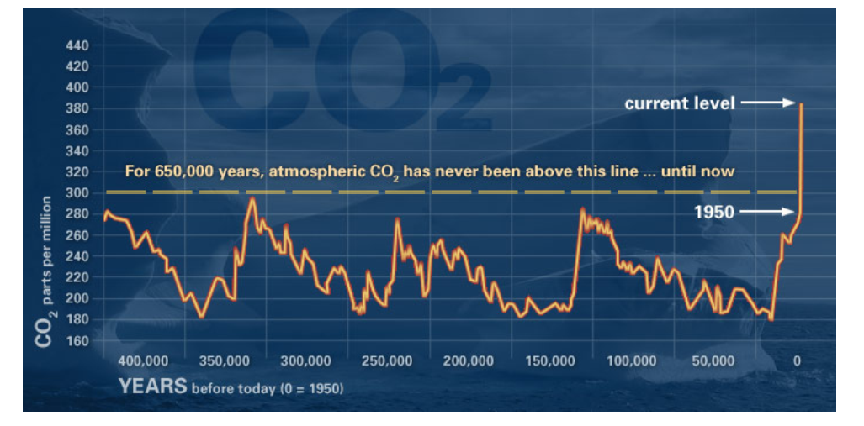
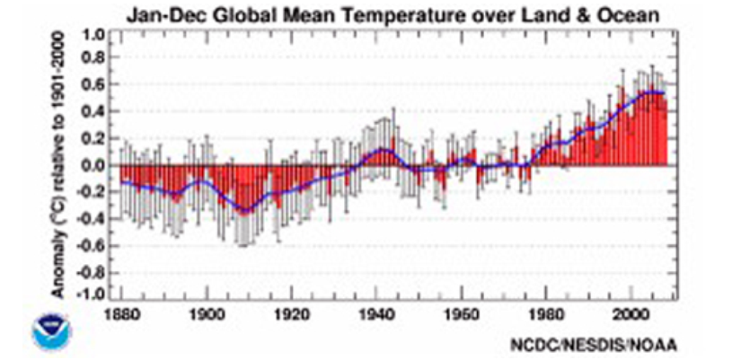
Theoretically, the growth of tiny drifting plants known as phytoplankton is increased by the increase in nutrients and warmth —as evidenced by seasonal dead zones that form at the mouths of many rivers worldwide when the tiny plants bloom, die and, while decaying, suck up all the available oxygen in the seawater. But the researchers found that increasing temperatures, although initially enhancing the growth of phytoplankton, also allowed increased grazing by zooplankton (microscopic animals) and bacteria, according to the results published today in PLoS Biology
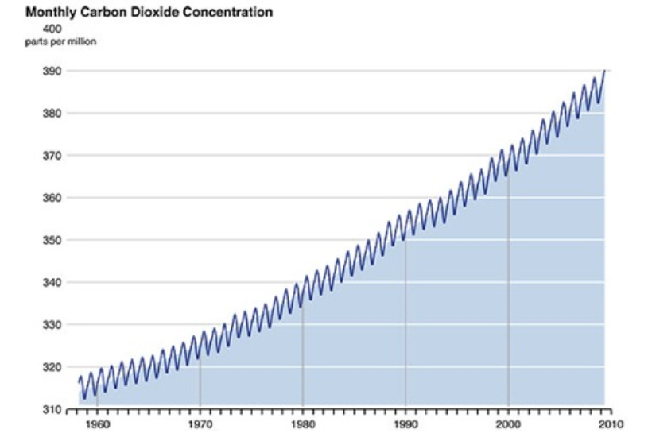

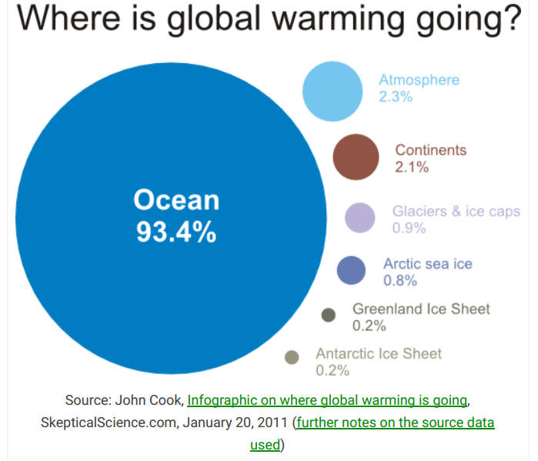
As temperature rises, the zooplankton start to grow faster than the phytoplankton. The zooplankton are more abundant and faster-growing, and are able to eat all the phytoplankton in warmer water. This creates a bottleneck in the food chain that could have large implications for the ocean's food web."
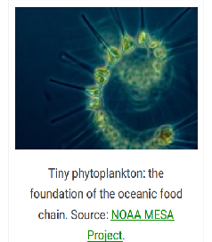
Not only does that mean that there are fewer phytoplankton around to suck up carbon dioxide, but it could also mean less food for other grazers. But it does not necessarily mean that the zooplankton will gorge themselves to death; other research has shown that food webs with more animals (consumers) than plants (producers) is sustainable for at least five years. And higher on the food chain it is zooplankton, such as krill, that are feasted on by marine life ranging from fish to whales.
Boosting the number of zooplankton, however, means the overall mass of ocean life declines: the tiny animals metabolically burn 90 percent of the phytoplankton they consume, incorporating only 10 percent. All told, with a 6-degree Celsius rise in water temperature, total biomass in the warmest microcosm shrank by 50 percent.
The ultimate effect of temperature on zooplankton and consumers higher in the food chain will depend on other ocean conditions that affect resource availability.
The satellite-imagery research on the phytoplankton in the North Atlantic reveals that bloom starts in wintertime as a result of deep, nutrient-rich water welling up to the surface. Warming is diminishing that upwelling and therefore the availability of nutrients.
Nevertheless, the experiment provides a glimpse of how the marine food chain might be transformed by climate change.

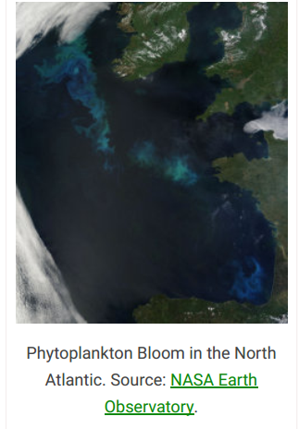
Climate change impacts on biodiversity in the Arctic
In the Arctic, it is not just a reduction in the extent of sea ice, but its thickness and age. Less ice
means less reflective surface meaning more rapid melting.
In terms of biodiversity, “the prospect of ice-free summers in the Arctic Ocean implies the loss of an
entire biome.
Less sea ice leads to changes in seawater temperature and salinity, leading to changes in primary productivity and species composition of plankton and fish, as well as large-scale changes in ocean circulation, affecting biodiversity well beyond the
Arctic.

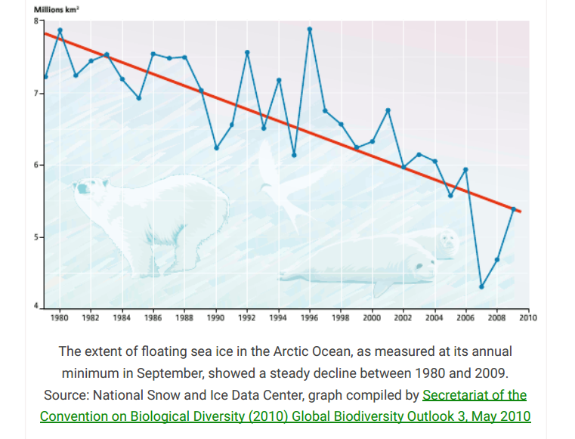
Climate change means ocean change
When talking about the impacts of climate change, we mostly hear about changes to land and the planet’s surface or atmosphere. However, most of the warming is going into the oceans where a lot
of ecosystem changes are also occurring.
Rapidly rising greenhouse gas concentrations
are driving ocean systems toward conditions not
seen for millions of years, with an associated risk
of fundamental and irreversible ecological
transformation. Changes in biological function in the ocean caused by anthropogenic climate
change go far beyond death, extinctions and
habitat loss: fundamental processes are being
altered, community assemblages are being
reorganized and ecological surprises are likely.

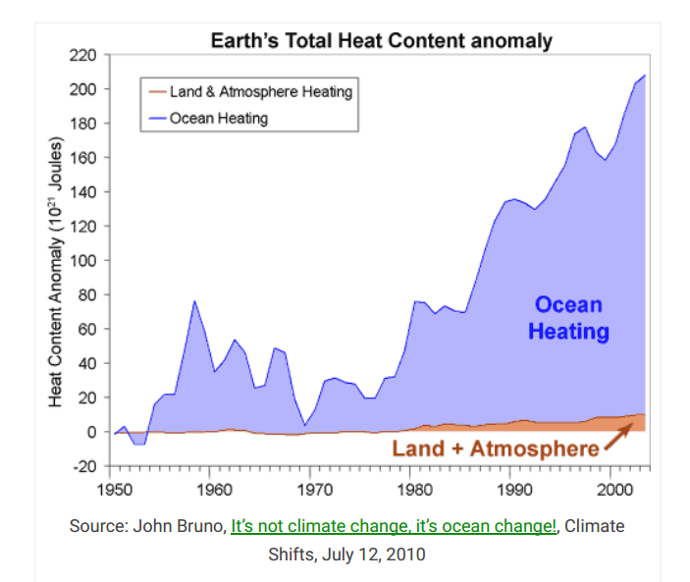

Altered lifestyles
Rising temperatures can directly affect the metabolism, life cycle, and behavior of marine species. For many species, temperature serves as a cue for reproduction. Clearly, changes in sea temperature could affect their successful breeding. The number of male and female offspring is determined by temperature for marine turtles, as well as some fish and copepods (tiny shrimplike animals on which many other marine animals feed). Changing climate could therefore skew sex ratios and threaten population survival.

Increasing Ocean Stratification & Dead Zones
As climate change warms the oceans (even just an increase of about 0.2C per decade, on average),
the warmer water (which is lighter) tends to stay on top of what is then a layer of colder water.
This affects tiny drifting marine organisms known as
phytoplankton. Though small, “Phytoplankton are a critical part of our planetary life support system. They produce half of the oxygen we breathe, draw down surface CO2, and ultimately support all of our fisheries. The phytoplankton can only live in the top 100 or 200 meters of water, but if it is getting warmer, they eventually run out of nutrients to feed on unless
the cold, deeper waters mix with those near the surface.
Ocean stratification is occurring in more and larger
areas of the world’s oceans. Researchers have found a direct correlation between rising sea surface temperatures and the decline in phytoplankton growth around the world. Stratification cuts down the amount of carbon the ocean can take up.
Ocean stratification, where warm water sits firmly on top of cold, nutrient-rich water, also creates dead zones and lowers the overall productivity of the oceans. Such dead zones were rare 40 years ago but now number several hundred. Without urgent action, climate change will continue to warm oceans, increasing stratification and producing larger and more dead zones with a major impact on future fisheries.
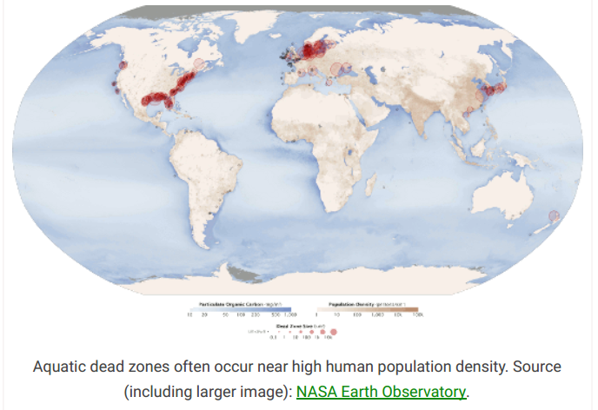

Coral reefs threatened by climate change
Around the world, coral reefs have been dying largely due to climate change. There is no hope of reefs surviving to even mid-century in any form
that we now recognize. If, and when, they go, they will take with them about one-third of the world’s
marine biodiversity. Then there is a domino effect, as reefs fail so will other ecosystems. This is the
path of a mass extinction event, when most life, especially tropical marine life goes extinct.
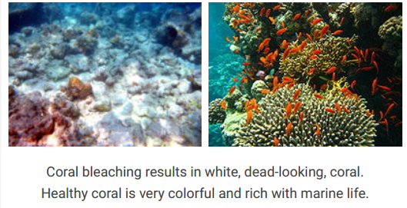

Increasing ocean acidification
Although it has gained less mainstream media attention, the effects of increasing greenhouse
emissions — in particular carbon dioxide — on the oceans may well be significant.
These are the 3 main concepts:
1. More CO2 in the atmosphere means more CO2 in the ocean;
2. Atmospheric CO2 is dissolved in the ocean, which becomes more acidic; and
3. The resulting changes in the chemistry of the oceans disrupts the ability of plants and animals in the sea to make shells and skeletons of calcium carbonate, while dissolving shells already formed.
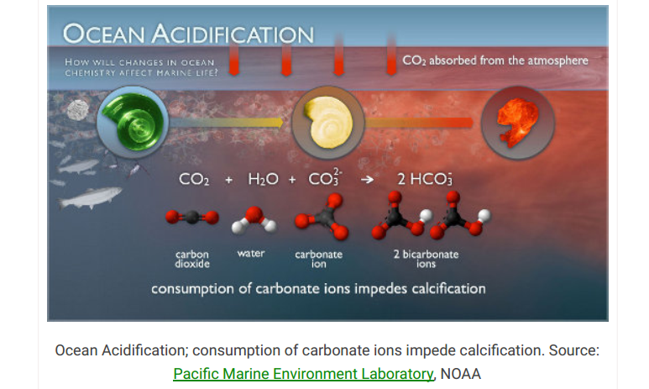

Scientists now believe that ocean acidification is unparalleled in the last 300 million years, “raising
the possibility that we are entering an unknown territory of marine ecosystem change.

C
limate change is transforming the way we think
about security. “This will not be the first time people have fought over land, water and resources, but this time it will be on a scale that dwarfs the
conflicts of the past, said the Congolese representative at the UN Security Council debate in April 2007. The French called it the "number one threat to mankind".

Climate change will affect individuals and groups
differently. Certain groups of people are particular sensitive to climate change impacts, such as the
elderly, the infirm, children and pregnant women, native and tribal groups, and low-income population.
The representative from Papua New Guinea said the
dangers that small island States and their populations faced [from climate change] were "no less serious than those faced by nations and peoples threatened by guns and bombs". An increase of just half a meter in sea level would put at risk the very survival of the human population of many Pacific Island nations.
Food security
Changes in climate could have significant impacts on food production around the world. Heat stress, droughts, and flooding events may lead to reductions
in crop yields and livestock productivity. Areas that are already affected by drought, will likely experience
reductions in water available for irrigation.
Climate change increases the frequency and intensity of some disasters such as droughts, ﬂoods and storms. This has an adverse impact on livelihoods and food security. Climate-related disasters have the potential to destroy crops, critical infrastructure, and key community assets, therefore deteriorating livelihoods and exacerbating poverty.
Sea-level will rise as a result of climate change, affecting livelihoods in coastal areas and river deltas. Accelerated glacial melt will also affect the quantity and reliability of water available and change patterns of ﬂooding and drought.

Food availability: Changes in climatic conditions have already affected the production of some staple crops, and future climate change threatens to exacerbate this. Higher temperatures will have an impact on yields while changes in rainfall could affect both crop quality and quantity.
Food access: Climate change could increase the prices of major crops in some regions. For the most vulnerable people, lower agricultural output means lower incomes. Under these conditions, the poorest people — who already use most of their income on food — sacriﬁce additional income and other assets to meet their nutritional requirements, or resort to poor coping strategies.
Food utilization: Climate-related risks affect calorie intake, particularly in areas where chronic food insecurity is already a signiﬁcant problem. Changing climatic conditions could also create a vicious cycle of disease and hunger. Nutrition is likely to be affected by climate change through related impacts on food security, dietary diversity, care practices and health.

Food stability: The climatic variability produced by more frequent and intense weather events can upset the stability of individuals’ and government food security strategies, creating ﬂuctuations in food availability, access and utilization.
Food insecurity index
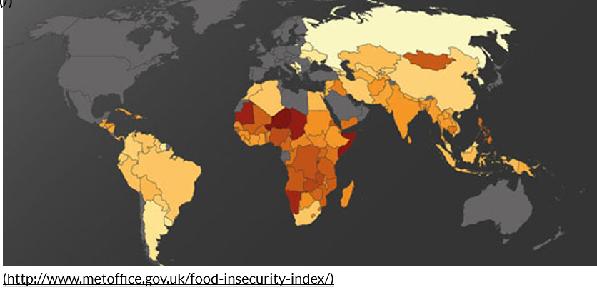
Water Security

Semi­arid and arid areas (such as the Mediterranean, southern Africa, and northeastern Brazil) are particularly vulnerable to the impacts of climate change on water supply. Over the next century, these areas will likely
experience decreases in water resources, especially in areas that are already water­stressed due to droughts, population pressures, and water resource
extraction.
As climate changes, water is very likely to become scarce at least part of the time in many areas, but more plentiful part of the time in some areas as well. The availability of water is strongly related to the amount and timing of runoff and precipitation.

With a 2.7°F rise in global mean temperature, annual average streamflow is projected to increase by 10­50% at high latitudes and in some wet tropical areas, but decrease by 10­50% in some dry regions at mid-latitudes and in the subtropics.
As temperatures rise, snowpack is declining in many regions and glaciers are melting at unprecedented rates , making water less available in areas that depend on it from melting snow and glaciers during spring and summer. Droughts are likely to become more widespread. When it does rain, more precipitation is expected to fall in extreme heavy precipitation events. Increases
in heavy precipitation events would not increase water supply, but instead result in increased flooding, except in river basins with large dams able to hold excess water until it is needed.
Water quality is important for ecosystems, human health and sanitation, agriculture, and other purposes. Increases in temperature, changes in precipitation, sea level rise, and extreme events could diminish water quality in many regions. Large rainstorms may cause large amounts of pollutants to enter rivers and estuaries, as excess water may overwhelm wastewater systems and natural buffers.

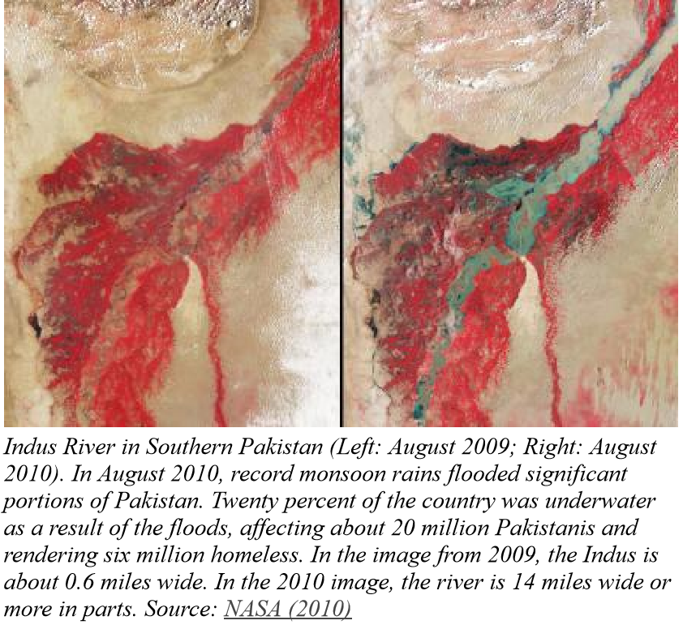

Increased pollution as well as increasing water
temperatures can cause algal blooms and potentially increase bacteria in water bodies. In coastal areas and small islands, saltwater from rising sea level and storm surges threaten water supplies. These impacts may require communities to begin treating their water in order to provide safe water resources for human uses.
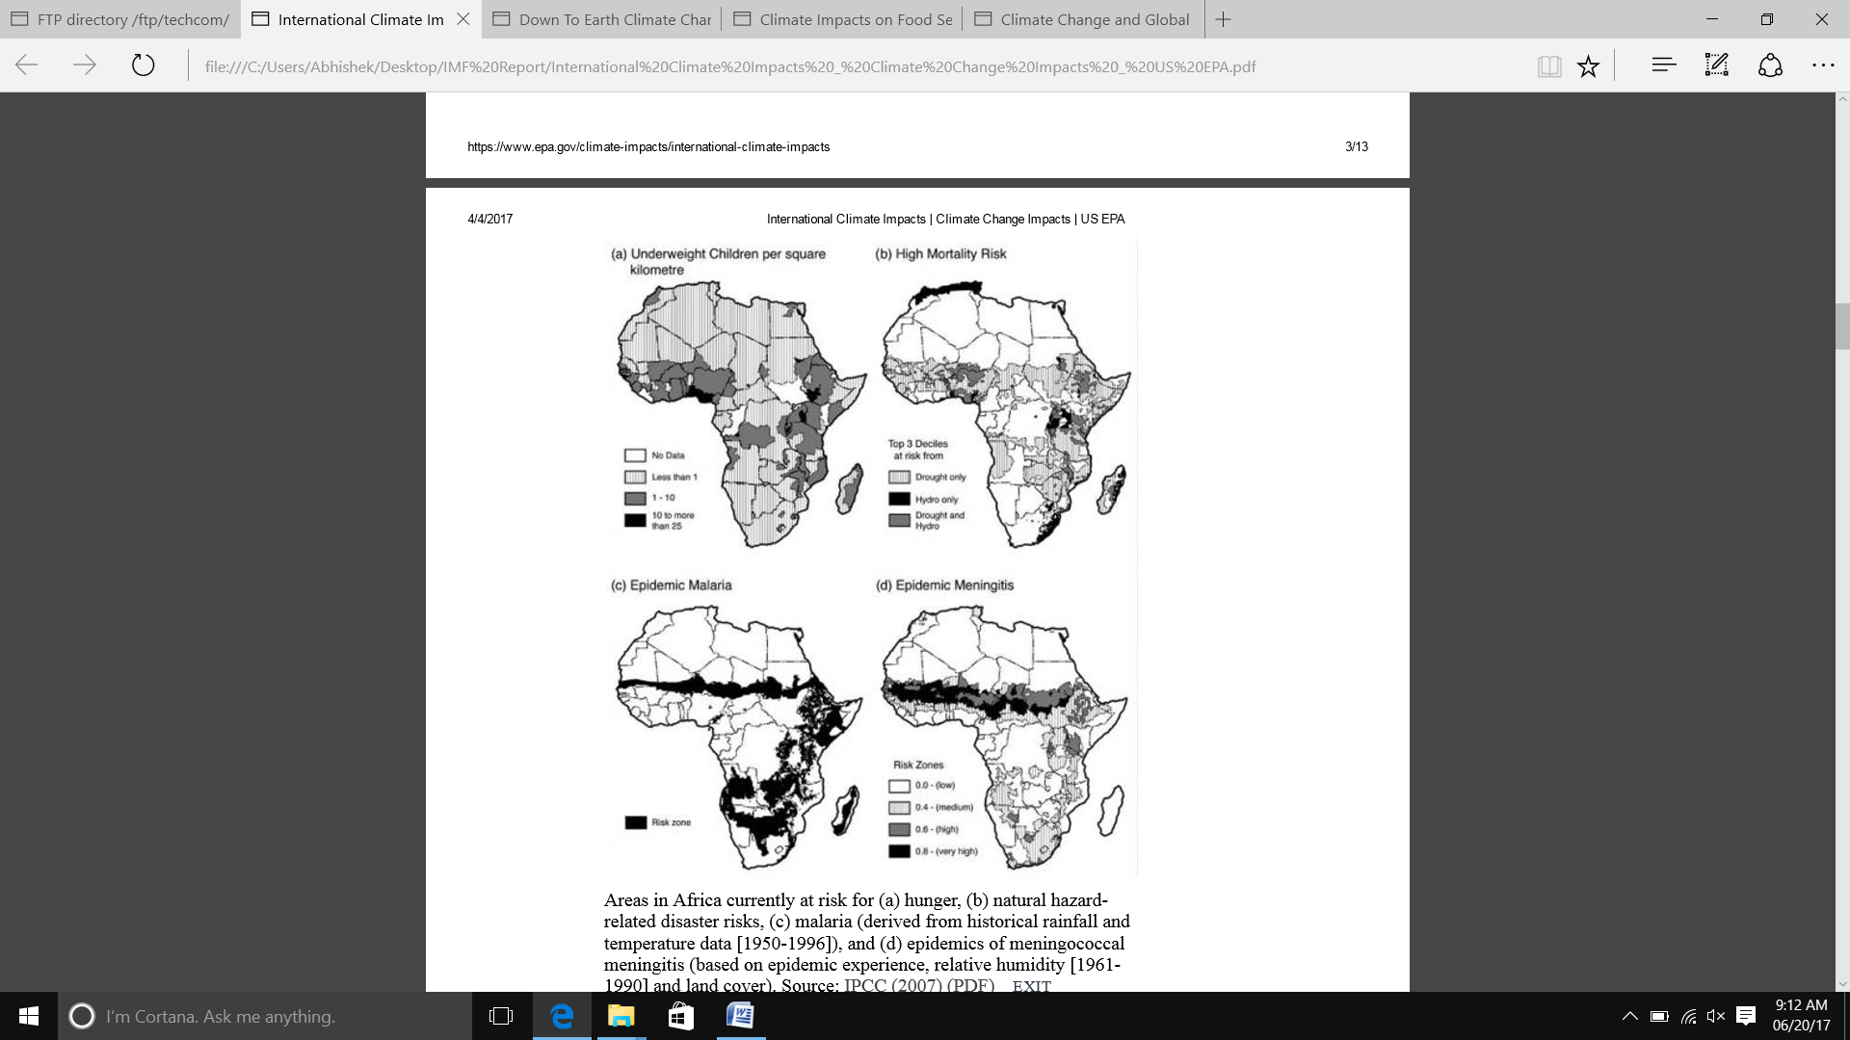

Areas in Africa currently at risk for (a) hunger, (b) natural hazard related disaster
risks, (c) malaria (derived from historical rainfall and temperature data [1950­1996]), and (d) epidemics of meningococcal meningitis (based on epidemic experience, relative humidity [19611990] and land cover). Source: IPCC (2007).

National Security

Climate change impacts are expected to exacerbate national security issues and increase the number of international conflicts. Climate change is likely cause instability in other countries­impairing access to food and water, damaging infrastructure, spreading
disease, uprooting and displacing large numbers of people. Many concerns revolve around the use of natural resources, such as water. In many parts of the world, water issues cross local and national borders.
Access to consistent and reliable sources of water in these regions is greatly valued. Changes in the timing and intensity of rainfall would threaten alreadylimited water sources and potentially cause future conflicts.
Threatened food security in parts of Asia and sub­Saharan Africa could also lead to conflict. Rapid population growth and changes in precipitation and temperature, among other factors, are already affecting crop yields. Resulting food shortages could increase the risk of humanitarian crises and trigger population migration across national borders, ultimately sparking political instability.
The ongoing loss of the ice cover in the Arctic Ocean is very likely to have with national security implications.
The Arctic Ocean has a long history of modest, though growing, shipping activity, including trans­Arctic shipping routes. Declining sea ice coverage will allow more access to these waters. However, a number of other international issues will influence the
potential growth in shipping. In the case of the Arctic Ocean, increasing access to these waters means that issues of sovereignty (priority in control over an area), security (responsibility for policing the passageways), environmental protection (control of ship­based air and water pollution, noise, or ship strikes of whales), and safety (responsibility for rescue and response) will become more important.

BIBLIOGRAPHY

http://www.globalissues.org/
http://www.americansecurityproject.org/
http://www.metoffice.gov.uk/
http://www.wfp.org/
https://globalclimate.ucr.edu
https://www.epa.gov/
http://wwf.panda.org/
http://ocean.nationalgeographic.com/
https://unchronicle.un.org/
And Scientific American Magazines

