C.V. RAMAN COLLEGE OF ENGINEERING - (BHUBANESWAR)

Pravin Kumar Mishra
Rahul Sharma
Ashish Kumar
Anurag Chakravarty
World Technical Vision 2040- Think Wild
ENERGY HARVESTING BY PIEZO ELECTRIC CELLS
PAPER PRESENTATION

ELECTRICITY GENERATION ( PIEZO-ELECTRIC CELLS )
ENERGY HARVESTING TECHINIQUES
Abstract
Generation of electricity onboard involves diesel engine driven alternators, turbo alternators and storage batteries .In future there will be considerable shortage of fuel .which will lead to shifting of main source of power to alternate sources of power, then piezoelectric cell could play a significant role for catering the power requirements as these kind of sources can reduce the power load significantly for main power source.

Introduction
Piezoelectricity refers to electricity produced by some special types of crystal in response to applied mechanical stress. Research work is being conducted in various parts of world to enhance the capacity of piezo electric materials to generate more electricity. With the rapid development in the field of nanotechnology it can be considered that around 2040 these piezo cells will be highly improved. Presently LeadZinconate titanate crystal generates measurable amount of piezoelectricity when their static structure is deformed by 0.1% of original dimension.
The main reasons for using these cells will be-
1) No requirement of prime movers.
2 ) Eco friendly as there is no direct pollution involved.
3) Various positions on ship can be utilized for the electricity generation.

The Body
These cells are not able to perform satisfactorily till now as mechanical stress on piezoelectric Cells produce a large voltage but current developed is of a small magnitude generally a few milli -ampere, so these cells are being used in lighters to generate spark for the ignition. The reverse effect where electricity causes mechanical stress in the material has proved very useful in development of sensor like SONARS and some other important devices in the field of acoustic. The latest development in field of nanotechnology has improved the materials and research are carried out to generate electricity from movement of people in crowded areas like railway platforms .Research work in USA has shown a leap in electricity generation by planting piezoelectric cells in soldiers boot.
For the use of piezoelectric cells on board ships various place are needed to be identified where mechanical vibration can be used to harvest significant amount of electricity to run low power equipments like light , control equipment ,and several other equipments. These cells can be used in conjunction with photovoltaic cells for generation of a large amount of electricity .various experiment were conducted on this in which it was found that photocells made up of piezo electric materials are giving more out than bare photovoltaic cell at small increase in noise level around 75 decibels..(details below)

Facts based on research study
[The efficiency of a hybrid photovoltaic cell that contains piezoelectric materials can be increased simply by placing it near a source of ambient noise or vibration. The effect was demonstrated with organic cells using zinc oxide nanotubes. The electricity generated by the piezoelectric effect itself is a negligible percentage of the overall output. Sound levels as low as 75 decibels improved efficiency by up to 50 percent. Efficiency peaked at 10 kHz, the resonant frequency of the nanotubes. The electrical field set up by the vibrating nanotubes interacts with electrons migrating from the organic polymer layer. This process decreases the likelihood of recombination, in which electrons are energized but settle back into a hole instead of migrating to the electron-accepting ZnO layer.]
Specially designed capacitors can be used for storage of efficiency of these capacitors are high and as losses are minimized greater amount of electricity will be useful. These capacitors can be charged by batteries of piezoelectic cells placed at various places .Storage of electricity will eliminate the transient effect due to fluctuation in current resulting from mechanical vibrations. Design of battery can changed according to place of action ,viz battery which will generate electricity due action of waves in the ocean will be flat to provide more surface area .while spring loaded cells can used for machinery space ,similarly swinging cells can be used in conjunction with photovolataic cells as wind will impart movement in them.

- The piezoelectric cells so far seems to be useful only for low power equipments but special designed acoustic transformer converts low voltage into high voltage and thus high voltage equipments such as motors and other equipment can also be made to run…..

Research study shows
A piezoelectric transformer is a type of AC voltage multiplier. Unlike a conventional transformer, which uses magnetic coupling between input and output, the piezoelectric transformer uses acoustic coupling An input voltage is applied across a short length of a bar of piezo ceramic material such as PZT, creating an alternating stress in the bar by the inverse piezoelectric effect and causing the whole bar to vibrate. The vibration frequency is chosen to be the resonant frequency of the block, typically in the 100 KH to 1 megahertz range. A higher output voltage is then generated across another section of the bar by the piezoelectric effect. Step-up ratios of more than 1000:1 have been demonstrated.

Typical piezoelectric cell

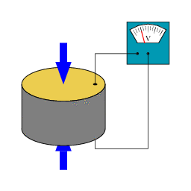
DESIGN ASPECT
1) The piezoelectric cells can be placed on ship side and bulbous bow covered with a diaphragm to prevent water ingress without dampening the stress on the cells.
2) In machinery spaces vibration of machines can be utilized to produce electricity from piezo electric cells.
3) Piezo photovoltaic cells which is combination of photovoltaic cells and piezo cells which generates higher amount of electricity in an area with higher level of vibrations. These hybrid photovoltaic cells can be placed on cargo hatches, accommodation, forecastle &other open space .

The electricity generated by these cells will be supplied to a capacitor where electrical energy will be stored. The capacitor will be providing supply to the devices according to the requirement. This whole system is comprised of piezoelectric cells situated at various places. The storage device which is a capacitor is placed in a special compartment .the capacitor can be charged from the piezo cells situated at above mentioned locations.

zz
As shown above such arrangement can serve the purpose of obtaining electricity from piezo electric cells placed at various places.

The block diagram below shows the network between the cells and the storage module.
Three cells will be supplying to a storage device.

. SUPER CAPACITOR
The capacitors which can be used in increasing the efficiency of piezo cell electricity generation can on one of the type as shown below. These are presently used in wireless communication devices. In the schematic diagram it is shown that how these super capacitor is being used.
The environment provides infinite ambient energy, including piezoelectric and photovoltaic energy. A battery or a supercapacitor acts as a power buffer to store enough energy to provide the power bursts needed to acquire and transmit data. These energy-storage devices charge at low power and deliver the burst power when necessary. Supercapacitors can offer an ideal solution for microharvesting applications characterized by long periods of inactivity interrupted by bursts of activity. For these applications, supercapacitors can typically easily meet demands for peak power that lie well above the steady-stage power available from the ambient energy source. By drawing on specialized power management devices, engineers can readily incorporate supercapacitors in microharvesting circuits.

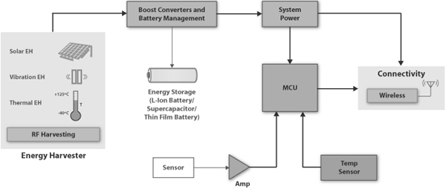

SHORE BASED APPLICATION IN ENERGY HARVESTING
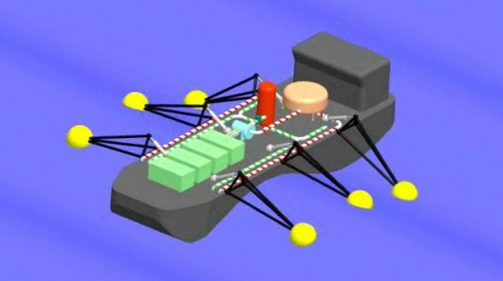
The ship would consist of floating buoys which would be deployed on both the sides of the ship. It would be approximately 50 meters long and would have hinged arms, on which, floating buoys would be deployed on both the sides.
As the ship moves through the water, the oscillating motion of the buoys would be used to generate and store power in the system mounted on the ship.
The system can generate power even while the ship is anchored in the sea. In case of rough weather, the ship can be brought back to the port with the whole set up. The powered generated and stored on the ship can be transferred from the on board battery .system to any shore power grid system.
It is expected that such ship would have a power storage capacity of 20 megawatt-hours and would generate electricity at the cost of 15 cents per kilowatt-hour – way less than those offered by conventional offshore wave power generation systems.

CONCLUSION
Based on the speculations concluded by the present day developments in the field of piezo electric materials, it would not be great task to generate enough electricity to drive electrical propellers. This system will be a great achievement as it will reduce the dependency on fuel oil and make the green shipping dream come true.
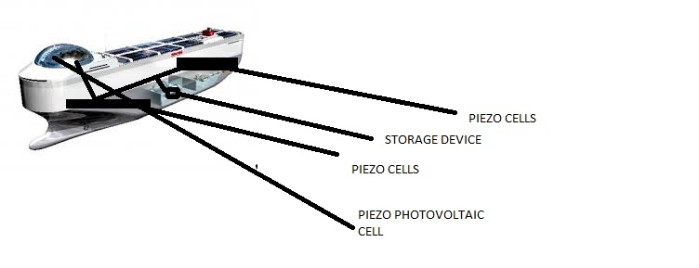
……………………………………………………………………………………………………………………………………………....

REFERENCES

WIKIPEDIA, MARINE INSIGHT AND POSSIBLE CONCEPTS CULTIVATED
Damjanovic, Dragan (1998). "Ferroelectric, dielectric and piezoelectric properties of ferroelectric thin films and ceramics
Market Report: World Piezoelectric Device Market
Machinedesign.com
Gautschi, G (2002). Piezoelectric Sensorics: Force, Strain, Pressure, Acceleration and Acoustic Emission Sensors, Materials and Amplifiers. Springer

