Block Construction of Ship
Socioeconomic Impact of Futuristic Technologies

Impact of Advanced Technologies on Human Life
TRANSTECH ’14
Authors:

Sujoy Dey Sarkar (Corresponding author) (201037TP309)

Tel:+91-7875628199 E-mail:sujoydeysarkar@gmail.com

Rishabh V. Pandey (201137TP269)

Tel: +91-8975666064 E-mail: rishabh.v.pandey@gmail.com



Tolani Maritime Institute
Talegaon-Chakan Road, Induri, Pune, India 410507
Tel: +91-2114242067Fax:+91-2114242013

Abstract

The modern advancements in the field of science and technology have helped us allotin variousareas of the industry, naval architecture is one such area. In this report we would discuss the fast production of ship by block construction method and its socioeconomic impact on our country as well as the world. Which has bought a revolution in this industry; we will give example of Indian company like Pipavav,which ispursuing these technologies to become best shipbuilding company in India.

Preface

This paper contains information regarding Block Construction of Ships and its socio-economic impact on various sectors of our environment and society, in accordance with the theme of TRANSTECH ’14. It contains thorough knowledge about the design aspects of various blocks of a ship during its construction phase implying various work practices, techniques and technologies.

The data in this paper is presented in SI units (System International) since SI units are already been accepted in our country. The symbols used in the paper are also pertaining to SI units. Reference have been made to different sources of information while compiling the data for the paper and a list of reference is included in the end of the paper so that further information on the topic can be obtained.

Care has been taken to cover almost all the related important topics embracing Block Construction of Ships there are chances for error in the paper in spite of care taken in reading the sources. We will be highly grateful to the readers if they could bring to our attention, the errors if any, noticed by them.

Sujoy Dey Sarkar
Rishabh V. Pandey

Key Words
Assembly: Joining of two or more blocks.
Block: A big structure that will later become part of a mega-block.
Mega-Block: A big structure that will later become part of a ship.
Preassembly: Joining of various parts before the assembly
Contents

1. Introduction 4

2. Design and Implementation 4

3. Building of Subassembly 5

4. Building of a Block. 5

5. Hull Erection 6

➢ 5.1 Pre-erection 6

➢ 5.2 Erection 6

6. Pre Outfitting at Block Stage. 7

7. Socio-economic Impact. 7

8. Conclusion 10

9. Acknowledgement 10

10. Appendix 10

11. References 11

1. Introduction
Each year, some 86,000 ships move more than 9 billion tons of cargo, more than a ton for each person on the planet, across our seas.
Business is made by entrepreneurs by shuttling products and commodities from where they're most efficiently produced to where they're most profitably consumed. But what socioeconomic impact does these businesses and ship building industries are having on our world right now, is a matter of discussion.
Around 90% of world goods are carried through sea, making shipping a major form of transport sector, also an essential communication link connecting coastal cities, countries and continents.
The gigantic growth of population in India as well as the world has caused a huge increase in energy demand which can only be met by offshore exploration and production of hydrocarbons, as alternate forms of energy are still at developing stages and cannot realise these demands.
The shipping industry until recently was a booming industry in developing nations thanks to globalisation, low cost manufacturing and advancement in technology of ship building, but in recent years global terrorism, piracy, transnational crimes along with cost of security measures to combat these situation has affected the industry adversely.

2. Design and Implementation
The process of building a ship requires production of various drawingsbut for that we require owner’s stipulation, once procured the first procedure is to produce forward design.
Forward design consists of technical specifications of the ship, the estimate cost, amount and quality of raw materials required, and labour cost. Also many other factors like inflation market costing etc. are considered while estimating these various costs.
These forward designs are submitted by various companies each having their own league of naval architects producing both innovative and cost effective designs. The company which the owner chooses is then given further plow ahead to the designing process, which is the basic design.
Figure 1: Various Steps in Designing.
Basic design is one of the most important drawing of vessel and thus once finalised cannot be changed. It basically has following parts.
- Hull Form,which consist of CFD analysis, model testing, transverse draft stability, this basically affects the water resistantfeatures of the vessel.
- Hull structure, which consists hull shape, scantling profiles, strength calculation (section modulus as per max stress), detailed finite element analysis of box girders.
- Machinery, power of main engine required, pressure head required for pumps, flow rate required for air compressor system and schematic for different systems.
- Outfitting both structural as well as of accommodation.
- Electrical equipment, power flow chart.
- Electronic equipment.
All these drawings need to be approved by classification society.
There after finally comes a production drawing, which contains detail three dimensional drawings of the various structures and hull. These drawings are used by production engineers in yard workshops to build structures and easily translate what’s to be done to the workers.

3. Building of Subassembly
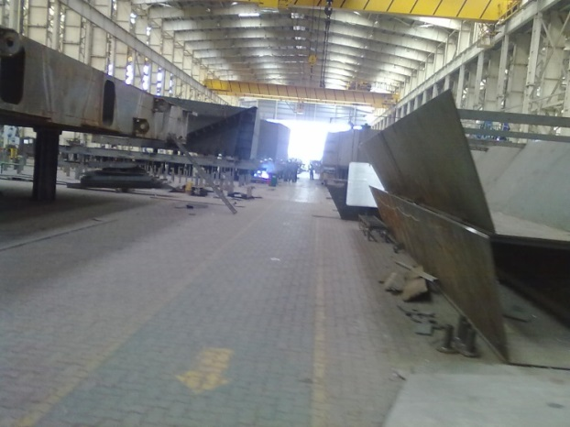

All block units are constructed at BCS (Block Construction Site).The procedure of building a block involves creation of subassemblies, which is done by cutting and bending of steel plates; which are bought from steel factories.
These steel plates are first cut into proper dimension by various CNC laser cutting machines like plasma cutter and LPG + O2. Once the desired dimensions areachieved then the plate is sent to bending section; here, by the help of templates a bending curve is procured.With the help of this curve various bending lines are drawn on the plate, onto which hydraulic press or line heating method is used to achieve the desired curve.
Figure 2: Corrugation Subassembly.
Note: Thicker the plate is, harder is it to bend and thus line heating method is used over hydraulic press in such situations.
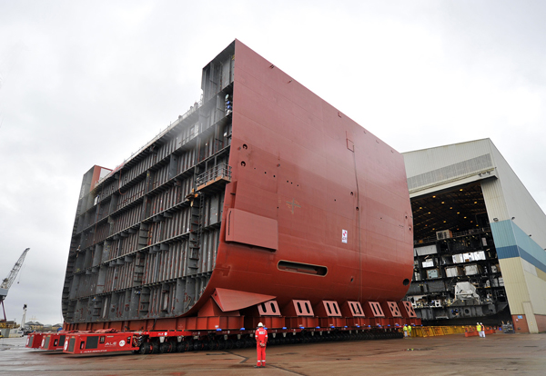
After cutting and bending, the plates are welded together to form subassembly.These subassemblies later help us to form a block unit, for example A-bracket, frames, L-bar, corrugations, etc. are used for giving support to the ship, and hence can be pre-constructed.


4. Building of a Block.
The process of building a block involves creation of a base, which is done by the help of adjustable height supports or by manually cutting and placing steel plate for supports.
Figure 3: Mega Block.
Once the base is created (which has a particular curvature due to specific height of each support) the curved plates are placed on it and welded together; such that the plates matches exactly to the required curvature.
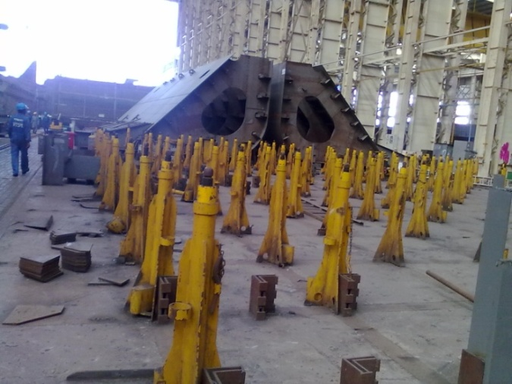
This base is used for further constructions, various frames and stiffeners are installed on it to act as a support. These supports are then covered by another set of curved plates, to form a closed unit. Thereafter this unit is turned over (with new base created for turnover support) and additional supports are installed, making this face as the interior part of the ship.
Figure 4: Block supports.
Note: This is just one of the ways to create a block unit; many other ways are also used and are varied as-per the type of block. However this is the most common of them all.

5. Hull Erection
Once the block units are constructed they are transferred to the SCS (Ship Construction Site), where these blocks are joined together to create pre-erection, mega-block, and finally the shipitself.

5.1 Pre-erection
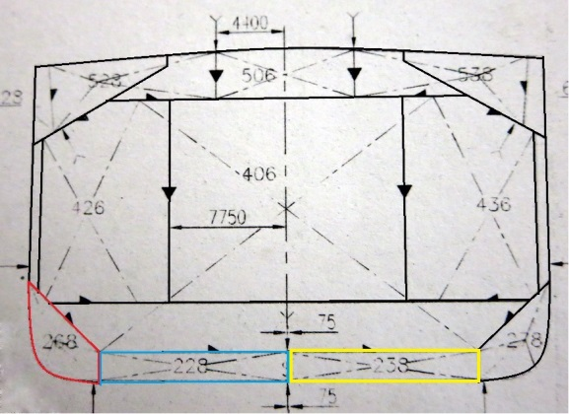
Various blocks are joined together to form pre-erections; which are later used in erection as a whole.This saves a lot of time and resource; since joining small and complex parts is allot easier. For example a side-shell and tank top can be joined much conveniently by keeping the side shell horizontal rather than vertical which makes it unstable, also we have to do 4G welding instead of 2G in-case the latter method is followed.

5.2 Erection
Erection involves laying of the keel plate by the help of an instrument know as Total Stations, this is perhaps the most crucial part of the process; since if the keel moves the whole aligning goes haywire.
Figure 5: Hull Structure.
Thereafter usually the centre block or E/R block is placed with the help of various supports (Jigs, Dock-Block, etc.), this is done because from here we can add a block inany directionwe want (Top, bottom, port, star-board), the E/R block is also sometimes placed first since it is the most complicate part of the puzzle.
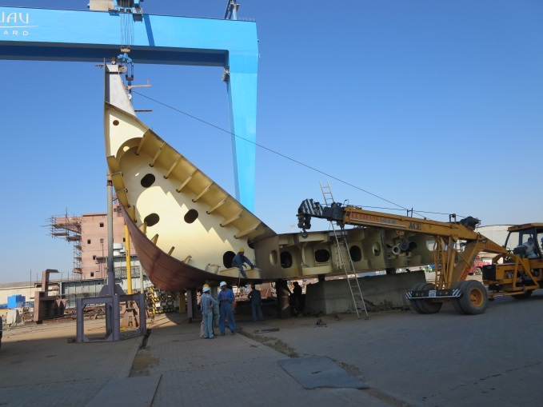
All blocks have a specific amount of tolerance so that fitting can be done without any inconvenience, however if the misfit still persist the block may have to go through repair work.
Note: Pre-erection can be done on land; since the size of the block is still small enough for lifting, however erection should take place inside a dock; since now various blocks are joined together to form mega-block; which cannot be moved once erected.
Figure 6: Hull Pre-erection.

6. Pre Outfitting at Block Stage.
The auxiliary parts like pipefitting, manhole covers, ladders etc. are already pre-installed in the blocks to save time, however this procedure requires the production drawings to be very accurate.
The cabling and other electrical installation are only done after the erection of the ship, whichincludes loading of the main engine and other auxiliary machinery on-board.

7. Socio-economic Impact.
The Socio-economic impact of Ship Building or the Shipping Industry is both positive as well as negative; some of these impacts are discussed below, though categorizing them under pros or cons seems impractical and hence is left at reader’s discretion:
- Increase in employment inOECD countries and BRICTIM Nations.
- Development of Infrastructure in developing nations.
- Many transportation analysts report that most of the critical infrastructure in developed countries was built more than 50 years ago. The demand for raw materials to create and rebuild such structures will spark the demand for more ships.
- Increase in Quality of Life especially rise of Middle Class.
- Energy Demand,between China and India, we have almost 2.7 billion people and,assuming these two countries continue to improve their standard of livinggrow their domestic economy, and offer better local distribution,Itis expected of them to increase the general commodity trades, and of finished goods.
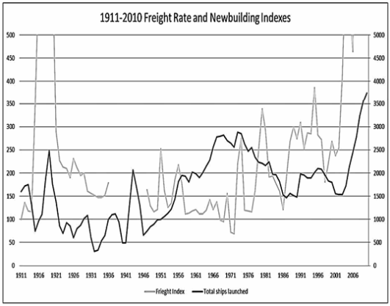
- US Natural Gas and Shale boom and Strict Laws in maritime industry are changing its role from major importer to an exporter.
Figure 7: Cyclic nature of shipping industry.
- Recession of 2008 and European Sovereign Debt Crisis has caused the trade to shift more toward Asia, EspeciallywithEuropean Financial Banks reducing shipping loans.
- China’s cheap labour advance technology has made it a major maritime industry. Coal to Oil or natural gas transition will also increase in the country.
- Venezuela, which used to sell its crude primarily to the U.S. Gulf Coast, has now entered into a long-term development contract with Chinabecause of political friction between Venezuela and the U.S.“The trip to China is three-and-a-half times as long as the trip to the Gulf Coast, so even though the same amount of crude is being transported, it’s the distance that is a boom for us.
- Earlier Public Equity and Family Business were the main investors in shipping but Private Equity are also entering the shipping industry and bringing along what is considered as “smart money” into the market.
- Expansion of refineries in India and China; combined with less stringent rules makes them ideal for crude oil import and refined products export.
- Consolidation and Outsourcing are being followed by shipping companies to become more efficient in both market and management respectively.
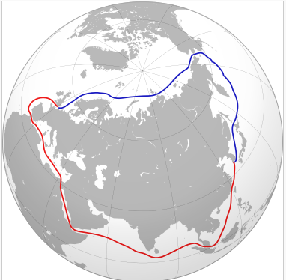
- Cyclic nature of shipping industry makes it a very risky business.The current overcapacity of ships is 2.5 times the requirement; still there is requirement for specialised ships.
- Free Trade, The ability to export on trade has been a central pillar for bringing a billion people out of poverty in the last 15 years. China and India have seen a huge boom in development, moving up from poor countries to middle-income. Historically, free trade is fundamental for innovation. Countries that trade are more open outside of their borders. They are open to new ideas, which spark innovation and economic growth. For e.g. of previous countries like North American Free Trade Agreement.
Figure 8: A graphical comparison between use of the North East Passage (blue) and an alternative route through the Suez Canal (red)
- New Trade routes have been found like the north east passage (Arctic Ocean shipping route) which was caused due to melting of ice has reduced the distance considerably between Asia and European countries. This could lead to designing of specialised ships that could face the harsh climatic condition such as present in artic.
- Earlier ships use to have a life of 25 to 27 years but nowadays ships are being scrap in 15 to 17 yrs. This is mainly due to stricter reforms bought by the IMO and is thus causing to build more advance ships which can reduce environmental pollution more effectively.
- Piracy has affected the shipping industry abysmally but prosecution of these crimes is complex mainly because of jurisdiction and multiple countries involvement (nation of the flag of the vessel or the nation(s) of the crew; hence there should be an international tribunal that judges pirates. For e.g. The Hague, in the Netherlands, where pirates are prosecuted by one common law.
- The ISM code is established for safe management and operation of the ship more importantly it helps the crew to be out of harm’s way.
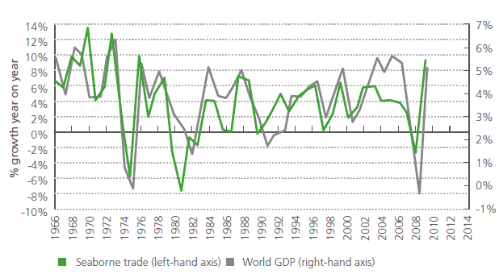
- Increase in usage of LNG fuelled shipsinstead HFO fuelled ships in future, mainly due to increase in global sulphur limit in futureand the EEDI norms.Also there can be increase in usage of scrubbers, if the LNG prices don’t fall in future.
Figure 9: The relationship between GDP growth and seabornetrade growth. Source: Clarkson Research Services Ltd.
- New ship buildings will be fitted with EGR or SCR by 2016.The Tier III80% reduction requirementEmission Control Areas (ECA) being the driving force behind it.
- The Ballast Water Management Convention(BWMC) once mandatory will affect the designs of thenew ships built in future.
- Fuel cost is the largest cost element for virtually every shipping company today. The regulatory shift towards low sulphur fuel is one of the developments in the industry that will have the largest impact in terms of shipping costs and operations, and may have a strong impact on the ‘uptake’ of new technologies.

8. Conclusion
To conclude it can be said that ship construction is an important part of the shipping industry, and development in this is field affects the whole industry significantly.
The Shipping industry hence is only going further evolve from here into a more energy efficient and economically balanced industry, which will affect and change the lives of billions humans at various levels.

9. Acknowledgement
We would like to acknowledge ourinstructors at PDOECL (Pipavav Defense and Offshore Engineering Company Ltd.), our friends and teachers at TMI (Tolani Maritime Institute) for providing us unconditional help for devising this paper. We are also thankful to various sources (on internet and books both) which provided us with valuable material required. We will be glad to receive any suggestions and comments for improvement of this paper.
Regards,

Rishabh Vishal Pandey, Sujoy Dey Sarkar.

10. Appendix

BCS: Block Construction Site.
SCS: Ship Construction Site.
IMO: International Maritime Organisation.
HFO: Heavy Fuel Oil.
EGR: Exhaust gas recirculation.
SCR: Selective catalytic reactors.
LNG: Liquefied Natural Gas.
CFD: Computer Fluid Dynamics.
CNC: Computer Numerical Control.
EEDI: Energy Efficiency Design Index.
BRICKTIM: Brazil, Russia, India, China, Korea, Turkey,
Indonesia and Mexico.
Inflation: A progressive increase in prices.

Auxiliary part: Parts of the ship which are not directly involved in propulsion.
Erection: Putting up the ship’s structure
Forward design: Preliminary Designs given as a tender under a given quotation, for the owner’s consideration.
Basic Design: The final drawing from which the ship will be constructed.
Production Drawing: Made from Basic Drawings, detailed drawingsused for production of various parts of the ship.
Template: A wooden instrument use to measure the twist, curvature, and height and thus get the bending curve of the plate.
North American Free
Trade Agreement(NAFTA): A 1993 agreement between the United States, Canada, and Mexico with to eliminate tariffs between the signatories.

11. References

- Lorri Ann LaRocco, Dynasties of the Sea: The shipping owners and Financers Who Expanded the Era of Free Trade. Marine Money, Inc.year 2012.
- Statistics of India’s ship building and ship repairing industry2011-12. Government of India.
- Annual report 2012-2013.Government of India, Ministry of shipping.
- Department of Economic and Social Affairs, Commission on Sustainable Development Ninth Session 16 - 27 April 2001, New York.
- Maritime sectorwww.windrosenetwork.com (https//Maritime%20Sector.htm).
- William V. Harris and Kristine Iara, eds.Maritime Technology in the Ancient Economy: Ship-Design and Navigation.
- Mark Brown and Alex Chambers. How Europe’s Governments have Enronized their debts, Euro money, September 2005.
- Counter Piracy Workshop Focuses on Unified Standards http://www.jfcnaples.nato.int/page8840291.aspx
- PIRACY DEFINITIONS IN DOMESTIC AND REGIONAL SYSTEMS Public International Law & Policy GroupMarch 2013
- Shipping 2020. DNV 2012

