Global Logistics Industry: An Overview
Introduction
The global logistics industry is the backbone of international trade and commerce, facilitating the movement of goods, services, and information across borders. It encompasses transportation, warehousing, inventory management, freight forwarding, packaging, and supply chain management. As globalization, e-commerce, and technological advancements continue to reshape trade patterns, the logistics sector has become increasingly strategic for economic growth and business competitiveness.
Global Market Overview
The logistics industry is one of the world's largest economic sectors, supporting manufacturing, retail, agriculture, healthcare, and e-commerce. The market has experienced robust growth due to rising international trade, digital transformation, and increasing consumer demand for faster and more reliable deliveries. The expansion of cross-border trade agreements, urbanization, and global supply chains has further accelerated industry growth.
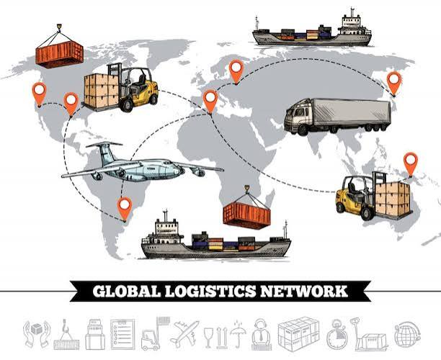
Key characteristics of the global logistics market include:
- Strong growth driven by globalization and digital commerce.
- Increasing integration of multimodal transportation systems.
- Rising investments in logistics infrastructure and automation.
- Expansion of third-party logistics (3PL) and fourth-party logistics (4PL) services.
- Growing emphasis on sustainability and carbon-neutral logistics.
Major Segments of the Global Logistics Industry
1. Transportation
Transportation remains the largest segment of the logistics industry and includes:
- Road freight
- Rail freight
- Air cargo
- Maritime shipping
- Inland waterways
- Intermodal and multimodal transport
2. Warehousing and Distribution
Modern warehouses have evolved into highly automated distribution centers equipped with robotics, AI, and warehouse management systems (WMS) to improve efficiency and order fulfillment.
3. Freight Forwarding
Freight forwarders coordinate international shipments by managing customs documentation, cargo consolidation, insurance, and multimodal transportation.
4. Contract Logistics (3PL and 4PL)
Organizations increasingly outsource logistics operations to specialized providers to reduce costs, improve efficiency, and focus on their core business activities.
5. E-commerce Logistics
Rapid growth in online retail has significantly expanded demand for fulfillment centers, last-mile delivery networks, and reverse logistics services.
Key Drivers of Growth
Several factors continue to fuel the expansion of the global logistics industry:
- Growth of international trade
- Rapid expansion of e-commerce
- Increasing demand for same-day and next-day deliveries
- Digital transformation of supply chains
- Government investments in transport infrastructure
- Global manufacturing and outsourcing
- Rising consumer expectations for supply chain visibility
Technology Transforming Logistics
The logistics industry is undergoing rapid digital transformation through:
- Artificial Intelligence (AI)
- Internet of Things (IoT)
- Blockchain technology
- Big Data Analytics
- Cloud-based Transportation Management Systems (TMS)
- Warehouse Management Systems (WMS)
- Robotics and warehouse automation
- Autonomous vehicles and drones (pilot deployments)
- Digital freight platforms
- Predictive analytics for demand forecasting
These technologies improve operational efficiency, reduce costs, enhance shipment visibility, and optimize supply chain performance.
Sustainability and Green Logistics
Environmental sustainability has become a major priority for logistics companies. Key initiatives include:
- Electric delivery vehicles
- Alternative fuels (hydrogen, biofuels, and sustainable aviation fuel)
- Green warehouses powered by renewable energy
- Carbon emissions monitoring
- Route optimization using AI
- Sustainable packaging
- Circular supply chains and reverse logistics
Key Challenges
Despite strong growth, the industry faces several challenges:
- Supply chain disruptions due to geopolitical conflicts and pandemics
- Rising fuel and transportation costs
- Labor shortages in trucking and warehousing
- Port congestion and infrastructure bottlenecks
- Cybersecurity threats
- Regulatory compliance across multiple jurisdictions
- Climate-related disruptions affecting transportation networks
Emerging Trends
Major trends shaping the future include:
- Supply chain diversification and regionalization
- Nearshoring and friend-shoring strategies
- Growth of omnichannel retail logistics
- Expansion of cold chain logistics
- AI-driven logistics planning and decision support
- Hyper automation in warehouses
- Digital twins for supply chain simulation
- Greater resilience through end-to-end supply chain visibility
Leading Global Logistics Companies
Some of the world's leading logistics service providers include:
- DHL Group
- DSV
- FedEx
- United Parcel Service (UPS)
- Maersk
- C.H. Robinson
- DB Schenker
- Nippon Express
Future Outlook
The global logistics industry is expected to continue expanding over the coming decade, driven by digitalization, automation, cross-border trade, and sustainable logistics practices. Asia-Pacific is projected to remain the fastest-growing region due to its strong manufacturing base, rising domestic consumption, and expanding e-commerce ecosystem. Companies that invest in advanced technologies, resilient supply chains, and environmentally sustainable operations are likely to gain a significant competitive advantage.
Conclusion
The global logistics industry has evolved from a traditional transportation function into a technology-enabled, integrated supply chain ecosystem. As businesses increasingly prioritize speed, resilience, transparency, and sustainability, logistics will remain a critical enabler of global trade and economic development. Future growth will depend on the industry's ability to leverage digital innovation, strengthen supply chain resilience, and adapt to changing geopolitical, environmental, and consumer demands.

