Satellites Communication: Present and Future

Presented by: Cdt. Avijit Sharma(12TP147)
Cdt. Himanshu Sharma(12TP185)
Cdt. Ashutosh Patel(12TP144)
Abstract
In the last fifty years, satellites played a key role in the growth of global communications and grew to a mega industry, enabling breakthroughs like intercontinental telephony, live television from remote regions, broadcasting of television channels, global positioning and reliable data network. Satellite technologies in recent past has seen a significant leap in advancement like Multi-spot beams allowing much higher throughput at lower cost and more efficiently. Thus there is need to look into the existing available satellite communication technologies to harness the optimum from this mega resource. This paper aims at analysing the Use of Satellites in Communication Technology.
Keywords: satellites, communication, uplink, downlink, gateway.
BASIC ELEMENTS OF SATELLITE COMMUNICATION
Long range communication via modulated micro waves was first introduced in 1920s. These systems had limited communication range thus in 1950s a concept was introduced of using orbiting space vehicles as relay stations. Echo Satellite – a metallic reflecting balloon placed in orbit successfully demonstrated communication link across Atlantic Ocean. A communication satellite acts as a microwave repeater in space, consists of two major sections namely the spacecraft bus and communication payload. The spacecraft bus provides the functional support like attitude control, electric power, thermal control, etc. whereas the communication payload functions as microwave repeater for retransmission of the microwave back to ground. The communication between earth station and satellite can take any of the under mentioned forms:-

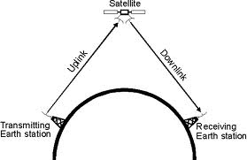
- Type A System. This basic system consisting of an uplink from an earth station to satellite and a downlink from satellite back to the earth. A satellite that merely relays the uplink carrier signal as a downlink is called relay satellite / repeater satellite whereas the satellite that electronically operates and reformats the uplink prior to re transmit is called as processing satellite.

- Type B System. In this system, it accommodates a satellite cross link which is establish between two satellite prior to down link remission. Such system allows communication between the earth stations which are not visible to each other and by spacing multiple satellites in proper orbits around the earth, worldwide communication can be achieved.

- Type C System. In this system, the relay stations can be satellite or/and near earth user (aircraft/ships). In this system the uplink is called forward link and downlink as return link. Satellites increase their area of coverage area by using inter-satellite links between satellites in the same orbital plane or different planes. The Inter-satellite links reduce the number of ground stations needed by routing traffic through the satellite network.

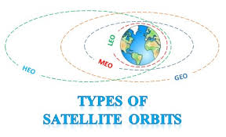
- Orbits. There are three orbital heights associated with communication satellite. They are as under:-
- Low earth orbits (LEO) : 500 - 900 Km
- Medium earth orbits (MEO): 5000 - 12000 Km
- Geo stationary earth orbit (GEO): 36000 Km
Most of the communication satellite uses GEOs. The LEO and MEO are used for earth observation, navigation, data, and voice communication. Based on the Kepler’s Law at one particular height the speed of satellite will exactly match the rate of rotation of the earth. If such a satellite is in circular equatorial orbit, it appears to remain stationary in the sky to ground observer. This occurs at 35,786 Km above the earth’s equator.
The major reason for popular use of this orbit by communication satellite is due to lack of tracking need and by using three communications satellite placed at 120 degree apart it is theoretically possible to cover the entire world. However there are certain disadvantages of using GEO like the satellite coverage in practice is limited to regions below 70 degree latitude North or South.
SATELLITE COMMUNICATION APPLICATIONS
Media Content Distribution (MCD)
Satellites have been used by the media industry to gather content, exchange, distribute and broadcast it. The direct-to-home satellite broadcasting is one of the most important technologies for MCD.
Satellite News Gathering (SNG)
Satellite news gathering enables journalists around the world to create TV reports and transport them via satellite to post-production or broadcast. This ranges from single journalists with video cameras in war zones to full production crews in a satellite truck. Depending on the available time for planning as well as the local conditions, a variety of solutions can be employed for SNG as under:-
- Mobile satellite solutions in the L band: This system uses a PC laptop, an Inmarsat’s BGAN and Mini-M devices, providing basic broadband (around 0.5 Mbit/s) access globally. These can be used for first reports from disaster locations or in war zones, normally providing audio and basic picture/video reports.
- Van-Based systems. Such system use Ku/Ka band, antenna dishes with up to 1.5-m diameters, allowing enough bandwidth for the transmission of professional audio and video. These systems are often used to broadcast from a sports or social event.
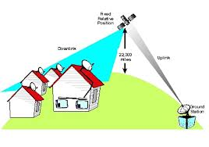
- Larger Production Trucks, Such system operates in Ku, Ka or C bands such systems also use C band to take advantage of more available capacity with larger dishes. These solutions are suitable to provide coverage from larger events, with multiple streams, cameras in high definition or even 3D programs, leveraging a significantly larger team on the ground.
Satellite TV
The Direct Broadcast Satellite (DBS) television system launched in 1989 makes use of GEO satellites. The DBS provider broadcasts a set package of channels directly to the subscriber via a satellite, the broadcast being completely digital (lying in the Ku-band, 12-14GHz) eliminates all the problems of Fixed Satellite Service. The terrestrial component of this network consists of the programming source, central broadcast hub, dish antenna and receiver. The broadcast centre converts all of this programming into a high-quality, uncompressed digital stream containing data up to 270 Mbps in each channel. Then it compresses these digital signals using MPEG-2 encoder that analyses and eliminates irrelevant data using intra-frame, predicted frame and bidirectional frame encoding technique thus reducing the 270 Mbps stream to about 5 or 10 Mbps.
The GEO satellite picks up the signal with an on-board dish amplifies the signal and uses another dish to beam the signal back to Earth, where viewers pick it up. At the subscribers end a dish antenna (very small aperture transponder) receives the digital stream. The end component i.e. the receiver descrambles the encrypted signal and converts it into analog format.
Latest Trends in Satellite TV and Analysis
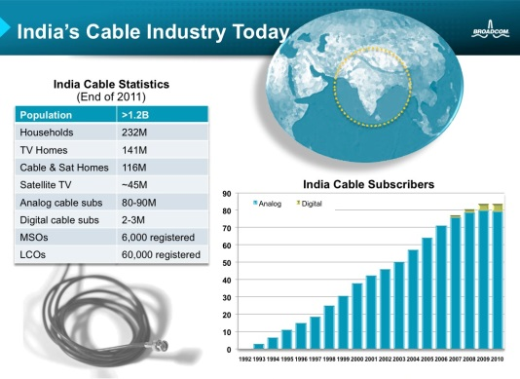
The majority of TV channels are in standard definition (SDTV), meaning a resolution comparable to old analog TV. The high-definition television (HDTV), providing a resolution of up to five times that of SDTV. In parallel, the next evolution of TV program is Ultra- HD (UHDTV), which will again increase the number of pixels by a factor of four. The user statistics of the TV network above indicates a clear shift from analog to digital satellite TV user in next one decade.
Satellite Phones
It is a radio transceiver that uses satellite to establish its communication network without any requirement of terrestrial coverage network thus providing network coverage around the globe. The network consists of satellite, ground station (gateway) and the subscriber. A satellite constellation is used for the purpose of transmitting signals from source to destination. The gateway is established for the purpose of command and control also for transmission/reception of user signals. The frequency specification of a satellite phone is 626.5 to 1660.5 MHz for transmitter and 1525.0 to 1559.0 MHz for receiver. There are four major satellite phone systems: Iridium, Globalstar, Thuraya and Inmarset. The widely used Inmarset in brief is explained as under:-
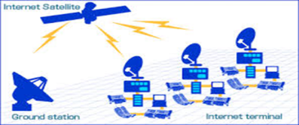
- Inmarsat The International Mobile Satellite Organization (INMARSAT), founded in 1979 as the International Maritime Satellite Organization, is a mobile telecommunications network, providing digital data links, telephone, and fax service between ships, offshore facilities and shore-based stations throughout the world. It is also now extending satellite links to aircraft on international routes. The coverage area is global except Polar Regions. The Inmarsat system consists of eight satellites in geostationary orbit. Four of the satellites are provided with the latest Inmarsat-3 technology, giving overlapping operational coverage for every square inch of the Globe enabling the satellites to concentrate power in areas of high demand. Inmarsat offers several different mobile communications systems designed to provide user with a wide variety of terminal and services. They are Inmarsat-phone, Inmarsat-A, Inmarsat-B and Inmarsat-C terminals.
Satellite Radio
The Satellite Radio or Digital Audio Radio Service (DARS) is a subscriber based radio service that broadcasting up to100 radio channels featuring Compact Disk digital quality music, news, weather and sports. It is allocated "S" band (2.3 GHz) for nationwide broadcasting. The DARS network consists of the satellite, ground repeaters and radio receivers. Due the interference caused by tall structures, the radio stations are supplementing their satellite coverage ground repeaters. The receiver antenna picks up the downlink, amplifies and filters it before sending it to receiver. The receiver converts signal from analog to digital, analyses, processes and combines it to produce the best quality wave which is converted back to analog audio for the speakers. Presently there are three space based radio broadcasters which are as followings:-
- XM Satellite Radio This is a commercial service uses two Boeing HS 702 satellites, "Rock" and "Roll", placed in parallel geostationary orbit. It uses two GEO satellites, which bounce the signals back down to radio receivers on the ground having a downlink frequency range between 2.33-2.34 GHz. XM offers both fixed and portable radios. Each receiver contains a proprietary chipset for receiving XM signal.
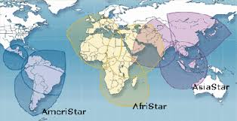
- Sirius Satellite Radio It is operational in the United States. It has three SS/L-1300 satellites constellation spending about 16 hours a day over the United States.

- Worldspace It has put two of its three satellites, AfriStar (210 East orbit) and AsiaStar (1050 East orbit) in geostationary orbit. WorldSpace satellites' can deliver over 50 channels of crystal clear audio and multimedia programming via the 1.467 to 1.492 MHz segment. The uplink frequencies are 7.025-7.075 GHz. The downlink signals in each spot beam are combined into two Time Division Multiple Access (TDMA) carriers.
Broadband Satellite
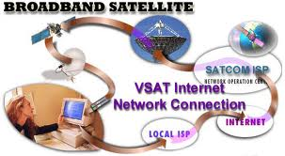
The satellite broadband has made internet access to locations where setting up a terrestrial network proved to be a costly affair. The first internet ready satellite Eutelsat (Ka-band satellite) was launched in September 2003. The satellite broadband network consists of ground based equipment consists of VSAT dish, indoor modem, gateways and the network operation centre and satellite equipment have transponder space segment and internet backbone. End user computer sends a request for a transfer of data. The request is received by indoor modem and passed on to VSAT dish which directs it to the satellite. The satellite processes the signal before routing them to their destination address on Earth. In the network operation centre, retrieves the requested web page from the web server across the internet backbone and passes on to the user.
Since in this process a GEO satellite is being used, a considerable latency occurs which needs to be compensated. By using techniques like IP spoofing, digital compression. The current satellite systems’ capacities vary from 10 GB/s to 100 GB/s. In order to meet the ever increasing need for data transfer speeds, new techniques are being employed like the DirecPC system using asymmetric TC/IP that provides high speed. The other techniques to speed up are the terabit satellite network, surfbeam system 2, Smart gateway concept involving interconnection of gateways and redirecting traffic to gateway experiencing reduced capacity are under development.
Earth Observation
The satellites offer unique capabilities for earth observation (EO). Based on orbital position a large area can be observed at once, independent of ground conditions. These benefits are enabled by improvements in forest monitoring, food security monitoring, costal monitoring, sea ice monitoring, ocean monitoring, humanitarian aid, urban monitoring, aqua-soil monitoring, land hazard monitoring, arctic monitoring, natural hazard monitoring, the earth observation services are used in under mentioned domains:-
- Atmosphere Monitoring. The atmospheric chemistry and composition to contribute toward Essential Climate Variables (ECVs) measurement of air quality and monitoring of solar irradiance ultraviolet radiation.
- Emergency Management. This services enabling better responses to natural and man-made disasters. This includes supporting pre-event preparation, providing rapid mapping during crisis, supporting post-event recovery and damage assessment and providing early warning flood alerts.
- Security. Use of earth observation to support for border control, and maritime surveillance. This includes support to peacekeeping, law-enforcement and crisis management operations and to gather intelligence for early warning.
Vessel Monitoring Systems
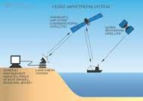
Fisheries management authorities need commercial fishing operators to fit their vessels with satellite radio equipment to be part of the Vessel Monitoring System (VMS). VMS allows shore based users to interrogate a vessel’s position, course and speed and facilitates the interchange of fishing data with immediate, direct and assured access to search and rescue authorities in the case of distress. The shipboard satellite communications equipment which supports VMS is based on Inmarsat-C terminals.
Future Satellite Communication Technologies and Analsis

Advanced Communication Technology Satellite (ACTS) designed by NASA is based on the frequency reuse concept. The multi-beam antenna provides dynamic coverage with the hopping spot beams using time division multiplexing programmed to cover a sequential set of spots and assigning each user an access time. This technique has on board high speed switching network and high-speed digital processor to undertake circuit switching. It is capable of routing high volume point-to-point traffic and point-to-multipoint traffic over a very wide bandwidth channel. In ACTS the beam hopping system provides a more efficient traffic routing, no-regular frequency reuse, flexibility in bandwidth and power allocation to beam.
The analysis of satellite based communication in world indicates that from 2009 to 2014 there had been 500% growth in this industry and in future it is going to witness unprecedented growth in next one decade.
Ka-band Technology
As the demand for data is increasing, higher frequency bands like the Ka-band (27-40GHz) have come into use. Being a high frequency band, it is considerably affected by atmospheric attenuation. Thus its use has become more popular for high speed internet access where loss of a few packets of data can be retrieved by continually sending requests.

CONCLUSION
This paper has addressed use of satellite communications and its latest trends. The convergence of satellite and information technology with development of high end processor and terabit transfer technology will allow the satellite services to reach rural areas which were not feasible in past. By exploiting these technologies in past two decades the world has come closer and days are not far away when earth will become a Global Village.
ACKNOWLEDGMENT
The authors wish to thank Dr. Ganesh Ingle and Brig. Sanjay Sharma, for keeping them motivated and opening their vision to the technologies.

REFERENCES
Satellite Communication Advancement, Issues, Challenges and Applications, IJARCCE, Vol. 2, Issue 4, April 2013.
Janis Indrikis and Robert Cleave, "SPACE EGGS", Satellite Coverage Model for Low Earth Orbit Constellations
Experiment Opportunity Guide (ACTS), March 1998(revision1:January 2000).
Argyrios Kyrgiazos CCSR ‘Towards a Very High Capacity Broadband Satellite’.
M. Richharia, ‘Satellite Communication Systems’.

