Analysis of Cycle Time and Total WIP in a Reverse Supply Chain
Sohit Chhabra
School of Mechanical and Building Sciences, VIT Chennai
sohitchhabra92@gmail.com

Abstract - In this article reverse supply chain model is proposed. Design of experiments is conducted for model with $2^{5}$ full factorial design. The cycle time for the defected part to be returned to the customer after being repaired and total WIP in the system are analysed. The impact of the various factors i.e. customer arrival, initial testing, inspection, repair, and problem solving on the average cycle time and total WIP is also studied and observe that for low values of standard deviation of factors, the average cycle time and total WIP are minimum. The interactions between various factors are also analysed.

Keywords – Reverse Supply Chain, Cycle Time, Total WIP

- INTRODUCTION

Reverse supply chain management has been an area of increasing attention in industry. With the increasing competition companies have to manage their reverse supply chains along with the forward supply chain. Reverse supply chains which involves the flow of information and goods in the reverse direction compared to forward supply chain aims to reduce and control the waste generation and its disposal and maximise the long term profitability of the business [1]. Moreover, the effective reverse supply chain contributes to the better customer relationship as the commercial returns are sent back for reconditioning and maintenances and customers tend to be free from the risk of buying damaged and malfunctioning products [1]. The green image along with the customer satisfaction strengthens customer loyalty towards company and thus increases long term profitability of the company [2].
The reverse supply chain theory suggests that the product lifecycle does not actually end with its delivery to end customers but still continues as the end-of-use or end-of-life products which may be brought back from the consumers to the manufacturers for reuse, recycle, repair and disposal (Alvarez-Gil et al., 2007).

- LITERATURE REVIEW

This section reviews the relevant literature on reverse supply chains. The review is structured as follows. First we review the literature that describes the five key processes involved in reverse supply chains. Then we review the literature on hierarchy of reverse logistics activities. Next we review the literature on typical return collection methods.

- Five key processes in reverse supply chain

Guide & van Wassenhove (2002) identified five key processes in reverse supply chains:-
- Product acquisition: Obtaining the used product from user by reseller or manufacturer.
- Reverse logistics: Transporting products to a facility for inspection, sorting and disposition.
- Inspection and disposition: Assessing the condition of the return and making the most profitable decision for reuse.
- Remanufacturing or refurbishing: - Returning the product to its original specification.
- Marketing: Creating secondary markets for the recovered parts.

A basic reverse supply chain is illustrated in the figure 1.

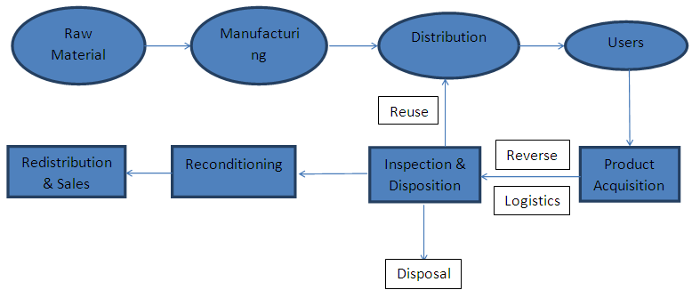
Fig. 1 A general reverse supply chain

- Hierarchy of Reverse Logistics Activities

Dyckhoff et al. (2004) demonstrated the reverse logistics activities with a hierarchy according to how the wastes are treated in the system.
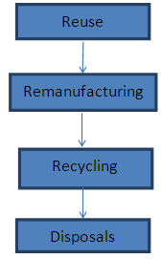
Fig. 2 The hierarchy of reverse logistics activities

The above figure shows that the reuse has the first priority followed by remanufacturing, recycling and disposals. At the first level products are reused for the nearly same purpose which maximizes the efficiency. If reusing is not beneficial then remanufacturing is preferred. In remanufacturing the product or its components are remanufactured or repaired to be used again. The next level i.e. recycling requires additional treatment, as the product is disassembled into components, some of which may be reused or remanufactured while the rest would turn out as inputs to production. If the product cannot be reused, remanufactured or recycled then disposal is the only way it could be treated [3].

- Reverse Supply Chain Designs

A plenty of investments is required by the individual companies for the implementation and management of reverse supply chains [6] as every step in supply chain requires considerable amount of costs, from waste acquisition to its ultimate disposition. Hence most reverse supply chains have been designed with the primary purpose to minimize the overall costs of the product recovery.
Kumar and Putman (2008) proposed that for the design of efficient reverse supply chain, the first step is to decide the effective take-back channel i.e. the most effective collection method that would return the products back to manufacturers. Three typical collection methods were discussed in their research: manufacturers collects directly from users (A), or via retailers (B), or by third party companies (C).
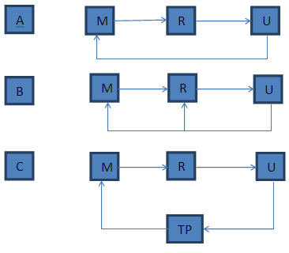
Fig. 3 Typical returns collection method [5]

The figure 3 illustrates the three typical collection methods. In this figure M are manufacturers, R – the retailers, U - the users and TP is the third party. It was found that the collection method by third party companies is preferable if the companies are to benefit from the remanufacturing and the third party company is in association with a number of manufacturers [5].
Apart from overall costs, the time value in reverse supply chain should also be addressed. The cost efficiency varies in inverse proportion to the responsiveness of reverse supply chain i.e. cost efficient chain always take longer time to redistribute the returned products. The value of the product reduces as the time delay increases while the products move through the reverse supply chain to their ultimate dispositions. Blackburn et al. (2004) introduced the concept of marginal value of time (MVT) as one important factor in the design of reverse supply chains. It is defined as the loss of value of product per unit time spent in reverse supply chain [4]. The MVT varies for different products and based on this difference products can be classified into two different categories time-sensitive products and time-insensitive products. Products with higher MVT are time sensitive i.e. their value decreases with time rapidly. On contrary, products with lower MVT are time insensitive i.e. their value decreases slowly with time. So in order to reduce timely losses responsive reverse supply chain can be used for time sensitive products while cost efficient reverse supply chains can be applied for time insensitive products [4].

- MODEL DEVELOPMENT

The conceptual model of basic reverse supply chain is illustrated in figure 4.
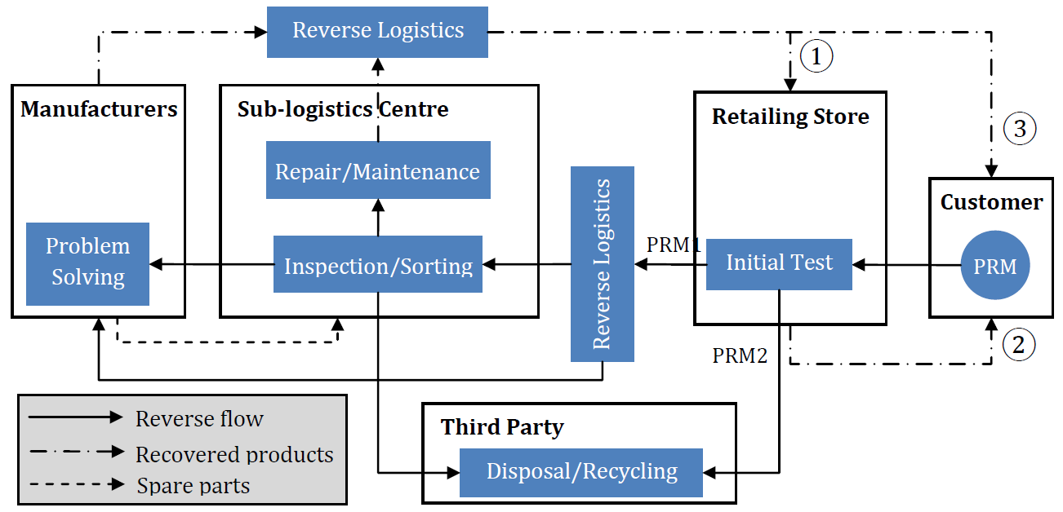
Fig. 4 Illustration of basic reverse supply chain

The same conceptual model was modelled in Extend Sim as shown in figure 5.

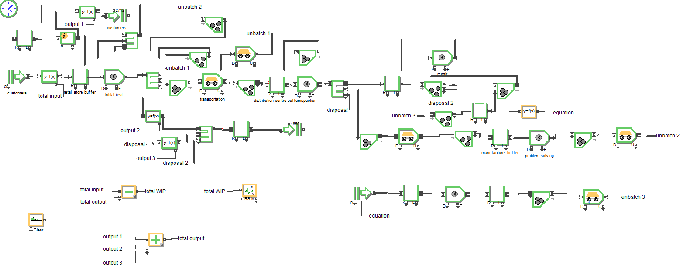

Fig. 5 Extend Sim model of reverse supply chain

- Model Explanation

The introduction of defected product in the system is controlled by customer arrival (factor 1). The customer gives its defected product at the retail store. At the retail store initial testing (factor 2) of the defected product is done. After initial testing the product which is repaired is sent back to the resale counter of retail store. The products which are not repaired but can be repaired at further stage by use of some sophisticated machines are sent to distribution centre. The products which cannot be repaired even at further stage are sent for disposal. At the distribution centre inspection (factor 3) and sorting of defected products is done. After inspection the defected products which need replacement of spare parts, undergo repair (factor 4) by replacing the defected spare parts with the new spare parts supplied by manufacturers. The defected products which address some new problem which cannot be solved at distribution centre are transported to manufacturers for problem solving (factor 5). The products which cannot be repaired are sent for disposal. After the replacement of spare parts in the defected products, the products are transported to the retail store for resale. In the manufacturers stage the research on the new problem addressed by the defected part is done and after solving problem the products are transported to retail store. The manufacturers also produce spare parts which are transported to the distribution centre The ordering of spare parts from manufacturers by distribution centre follow (S,s) policy of (30,15). The equation written in equation block to follow this policy is shown in figure 6.

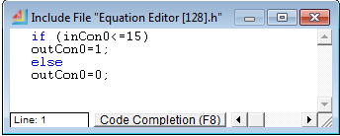
Fig. 6 Picture of equation code for (S,s) policy of (30,15)

- Simulation of Model

The simulation run time of model is 18 days. The statistics are cleared after 6 days i.e. warm up period of 6 days is used so that the system achieves steady state.

- Measuring Cycle Time
Cycle time is the average time taken for the product to be returned to the customer after being repaired. The information block of Extend Sim is used to measure it. The block is connected to the resale queue block and equation block.

- Measuring total WIP

WIP is the total number of work in process inventories in the system. The mean and variance block is used to measure it.

- Assumptions

The reverse supply chain model is simplified by removing some aspects of the system which have no relevant effect on the outcome of result. Therefore the model is assumed to have the following:-
- The transportation time i.e. time taken to transport defected parts from one point to other point is assumed to be constant in this model. The description of transportation time from one point to other point is given in table 1.

TABLE 1
DESCRIPTION OF TRANSPORTATION TIME BETWEEN VARIOUS POINTS

From | To | Time (min)
Retail Store | Distribution Centre | 20
Distribution Centre | Manufacturers | 15
Manufacturers | Retail Store | 35

- The ordering of spare parts from manufacturers by distribution centre follow (S,s) policy of (30,15). This means that the maximum quantity of spare parts in the distribution centre can be 30 and if the quantity is more than 15 there will no introduction of raw material for the production of spare parts. If the quantity of spare parts is less than or equal to 15 the introduction of raw material into the system starts for producing spare parts so as to replenish the inventory of spare parts at the distribution centre. This (S,s) policy is modelled in Extend Sim using equation block. This policy is followed so as to control the level of inventory of spare parts in the model.
- The machines of the system have no shut down for maintenance because shutdown mechanism has insignificant effect on the reverse supply chain under consideration.
- Only 1 defected spare part is assumed to be replaced at distribution centre.

- EXPERIMENTATION

- Experimental Parameters

The factors whose effect on the response is studied are Customer Arrival, Initial Testing, Inspection, Repair and Problem Solving. All these factors follow lognormal distribution. The values of mean and standard deviation of these factors are described in the table 2

TABLE 2
MEAN AND STANDARD DEVIATION VALUES OF FACTORS

Factor ID | Factor | Mean | Standard Deviation
Factor ID | Factor | Mean | Low | High
A | Customer Arrival | 6 | 3 | 6
B | Initial Testing | 5 | 2.5 | 5
C | Inspection | 10 | 5 | 10
D | Repair | 7 | 3.5 | 7
E | Problem Solving | 60 | 30 | 60

- Design of Experiments

After building the model in Extend Sim, design of experiments is conducted using Design Expert. In this case five factors i.e. customer arrival (A), initial testing (B), inspection (C), repair (D) and problem (E) solving were studied for high and low values of standard deviation, so $2^{5}$ full factorial design was considered. 2-level factorial design is useful for estimating main effects and interactions. The design summary is shown in figure 7.

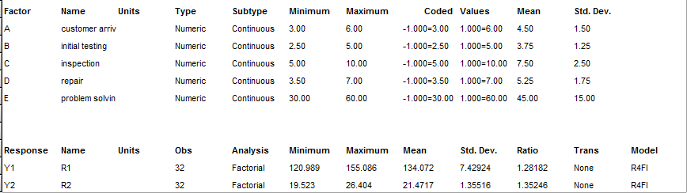

Fig. 7 Picture of design summary

- ANALYSIS

In this model the average cycle time (response R1) and total WIP (response R2) in the system are analysed. The transformation option is set to none in Design Expert to analyse the responses which means that the response data will be analysed as it is.

- ANOVA Output for Response R1

The Model-F value of 10.37 implies the model is significant. There is only a 0.01% chance that a “Model-F Value” this large could occur due to noise.

- ANOVA Output for Response R2

The Model-F value of 8.76 implies the model is significant. There is only a 0.61% chance that a “Model-F Value” this large could occur due to noise.

- Summary of ANOVA results

- In ANOVA output values of "Prob > F" less than 0.0500 indicate model terms are significant. The significant terms and interactions for both the responses are shown in table 3.

TABLE 3
SIGNIFICANT TERMS FOR RESPONSE R1 AND R2

Response ID | Response | Significant Terms | Significant Interactions
R1 | Cycle Time | A, B, C, E | CE, DE, BDE, ACDE
R2 | WIP | A, B, E | AE, DE, ABC, BDE

- The statistical data for both the responses is shown in table 4.

TABLE 4
STATISTICAL DATA FOR RESPONSE R1 AND R2

Statistics | Cycle Time | WIP
Standard Deviation | 2.86 | 0.5
Mean | 134.07 | 21.47
C.V.% | 2.13 | 2.34
PRESS | 698.23 | 43.18
R-Squared | 0.9426 | 0.9733
Adj R-Squared | 0.8518 | 0.8622
Pred R-Squared | 0.5919 | 0.2416
Adeq Precision | 13.514 | 14.523

- Customer arrival has most significant effect on the cycle time and total WIP in the system. It is a noise factor and cannot be controlled and hence accounts for robust systems.
- After customer arrival initial testing effects the responses significantly.
- The interactions between various factors also effect responses significantly.
- Interaction BDE has most significant effect on responses R1and R2.

- Model Graphs for Response R1

The perturbation plot for response R1 is shown in figure 8.

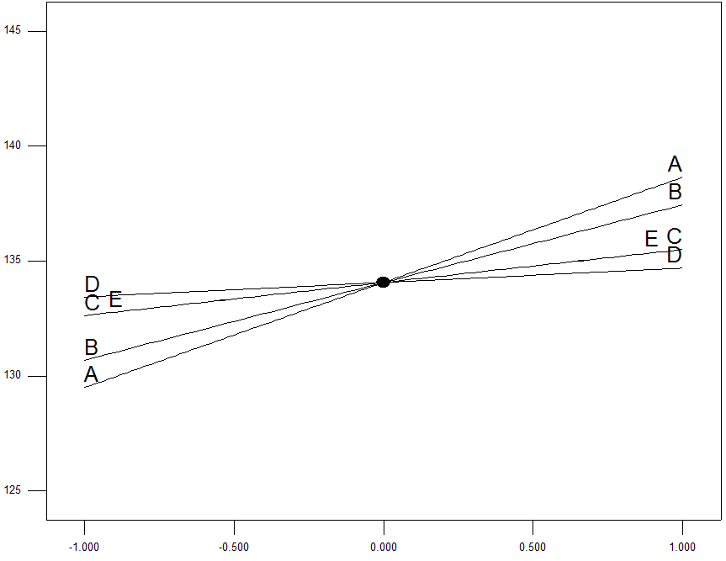
R1
Response R1
Deviation from Reference Point (Coded Units)
Fig. 8 Perturbation plot for R1

The plot shows that A has most significant effect on the cycle time as slope is maximum for A followed by B, C and E which have same slope, and D which has minimum slope. As A is increased response also increases. The other factors i.e. B, C, D, E also have the same effect but magnitude differs. As the factor is changed the response also changes along the slope of that factor.
The effect of one factor on the response cannot be interpreted as it is involved in multiple interactions with other factors. Interaction occurs when the response is different depending on the setting of two factors. The effect of interaction on the response can be interpreted from the interaction plot. As an example DE interaction plot for R1 is shown in figure 9.

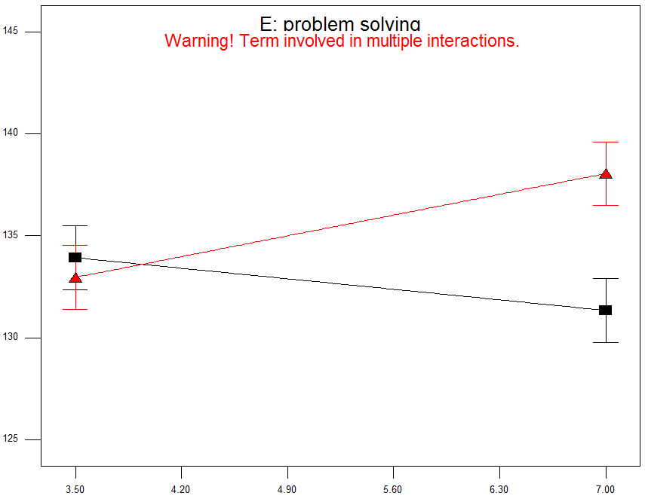
R1
D: Repair
Fig. 9 DE interaction plot for R1

The plot shows that when D is low E has less significant effect on the response.When D is increased the effect of E on response decreases, becomes constant and then increases.

- Model Graphs for response R2

The perturbation plot for response R2 is shown in figure10.
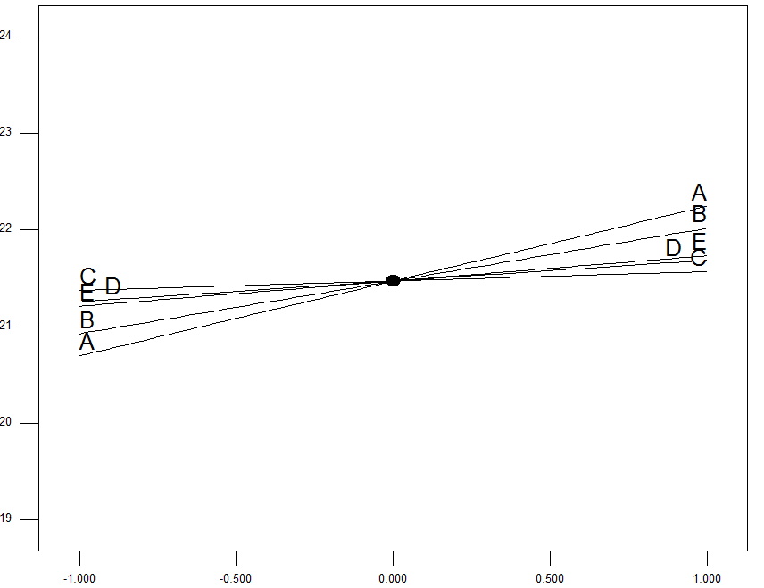
Response R2

Deviation from Reference point (Coded Units)
Fig. 10 Perturbation plot for R2

The plot shows that A has most significant effect on the cycle time as slope is maximum for A followed by B, E, D and C which has minimum slope. As A is increased response also increases. The other factors i.e. B, C, D, E also have the same effect but magnitude differs. As the factor is changed the response also changes along the slope of that factor.

The DE interaction plot for R2 is shown in figure 11.

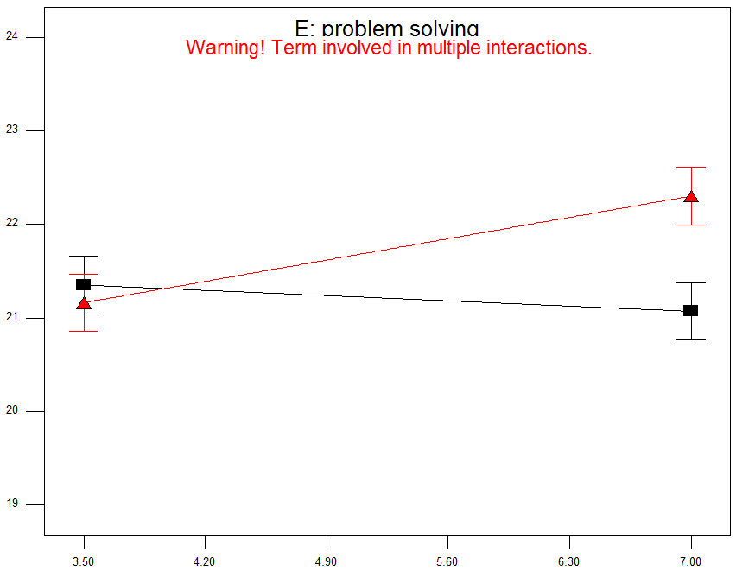
R2

D: Repair
Fig. 11 DE interaction plot for R2

The plot shows that when D is low E has less significant effect on the response.When D is increased the effect of E on response decreases, becomxes constant and then increases.

- CONCLUSIONS

Reverse supply chain system was studied in this work. The reverse supply chain was modelled using Extend Sim and design of experiments was conducted using Design Expert.
The cycle time and total WIP for the model were analysed and observe that minimum cycle time and total WIP in the system occurs for the low values of standard deviation for customer arrival, initial testing, inspection and sorting, repair, and problem solving. The minimum cycle time and Total WIP are found to be 120.989 minutes and 19.523 respectively. The effects of the various factors on the average cycle time and total WIP in the system are also studied. The significant terms effecting response R1 are A, B, C, E and response R2 are A, B, E. The interactions between the various factors are also studied. The significant interactions effecting response R1 are CE, DE, BDE, ACDE and response R2 are AE, DE, ABC, BDE.

- FUTURE WORK

Further work would be necessary in this area to analyse the service level also. The (S,s) policy of (30,15) for ordering spare parts from manufacturers and transportation time between various locations would be experimented so as to reduce cycle time and total WIP in the system to make efficient reverse supply chain.

ACKNOWLEDGEMENT
With a joyful heart, I am grateful to my supervisor, Dr. John Geraghty, whose immerse guidance, direction and support from the beginning to the finish point helped me to gain great understanding of the work.
A big thank you to all the staff of the school of mechanical and manufacturing engineering for their willingness to guide and support me, especially the academic staff who taught me during my programme. This project would not have been a success without your support.
And above all, I am profoundly grateful to God in His infinite majesty and wisdom for His grace and mercy upon me which strengthened me to unravel knowledge in this work.

REFERENCES

[1] Vogt, J., Pienaar, W., & de Wit, P. (2002). Business Logistics
Management: Theory and practice. Oxford: Oxford
University Press Southern
Africa.
[2] Blumberg, D. (2005). Introduction to management of reverse
logistics and closed loop supply chain processes. New York:
CRC Press.
[3] Rogers, D.S., &Tibben-lembke, R.S.(1999). Going
Backwards: Reverse Logistics Trends and Practices.
Pittsburgh: Reverse Logistics Executive Council.
Review, 80 (2), pp.25-26.
[4] Blackburn, J., Guide, V., Souza, G., & van Wassenhove, L.
(2004). Reverse Supply Chains for Commercial
Returns.California Management
Review, 46 (2), pp.6-22.s
[5] Kumar, S., & Putman, V. (2008). Cradle to cradle: Reverse
logistics strategies and opportunities across three industry
sectors. International Journal of Production Economics, 115,
pp.305-315.
[6] Brodin, M.H. (2002). Logistics Systems
for Recycling.Linkoping Universitet.

