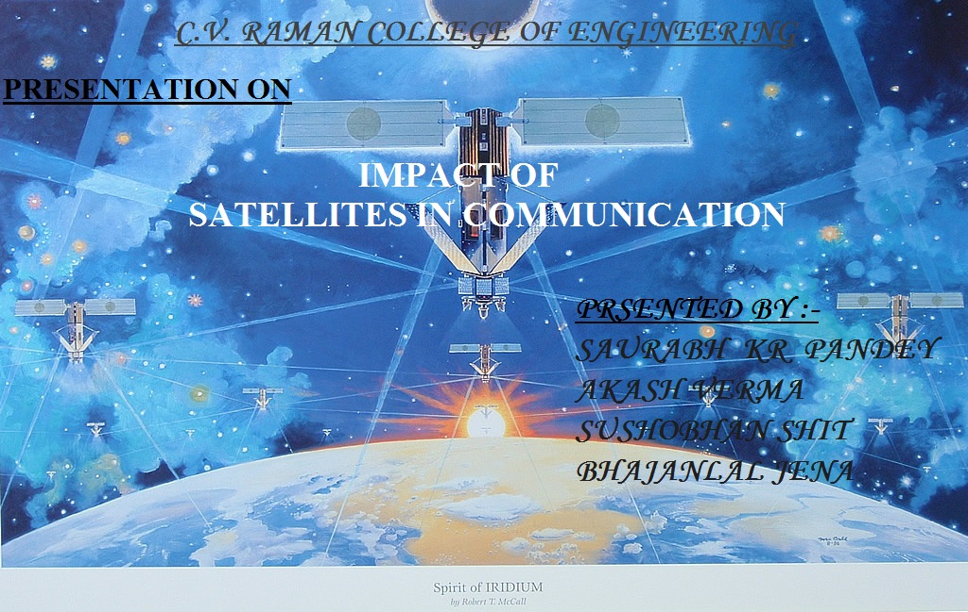
ABSTRACT

Before satellites, transmission were difficult or impossible at long distances. Satellites are in orbit, the signals can be sent instantaneously into space and then redirected to another satellite or directly to their destination. The signals which travel in straight line could not bend around the round earth to reach a destination far away. Previously polar satellites were used for the communication system but it will not so helpful in communication because can not provide continuous viewing of one location process because signal only transmitted along the poles and for the communication along the equator we have to use a satellite which revolve around the equator that's why communication satellites whose time period is equal to the time period of the earth. It will give the perfect communication process.

INTRODUCTION
Satellites -: Just as various planets revolve around the sun, in the same way few celestial bodies revolve around these planets. These bodies are called satellites. Satellites allow radio, television and telephone transmission to be sent live anywhere in the world.

HISTORY
Arthur C. Clark wrote the first well-known article on communication satellites. "Extra-Terrestrial Relays" was published in Wireless World in 1945.The first communication satellite was launched on December 18, 1958.
Types of satellites:-

Active Satellites :- The satellites which carries all the equipments to used for receiving wireless signal sent from the earth, processing them, and then re-transmitting them to the earth is called 'Active Satellite' .

Passive Satellites :- The satellites which is used only as a reflector of the signals transmitted from earth is called 'Passive Satellites' . This satellite does not carry any equipment for receiving and transmitting wireless signals. It however, need to receive high transmitted signals so that it may reflect signals of suitable strength to the earth.

Communication Satellites :- A wireless communication that uses a satellite placed in an orbit around the earth for a long distance communication of signals to different parts of the world is known as 'Communication Satellites' .
When a satellite revolves around the earth in an orbit near the earth's surface then its orbital velocity is about 8 km/sec by means of a multistage rockets then the body is placed in an orbit around the earth. Such a body is called an 'Artificial Satellite'.
If an artificial satellite be placed in an earth's orbit in the equatorial plane at a height of 35830 km above the surface of the earth. Then its period of revolution around the earth would be exactly equal to the period of axial rotation of earth that is 24 hours. This is satellite communication.

BODY

Communication Satellites can be used for a number of purposes. Some of them are the following -

- Television Distribution
- Long distance Telephone Transmission
- Business Networks

1) Television Distribution :- Programs are transmitted to the satellite and then broadcast down to a number of stations, which distribute the programs to individual viewers.

2) Long distance Telephone Transmission :- Satellite transmission is also used for point to point trunks between public telephone exchange offices.

3) Business Networks :- The satellite divides the total business datas or a network into a number of channels and these channels to individual businessmen.

Satellite Communication Basics
The process begins at an earth station--an installation designed to transmit and receive signals from a satellite in orbit around the earth. Earth stations send information in the form of high powered, high frequency (GHz range) signals to satellites which receive and retransmit the signals back to earth where they are received by other earth stations in the coverage area of the satellite. The area which receives a signal of useful strength from the satellite is known as the satellite's foot print. The transmission system from the earth station to the satellite is called the up link. and the system from the satellite to the earth station is called the download link.

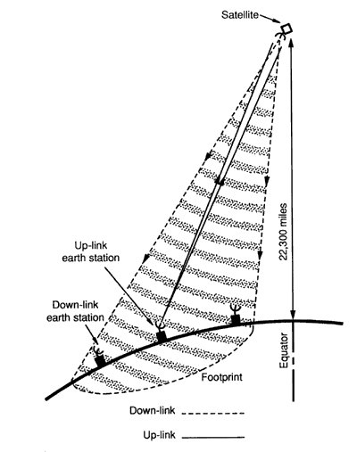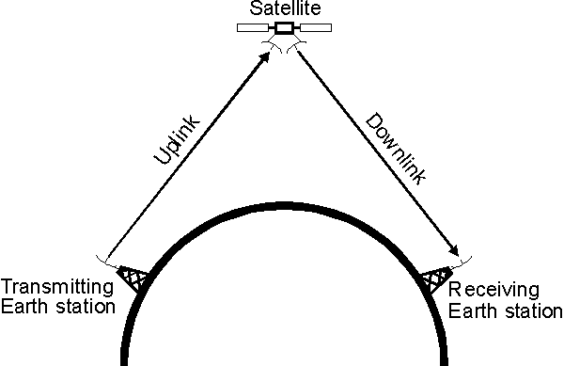

Satellite Frequency Bands
The three most commonly used satellite frequency bands are the C-band, Ku-band, and Ka-band. C-band and Ku-band are the two most common frequency spectrums used by today's satellites. The relationship between antenna diameter and transmission frequency is inverse relationship between frequency and wavelength--when frequency increases, wavelength decreases. As wavelength increases, larger antennas are necessary to gather the signal.
C-band satellite transmissions occupy the 4 to 8 GHz frequency range.
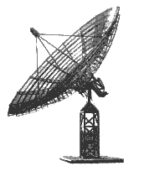
c-band

ku-band satellite transmissions occupy the 11 to 17 GHz frequency range. These relatively high frequency transmissions correspond to shorter wavelengths and therefore a smaller antenna can be used to receive the minimum signal strength. Ku-band antennas can be as small as 18 inches in diameter.
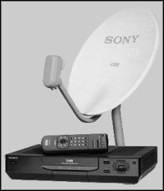
Ka-band
Ka-band satellite transmissions occupy the 20 to 30 GHz frequency range. These very high frequency transmissions mean very small wavelengths and very small diameter receiving antennas.

Geosynchronous Earth Orbit (GEO) Satellites
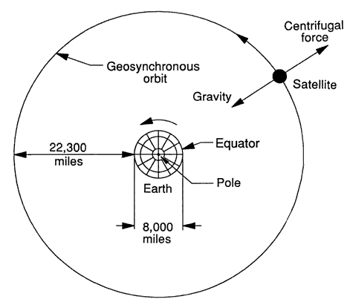
The Clarke Orbit

MODULATION

While sitting at home, we watch a cricket match being played thousand a kilometer away .To broadcast a program over such large range. We need modulation. Modulation is the process of superimposing the signal to be transmitted on the other wave of high frequency called carrier wave so that it can be transmitted to large distance.

NEED FOR MODULATION

1) To separate signal from different transmitter

2) Size of the antenna
TO SEPARATE SIGNAL FROM DIFFERENT TRANSMITTERS

Audio frequencies are with in the range of 20 hz to 20khz without modulation all signal at same frequencies from different transmitters would be mixed up.
Each radio station must be given its own frequencies band this is achieved by frequency translation as a result on modulation process.
SIZE ON THE ANTENNA

For efficient transmission the transmitting antenna should have length at least equal to a quarter of the wavelength of the signal to be transmitted. For an electromagnetic wave of frequency 15khz,the wavelength is 20 km and one – quarter of this will be equal to 5km, obviously ,a vertical antenna of this size is impossible. On the other hand for a frequency of 1MHz, this height is reduced to 75m.

THREE TYPE OF MODULATION

- AMPLITUDE MODULATION (AM)
2) FREQUENCY MODULATION (FM)
3) PHASE MODULATION (PM)

DEMODULATION

As the modulated signal reached the destination, we need to extract information from it. The process of unloading the information from the modulated wave is called demodulation.
Information signal → Modulator → Amplifier →Channel →Amplifier → Demodulator →Information signal.

TRANSMITTER :-The sub- system that takes the information signal and process it prior to transmission. The transmitter modulates the information onto a carrier signal , amplifies the signal and broadcast it over the channel.

CHANNEL :- The medium which transports the modulated signal to the receiver . Air acts as the channel for broadcasts like radio . may also be wiring system like cable tv or the internet.

RECEIVER :- The system that takes in the transmitted signal from the channel and processes it to retrieve the information signal.

SIGNAL :- In order to achieve speed in communication we have to depend on electric waveform since they propagate with the speed of light . The information is first converted into electrical waveform by suitable circuits. The variation correspond to the information the instrument which converts information into a signal is called transducer. The signal is transmitted and received at the destination where another transducer converts it back into information.
A carrier signal is used for two reasons:
- To reduce the wavelength for efficient transmission and reception. A typical audio frequency or 3000hz will have a wavelength 100 km and would need an effective antenna length of 25km by comparision , a typical carrier for FM is 100mhz with a wavelength of 3m and could use an antenna only 80 cm long.
- To allow simultaneous use of the same channel called multiplexing. Each unique signal can be assigned a different carrier frequency and still share the same channel.
HOW DOES SATELLITE COMMUNICATION WORK?

It works on two main components.
1) Ground base on the earth.
2) Space component.
In this mode a communication,the satellite stationed at the space receives signal from the earth with the aid of an antenna.The signals are amplified to an optimum level and then with the help of transponders they are re-transmitted back to the earth. The earth station then receives the signal from satellite and re-amplifies it and helps in the communication.

TRANSPONDERS
A communication satellite transponder is the series of interconnected unit which form a communication channel between the receiving and transmitting antennas.
It is mainly used in satellite and composed of :-
- A input band limiting device (a band pass filter).
- An input band limiting low-noise amplifier (LNA),designed to amplify the signals received from the earth station.
- A frequency translator used to convert the frequency of the receiver signal to the frequency required for the transmitted signal.
- An output pass filter

UTILITY OF COMMUNICATION SYSTEM IN SHIP:-

- RADAR

- SART

- EPIRB

4) GPS

5) TELEPHONE
RADAR

RADAR stands for Radio Detecting And Ranging and as indicated by the name, it is based on the use of radio waves. Radars send out electromagnetic waves similar to wireless computer networks and mobile phones. The signals are sent out as short pulses which may be reflected by objects in their path, in part reflecting back to the radar. When these pulses intercept precipitation, part of the energy is scattered back to the radar. This concept is similar to hearing an echo. For example, when you shout into a well, the sound waves of your shout reflect off the water and back up to you. In that same way, the pulse reflects off precipitation and sends a signal back to the radar. From this information the radar is able to tell where the precipitation is occurring and how much precipitation exists.

Components Of The Radar;
Radars in their basic form have four main components:
- A transmitter, which creates the energy pulse.
- A transmit/receive switch that tells the antenna when to transmit and when to receive the pulses.
- An antenna to send these pulses out into the atmosphere and receive the reflected pulse back.
- A receiver, which detects, amplifies and transforms the received signals into video format.

SART
It's primary role is to assist in locating survivors or vessels in distress. It is the main means of rescue craft homing in on the Global Maritime Distress and Safety System. " GMDSS". It allows any vessel or aircraft fitted with Marine Band radar to detect and locate survivors at a range of up to 5 nautical miles from a surface rescue vessel, and further distances from aircraft.
All commercial shipping is required to carry SART's for use in life rafts, as well as for emergency location of the main vessel.
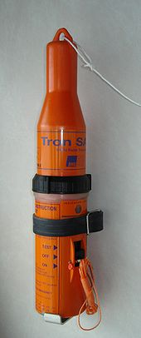
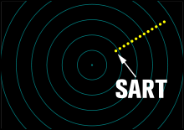

How does SART work?
A SART unit is a Transponder which means that it is a transmitter that,once turned on, goes into operational mode after receiving a Radar pulse. Utilizing the principles of normal Radar the operator of the Search vessel can determine a range and bearing to the target.

EPIRB
An Emergency Position Indicating Radio Beacon or EPIRB is used to alert search and rescue services in the event of an emergency. It does this by transmitting a coded message on the 406 MHz distress frequency via satellite and earth stations to the nearest rescue co-ordination center.
Some EPIRBs also have built-in GPS which enables the rescue services to accurately locate you to +/- 50 meters.
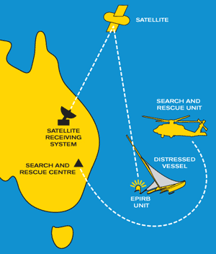
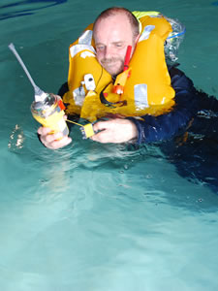

EPIRBs

EPIRBs are generally installed on boats and can either be operated automatically after an incident or manually. In most countries they are mandated to be used in all commercial shipping. However, they are also used on yachts and leisure boats.

EPIRBs used in ships and boats are designed to float in the water to optimize the signal to the satellite. An EPIRB is required to operate for a minimum of 48 hours continuously once activated. It has a lanyard used to secure it to something that is not going to sink so that it can float free.

Personal locator beacons are designed for personal use in both the land and marine environment. Personal locator beacons are required to operate for a minimum of 24 hours once activated.

GLOBAL POSTIONING SYSTEM
The GPS is a space-based satellite navigation system that provides location and time information in all weather condition ,any where on or near the earth. It is important in marine navigation for the ships officer to know vessel position while in open sea and also congested harbors and waterways while at sea ,accurate position,speed and heading are needed to ensure the vessel reaches its destination in the safest.
GPS information is embedded within a system known as the automatic identification system transmission. The AIS is used for vessel traffic control around busy seaways.
The AIS is an automatic tracing system used on ships and by vessel traffic services for identifying and locating vessels by electronically exchanging data with other nearby ships.

CONCLUSION :- Because the satellite is stationary relative to the earth, there is no problem with frequency changes due to the relative motion of the satellite and antennas on earth (Doppler effect). Tracking of the satellite by its earth stations is simplified. Artificial satellites has given the revolutionary success in the communication system. It decreases the long distance communication gap which helps human society for their own goodness.

REFRENCES :- The Modern Physics by R. MURGESHAN, Internet, The Modern Physics by G. GRIFFITH.

