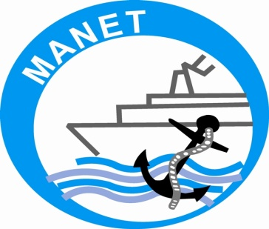

MAHARASHTRA ACADEMY OF NAVAL EDUCATION AND TRAINING

PRESENTS

A PAPER ON “CONSERVATION OF ENVIRONMENT”

PREPARED BY:-
- CDT. MAYANK ARORA
- CDT. ABHISHEK PANDE
- CDT. MAUN SATYAM
SEMESTER VIII

Conservation of Environment

What is environment??
The environment is something you are very familiar with. It's everything that makes up our surroundings and affects our ability to live on the earth—the air we breathe, the water that covers most of the earth's surface, the plants and animals around us, and much more

Why do we need to save the environment/wildlife/etc?
I understand that if we don't, it would be selfish in a way, like it may be putting ourselves higher than nature. Or, that if we don't it will affect us and we will perish...
But aren't we a part of nature and everything we do is somewhat 'natural'. What makes us to be labeled as against nature? We use our brain to develop electronics and such , but then they are labeled as damaging the environment?
Isn't it true that every cause has an effect. So, what does protecting the natural world really do?
Why would protecting a national park, for example, be important other than to show that our creations are doing damage to the planet and causing people to go green?
My question is, why do people work to save or protect the environment? Is it because they are afraid to die, or because they think it is how our real world should be, or do they sympathize with wildlife or what...
we will concentrate our presentation towards saving the water environment through the issues related to ballast.
WHAT IS BALLAST?
- Ballast is defined as any solid or liquid that is brought on board a vessel to increase the draft, change the trim, regulate the stability or to maintain stress loads within acceptable limits.
- Ships are designed and built to move through water carrying cargo, such as oil, grains, containers, machinery and people.
- If the ship is travelling without cargo, or has discharged some cargo in one port and is on route to its next port of call, ballast may be taken on board to achieve the required safe operating conditions.
- This includes keeping the ship deep enough in the water to ensure efficient propeller and rudder operation and to avoid the bow emerging from the water, especially in heavy seas.
WHY WATER IS USED FOR BALLASTING?
- Prior to the 1880s, ships used solid ballast materials such as rocks and sand, which had to be manually shoveled into cargo holds.
- If not properly secured, solid ballast was prone to shifting in heavy seas causing instability.
- With the introduction of steel-hulled vessels and pumping technology, water became the ballast of choice.
- Water has a good weight-to-volume ratio and is carried in separate tanks used just for ballast, or in empty cargo tanks.
- Water can be easily pumped in and out of ballast tanks, requires little manpower, and as long as tanks are kept full, poses little to no stability problems.
BALLASTING/DE-BALLASTING PROCESS 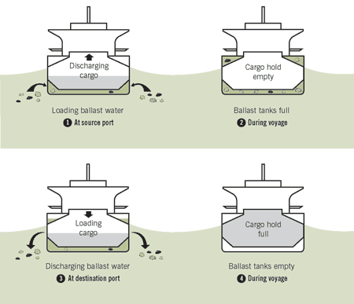
- The ship takes in ballast at the source port(discharge port) as it discharges its cargo. Along with the ballast we can see the micro-organism flowing in the tanks along with the ballast water.
- This shows the ship going enroute with ballast tanks full and no cargo. The micro organism may multiply during its voyage to loading port.
- The ship discharges its ballast into the sea water at the loading port. This is typically important as transfer of species takes place. The species that were loaded along with ballast water at the discharge port are discharged here. Here the major problems occur as a competition between species start for survival.
- The ship has discharged its ballast and is on its route to discharge port with loaded cargo and empty ballast tanks.
WHY BALLAST WATER AN ISSUE?
- While ballast water is essential for safe and efficient modern shipping operations, it may pose serious ecological, economic and health problems due to the multitude of marine species carried in ships’ ballast water.
- These include bacteria, microbes, small invertebrates, eggs, cysts and larvae of various species.
- The transferred species may survive to establish a reproductive population in the host environment, becoming invasive, out-competing native species and multiplying into pest proportions.
- Problems Associated with Species Introduction via Ballast Water
Ecological Effects
- Predation
- Parasitism
- Competition
- Introduction of new pathogen
- Genetic changes
- Habitat alterations
- Species shift/loss of biodiversity
Public Health Concerns
- Cholera risk
- Paralytic shellfish poisoning
- Harmful algal blooms.
Economic Impacts
- Industrial water users
- Municipal water systems
- Nuclear power plants
- Commercial and recreational fishing
Types of Ballast Water Treatment
- De-oxygenation using nitrogen gas
- Ozone
- Ultrasound
- Heat Treatment
- Ultraviolet Light
- Chemical Biocides
- Filtration/Physical Separation
- Ballast Water Exchange

WHY DO WE NEED BALLAST WATER TREATMENT METHODS?
In an age of rapid globalization, the world seems to grow smaller as transportation becomes easier. However, humans are not the only ones that can now travel great distances; sneaky invasive species have the ability as well.
The treatment of ballast water stands as a critical issue in today’s society. Ships take on ballast water for improved stability at sea, but when they arrive at their destinations, they release this water. If it is not properly treated, there is high probability of new organisms being introduced into non-native marine ecosystems. Many aquatic invasive species have been introduced this way.
BALLAST WATER TREATMENT METHODS:
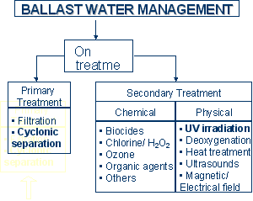

- CHEMICAL BIOCIDE
- 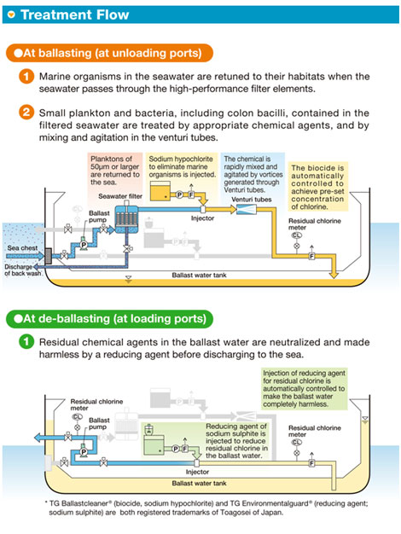
The ballasting process of chemical biocide includes a set of filters, pumps that work both as ballast and de-ballast pump, chlorination chamber, venturi tubes and finally the ballast tanks. The ballast water pump takes suction and passes it through various types of filters where larger organisms are separated and returned back to sea. It then passes in the line where sodium hypochlorite is added to kill the micro-organism. This chemical and mixture of water is passed through venturi tubes for intimate mixing and then it is pumped to ballast tanks for storage purpose.

The de-ballasting process consists of the ballasting pump which now works as a de-ballasting pump takes suction pump from ballast tanks and before it is discharged overboard it is treated with the reducing agent to reduce the effects of chlorine in water. It is then pumped overboard at the loading port.
Disadvantages:
- Costly
- Efficient only when correct amount of dosing is done.
- Harmful to marine life if not reduced before discharging.

- ULTRAVIOLET TREATMENT

- 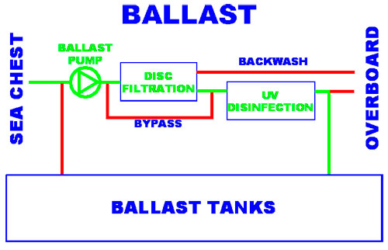
The chief components of this system are pumps which has a dual purpose of ballasting and de-ballasting, filter, UV dis-infection chamber and the ballast tanks. This process includes killing the micro organism by the action of UV rays. As we all are aware this is the same technology used in our water purifiers. The harmful radiations are used to kill bacteria and micro-organism present in sea water. The safe and dis-infected water is pumped into the ballast tanks.

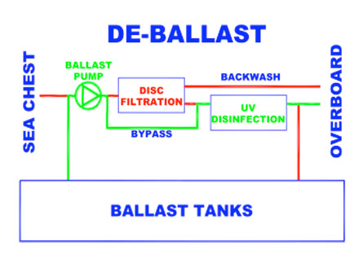
This involves the ballast water which was stored in the tanks is removed from the ballast water tanks at the loading port. This process begins when at the de-ballast pump pumps out water from the tanks. The water is now bypassed and is directly pumped into the UV disinfection chamber where the micro-organism which may have multiplied during the voyage before it is discharged overboard.
Disadvantages:
- Exposure to UV light is harmful. Hence extra care needs to be taken.
- High running cost as UV lamps have to be changed periodically.

- BALLAST FREE SHIP DESIGN (ballast exchange method):
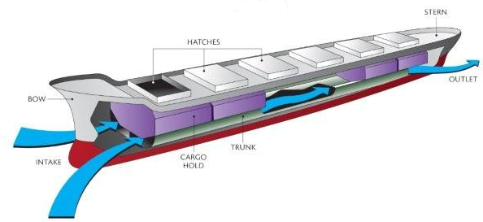
- This is one promising design to block hitchhiking organisms and terminate the entire requirements for expensive sterilization equipment like costly filters, ultraviolet irradiation, chemical biocides and other technologies.
- Ballast trunks: Ship ballast tanks are replaced with longitudinal structural ballast trunks consisting of one centre tank, two intermediate tanks and two side tanks which surround the cargo hold below the ballast draft and are connected to an intake opening near the bow and a discharge opening near the stern. These ballast trunks are swamped in the ballast circumstance to diminish the ship’s buoyancy.

OZONE TREATMENT:

Ozone is an oxidizing biocide that has been used to disinfect water supplies. Ballast water is treated as it flows through a device that bubbles ozone gas into the water. Most of this gas dissolves into the water, decomposes and reacts with other chemicals in the ballast water to kill organisms.
Ozone is especially effective at killing microscopic organisms. Combining ozone with a treatment method that successfully eliminates larger organisms would be more effective than using ozone as a solitary treatment.

Disadvantage:
- Ozone is a toxic gas.
- Installation of large size of ozone generator causes a problem.
- Leads to smog in lower atmosphere.
- It is not effective in treatment of larger organism.
DEOXYGENATION USING NITROGEN GAS:
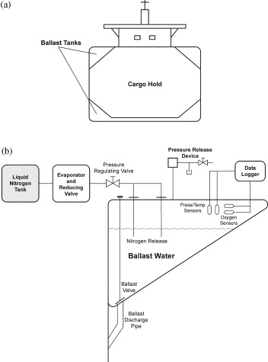
A relatively new method of ballast water treatment involves deoxygenation. This technique involves pumping nitrogen gas into the water to displace most of the oxygen. A low oxygen level then kills most of the oxygen-dependent organisms. In addition to offering a new approach to water treatment, this method appears to be safe for the environment and actually reduces the cost of shipping due to less tank corrosion.
Disadvantage:
- Deoxygenating requires certain unique equipment and current research into this topic suggests that some species require up to three days to kill.
- This time period may be too long to be of use. Like the other techniques, treating ballast water may not fully eliminate all organisms as well.
HEAT TREATMENT:
Heating ballast water to temperatures between 35oC (95oF) and 45oC (113oF) and maintaining that temperature for a long enough period of time is effective at killing larger organisms, such as fish, but not as effective at killing microorganisms. Ballast water is heated by using the engine cooling system, either by using ballast water to cool the engine or by flushing
ballast tanks with the heated water that was used as coolant. This is a very efficient method because coolant water is necessary and would most likely be discharged
into the ocean if it were not used to treat ballast water.
Another benefit to this method is that there are no resulting chemical byproducts.
A number of factors need to be considered
before using heat treatment on a specific ship or a particular voyage. The voyage must be long enough to allow water to reach the specified temperatures for the necessary amount of time.
Another consideration is the possibility of ballast tank corrosion from the high temperatures.
Disadvantage:
- Ineffective for microorganisms.
- Require pipe lines to bring ballast water in contact with heated fresh water.
- Treatment is limited by the amount of heat provided by the engines.
- In some cases, it may be necessary to be filter out dead organisms before releasing the heated ballast water into the environment.
- Temperature of ballast water is affected by the ambient water temperature, this method may not be as useful in colder waters since more energy would be needed to raise ballast water to the necessary temperature.

FILTRATION :
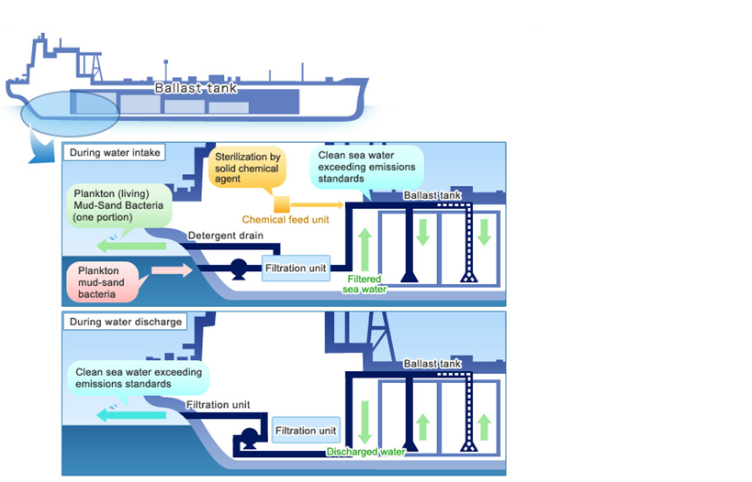
Ballast water can be filtered before it enters the tanks or while it is being discharged. The advantage to filtering as water is pumped into the tanks is that organisms that are filtered out may be retained in their native habitat.
Since the size of filters used to treat ballast water are not likely remove microorganisms, another treatment method would have to be used to remove microbial invaders. New technologies are developing ways to increase the flow rate through filters and prevent organisms from clogging filters, making this method of treatment more useful.

Disadvantage:
- Expensive installation due to specialized equipment.
- The cost of filtration increases as smaller particles, and organisms, are removed from ballast water.
- Special care must b taken if ballast is filtered during discharging to prevent accidental introduction of species into water.
CONCLUSION:

REFERENCES:
Websites:
- www.google.com
- www.wikipedia.com
- www.dnv.com
Faculty:
- PROF. A.V. KADAM
- PROF. V.G. MEHENDALE
- PROF. A. KUMAR

