DEVELOPMENT OF PORT & ITS SOCIO- ECONOMIC EFECTS ON HINTERLAND
THERMAL IMAGING ON PORT SECURITIES
1. Arpit Choubey, ETO -14 ,Great Eastern institute of Maritime Studies, Lonavala,
arpitpc009@gmail.com
2. Mohit Jha, ETO-14 Great Eastern institute of Maritime Studies, Lonavala,
mohitjha_1989@yahoo.com

Abstract
Thermal security cameras provide excellent visibility at long ranges without lighting or other artificial illumination to secure large waterfront areas and airports. Under a growing threat of terrorist attacks as like 26/11 Mumbai, and border authorities around the world are installing thermal security cameras to keep their passengers, employees, and valuable equipment safe. Operations continue night and day, and all year round, so the security infrastructure needs to be effective regardless of weather or lighting conditions. Making sure that the port is a secure area and that not only the passengers but also the vessels and their cargo are safe. Still other parts of the Port's security upgrade involved the Terminal's physical security. These included the installation of improved access control through the implementation of the nationwide Transportation Worker Identification Credential (TWIC) system, and the integration of thermal imaging cameras.

Keywords: Port Securities, Ship Security Analysis, Security using Infrared radiations, Thermal Imaging camera on ports.

- Introduction
A complex of four marine terminals, the Port processes a diverse mix of cargo including bulk, break-bulk, containers, and automobiles. Terminal operations continue night and day, and all year round, so the security infrastructure needs to be effective regardless of weather or lighting conditions. To meet these ever-changing demands and conditions, the Port has spent the last two years designing and implementing an impressive security upgrade, funded in part through a grant from the Department of Homeland Security. These improvements focused on his all Terminals, multipurpose and multi-modal facilities that need to control access from pedestrian, vehicle, rail, and different sea routes.
Some of these new security systems focused on the cargo and its containers. Examples include an Optical Character Recognition system, which scans shipping container markings and matches these markings to their truck's license plate, and Radiation Portal Monitors that scan containers for abnormal levels of radiation that may betray the presence of a dirty bomb. Interest for thermal imaging has grown considerably over the last few years in large varieties in the world of security markets.
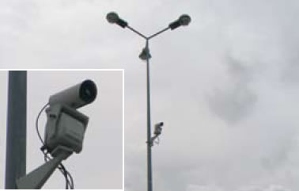
FIGURE 1. Thermal Image Cameras Installed on Port.
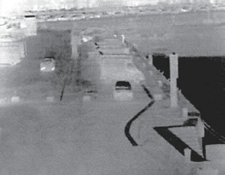
FIGURE 2. Thermal image taken by one thermal imaging camera. Cars and people can clearly be detected, in total darkness, from a distance of more than 400 meters.
- Main Work

A thermal imaging camera records the intensity of radiation in the infrared part of the electromagnetic spectrum and converts it to a visible image. Our eyes are detectors that are designed to detect electromagnetic radiation in the visible light spectrum. All other forms of electromagnetic radiation, such as infrared, are invisible to the human eye. The existence of infrared was discovered in 1800 by astronomer Sir Frederick William Herschel.

Curious to the thermal difference between different light colors, he directed sunlight through a glass prism to create a spectrum and then measured the temperature of each color. He found that the temperatures of the colors increased from the violet to the red part of the spectrum. After noticing this pattern Herschel decided to measure the temperature just beyond the red portion of the spectrum in a region where no sunlight was visible. To his surprise, he found that this region had the highest temperature of all.
Infrared radiation lies between the visible and microwave portions of the electromagnetic spectrum. The primary source of infrared radiation is heat or thermal radiation. Any object that has a temperature above absolute zero (-273.15 degrees Celsius or 0 Kelvin) emits radiation in the infrared region. Even objects that we think of as being very cold, such as ice cubes, emit infrared radiation we experience infrared radiation every day. The heat that we feel from sunlight, a fire or a radiator is all infrared. Although our eyes cannot see it, the nerves in our skin can feel it as heat. The warmer the object, the more infrared radiation it emits.

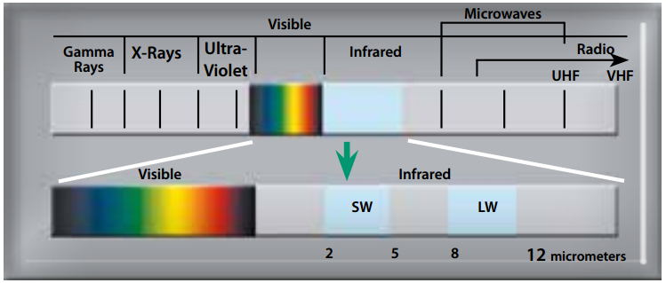
FIGURE 3. Statistics of Infrared among All Radiations.
2.1 The thermal imaging camera:

Infrared energy (A) coming from an object is focused by the optics (B) onto an infrared detector (C). The detector sends the information to sensor electronics (D) for image processing. The electronics translate the data coming from the detector into an image (E) that can be viewed in the viewfinder or on a standard video monitor or LCD screen.
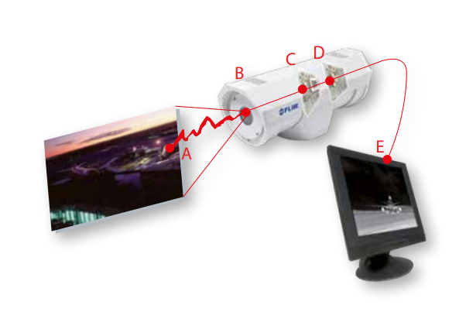
FIGURE 4. Working Process of Thermal Camera.

  - A cost effective solution for perimeter protection:

Today, the challenge to CCTV professionals is to make sure that video footage is effective on a 24/7 basis, 365 days a year. Securing an area during the daytime is one thing. But what can be detected if CCTV cameras are blinded by the sun? And in weather conditions like fog, rain and snow? And what happens during the night, in total darkness?

A number of tools are available to help detect potential intruders in the dark. Often different technologies are being combined to create a secure perimeter. Fences can be complemented with Closed-Circuit Television (CCTV) systems with or without active infrared illumination or old fashioned light bulbs, Radio Frequency Intruder Detection (RAFID) systems, thermal imaging cameras and/or walking patrols. Every technology has advantages and disadvantages and some are more expensive than others. To get a full picture of the Total Cost of Ownership (TCO) for a certain solution, not only the initial installation cost but also the maintenance cost needs to be taken into account.

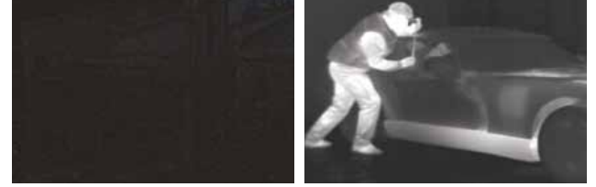
FIGURE 5. Normal CCTV Footage and Thermal Infrared Vision Camera Footage.
An excellent tool for detecting potential intruders in total darkness is thermal imaging cameras. They need no light whatsoever to operate. Based on subtle differences in temperature, called heat signatures, thermal imaging cameras create a crisp image. A thermal imaging camera can also see through light fog and smoke. Thermal imaging cameras are also extremely useful during daylight. Thermal contrast is extremely difficult to mask. Someone trying to hide in shadows or bushes and people that are trying to camouflage themselves, will become clearly visible on a thermal image. Thermal imaging cameras are also not blinded by the glare from the sun. They produce a crisp image in practically all weather conditions.
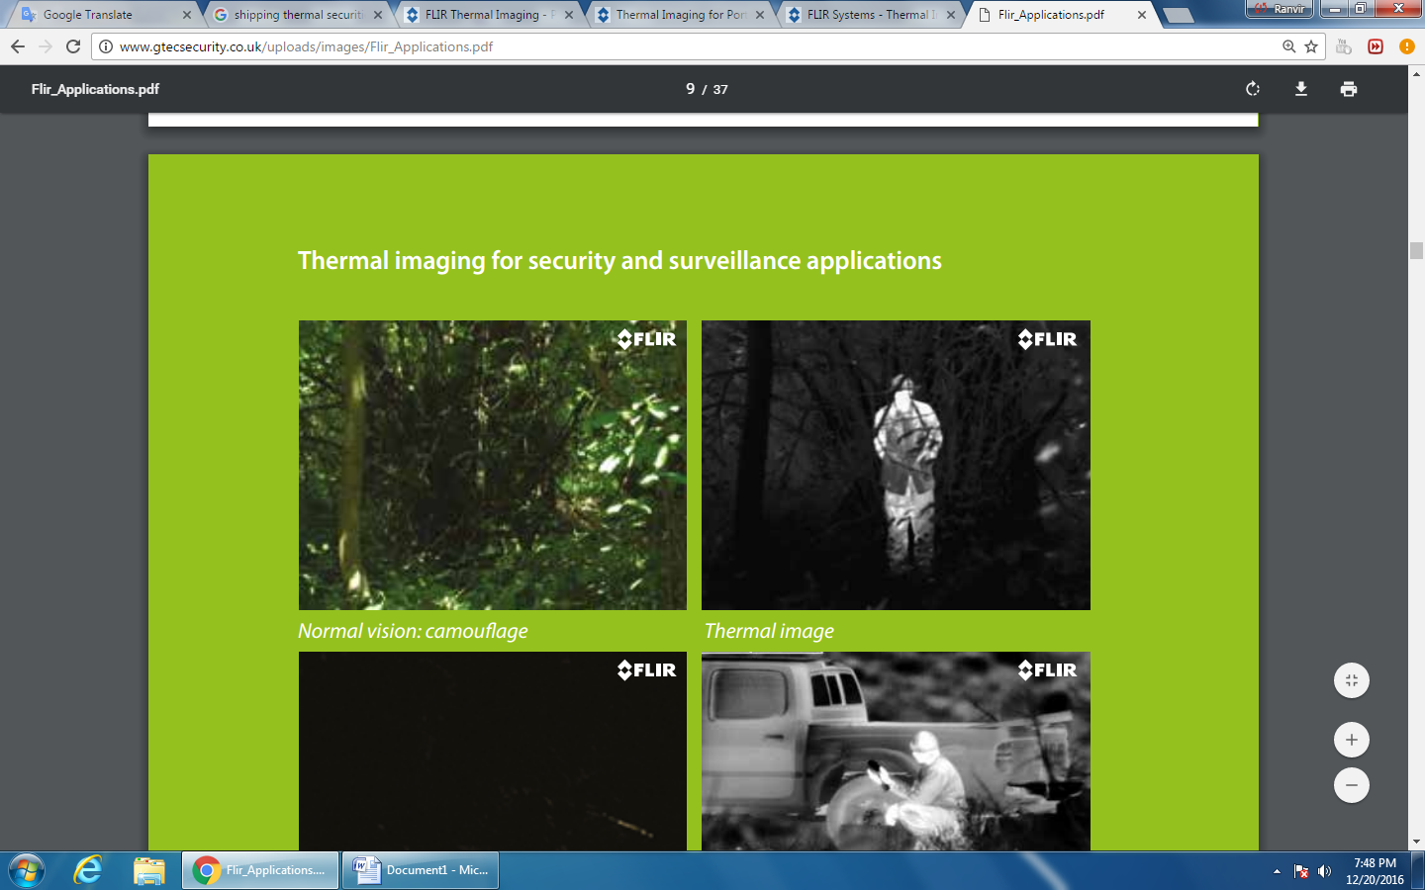
(A)
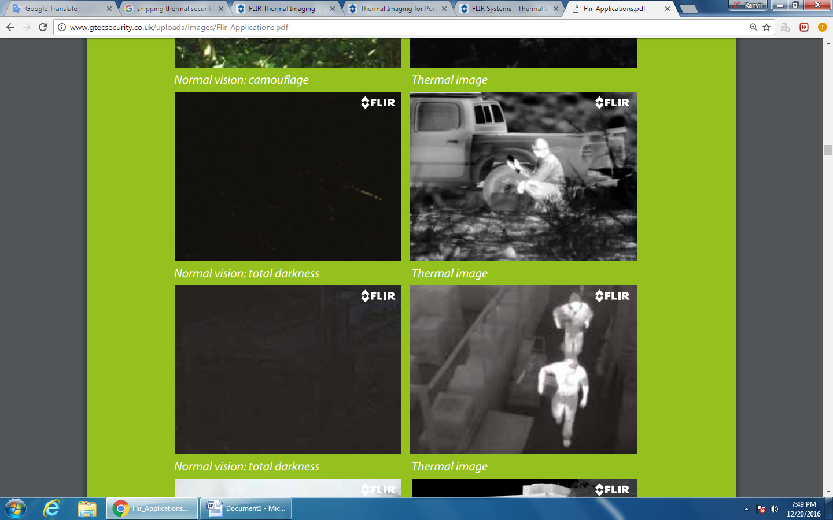
(B)
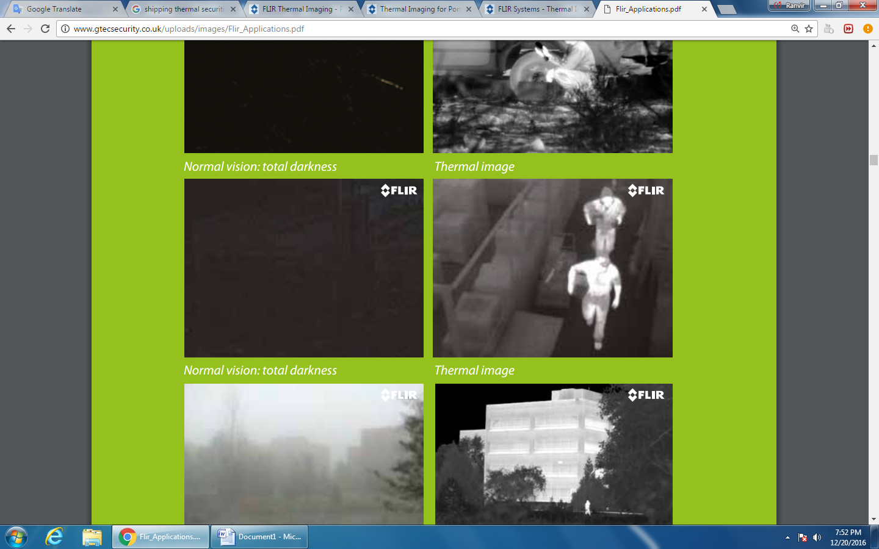
(C)
FIGURE 6. (A) Camouflage Normal & Thermal Image,
(B) Total darkness Normal and Thermal Image.
(C) Normal Passage Passing Night View with Thermal Image

2.3 Thermal imaging cameras and video analytics:

Thermal imaging cameras work seamlessly together with video analytics. One of the advantages of thermal imaging cameras is that they are always producing a high-contrast image. Not only during the night. Also in difficult light conditions where CCTV cameras are giving hardly any contrast. Thermal imaging cameras are generating fewer unwanted alarms then CCTV cameras. This makes thermal imaging perfect to work together with video analytics.

2.4 Thermal imaging:

An affordable technology Demand for thermal imaging cameras has increased drastically over the last few years. This increase in demand, production volumes have gone up and prices for thermal imaging cameras have come down. Although a thermal imaging camera is still more expensive than a CCTV camera, fewer cameras need to be deployed to cover the same area. The civil works that need to be carried out are minimal. Furthermore, since thermal imaging cameras produce a clear image in the darkest of nights, no complimentary technologies like light or infrared illuminators need to be installed. Not only is this limiting the amount of civil works that needs to be carried out but is it also reducing the maintenance cost.

2.5 Thermal Imaging: a wide variety of applications

As more and more people are discovering the benefits that thermal imaging cameras have to offer, volumes have gone up and prices are coming down. This means that thermal imaging cameras are finding their way to more and more markets.

- Maritime: On both yachts and commercial vessels, thermal imaging cameras are being used for night time navigation, shipboard security, manoverboard situations and anti-piracy.
- Security: Our security customers benefit from thermal imaging cameras because they help them to secure facilities like ports, airports, nuclear facilities, warehouses, estates and many more against intruders.
- Electrical / Mechanical: In industrial environments thermal imaging is used to find hot-spots that can lead to failures in electrical and mechanical installations. By detecting anomalies at an early stage production breakdowns can be avoided and money can be saved.
- Building diagnostics: Building professionals look for insulation losses and other building related defects with a thermal imaging camera. Finding insulation losses and repairing them can mean huge energy savings.
- Border security: Border security specialists protect their country’s border against smugglers and other intruders. With a thermal imaging camera they are able to see a man at a distance of 20 kilometers away in total darkness.
- Science / R&D: Thermal imaging also plays a pivotal role in both applied and fundamental R&D. It can speed up the design cycle so that products can go to market faster. For these demanding applications FLIR Systems markets extremely high performance thermal imaging cameras.
- Transportation: Thermal imaging cameras are installed in cars for driver vision enhancement. They help the driver to see up to 4 times further than headlights. They are also installed in specialty vehicles such as fire-trucks, mining and military vehicles.
- Automation / process control: Thermal imaging cameras are also installed to continuously monitor production processes and to avoid fires.
- Law enforcement: Police officers use the power of thermal imaging to see without being seen. They can easily find suspects in total darkness without giving away their position.
- Optical gas imaging: Gas leaks can also be detected seamlessly with a thermal imaging camera.
- Personal vision systems: Outdoor enthusiasts can see clearly at night with the help of a thermal imaging camera.
- Firefighting: Firefighters are able to see through smoke. It helps them to find victims in a smoke filled room and also to see if fires are well extinguished. It helps them to save lives.

- Conclusions

We are in the middle of a change in how security is done. Ten years ago, the security manager of a large company was usually a retired soldier or policeman, for whom camera security was a relatively unimportant specialty which he left to the computer department, with occasional help from outside specialists. In ten years’ time, his job will be occupied by a systems person; they will consider locks and guards to be a relatively unimportant specialty which he’ll farm out to a facilities management company, with an occasional review by outside specialists. Ten years ago, security technology consisted of an archipelago of mutually suspicious islands—the cryptologists, the operating system protection people, the burglar alarm industry, right through to the chemists who did funny banknote inks. We all thought that the world ended at our shore.
In ten years’ time, security engineering will be an established discipline; the islands are being joined up by bridges, and practitioners will need to be familiar with all of them. Information security was said to be about ‘confidentiality, integrity and availability’. This list of priorities will be the other way round (as it already is in many applications). Thermal Security will be about ensuring that systems are predictably dependable in the face of all sorts of malice, and particularly in the face of service denial attacks. They will also have to be resilient in the face or error and mischance. So tolerance of human carelessness and incompetence will be at least as important as tolerating dishonesty, and this will mean paying close attention to economic and institutional issues as well as technical ones. The ways in which real systems will provide this dependability will be much more diverse than today: tuning the security policy to the application will be an essential part of the secure art.

Acknowledgements:
- The Great Eastern Institute of Maritime Studies
- Tolani Maritime Studies. Thanks for giving a platform for exploring our ideas
- Mr. Ajoy Chattarjee – Principal and head of GEIMS.
- Captain Ravi Shankar - Vice- Principal of GEIMS.
- Mr. M.. Patrao , C/E- Course Coordinator GEIMS (ETO)
- Mrs. Meena Ravishankar – Soft skill Trainer.
- All other faculties
References:
[1]. King, John. "The security of merchant shipping." Marine Policy 29.3 (2005): 235-245.
[2] Borror, Alan L., and Ernest W. Ellis. "Thermal imaging method." U.S. Patent No. 4,720,449. 19 Jan. 1988.
[3] Kaplan, Herbert. Practical applications of infrared thermal sensing and imaging equipment. Vol. 75. SPIE press, 2007.
[4] Rosell, Fred A., et al. The Fundamentals of Thermal Imaging Systems. No. NRL-8311. NAVAL RESEARCH LAB WASHINGTON DC, 1979.
[5] Chen, Wen, and Xudong Chen. "Ghost imaging for three-dimensional optical security." Applied Physics Letters 103.22 (2013): 221106.
[6] Vollmer, Michael, and Klaus-Peter Möllmann. Infrared thermal imaging: fundamentals, research and applications. John Wiley & Sons, 2010.
[7] Holst, Gerald C. Common sense approach to thermal imaging. Washington, DC, USA:: SPIE Optical Engineering Press, 2000.

