Advanced technology for safety and security
Corresponding author:
B V Raghuram
Ph: +91 8139919065, +91 8125973867
E-mail: raghuram.marine@gmail.com
Postal address:
Sri Mangathayaru medical agencies,
Opp. E-seva, Bus-depot road,
Khammam,
Andhra Pradesh. 507001.
Co-author:
N M Neeraj
Ph: +91 9008190064
E-mail: nrj.coorgie@gmail.com
Postal address:
S/o N P Madappa,
Ponnumala Estate,
Kattemadu village & post,
Madikeri Tq,
Coorg district,
Karnataka. 571252.
Affiliated to: Mangalore Marine College

Abstract
Day after day we read and hear in the media about natural disasters, accidents and terrorist attacks. Advanced technology for safety and security ensures the protection people and the environment from threats as far as possible. They focus on early detection, prevention, direct protection and quickly overcoming the consequences of an incident.
Here, we’re going to look into a few of them.
1. Electronic noses
2. Robots as disaster helpers
3. Flying 3D eye-bots
4. Mini helicopters
Key words: safety-security, E-nose, Robots, eye-bots, quadrocopters.
SNIFFING OUT THE TERRORISTS
Basic principle of E-nose
An electronic nose can be a modular system comprising of active materials which operate serially on an odorant sample. These active materials can be classified into two: an array of gas sensors and a signal processing system. The output of E-nose can be the identification of the odorant, an estimation of the concentration of the odorant or the characteristic of the odour as might be perceived by the human. Fundamental of artificial nose is that each sensor in the array has different sensitivity. The pattern of response across the sensors is distinct for different odors. This distinguishably allows the system to identify the unknown odor from the pattern of sensor responses. The pattern of response across all the sensors in the array is used to identify the odor. Different e-noses use different types of gas sensors which form heart of e-nose.
Sensing an odorant
In a typical e-nose, an air sample is pulled by a vacuum pump through a tube into a small chamber housing the electronic sensor array. Next the sample handling units expose the sensors to the odorant, producing a transient response as the VOCs interact with the surface and bulk of sensor’s active material. A steady state condition is reached in a few seconds to a few minutes. During this interval, the sensor’s response is recorded and delivered to the signal processing unit. Then a washing gas such as alcoholic vapor is applied.

The advantage of sensor array over single sensor is, sensitivity to a wide-range of analytes, better selectivity, multi-component analysis and analyte recognition
Types of sensors: - 1. Polymer sensors 2. MOSFET sensors 3. Optical fibre sensors 4.Surface acoustic wave sensors 5. Quartz crystal microbalances
In sniffing out the terrorists, an electronic nose named HAMLeT is used. It stands for “Hazardous Material Localization and Tracking”. This uses quartz crystal sensors.
Working
The QCM types consist of a resonating disk a few millimeters in diameter, with metal electrodes on each side connected to lead wire. The device resonates at a characteristic frequency(10 MHz to 30 MHz) when excited with an oscillating signal. During manufacture, a polymer coating is applied to the disk to serve as the active sensing material. In operation, a gas sample is adsorbed at the surface of the polymer, increasing
The mass of the disk-polymer device and thereby reducing the resonance frequency. The
Reduction is inversely proportional to odorant mass adsorbed by the polymer. For example, a 166-μm- thick quartz crystal cut along a certain axis will resonate at 10 MHz. If a QCM sensor made with this resonator undergoes a positive 0.01 percent change in mass, a negative shift of 1 kHz will occur in its resonance frequency. Then when the sensor is exposed to a reference gas, the resonance frequency returns to its baseline value.

Fig. Quartz crystal sensor

The sensor, shown in Figure 3, is composed of a quartz disc coated with the absorbing
Polymer layer and a set of gold electrodes evaporated onto either side of the polymer/
Quartz structure. Micromachining is used to fabricate the QCM devices, which makes the
Fabrication of small sensor structures possible. Coatings can be between 10nm and 1mm and are applied using spin coating, airbrushing, inkjet printing or dip coating.

When an ac voltage is applied across the piezoelectric quartz crystal the material oscillates at its resonant frequency, normally between 10 and 30MHz. The three-dimensional wave produced, travels through the entire bulk of the crystal. A membrane is deposited onto the surface of the crystal and this layer adsorbs gas when exposed to the vapour, which results in an increase in its mass.

APPLICATIONS OF ELECTRONIC NOSE
The electronic nose has been used in a variety of applications and could help solve problems in many fields. The electronic nose can be applied by food manufacturers to such tasks such as freshness testing, quality screening of incoming raw material, and monitor for accidental or intentional contamination. In the medical field, e nose has a variety of application such as rapid diagnosis of acute infection through breath analysis and screening of bacterial cultures for early detection of pathogens. E-nose can serve in safety and security applications such as hazard alarm for toxic and biological agents, screening airline passengers for explosives and drugs. Its military applications include land- mine detection, biological and chemical agent detection etc.

E-NOSE: ADVANTAGES AND DISADVANTAGES
ADVANTAGES
It can be used without fall over hours, days, weeks and even months and can even circumvent problems associated with the use of human panels such as individual variability, adoption, fatigue mental state and exposure to hazardous material. The e-nose is a compact device and so it is portable and reliability is very high. It can identify simple molecules which cannot be accomplished by human nose. It can identify a smell objectively.
DISADVANTAGES
There are a few disadvantages to the e-nose technology which includes the price. The cost of an e-nose ranges from $5000 to $100,000. Another disadvantage has been the delay between successive tests, the time delay ranging between 2to 10 minutes during which time, the sensor is to be washed by a reactivating agent, which is applied to the array so as to remove the odorant mixture from the surface and bulk of the sensors active material.

The future by a nose
Electronic noses for detecting explosives are still in various stages of testing and have a long way to go before being field-operational. However, there is an increasing trend in the development of these devices for detecting hidden explosives in various security scenarios and explosives’ vapors emanating from landmines. It seems that we will see more and more of these systems replacing some of the larger and more expensive detection devices. Because these electronic noses are smaller and less expensive, law-enforcement and security agencies will be able to deploy them in a wider range of potential terrorist targets and in larger numbers.

Robot reconnoiters uncharted terrains
Now a new generation of high-tech helpers is at hand: Mobile robots are being used in place of humans to explore hazardous and difficult-to-access environments such as buildings in danger of collapsing, caves, or ground that has been polluted by an industrial accident. Equipped with sensors and optical cameras, these robots can help rescue services search for victims in the wake of natural disasters, explosions or ﬁre and can measure concentrations of hazardous substances. There’s just one problem: Often there is no map to show them the location of obstacles and steer them along navigable routes. Yet the high-tech machines are able to make progress, either independently or guided by remote control. Researchers are now developing a roaming land robot that autonomously reconnoiters and maps uncharted terrain. The robot uses special algorithms and multi-sensor data to carve a path through unknown territory. The robot localizes itself within its immediate surroundings, continuously recalculating its position as it makes its way through the dangerous areas, and simultaneously reﬁnes the map which it generates. This is made possible, by an algorithm toolbox for the robot that runs on a built-in computer. The robot is additionally equipped with a variety of sensors. Odometry sensors measure wheel revolutions, inertial sensors compute accelerations, and distance-measuring sensors register clearance from obstacles. Cameras and laser scanners record the environment and assist in the mapping process. The algorithms read the various data supplied by the sensors and use them to determine the robot’s precise location. The interplay of all these different elements concurrently produces a map, which is updated continuously. Experts call the process Simultaneous Localization and Mapping, or SLAM.

Figure 1: A destroyed PackBot, made by iRobot, displayed at the 2007 Association
for Unmanned Vehicles International (AUVSI) show. The robot was destroyed while
surveying an explosive device in Iraq.

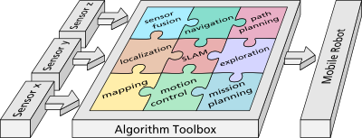
Figure 2: algorithm tool box and sensors. Figure 3: The Sojourner Mars rover

The work is divided into two distinct parts. The first part is to create a graphical user interface with which the operator easily can get an intuitive overview of what is going on around the robot, while also allowing him or her to access the control functions of the robot. The other part consists mainly of semi-autonomous (or) autonomous, parts that allow the robot to carry out high-level tasks, such as navigation from one location to another, and thereby minimizing the cognitive load that is put on the operator.
In addition to a number of sensors, with which it observes the world, a successful Urban Search and Rescue (USAR) robot also needs an intelligent user interface (UI). The UI between the human operator and the robot should be able to transfer commands from the human to the robot and information from the robot to the human operator. The UI should maximize this information transfer and at the same time minimize cognitive load on the operator. The software should make it possible for the operator to easily control the robot with the help of, for example, a regular keyboard and a mouse. The operator should also have quick access to several options, making it possible to choose what sensors to receive information from, how the robot should respond to various commands, etc. The operator should also be able to instruct the robot to move to some location with a click in the map in the user interface.
The map, depicting the robots surroundings, should be constructed with the help of the robot’s sensor readings. This map should be good enough to be of use for both the robot’s navigation and the operator’s situational awareness later on.
In summary, the goal is to program a robot with the following capabilities:
– Manual navigation.
– Semi-autonomous navigation.
– A human-finding behavior.
– A autonomous exploration behavior.
A graphical user interface should be constructed, with the capability of controlling the
robot and to observing its environment.
The requirements that are essential to USAR-robots can be classified into three categories:
1. Awareness. How well both the robot and the operator conceives a mental image of the environment the robot currently is in.
2. Mobility. What amount of time and at what distance the robot can operate, and how well the robot can traverse a particular area
3. Robustness. How consistent and durable the robot is.
Choosing Sensors
“The sensor is a device that measures some attribute of the world”. A sensor suite is a set of sensors for a particular robot. The selection of a sensor suite is a very important part of the USAR-robot design process. There are eight attributes to consider when choosing a sensor for a sensor suite:

1. Field of view and range 2. Accuracy, repeatability and resolution 3. Responsiveness in the target domain 4. Power consumption 5. Hardware reliability 6. Size 7. Computational complexity 8. Interpretation reliability.

The points that ties the most into the requirements mentioned earlier are:
– Awareness: 1, 2 and 8.
– Mobility: 4 and 6.
– Robustness: 2, 3, 5 and 8.

Here is a list of examples of sensors that often are chosen for use in USAR-robots:
1. CCD Cameras 2. Laser range imaging 3. 3D-cameras 4. Carbon dioxide sensors
5. IR sensors 6. Thermal cameras 7. Sound sensors 8. Sonar.

The list of past missions the USAR task forces have performed include
– Hurricane Iniki – Kauai, Hawaii; 1992
– Northridge Earthquake – Los Angeles, California; 1994
– Murrah Federal Building, Oklahoma City Bombing – Oklahoma, 1995
– Hurricane Opal – Ft. Walton Beach, Florida; 1995
– Humberto Vidal Building Explosion – Puerto Rico, 1996
– DeBruce Grain elevator explosion – Wichita, Kansas; 1998
– Tornadoes – Oklahoma, 1999
– Earthquakes – Turkey, 1999
– Hurricane Floyd – North Carolina, 1999
– World Trade Center and Pentagon Disaster – New York & Washington, D.C.; 2001
– Olympic Games – Utah, 2002.
Other similarly dangerous environments where teleoperated robots have been applied include:
– Underwater missions (such as the exploration of the wreck of the Titanic.
– Volcanic missions.
– Explosive Ordnance Disposal.

Flying 3D eye-bots
These mini UAVs, can be majorly used for conducting intelligent aerial surveillance of major events. It is beneficial to disaster relief workers, and likewise to urban planners, who could utilize them to produce detailed 3D models of, to monitor construction sites or to measure contamination at nuclear power plants. These UAV eye-bot prototypes have been developed based on a quadrotor design.
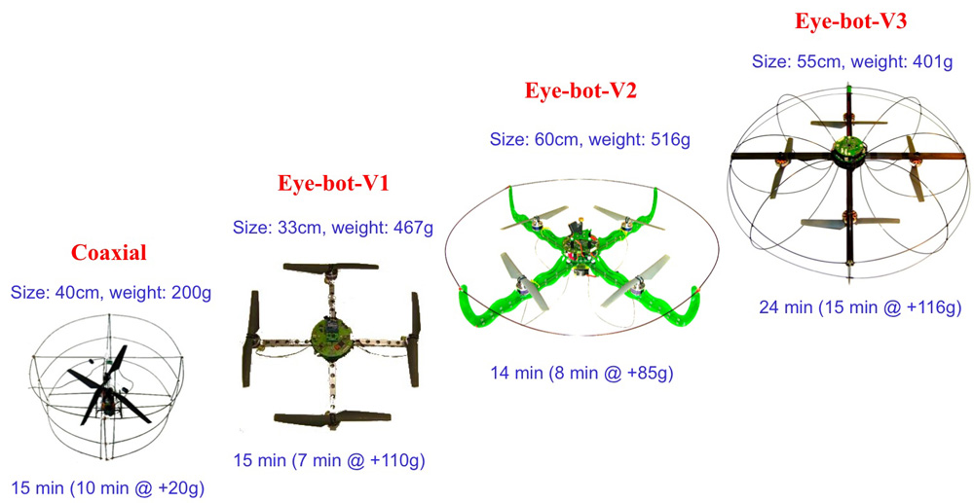
A CMOS sensor developed by researchers for Microelectronic Circuits and Systems IMS lies at the heart of the anti-collision technology. The sensor can measure three-dimensional distances very efficiently. Just as in a black and white camera, every pixel on the sensor is given a gray value. The assigned distance value of each pixel enables the drones to accurately determine their position in relation to other objects around them.
Fig 1:Size and weight of the platform is defined above and the flight endurance is defined below
The distance sensor developed by the IMS offers significant advantages over radar, which measures distances using reflected echoes. Sensor also has a higher resolution than radar. The distance information is transmitted at the very impressive rate of 12 images per second.
Rather than use radar and GPS as do virtually all other drones, these eye-bots use a special photography trick. It works by taking a picture of a scene, and then another of the same scene right away. A processor compares the light that is bounced back between the two to calculate distance. And that is how the eye-bots are able to figure out both how close they can fly to a future crowd below, and also how they can take note of other objects such as buildings, so as to avoid flying into them. The double-snapshots are taken at a rate of twenty every second, giving the eye-bots plenty of information to work with.
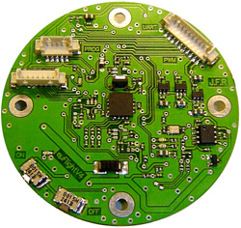
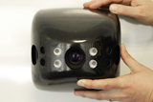
Fig: latest eye-bot fig: The flight stability controller

Control System: The system incorporates three levels of control, the low-level flight stability controller, middle-level autonomous controller and high-level guidance system. The two lower levels are incorporated in a single printed circuit board which also contains 3D inertial sensing and connectivity for additional sensing. The guidance system is based on a custom developed.

Onboard Sensing: There are several onboard sensors to help the eye-bot navigate through an indoor environment and coordinate with other eye-bots including:
- Sonar and pressure sensing for altitude control
- Optical-flow for drift detection
- Magnetometer for heading determination
- 360° infrared distance scanner for collision detection and navigation
- Relative positioning sensor for swarm co-ordination and communication

Mini helicopters as disaster helpers
The “quadrocopter” has a diameter of one meter and, thanks to its maneuverability, can negotiate collapsed buildings. At present the flying disaster helper operates solo, but it could soon be joined by reinforcements: Fraunhofer research scientists are working on their deployment in swarms. Currently this would only be possible with considerable manpower effort – the helicopters cannot communicate with each other and each one would have to be individually controlled.
To ensure that, in future, one person can control all the helicopters deployed, the scientists have developed software which functions as a director of operations. When one of them flies close to victims to investigate their injuries, another reconnoiters the fastest route for getting them out.
The program consists of individual modules, the software agents, which can be programmed with a repertoire of tasks. One software agent is assigned to each quadrocopter. The miniature flying machines are equipped with various sensors such as cameras, infrared cameras, laser measurement equipment and sniffer devices for identifying hazardous substances. They can also radio images, videos and other data to the ground station, where the software agents assess the information and, via an interface, send instructions for action to the quadrocopters.
The special factor is that they memorize what happened in particular situations and respond more quickly the next time.
Further applications include monitoring of premises.

A quarocopter is a multicopter that is lifted and propelled by four rotors. The lift of this mini helicopter is generated by a set of revolving narrow-chord airfoils. Control of vehicle motion is achieved by altering the pitch and/or rotation rate of one or more rotor discs, thereby changing its torque load and thrust/lift characteristics. Each rotor produces both a thrust and torque about its center of rotation, as well as a drag force opposite to the vehicle's direction of flight. A new fuel cell that weighs only 30 grams and produces an amazing twelve watt power will fuel up these un-manned quadracopters.

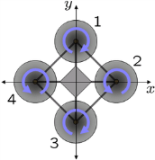
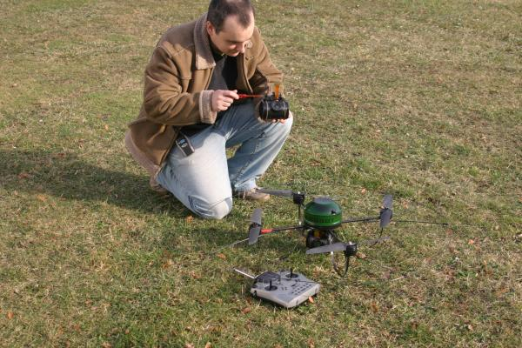
Flight control: Each rotor produces both a thrust and torque about its center of rotation, as well as a drag force opposite to the vehicle's direction of flight. If all rotors are spinning at the same angular velocity, with rotors one and three rotating clockwise and rotors two and four counterclockwise, the net aerodynamic torque, and hence the angular acceleration about the yaw axis is exactly zero, which implies that the yaw stabilizing rotor of conventional helicopters is not needed. Yaw is induced by mismatching the balance in aerodynamic torques (i.e., by offsetting the cumulative thrust commands between the counter-rotating blade pairs).
Angular accelerations about the pitch and roll axes can be caused separately without affecting the yaw axis. Each pair of blades rotating in the same direction controls one axis, either roll or pitch, and increasing thrust for one rotor while decreasing thrust for the other will maintain the torque balance needed for yaw stability and induce a net torque about the roll or pitch axes. This way, fixed rotor blades can be made to maneuver the quad rotor vehicle in all dimensions. Translational acceleration is achieved by maintaining a non-zero pitch or roll angle.

Acknowledgement
I’d like to thank our principal prof. Ramesh V Anvekar, my co-author N M Neeraj, my mom, Mr. Sandesh, my mom and all my friends for their constant and continuous support.
References
Albert, K.J. and Lewis, N.S. (2000), “Cross reactive chemical sensor arrays”.
Behr, G. and Fliegel, W. (1995), “Electrical properties and improvement of the gas sensitivity in multiple-doped sno2”, Sensors and Actuators B: Chemical, Vol. 26.

David Breummer, Douglas Few, Heather Hunting, Miles Walton, and Curtis Nielsen. Virtual camera perspectives within a 3-d interface for robotic search and rescue. Technical report, Idaho National Laboratory, Idaho Falls, Idaho, USA, 2005.

Herwitz, S.R., Johnson, L.F., Dunagan, S.E., Higgins, R.G., Sullivan, D.V., Zheng, J., Lobitz, B.M., Leung, J.G., Gallmeyer, B., Aoyagi, M., Slye, R., E., Brass, J., 2004. Demonstration of UAV-based imaging for agricultural surveillance and decision support.

K. Arshak, E. Moore, G.M. Lyons, J. Harris and S. Clifford are all based at the College of Informatics and Electronics, University of Limerick, Limerick, Ireland

www.fraunhofer.de

.

