LNG CARRIER DUAL FUEL ELECTRIC PROPULSION
COMPILED BY :
PRAMOD RAJAN AND ANURAG SRIVASTAVA
AMET UNIVERSITY
ABSTRACT
After some forty years of steam turbine dominance in LNG shipping, dual-fuel-electric machinery has established itself as a new market standard. This paper provides the essentials about dual-fuel engine technology and the dual-fuel-electric machinery concept for LNG carriers, compares different LNG carrier propulsion alternatives technically and commercially, and focuses on the latest developments with respect to both dual-fuel engine technology and the dual-fuel-electric machinery concept.
Outline of the DF-electric LNG carrier

The Wärtsilä DF-electric LNG carrier concept is designed for a single-screw vessel with four cargo tanks and a capacity of about 138,000 m3. The hull has a transom stern, a single-skew aft body and a bulbous bow. The propulsion machinery and accommodation spaces are arranged in the stern part. The cargo machinery room is arranged separate from the accommodation space on the upper deck. Two cargo tank system variants can be applied: membrane and spherical types. Both variants have a length BP of 275 m, breadth of 43 m and 48 m respectively, and design draught of 11 m. The main machinery consists of four nine-cylinder in-line Wärtsilä 50DF dual-fuel engines, each driving an alternator. Each main engine develops 8550 kW at 514 rev/min, giving a total output of 34.2 MW. The main generators feed the ships electrical Network and, through a variable-speed drive system, the propulsion motors. A 500 kW emergency diesel Generator set is also installed. The single, five-bladed fixed pitch propeller is driven by two 13.5 MW AC propulsion motors through couplings and a twin-input/single-output reduction gear. There are also two 1000 kW bow thrusters. To enhance the redundancy of the propulsion plant, the main engine rooms and casings are divided with afire-resistant bulkhead. The main engine rooms are under diminished air pressure. A back-up arrangement of a thermal oxidizer is provided to dispose of boil-off gas during long periods of low-load operation. The service speed of the ship is about 19.5 knots at the design draught of 11.0 m and with 15 % sea margin, which corresponds to 27 MW shaft power.

INTRODUCTION
Steam turbine installations have dominated LNG shipping since the emergence of the segment some four decades ago. The ease with which such installations can use the gas that is left to evaporate from the ship’s cargo tanks, dubbed Natural Boil-Off Gas (N-BOG), and their apparent reliability has left them in a position that has long been lost to reciprocating engines in any other segment of the shipping industry. Steam turbine installations have successfully met market requirements for many years, but market requirements change and new technologies emerge. This creates a potential for innovation. LNG carriers have traditionally been propelled by steam turbine Power plant mainly because the cargo boil-off gas can then be used as fuel. This propulsion system is also considered to be very reliable. However, the economic and environmental disadvantages of steam turbine propulsion are driving operators to seek alternative means of propulsion.the composition of the boil-off and thus its energy value also varies during the voyage and is an important consideration for alternative power plants. As nitrogen has a lower boiling point than methane, the nitrogen content of the boil-off gas is high at the beginning of the laden voyage and decreases during the voyage. In ballast, boil-off gas is mainly generated from the tank cooling spray; the heavier hydrocarbons evaporate, thereby giving the boil-off a higher energy content. The same result applies to forced boil-off gas.
MAIN DISADVANTAGES:-
- ECONOMY
- EMISSIONS
- CREWING
1) EMISSION- Steam turbine installations are not very environmentally friendly. As a consequence of the modest efficiencies of the propulsion equipment and electric power generation equipment, substantial amounts of additional fuel are required to complement the available N-BOG. On the laden voyage, only some fifty-five percent of the energy produced on board can on average be derived from N-BOG. On the ballast voyage, this is just above twenty-five percent on average. Most often, HFO is selected as additional fuel. HFO does not possess particularly good clean burning characteristics.
2) ECONOMY- Steam turbine installations use N-BOG very easily, but not very efficiently. This leads to high fuel costs. Losses in the boilers, the steam turbine, the reduction gear and the shafting bring the efficiency of the propulsion machinery to a modest twenty-nine percent at full load. At full load, twenty-five percent efficiency is achieved by the electric power generation machinery. These efficiencies are even lower at part load. The maintenance costs of steam turbine installations are however low, and the capital costs are within limits. Lubricating oil costs are no issue either.
3) CREWING: Crewing of ships with steam turbine installations poses a challenge today, and will pose a greater challenge in the future. In the nineteen-seventies, all shipping segments, except LNG shipping, have made the move from steam turbine installations to diesel engine installations. As a consequence, the pool of qualified and experienced steam turbine engineers, as well as superintendents with steam turbine knowledge, has rapidly decreased. At the same time, the fleet of steam turbine driven LNG carriers is growing rapidly. The shortage of suitable personnel results in a manning challenge, as well as a challenge to keep manning costs within limits.
SO THE QUESTION ASKED WAS “WHY” THE DUAL FUEL CAME INTO THE MARINE WORLD AND THE ANSWER WAS TRIPLE “E”
E-ECONOMY E-EMISSION E-EFFICIENCY
NOW IF WE TALK ABOUT EMSSION WE KNOW THAT ACCORDING TO MARPOL 73/78 ANNEX 6 WHOLE WORLD MARITIME FRATERNITY ARE TAKING STEPS TO STOP OR TO PREVENT THE EMISSION OF HARMFUL EXHAUST GASES SO WE SEE HERE THAT AT PRESENT WE ARE USING 4.5%.
EMISSION
Sox EMISSION

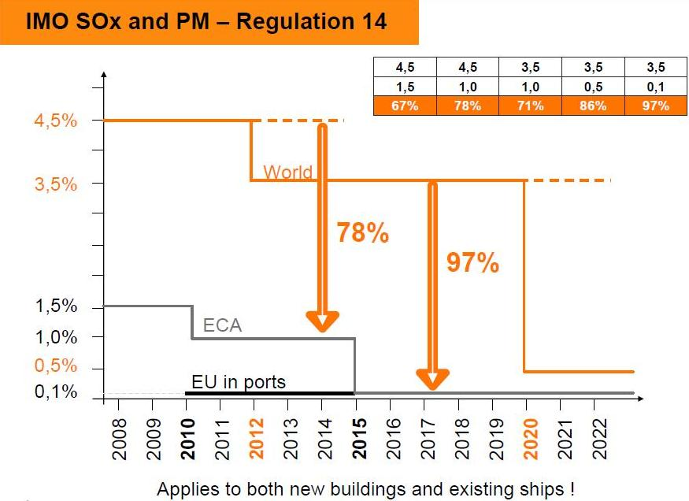
NOW IF WE TALK ABOUT EMSSION WE KNOW THAT ACCORDING TO MARPOL 73/78 ANNEX 6 WHOLE WORLD MARITIME FRATERNITY ARE TAKING STEPS TO STOP OR TO PREVENT THE EMISSION OF HARMFUL EXHAUST GASES SO WE SEE HERE THAT AT PRESENT WE ARE USING 4.5%S IN THE FUEL RIGHT NOW WHICH IS EXPECTED TO COME DOWN TO 3.5% IN 2012 AND WHICH WILL FURTHER COME DOWN TO 0.5% IN 2020 ONWARDS .IF WE TALK ABOUT SULPHUR EMISSION CONTROL AREA AT PRESENT THEY ARE USING 1.5% S IN THE FUEL WHICH IS LIKELY TO COME DOWN TO 1.0% IN 2010 AND WHICH WILL FURTHER COME DOWN TO 0.5% IN 2015 ONWARDS.IF WE TALK ABOUT EUROPEAN UNIONS IN PORTS RIGHT NOW WE ARE USING 0.1% S IN THE FUEL WHICH IS LIKELY TO BE COME DOWN TO ALMOST ZERO.

NOx EMISSION
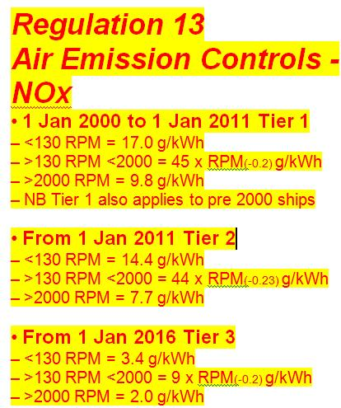
FROM THE GRAPH IT IS CLEAR THAT THE SHIPS IN 2000 BELONG TO TIER 1 AND SHIPS IN 2011 BELONG TO TIER 2 AND SHIPS IN 2016 IN DESIGNATED AREAS BELONG TO TIER 3 THAT IS THE EMISSION OF NOX WILL ONLY BE 2.0g/kwh IF THE SPEED OF THE ENGINE IS MORE THAN 2000 RPM AND OUR DUAL FUEL ENGINE ALREADY FEATURE IN THE TIER3
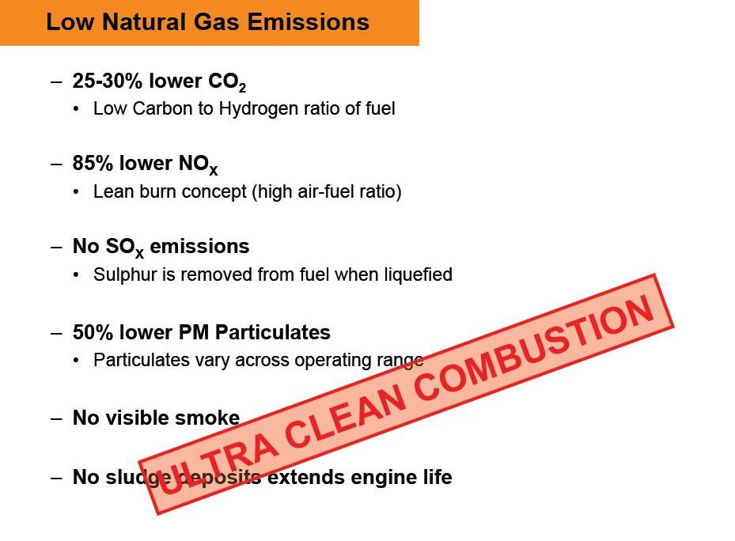
NOW IF TALK ABOUT THE CO2 EMISSION WE CAN SEE THAT BY USING DUAL FUEL MACHINERY CONCEPT WE CAN REDUCE THE CO2 EMISSION BY 25-30% BECAUSE LNG MAINLY CONTAINS METHANE(CH4) WHICH SHOWS THAT WITH RESPECT TO FOUR MOLECULES OF H WE HAVE ONLY ONE MOLECULE OF C.ALSO ACCORDING TO LEAN BURN PRINCIPLE WHICH WILL BE DEALT LATER WE CAN REDUCE NOX EMISSION BY 85% AND DUE TO LIQUEFICATION THERE WONT BE ANY SULPHUR OR ALMOST ZERO IN THE FUEL.THE PARTICULATE MATTER MAY EVEN COME DOWN TO 50% ,THERE WONT BE ANY SMOKE BECAUSE OF LOW NOX AND SOX AND SLUDGE DEPOSIT WILL BE VERY LEAST WHICH WILL ENHANCE THE ENGINE LIFE WHICH WILL LEAD TO ULTRA CLEAN COMBUSTION.

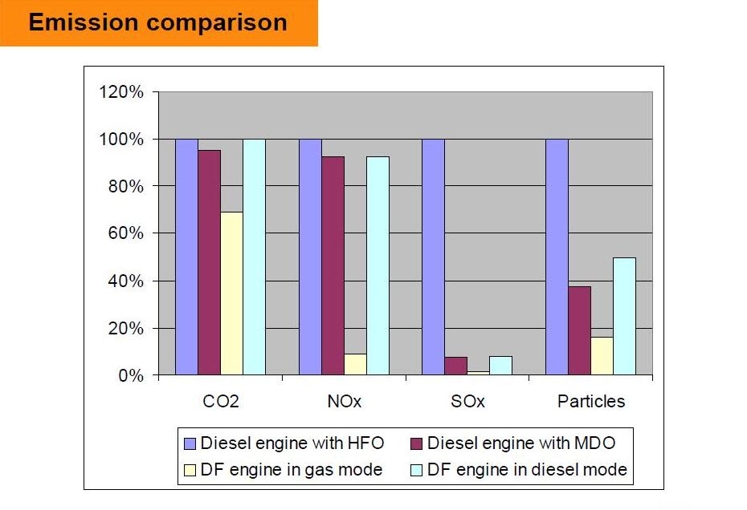

NOW THIS IS A BEAUTIFUL STATISTIC PRESENTED BEFORE YOU .YOU CAN EASILY SEE THERE IS A COMPARISON GIVEN BETWEEN DIESEL ENGINE WITH HFO AND MDO AND DUAL FUEL ENGINE WITH GAS MODE AND DIESEL MODE .SO WE CAN CLEARLY SEE THAT AS COMPARED TO DIESEL ENGINE WITH MDO MODE EMISSION OF CO2 IS APPROX2 5% LESS WHILE WE ARE USING DUAL FUEL ENGINE IN GAS MODE,SIMILARLY THE NOX REDUCES BY 85% SOX IS ALMOST NEGLIGIBLE AND PARTICLES ARE HALF AS COMPARED TO DIESEL MODE.

ECONOMIC LNG carriers with an equal displacement but equipped with different machinery installations will amounts of energy while operating, will use different fuels with different prices, will have different maintenance costs, will have different machinery and bunker weights, and will load and he propulsion machinery in the dual-fuel-electric concept has an efficiency of roughly forty-three Percent, For all these reasons, an economic comparison of LNG carriers with different machinery installations goes well beyond a comparison of prime movers efficiencies.
AS WE CAN CLEARLY SEE THAT COST OF LNG IS ONLY 2.10US$/MMBTU AS COMPARED TO HFO AND MDO BUT THEIR LATENT HEAT OF VAPOURISATION LIES BETWEEN 40-43MJ/KG BUT FOR LNG THIS VALUE IS HIGHER ,IT GOES UPTO 49.2MJ/KG THAT MEANS IF WE BURN 1 KG FUEL AS LNG 49.2MJ/KG OF ENERGY WILL BE LIBERATED

FUEL COSTS:-
- 160 US$/ton for HFO (LHV: 40.4 MJ/kg)
- 240 US$/ton for MDO (LHV: 42.7 MJ/kg)
- 2.10 US$/mmBTU for LNG (LHV: 49.2 MJ/kg)

AGAIN BY THIS STATISTIC WE CAN SEE CLEARLY THAT BY USING LNG DUAL FUEL WE CAN SAVE UPTO 1.50000US$ WHICH IS A HUGE SUM AS COMPARED TO STEAM TORBINE AND TWO STROKE ENGINES

EFFICIENCY
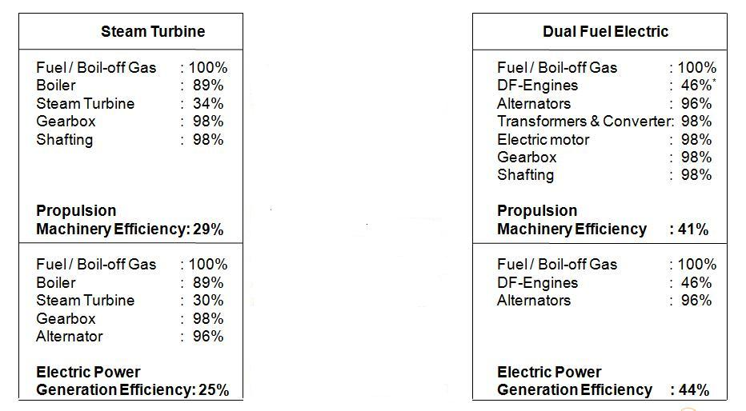

AS FROM THE TABLE WE CAN SEE IN STEAM TURBINE WE ARE ABLE TO GET ONLY 29%PROPULSION MACHINERY EFFICIENCY AND ELECTRICAL POWER GENERATION EFFICIENCY ONLY 25% WHICH IS VERY LESS AS COMPARED TO 41%AS PROPULSION MACHINERY EFFICIENCY AND 44% AS ELECTRIC POWER GENERATION EFFICIENCY I DUAL FUELCELECTRIC MACHINERY CONCEPT.SO WE CAN CLEARLY SEE THE ADVANTAGE.
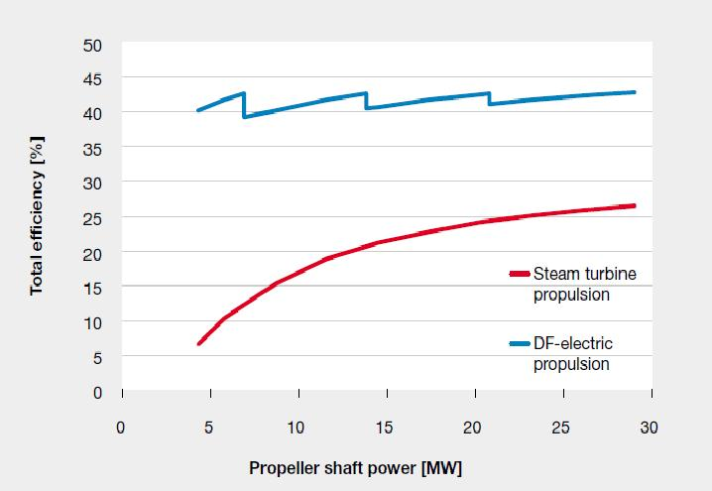

AS FROM THE GRAPH WHICH SHOWS ABOUT PROPELLER SHAFT POWER IN MW AND TOTAL EFFICIENCY IN %, IT IS CLEAR THAT FOR STEAM TURBINE IT STARTS FROM 5%TO28% AND IN THE CASE OF DUAL FUEL ELECTRIC PROPULSION IT STARTS FROM 40% AND GOES UPTO 45% WHICH IS MUCH HIGHER.

ALTERNATIVE FUEL
LNG AS PRIMARY FUEL CAN BE CONSIDERED AS A VERY STRONG OPTION
  - ECONOMIC IF THE PRICE OF LNG IS CALCULATED
  - WHY UTILIZE DIRTY FUELS TO TRANSPORT A CLEAN FUEL?
  - LNG IS LIGHT: LNG 49.2 MJ/KG, HFO 40.4 MJ/KG, MDO 42.7 MJ/KG
  - RISING PRICES FOR DIESEL, ESPECIALLY FOR LOW SULPHUR DIESELS?
  - INSULATION OF THE CARGO TANKS CAN BE OPTIMIZED
THE ANSWER TO THE ABOVE QUESTION IS LNG GAS BECAUSE GAS IS OUR FUTURE AS IT IS CLEAN LIGHT AND CHEAP .ALSO IF THE FUEL IS LIGHT THEN A SHIP CAN RUN AT A HIGH SPEED AND ALSO BECAUSE GAS IS EASILY AVAILABLE. AND ALSO THE INSULATION OF THE CARGO TANKS ARE INSULATED PROPERLY SO THAT THERE IS NO THREAT OF ANY ACCIDENTS.

ENGINES
CONFIGURATION
- WARTSILA 50DF SERIES
- OPTIMIZED FOR RUNNING ON GAS PRIMARILY
- CYLINDER CONFIGURATION
  - 6, 8 , 9 L
  - 12, 16, 18 V

THIS IS THE CONFIGURATION OF THE ENGINE .HERE 50 MEANS BORE OF THE CYLINDER WHICH IS 500MM IN DIAMETER AND IT IS VERY EFFICIENT IN RUNNING ON GAS PRIMARILY.ITS CONFIGURATION STATE THAT IT MAY BE 6,8,9 UNITS IN LINE OR IT MAY BE 12,16,18 UNITS IN V TYPE.

KEY FACTS
- HIGH EFFICIENCY (40 -45%)
- LEAN BURN COMBUSTION
- LOW EMISSIONS(NO_{X}, SO_{X}, CO₂)
- FUEL FLEXIBILITY:
  - GAS MODE
  - DIESEL MODE
(MDO)
- LOW-PRESSURE GAS

AS WE HAVE ALREADY SEEN ABOVE THE EFFICIENCY IS MUCH HIGHER AND IT OPERATES ON LEAN BURN PRINCIPLE IN WHICH WE CAN ADJUST THE AIR FUEL RATIO TO INCRESE THE EFFICIENCY AND ALSO TO AVOID KNOCKING WHICH IS A VERY BIG PROBLEM FOR ALL THE ENGINES.AGAIN EMISSION IS VERY LESS, AND THE BIGGEST FACT IS THAT IT CAN RUN ON BOTH GAS MODE AS WELL AS DIESEL MODE WHICH IS AS A BACK UP FUEL.AND FOR INJECTION WE REQUIRE ONLY 5.5 BAR APPROX PRESSURE.

OPERATING PRINCIPLE
Dual-fuel engines can operate in two distinct operating modes; the gas mode and the diesel mode. In gas mode, dual-fuel engines act according to the Otto principle. Just like with spark-ignition gas engines, gas is mixed with air and admitted to the combustion space during the expansion stroke. Again, a low gas admission pressure of some five Bar is thus sufficient. At the end of the compression stroke, a small quantity of Marine Diesel Oil (MDO) is injected into the combustion space to trigger a stable and complete combustion of the gas and air mixture the injected MDO is called the pilot fuel, and can be of quality DMX, DMA or DMB. With dual-fuel engines, gas has to be of reasonable quality to ensure availability of the full engine output. Gas derived from LNG is generally of sufficient quality. Dual-fuel technology is only available on four-stroke engines.
GAS & MICRO-PILOT FUEL SYSTEM
It shows the system used for injection of charge and the pilot fuel. The gas as well as the fuel is provided with a common rail system and with injectors to maintain correct pressure of injection.
MICRO PILOT FUEL SYSTEM
- PRESSURISED MICRO-PILOT FUEL IS DELIVERED FROM THE PUMP UNIT INTO A DOUBLE WALLED COMMON RAIL PIPE
- THE MICRO-PILOT FUEL PRESSURE IS 1000 BAR
- THE COMMON RAIL PIPING DELIVERS PILOT FUEL TO EACH INJECTION VALVE PILOT SIDE AND ALSO ACTS AS A PRESSURE ACCUMULATOR AGAINST PRESSURE PULSES.
- THE CYLINDER FEED PIPES DISTRIBUTE PILOT FUEL FROM THE COMMON RAIL TO THE INJECTION VALVES IN EACH CYLINDER HEAD
TWIN INJECTION VALVE
This shows a twin injection system which comprises of twin needle for pilot fuel as well as for main diesel fuel injection.
- TWIN NEEDLE INJECTION VALVE IN CYLINDER HEAD
- COMBINED MAIN AND MICRO-PILOT FUEL INJECTION VALVE
- MICRO-PILOT FUEL TIMING AND DURATION ELECTRONICALLY CONTROLLED DURING OPERATION
OPERATING PRINCIPLE
In diesel mode, dual-fuel engines act like normal diesel engines, with the gas admission ceased and the pilot fuel injection complemented by the injection of additional HFO or MDO. The additional MDO can be of quality DMX, DMA, DMB or DMC, while the additional HFO can be as low in quality as RMH 55 and RMK 55. Just one lubricating oil can be selected for operation in gas mode and diesel mode.

CYLINDER CONTROL PRINCIPLE
- INDIVIDUAL ADJUSTMENT OF GAS FEED AND INJECTION FOR EACH CYLINDER
- EACH CYLINDER EQUIPPED WITH A COMBUSTION SENSOR
- THE GAS FEED IS ADJUSTED INDIVIDUALLY TO GET THE
CORRECT AIR-FUEL RATIO IN EACH CYLINDER
- IN CASE OF KNOCKING, ONLY THAT SPECIFIC CYLINDER IS
ADJUSTED
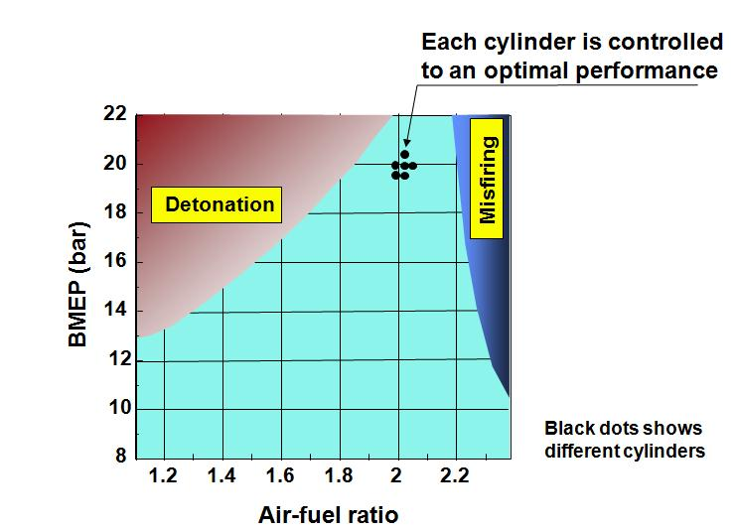

ENGINE CONTROL SYSTEM (ECS)
THE FUNCTIONALITY OF ECS COMPRISES THE FOLLOWING MAIN CATEGORIES:-
- HANDLING OF ENGINE SLOWTURNING, START & STOP SEQUENCES
- CHANGING OF FUEL MODES
- INSTRUMENTATION & COMMUNICATION
- SPEED MEASUREMENT
- ENGINE SAFETY
- SPEED/LOAD CONTROL
- GAS PRESSURE- & GAS ADMISSION CONTROL
- PILOT PRESSURE- & PILOT INJECTION CONTROL
- AIR/FUEL RATIO CONTROL
- CYLINDER BALANCING & KNOCK CONTROL

The main diesel mode is timed by camshaft unlike the operation in gas mode which is electronically controlled and all other systems such as common rail systems etc are same as that of gas mode. It shows ways in which sensors are applied to achieve the optimum fuel air ratio for optimum combustion in the chamber. Thus the combustion can be controlled for better efficiency as well as for meeting emission standards. This explains about the different functions carried out by the engine control system incorporated in this technology.

MAINTAINABILITY
  - NATURAL GAS IS VERY CLEAN FUEL!
  - LESS ABRASIVE AND CORROSIVE COMBUSTION PRODUCTS
  - CLEANER LUBRICATING OIL
  - LESS CLEANING OF ENGINE PARTS DURING MAINTENANCE
  - LONGER TIME PERIODS BETWEEN OVERHAULS
  - MINOR ROUTINE MAINTENANCE CAN BE PERFORMED DURING TERMINAL CALLS OR DURING SAILING
  - OVERHAULS CAN MOSTLY BE TIMED TO BE CARRIED OUT DURING DOCKING (DEPENDING ON 2.5 OR 5 YEARS DOCKING INTERVALS)

SAFETY
The safety functions of dual fuel engines can be divided into three categories:
- Gas system safety functions, causing a gas trip
- Pilot fuel safety function, causing pilot trip
- Engine safety functions, causing an engine shutdown
- ALL THE GAS LINES ARE DOUBLE WALLED
- LNG LEAK DETECTORS ARE FITTED

ELECTRIC PROPULSION
FIXED PITCH PROPELLER
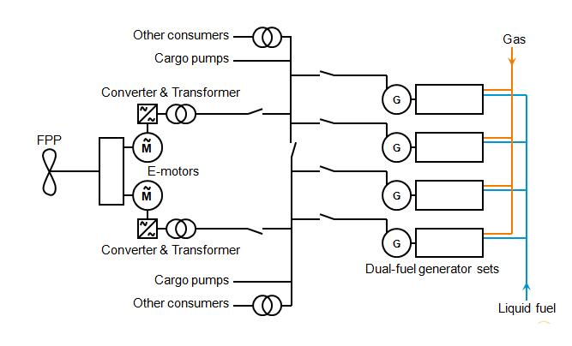

An electric propulsion system based on a combination of heavy fuel burning generator sets and gas burning generator sets has been proposed as well. This is based on the desire not to install any reliquification plant and instead to use natural boil-off gas only as fuel (without forced boil-off gas) and to top up the remaining energy requirement with heavy fuel. However, to cater for the wide Variation in boil-off gas energy available, the total installed engine power would be high, perhaps up to 65 % greater than with a single type of engine. Furthermore, since the energy price of LNG compared to heavy fuel is about the same, it is illogical to use gas-burning engines if only to keep the propulsion power plant simple, not to mention the environmental benefits gas fuel can offer dual-fuel engines elegantly match the requirements of LNG shipping when they are being combined with electric propulsion. Central in the resulting machinery concept, dubbed the dual-fuel-electric machinery concept, are multiple dual-fuel engine-driven generators (Redundancy, maintainability and plant efficiency at part load increase with the number of dual-fuel engine-driven generators. Typically, four such generators are installed. They provide electric power for propulsion and the ship, so to power cargo pumps and other consumer’s additional auxiliary engines are not required. Fuel systems for N-BOG, F-BOG and MDO are provided. More fuel flexibility can be obtained by installing an Optional hfo system

AZIPODS

In this figure the concept is almost same but we get little more higher efficiency of propeller and the speed is also more.
Four generating sets

The number of engines and the power output of each unit are determined by the shaft power needed and also by the degree of redundancy requested. Generally speaking on a typical 138,000 m3ship with the need for some 34 MW total engine output, the power plan would consist of four generating sets with Wärtsilä 9L50DF engines. The maximum continuous output of these engines is 950 kW/cylinder at500 or 514 rev/min (50 or 60 Hz respectively) and their thermal efficiency is as high as 48 %.Four engines provide some redundancy if one of the engines is out of service, and also flexibility for the different operating modes such as manoeuvring, waiting off ports, loading and unloading. Additionally, they allow flexible preventive maintenance at sea and during port calls, which is not the case with the steam plant or other single-engine alternatives.

CONTRA ROTATING PROPELLER
The machinery for the 28 knot machinery is selected according to the same principal. In this case the optimum power split between the proposers has moved so that more power should be mechanical and less electrical, since this machinery is intended mostly for short route operation. In this case the capital cost has more impact on the total costs as indicated in the mechanical propulsion is powered by two16V46C engines, the same as for the 30 knot version. The pod size is on the other hand reduced to 14 MW to reflect the lower delivered propulsion power demand of 40-41 MW. The power split between the installed mechanical propeller and the pod power is therefore about30/70.The electrical generation capacity is matched to the lower power demand and two 8L46 plus one 6L32 genset are selected, with a combined
Power of 19500 kW.

COMMERCIAL
The benefit from a shorter engine room is 6 - 12 frames
the increased cargo capacity is about +5% now we come forth with the concepts in which the technology can be applied in the tugs used in terminals, in ice operations and in Ferries and RO-RO vessels.

Example
Gaz de France Energy will primarily trade between Algeria and France.

SHIPYARD CHANTIERS DE L’ATLANTIQUE
HULL N32
SHIP OWNER GAZ DE FRANCE
CARGO CAPACITY 154’000 M³
DELIVERY AUTUMN 2008
MACHINERY 3X WÄRTSILÄ 12V50DF + 1X WÄRTSILÄ 6L50DF
PRIMARY FUEL NATURAL BOIL-OFF GAS, COMPLEMENTED W ITH FORCED BOIL-OFF GAS
SECONDARY FUEL MDO
Four six-cylinder Wärtsilä 50DF dual-fuel engines, with an aggregate power of 22.8 megawatt, will power the ship to a service speed of 17.5 knots. Natural boil-off gas Complemented by forced boil-off gas will serve as fuel in Normal operating conditions. In case no gas is available, the engines will run on MDO.

ADVANTAGES
REVIEW OF ADVANTAGES
- ECONOMIC
- ENVIRONMENTALLY FRIENDLY
- SAFE
- RELIABLE
- MAINTAINABLE
- CREW-ABLE

DISADVANTAGES
- SLIGHTLY HIGHER INITIAL COSTS
- SLIGHTLY HIGHER MAINTENANCE COSTS
- LUBE OIL COSTS

CONCLUSION
DUAL-FUEL-ELECTRIC LNG CARRIERS ARE ECONOMIC, ENVIRONMENTALLY FRIENDLY, SAFE, RELIABLE, MAINTAINABLE AND CREW-ABLE SUBSTANTIAL AMOUNTS OF RUNNING HOURS HAVE BEEN COLLECTED ON BOTH ONSHORE, OFFSHORE AND SHIP APPLICATIONS. ENDURANCE TESTS ARE CARRIED OUT TO CONFIRM THE ENGINE PERFORMANCE
Now as I have explained earlier we are proud to bring in our own idea by which we can upgrade this technology. With this up gradation it can take its efficiency to a higher level. The application of HCCI makes the technology to have a better control over the combustion and there by attain all the advantages in doing so, as stated above.

