High Voltage Applications in Industries & Transportation

Submitted to:

TRANSTECH’14
Tolani Maritime Institute, Pune


Submitted by-
Cadet Akshay Sharma
Cadet Samrat Kothari
Cadet Vikash Khaliyav
R.L. Institute of Nautical Sciences,
Madurai, TN

Abstract
This paper aims to elucidate the vast and varied high voltage applications in our industries and transportation. Despite the fact that a wide range of high voltage devices with attractive electrical characteristics exist, higher power and superior overall performance remain as the main targets for satisfying the demands of new high power system designs. Modern Technology has enabled the construction of bigger machinery, ships and installations, and their designers have installed High Voltage equipment to handle the massive power requirements. With backing of unprecedented network of power generation and distribution, scaling to even higher spectrums of technological advancements has been possible. High voltage technology is related to issues of design, manufacture, packing, testing, failure analysis and others. This paper thus summarizes the introduction to high voltage applications used for different purposes under broad categories of scientific uses, Food Processing, Material treatment and Testing, Mining and Transportation.

The presentation is divided into three parts. At the beginning, the basics of high voltage and their combined applications are introduced in general. This is followed by a showcase of varied applications in Industries and Transportation used in airborne, marine or terrestrial environment. It also points out the safety issues pertaining to high voltage applications. The last part of the presentation would briefly show different research topics under process and futuristic technologies utilizing high voltage in an effort to make our lives easier.

Contents

Introduction

A. High Voltage In Industries

1.Electric Power Transmission
2. Electric Distribution System
3.X-ray Generators
4. Electron beam welding (EBW)
5. Dielectric Testing
6. Air Ionisers
7. Microbial Inactivation for Alternative Food Processing Technologies -- High Voltage Arc Discharge

8. Modern Ignition Systems

B. High Volatge In Transportion- MAGLEV TRAINS

Introduction

The term high voltage usually means electrical energy at voltages high enough to inflict harm or death upon living things. The International Electro-technical Commission and its national counterparts (IET, IEEE, VDE, etc.) define high voltage as above 1000 V for alternating current
IEC voltage range | AC | DC | defining risk
High voltage (supply system) | > 1000 V_{rms} | > 1500 V | electrical arcing
Low voltage (supply system) | 50–1000 V_{rms} | 120–1500 V | electrical shock
Extra-low voltage (supply system) | < 50 V_{rms} | < 120 V | low risk

Voltages over approximately 50 volts can usually cause dangerous amounts of current to flow through a human being who touches two points of a circuit—so safety standards, in general, are more restrictive around such circuits. The definition of extra high voltage (EHV) again depends on context. In electric power transmission engineering, EHV refers to equipment that carries more than 345,000 volts between conductors. In electronics systems, a power supply that provides greater than 275,000 volts is called an EHV Power Supply, and is often used in experiments in physics.
High voltage is used in electrical power distribution, cathode ray tubes, to generate X-rays and particle beams, to demonstrate arcing, for ignition, in photomultiplier tubes, and in high power amplifier vacuum tubes and other industrial and scientific applications.
The accelerating voltage for a television cathode ray tube may be described as extra-high voltage or extra-high tension (EHT), compared to other voltage supplies within the equipment. This type of supply ranges from >5 kV to about 50 kV. Other notable applications of High Voltage are:

Aerospace
From satellite communications systems to spacecraft charge monitors, aerospace technologies require HV power supplies that provide a stable source of high voltage under the most extreme conditions, undergoing rigorous temperature, shock, electromagnetic, and vibration testing.
- Charged Particle Energy Analyzer
- Satellite

Consumer/Industrial
High stability, low ripple, noise, EMI/RFI and well-regulated output levels for use into precision measurement devices and other high sensitivity equipment
- Air Filtration
- Air Quality Testing
- Dielectric Testing
- Electro-Static Chuck
- Food and Beverage Testing
- Water Quality Analysis

Medical
High voltage power supplies are immune to electrostatic discharge events and radiate neither emissions nor noise. These and other reliability features make them suitable for use in sensitive equipment.
- Capillary Electrophoresis
- Cell Separation
- Imaging
- Quadrupole Mass Spectrometers
- Spectrometry

Military/Defense
Redundancy and protection for primary circuits and are immune to electrostatic discharge events and RF.
- Baggage Scanners
- Radiation Detection
- Threat Detection

Scientific

- The development of precision scientific instruments
- Neutrino Telescope

Material Treatment& Mining
- Drilling
- Cutters
- Grinders

Offshore Drilling

Transportation
- Shipping
- Metro/Mono Rails
- Cable Cars
- Maglev

Non Destructive Tests

Flow Meters, etc.

A. High Voltage in Industries

1. Electric Power Transmission
Most transmission lines use high-voltage three-phase alternating current (AC). High-voltage direct-current (HVDC) technology is used for greater efficiency in very long distances (typically hundreds of miles (kilometers)), or in submarine power cables (typically longer than 30 miles (50 km)). Electricity is transmitted at high voltages (110 kV or above) to reduce the energy lost in long-distance transmission.
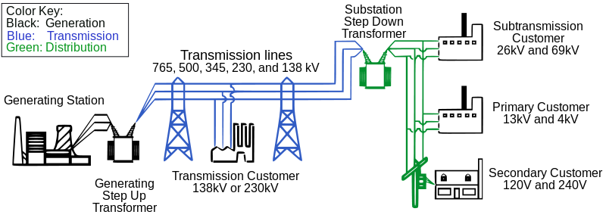
Lower voltages such as 66 kV and 35 kV are usually considered sub transmission voltages but are occasionally used on long lines with light loads. Voltages less than 35 kV are usually used for distribution. Voltages above 230 kV are considered extra high voltage and require different designs compared to equipment used at lower voltages.

2. ELECTRIC POWER DISTRIBUTION
Electricity distribution is the final stage in the delivery of electricity to end users. A distribution system's network carries electricity from the transmission system and delivers it to consumers. Typically, the network would include medium-voltage (2kV to 34.5kV) power lines, substations and pole-mounted transformers.
The voltage used is appropriate for the shorter distance and varies from 2,300 to about 35,000 volts depending on utility standard practice, distance, and load to be served.

Voltage can readily be taken up to about 765,000 volts (765 kV) for an AC powerline (this is the current maximum AC voltage in the US) but beyond that, power dissipation through dielectric loss becomes significant. Voltage for DC overhead power lines can be taken up to higher voltage than the maximum practical AC voltage; at present the worldwide maximum is ±800 kV for HVDC lines.

3. X-ray Generators

The major components of an X-ray generator are the tube, the high voltage generator, the control console, and the cooling system. X-rays are generated by directing a stream of high speed electrons at a target material such as tungsten, which has a high atomic number. When the electrons are slowed or stopped by the interaction with the atomic particles of the target, X-radiation is produced. This is accomplished in an X-ray tube. The tube cathode (filament) is heated with a low-voltage current of a few amps. The filament heats up and the electrons in the wire become loosely held. A large electrical potential is created between the cathode and the anode by the high-voltage generator. Electrons that break free of the cathode are strongly attracted to the anode target. The stream of electrons between the cathode and the anode is the tube current. The high-voltage between the cathode and the anode affects the speed at which the electrons travel and strike the anode. The higher the kilo voltage, the more speed and, therefore, energy the electrons have when they strike the anode

4. Electron beam welding (EBW)
It is a fusion welding process in which a beam of high-velocity electrons is applied to two materials to be joined. The work pieces melt and flow together as the kinetic energy of the electrons is transformed into heat upon impact. EBW is often performed under vacuum conditions to prevent dissipation of the electron beam.
In the electron gun, the free electrons are gained by thermo-emission from a hot metal strap (or wire). They are then accelerated and formed into a narrow convergent beam by an electric field produced by three electrodes: the electron emitting strap, the cathode connected to the negative pole of the high (accelerating) voltage power supply (30 - 200 kV) and the positive high voltage electrode. There is a third electrode charged negatively with respect to the cathode, called the Wehnelt or control electrode. Its negative potential controls the portion of emitted electrons entering into the accelerating field, i.e., the electron beam current.

5. Dielectric Testing
Dielectric testing is an evaluation process performed by applying a very high voltage to an electrical component that exceeds its normal operating voltage. This testing procedure is performed on electrical components, such as circuit boards, appliances, cables, transformers, and electric motors. The manufacturer of an electrical component typically conducts the testing at the end of the production process, using a special device known as a dielectric tester.
The Dielectric Withstand Test consists in measuring the current leak of a device under test, while phase and neutral are short circuited together. The measure result of a Dielectric Withstand Test is a current value, which has to be lower than the indicated limit from the international standards.

6. Air Ionisers
Air Ionisers are used in air purifiers. An air ioniser is a device that uses high voltage to ionize(electrically charge) air molecules. Negative ions or anions, are particles with one or more extra electrons, conferring a net negative charge to the particle. Airborne particles are attracted to the electrode in an effect similar to static electricity. These ions are de-ionised by seeking earthed conductors, such as walls and ceilings.

7. Microbial Inactivation for Alternative Food Processing Technologies -- High Voltage Arc Discharge
High voltage arc discharge is a method to pasteurize liquid foods by applying rapid discharge voltages through an electrode gap below the surface of aqueous suspensions of microorganisms.

Pulsed electric field processing (PEF) applies short bursts of high voltage electricity for microbial inactivation and causes no or minimum effect on food quality attributes. Briefly, the foods being treated by PEF are placed between two electrodes, usually at room temperature. The applied high voltage results in an electric field that causes microbial inactivation. The applied high voltage is usually in the order of 20-80 kV for microseconds.

8. Modern Ignition Systems
In modern systems, ignition is electronically controlled. Small coils are used with one coil for each spark plug or one coil serving two spark plugs (for example two coils in a four-cylinder engine, or three coils in a six-cylinder engine). A large ignition coil puts out about 20 kilo Volts and a small one such as from a lawn mower puts out about 15 kV.

Mechanically timed ignition
Mostly used in 4-stroke engines, this system is powered by a lead-acid battery, which is charged by the car's electrical system using a dynamo or alternator. The engine operates contact breaker points, which interrupt the current to an induction coil (known as the ignition coil).
The ignition coil consists of two transformer windings sharing a common magnetic core—the primary and secondary windings. An alternating current in the primary induces alternating magnetic field in the coil's core. Because the ignition coil's secondary has far more windings than the primary, the coil is a step-up transformer which induces a much higher voltage across the secondary windings. For an ignition coil, one end of windings of both the primary and secondary are connected together. This common point is connected to the battery (usually through a current-limiting ballast resistor). The other end of the primary is connected to the points within the contact breaker. The other end of the secondary is connected, via the distributor cap and rotor, to the spark plugs.
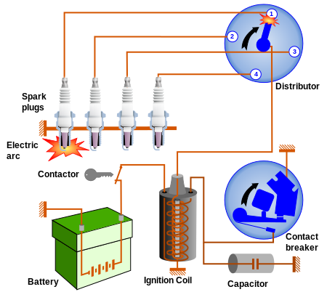
Ignition Circuit Diagram - Mechanically Timed Ignition

The ignition coil's secondary windings are connected to the distributor cap. A turning rotor, located on top of the breaker cam within the distributor cap, sequentially connects the coil's secondary windings to one of the several wires leading to each cylinder's spark plug. The extremely high voltage from the coil's secondary (typically 20,000 to 50,000 volts) causes a spark to form across the gap of the spark plug. This, in turn, ignites the compressed air-fuel mixture within the engine. It is the creation of this spark which consumes the energy that was stored in the ignition coil’s magnetic field.

B. High Voltage In Transportation- MAGLEV TRAINS

Maglev trains are magnetically levitated trains that traverse in a very high speed, with only electricity being its main source of energy. The train propels forward without any friction from moving mechanical parts. It has many advantages with minor drawbacks.
The basis of maglev trains mechanisms are magnetic levitation. This is achieved with the principal of repulsion and attraction between two magnetic poles. When two magnets have the same poles, it will repel with each other and when it has different poles, the result would be otherwise.
There are currently three known maglev suspension systems.
- Electrodynamic Suspension Systems (EDS)
- Electromagnetic Suspension Systems (EMS)
- Inductrack.
While EDS and EMS both use only the interaction of magnets and superconductors, Inductrack uses coils on the track underneath the train body. The maglev propulsion systems uses the interaction of stators, superconductors and magnets between the railway and the train to control speed and direction, which are based on electricity.
Maglev’s levitation is basically based on two simple and fundamental laws of electromagnetic.
• FARADAY’S LAW
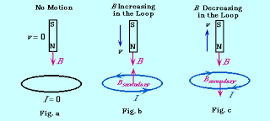
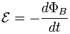
The emf (electromagnetic force) induced in a circuit is directly proportional to the time rate of change of magnetic flux through the circuit."

• LENZ’S LAW
“Induced electromotive force generates a current, which flows in such direction as to induce a counter magnetic field that opposes the magnetic field generating the current”.

How is magnetic levitation achieved?
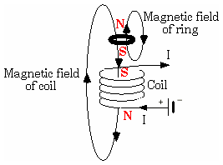
Magnetic levitation can be further understood by considering a current carrying coil. When current flows through the coil, it induces magnetic field. The change in magnetic field in the coil due to the change in current induces Eddy current in the metal ring, which induces magnetic field, as to oppose the field generating it. There repulsive force of the south-south pole (here) lifts the ring.
There are two types of magnetic levitation.
• Electromagnetic levitation (the ring example)
• Electrodynamics levitation.
The two figures as given further explain both type of magnetic levitations. Basically both employ same phenomenon, for levitation. In figure a, we have coil wrapped around the iron core, placed over a metal plate. Now when current flows through the coil, iron core is induced with the magnetic field.
This magnetic field as a result induces the magnetic field in the metal, but in opposite direction. Hence both fields repel each other and iron core is lifted upward. In figure b, we have a permanent magnet instead of iron core. When magnetic flux is changed by moving the magnet, it induces the magnetic field in the metal plate.
Thus both methods can be used to achieve levitation.
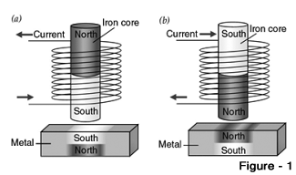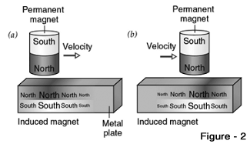

Maglev Suspension Systems
- Electromagnetic Suspensions
The electromagnetic suspension EMS uses attractive force system to levitate. The train’s levitation magnet will be attracted to the conductors onthe underside of the guideway. The attractive force between them will overcome the gravitational force. This will in turn levitates the train on the track.
- Electrodynamic Suspension
The electrodynamic suspension (EDS) train uses magnets that has same polarity (refer to figure above) to create repulsive force between levitation magnet and guideway magnet. This repulsive force then will be high enough to overcome gravitational force and allows it to levitate.
- Inductrack
The inductrack is a newer type of EDS that uses permanent room-temperature magnets to produce the magnetic fields instead of powered electromagnets or cooled superconducting magnets. The magnets are configured in a Halbach array such that the intensity of the magnetic field concentrates above the array instead of below it. They are made from a newer material comprising a neodymium-iron-boron alloy, which generates a higher magnetic field than normal magnets.

Magnetic Levitation or Maglev Propulsion
An EMS system can provide both levitation and propulsion using an on board linear motor.
The polarity of the stators at the track will quickly change its polarity continuously to move the Maglev train. Stators at the sides are excited sequentially. The electromagnets onboard 'chase' the current forward along the track with the continuous magnetic field moving forward. Speed controlled by frequency of alternating current.
The process of propulsion for EDS is same as EMS except that the stators will stop for a moment after polarity change. Referred as "pull- then neutral- then push” system. Coils or aluminum sheet at the sides. The direction of current of the particular segment is reversed. Polarity of that segment changes which causes repulsion.
Propulsion coils on the guideway are used to exert a force on the magnets in the train and make the train move forward. The propulsion coils that exert a force on the train are effectively a linear motor.

Magnetic Levitation or Maglev Track
The magnetized coil running along the track, called a guideway, repels the large magnets on the train's undercarriage, allowing the train to levitate between 0.39 and 3.93 inches (1 to 10 cm) above the guideway. Once the train is levitated, power is supplied to the coils within the guideway walls to create a unique system of magnetic fields that pull and push the train along the guideway. The electric current supplied to the coils in the guideway walls is constantly alternating to change the polarity of the magnetized coils. This change in polarity causes the magnetic field in front of the train to pull the vehicle forward, while the magnetic field behind the train adds more forward thrust.
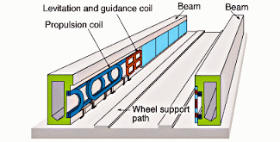
Maglev trains float on a cushion of air, eliminating friction. This lack of friction and the trains' aerodynamic designs allow these trains to reach unprecedented ground transportation speeds of more than 310 mph (500 kph), or twice as fast as Amtrak's fastest commuter train. In comparison, a Boeing-777 commercial airplane used for long-range flights can reach a top speed of about 562 mph (905 kph). Developers say that maglev trains will eventually link cities that are up to 1,000 miles (1,609 km) apart. At 310 mph, you could travel from Madurai to Pune in just less than three hours.

CONCLUSION
Power supplies are an essential part of everyday life, with many pieces of equipment and machinery relying on an adequate supply of high voltage power in order to function. Power supply failure can have catastrophic effects and therefore it is absolutely crucial that the supply can stand up to whatever conditions are thrown at it. This means that the supply will be thoroughly tested, not only under normal working conditions but after careful consideration of every scenario that could possibly affect the system whilst in use. And as every application is unique in some way, research into and comprehension of the long uses of the device is absolutely of key importance.

ACKNOWLEDGMENT

We would like to express our deepest appreciation to all those who provided us the possibility to complete this report. A special gratitude we give to Tolani Maritime Institute for providing us an opportunity to present our paper.
We would like to extend our gratitude towards our R.L. Institute of Nautical Sciences for granting us a permission to participate in TRANSTECH’14.
Further we are very thankful to our Senior Faculty Mr. Umamaheswaran and our Vice Principal Mr. C. Chandrasekaran for guiding us and providing immense help related to the topic.

