  - Artificial Intelligence

1.Siddhant Kumar Srivastava,
B. Tech Marine Engineering,
Tolani Maritime Institute, Pune.
sidna.0243@gmail.com

Last few decades have seen a massive technical development in the field of robotics. Now, robots are used in every possible field to reduce the human efforts. But the robots still require some input to perform the required task and that is where artificial intelligence gets its cue.
Although the development of artificial intelligence has taken place to some extent, there is still need to better the interface. The specific requirements of planning in robotics, as compared with other application domains of planning, are mainly the need to handle:
- online input from sensors and communication channels;
- heterogeneous partial models of the environment and of the robot, as well as noisy and partial knowledge of the state from information acquired through sensors and communication channels; and
- direct integration of planning with acting, sensing, and learning.
These very demanding requirements advocate for addressing planning in robotics through domain-specific representations and techniques. Indeed, when planning is integrated within a robot, it usually takes several forms and is implemented throughout different systems. Among these various forms of robot planning, there is in particular path and motion planning, perception planning, navigation planning, manipulation planning, and domain-independent planning.

Keywords: Robotics, Online Input, Sensors and Communication Channels, Heterogeneous Partial Models, Direct Integration of Planning.

1. INTRODUCTION
Artificial intelligence (AI) is intelligence exhibited by machines. In computer science, the field of AI research defines itself as the study of "intelligent agents": any device that perceives its environment and takes actions that maximize its chance of success at some goal. Colloquially, the term "artificial intelligence" is applied when a machine mimics "cognitive" functions that humans associate with other human minds, such as "learning" and "problem solving". As machines become increasingly capable, mental facilities once thought to require intelligence are removed from the definition. For example, optical character recognition is no longer perceived as an exemplar of "artificial intelligence", having become a routine technology. Capabilities currently classified as AI include successfully understanding human speech, competing at a high level in strategic game systems (such as Chess and Go), self-driving cars, intelligent routing in Content Delivery Networks, and interpreting complex data.
AI research is divided into subfields that focus on specific problems or on specific approaches or on the use of a particular tool or towards satisfying particular applications.
The central problems (or goals) of AI research include reasoning, knowledge, planning, learning, natural language processing (communication), perception and the ability to move and manipulate objects. General intelligence is among the field's long-term goals. Approaches include statistical methods, computational intelligence, and traditional symbolic AI. Many tools are used in AI, including versions of search and mathematical optimization, logic, methods based on probability and economics. The AI field draws upon computer science, mathematics, psychology, linguistics, philosophy, neuroscience and artificial psychology.

2. PLANNING
It is an abstract, explicit deliberate process that chooses and organises action by anticipating their expected outcomes. This deliberation aims at achieving as best as possible some pre-stated objectives. Automated planning is an area of Artificial Intelligence (AI) that studies this deliberation process completely. Planning is also needed when the adaptation of actions is constrained, for example, by a critical environment involving high risk or high cost, by a joint activity with someone else or by an activity to be synchronised with an active system.
One motivation for Automated Planning is very practical: designing information processing tools that give access to affordable and efficient planning resources. That operation may involve a large number of actors and the deployment of a communication and transportation infrastructure. Also, planning is an important aspect of rational behaviour if one purpose of the AI is to grasp the computational aspect of intelligence, then we can say that planning is the reasoning side of acting which is in truth a key element in such a purpose.
Conceptual Model for Planning
A conceptual model is a simple theoretical device for describing the main elements of a problem. It can depart significantly from the computational concerns and algorithmic approaches for solving a problem. However, it can be very useful for explaining basic concepts, for clarifying restrictive assumptions, for analysing requirements on representations and trade-offs, and for proving semantic properties.
Since planning is concerned with choosing and organising actions for changing the state of a system, a conceptual model for planning requires a general model for a dynamic system. Most of the planning approaches rely on a general model, which is common to other areas of computer science, the model of a state transition system (also known as discrete-event system).
- STATE-TRANSITION SYSTEM
A State-transition system is a 4-truple ∑= ( S,A,E,γ) where:
S = a finite or recursively enumerable set of states
A = a finite or recursively enumerable set of actions
E = a finite or recursively enumerable set of events
γ = S x A x E → 2^{s} is a state-transition system.
A state-transition system may be represented by a directed graph whose nodes are the states in S. If s^{I} Є y (s, u), where u is a pair (a, e), a Є A and e Є E, then the graph contains an arc from s to s p that is labelled with u. Each such arc is called a state transition. It can be convenient to introduce a neutral event E to account for transitions that are due only to actions and, symmetrically, a neutral action no-op for denoting transitions caused solely by an event.
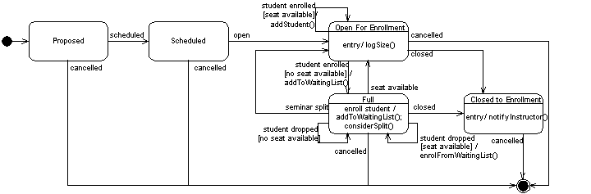
Figure: Example for working of a State-transition Diagram for enrolling a student in seminar
- MARKOV’S DECISION PROCESS
Planning based on Markov Decision Processes (MDPs) is designed to deal with Non-determinism, probabilities, partial observability, and extended goals. It's key idea is to represent the planning problem as an optimization problem.

    - Components
      - States ‘s’
      - Actions ‘a’
        - Each state ‘s’ has actions A(s) available from it.
      - Transition model P(s^{I}|s,a)
        - Markov’s assumption: the probability of going to ‘s^{I}’ from s depends only on s and a and not on any other past actions and states.
      - Reward function R(s)
    - The Solution
      - Policy ∏(s): mapping from states to actions.

3. OBJECTIVES
What we want to do is to define some desirable property P, then we ought in the principle that provably possesses the property P.
Three main choices for P are:
- Perfect Rationality: Such an agent acts at every instant to maximize its expected utility, given the information it has taken in from the surroundings.
- Calculative Rationality: Such an agent eventually returns what would have been the rational choice at the beginning of the deliberation. Such a property is interesting to exhibit in a system because it constitutes an “in-principle” capacity to do the right thing.
- Bounded Optimality: Such an agent behaves as well as given its computational resources. This means, the expected utility of the agent for a bounded optimal agent is at least as high as the expected utility of any other agent program running on the same machine.
Although the three are equally competent and self-sufficient to form an independent AI system, it would rather be if Bounded Optimality was to be given the priority with Perfect Rationality and Calculated Rationality assisting it to form an optimal environment to sense, organise and act in a given situation.
4. APPLICATIONS
- ROBOTS
Computers have already taken over most of the human related working in the limited conditions. But the basic objective here is to create such a programme that can take in information from whatever surrounding that it is in and act accordingly, the basic idea of automated planning and control as was being discussed. Just like the humans have five most important sense organs, the robots can be installed with surrounding sensitive sensors to take in input. Now artificial intelligence has been the life and beat of this discussion and here also it has a part to play. The sensors that will take in the input from the surrounding will be connected with this system of artificial intelligence where in it will analyse and put the situation into the respective category of state-transition system and act according to the data present in any one of the sets or a combination of them.
Some robots have the ability to learn in a limited capacity, for example the Massachusetts Institute of Technology’s Artificial Intelligence lab has created a robot called ‘KISMET’ which can interact socially. It recognises the human’s body language and voice inflection and responds appropriately. KISMET’s creators are interested in how humans and babies interact, based only on the tone of speech and visual cue.
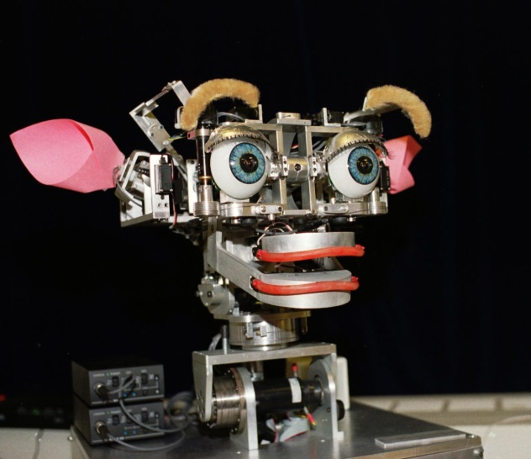
Figure: ‘KISMET’ Artificial Intelligence powered robot designed
By the Massachusetts Institute of Technology’s Artificial Intelligence lab
- DOCK WORKER ROBOTS
A container is a large metallic cell of a standard size that can be conveniently piled on docks and loaded on ships, trains, and cargo planes. It is intended to allow safe transportation of some freight from a shipping point to a destination point. A significant part of the shipment cost lies in the transition phase between two transportation media, e.g., when a container has to be moved between two ships, or from a ship to a train or a truck, usually via some storage area. The high cost of these trans-shipment operations explains the motivation of their automatization. Several sites, such as the Rotterdam Harbour, already perform trans-shipment operations with Automated Ground Vehicles (AGVs). These AGVs are mostly tele-operated. They require fixed navigation equipment and a site specifically designed to suit their human-controlled operations. The objective is to turn the tele-operated AGVs into self-operated AGVs.
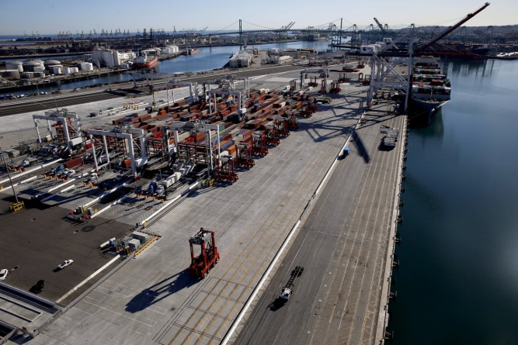
Figure: Dock using the Dock Worker Robots
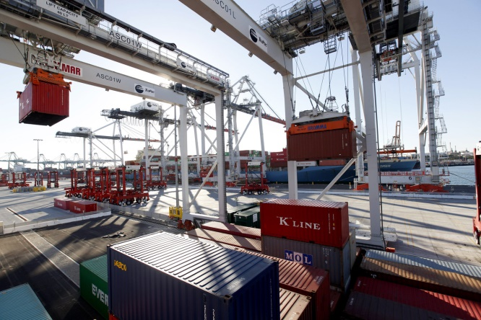
Figure: Dock using the Dock Worker Robots
- MARTHA PROJECT
The planning and the execution control of a trans-shipment task are managed in the Martha project at several levels. At the highest level, the mission allocation is performed incrementally by a centralized planner that allocates to each robot the container transportation jobs it has to perform. It views the robots as resources and container transportation tasks as jobs to be allocated to available robots. It can handle priorities and cost estimates of jobs, as well as a fairly flexible model of the uncertainty of the specified tasks, e.g., the uncertainty of the arrival time of the ships to be handled. The planner works incrementally, taking into account newly specified transportation tasks with respect to the running ones; it is able to modify part of the already allocated missions whose execution has not started yet.
Figure: Dock work environment as described under
The Martha Project
5. CONCLUSION
Artificial Intelligence is a boon for every sector that we are working into. We cannot even imagine how immensely useful it can prove to be to the human kind in researches, discoveries, inventions, explorations and what not. The integrated system installed can help to intake the input from the surroundings via the sensors and plan and arrange it according to the intelligent program especially designed for the purpose and thus draw out a suitable reaction to the environment.
The examples have already been set with the invention of ‘KISMET’ the AI based talking robot which has the capability to talk to any person just like a human, taking into consideration the body language and voice inflection.
Also, the Dock Worker Robots and The Martha Project have brought forward the plan of independent working of the artificial intelligence program as and when they are required.
So, there are more number of things that are left to be explored and discovered that we have only guessed at. These AI powered robots can be used to get information from the places that are, as of now, out of the human boundaries. Definitely these systems can help bring out the mysteries unexplored and solve the most important question in life, our existence.
6. REFERENCES
- Malik Ghalib, Dana Nau,Paolo Traverso,Conceptual Model for Planning, Automated Planning theory and theory and practice, Chapter 2.
- Malik Ghalib, Dana Nau,Paolo Traverso, State transition Systems, Automated Planning theory and theory and practice, Chapter 2.1
- Stuar J. Russel, Peter Norvig, Artificial Intelligence A Modern Approach,Objectives,Chapter 27.2
- Malik Ghalib, Dana Nau,Paolo Traverso,Dock Worker Robots, Automated Planning theory and theory and practice, Chapter 20.4
- Malik Ghalib, Dana Nau,Paolo Traverso,The Martha Project, Automated Planning theory and theory and practice, Chapter 20.4

