Azimuthal pod propulsion
Authors: Adithya manda and bhavesh haswani,
( 2nd Year B.Tech MArINE)
COLLEGE: Indian maritime university, chennai

An azimuthal pod thruster is a configuration of ship’s propeller placed in pods that can be rotated in any horizontal direction making the rudder unnecessary. The pods propeller usually faces forward because in this configuration the propeller is more efficient. Since it can rotate about its mount axis the pod can apply its thrust in any direction. Azimuth thrusters allow ships to be more maneuverable and enable them to move astern nearly as efficiently as they move ahead.
The pod incorporates an electric single or double wound A.C motor mounted directly on an extremely short propeller shaft. The electric motor drives a fixed pitch propeller. The motor is controlled by a frequency converter which produces full nominal torque over the entire speed range.
The pods are in the power range of 0.4MW to 30MW. The pods in the power range of 0.4MW to 5MW are referred to as “small pods”, whereas those which are in the range of 5MW to 30MW are referred to as ‘large pods”.
This concept has a great potential for container vessels, Ro-Ro vessels, shutter tankers, chemical tankers and LNG/LPG carriers.

Most of the pods sold today generally have the same design. However there are two major variants, based on the location of the motor:
- Mechanical transmission, where a motor inside the ship is connected to the pod by gearing. The motor may be diesel or diesel-electric.
- Electrical transmission, where an electric motor is in the pod itself, connected directly to the propeller without gears. The electricity is produced by an onboard engine, usually diesel or gas turbine.

The conventional pods which are being manufactured use electrical transmission where motor is placed inside the pod, the rotor is placed on the same shaft as the propeller which eliminates the use of gears. The shaft is held in place by a thrust bearing arrangement at the non drive end and a radial bearing arrangement at the drive end.

Electrical systems in pod propulsion usually consist of Transformers, Frequency converters and Propulsion motors.

- Transformer

The transformer is used to divide the system into several parts in order to obtain different voltage levels but also for phase shifting. The transformer isolates the two sides electrically. In pod propulsion two types are most common, wet and dry type.
The output of a transformer, supplying a pod system, is adjusted to the input rectifier stage of the converter.

- Frequency converter

The purpose of the frequency converter is to control the speed and torque of the motor by changing constant frequency into variable frequency. The technical development of semiconductors has been important and made many different designs of converters possible
.
- Electric motor

The electric motor is used for conversion from electrical to mechanical power. In pod propulsion three motors are used: synchronous-, permanent magnet- and induction motors. The by far most common motor is the synchronous motor (SM), because of the high efficiency in high power range. The motor is called synchronous because the rotor runs at synchronous speed, meaning that the rotor is spins at the same rate as the oscillating field which drives it.

Comparisons:

The purpose of this thesis is to compare the Azimuthal pods to the conventional propeller and rudder system.

- EFFICIENCY OF PROPULSION UNIT

When compared with the efficiency of a propeller alone, the propulsion efficiency of a single pod unit is lower. A realistic conclusion can only be drawn if the unit efficiency of the pod is compared with the unit efficiency of the conventional propeller with rudder.
A gain in propeller efficiency can be expected for twin pod arrangements because the inflow to the propeller is more uniform (absence of shafts and shaft brackets). This leads to better design conditions for the propeller and therefore to higher propeller efficiencies.

- ManeuverablITY
Since it can rotate around its mount axis, the pod can apply its thrust in any direction. Azimuth thrusters allow ships to be more maneuverable and enable them to travel backward nearly as efficiently as they can travel forward.
The M/S Elation which uses Azimuthal pods can travel
17 knots astern
25 knots ahead
5 knots sideways.
Also ships working on azimuthal pods do not require tug boats to dock thus proving to be economical to use.Full scale comparison of turning circles of M/S Elation and Paradise with conventional propulsion with rudder is shown.

Benefits:
The benefits of the pod drives are (in order of their significance):

- Easy to handle.
- More cargo space because the engine can be located more freely.
- Excellent harbor maneuverability.
- Greater fuel efficiency.
- Lower emissions.
- Lower noise level.
- Lower vibrations hence better passenger comforts.
- Low speeds are possible.
- Suited as booster drive in order to increase the speed.
- Less working expense in ship manufacturing.
- Power requirement can be lower for twin screw ships.

The demerits of the pod drives are (in order of their significance):

- Higher capital costs
- Diesel electric system required (power loss).
- Lesser efficiency in case of single screw arrangement.
- Higher lube oil demands

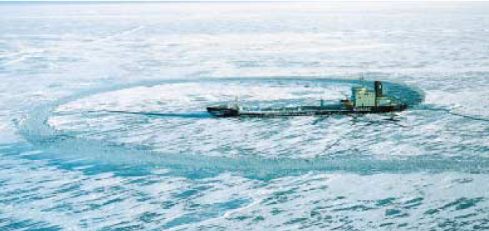

CONCLUSION:

Azimuthal propulsion units have extremely good fuel efficiency saving up to 10-15% when compared to conventional propellers. They also enable ships to be free of vibration and to be handled easily even in poor weather conditions and difficult passages. They are very well suited for Cruise liners, Icebreakers, Ro-Ro passenger ferry, Bulk carriers and Tankers.

We strongly affirm the technical superiority and reliability of AZIMUTHAL PODS and it would be very surprising if future merchant vessels were fitted with any other propulsion system other than AZIMUTHAL PROPULSION UNITS.

ACKNOWLEDGEMENTS:

We would like to thank the following people without whom this paper would not have possible today:

- First and foremost we would like to thank our Head of the Dept (Marine Engineering), Mr. S.K.Sarkar who encouraged us to write and present papers.

- We would also like to thank Chief Engineer V. Shrinivasan, for his constant guidance and support.

- We also extend our heartfelt gratitude to Dr. T Sathish, who helped us tremendously with our paper.

- And last and not the least we would like to thank Transtech ’11 for giving us this opportunity, and allowing us to present our paper in their esteemed event.

References:

- Electrical systems in pod propulsion
Master of Science Thesis of Electric Power Engineering
Lena Bergh
Ulrika Helldén
Department of Energy and Environment
Division of Electric Power Engineering
CHALMERS UNIVERSITY OF TECHNOLOGY
Göteborg, Sweden, 2007

- The Efficiency of Pod Propulsion
Friedrich Mewis
Hamburgische Schiffbau-Versuchsanstalt GmbH
Hamburg, Germany.

- ABB Oy
Marine and Turbocharging
Strömbergintie 1 P.O. Box 185
00381 Helsinki, Finland

- MARINELOG.COM

- YOUTUBE.COM

