Paving The Road Ahead for The Indian Shipbuilding and Ship Repairing Industry

- Shubham Shandilya, Tolani Maritime Institute, Induri, shubhamshandilya11@gmail.com
- Snehadri Banik, Tolani Maritime Institute, Induri, banik.snehadri@gmail.com

ABSTRACT:

Ship building acts as a catalyst for the overall industrial as well as economic growth of a country along with several other factors. The direct potential of ship building industry in contribution towards the GDP of a nation is therefore tremendous. India has 23 shipyards, of which 7 are under administrative control of the central government, 2 with state governments, and the rest in the private sector. The present shipbuilding capacity of India is only 2,81,000 DWT, which is small according to global shipbuilding standards and inadequate given the country's requirements. India has only about 0.3 percent of the total global market share. Till recently, most Indian shipyards were incurring losses. However, the current uptrend in the global shipbuilding industry, the government's shipbuilding subsidy and the ambitious vision of “Make in India” has led to a turnaround in this sector. With the exponential growth in the number of ships calling on Indian ports, providing ship-repair facilities are becoming an increasingly attractive opportunity. The dynamics of India’s economic growth will contribute to create demand for new ships and ship building capacity with in country needs to be augmented to cater to this demand by studying the all above data this paper has been prepared to find out the performance over the years later to understand the challenges and opportunities for the ship building and repairing industry.

Keywords: Challenges of Shipbuilding Industry, Performance of Shipbuilding Industry, Shipbuilding Industry.

- Introduction
Shipbuilding Industry is mainly dominated by technology, skill and material intensive assembly operation. The end product is a high value floating asset. For nearly three decades in the post-World War II era, shipbuilding industry was dominated by Europe and the US. India has a total coast line of 7517 km with 12 major ports and 205 notified non major ports facilitating sea borne trade. India also has an extensive network of Inland water ways in the form of river, canals, backwaters and creeks which create demand small ships/barges. Ships owned by Indians carried over 7.45% of India’s overseas trade during 2014-15. India’s emergence as a major economic power would mean greater integration in terms of trade with the rest of the world requiring huge shipping tonnage. As on 31st march 2015, Indian shipping tonnage was 10.51 million Gross Registered Tonnage (GRT) with 1210 ships.

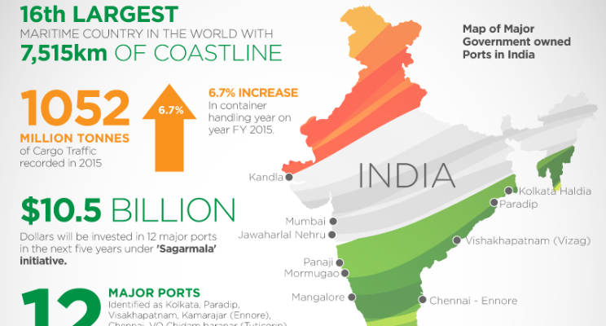

Fig. 1: Emerging of the Indian Maritime Sector

With the booming of Indian economy to globalization, there has been a significant increase in handling of cargo traffic at Indian Ports. India’s share in global exports has increased from 0.7% in 2000 to 1.7% in 2014 (Source: WTO). At the time of independence, there were about a dozen shipyards around Kolkata and Mumbai, which rose to around 45 shipyards in the late seventies. At present, there are 31 shipyards, out of which 8 shipyards are in the public sector and the rest are in the private sector.
Apart from shipyards there are 34 dry-docks for repairing ships in India both in public and private sector as per data reported. These dry docks include the 12 dry docks operated by 8 major ports. The major ports which have no dry-dock facilities are JNPT, New Mangalore, Chennai, Ennore, and Haldia Dock Complex of Kolkata Port.
There are 34 dry-docks for repairing ships in India both in public and private sector as per data reported. These dry docks include the 12 dry docks operated by 8 major ports. The major ports which have no dry-dock facilities are JNPT, New Mangalore, Chennai, Ennore, and Haldia Dock Complex of Kolkata Port.

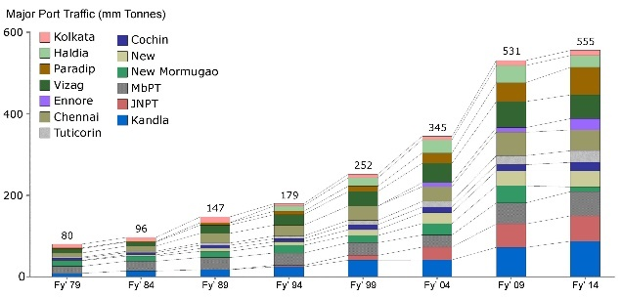
Fig. 2: Growth of maritime sector over the years

- Background
Shipbuilding is a truly global industry as trading of ships is not protected by any tariff barriers. This can be ascertained by the fact that more than 90 percent of the world’s leading
shipbuilding is carried out Korea. The industry has changed supply bases to low cost destinations in the last century due to which new countries have gained prominence, especially during boom periods. England and US were the world leaders till 1950. Japan and Korea emerged as prominent shipbuilding nations during the 1950s and 1970s. The current boom has brought forward to China. Korea, Japan and China account for more than 85 percent of world deliveries at present.

Table 1: Proportion of Shipbuilders in the world(%)
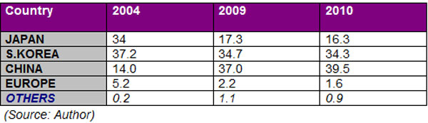

- Performance of Indian Shipbuilding Industry

The global shipbuilding industry is in the midst of an unprecedented boom at present. At the end of 2007, the global order book had swelled to 457mn DWT having quadrupled in the previous 5 years. Indian shipbuilding industry has also witnessed healthy growth in the recent past. The annual turnover of the industry has increased by 259 percent from 2002-2007, which is quite an astounding figure.

DWT is the number of tons (2240 pounds) of stores, fuel and cargo that a ship can transport. This presents the actual carrying capacity of a ship. While looking into the data available in public domain, it was analysed that the productivity of the industry is going downwards. The downfall is not a good sign for the industry as well as the country. There is a huge gap of 69.31% in delivered DWT of 2011-12 to that of 2014-15. Similarly, while analysing the numbers of ships delivered, there was a slight rise in 2012-13 and then onwards, it has been ever decreasing; both public and private sector units have shown downward trends.

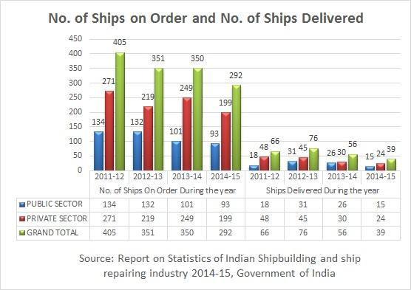
Fig. 4.: Comparison of ships order and delivered

There has been a huge order received which is still pending with the companies. As it is clear, in last 4 financial years the industry has received orders for 1398 ships and delivered only 237 ships, so there is huge pending order which still to be entertained on priority basis. According to the estimates of various economists, it would take more than 16 years to clear the order books. Shipbuilding capacity of the Indian Industry is a critical issue which is still not supported. As a result the new orders are decreasing year on year basis. Ship repairing is also as important as shipbuilding. It has been observed that both public and private firms have performed well in last few years and maintained their productivity and also increased their strength as a result the ship repairing numbers had just doubled in 2014-15 as compared to 2013-14. It is a good sign for the industry that capacity is built up which would attract more customers around the globe.

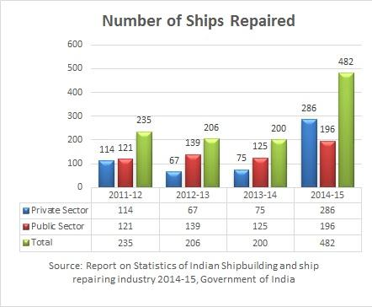
Fig. 5: Statistics of ships repaired

- Challenges to Indian Shipbuilding Industry

There are a number of challenges which, if not encountered and eliminated, could spell trouble for the industry.

- Statutory Burden
When it comes to do business in India, one must be ready to entertain a complex set of levies and duties. Shipbuilding industry is not an exception till date, it also attracts a complex set of levies and duties. The differential rate of duties and taxes between India and other nations leads to additional cost burden for Indian shipyards.
- Levies
Octroi, CST, VAT, excise, service tax and corporate tax are some of the levies applicable to shipyards. Several shipbuilding nations have relaxed these levies to encourage shipyards. For example, China refunds VAT completely on domestic sale of ships whereas in India VAT is refunded only on inputs.

- Bank Guarantees
Shipyards are required to provide bank guarantees to protect the ship buyer. These guarantees include performance guarantee (for timely delivery), refund guarantee (forstage payments) and post-construction guarantee (towards defects). In China, the government provides sovereign refund guarantees for certain class of vessels, thus removing any related burden on the shipyard. In Korea, shipyard financing has matured and the evolved mechanisms drive the cost lower. However, in India, financial institutions do not have a focus on the shipbuilding sector and there is no support from the Government to reduce the charges as in the case of Korea. As a result, the cost of bank guarantees in India is higher than competing countries.

- Working Capital
A typical shipyard requires a working capital of around 25-35 percent of the cost of the ship during the entire production period. The interest rates on working capital in India averages 10.5 percent. On the other hand, the interest rates presently offered to shipbuilding yards overseas are considerably lower at around 5-6 percent in Korea and around 4-8 percent lower in China.

- Lack of Educational Institutions
As concerned to education, there are four institutions providing naval architecture degree to about 120 graduates per year, whereas, the country needs about ten times more naval architecture and shipbuilding engineers per year. If the country is unable to provide JIT training to convert other engineers of mechanical sciences to shipbuilding engineers, the immediate need of the industry cannot be fulfilled and it may suffer. Further, unless there is a plan to increase the strength of graduates in this specialized field in the next four to five years there may be a shortage of man power which will have a very adverse effect on the industry.

- Lack of Government Recognition
It prevents shipbuilding and repair industry from achieving infrastructure status and helping subsequently from tax concessions and tax holidays. If this industry is not recognized by government as an important strategic industry, it will be difficult for it to grow and compete with shipbuilding giants like China, South Korea and the new entrant Vietnam. Another major challenge to the growth of shipbuilding industry is lack of proper professional education and research & development facilities in the country. The growth of Indian Register of Shipping has not been as it should have been and it is yet to receive the status of a full member of IACS. NSDRC, as the sole design and Research and Development organization of Ministry of Shipping, Government of India is not functioning properly. The other Research and Development laboratories, such as, NIO, NIOT, NSTL, NPOL, which are not under Ministry of Shipping are doing all right.

V. Opportunities for Indian Shipbuilding Industry:

One of the big opportunities that Indian shipbuilding industry has encountered is the present shipbuilding market which has come to Indian door steps almost unsolicited. Since the stress of finding a market is reasonably eased, Indian shipbuilding community should take this opportunity to frame strategies for long term development and endurance of this industry. India is also witnessing a boom in offshore oil exploration and production in Indian shores and abroad through collaborations. There is a high demand inside the country for production of offshore platforms and their repair facilities. Besides the above facts there are many other factors which makes India competitively strong enough to start and stand up in the coming future. Some of the facts are as follows:

- Low Labour Cost
As we all know that low labour cost is a key driving factor in development of any in industry in nations, as it accounts for a major part of production cost. Indian labour costs are on the lower side as compared to those of the leading shipbuilding nations. Even after factoring in impact of efficiency, Indian labour is considerably cheaper than Korean and Chinese labour. More importantly, Indian labour cost is increasing at half the rate in China, which implies that India might continue to have an edge over China in the future.
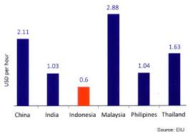
Fig. 8: Comparison of labour cost over the globe

- Strong Domestic Demand
Indian shipping trade is flourishing on the back of economic growth at the rate of around 8 percent. Domestic shipping lines are expanding their fleets and have placed orders with global yards. There is also a strong thrust in basic sectors such as power and steel and companies are looking to procure ships to control transport from international mines. The Government’s new initiatives in Coastal Shipping and IWT, is likely to further increase demand for new ships. New ports and IWT lanes would require searching and other port-related vessel support. Finally, the current offshore explorations are expected to create demand for rigs, OSV and PSV. Thus, even in a possible short-term low demand scenario, there is enough domestic demand, which Indian shipbuilders can take advantage of.

- Supporting Industry Infrastructure for Some Components
India has domestic industries which can produce some of the raw materials required in shipbuilding. Specifically, India has competitive steel manufacturing, light engineering and IT/ITES industries which can offer the required products at economical costs. Also, new orders in the other industries would result into new job creations in the nation.

- Long Coastline
India has a long coastline of more than 7,500 km long with several deep water ports serving as good locations for setting up shipyards. So, no worries for the availability of space for new entrants as well as existing companies for setting up production units.

5. Replacement Demand

5.1. Age Profile of World Fleet
Various international organizations like International Maritime Organization (IMO) have proposed to scrape & phase out vessels of more than 25 years of age. The Director General of Shipping (DGS), India has also announced a mandate CAP 2 (Condition Assessment Programme) rating for all vessels that are 20 years old & a complete ban on oil tankers aged above 25 years from entering into Indian waters effective 1st April 2004. More than 65% of the world fleet is above the age of 15 years. These dues would apparently need new buildings primarily to be used to replace the aging fleet.

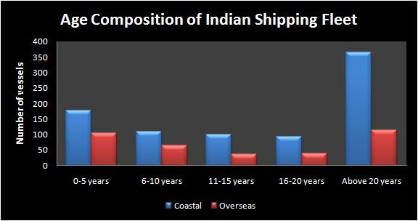
Fig. 9: Age profile of Indian Shipping Fleet

5.2 Scrapping of Single Hull Vessels
IMO regulation mandates the conversion of all oil tankers to double hull by 2010 & scrapping of single hull tankers. Tankers constitute more than 45% of the total vessels, of which about 33% are single hull. This is expected to drive an increase in demand for new vessels.
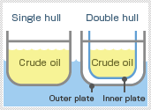
Fig. 10: Difference between single and double hull

6. New-Building Prices
Vessels prices, in the recent past have increased rapidly, indicating that the demand for new builds has far exceeded supply. This scenario also indicates that the ship repairing industry has a huge potential.
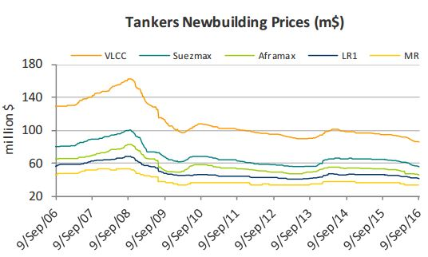
Fig. 12: Tankers newbuilding prices between 2006-2016

- Retention and Training for Personnel

While training has been identified as a focus area by the government, it is also necessary to address the need for training for special skills in areas where ports face manpower shortage. This includes training for crane operators, pilots, VTS (full form) operators, etc. Incentives should be provided to ports to invest in training infrastructure such as simulators, etc. Plans should also be developed to retain key staff such as pilots, IT personnel, VTS operators, etc. India has always been regarded as a major source of skilled manpower for world shipping. India has around 150 training institutes with 4 in the public sector and around 146 in the private sector, capable of producing 11,164 seafarers (4,575 officers and 6,589 ratings) annually.

Conclusion
India's maritime sector is witnessing promising growth, which is reflected in the increase in the demand for infrastructure and services across the entire value chain comprising shipping, ports, ship-building/repair, and logistics. While this growth has thrown up bottlenecks in infrastructure and service provisioning across the sector, it has also opened up opportunities in each segment. Therefore, it is critical to pursue comprehensive measures at the policy, administration, and project level in each segment, so that bottlenecks are addressed and opportunities are capitalized upon, thereby ensuring that the growth momentum is sustained.

Acknowledgment:

We would like to thank Tolani Maritime Institute, Induri for providing us with an opportunity to do a research project on “Paving The Road Ahead for The Indian Shipbuilding and Ship Repairing Industry”.

We wish to express my sincere gratitude to Prof. Arun O. Mahajan, Prof. Dr. N. D. Junnarkar and Prof. Nilima C. Joshi for their constant guidance and encouragement in carrying out this research project.
References:

- Indian Shipping Industry: A Catalyst for Growth, Export Import Bank of India, October 2010.
- Report on Statistics of Indian Shipbuilding and ship repairing industry 2014-15, Government of India. Ministry of Shipping, Road Transport and Highway, New Delhi.
- DIBD analysis report : The Shipbuilding Industry.
- K. Muthuchelvi and D. Sureshkumar :- Competitiveness of Indian Ship Building Industry, IJIRD, ISSN 2278-211.
- www.shipping.nic.in
- www.dsir.gov.in

