C.V.RAMAN COLLEGE OF ENGINEERING

SMART MATERIALS FOR SMART FUTURE

INDEX

- SUPERCONDUCTOR ELECTRICAL MACHINE
- SUPERCONDUCTING MAGNETIC ENERGY STORAGE
- MAGNETIC REFRIGERATION

PRESENTED BY :-
- HEMANT KUMAR
- SAURABH KUMAR
- ARINDAM BHATTACHARYA
- PRADEEP KUMAR RAJPUT

ABSTRACT:
The problem with modern diesel engine are:
- Mechanical efficiency limits between 40-45%.
- Nox Sox emission.
- Depletion of non-renewable energy resource.
- Increased vibration, wear and tear in mechanical parts causing power loss.
- Decreasing cargo carrying capacity due to large engine room space.
The associated problems with diesel engine can be overcome by introducing compact size superconductor electrical machine for all electric, diesel electric, turbo electric propulsion system. Superconductor electrical machines have numerous advantages over conventional copper coil wound electrical machines.
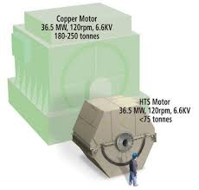
The fluctuating loads in the ships electrical system can be stablized by superconductor magnetic energy storage system. Magnetic refrigeration system will replace vapour compression refrigeration system in near future saving energy, money and labour onboard.

INTRODUCTION:
In this paper we have highlighted the concept of super-conduction, superconductor electrical machine, superconducting magnetic energy storage and magnetic refrigeration and how they can be used in future for increased efficiency onboard.

BODY:
SUPERCONDUCTOR

SUPERCONDUCTOR :-It is a material that can conduct electricity or transport electrons from one atom to another with no resistance.
This means no heat, sound or any other form of energy would be released from the material when it reached “critical temperature”(Tc) or the temperature at which the materials become superconductive.

SUPERCONDUCTIVITY:-It is phenomenon of exactly zero electrical resistance and expulsion of magnetic fields occurring in certain materials when cooled below a characteristic critical temperature.

TYPES OF SUPERCONDUCTOR:-

- Type I superconductors:-
Type I superconductors are those superconductors which loose their superconductivity very easily or abruptly when placed in the external magnetic field.
From the graph, intensity of magnetization (M) versus applied magnetic field (H), when the Type I superconductor is placed in the magnetic field, it suddenly or easily looses its superconductivity at critical magnetic field (Hc) (point A).
After Hc, the Type I superconductor will become conductor.

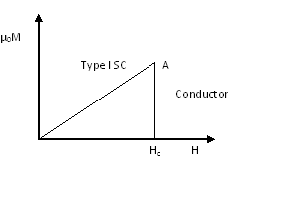

- Type II superconductors:-
Type II superconductors are those superconductors which loose their superconductivity gradually but not easily or abruptly when placed in the external magnetic field.
From the graph of intensity of magnetization (M) versus applied magnetic field (H), when the Type II superconductor is placed in the magnetic field, it gradually looses its superconductivity.
Type II superconductors start to loose their superconductivity at lower critical magnetic field (Hc1) and completely loose their superconductivity at upper critical magnetic field (Hc2).

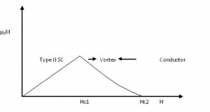

Recently, physicists discovered ceramic compounds that exhibit superconductivity at temperatures as high as -145º Celsius. This temperature is high enough that the materials need be cooled only with liquid nitrogen, which is far less expensive to do than with liquid helium. They are called high temperature superconductor.

APPLICATION OF HIGH TEMPERATURE SUPERCONDUCTOR

Most large HTS machines are of synchronous type which uses wires in direct current field winding at cryogenic temperatures and copper wires in the stator winding at ambient temperatures.

A ship propulsion system, comprising a synchronous machine having:- 1) a rotor with a multi-pole rotor winding, 2) a rotor cooling system thermally coupled to the rotor winding for cooling the rotor winding to a low temperature, 3) a stator surrounding the rotor and including a stator winding, 4) a stator cooling system for cooling the stator to a temperature where the stator winding is normally conducting.

The HTS motor is a cryogenically cooled, ultra-efficient synchronous motor with HTS field windings. The Adjustable Speed Drive (ASD) used to power the motor will be a conventional rectifier/inverter system as used with present AC induction motor products, modified to operate with a synchronous motor.
The HTS field winding will operate in the 25 to 40 Kelvin temperature range at a DC magnetic field of up to 4 Tesla.
The field coils will be cooled by a commercially available cryo-cooler system that feeds cold helium gas to and receives warmed helium gas from the rotor.

The HTS motor components are shown below:-
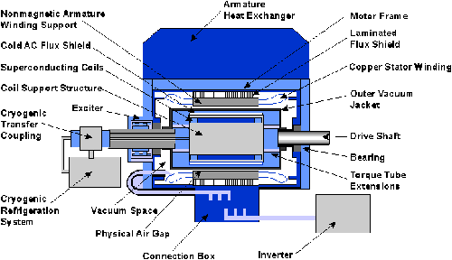

The rotating HTS field winding creates a magnetic field in the copper armature winding. The magnitude of this field is approximately twice that of a conventional motor. The HTS motor has an air core (i.e., nonmagnetic) construction so that the air gap field can be increased without the core loss and saturation problems inherent in a laminated iron stator and rotor core. The copper armature winding lies just outside the air gap.

Inside the warm outer AC flux shield will be a thermal insulation space (vacuum) that surrounds the rotor cryostat. The cold AC flux shield is on the inside surface of this vacuum space and is a high-conductivity shell near the operating temperature of the superconducting coils. The superconducting field coils are located within the inner shield on a non-magnetic support structure.

ADVANTAGES OF HTS MOTOR

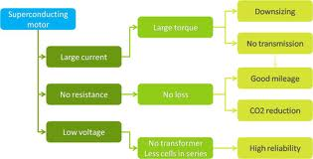

APPLICATION

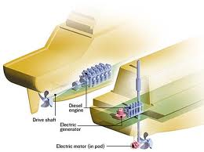

German engineer designed a motor that uses high-temperature superconductors which only need to be cooled to about -140°C or so. The motor is also placed inside a pod that sits directly beneath the ship, so it is almost completely surrounded by seawater. The heat is then pumped away and the surrounding seawater allows it to dissipate far more efficiently, keeping the motor at the required temperature. HTS propulsion motor can be used in ships all electric, diesel electric and turbo electric propulsion system. Its efficiency is about 98%, capable of reducing weight and volume by 50%,reduces capital cost by 25%.

ADVANTAGE OF SUPERCONDUCTOR:-
- More compact size.
- No current wastage.
- Noise reduction.
- Potential energy saving.
- Increased stability.
- Faster delivery and installation.
- Reduce the fuel consumption by 20%.

SUPERCONDUCTING MAGNETIC ENERGY STORAGE (SMES)

Systems store energy in the magnetic field created by the flow of direct current in a superconducting coil which has been cryogenically cooled to a temperature below its superconducting critical temperature.

INTRODUCTION

The major components of a SMES unit are:-
- superconducting coil,
- non-magnetic vacuum vessel
- cryogenic system with liquid helium refrigerator
- ac/dc thyristor converter
- local control system.
The coil made of NbTi is immersed in a superfluid helium bath supplied from helium refrigeration system and is contained in a helium vessel maintained at a lowtemperature of 1.8 Kelvin (Critical temperature of material).
The helium vessel is called a cryostat.
The helium vessel is surrounded by and supported from a vacuum vessel in nitrogen shroud surrounding helium vessel.
The vacuum vessel assembly is known as Dewar.
The superconducting coil once charged with direct current from ac/dc converter supports a magnetic field of approximately 1.2 Tesla without any losses
Once the superconducting coil is charged, the current will not decay and the magnetic energy can be stored.
The stored energy can be released back to the network by discharging the coil. The power conditioning system uses an inverter/rectifier to transform alternating current (dc) power to direct current(dc) or convert dc back to ac power. The inverter/rectifier accounts for about 2–3% energy loss in each direction. SMES loses the least amount of electricity in the energy storage process compared to other methods of storing energy. SMES systems are highly efficient; the round-trip efficiency is greater than 95%.

OPERATING PRINCIPLE

Electrical energy is stored in the magnetic field of superconducting inductor coil, which is connected to the ac power system through inverter/converter unit.
Each converter is of conventional 6-pulse type. Two such converters areconnected as shown provide a 12-pulse arrangement outside the Dewar with only the inductor L as a load on the dc side.

Basic circuit elements for SMES unit

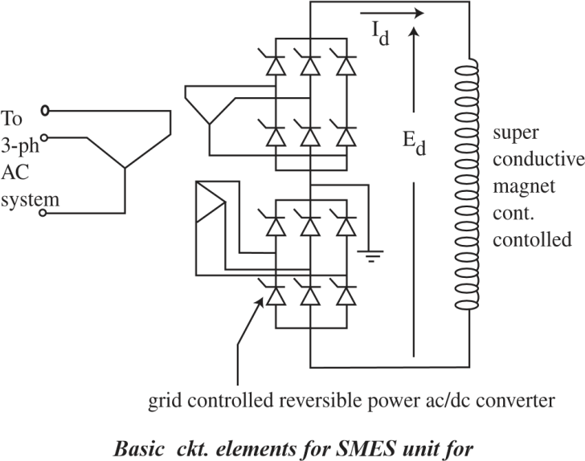
power system applications

The control of power from ac system to the SMES unit and vice versa can be achieved by varying the commutation angle of the thyristor controlled inductor-converter set. Energy stored in SMES coil can be described as:-

Esmes=(L*Ismes*Ismes)/2

L=inductance of the SMES coil,
Ismes=current flowing in the SMES coil
SMEScoil discharge power P0 within specific
Time ts, the energy in the SMES coil
E(t) at t<tsis
Et=Esmes-Pot

When t=ts,
the current in SMES coil is Is=Po/V

V=voltage across the coil during discharging.
If the current in the coil drops below the critical value Is,
the system can no longer discharge with constant power
Po

.
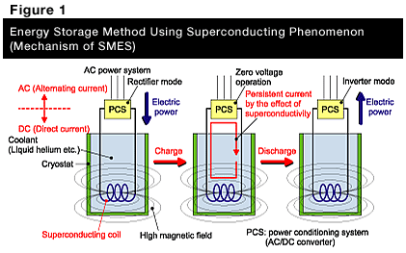

Improving the stability demonstrates that SMES can damp system oscillations, thus improve the transmitting capacity of the power system. SMES can prevent voltage drops, caused from the generator fault or the large load inserted in the system, through the active and reactive power compensation. Improvement of power supply quality has several considerations:-
(1)Improving flexible AC transmission system,
(2)Compensation of fluctuating loads,
(3) Spinning reserve,
(4) Improving power system symmetry,
(5) Protection of critical loads,
(6) Compensation of dynamic voltage in dynamic voltage support,
(7)Backup of power supply.

ADVANTAGES OVER OTHER STORAGE METHOD:-
- The time delay during charge and discharge is quite short.
- Power is available instantaneously.
- Very high power output can be provided for a brief period of time.

MAGNETIC REFRIGERATION:

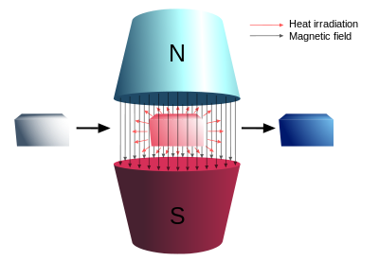

Magnetic refrigeration is a cooling technology based on the magneto-caloric effect. This technique can be used to attain extremely low temperature, as well as the ranges used in common refrigerators, depending on the design of the system.

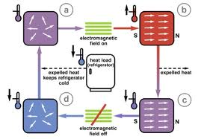

MAGNETO-CALORIC EFFECT

The magneto-caloric effect is a magneto-thermodynamic phenomenon in which a change in temperature of a suitable material is caused by exposing the material to a changing magnetic field. This is also known as adiabatic demagnetization, a decrease in the strength of an externally applied magnetic field allows the magnetic domains of a magneto-caloric material to become disoriented from the magnetic field by the agitating action of the thermal energy (phonons) present in the material. If the material is isolated so that no energy is allowed to (re)migrate into the material during this time, i.e., an adiabatic process, the temperature drops as the domains absorb the thermal energy to perform their reorientation, magnetic dipoles overcome a decreasing external magnetic field while energy remains constant.

THERMODYNAMIC CYCLE:-

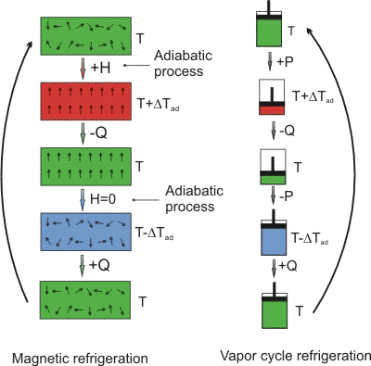
H = externally applied magnetic field; Q= heat quantity; P = pressure; ΔT_{ad} = adiabatic temperature variation.

The cycle is performed as a refrigeration cycle, analogous to the Carnot cycle, and can be described at a starting point whereby the chosen working substance is introduced into a magnetic field, i.e., the magnetic flux density is increased. The working material is the refrigerant, and starts in thermal equilibrium with the refrigerated environment.
- Adiabatic magnetization:-A magneto-caloric substance is placed in an insulated environment. The increasing external magnetic field (+H) causes the magnetic dipoles of the atoms to align, thereby decreasing the material's magnetic entropy and heat capacity. Since overall energy is not lost (yet) and therefore total entropy is not reduced, the net result is that the item heats up(T + ΔT_{ad}).

- Isomagnetic enthalpic transfer:-This added heat can then be removed (-Q) by a fluid or gas — gaseous or liquid helium, for example. The magnetic field is held constant to prevent the dipoles from reabsorbing the heat. Once sufficiently cooled, the magneto-caloric substance and the coolant are separated (H=0).

- Adiabatic demagnetization:-The substance is returned to another adiabatic (insulated) condition so the total entropy remains constant. However, this time the magnetic field is decreased, the thermal energy causes the magnetic moments to overcome the field, and thus the sample cools, i.e., an adiabatic temperature change. Energy (and entropy) transfers from thermal entropy to magnetic entropy (disorder of the magnetic dipoles).

- Isomagnetic entropic transfer:-The magnetic field is held constant to prevent the material from heating back up. The material is placed in thermal contact with the environment being refrigerated. Because the working material is cooler than the refrigerated environment (by design), heat energy migrates into the working material (+Q).Once the refrigerant and refrigerated environment are in thermal equilibrium, the cycle begins again.

APPLICATION
To provide the cooling power required for specific markets like home refrigerators, air conditioning, electronics cooling, and fluid chilling, the magnetic refrigerator employs a rotary design. It consists of a wheel that contains segments of gadolinium powder and a high-powered, rare earth permanent magnet. The wheel is arranged to pass through a gap in the magnet where the magnetic field is concentrated. As it passes through this field, the gadolinium in the wheel exhibits a large magneto-caloric effect, it heats up. After entering the field, water is circulated to draw the heat out of the metal. As the gadolinium leaves the magnetic field, the material cools further as a result of the magneto-caloric effect. A second stream of water is cooled by the gadolinium. This water is then circulated through the refrigerator's cooling coils. The overall result is a compact unit that runs virtually silent and nearly vibration free, without the use of ozone-depleting gases, a dramatic change from the vapour-compression-style refrigeration technology in use today.
"The permanent magnets and the gadolinium don't require any energy inputs to make them work," Gschneidner says, "so the only energy it takes is the electricity for the motors to spin the wheel and drive the water pumps."
The Gd5(Si2Ge2) exhibits a giant magneto-caloric effect that offers the promise to outperform the gadolinium powders used in the current rotary refrigerator.

WORKING MATERIAL

Alloys of gadolinium producing 3 - 4 K per tesla of change in a magnetic field are best material available today for magnetic refrigeration near room temperature since they undergo second-order phase transitions which have no magnetic or thermal hysteresis involved.
This refrigeration technology, has not proven viable by the end of 2013 for mass commercial applications (only for some ultra low cryogenic applications but this has been for the last 50 years). If it can be proven to be competitive and cost effective and environmental friendly then it could be used in any possible application where cooling, heating or power generation is used today. The magneto-caloric refrigeration system is composed of pumps, electric motors, secondary fluids, heat exchangers of different types, magnets and magnetic materials. These processes are greatly affected by irreversibilities and should be adequately considered.
Appliances using this method could have a smaller environmental impact if the method is perfected and replaces hydro-fluorocarbon (HFCs) refrigerators (some refrigerators still use HCFCs which have considerable effect on the ozone layer. At present, however, the superconducting magnets that are used in the process have to themselves be cooled down to the temperature of liquid nitrogen, or with even colder, and relatively expensive, liquid helium. Considering these fluids have boiling points of 77.36 K and 4.22 K respectively, the technology is clearly not cost- and energy-efficient for home appliances, but for experimental, laboratory, and industrial use only.

CONCLUSION:
The use of this technology to replace larger vapour-compression refrigeration units, which typically achieve performance coefficients of 60% of that of a theoretical ideal Carnot cycle.
Large-scale applications using magnetic refrigeration, such as commercial air conditioning and supermarket refrigeration systems, could be available within 5–10 years. Within 10–15 years, the technology could be available in home refrigerators and air conditioners."
Superconductor motor with ceramic wire with nitrogen cooling can be used in reduced cost on board in future.

