Study of Azimuthal Propulsion Coupled With CCS Technology And Powered by Piezo Electricity

Arpit Jajoo , IndianMaritime University, Chennai
E-mail: arpit.jajoo001@gmail.com

Rupesh Raj, IndianMaritime University, Chennai
E-mail: coolrajrupesh@gmail.com

1.Abstract

This paper deals with the conceptual study of Azimuthal propulsion of merchant vessels. The optimum performance with LH2 and LCO2 fuels which will be efficiently produced using CCS technology. In addition, the innovative concept of piezo-electricity generation and its application have been discussed with respect to vessels. These technologies and design has the potential to be very sustainable in the long-term.

2. Keywords

Azimuthal Propulsion, CCS, Electro-Chemical Acidification Cell, Piezo-Electricity , Clean Advantage

3. Introduction

In this modern era, majority or we may say 90 percent of imports and exports are carried out by shipping industry. This transportation of goods involves huge running cost and heavy emissions to the environment thus it’s necessary to have a technology cut out to both reduce emissions as well as to meet the investments. International Shipping is a major source of emissions of Nitrogen Oxides (NOx). Globally, ocean –going vessels emitted about 25 million tons of NOx in 2007, representing about 15 per cent of total anthrogenic emissions. While NOx emissions from land-based sources in industrialized countries are gradually coming down, those from shipping shows continuous decrease. Keeping this concern in the mind we propose an idea to use Azimuthal Propulsion in future vessels. Azipod in modern engines is electricity based propulsion. This propulsion is far more efficient and advantageous over conventional rudder and propeller. With the use of these emissions can be minimised to the minimal level. This engine runs on clean fuel because of which the only combustion product is H2O. However, here rises an issue of bunkering clean fuel that is LCO2 and LH2 on board vessels. Capture Skid (CCS). This technology produces sufficient amount of liquid hydrogen and carbondioxide which is in abundance as required. The CCS also produces 15000 gal/day of hydrocarbon fuel which can be used to power generators as well as other auxiliary machines and pumps. Researches on these have also proved them to be efficient for lighting fuel such as LCO2 and LH2.

Electricity for CCS plant can be assisted with the use of piezo-ceramic pads. These pads are capable of producing fairly high amount of electricity with low as well as high frequencies. These pads can be installed beneath bed-plates or machineries with heavy weights and vibrations, ships flooring, bulbous bow and other such parts which are under some load or face vibrations.

4. Principles Involved

Azimuth Propulsion :-

An azimuth propulsion is a configuration of marine propellers placed in pods that can be rotated to any horizontal angle (azimuth), making a rudder unnecessary. These give ships better maneuverability than a fixed propeller and rudder system.

Electrical Transmission:-
An electrical transmission thruster doesn't consist of a mechanical gear system. The Electrical Motor is located in the pod itself which is connected to the shaft without using gears. The power required by the electric motor can be derived from the main power system, i.e. diesel engine or gas turbine. All these thrusters can move 360 degrees, thus making the process of docking and maneuvering through channels, a smooth one

Piezo-Electricity:-

Some atomic lattice structures have as an essential unit (or "cell") a cubic or rhomboid cage made of atoms, and this cage holds a single semi-mobile ion which has several stable quantum position states inside the cell. The ion's post ion state can be caused to shift by either deforming the cage (applied strain) or by applying and electric field. The coupling between the central ion and the cage provides the basis for transformation of mechanical strain to internal electric field shifts and vice versa.

Reduce Ballast:- The Clear Advantage Ballast reduced ballast designs provides substantial performance improvement over conventional vessel design.

Carbon Capture Skid (CCS):-

This technology is used to extract liquefied Hydrogen (H2) and removal of Carbon dioxide (CO2) from seawater.

5. Main text
.
5.1 Extraction of Propellant (LH2 & CO2) by Electrochemical Acidification in CCS from seawater
- Semipermeable membrane sandwiched between electrodes.
- H⁺ and OH⁻ is generated by electrolysis,
- CO₂ bubbles off.

Cell Reaction:-

$$Anode: 2H_{2}O→4H^{+}+O_{2}+4e^{-} \left(1\right)$$
$IX 4\left|NaCl\right|seawater + H^{+}→4Na^{+}+4\left|HCl\right|acidic seawater (2)Cathode: 4H_{2}O+4Na^{+}+4e^{-}→4NaOH+2H_{2}$(3) $Overall: 6H_{2}O+4NaCl→4\left|HCl|_{IX}+4\right|NaOH\left|+2\right|H_{2}|_{CATHODE}+|O_{2}|_{ANODE}$
$$- (4)$$
The production of hydrocarbons, which are compounds solely made up of hydrogen and carbon, from the recovered gases through the following process:-
- Extract liquefied Hydrogen (H2) and removal of Carbon dioxide (CO2) from seawater. This is achieved through the use of ELECTROCHEMICAL ACIDIFICATION CELLS.
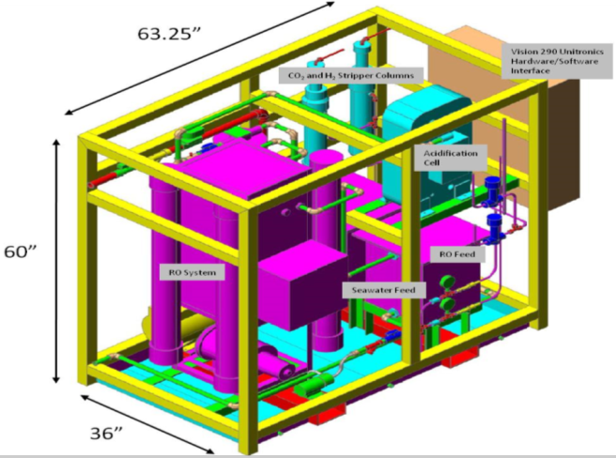
- Liquid hydrogen and Liquid carbon dioxide produced are supplied to the two different tanks through two different pumps.
- Liquid H2 and Liquid CO2 are obtained.
- Further, the CO2 and Part of H2 obtained are converted into unsaturated hydrocarbon starter molecules called Olefins using an iron-based catalyst.
- Then, these olefins are converted into a liquid containing larger hydrocarbon (C16-C19 range) molecules by polymerization.
- They are fed to ship’s generators as fuel.

5.2Piezo-Electric pads to generate electricity

Squeeze certain crystals and we can make electricity flow through them. The reverse is true as well; if we pass electricity through the same crystal, they squeeze themselves by vibrating back and forth it is known as piezo electric effect.
Stretching PSI-5A (1.5" x 2.5" x .0075") sheet to ±500 micro strains quasi static at a resonance of 15 KHz, and that we collect 100% of the stored electrical energy at its height twice per cycle we would get approximately 9 watts of electrical power from the sheet.

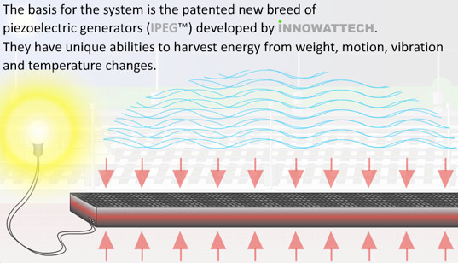
- On-board, the piezo electric pads can be installed in all pressure sensitive areas and areas with high vibrating forces such as bed plate of various machineries, beneath cargo hold, accommodation etc.

- The charges in the piezo electric crystal are exactly balanced even if they are not symmetrically arranged.
- The effect of charges exactly cancel out, leaving no net charge on crystal face.
- If we squeeze crystal charges are forced out of balance.
- Now dipole moments no longer cancel one another and net positive and net negative charges appear on opposite crystal faces.
- By squeezing the crystal, voltage across its opposite faces is produced-this is known as piezo electric effect and electricity generated is known as piezo- electricity.
- This electricity is feed to large batteries where it stored.
- Then it is utilized to power accommodation.

5.3 Electricity from generator & Piezo is used to run Azipod Electric Propulsion System:-

- In the Azipod unit, the electric motor is mounted inside the propulsion unit and the propeller is connected directly to the motor shaft.
- The Propeller can be further below the stern of the ship in a clear flow of water, thereby providing greater hydrodynamic and mechanical efficiency.
- Furthermore, it increases flexibility in the general arrangement of the vessel's power plant.
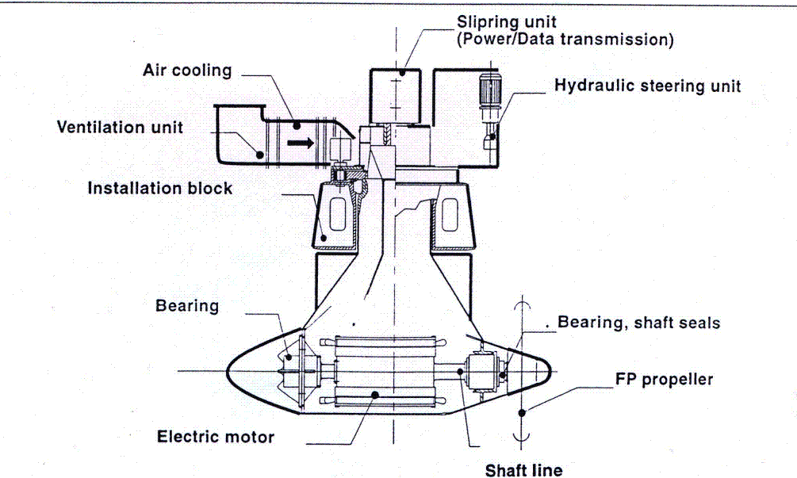
- The Pod incorporates An Electric Single or Double Wound A.C. mounted directly on an extremely short propeller shaft.
- The electric motor drives a fixed pitch propeller.
- Motor is controlled by frequency converter which produces full nominal torque over the entire speed range.
- Electric power for the propulsion motor is conducted through slip rings.
- It let the Azipod unit rotate 360 degrees about the vertical axis.
- The pod's propeller usually faces forward because in this pulling (or tractor) configuration the propeller is more efficient due to operation in undisturbed flow.
- It can rotate around its mount axis, the pod can apply its thrust in any direction.
5.4 Clean Advantage Ballast:-
- Removing 3000 tons of permanent ballast from a PCTC and increasing the beam by 0.25 m to achieve the same stability will reduce the propulsion power demand by 8.5%.

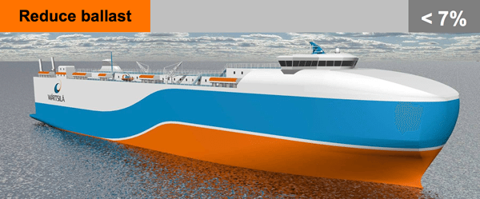
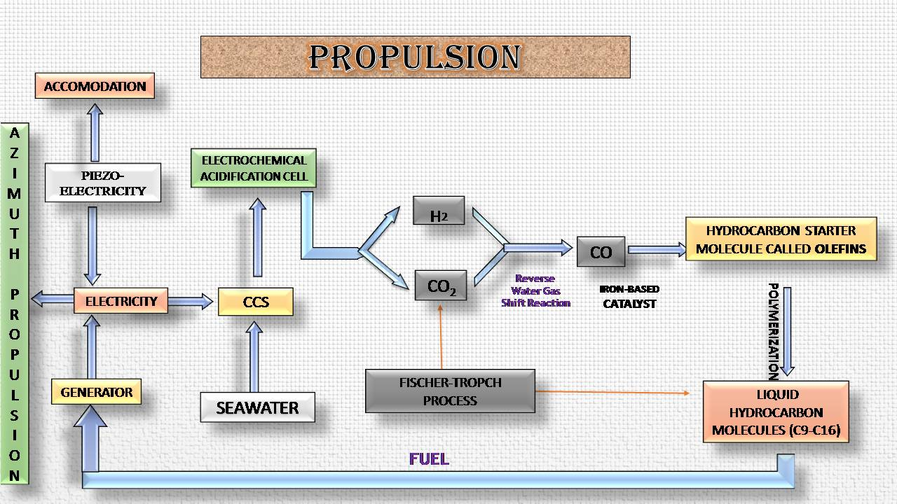
Benefit:-

- High Energy per unit mass and High Thermal thrust.
- Zero emission fuel.
- Less SOX and NOX emission from engine.
- Highly cost-effective.
- CCS technology removes CO2 and LH2 at 92% efficiency.
- Hydrocarbons fuel formed is utilised to run various machines on-board.
- Ships need not stop for refueling during voyages, as a continuous production of fuel takes place on board.
- Azimuth thrusters allow ships to be more maneuverable and enable them to travel backward nearly as efficiently as they can travel forward.
- Greater maneuvrability as 360 degree rotation possible.
- Higher propeller efficiency.
- Low noise and Vibration.
- 9% Better fuel efficiency.
- Transmission losses reduced upto 12-15%.
- Low fuel consumption.
- Side Thruster Eliminated.
- Low maintenance.
- Better use of ship space.
- Tug boat not required for docking.

7. Conclusion

- This paper presents a concept study for the use of Azimuth Propulsion with alternative sources of energy- CCS and Piezo-electricity. The paper puts forward the reasons why such a study is welcomed at this moment. With the vast growth in shipping industry, the fuel consumption has increased manifold. Thus Alternate Eco-Friendly Technologies are the need of the hour and as the proverb goes” Necessity is the Mother of Invention” ,a new coupled technology can be developed in which eternal piezo electricity can be used as power source .
- The Electrical Energy thus produced using piezoelectric concept can be used to meet electric requirement for CCS Plant and accommodation.

8.Acknowledgments

We also extend our sincere thanks to our worthy mentors Mr. T.B.Srinivasan, Mr V Srinivasan for their guidance and support and for putting their precious time and effort for the successful completion of this paper.

9. References

- https://www.bing.com/images/search?q=reduce+ballast+in+ship&view=detailv2&&id=2241BE5E999E5758BFCE2D7EBB00F1A556B3DF65&selectedIndex=23&ccid=UAr8kSKN&simid=608017106653872499&thid=OIP.M500afc91228d14268bbdf3faf2c7d50fo0&ajaxhist=0
- https://www.google.co.in/search?q=azipod+and+azimuth+thrusters+propulsion&oq=azipod+and+azimuth+thrusters+propulsion&gs_l=serp.3...7680.13870.0.14745.15.15.0.0.0.0.172.1240.14j1.15.0....0...1c.1.64.serp..0.14.1137...0i13k1j35i39k1j0i22i30k1j33i21k1j33i160k1.n0ZRo10g80o
- www.asrtro.wku.edu
- www.che.utexas.edu
- www.clean-energy-water-tech.com
- www.slideshare.net
- Why are major advantages & disadvantages of diesel & petrol engines_ - Quora.html
- Energy-Efficient Lighting_ LED & CFL bulb information, including where to buy _ Eartheasy.com.html

