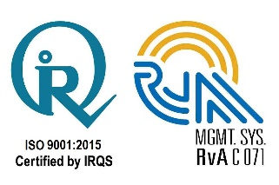
TOLANI MARITIME INSTITUTE
Talegaon-Chakan Road,
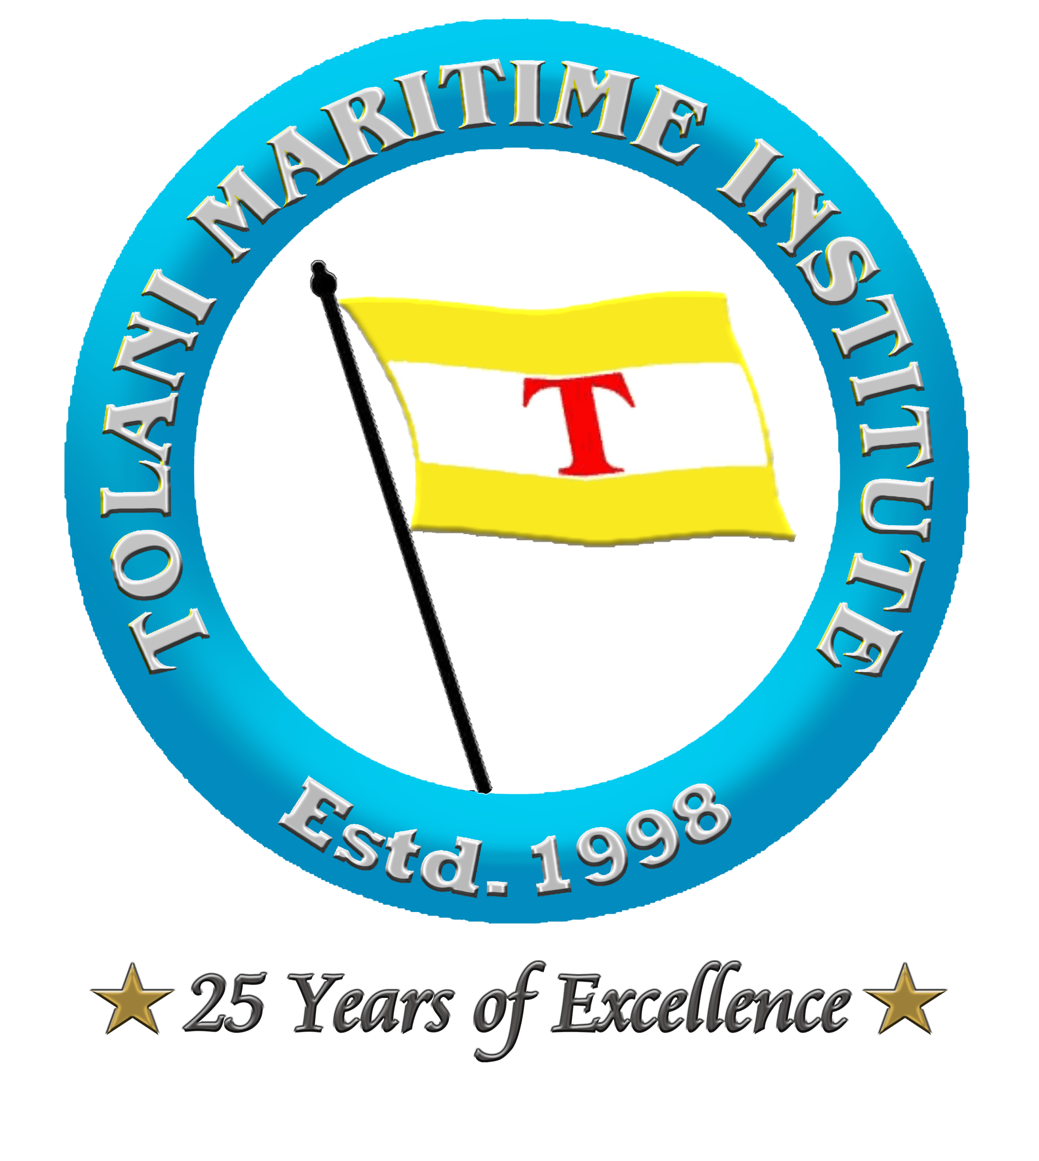
Induri Village, Maval Taluka, Pune 410 507. INDIA
Tel: +91-2114-242000; Fax: +91-2114-242013
Website: www.tolani.edu; Email: info@tmi.tolani.edu

Certificate No: TMI/RW/01-2022/01 Date: 17th November 2022

CERTIFICATE OF PARTICIPATION

This is to certify that Cadet_______________________________________________
TMI Roll No. ______________ From the Batch ______________ has actively participated in the
Book Review Competition
Organized on 17th November 2022 as a part of
“Celebration of National Library Week”

By Learning Resource Centre
in association with
Reading and Writing Club
at
Tolani Maritime Institute

Signature of Candidate Mr. Shailendra Kumar

Vice Principal (ME)

Capt. Manoj Kumar Hirkane Dr. Sanjeet Kanungo

Sr. Vice Principal Principal

Date of Issue: 17th November 2022 Place: Induri, Pune

