ICT (information and communication technology) Innovations for Transport Sector
1) A.D. Joil, MANET,PUNE, akashjoil1995@gmail.com
2) B.G. Gadkari, MANET,PUNE, bhagyeshgadkari08@gmail.com
3) M.N. Soman, MANET, PUNE, mayureshsoman8@gmail.com

ABSTRACT
Transport is a fundamental part of every nation’s economy, allowing people to travel, and ensuring that goods and services are effectively delivered. Across the world, ICT technologies have proved to be crucial to greatly enhance quality of transportation networks and satisfaction of their users. ICT applied to transport infrastructure and vehicles for improved mobility, safety, and sustainability. The manner in which ICT is implemented will be critical for overcoming pressures that are being exerted on transport industry. The purpose of this paper is to enhance mobility while reducing congestion,accidents and pollution which is a challenge common to all major cities.
KEYWORDS
1. ICT- Information and Communication Technology
2. Mobility
3. Sustainability
4. Congestion
5. Pollution

MAIN TEXT

What is ICT?
Information and Communications Technology (ICT) is an umbrella term that includes any communication device or application, encompassing: radio, television, cellular phones, computer and network hardware and software, satellite systems and so on, as well as the various services and applications associated with them such as videoconferencing and distance learning.

OVERVIEW OF THE POTENTIAL OF ICT IN THE TRANSPORTATION SYSTEM
Use of ‘smart cards’ in Hong Kong allows passengers to move seamlessly between different modes of public transport. Connected-Vehicle technology in the US is expected to greatly reduce the likelihood of road accidents. The port sector has also benefited from application of ICT. In order to improve the competitiveness of its ports and promote foreign trade, Philippines used large-scale application of ICT to implement a single window approach which has expedited the passage of goods and commodities through its customs administration. Similarly, in order to reduce congestion at the gates to the port,
Singapore has installed an ICT system called ‘Flow through Gate’ which identifies container trucks, completes the necessary formalities and provides unloading instructions in less than 25 seconds per truck, handling 8,000 trucks a day.
The value of ICT goes beyond just improving transport systems; ICT can also be used to integrate transport systems with other systems resulting in reduced energy use and greater customer satisfaction. For example, South Korea is building a smart city Songdo where all buildings, roads and other infrastructure will be connected with wireless sensors, chips and other communication technologies.
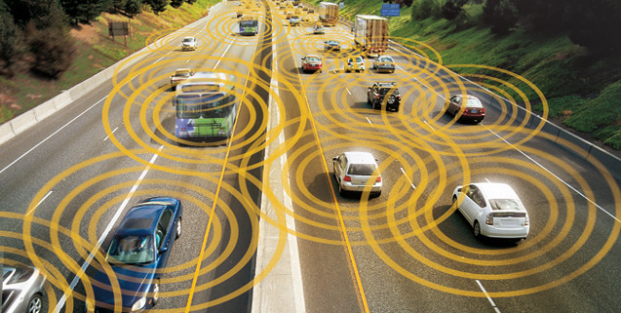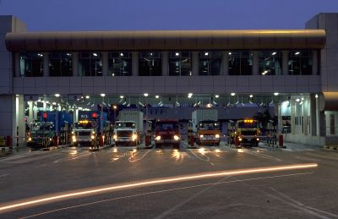
Fig 1. Connected Car Technology Fig 2.Flow through Gate (Singapore Port)
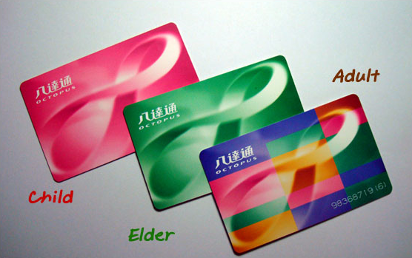
Fig 3.Smart Card in Hong Kong
TECHNOLOGY TRENDS IN THE TRANSPORTATION SECTOR
ICT components and technologies that could be used to improve the transportation system fall into three categories: (a) automation technology (sensors and controllers) which can help in location of vehicles and control of gates at access points; (b) communication technology (e.g., 3G) which can help in receiving and transmitting information to and from vehicles; and (c) information technology (hardware and software systems) which can be built on top of the underlying automation and communication systems to manage traffic, move victims during accidents to nearby medical facilities, plan trips and coordinate transportation systems.

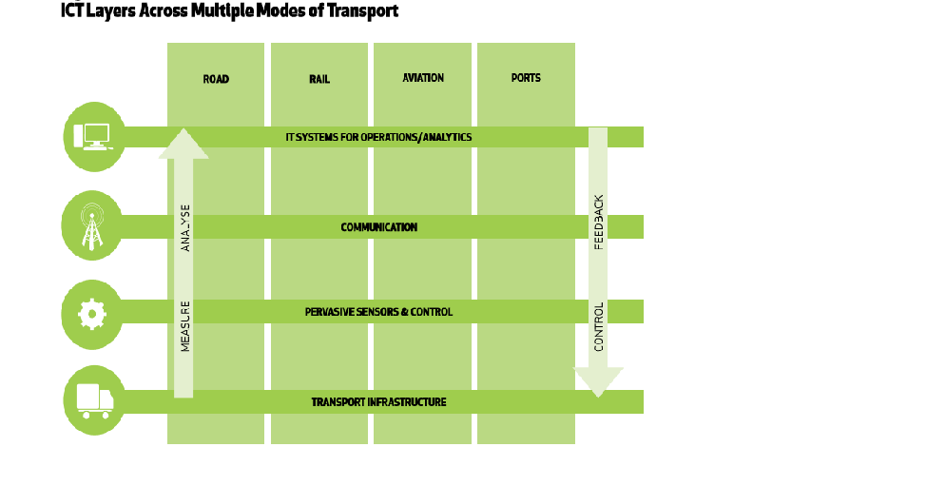
Fig 4. ICT Layers Across Multiple Modes of Transport
These three categories of technologies work together to improve transportation systems as shown in Figure (a).The transport infrastructure at the bottom forms the base for the system and provides a variety of information (data) such as: positions of vehicles, schedules of trains, identities of vehicles crossing check-posts. These data are ‘captured’ by sensors, ‘transmitted’ by communication networks, and ‘analyzed’ by information systems (left side of Figure a). Based on the analysis, the information systems then decide what action is necessary and that action is carried out either by a human being or directly through electronic signals to controllers which carry out the action, such as opening or closing a gate, or providing a warning message to motorists on electronic boards along highways etc. (feedback and control on the right side of Figure a).
A simple example of how these three categories work to enhance customer experience is the ‘Journey Planner’ application provided by Transport for London. This application provides ‘integrated’ solution options for journey planning using multiple modes. It also gives alerts in those options where there is an ongoing issue or planned maintenance activity. This solution is made possible in near real-time through the seamless usage of the three components of digital technology.
Sensors & Controllers
The spectrum of sensors ranges from large and expensive sensing and communication devices like satellites to tiny and inexpensive devices like RFID tags (Figure b).
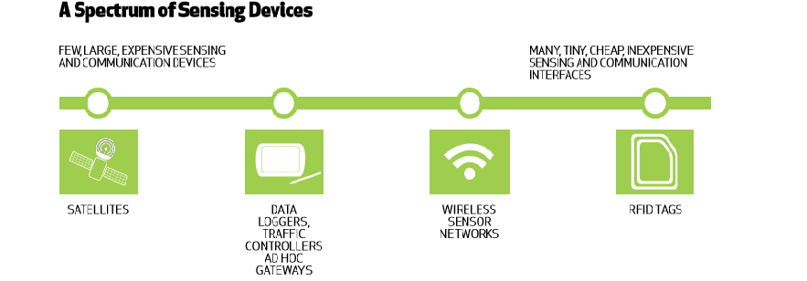
Fig 5.Spectrum of Sensing Device
Satellites have been used for global positioning of vehicles. RFID tags are now commonly used in highway toll booths where the tags can be read by stationary RFID readers.
Wireless sensor networks (WSNs) have huge potential in transportation. WSNs are being used to generate safety warnings to drivers in specific black spots along the roads. These warnings are given based on data gathered in terms of vehicle volumes, speed and direction.
Communication Technology
Some technologies that have been developed for transportation are: vehicle-to-vehicle, vehicle-to infrastructure; and other central level systems to communicate traffic conditions, weather conditions and road conditions. These technologies often are extensions of existing communication technologies such as DSRC (Dedicated Short Range Communication), 4G/LTE (Long-Term Evolution), High-definition radio etc., developed to make transportation efficient and safe.
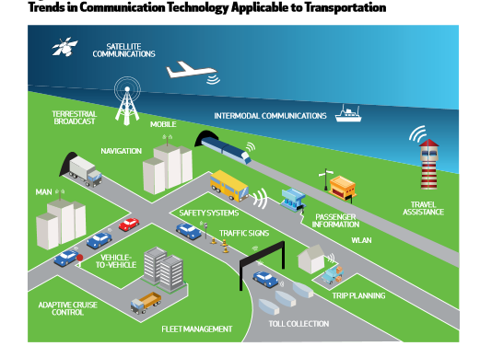
Figure 6. Trends in Communication technology applicable to transportation
As depicted in Figure 6, MAN (Metropolitan Area Network), mobile, satellite communications can be used to manage traffic through receiving information from vehicles (GPS technologies etc.) and providing real-time information to vehicles. Traffic signs can be suitably altered to manage traffic according to real-time requirements. Citizens can make use of communication technologies to appropriately plan their trips.
Information Technology
There are several new developments in software systems that could help improve the transportation sector very significantly.
Cloud Computing
Cloud computing relies on sharing computing resources rather than investing in resources for exclusive use. The sharing is done through the internet, with ‘the cloud’ being used as a metaphor for the internet. Cloud computing has traditionally offered significantly lower upfront capital costs; it also optimizes operational costs through the addition of computing resources on-demand which helps in real-time scaling up as needed. Various software applications in the transportation sector, especially the ones that interface between multiple modes, are well suited to making use of cloud computing.

Social Media/Collaboration/Mobility Application Platforms
The advent of smart phones, social media and mobile internet has resulted in a host of new smart mobile applications.
Some examples:
•Waze:-An application that determines if one is stuck in traffic and alerts friends to take alternative routes.
•Zimride:-An application that connects car poolers together for a one-time ride. It also integrates with the Facebook community to assess safety of travelling with an unknown person.
•Google Transit:-Helps people plan trips using multiple modes of public transportation in more than 425 cities.
ICT ENABLED SYSTEMS
ICT-based systems and services fall into the following four broad categories:
•Inter and intra-vehicle systems, which as the name suggests, are systems within vehicles which help in improving safety and navigation.
•Traffic management systems.
•Transport co-ordination systems which help in multi-modal transport of passengers and freight.
•Traveler or User Information Systems which provide users with real-time information about public transport or freight transport.
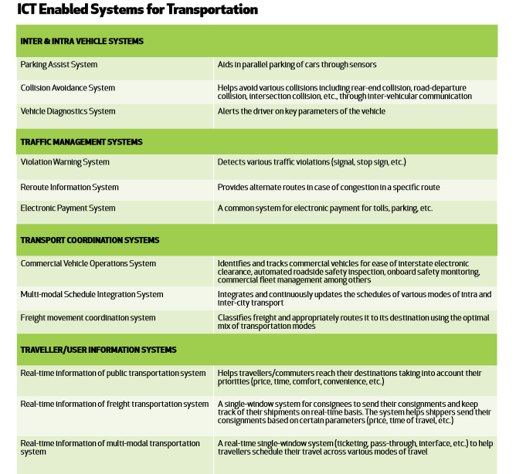
Figure 7. ICT enabled systems for Transportation
FRAMEWORK FOR PRIORITISATION OF INITIATIVES
Clearly, all the ICT-based measures and initiatives described earlier cannot be implemented all at once. How then should they be prioritised? We have developed a framework for prioritisation that groups the various ICT solutions or initiatives into three categories: solutions that need to be implemented in the short term (0-5 years); the medium term (5-10 years); and the long term (10-15 years). The solutions were prioritised by scoring them on four parameters on a scale of 1 to 10:
1. Cost of implementation
2. Time requirement for implementation of the solution
3. Potential benefit expected out of the solution, and
4. Criticality of the initiative or solution to the development of the overall architecture for a sector or for the whole transportation system
ICT FOR ROAD TRANSPORT
There are three areas of the road sector where ICT could play a significant role in mitigating problems: (1) Good quality data to support evidence-based policy-making; (2) Increase in efficiency of the road transport system and satisfaction of its users; and (3) Management of safety and care of the injured.
Good Quality Data
Effective policy making requires good quality data on aspects such as: composition and volume of current traffic; condition of roads and its association with the volume of traffic; and information about vehicles (number, kilometers travelled, level of pollution control). Data is also needed on the condition of roads so that maintenance can be more effective and efficient. More extensive data is required on accidents which include the circumstances of the accidents (location, how or why the accident happened, and number of injuries and fatalities, etc.) so that roads can be designed to be safer and measures taken to reduce the number of accidents. On the requirements for data on public transport, we find that while considerable data is collected on government-owned buses, there is very little data about privately-owned buses even though they provide about 90 per cent of public transport. Similarly, almost no data is available on the movement of freight by road.
ICT will play a pivotal role in filling these data gaps. Detailed studies will be required where sensors and controllers will help gather raw data about number of vehicles, passengers, etc.; communication technologies will be used to transmit the raw data to computer systems, and hardware and software systems will be used to set up the databases. Software programs and data analysis will facilitate drawing of conclusions.

Increasing Efficiency And User Satisfaction
A lack of integration between various transport agencies, both within and between states, leads to inefficiency, delays and poor customer service.
Standardisation Of Toll Payment
Operators of the many toll roads have different methods of payment resulting in long queues at toll booths. In order to increase efficiency and productivity of the toll-based system of payment, the method of toll payments should be standardised.
Safety Management And Care Of The Injured
Indian roads have high levels of accidents and injuries. The treatment of injured persons is extremely slow and ineffective leading to a high level of fatalities. A new safety initiative (post-accident initiative) called ‘Golden Care’ is recommended to reduce fatalities in the event of an accident on National Highways or State Highways. The ‘golden hour’ is a term used in emergency medicine and refers to the time immediately following a traumatic injury, when prompt medical attention is most likely to prevent death. Under the Golden Care Initiative, when an accident occurs, medical care should be provided to the victims within the golden hour. Administrators should ensure that whenever an emergency situation occurs on the highways, victims are rushed to a nearby medical centre within 10 minutes of the accident.
Automation And Computerization Of Inter-State Check Posts (Icps)
Presently, Gujarat and Andhra Pradesh have automated ICPs. This has resulted in 100 per cent checking of vehicles and a fourfold increase in revenue collection. The automation can lead to faster delivery time, fewer opportunities for leakage in revenue and stabilised revenue flows.
ICT FOR PORTS
While the cargo traffic at Indian ports is expected to grow rapidly in the coming two decades, the ports are already stretched to capacity, with the capacity utilisation already close to 100 per cent or higher at many major ports. Low productivity, congestion and delays are the norm at most Indian ports. While increases in capacity at ports will help, ICT can help improve productivity and efficiency at ports.
Smart Cargo
Smart cargo is the next step in automation of maritime operations. Recent developments in RFID and GPS technologies seek to make the cargo intelligent. The containers will have smart tags and will be able to identify themselves to the RFID tag reader providing information on content, origin- destination, etc. They can also have sensors attached to them which will raise alarms in case of unauthorised seal tampering or other unusual conditions like a rise/fall in temperature beyond threshold limits. We can also track the door to door movement of these containers right from the container yard to the delivery point using sophisticated technologies. This will reduce handling time and eliminate risks associated with container security and missing consignments.
Vehicle Traffic Management At Port Gates
Traffic congestion at the port gates is another critical problem area for terminal operators. Mandatory security checks and document verification is required before a truck can enter the port premises. Currently, most of these operations are controlled manually with very little or no automation. In order to manage the expected exponential growth in traffic, technological solutions will be essential for expediting movement of vehicles in and out of port premises without compromising on security and statutory requirements.
The entry and exit of vehicles and drivers through the gates of a container terminal can be automated. An Optical Character Recognition (OCR) system installed at the terminal gates can be used for identifying the tags on a container and vehicle. This information can then be compared with the expected arrival or departure of the vehicle as stored in the port database for authentication. The driver’s biometric identity and his authentication documents could be stored in a ‘smart card’ which he can flash at the counter to gain entry. An automatic barrier and traffic lights system can undertake the required physical control of the gate towards the inner area of the terminal. The yard operations manager would decide on the best possible storage location for the incoming container and pass on the information to the gate operator. At the gate, the operator would be able to identify the allotted location through the GIS system and accordingly provide the truck driver with a printed message showing the exact position or slot within the parking area.
RFID(Radio Frequency Identification)
Another useful application is the Radio Frequency Identification (RFID) technology for monitoring container movements in the yard. RFID provides the ability to automatically collect real-time data about the physical location and properties of any container which has been RFID-tagged. An active RFID system consists of two key components: a tag which is called a transponder, and a reader device, which is referred to as an interrogator. The reader can initiate communication with the tags by sending out a wake-up signal and listening to their response.
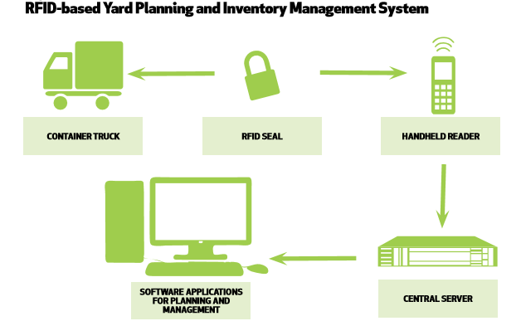
Figure 8. RFID

CONCLUSION
As a result of the deeper integration of ICT into the transport industry, new entry points are created into the industrial structure. The most obvious new entrants are the ICT manufacturers who are now critical parts of the supply chain for automotive manufacturers. ICT can play a role in reducing congestion without building entirely new transport infrastructure, and these solutions will need to be rapidly implemented in society in order to provide cost-effective transport solutions across the world.

“YOU CAN’T UNDERSTAND A CITY WITHOUT USING ITS PUBLIC TRANSPORTATION SYSTEM”

REFERENCES
1) https://en.m.wikipedia.org/wiki/Information_and_communication_technology
2)https://en.m.wikibooks.org/wiki/Transportaion_Deployment_Casebook/2014/Octopus_Card_System_in_Hong_Kong
3) www.certusportautomation.com/gate-operation.html
4) www.equipmentworld.com/usdot-announces-42-million-for-next-gen-connected-vehicles-and-infrastructure-technology/
5) NATIONAL TRANSPORT DEVELOPMENT POLICY COMMITTEE | 2013

