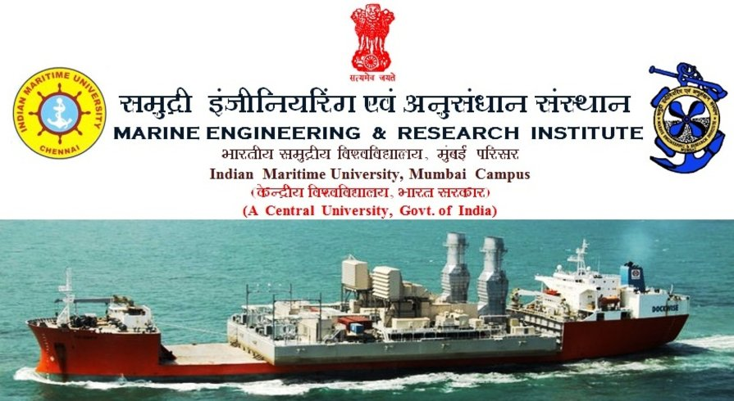
TRANSTECH 2013

Main Theme

Advancement in Technologies for Sustainable Development

Sub Theme

Conservation of Environment

BY: CADET ANUBHAV KUMAR (BSC-224)
Shipping is the most economical and viable means of import and export of goods. The shipping in -dustry’s greatest challenge will be to quickly and efficiently retrofit the existing cargo fleet in order to rapidly reduce the emission of climate-damaging greenhouse gases.
Following are the advancement in technologies that not only conserve environment but also enhance efficiency of ships:-
- ALTERNATIVE FUELS FOR SHIPPING:-
- NATURAL GAS: Using cryogenically stored LNG as a marine fuel we not only remove SO_{X} completely but also remove possibility of particulate matter along with 80-90% reduction in NO_{x}, 20% reduction in CO₂ . PRISMATIC CRYOGENIC methods can be deployed to solve some of the short comes of this fuel.

- BIO FUELS: Unlike their first generation counterparts, second and third generation biodiesels offer the potential for a realistic and sustainable alternative, and supplement, to conventional marine fuel oils. Third generation biofuels offer the prospect of large-scale production of carbon neutral fuels using land and water, totally unsuitable for crop, plant or food production.

These are the renewable liquid or gaseous fuels made by and/or from living organisms or the wastes that they produce.
Microbes play a crucial role in the production of sustainable biofuels
WHY DO WE NEED BIOFUELS?
Sustainable biofuels are essential to ensure a constant, secure supply of energy for individuals and industry. Advanced biofuels will reduce our dependency on fossil fuels and limit our impact on the environment. It is also argued that investing in biofuel production may boost the economy of developing countries
CURRENT BIOFUELS
Bioethanol and biodiesel are the two main types of biofuel that are currently commercially produced. These can replace, or be used in combination with, petrol, diesel and aviation kerosene as transport fuels. Biodiesel is currently produced by extracting the oil from crops such as soybean (USA), oilseed rape and oil palm (Europe), and converting it to biodiesel. Bioethanol is produced from sugar beet, sugar cane and corn. The sugars are fermented to ethanol by the micro-organism yeast. Biofuels that are produced from edible crops are called traditional, or ‘first-generation’ biofuels. These biofuels are considered to be less sustainable than more advanced biofuels, as the feed stocks they use represent energy that can be used by humans or other animals.

NEW APPROACHES TO BIOFUELS
‘Second-’ and ‘third-generation’ biofuels are generated from non-food crops. Microbes play a key role in the development of these biofuels. They are more sustainable than first-generation biofuels as they produce higher yields, reduce greenhouse gas production and do not compete with crops grown for food. Two major areas of research are lignocellulosic biofuels and algae.

LIGNOCELLULOSIC BIOFUELS
Lignocellulosic biofuels are produced through the breakdown of carbohydrates (celluloses) locked in the cell walls of plants, which can then be fermented by yeast or other micro-organisms.

Lignocellulosic biomass makes up about half of the total biomass in the world and represents the non-edible parts of crops such as stalks, chaff, sawdust and wood chip. Approximately 430 million tons of plant waste is produced from farmland each year, which could be recycled in biofuel production. Lignocellulose is designed to be strong and resistant to degradation. This means it is very difficult to release it from the cell walls and to break down the celluloses into sugars for microbial fermentation.

Microbiologists are working to find microbes that produce an enzyme complex called cellulase that breaks down celluloses into sugars. Microbes that naturally produce cellulase have been identified in diverse environments such as the stomachs of cows and termites and in volcanic soil. Microbiologists are using genetic techniques to improve the production of cellulase in two ways; by improving the yields from cellulase-producing microbes or by transferring microbial cellulase genes into standard strains of bacteria used in industry, to enable large-scale production of cellulase.

Once the celluloses are broken down, the sugars can be fermented by yeast or other micro-organisms. New strains have been identified that are suitable for fermentation in industry; for example, heat-loving (thermophilic) bacteria that can ferment sugars into ethanol very efficiently at high temperatures, making the process more cost-effective.

If lignocellulose in cell walls can be released and converted to ethanol efficiently, bioethanol could eventually be commercially produced from wood, straw and waste materials. If all cell wall sugars were readily accessible to fermenting microbes, 5 kg of wood could theoretically produce up to 2.5 litres of ethanol.

ALGAE
Algae are a diverse group of photosynthetic micro-organisms. They use the energy from sunlight and carbon dioxide to produce biomass including oil, which can be converted into biodiesel.

Algal-based biofuels have several advantages. Microalgae have the potential to produce up to 100 times more oil per acre than any terrestrial plant. Also, algae do not compete with food crops for land as they can be grown on non-productive, non-arable land using a variety of water sources. The development of algal biofuels is at an experimental stage and production is currently very costly due to a limited knowledge of scale-up possibilities.
At present, industrial-scale production of biodiesel from algae costs at least 10–30 times more than making traditional biofuels. Algal biofuels can also be produced by processing algal biomass. This is similar to lignocellulosic processing, where the end product is sugars that can be fermented to alcohol by microbes.

CURRENT RESEARCH
Microbiologists are currently working in a number of areas to make biofuel production more efficient. These include:
– Scaling-up the production of microbial cellulase that will break down celluloses into fermentable sugars.
– Engineering yeast to tolerate higher concentrations of alcohol to increase bioethanol production.
– Genetically modifying micro-organisms to ferment sugars more efficiently to increase bioethanol yields.
– Optimizing microbial strains that will convert sugars into biobutanol as an alternative to bioethanol.
– Finding algae that produce high yields of oils or are otherwise well-adapted for biodiesel production

- HYDROGEN:

In the longer term hydrogen would appear to be the ultimate clean fuel or more accurately ‘energy carrier’. If used to supply fuel cell generators, there is a prospect of true zero emission power generation (no Sox, NOx, CO2 or PM [particulate matter]) with extremely high electrical efficiency (60–70%).

Fuel cells generate power quietly and efficiently without pollution. Unlike the conventional sources of energy the by products are water and heat. It is basically an electrochemical energy conversion devise. It converts the hydrogen and oxygen into water and produces electricity in the process. They provide great potential for use on board ships.

Possible fields of application on merchant ships and naval ships:
- Emergency power supply
- Electric energy generation
- Power output for propulsion
- Electric power generation for ship’s network

In addition fuel cell has special importance for realizing air independent propulsion(AIP) on submarines. The favorites are PEMFC (proton exchange membrane fuel cell) because of their simplicity and working temperature ranges.

In this type of fuel cell, the membrane must be hydrated, requiring water to be evaporated at precisely the same rate that it is produced. If water is evaporated too quickly, the membrane dries, resistance across it increases, and eventually it will crack, creating a gas "short circuit" where hydrogen and oxygen combine directly, generating heat that will damage the fuel cell. If the water is evaporated too slowly, the electrodes will flood, preventing the reactants from reaching the catalyst and stopping the reaction.

Aboard ship, fuel cell system Could replace the diesel generators when docked in port. When the battery banks cannot obtain power from FC, they will be charged directly from shore power and The vessel’s AC bus is energized. It is likely that a FC installation on board will be employed to provide propulsion or auxiliary power for cruise ships, power barges, ferry boats, offshore supply boats, tow boats, oceangoing tug, submersibles, refrigerated containers on containerships, offshore oil platforms, and underwater facilities. Some of these possible applications may be technically feasible and cost effective in a decade or so.
A typical fuel cell plant layout is as follows:
The plant basically consists of the following major components: refer above figure
- Oxygen storage cylinders
- Hydrogen storage cylinders
- Fuel cell modules
- Control panel
- Dc to ac converters
- Reaction water tanks

BASICS OF A FUEL CELL
The pressurized hydrogen gas (H2) enters the fuel cell on the anode side. This gas is forced through the catalyst by the pressure. When an H2 molecule comes in contact with the platinum on the catalyst, it splits into two H+ ions and two electrons (e-).

The electrons are conducted through the anode, where they make their way through the external circuit (doing useful work such as turning a motor) and return to the cathode side of the fuel cell. Meanwhile, on the cathode side of the fuel cell, oxygen gas (O2) is being forced through the catalyst, where it forms two oxygen atoms. Each of these atoms has a strong negative charge. This negative charge attracts the two H+ ions through the membrane, where they combine with an oxygen atom and two of the electrons from the external circuit to form a water molecule (H2O).
Figure 2
Chemistry of a Fuel Cell
Anode side:
2H2 => 4H+ + 4e-
Cathode side:
O2 + 4H+ + 4e- => 2H2O
Net reaction:
2H2 + O2 => 2H2O

- AIR CAVITY SHIPS:

Developments of air cavity ships leads to reduction in resistance and hence increase in fuel efficiency (15-20%) , thereby reducing emissions of harmful gases like SO_{X,} NO_{X ,} CO₂ etc. and hence are environmental contributing. It has additional benefits like reducing overload in rough seas through dampening effect , fouling growth is reduced etc.

Principle:
The basic principle of air cavity hull is to form a layer of air between the hull surface and water surface and hence thereby reducing the drag. ACHs use the same basic principle as super cavitating torpedoes, in that an object or hull encased in a bubble of air can slip through water much more easily than a hull slicing the water directly. Most drag in water is caused by friction created by the hull and water.

Air has less than 1% the viscosity of water, so it basically "lubricates" the ship as it moves through the thicker medium, allowing much easier passage. But where super cavitating torpedoes completely encase the torpedo, an ACH uses a broad cavity filled with compressed air to allow a large percentage of a ship’s subsurface hull to glide through the water with less resistance. This produces less drag and increases fuel efficiency.

Construction:
- Its construction is quiet simple.
- About 20% of the bow is arranged as conventional semi-planing /planing hulls,hence good sea keeping ability is assured .

- A cavity chamber is created by arranging a step behind the bow part and a longitudinal channel with deeper hull section on the sides.
- The stern part of the air cavity chamber is inclined downwards forming a planing surface.
- This surface is in contact with water to reduce air escape from the cavity.

Working:
- A compressor near the bow would draw in air from the deck and pump it into the subsurface cavity.
- Air would build up in the cavity under pressure, giving the vessel a large swath of its ‘hull’ that produces far less drag than the rest.
- Air would also slowly seep away along the sides and the stern of the cavity, but under most circumstances can be readily replaced by the compressor to maintain optimal pressure.
- Tests have shown that the compressor would use about one percent of the ship’s available power, which is more than made up for in the increased engine efficiency the air cavity hull provides.
Economic impacts of air cavity technology:
- It reduces the fuel oil consumption .Ship owners would save between $0.5m and $3m per year in bunker fuel costs.
- It is being stated that for a 300,000 DWT VLCC annual savings would be approximately DKK 3.5 millions.
- With a predicted annual average growth of the world economy of 2.8%, the cost of a barrel of oil is expected to rise to $120 a barrel by 2030; equivalent to bunker fuel costs in excess of $600 per metric tonne.
Hence cost savings would increase incrementally throughout the life span of vessel.
- The most exciting and economic feature of this technology is that existing vessels can also be retrofitted with this technology and that also with just an investment of 2-3% of the cost of a new vessel.
- This technology has an average fuel cost payback of under two years at current bunker fuel prices, with some ship classes achieving substantially better payback periods.
- In today’s world time is everything, keeping this thing in mind this technology can be installed in any vessel within 2 weeks.

Advantages:
- According to DK group , their test vessel showed a 7% increase in fuel efficiency with air cavity hull installed in it.
- Emissions of harmful gases such as CO, SOx, NOx are reduced.Substantial reduction in resistance is observed i.e. upto 20%.
- Overloads in rough seas are reduced due to a damping effect of the air cavity.
- Fouling growth on the hull in warm seas is lessened due to decreased wetted surface.
- ACS is a convenient platform for effective landing and shallow-water operations.
- CO2 emissions are reduced by 6000 tonnes per year.
Disadvantages:
- Low directional stability.
- Not effective during extreme manoeuvres.
- Smaller fuel saving when traveling in large waves.
- Smaller savings with relatively lower speeds.
- Chances of corrosion.

Conclusion:
- A simplified air cavity form can be created from a conventional planning form with a low resistance penalty.
- Wave pattern resistance is also reduced by using air supply which causes pressure field changes due to air film .Penalty was 10% at low speeds ,dropping down to 2%.
- Wave pattern resistance reduction is small as compared to viscous resistance reduction. Air can be supplied only to maintain the air film and replenish it.
- Further research is required to establish optimized hull forms.
- The forming of air cavity is related to the ship velocity, pressure in the air cavity and geometric size and shape of the groove.
- Most important of all, air cavity system when fully developed would reduce the fuel consumption to a lot and hence would make transportation more economically viable.
- This would be the most successful technology in history of shipping to decrease the fuel consumption to highest i.e. around 15-20% after full research and development of this technology.

- BALLAST FREE SHIPS: The new ship concept that will essentially eliminate the trans oceanic transport of non-invasive species through ballast water and hence conserve marine environment for indigenious species.

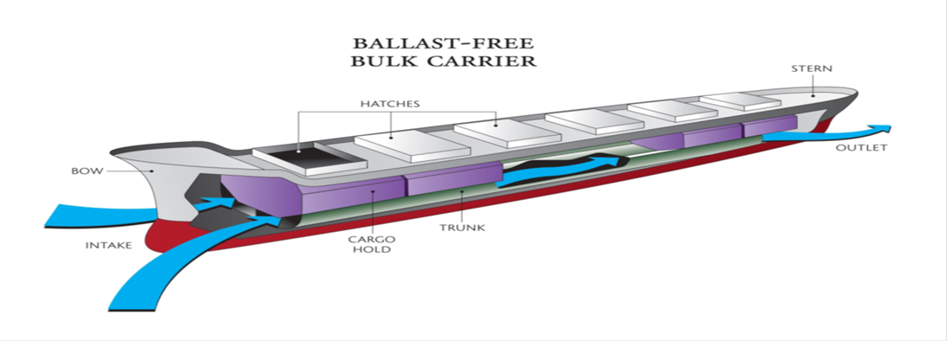

BALLAST-FREE SHIP CONCEPT
Question from biologists/ecologists is:
“Why not just eliminate the use of water ballast?”

Response:
“Water ballast is necessary in the light cargo condition to ensure:
– Transverse stability
– Bow submergence
– Propeller submergence
– Reduce wind age for adequate maneuverability …”

CONCEPT ADVANTAGES:
– Eliminates the need for costly ballast water treatment equipment.
– Effective approach even for transport of biota smaller than 50 Microns; e.g. Vibrio cholera

CONCEPT DEVELOPMENT REQUIREMENTS:
– Prove feasibility of concept (CFD studies of available pressure differential, trunk flow development, effect of waves).
– Investigate resistance and propulsion impacts (model tests).
– Re-design the internal structure to implement the concept and ensure structural strength adequacy.
– Assess intact stability, probabilistic damage stability and sea keeping performance.
– Evaluate economic feasibility.
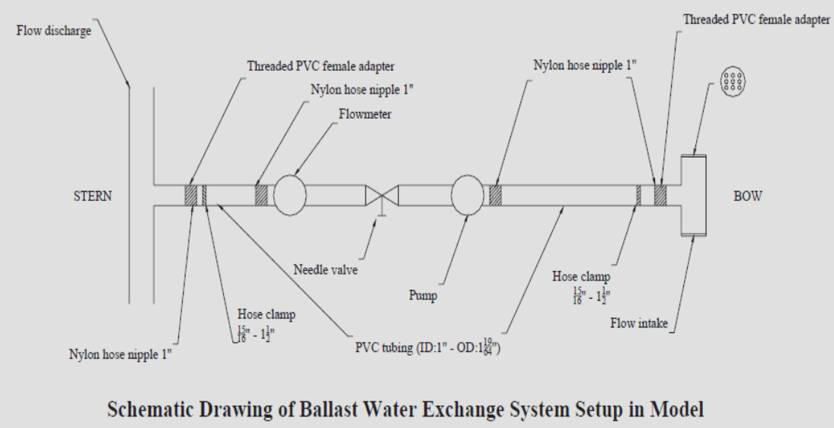 Impact of Ballast Free ship Concept
- The Ballast-Free Ship concept essentially eliminates the transport of Foreign ballast water.
- Provides a viable alternative to ballast water treatment systems and Ballast exchange; and should be equally effective even with stricter requirements.
- Hydrodynamic optimization should eliminate most of the added power Penalty.
- This should be a cost effective alternative (DRFR < 0) to filtration.

- LATEST SCRUBBING TECHNOLOGY:
Using recently generated closed loop scrubber with “CAUSTIC SODA” i.e. NaOH and open loop scrubber system (hybrid scrubber) that can utilize sea water as well as fresh water greatly suppress SOx , NOx and other harmful effluent from exhaust gases.
How Selective Catalytic Reduction Technology Works:-
SCR technology is designed to permit nitrogen oxide (NOx) reduction reactions to take place in an oxidizing atmosphere. It is called "selective" because it reduces levels of NOx using ammonia as a reductant within a catalyst system.
The reducing agent reacts with NOx to convert the pollutants into nitrogen, water and tiny amounts of carbon dioxide (CO2) - natural elements common to the air we breathe everyday. The reductant source is usually automotive-grade urea, otherwise known as Diesel Exhaust Fluid, which can be rapidly hydrolyzed to produce the oxidizing ammonia in the exhaust stream. SCR technology alone can achieve NOx reductions in excess of 90%.
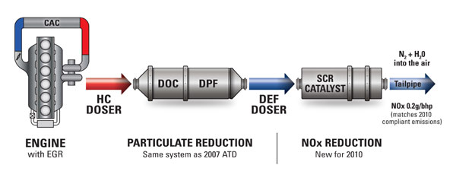
- SKY SAILS:
Sky Sails is offering world’s most attractive technology that contributes both to cutting ship operating costs and significantly reducing ship emissions (by 10-35%) at the same time. Using “Dynamic flight maneuvers” sky sails generates 5 to 25 times more power as compared to conventional sails.

The kite is controlled by computers. One computer helps it to fly in figures of eight in the sky - maximising the power it produces. Another computer adjusts the kite’s direction. If the project is successful, expect to see even bigger kites soon - some up to 5,000sq m (53,820sq ft) in size pulling ships across the seas and oceans.

6.HYBRID PROPULSION SYSTEM:
It is the advanced concept of utilizing mostly all innovative technology simultaneously like kite sailing, solar panel aid ,fuel cell technology , batteries for generating power , dual fuel engine etc. on one ship thus achieving maximum efficiency and conserve environment to the maximum extent.

Concept vessel E/S ORCELLE is developed by WALLENIUS WILHELMSEN LOGISTICS (WW). The conceptual work started in 2004 and WW envisages a service date of 2025. The design of the E/S ORCELLE is based on the utilisation of energy from renewable resources. WW is working on the technologies that need to make this concept a reality in the next 16 years. The commitment to protect the environment made E/S ORCELLE the future vision of WW , as they are looking forward to make
an environment friendly ocean transport industry.

This concept vessel does not release any emissions into the atmosphere or into the ocean. It uses renewable energy resources: wind, solar and waves as well as, fuel cells to generate the energy required to power the vessel. Its highly advanced design provides optimum cargo capacity to transport cars and other goods around the world more efficiently.

Developed as a versatile vessel, it has a cargo deck stowage area of 85,000 sq m having a capacity to carry 10,000 cars. This is almost 35% more than today’s car carrier having an average capacity of 6,500 vehicles. To support this capacity of 10,000 automobiles, it has 8 decks out of which 3 are adjustable to accommodate cargo of different heights and weights. Moreover, its PENTAMARAN hull structure and utilisation of energy from renewable resources adds to it optimisation of cargo carrying capacity. E/S ORCELLE has a maximum deadweight capacity of 13,000 tons and weighs 21,000 tons, much like today’s car carriers. Owing to the use of light weight materials in its construction and the elimination of ballast water, it is capable of carrying 3000 more tons of cargo.

