TITLE: - SMART MATERIALS FOR SMART FUTURE:

BUCKYPAPER
AUTHORS:-
INSTITUTE: - MANGALORE MARINE COLLEGE
- Cdt. Abhinav Yadav Godha (GME)
Contact no: - 8152072577
E-mail id: - abhi.aryan306@gmail.com
- Cdt. Devprasad Ojha (GME)
Contact no: - 8152073379
E-mail id: - devprasadojha@gmail.com

ABSTRACT
Bucky paper is a thin sheet made from an aggregate of carbon nanotube. The nanotubes are approximately 50,000 times thinner than a human hair. Originally, it was fabricated as a way to handle carbon nanotubes, but it is also being studied and developed into applications by several research groups, showing promise as vehicle armor, personal armor, and next-generation electronics and displays.
Buckypaper is a macroscopic aggregate of carbon nanotubes (CNT), or "buckytubes". It owes its name to the buckminsterfullerene, the 60 carbon fullerene (an allotrope of carbon with similar bonding that is sometimes referred to as a "Buckyball" in honor of R. Buckminster Fuller).
Buckypaper is one tenth the weight yet potentially 500 times stronger than steel when its sheets are stacked to form a composite. It could disperse heat like brass or steel and it could conduct electricity like copper or silicon.
In particular, owing to their extraordinary thermal conductivity and mechanical and electrical properties, carbon nanotubes find applications as additives to various structural materials. For instance, nanotubes form a tiny portion of the material(s) in some (primarily carbon fiber) baseball bats, golf clubs, or car parts.
Since individual carbon nanotubes are one of the most thermally conductive materials known, buckypaper lends itself to the development of heat sinks that would allow computers and other electronic equipment to disperse heat more efficiently than is currently possible. This, in turn, could lead to even greater advances in electronic miniaturization.
As a smart material for smart future, Bucky paper can be used in many revolutionary fields like Automobile, Aerospace, Electronics, Medical, Industrial purposes etc.
Keywords: Nanotechnology, buckypaper, nanotubes.

INTRODUCTION
Nanotechnology (sometimes shortened to "nanotech") is the manipulation of matter on an atomic and molecular scale. The earliest, widespread description of nanotechnology referred to the particular technological goal of precisely manipulating atoms and molecules for fabrication of macroscale products, also now referred to as molecular nanotechnology. A more generalized description of nanotechnology was subsequently established by the National Nanotechnology Initiative, which defines nanotechnology as the manipulation of matter with at least one dimension sized from 1 to 100 nanometers. This definition reflects the fact that quantum mechanical effects are important at this quantum-realm scale, and so the definition shifted from a particular technological goal to a research category inclusive of all types of research and technologies that deal with the special properties of matter that occur below the given size threshold. It is therefore common to see the plural form "nanotechnologies" as well as "nanoscale technologies" to refer to the broad range of research and applications whose common trait is size. Because of the variety of potential applications (including industrial and military), governments have invested billions of dollars in nanotechnology research. Through its National Nanotechnology Initiative, the USA has invested 3.7 billion dollars. The European Union has invested 1.2 billion and Japan 750 million dollars.
Nanotechnology as defined by size is naturally very broad, including fields of science as diverse as surface science, organic chemistry, molecular biology, semiconductor physics, micro fabrication, etc. The associated research and applications are equally diverse, ranging from extensions of conventional device physics to completely new approaches based upon molecular self-assembly, from developing new materials with dimensions on the nanoscale to direct control of matter on the atomic scale.
Scientists currently debate the future implications of nanotechnology. Nanotechnology may be able to create many new materials and devices with a vast range of applications, such as in medicine, electronics, biomaterials and energy production. On the other hand, nanotechnology raises many of the same issues as any new technology, including concerns about the toxicity and environmental impact of nanomaterials, and their potential effects on global economics, as well as speculation about various doomsday scenarios. These concerns have led to a debate among advocacy groups and governments on whether special regulation of nanotechnology is warranted.
Buckypaper is a thin sheet made from an aggregate of carbon nanotubes. The nanotubes are approximately 50,000 times thinner than a human hair. Originally, it was fabricated as a way to handle carbon nanotubes, but it is also being studied and developed into applications by several research groups, showing promise as vehicle armor, personal armor, and next-generation electronics and displays.

HISTORY
Buckminsterfullerene (or Bucky-ball) is a spherical fullerene molecule with the formula C₆₀. It has a cage-like fused-ring structure (truncated icosahedron) which resembles a soccer ball, made of twenty hexagons and twelve pentagons, with a carbon atom at each vertex of each polygon and a bond along each polygon edge.
Theoretical predictions of buckyball molecules appeared in the late 1960s – early 1970s, but they went largely unnoticed. In the early 1970s, the chemistry of unsaturated carbon configurations was studied by a group at the University of Sussex, led by Harry Kroto and David Walton. In the 1980s a technique was developed by Richard Smalley and Bob Curl at Rice University, Texas to isolate these substances. They used laser vaporization of a suitable target to produce clusters of atoms. Kroto realized that by using a graphite target, any carbon chains formed could be studied. Another interesting fact is that at the same time astrophysicts were working along with spectroscopists to study infrared emissions from giant red carbon stars.Smalley and team were able to use laser vaporization technique to create carbon clusters which could potentially emit an infrared of same wavelength as been emitted by the red carbon star.Hence the inspiration came to Smalley and team to use the laser technique on graphite to create the first fullerene molecule.
C₆₀ was discovered in 1985 by Robert Curl, Harold Kroto and Richard Smalley. Using laser evaporation of graphite they found C_{n} clusters (where n>20 and even) of which the most common were C₆₀ and C₇₀. The figure below shows the model of the pulsed supersonic nozzle used to create the carbon cluster beams. A solid rotating graphite disk was used as the surface from which carbon was vaporized using a laser beam creating hot plasma that was then passed through a stream of high-density helium gas. The carbon species were subsequently cooled and ionized resulting in the formation of clusters. Clusters ranged in molecular masses but Kroto and Smalley found predominance in C60 cluster that could be enhanced further by letting the plasma to react for longer. [3, 6] They also discovered that the C60 molecule formed a cage like structure, a regular truncated icosahedron.
For this discovery they were awarded the 1996 Nobel Prize in Chemistry. The discovery of buckyballs was surprising, as the scientists aimed the experiment at producing carbon plasmas to replicate and characterize unidentified interstellar matter. Mass spectrometry analysis of the product indicated the formation of spheroidal carbon molecules.
The experimental evidence, a strong peak at 720 atomic mass units, indicated that a carbon molecule with 60 carbon atoms was forming, but provided no structural information. The research group concluded after reactivity experiments, that the most likely structure was a spheroidal molecule. The idea was quickly rationalized as the basis of an icosahedral symmetry closed cage structure. Kroto mentioned geodesic dome structures of the noted futurist and inventor Buckminster Fuller as influences in the naming of this particular substance as buckminsterfullerene.
What is buckypaper? 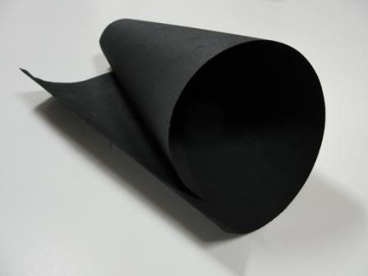
- A novel easy-to-handle thin film formed using carbon nanotubes or fibers
- Composed of single-walled, multi-walled carbon nanotubes or carbon nanofibers that undergo a repeatable and scalable manufacturing process
- Extremely thin (~25 microns) and lightweight (areal density: 0.0705 oz/ft²)
- Thermally conductive
- Electrically conductive
- High mechanical strength and modulus
- High strain rate
- Highly efficient field emission
- Self-actuation
TYPES OF BUCKYPAPER:-
- Single-Walled Carbon Nanotube Buckypaper (SBP) 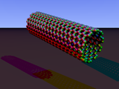
- Strongest fiber that's ever been made (250x stronger than steel, yet 10x lighter)
- Electrical conductivity of copper or silicon
- Thermal conductivity higher than diamond
- First discovered by Nobel Laureates Bob Curl, Harry Kroto and Richard Smalley
- Key problems are price and the difficulty of working with them.

- Multi-Walled Carbon Nanotube Buckypaper (MBP)
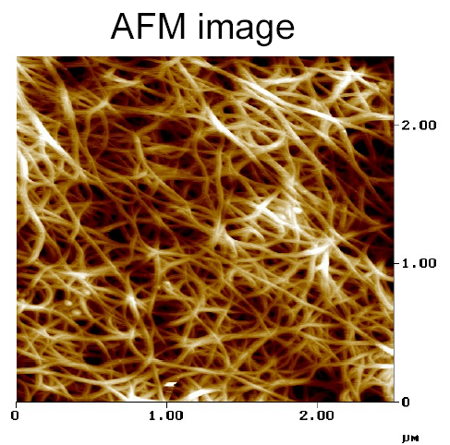
- It combines SWNTs with low-cost multi-walled nanotubes (MWNTs) or carbon nanofibers (CNFs) to retain most of the excellent properties of SBP while significantly reducing the cost.
- Double-walled carbon nanotubes (DWNT) form a special class of nanotubes because their morphology and properties are similar to those of SWNT but their resistance to chemicals is significantly improved. This is especially important when functionalization is required (this means grafting of chemical functions at the surface of the nanotubes) to add new properties to the CNT.

How buckypaper is made?
NanoLab prepares Buckypaper, a sheet form of our carbon nanotubes, in various sizes and thickness for your research and development needs. Buckypaper is made from our 95% purity multiwall carbon nanotubes, and can be made from our single-wall or double-wall nanotubes on request.
Preparation:
To prepare Buckypaper, our carbon nanotubes are suspended in water, using our NanoSperse AQ surfactant. We then filter the suspension onto a membrane support. After drying, the paper is removed from the support, leaving a free-standing paper. Details are below.
Porosity & flow:
Standard Buckypaper is ~50% dense, and can be tailored for particular applications. Our testing shows that standard Buckypaper excludes the passage of colloidal particles ~50nm and larger.
Electrical:
The resistance of Buckypaper was measured by sputtering gold contacts on a strip of nanotube paper with dimensions 3.3mm wide by 0.13mm thick. The two point resistance measured over a 7.8mm gap was ~18ohms. The resistivity of the paper is ~ 0.1 ohm-cm.
Mechanical:
Buckypaper can be folded, cut with scissors, like notebook paper. We have investigated its mechanical properties after infiltrating the paper with epoxy base matrix phases.
Usage:
Electrochemical electrodes, filters, scaffolds, cell culturing, composite.
Catalog# | CNP40 | CNP125 | CNP175x 225
Shape | Disc | disc | rectangle
Size | D40 mm | D125 mm | 175mm x 225mm
Price | $200.00 | $1000 | $1500

Thickness = ~ 0.1mm ± 0.05mm
Density = 0.5g/cm³
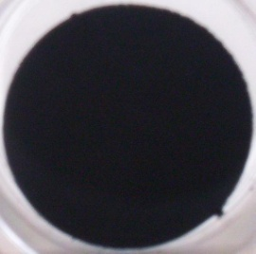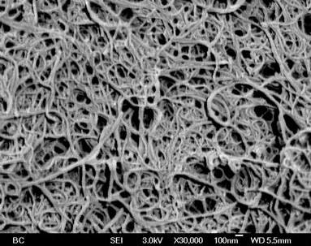

Preparation:
In 2002, NanoLab developed our process for the production of freestanding carbon nanotube paper, a.k.a. "buckypaper." Using our process, we can make buckypapers from MWNT, DWNT and SWNT. To make the carbon nanotubes amenable to aqueous processing, they need to be first purified. Purification of our carbon nanotubes takes place in hydrochloric acid (HCl) to dissolve residual catalyst iron particles. Once the nanotubes have been acid treated and washed with DI water, they are resuspeded in deionized water, using our Nanosperse AQ surfactant. After sonication, we obtain a nanotube suspension that is stable for months at a time without settling. A volume of this suspension is poured into a filtration unit. Both vacuum based and pressurized filtration units can be used to pull/push the suspension through the filter membrane. Nanotubes deposit on the filter surface, and this rapidly turns into a continuous nanotube sheet. The volume of suspension and its concentration dictates the resulting thickness of the paper. After deposition, the nanotube paper is removed from the supporting filter membrane, leaving a free-standing paper, as large as 8 X 10”. Other standard sizes are 40 mm and 125 mm diameter. Free-standing papers are typically ~100 microns or more in thickness. Thin papers (<20 micron) are difficult to remove from the filter support, although binders or very long (>50 micron) carbon nanotubes make thinner free-standing papers possible.
The process makes a porous buckypaper that can be tailored by changing the deposition parameters. Our typical MWNT buckypaper product is ~50% dense, and the replacement of the water base for ethanol results in lower density ~25%. Despite the low density of these ethanol-based papers, our testing shows that they exclude the passage of colloidal particles ~50nm and larger.
APPLICATIONS
Among the possible uses for buckypaper that are being researched:

- Fire protection: covering material with a thin layer of buckypaper significantly improves its fire resistance due to the efficient reflection of heat by the dense, compact layer of carbon nanotubes or carbon fibers.
- If exposed to an electric charge, buckypaper could be used to illuminate computer and television screens. It could be more energy-efficient, lighter, and could allow for a more uniform level of brightness than current cathode ray tube (CRT) and liquid crystal display (LCD) technology.
- Since individual carbon nanotubes are one of the most thermally conductive materials known, buckypaper lends itself to the development of heat sinks that would allow computers and other electronic equipment to disperse heat more efficiently than is currently possible. This, in turn, could lead to even greater advances in electronic miniaturization.
- Films also could protect electronic circuits and devices within airplanes from electromagnetic interference, which can damage equipment and alter settings. Similarly, such films could allow military aircraft to shield their electromagnetic "signatures", which can be detected via radar.
- Buckypaper could act as a filter membrane to trap micro particles in air or fluid. Because the nanotubes in buckypaper are insoluble and can be functionalized with a variety of functional groups, they can selectively remove compounds or can act as a sensor.
- Produced in high enough quantities and at an economically viable price, buckypaper composites could serve as effective armor plating.
- Buckypaper can be used to grow biological tissue, such as nerve cells. Buckypaper can be electrified or functionalized to encourage growth of specific types of cells.
- The Poisson's ratio for carbon nanotube buckypaper can be controlled and has exhibited auxetic behavior, capable of use as artificial muscles.
PROPERTIES
Avg. thickness = 15-250micron(Multi-walled)
Color: Black
Odor: Odorless
Decomposition temperature:~565ºC
Density: at 20 ° C ~ 0.3-0.4g/cm³
Solubility with Water: Insoluble

Transport information

DOT regulations: Hazard class – none
IMDG(international maritime dangerous goods) Class: None
Acute toxicity: irritant to skin & eyes (wash with water).

DRAWBACKS

- Less effective on environment.
- Direct contact of carbon with skin and eyes can cause irritation. Can be cured by cleaning with normal water.
- Manufacturing cost is more.

Future Scopes
- Replacing copper with buckypaper would save weight and fuel.
- Using Bucky paper as a therapeutic aid in medical applications.
- Can be used as electrodes for fuel cells, super capacitors and batteries.
- Buckypaper could be a more efficient and lighter replacement for graphite sheets used in laptop computers to dissipate heat, which is harmful to electronics.
- Electromagnetic shielding (EMI) (Cables, Computers, Radios, Planes, general interference).
- Super capacitors (Buckypaper has great electrical conductivity although it depends heavily on the temperature of the environment).
- Build planes, automobiles and other things with buckypaper composites.
- Use in armor plating and stealth technology.

CONCLUSION
As hereby, we conclude that by the use of buckypaper we can bring many revolutionary changes in many important fields like automobile, aerospace, medical, electronics and many industrial purposes, etc.
Since the making process of buckypaper takes lot of time, price of production and there are less manufacturers of buckypaper in the world .So, to overcome the price we must increase the production facility all over the world which is done by the scientists and engineers. Hence, by increasing the production there will be more usage of bucky paper in the coming future and by that cost can also be reduced.
Ben Wang, director of the Florida Advanced Center for Composite Technologies is tackling that problem. They’ve already built a prototype production machine that makes buckypaper ribbons 1.5 inches wide and 36 inches long. The next step is automating the process.
By this we can conclude that the bucky paper can be a futuristic material for the coming generation.

References :
1."Future planes, cars may be made of `buckypaper'". Yahoo! Tech News. 2008-10-17. Retrieved 2008-10-18.

2."Nanotechnology to soon provide paper stronger than steel for commercial uses" James B. Lewis, the Foresight Institute 2008-10-24. Retrieved 2012-12-7.

3. 2008 Buckypaper High Performance Materials Institute, Source: Florida State University,
21 October 2005.

4.http://www.nanotechlabs.com/pdfs/msds%20High%20Conductivity%20MWCNT%20Blend%20Buckypaper%20Rev%200.pdf.
5.http://www.sme.org/uploadedFiles/Publications/ME_Magazine/2013/March_2013/March%202013%20f5%20Buckypaper.pdf
6. http://finance.yahoo.com/news/american-graphite-technologies-inc-announces-123321125.html.

