MAGNETIC BEARING
ANBUSELVAN.T , VINOTHKUMAR.K & SAI VIKASH.M
Final year marine cadets, department of marine engineering, sri venkateswara college of engineering,post bag.no:3,pennalur,sripreambadur, Chennai-60210105 e-mail: vinoth.yeskay129@gmail.com Contact.no:09715254064 , 09444487702
ABSTRACT :
The use of bearings is essential to all types of machines, especially in marine aspects they provide the function of supporting heavier component in a desired position. These bearings have contact with the rotating part and causes surface wear which can be controlled by lubrication. Researches have raised the standards of performance for rotating equipment by providing robust, cost effective, easy to implement magnetic bearing solutions. Use of magnetic bearings in ships can be more advantageous because it is contact –free resulting in no surface wear and hence no need for lubricant, no servicing and can work in clean environment. It has several other benefits like high reliability, clean environments, high speed applications, position and vibration control and can withstand in extreme conditions. Magnetic bearing will also restrict the translational sliding, which is merely a linear case of supporting a rotating object thus use of thrust block also eliminated. Magnetic bearing technology has become viable because of advances in micro-processing controllers that allows for confident and robust active control. This paper discusses more about the construction, principle and working of magnetic bearing in detail.
Keywords:
High reliability, clean environment, high speed application, positon and vibration control and withstand in extreme conditions.

MAGNETIC BEARING

INTRODUCTION
In an ever changing world, limits of current designs are constantly pushed further, requiring genuinely new ideas and technologies to meet new targets. Active Magnetic Bearings can make a difference in both new designs and redesigns of existing ones. There are numerous advantages to using magnetic bearings, the most notable being contact-free, in that the magnetic force is used to support the object as opposed to contact between two surfaces
WHAT IS MAGNETIC BEARING?
A magnetic bearing is a bearing which supports a load using magnetic levitation. Magnetic bearings support moving machinery without physical contact.
PRINCIPLE
- Magnetic bearing works on the principle of electromagnetic suspension and consists of an electromagnet assembly, a set of power amplifiers which supply current to the electromagnets, a controller, and gap sensors with associated electronics to provide the feedback required to control the position of the rotor within the gap.
WHY DO WE WANT TO USE IT?
- No contacts.
- No Abrasion
- Close to Zero friction
- No Noise or Vibration
- Extreme Life time expectancy
- No lubricants
- No Maintenance
- Cost effective
- Ultra High Performance
- Enabling Extreme high speed operation
MAJOR CAUSES OF PREMATURE BEARING FAILURE
The table below lists the major causes of premature engine bearing failure, along with percentage figures which indicate how often each has been found to be the prime contributor to a bearing’s destruction. However, it is important to note that in many cases a premature bearing failure is due to a combination of several of these causes.
1 DIRT ……………………………………………….45.4%
DIRT IN THE LUBRICATION SYSTEM
The presence of dirt particles entrained in the lubrication system is one of the most frequent causes of bearing damage. The root of the problem is usually that the engine is not sufficiently clean. In line with the nature and size of the foreign
particles, the bearing will exhibit a correspondingly lesser or greater degree of circumferential scratching and, usually, any debris that may have become embedded in the lining.
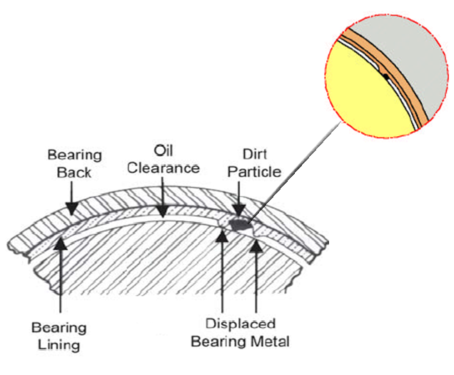
2 OIL STARVATION………………………………....11.4%
MALFUNCTION IN THE LUBRICATION SYSTEM
A total absence of lubrication of the bearing system leads to bearing seizure and, normally, to total destruction of the part. However an altogether more frequent phenomenon is fatigue due to oil starvation, whereby the amount of oil reaching the bearing system is insufficient to maintain the oil film, leading to metal-to-metal contact between the two parts. Prolonged operation under such conditions will also result in total destruction of the whole.
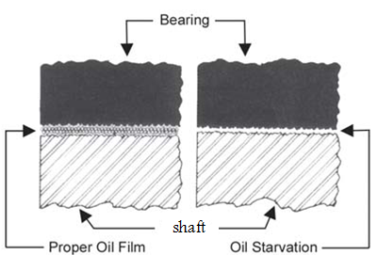

3.MISASSEMBLY……………………………………..12.8%
BEARING REVERSED
Where a bearing having no oil hole is mistakenly fitted in a position in which it ought to have one, e.g., in a case where the upper and lower seats of a pair of bearing shells are inadvertently switched. As a consequence, no lubrication can reach the shaft through such oil holes, eventually leading to seizure of the bearing. From the bearing back, it will be evident that the oil passage hole has been blocked off.
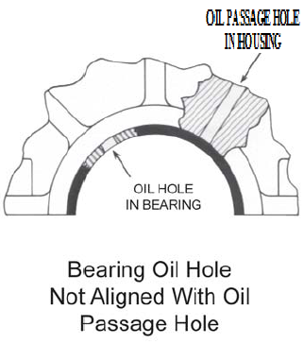
Bearings will not function properly if they are installed wrong. In many cases, misassembly will result in premature failure of the bearing. The following are typical assembly errors most often made in the installation of bearings.

4 IMPROPER MACHINING OF COMPONENTS…….12.6% OUT OF ROUND BORE
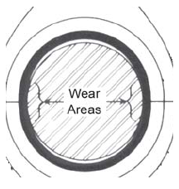
Alternating loading and flexing of the shaft can cause the bearing housing to become elongated. And because replacement bearing shells, when installed, tend to conform to the shape of the bearing housing, this can result in an out-of-round bearing surface.
Oil clearance near the parting line is decreased to such an extent that metal-to-metal contact between bearing and journal takes place, resulting in areas of above-normal wear. Also, improper seating between the bearing back and the housing bore may be present which hinders proper heat transfer causing localized heating of the bearing surface and thus reducing fatigue endurance.

5 OVERLOADING…………………………………......8.1%
Where operating conditions cause excessive load to be exerted upon the bearings,this leads to damage due to metal fatigue

6.CORROSION………………………………………..3.7%
Oil in poor condition can damage the bearing surface. This effect is due to dilution of the lead in the alloy by certain of the compounds produced by oil degradation.
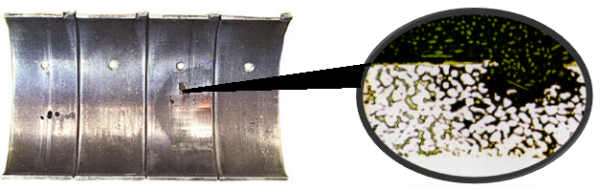

7 CAVITATION……………………………………….2.8%
Under certain operating conditions, oil pressure drops locally, producing vapour bubbles that cause damage to the bearing surface. This damage will be evident in certain bearing areas, such as oil grooves or holes, that are affected by discontinuities in the oil flow.

All these being the failures in shaft bearings, thrust bearings too have their own drawbacks.

Thrust bearings run on a thin film of oil, just like radial journal (connecting rod and main) bearings, they cannot support nearly as much load, thrust bearings can only support loads of a few hundred psi. The vast majority of the bearing surfaces and the entire shaft surface are flat making it much harder to create and maintain an oil film. If you have ever taken two gauge blocks and wiped them perfectly clean and pressed them together with a twisting action you know that they will stick together. This is very much like what happens as a thrust load applied to the end of a crankshaft squeezes the oil out from between the shaft and bearing surfaces. If the load is too great, the oil film collapses and the surfaces want to stick together, resulting in a wiping failure.Magnetic bearings offer a myriad of operational advantages and efficiency improvement over traditional oil lubricated bearings. The propeller shaft bearing and the thrust bearing can be replaced by the magnetic bearings. The construction and working of it is as follows

COMPONENTS OF ACTIVE MAGNETIC BEARING

Iron Core
The iron core is a material conducting the magnetic field to the air gap. Its magnetic permeability has to be high, as well as its magnetic saturation. In order to minimize eddy current losses, the core usually consists of insulated lamination sheets.

Windings
The current through the winding is the source of magnetic field. The winding is made of an insulated conductor wound on the soft magnetic core. In order to improve the efficiency of the AMB, the conductor has to have a low electrical resistance and must be wound with a high fill-factor.

Rotor
The rotor, in standard constructions, is realized with a lamination packet shrinked on a non magnetic shaft. Tight manufacturing tolerances are needed in order to avoid unbalances. The mechanical properties of the rotor lamination have to be good, in order to overcome the centrifugal stress due to high speed rotation.

Position Sensors
In most applications, there are position sensors in AMBs. Since AMB are actively controlled regarding to the sensor signal, the control performance strongly depends on the sensor performance. Several sensor types are used in AMBs: inductive, eddy current, capacity and optical displacement sensors.

Controller
Today controllers are mainly based on digital technology. They provide a great flexibility and high computation speed. Digital controllers enable principally an adaptative control, unbalance compensation and provide a great tool for system diagnosis. For real time processing, Digital Signal Processors (DSPs) are used. AMBs are controlled in closed-loop. Different methods such as PD, PID, optimal output feedback or observer based state feedback are in use.

Power Amplifiers
The power amplifiers convert the control signals into control currents. Switching amplifiers are usually used because of their low losses. The amplifier is often the limitating component in an AMB system. Amplifiers with voltage or flux density control may improve AMB performance in certain cases, but are not yet widely used.

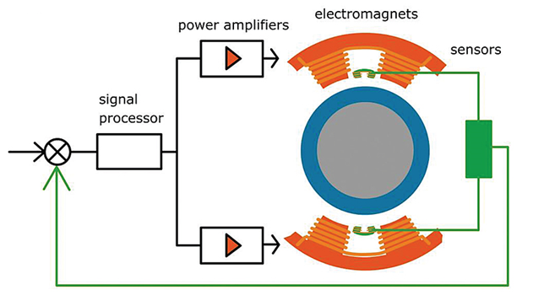
HOW STUFF WORKS ?
Magnetic bearings are basically a system of bearings which provide non-contact operation, virtually eliminating friction from rotating mechanical systems. Magnetic bearing systems have several components. The mechanical components consist of the electromagnets, position sensors and the rotor. The electronics consist of a set of power amplifiers that supply current to electromagnets. A controller works with the position sensors which provide feedback to control the position of the rotor within the gap.
The position sensor registers a change in position of the shaft (rotor). This change in position is communicated back to the processor where the signal is processed and the controller decides what the necessary response should be, then initiates a response to the amplifier. This response should then increase the magnetic force in the corresponding electromagnet in order to bring the shaft back to center. In a typical system, the radial clearance can range from 0.5 to 1 mm.
This process repeats itself over and over again. For most applications, the sample rate is 10,000 times per second, or 10 kHz. The sample rate is high because the loop is inherently unstable. As the rotor gets closer to the magnet, the force increases. The system needs to continuously adjust the magnetic strength coming from the electromagnets in order to hold the rotor in the desired position.

BENEFITS OF MAGNETIC BEARINGS
FIVE AXIS CONTROL (ELIMINATION OF THRUST BEARINGS)
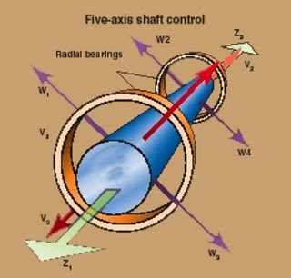
Conventional active magnetic bearing systems, whether electromagnet bias or permanent magnet bias, typically utilize three actuators for a 5-axis system (shown in Figure below). This would be in the form of two radial actuators, each supporting and controlling two radial axes, and a thrust actuator supporting and controlling a single axial axis. Each actuator axis functions independently to provide forces in its defined axis for stable support and control of the levitated shaft.

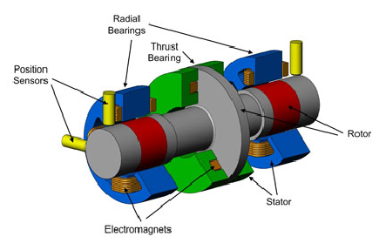
Thus the need for large thrust bearings are eliminated which can then be replaced by magnetic thrust bearing
HIGH RELIABLITY
With magnetic bearings there is no contact between the rotating and stationary parts, meaning there is no wear. In most cases failure modes are limited to control electronics, power electronics, and electrical windings. These components have designs lives far greater than that of conventional bearings. Magnetic bearings are the only type of bearing which is fitted with protective back-up bearings. In addition, magnetic bearings have a built-in overload protection. Magnetic bearings can signal process control equipment to stop the machine instantaneously in the case of excessive load.

CLEAN ENVIRONMENTS
In a magnetic bearing system, particle generation due to wear and the need for lubrication are eliminated. There is therefore no chance of contaminating a clean process with oil grease or solid particles.

POSITION AND VIBRATION CONTROL
Magnetic bearings use advanced control algorithms to influence the motion of the shaft and therefore have the inherent capability to precisely control the position of the shaft within microns and to virtually eliminate vibrations.

CONCLUSION
Though magnetic bearing technology is far from young, it did not become practical for widespread application until fairly recently. The magnetic bearing is no longer an exotic technology, but finds applicability in an array of industries. One such is marine engines because of lubrication free operation with no air requirements, operation in extreme temperature environments, and active control for intelligent engines.

REFERENCE
Website :worlddesign.com

AUTHOR
Anbuselvan.T(4th year,B.E.Marine)
Sai vikash.M(4th year,B.E.Marine)
VinothKumar.K(4th year,B.E.Marine)

