SAGARMALA: “Building Gateways of Growth” The Road Ahead
1. V.A.Tamhanekar, Tolani College Of Commerce, Andheri (E), Mumbai-93, tamhanekarvibhu2107@gmail.com
2. Y.A.Bohara, Tolani College Of Commerce, Andheri (E), Mumbai-93, 1999.jainyash@gmail.com
3. S.S.Cherukada, Tolani College Of Commerce, Andheri (E), Mumbai-93, cherukadasooraj@gmail.com

Abstract:
A robust maritime logistics with modern & efficient port infrastructure can be a strong catalyst for economic growth. Indian maritime sector is infested with numerous hurdles in relation to developmental, procedural & policy related challenges.
` To overcome these challenges the GOI has embarked on an ambitious project that aims towards development of ports & transforming them into opportunities for regional development & that is the “SAGAR MALA PROJECT”. This paper looks into the various dimensions of this ambitious project and its strategic importance that is further supported by other related infrastructure projects.

Key words: Ports, Infrastructure, Sagar Mala, Objectives.

Introduction:
One of the major steps taken by the present government towards faster economic growth is focusing on development of trade related infrastructure. The Ministry of Shipping has states that of the total Indian overseas trade around 95 per cent of by volume and 70 per cent by value is done through maritime transport. This fact itself is an indicator that The Indian ports and shipping industry plays a vital role in sustaining growth in the country’s trade and commerce’
India with a combined coastline of about 7517 kms has just 12 major and 200 notified minor and intermediate ports indicates inadequate port infrastructure. The total 200 non-major ports are in the following States:- Maharashtra (48); Gujarat (42); Tamil Nadu (15); Karnataka (10); Kerala (17); Andhra Pradesh (12); Odisha (13); Goa (5); West Bengal (1); Daman and Diu (2); Lakshadweep (10); Pondicherry (2); and Andaman & Nicobar (23).
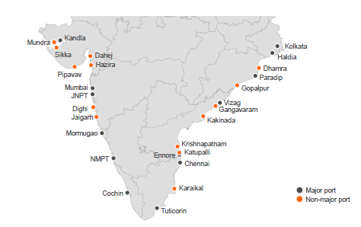
Fig 1: Major and Minor Ports of India.
Source: http://barandbench.com
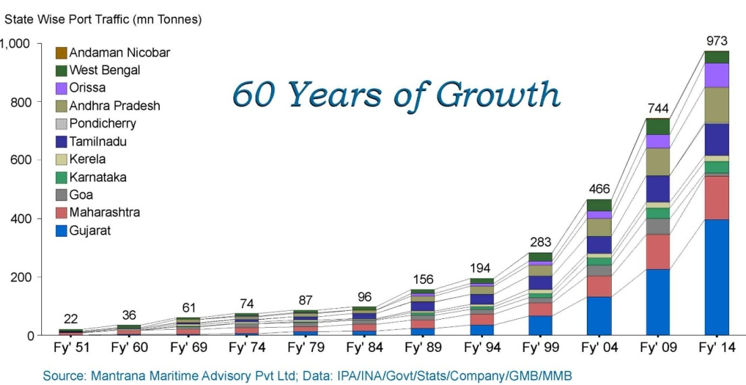
Fig 2: http://www.mantrana.in/Ports.php

Since ports handle almost 95 per cent of trade volumes in India, the rising trade has contributed significantly to the country’s cargo traffic. Presently the ports in total handle about 1,052 Million Metric Tonnes (MMT) of cargo in 2015, the figure that is expected to reach 1,758 MMT by 2017. During April to September 2016, 12 major ports in India handled 315.4 MT (Million Tonnes) of cargo, showing a growth of 5.1 per cent in comparison to the same time during previous year.

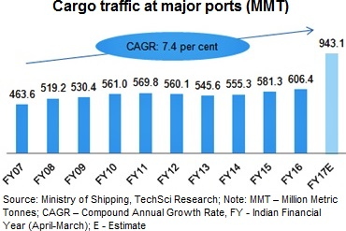
Fig 3: Source: http://www.ibef.org/industry/indian-ports-analysis-presentation

Cargo traffic handled by India’s Major ports increased 4.6 per cent year-on-year to 264.73 million tonnes (MT) during April-August 2016. In terms of composition of cargo traffic, the largest commodity was P.O.L. (32.44 per cent), followed by coal (24.09 per cent), container traffic (19.65 per cent), other cargo (12.68 per cent), iron ore (4.6 per cent) and other liquids (4.13 per cent).

A robust maritime logistics with modern and efficient port infrastructure can be a strong catalyst for economic growth. Exim trade can become competitive through cost-efficient and timely logistics, coastal and inland waterway transportation is energy efficient, eco-friendly and reduces logistics cost for domestic freight. Logistics costs account for a large part of Indian non-services GDP compared to developed nations. EXIM containers have to travel anywhere from 700 kms to 1,000 kms between production centres and ports as compared to China where the distance is just 150 kms to 300 kms. Lack of seamless connectivity, complex modes of transport contribute highly towards varied transit times seriously affecting the export trade. Adequate road and rail connectivity linkages to ports have not been developed in tandem with port development. The net outcome is new ports with modern facilities being underutilized due to connectivity bottlenecks. For example the non-major ports in South Maharashtra have remained underutilized due to poor connectivity between industrial centres and ports.
The existing master plans of industrial cluster and zones (often with high EXIM traffic) development does not adequately take into account proximity to ports. The port lands are also underutilised for industrial development for instance the land under major ports is 2.71lakh acres of which 2.35 is underutilised. Internationally several ports have been successful in generating higher value-add and jobs inside the port area compared to metropolitan area.

Problems of Indian Maritime Sector: Indian maritime sector is infested with numerous hurdles in relation to developmental, procedural and policy related challenges. The major ones being involvement of multiple agencies in development of infrastructure to promote industrialization, trade, tourism and transportation; presence of a dual institutional structure that has led to development of major and non-major ports as separate, unconnected entities; lack of requisite infrastructure for evacuation from major and non-major ports leading to sub-optimal transport modal mix; limited hinterland linkages that increases the cost of transportation and cargo movement; limited development of centres for manufacturing and urban and economic activities in the hinterland; low penetration of coastal and inland shipping in India, limited mechanization and procedural bottlenecks and lack of scale, deep draft and other facilities at various ports in India.
The existing ports are operating to their fullest and have a large turnaround time, and pose problems in relation to cargo handling facilities. Indian ports still face problems in relation;
- Obsolete cargo handling facilities,
- Breakdowns
- Lack of co-ordination
- Lack of adequate draft to handle modern ships.
- Need of repeated maintenance dredging add to the problems,
- Longer turnaround time as they are not comparable to global standards.
- Political pressure, lack of autonomy, absence of incentives, excessive bureaucracy, and hierarchical rigidities are contributors to the current state of the Indian ports.
Sagar Mala: Understand the importance of ports and shipping industry in the overall economic development and sustaining trade and commerce the government of India has undertaken several steps to improve operational efficiency through mechanisation, deepening the draft and speedy evacuations. In FY 2015-16, the Indian Port sector witnessed capacity addition of 94 Million Tonnes Per Annum (MTPA), which is the highest in the history of major ports. The Indian Government has allowed Foreign Direct Investment (FDI) of up to 100 per cent under the automatic route for port and harbour construction and maintenance projects. It has also facilitated a 10-year tax holiday to enterprises that develop, maintain and operate ports, inland waterways and inland ports. The government has also initiated National Maritime Development Programme (NMDP), an initiative to develop the maritime sector with a planned outlay of US$ 11.8 billion.

As a part of the initiative the Government of India has embarked on an ambitious project that aims towards development of Ports and transforming them into opportunities for regional development and that is the “Sagar Mala” project. The Origins of The Sagarmala project was mooted by the Vajpayee govt in 2003, but shelved by the UPA It was supposed to be the shipping equivalent of the Golden Quadrilateral, which revived India’s roads
The Project: “Sagar Mala” was once again initiated by the present government. It is a “strategic and customer-oriented initiative of the government of India to modernize Indian Ports so that port-led development can be augmented and coastlines can be developed to contribute in India's growth. It looks towards "transforming the existing Ports into modern world class Ports and integrate the development of the Ports, the Industrial clusters and hinterland and efficient evacuation systems through road, rail, inland and coastal waterways resulting in Ports becoming the drivers of economic activity in coastal areas”. “Sagarmala” is the government’s flagship program to promote port-led development in the country. The project was conceived by the ‘National Sagarmala Apex Committee’ (NSAC), comprising of the Minister in-charge of Shipping, with Cabinet Ministers from stakeholder Ministries and Chief Ministers / Ministers in-charge of ports of maritime states as members, will provide policy direction and guidance for the initiative’s implementation, shall approve the overall National Perspective Plan (NPP) and review the progress of implementation of these plans.
The programme aims to promote port-led development in the country by harnessing India's 7,500-km long coastline, 14,500-km of potentially navigable waterways and strategic location on key international maritime trade routes. The concept of "port led development" is central to the Sagarmala vision. Port led development focuses on logistics intensive industries (where transportation either represents a high proportion of costs, or timely logistics are a critical success factor).

The “Sagarmala Development Company” was given the nod for incorporation under the Companies Act, 1956, by Indian Cabinet on 20th July 2016 with an initial authorized share capital of Rs 1000 Crore and subscribed share capital of Rs 90 Crore, to give a push to port-led development. The Sagarmala National Perspective Plan was released on 14-April-2016 with details on Project Plan and Implementation. The Union Minister of Shipping on 5 October 2015 said, "The project includes modernization of our ports and islands, setting up of coastal economic zones, new major ports and fish harbors. We expect that the total investment in the project would be to the tune of 700 billion (US$10 billion)
Table 1: Six mega-ports are planned in Sagarmala project.
State | Place | Sea/Bay | Port
Kerala | Vizhinjam | Arabian Sea | Vihinjam International Seaport
Tamil Nadu | Colachel | Bay of Manner | Colachel Seaport
Maharashtra | Vadhavan | Arabian Sea | Vadhavan Port
Karnataka | Tadadi | Arabian Sea | Tadadi Port
Andhra Pradesh | Machilipatnam | Bay of Bengal | Machilipatnam Port
West Bangal | Sagar Island | Bay of Bengal (Mouth of Hoogly river) | Bhor Sagar Port
Source: https://en.wikipedia.org/wiki/Sagar_Mala_project
Aims, Objectives and Challenges:
The Sagar Mala also intends to achieve the broad objectives of;
- Enhancing the capacity of major and non-major ports and modernizing them to make them efficient, thereby enabling them to become drivers of port-led economic development.
- Optimizing the use of existing and future transport assets and developing new lines/linkages for transport (including roads, rail, inland waterways and coastal routes).
- Setting up of logistics hubs, and establishment of industries and manufacturing centres to be served by ports in EXIM and domestic trade.
- Strengthening port and evacuation infrastructure
- Simplifying procedures used at ports for cargo movement.
- Promotes usage of electronic channels for information exchange leading to quick, efficient, hassle-free and seamless cargo movement.
- Optimizing logistics (rails, roads and inland waterways).
- Identify capacity additions (more ports wherever viable).
- Modernize India’s Ports so that port-led development can be augmented.
The Sagarmala initiative will address challenges by focusing on three pillars of development, namely:
- Supporting and enabling Port-led Development through appropriate policy and institutional interventions and providing for an institutional framework for ensuring inter-agency and ministries/departments/states collaboration for integrated development.
- Port Infrastructure Enhancement, including modernization and setting up of new ports, and
- Efficient Evacuation to and from hinterland.

The Sagar Mala intends to undertake several development projects, an indicative list is as follows;
- Port-led industrialization
- Port based urbanization
- Port based and coastal tourism and recreational activities
- Short-sea shipping coastal shipping and Inland Waterways Transportation
- Ship building, ship repair and ship recycling.
- Logistics parks, warehousing, maritime zones/services.
- Integration with hinterland hubs.
- Offshore storage, drilling platforms
- Specialization of ports in certain economic activities such as energy, containers, chemicals, coal, agro products, etc.
- Offshore Renewable Energy Projects with base ports for installations.
- Modernizing the existing ports and development of new ports. This strategy incorporates both aspects of port-led development viz. port-led direct development and port-led indirect development.

Sagar Mala Vision

Fig 4: Source: Sagar Mala National Perspective Plan, April 2016

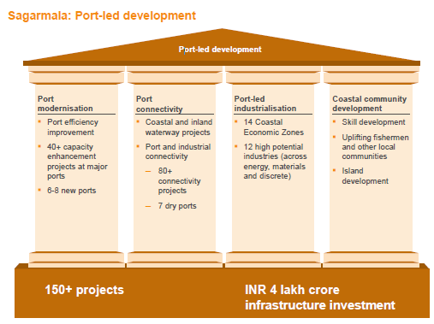
Fig 5: Source: Sagar Mala National Perspective Plan, April 2016

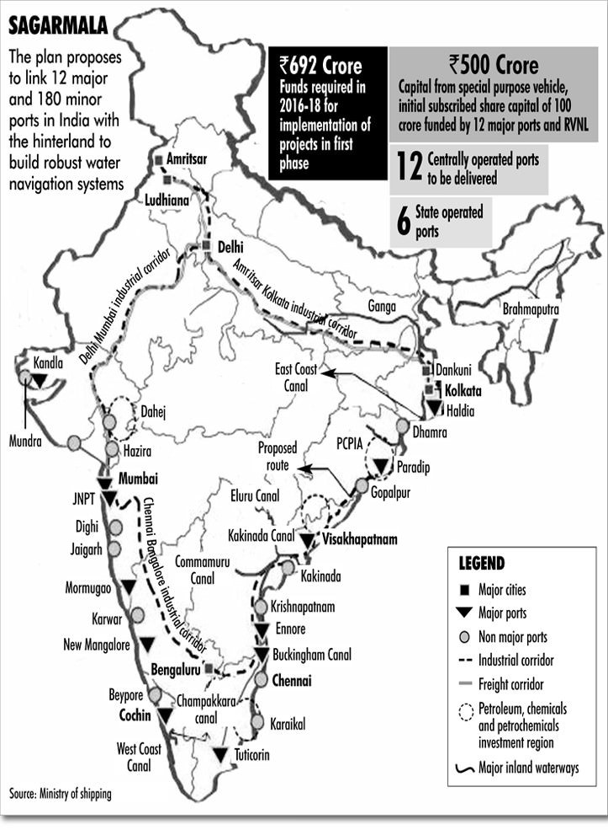
Fig 6: http://www.rajras.in/index.php/sagarmala-program-port-led-development/
The project also aims at a comprehensive and integrated planning and it for this a National Perspective Plan (NPP) for the entire coastline will be prepared to identify potential geographical regions to be called “Coastal Economic Zones” (CEZs). The NPP, will be integrated with the already planned Industrial Corridors, Dedicated Freight Corridors, National Highway Development Programme, Industrial Clusters and SEZs.
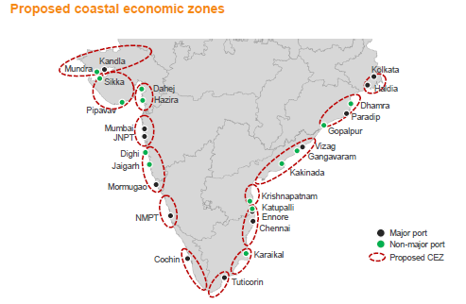
Fig 7: Source: http://barandbench.com/debriefed-the-sagarmala-project/

Implementation: For an effective implementation of the project “Sagarmala Coordination and Steering Committee” (SCSC) shall be constituted under the chairmanship of the Cabinet Secretary with Secretaries of the Ministries of Shipping, Road Transport and Highways, Tourism, Defence, Home Affairs, Environment, Forest & Climate Change, Departments of Revenue, Expenditure, Industrial Policy and Promotion, Chairman, Railway Board and CEO, NITI Aayog as members. The committee will establish coordination between various ministries, state governments and agencies connected with implementation and review the progress of implementation of the National Perspective Plan, Detailed Master Plans and projects. It will, inter alia, consider issues relating to funding of projects and their implementation. This Committee will also examine financing options available for the funding of projects, the possibility of public-private partnership in project financing/construction/ operation.
The coordination committees will also aim to strive to ensure sustainable development of the population living in the Coastal Economic Zone (CEZ). Dor this they are to synergize and coordinate with various ministries of state and central government on their existing schemes and programmes such as those related to community and rural development, tribal development and employment generation, fisheries, skill development, tourism promotion etc. It should provide a platform for central, state governments and local authorities to work in tandem and coordination under the established principles of “cooperative federalism”, in order to achieve the objectives of the Sagarmala Project and ensure port-led development.

Operational Efficiency: To improve the operational efficiency of existing ports the entire business process is to be re-engineered to simplify processes and procedures in addition to modernizing and upgrading the existing infrastructure and improved mechanisation. It will also involve increased use of information technology and automation to ensure paperless and seamless transactions will be an important area for intervention.

Strategic Objectives of Sagar Mala?
- It is a counter to China’s String of Pearls.
- It is a port-led development programme.
- It is a security infrastructure envisaged by India in the Indian Ocean region.
- It is a defence capability enhancement project of Indian Navy.
- Detailing the contours of ” Sagarmala”, the program aims for-
  - Development of ports
  - Development of national highways
  - Connecting National Highways to the ports
  - Development of maritime economic zones

Other Infrastructure development projects and Sagar Mala:

One of the major hurdle’ that the Indian maritime sector faces is port connectivity. The problem becomes acute due to involvement of multiple agencies in development of infrastructure and transportation and lack on integration amongst them. This has resulted in problems with hinterland connectivity and substantial delays in overland transport. So the question arises will this ambitious project really see the light of the day.
Integration of multimodal transport facilities will definitely be a huge asset in overcoming these limitations. It is with this viewpoint two other projects viz the “Golden Quadrilateral” and the “Diamond Quadrilateral” will be important to augment the efforts to make Sagar Mala a success.
The “Diamond Quadrilateral” of Indian railway was conceived to establish high speed rail network in India. This quadrilateral will connect the four metro cities in India, i.e. Delhi, Mumbai, Kolkata and Chennai. The entire project will involve two phases of development: first phase will involve upgrading of segregated rail corridors so that the trains reach speeds of 160 to 200 kmph and the second phase will involve identification of key intercity corridors to be developed as state of the art high speed corridors with speeds reaching 350 km/h using public private partnership and state ownership. The objective is to develop at least 4 corridors of 2000 km by 2020 and have at least 8 other corridors in different stages of progress.
On the other hand the “Golden Quadrilateral” s a highway network connecting many of the major industrial, agricultural and cultural centres of India. A quadrilateral of sorts is formed by connecting Chennai, Kolkata, Delhi and Mumbai, and hence its name. The economic benefits of the project are;
- Establishing faster transport networks between major cities and ports.
- Providing an impetus to smoother movement of products and people within India.
- Enabling industrial and job development in smaller towns through access to markets.
- Providing opportunities for farmers, through better transportation of produce from the agricultural hinterland to major cities and ports for export, through lesser wastage and spoils.
- Driving economic growth directly, through construction as well as through indirect demand for cement, steel and other construction materials.
- Giving an impetus to Truck transport throughout India.
Targeting for all inclusive growth the third project named as Bharatmala is being developed to provide connectivity from Gujarat and Rajasthan in West to the reach Punjab and entire string of Himalayan states to from project of Modi Government. The project and then cover the entire string of Himalayan states upto the Indo-Myanmar border.
Conclusion: Pace of economic development can be achieved only when supported by a robust infrastructure. Project Sagar Mala cannot be viewed only as a path to economic development but also at other dimensions. The traditional growth poles of Indian economy will be now supported by alternate growth poles. Emergence of new centres will contribute substantially towards regional and balanced growth. This will save a lot in terms of turn around and transhipment delays. Further the most important aspect is long term strategic objective is enhance the maritime security concerns and develop a strong naval presence both merchant marine and Navy. This becomes essential as India is being looked as regional power for now and possibly a global power of future.
Sagar Mala, supported by other infrastructure projects will go a long way to achieve the desired economic growth while securing the safety of our coasts and maritime interests.

http://www.ibef.org/industry/ports-india-shipping.aspx
pibphoto.nic.in/documents/rlink/2016/apr/p201641402.pdf
pibphoto.nic.in/documents/rlink/2016/apr/p201641402.pdf
http://pib.nic.in/newsite/PrintRelease.aspx?relid=117691
"Concept Note on Sagar Mala Project:Working Paper" (PDF). Ministry of Shipping, Government of India. Retrieved 4 July 2015.
"Sagarmala: Concept and implementation towards Blue Revolution". Press Information Bureau. 25 March 2015.
"One crore jobs in shipping, ports under Sagarmala: Nitin Gadkari", The Economic Times, 9 April 2016
http://economictimes.indiatimes.com/news/economy/policy/nod-to-sagarmala-development-company-with-rs-1000-crore-authorised-share-capital/articleshow/53308267.cms
http://pibphoto.nic.in/documents/rlink/2016/apr/p201641402.pdf
http://economictimes.indiatimes.com/news/economy/infrastructure/sagarmala-project-government-to-spend-rs-70000-crore-on-12-major-ports-says-nitin-gadkari/articleshow/49229434.cms
http://pib.nic.in/newsite/PrintRelease.aspx?relid=117691
http://pib.nic.in/newsite/PrintRelease.aspx?relid=117691

