Hydrogen Powered Gas Turbine
Eugene Fonseca (201137TP174), Gaurav Verma (201137TP176), Harsh Pandey (201137TP181)

Abstract:
Conventional marine fuels have always limited the endurance of ships leading to inefficient cargo ships. This research considers the use of hydrogen as a marine fuel. It is now accepted that environmental pollution from ships contributes to climate change .Hydrogen marine utilization provides an efficient solution for the above-mentioned cause of concern.
Owing to the advancement in technology, we are now able to produce and store hydrogen at much safer and cheaper way using nanotechnology.
The hydrogen is converted onboard into shaft power via combustion in aero derivative gas turbine. Gas turbine offers higher torque to weight ratio. It is compact in dimension and requires low maintenance.
This research has shown that hydrogen marine system for onboard electricity production provide an innovative solution for existing environmental shipping concern at cheaper rate beyond limitation set by conventional marine fuels .

Keywords: Hydrogen, Gas turbine, Beads, Clean energy.

INTRODUCTION
Emissions from shipping have a significant impact on ambient air quality in densely populated coastal areas merchant shipping is significantly responsible for emission of Nitrogen and Sulphur oxide emission (NOx, SOx). Hydrogen, is a carbon-free energy carrier, it is used in merchant ship will help reduce marine pollution due to greenhouse emissions as on combustion it produces only steam. This paper describes hydrogen as a fuel for gas turbine, in a view to reduce marine pollution.
NEED FOR NEW TECHNOLOGY
Low quality marine fuel has an adverse effect on the environment. A study made by Corbett et al. [1] estimates that the annual premature mortality caused by shipping will be approximately 87000 premature deaths annually in 2012 if shipping emissions are not further regulated. Lower calorific value of marine fuel results in higher fuel consumption, which in turn increases the fuel cost. This calls for the need of a new fuel which should be cheaper, safer, must require minimal change to infrastructure also the performance must be adequate. Hydrogen fulfills these requirements. Due to advancement in technology, it is now possible to store hydrogen at ambient temperature and pressure that makes it a perfect future fuel.
On the other hand, gas turbine has many advantages over the conventional reciprocating engine. It can run on varied calorific fuels. It has high power to weight ratio making it a very compact power source. It also has very low emission of NOx. Burning hydrogen in a gas turbine can produce required electrical power.

PROPERTIES OF HYDROGEN:
Hydrogen (H2) is a colorless, odourless gas that is the abundantly found in the form of water. It can be produced from electrolysis using renewable resources. Hydrogen has one of the highest energy density values per mass. Its energy density is between 120 and 142 MJ/kg. It is highly flammable, requires only a small amount of energy to ignite and burn. Moreover, it burns cleanly and produces environment friendly byproducts. [2]

PHYSICAL AND CHEMICAL PROPERTIES
- Appearance/Colour: Colourless gas
- Odour: None
- Auto ignition: 560 °C
- Flammability range: 4-75 vol% in air.
- Other data: Burns with a colourless invisible flame.

STORAGE OF HYDROGEN:
Mostly hydrogen storage required either high pressure storage cylinders at up to 700 times atmospheric pressure (700bar or 10,000psi) or super-cooled liquids at -253°C (-423°F). Neither of these storage methods are practical on a large scale, as large amounts of energy is required to either pressurized or cool the hydrogen, moreover this involves significant safety risks. Liquid hydrogen, the preferred form of hydrogen, still requires more storage space and pressure than other fuels. Using the innovative technology of Nano-structuring, hydrogen can be safely stored at ambient temperatures and pressures. A UK based company named Cella Energy [3] has achieved this new technology. The company has managed to encapsulate hydrogen-producing agent (NH3BH3) which produces hydrogen on heating up to 85 degree Celsius. This encapsulated hydrogen-producing agent is called a pellet. These pellets are not under pressure and can be handled safely in air.
The major advantage of this new storage technology is that, hydrogen can be stored at normal atmospheric temperature and pressure in irregular shaped tanks, thus reducing the storage space requirement.

PRODUCTION:
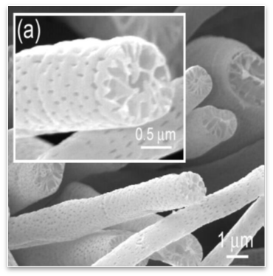
The pellet are made by compressing fibres (fig. a.) using electrospinnig technology (fig. b.), the core solution which is ammonia borane (NH3BH3) and a plastic polymer solution are forced together through a nozzle at high electrostatic voltage this produces a fiber of polymer encapsulated core hydride (fig. c.). Strong electric field is used to pull the fibres.

Fig. a. Fiber produced by electro spinning
Process of electro spinning:
:
HIGH VOLTAGE D.C
HYDROGEN PRODUCING SOLUTION

COATING PLASTIC POLYMER SOLUTION

FIBRE OF HYDROGEN STORAGE MATERIAL

Fig. b. Process of electro spinning

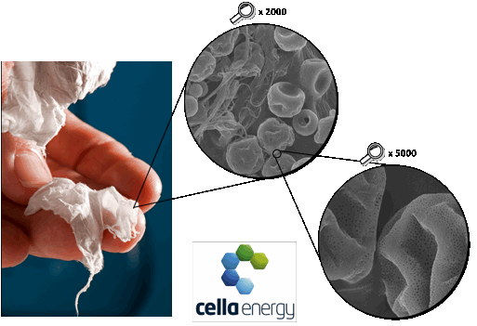
These fibers (fig. c.) have diameter of 1-3 $µ$m and 50-200 nm pores extending through bulk. The Porous fibre rapidly releases hydrogen when heated up to 85°C, without melting the pellet that can be further recycled. The fibers are compressed in the form of tiny pellets (fig. d.) so that they are easy to handle. Each tiny pellet can release 1 liter of hydrogen in gaseous form.

Fig. c. many fibres together forms a white substance show in the photo
Fig. d. The picture shows compressed fibres to form pellets

BLOCK DIAGRAM:
H₂ Storage Tank
wdasd
Compressor
Storage Tank no.2

Storage Tank no.1

Hot Tank
Gas Turbine

Waste Tank

SYSTEM EXPLANATION:
GAS TURBINE:
Hydrogen Gas Turbine Technology
- Aero derivative gas turbine
- Power Output: 1100Kw
- Hydrogen Calorific Value: 1,21,000 KJ/kg [4]
- Specific Fuel Consumption: 74.38g/Kwh
- Less NOx, No sulphur and carbon emissions.

Current Diesel Generator Technology
- Four Stroke Cycle Diesel Engine
- Power Output: 1100Kw
- HFO calorific value: 42,700 KJ/Kg[4]
- Specific Fuel Consumption: 198g/Kwh. [4]
- Releases high amount of toxic gases.
namely-NOx, SOx, CO2, CO.

Gas turbines are highly reliable and have proved their worth in aviation field under extreme climatically conditions with less maintenance. They are recently used in power plants for generating electricity. Some of the modern warships are also dependent on gas turbines for high-speed propulsion.
A gas turbine running on hydrogen will have low specific fuel consumption, owing to its high calorific value, which will ultimately reduce the overall fuel consumption .Thus using hydrogen as a fuel for gas turbine can lead to a reliable, greener, efficient, cheaper, non-polluting method of electricity production.
The major problems of using hydrogen as a fuel for a gas turbine are high flame temperature and high flame velocity.
Comparing Hydrogen with Natural gas
Fuels | Lower Calorific Value  kJ/kg | Flammability  % by Volume | Stoichiometric  Concentration  % by Volume | Flame speed  Cm/sec | Auto ignition Temperature  Celsius
Hydrogen | 121,000 | 4.0 - 75.0 | 29.60 | 306 | 500
Natural Gas | 36,000 | 5.0 - 15 | 9.60 | 33.8 | 580

Low Swirl Burner (L.S.B) [5]:
Low Swirl Burner (L.S.B.),Fig.e. is a readily adaptable technology for industrial process burners and gas turbine combustors to meet stringent emissions targets without significantly altering their system configurations, efficiencies, turndown, and costs.
Its basic premise is to produce a detached and freely propagating flame. The idea is fundamentally different from the conventional approaches to trap or hold the flame by physical means or by strong vortices. Laboratory experiments have verified that the basic LSB concept is amenable to operate on natural gas, synthesis gas (syngas), and hydrogen while meeting the aggressive emission target of <2 ppm NOX (less than two parts per million oxides of nitrogen).
L.S.B. is a mechanically static device that imparts a mild spin to the gaseous fuel and air mixture that causes the mixture to spread out. The flame is stabilized within the spreading flow just beyond the exit of the burner (as shown in fig. e.). The flame temperature is also lower than the conventional burners. L.S.B. is a promising technology under development for using hydrogen as a fuel for gas turbine. Experiment under laboratory condition have been performed and have successfully manage to burn hydrogen using L.S.B.
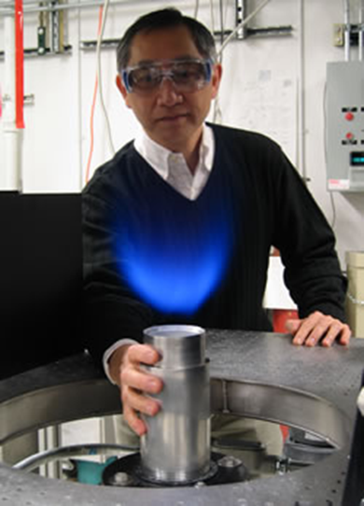
Fig. e. Robert Cheng views an LSI flame. He is touching the burner, demonstrating that it stays cool because the flame is completely lifted from its body.

The LSB development focus mainly on stabilizing the potentially faster H₂ flames at very lean conditions where the flame temperatures are sufficiently low to prevent NOx formations. Problems in burning H₂ are high diffusivity of H₂ and its low flammability limit. Moreover, H₂ rich mixtures have shorter auto-ignition delays than hydrocarbon mixtures. Burning lean hydrogen mixture using Low swirl burner can result in stable hydrogen flame, but increasing fuel to air ratio (φ) results in partially rim attached flame, which is not desirable as it affects flow field dynamics. As a part of the solution LSB with a modified flared nozzle is developed (fig. f.) and has shown improved results.

Fig.f. LSB with a modified flared nozzle

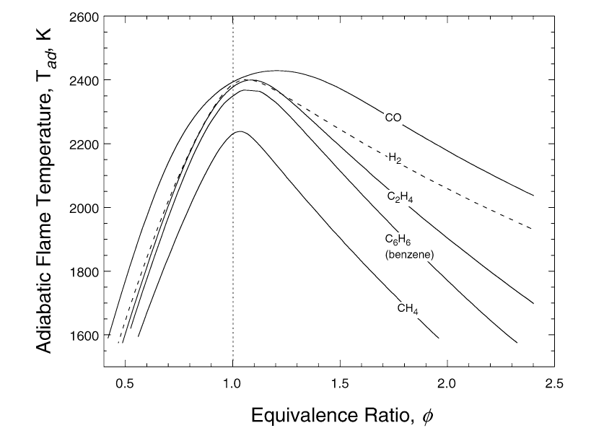
The stoichiometric air fuel ratio of Hydrogen 34: 1 by weight. The estimated theoretical mass flow rate of hydrogen-powered gas turbine of 1.1MW will be 81.8 Kg/h. Therefore, the estimated air mass flow rate will be 2,781.2 Kg/h as per stoichiometric ratio and the adiabatic flame temperature is 2330 K (natural gas adiabatic flame temperature is 2290K). In order to protect the blades from excessive exhaust temperatures the, TIT (turbine inlet temperature) can be reduced by providing excess air during combustion thus making the fuel air equivalent ratio (φ) near to 0.5. Moreover, the low swirl burners have proved their part on lowering the flame temperatures, thus increasing the life span of the turbine blades.
If the fuel air equivalent ratio (φ) near to 0.5 (Fig. g) then the excess air required to burn 1Kg of hydrogen per hour will be 34 kg. Thus, some modifications are required in the existing gas turbine’s combustion chambers.

Fig. g. Adiabatic flame temperature plotted as a function of the fuel equivalence ratio φ for several fuel/air mixtures at STP.

Existing hydrogen powered gas turbine in Italy:
The power plant is situated in Fusina, near Venice in the Veneto region of Italy, consists of a combined cycle in which is fuelled with hydrogen in order to produce electricity in the gas turbine, reaching power which amounts to approximately 12 MW, while the flue gas are constituted exclusively of hot air and water vapour.. The performance of the cycle is increased by exploiting the heat present in the flue gases to produce high temperature steam, which is sent to the existing coal plant, produces further energy for additional capacity amounting to approximately 4 MW. Overall, 16 MW is produced from hydrogen, with an overall efficiency of 41.6%. The system is capable of producing energy equal to the average annual consumption of a town of 20,000 inhabitants, by supplying 60 million kilowatt hours a year without emitting CO_{2. [6]}

Experimental results for 100% H₂ combustion
(Without L.S.B developed by ENEL in an 8.6MW gas turbine.) [7]
P_{air} | Bar(a) | 10.13
T_{air} | Degree Celsius | 313.60
Q_{air} | Kg/s | 11.45
Q_{H2} | Kg/s | 0.07167
T_{exhaust} | Degree Celsius | 939.00

STORAGE:
- Gas turbine running on hydrogen will consumes 1.9 MT/Day to produce 1100Kw
- On a 15 days voyage the hydrogen consumption will be 30 MT
- The volume of the tank required for 15 days voyage is 72.6 m3.
- Present diesel engine consumes 3.4 MT/Day to produce 1100Kw [8]
- On a 15 days voyage the heavy fuel oil consumption is 51 MT.
- The volume of the tank required for 15 days voyage is 53.125 m3.

The storage tank is preferable to be store on the upper decks outside the engine room, or else above the generator platform to get a positive pressure head this tank can be segregated into smaller irregular shape tanks to smartly utilize the available space.
HOT TANK AND WASTE TANK:
This tank will be maintained at constant temperature about 85-90 degree Celsius using low quality steam. The beads enter the hot tank through the inlet pipe and will be heated up to 85 degree Celsius releasing hydrogen in the gaseous state, which will be collected from the top of the tank and the residual part will go to the waste tank. The required mass flow rate of hydrogen is 1.36 Kg/Min, (for 1.1MW) so the size of the hot tank will be small. All the pipefittings should be of gas tight standards. The hot tank should be double layered with the higher-pressure gas maintained between the two layers. An intelligent automatic control and monitoring system is required for controlling the various parameters of the system.
Inside the tank the concentration of hydrogen will be maintain above 75% by volume, to avoid any chance of auto ignition.
SAFETY:
The safety standards will be very similar to that of a gas carrier. At special locations, electrical push buttons will be placed so that remotely activated valves can be shut-off, compressors and pumps can be stopped. Emergency shutdown valves may be pneumatic or hydraulically operated, but in either case, they must close automatically upon loss of activating power. The pipe lines from the hot tank to the hydrogen fuel injector will be doubled wall carrying hydrogen in the pipe and nitrogen in the outer pipe.
Gas | Nitrogen | Exhaust Gas
N2 | 99.5% | 85% to 89%
O2 | Less than 0.5% | 1% to 3%
CO2 | - | 14%
Nitrogen contains very less quantity of oxygen, which will be a better inerting gas for hydrogen handling. Nitrogen will be required in small quantities, which can be stored in cylinders.
The tanks need to be well insulated, to avoid the inside temperature of the tank to rise above 45 degree Celsius. The storage tank temperature should be monitored. The hot tank should be well insulated and constantly maintained at 85 degree Celsius.

DISADVANTAGE:
- Gas turbines are more costly than conventional engines, hence will increase the initial cost of this technology.
- Hydrogen is highly flammable and hence proper safety measure should be followed.
- This new technology need time to setup and is not used before.

ADVANTAGES:
- Hydrogen can be stored and utilized at atmospheric pressure and temperature which is not the case with LPG and CNG
- Reduces the emission of greenhouse gases.
- The fuel is prepared using raw materials such as boron readily available in nature
- Hydrogen fuel will have low and constant cost unlike the fluctuating cost of other fuels
- High energy contain per mass, which reduces fuel consumption.
- The gas turbine are highly reliable and requires low maintains
- The vibrations are lesser than convention
COST EFFECTIVENESS:
FUEL | COST OF FUEL | COMSUMPTION  PER DAY PER GENERATOR(1.1MW) | COST OF RUNNING  ONE GENERATOR  PER DAY
HFO | $800 | 3.4MT | $2720
Fuel | Energy/gal(U.S) | Cost | Cost of Fuel for Producing 1.1MW
Gasoline | 132MJ/gal | $3.45 | $6210
Hydrogen | 132MJ/gal | $1.5* | $2700
*Expected Cost (1.5$/Gal (U.S) energy equivalent of gasoline)
Concluding from the above two tables, that to produce 1.1MW power there is very less margin in using hydrogen against HFO. However, the expected exhaust temperature of a hydrogen gas turbine to produce enough steam to run in conjunction with the existing boiler, thus adding on to the overall saving. HFO is getting costlier due to the low sulphur requirement and oil refiners will not be able to meet the growing demands of low sulphur HFO in next 20 years. HFO is not the future fuel due to its limited resource, increasing price and environmental impact. Hydrogen offers a better solution for these problems. These new fuel is expected to be cheaper and stable in cost over a period.
Application:
On merchant ships generators are continuously running , thus this has a major part in global pollution .The use of Hydrogen fuel for generating electrical energy using a gas turbine can be a better solution to this.
POWER OUTPUT | 1.1MW | 2MW | 5MW
DAYS | 7 | 7 | 7
H₂ CONSUMPTION | 13.7 MT | 24.9MT | 62.4MT
TANK SIZE | 33.26M3 | 60.47M3 | 151.19M3

From the above table we can conclude that, the new system will be applicable for ships whose electrical requirements per generators are less than 2MW and which can refuel within 7 days. Particular application of this system will be on the feeder vessels, ships performing lighting operations and coastal ships.

Acknowledgements:
First and foremost, I would like to thank my advisor, Dr. SD Pohekar for assigning us this project and his guidance as well the facility necessary to complete this research It has been a privilege learning from him and developing our skills. We would also like to express our gratitude towards Commander Das Gupta for his extraordinary contribution in this project. I would like to acknowledge the technical assistance as well moral support provided by Mr. Shishur Dutt and Mr. Aniruddh kumar. Finally, we would like to express our deep regards towards Mr. John Fonseca (F/O Eugene john fonseca, Technical Electrical Officer, HMS) for providing valuable practical data for better analyzing and understanding of the current onboard power production system and lastly we would like to thank Cadet Anmol Malhotra for inspiring and guiding us throughout this research.
References:
1. James j. Corbett, Mortality from ship emissions: a global assessment, 2007
2. Physical and chemical properties of Hydrogen, www.eolss.net.
3. Cella energy, UK. www.cellaenergy.com.
4. Engineering Toolbox, www.engineeringtoolbox.com.
5. Spt .Crusader, ship manual.
6. Robert K. Cheng, L.S.B., Lawrence Berkeley National Laboratory. email:kcheng@lbl.gov.
7. Enel, www.enel.com.
8. H-j tomczak, g benelli, investigation of a gas turbine combustion system fired with mixtures of natural gas and hydrogen, IFRF Combustion Journal Article Number 200207, December2002.
9. Spt. Crusader, ship manual.

