Methods for Effective
NOx Emissions Reduction

A paper by-
Tolani Maritime Institute, Pune
Presenter- Cadet Akash Gupta (akashsja@gmail.com)
Co-author-Cadet Keshav Saini (keshavsaini1997@gmail.com)

1.] Abstract
The current age of seafarers treads in oceans in ever regressive regulations. Despite being the key driver, controlling 90% of the global trade, mariners are reliant on deleterious Heavy Fuel Oil (HFO) which constitutes copious amounts of sulphur. The shipping industry was responsible for about 2.8 million tonnes of NOx emissions in seas surrounding Europe in 2005 alone.
Living in a Global village whose backbone is formed by Maritime Transport which connects various trades and economies, the endeavour to save an ailing planet forms an integral part of all on-board operations. NEED OF THE HOUR is not only alternative fuels but also unleashing the untapped potential of efficient emission management.
2.] Keywords:
- Membrane Oxygen Separators
- Nitrogen Enriched Air
- Oxy-fuel combustion
- Oxygen-Reduction Method
- Water-Fuel Mixture
- Combination of ORM and WFM

3.] Introduction:
This model has a practical approach towards sustainable development of the engine exhausts systems by introduction of equipments currently in employment in other industries, thus leaving no questions unanswered about their practical feasibility.
Many theoretical and experimental investigation shows that the concentration of NOx in the exhaust gas is closely related to the peak cycle temperature and available amount of oxygen in the combustion chamber. Any process to reduce cylinder peak temperature and concentration of oxygen will reduce the oxides of nitrogen.
The authors wanted to provide an economic and efficient solution to problems concerning maritime environment. This paper explores means of induction of ceramic membranes in the suction system of the Marine Diesel Engine. It presents an unconventional approach by targeting the nitrogen content of the inlet combustion air. It suggests the use of varying oxygen and nitrogen percentage composition in the combustion air and also oxy-fuel combustion instead of air-fuel combustion (thus cutting off the root source of nitrogen in the combustion process), to shrink the possibility of NOx formation.

4.] Main Text:
This model, after revamping the design of the existing systems on-board a ship, is magnanimously economic, efficient and environment-friendly. It focuses on the utilization of Ceramic Membranes in Oxygen Separation to be applied in the various different ways and their effects on NOx Emissions in Marine Diesel Engine.
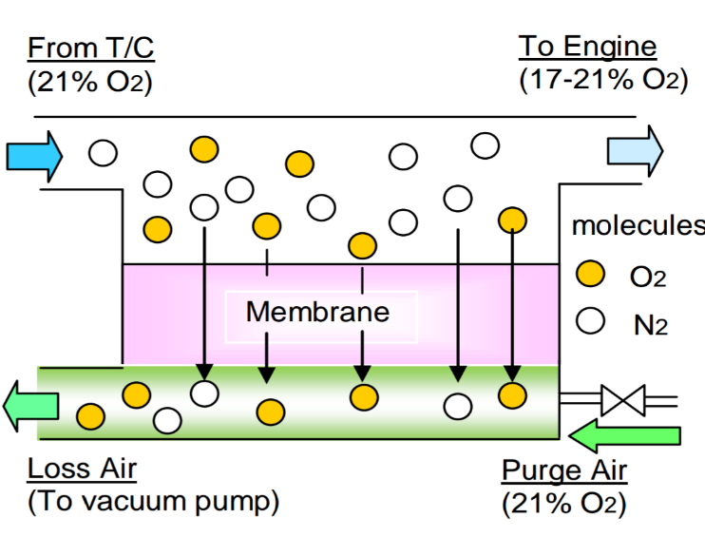
4.2] Ceramic Membrane Oxygen Separator:
Ceramic membranes are selectively permeable materials through which only oxygen can flow. Artificial membranes used in membrane operations for liquid filtration are called Ceramic Membranes Oxygen Separators. They separate oxygen through a mechanism called ion transport.
Ceramic Membranes are often made from inorganic materials (such as silicon carbide, alumina, zirconia oxides, titania or some glassy materials). They have an excellent Fig.1 Operation Principle Of the Membrane
thermal stability which makes them usable (CIMAC Congress 2016, Helsinki, Paper No. 176)
in high-temperature operations. They can be installed in tubular cross flow and dead-end as
well as flat sheet membrane configurations.
The separation is done by allowing the flow of oxygen ions across a membrane, drawn to the side which is deficient in oxygen. The air at the inlet is fed to the oxygen-separator at a very high temperature (around 550C). This heated air when subjected to active ions in the porous membranes, differentiates into its components. Out of those components, only oxygen ions are able to pass through this selectively permeable membrane, thus producing a pure oxygen stream at the outlet.
4.4] Nitrogen Enriched Air:
This model also utilizes the dilution effect of the increased nitrogen in the retentate of the Oxygen Seperator. A promising method of reducing NOx emissions involves the recycling of exhaust gas in a process called exhaust gas recycle which absorbs a portion of energy released during the combustion. A 25% EGR leads to a 50% reduction in NOx. However some problems, associated with the process are:
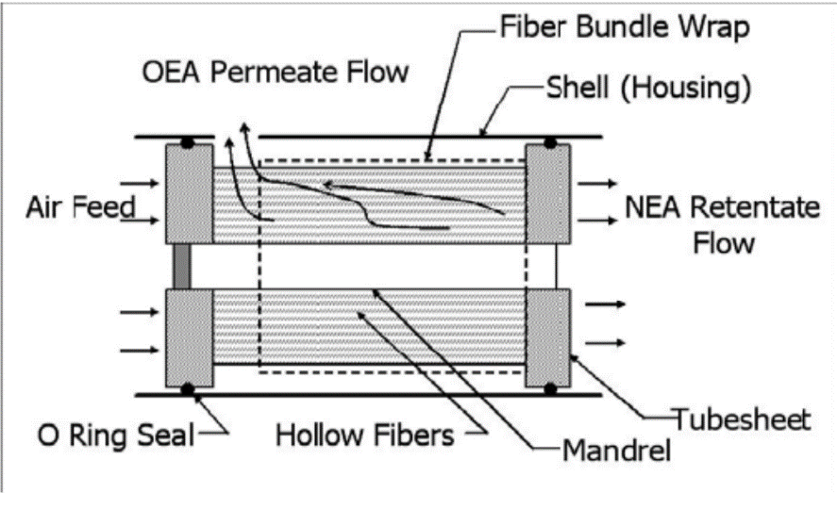
  - extra pumping and cooling of the EGR stream,
  - engine wear from re-circulating engine soot
  - high feed air water vapour levels.
These issues can be avoided by the dilution of fuel-air mixture entering the engine cylinder with Nitrogen Enriched Air (NEA obtained from the rententate of the Membrane), thereby affecting an overall reduction in the combustion temperature and consequent decrease in the NOx emission level. The NOx reductions Fig.2 Cross Section Of Hollow fibre Membrane
achieved through NEA are similar (ISSN 2248-9967 Volume 4, Number 3 (2014), pp. 197-202) those accomplished through the EGR process, while simultaneously avoiding the pumping, cooling, wear, and water vapour issues associated with EGR.
4.3] Oxy-fuel combustion
An alternative approach would be to utilize the Oxygen Enriched Air in the permeate as combustion air. Every modern-engine works on air-fuel combustion which is a process of burning fuel in an environment of air. This process is preferred over oxy-fuel combustion for the following simple reasons:
- Oxy-Fuel Separation is a costly operation and requires bulky machinery.
- Excess heat is produced during oxy-fuel combustion which makes keeping the engine cool a tedious task.
- Nitrogen in air helps in heat dissipation inside the marine diesel engines.
Oxy-fuel combustion is the process of burning a fuel using pure oxygen instead of air as the primary oxidant. Oxy-fuel combustion is often combined with staged combustion for nitrogen oxide reduction, since pure oxygen can stabilize combustion characteristics of a flame. Burning fuels in pure oxygen, as opposed to air can yield a pure stream of carbon dioxide which is much more environment friendly and serves the sole purpose of the paper.
4.3.1] No-Need for Turbocharger:
This high rotation device is a redundant accessory on-board for the following reasons:
- Turbocharger is a bulky and high power demanding machine that uses up a lot of the engines’ output and also increases Nitrogen intake, which produces high NOx emissions
- The usage of high speed rotation machinery turns problematic since it requires very specific conditions of rocking, pitching and external weather and might not be operational ubiquitously on course of voyage.
- Also, the power upkeep required to keep the larger parts in motion, against the developed resistance is massive.

The importance of increasing the air-fuel ratio becomes redundant in this model as the air being streamed into the engine is composed of almost pure oxygen and thus it automatically increases the fuel-combustion efficiency.
The replacement of the Turbocharger, thereby, saves the engine a lot of power, which can be utilized in other operations. It also provides an added advantage of reduced expenditure on turbochargers and lesser space occupation.
4.3] Oxygen Reduction Method:
This method entails the reduction in the concentration of oxygen in the inlet air and subsequent rise in the nitrogen percentage. The retentate at the end of the oxygen separation process from the ceramic membrane is utilized for combustion purposes.
In this model, an Oxygen Separator is connected to the suction lines of either
a four-stroke high-speed marine diesel engine or a two-stroke low-speed single cylinder engine. This system, incorporating a polymeric membrane, is used to tune the O2 concentration in the air being admitted to the engine. The humidity of the intake or scavenging air is adjusted to 0% using a dryer, and the oxygen concentration of the air is then decreased from 21 to 17% using the oxygen reduction membrane (ORM) system.
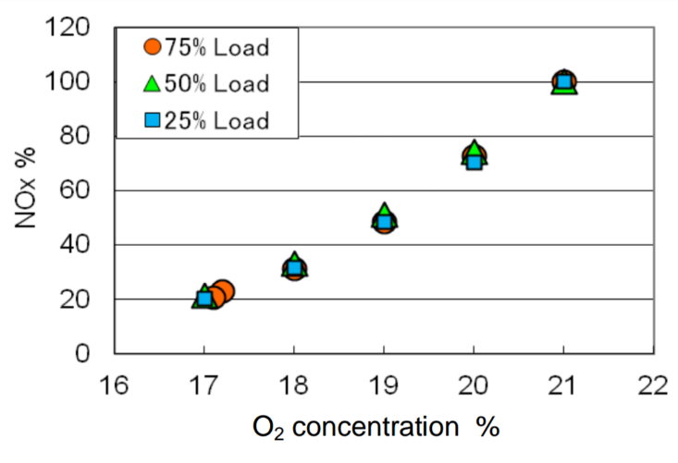
The results established after an experiment conducted on a 4-stroke high speed marine diesel engine by National Fisheries University, Japan stated that the NOx emissions were decreased by approximately 25 and 50% at O2 concentrations of 20 and 19% and, at O2 concentrations of 17% and below, fell to levels that satisfy the IMO tier III requirements. The reason behind this is the reduction in the combustion flame temperatures at lower O2 levels.
Fig3. Change in NOx with O2 Concentration
(CIMAC Congress 2016, Helsinki, Paper No. 176)

4.5] Water Mixed Fuel:
National Fisheries University, Japan has developed an experimental setup of a Water Infused Fuel Generator. It is being used to study the effects of emulsification of fuel with water on NOx Emissions. The WMF generator mixes fuel and water such that the W/FO ratio can be varied over the range of 0-80% without the use of additives by reducing the droplet size to the nano-level and as a consequence of its positioning near the fuel injection system.
Normally, there is a trade-off between reducing NOx emissions and specific fuel oil consumption, such that the SFOC increases as the NOx is decreased. However, this trend is not evident here. Both NOx emissions and SFOC decrease with increasing W/FO ratio.
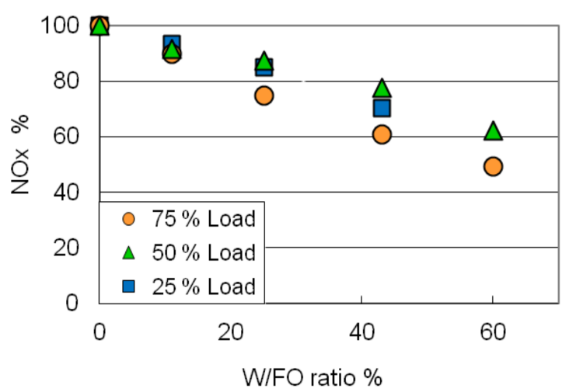
The results obtained after the various experiments were:
At engine load of 25, 50, and 75% in the 4 stroke and 2 stroke engines the NOx emissions were decreased by about 30% when W/FO ratio is 50% in the case of both 2-stroke and 4-stroke engines. Moreover, it was possible to decrease the NOx emissions by approximately 50% at 80% W/FO ratio.
The result of mixing water with fuel oil was more advantageous. The following are the positive effects:
The combustion duration is shortened by the Fig4. Change in NOx with Water-Fuel Ratio
in 4-Stroke Engine
(CIMAC Congress 2016, Helsinki, Paper No. 176)
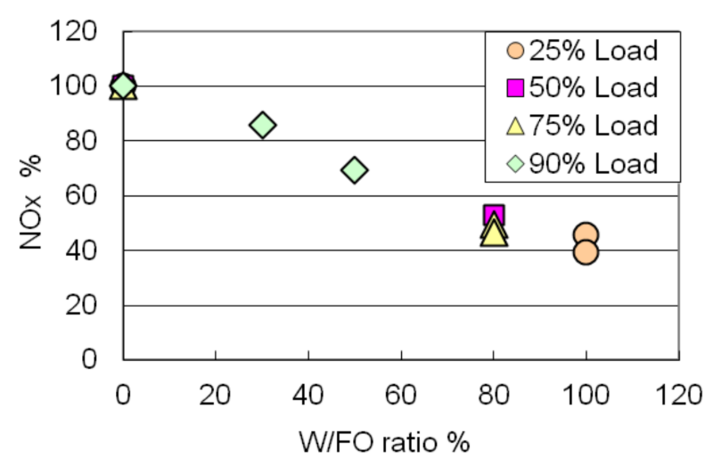
- increase in the amount of entrained air in the fuel spray
- The work on the piston is increased by the evaporated water
- The cooling loss is decreased by the decrease in the flame temperature.
The following are the negative effects:
- The injection duration is lengthened
- There is heat loss due to evaporation of the water.
The SFOC is improved if the positive effects Fig5. Change in NOx with Water-Fuel Ratio
outweigh the negative effects by optimally setting In 2-Stroke Engine
the W/FO ratio and the injection timing (CIMAC Congress 2016, Helsinki, Paper No. 176)

4.6] Combined Effect Of WFM and ORM Systems:
Even when the W/FO ratio is 100%, the maximum decrease in NOx emissions by this method is about 60%, which does not satisfy the IMO Tier III regulations. While, reduction in O2 concentration to 17%, sufficiently reduces the NOx levels to satisfy all regulations, it increased the SFOC 3%. Thus, it is necessary to combine WMF with other technologies;

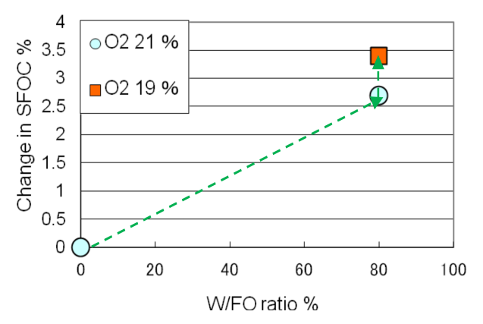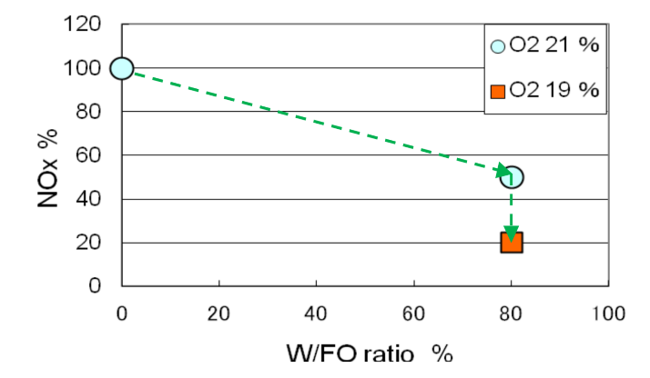
Fig6. Change in SFOC with WFM and ORM Fig7. Change in NOx with WFM and ORM
(2-Stroke Engine) (2-Stroke Engine)
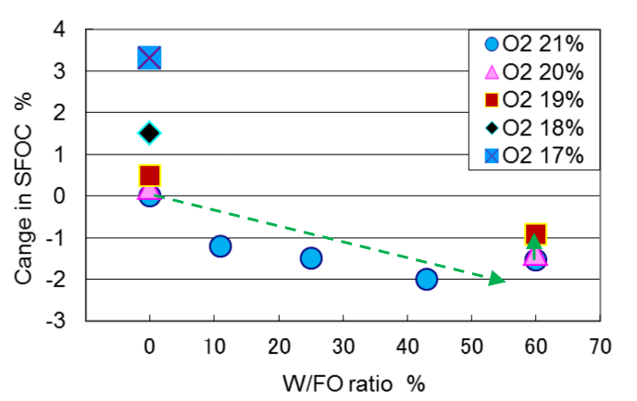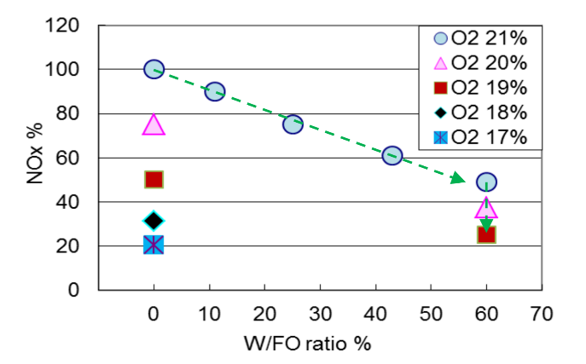
Fig8. Change in SFOC with WFM and ORM Fig9. Change in NOx with WFM and ORM
(4-Stroke Engine) (4-Stroke Engine)
(CIMAC Congress 2016, Helsinki, Paper No. 176)

The simultaneous use of the ORM system was also studied by a team at the National Fisheries University. The NOx level is seen to decrease by about 50% at 80% W/FO ratio. It further decreases by 83% when the ORM is added. The SFOC increases by 2.8% at 80% W/FO ratio and increases by further 0.5% when employing the ORM. These data demonstrate that it is possible to decrease NOx emissions most effectively by combining the ORM and WMF methods. Most importantly, since these systems operate using only air and water, there is no potential harm to the environment under all operating conditions.

5.] Conclusion
Our model, if brought into industrial application, can significantly reduce the NOx emissions by huge amounts thus contributing towards the sustainable development in the maritime industry which is the ultimate goal. These methods lead to a vital increase in the energy efficiency design index (EEDI) of the Marine Diesel Engine. They will not only contribute to the environmental and geological well-being but at the same time, it will maintain an economic balance and will cover a lot of major problems that can crop up, if it is applied to merchant vessels. The time has made it crystal clear that changes have to be made to protect the earth and this model might just be the solution to a lot of adversaries this industry is faced with.
6.] Acknowledgement:
The authors of this paper, would like to express their gratitude to Shri Venkateshwara College Of Engineering for providing them with this wonderful incentive to work on this great project. They would also like to thank Professor Mahajan of Tolani Maritime Institute, Pune for granting them with a great opportunity to explore their talents and learn more about this field. They would also like to thank their friends and families for their constant support and valuable advices. Their contribution is and will be invaluable to the authors and this paper.
7.] References:
- Pounder’s Marine Diesel Engines And Gas Turbines : Ninth Edition – Doug Woodyard
- Joyce Nelson, Stuart Nemser and Donald Stookey (2003), "DIESEL ENGINE NOX REDUCTION VIA NITROGEN-ENRICHED AIR" Paper presented at American Filtration and Separation Society meeting, MI American Filtration and Separation Society.
- The book by V.Ganesan, (2007), "Internal Combustion Engines", Tata McGraw hill publications, pp. 482, 497.
- International Review of Applied Engineering Research. ISSN 2248-9967 Volume 4, Number 3 (2014), pp. 197-202
- CIMAC Congress 2016, Helsinki, Paper No. 176
- Marine Insight
- Indian Marine Engineers Review
- http://www.google.com.pg/patents/US6293084
- https://link.springer.com/referenceworkentry/10.1007/978-3-642-40872-4_1775-1#page-1
- http://pubs.acs.org/doi/abs/10.1021/acs.energyfuels.6b03114?journalCode=enfuem

