Environmental and Social Impacts of Proposed Capital Dredging off Royapuram Fishing Harbour
* K. Balamurugan ª, U. Saravanan ^{b}

ª Institute for Ocean Management, Anna University, Chennai-600 025, India.
^{b} National Center for Sustainable Coastal Management, Anna University,
Chennai – 600 025, India

Abstract

The capital dredging activities can cause degradation of marine water quality and disturb the sea bed morphology (rearrange the sediment pattern) in the Royapuram fishing harbour area. Since it is extremely important that for any dredging operation should have an effective environmental assessment before it’s placed on proposed site. The present study will focus on the impacts of the proposed capital dredging and disposal of dredge materials on the marine ecology and the environment. The study also focuses the socio-economic impacts of the port development and its ancillerally developmental activities.
Keywords: Fishing Harbour, Capital Dredging, Environmental, Social, Livelihood issues
- Introduction
The port of Chennai which was formerly known as Chennai Port is the third largest major port in India and contributing significantly to the country’s GDP. It is situated on the Coromandel Coast in South-East India; the port of Chennai has more than 100 years of tradition. The Chennai port is strategically located and well connected with major parts of the world; today it is one among of the major the hub for the Indian subcontinent. The port authority of Chennai has decided to develop the cargo handling capacity of the port by expanding the port area, which is expected to cover the adjacent Royapuram fishing Harbour region. It is primarily proposed to carry out the capital dredging to achieve the desirable port draft of 14 m depth in the proposed port area before commencing the actual port construction works viz., jetty construction for berthing of the vessels of varying capacities.
- Existing Infrastructure
The marine infrastructure of the Chennai port comprises of three docks of 24 breaths ranging from 12m to 16.5m and has become a major home port for containers, cars and project cargo in the East Coast. The port has capacity to handle 61.06 million tons of cargos at one time and it has now increased to about 6.2% over previous years. Also the port handling capacity will be increasing yearly from 1216438 TEUs (in 2009-2010).

* Corresponding author: rayanbala1987@gmail.com (K. Balamurugan) Tel.: + 91 9489506011
Co –Author: U. Saravanan, Scientist – B, National Center for Sustainable Coastal Management, Anna University Campus, Chennai – 600 025, India.

- Proposed Development
The Chennai city has numerous cars and tools manufacturing industries and most of these products are exported to different countries by large vessels. In order to fulfill the exporting requirements of the manufactured products, the port authority has proposed for a RO-RO terminal and a multi level car parking facility with a capacity of 5000 cars and mega container terminal with a continuous quay length of 2 km with 18-22m side along draft for handling ultra large container ships carrying over 15000 TEU’s.
In order to accomplish the marine infrastructure of the port, capital dredging is proposed to deepen and widen the Royapuram fishing Harbour. The Capital Dredging proposal was published in news paper “The Hindu” Dated 12/07/2013. The quantity of dredging, type of dredger to be used, place of disposal is yet to be decided by the concern authorities.
- Description of Study Area
Royapuram fishing harbour, also known as Chennai fishing harbour or Kasimedu fishing harbour, is one of the major fishing grounds for catching fishes and crustaceans located at Royapuram in the Royapuram area of Chennai, TamilNadu, India (Fig 2.1). The harbour was constructed in 1975 and located north of the Chennai Port (at the latitude and longitude of 13°07'39"N & 80°17'56"E). It is primarily a fisherman community area, where the people migrated from Chepauk village in 1799 during the rule of the East India Company. The fishing harbour is under the administrative control of the Chennai Port Trust and it has 2m draft and 300 m of break waters to navigation of fishing boats.

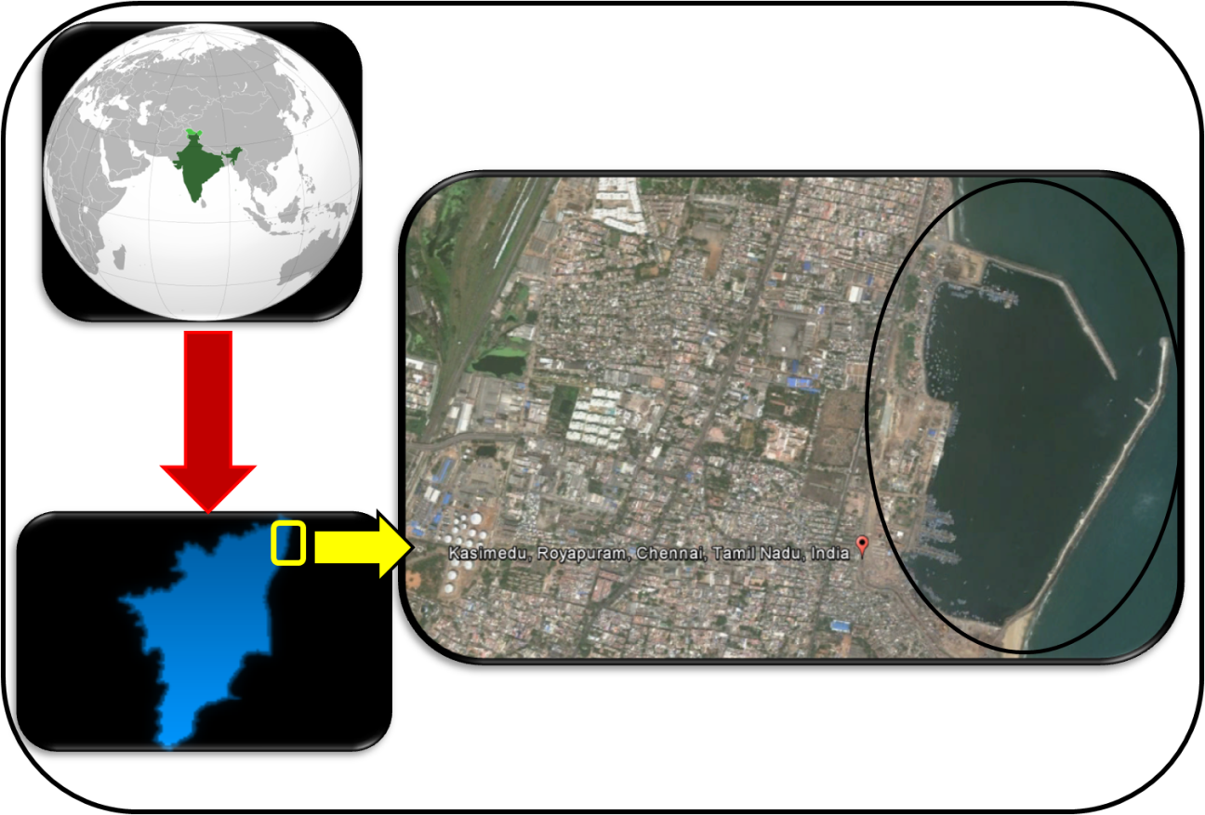

(Source: www.googleearth.com)
Figure 2.1 Location of Proposed Capital Dredging Area

- Demographic Profile of the Study Area - Chennai

The total population of the Chennai according to 2011 Census is 4646732. It is observed that there is 6.99% population growth since Census 2001. Further it is seen that male and female population of the area has increased by 5.24% and 8.79% respectively on Census 2001 to 2011. The Population growth of <6 years is 5.65%. The sex ratio of the area has improved from 957 in 2001 to 989 in 2011. The average family size has come down to 4 people in each house hold from 5 people in each household in 2001.

- Ecological Profile of the Study Area
The Marine Ecological Survey of India has estimated that, total of 52 species of macro benthos and 50 species of meio benthos were found in the proposed study area. The numerical abundance of the macro benthic fauna ranged between 650 and 2675 Numbers/m² and the meio benthic form fluctuated from 89 to 221 Numbers/10 cm². Among, the macro benthos and meio benthos, Cossura coasta and Halalaimus filum, Quadricoma sp. and Microsetella sp. were found to be the dominant species (Varghese et al. 2005). The levels of heavy metals and petroleum hydrocarbon were found to be below permissible level. The dominant fish species groupers, snappers and local crabs present in the proposed area; which provides the basic livelihood to the inshore fishing community. The proposed project area did not cover any marine protected areas and the area is free of ecologically sensitive coral reefs, mangroves and sea grass communities.

- Socio-Economical activities
The Royapuram fishing harbour is an important fishing hamlet in south India and has a capacity to handle 1,395 fishing boats. Over this 600 mechanized boats (45-ft and each operated by 11 peoples), 200 small mechanized boats (30-ft and each operated by 4 peoples), 300 fiber boats with external motor (each operated by 3 to 4 peoples) and hundreds of catamarans. The statistics says that the local people livelihood is based on fishing activities and their dependent activities (ice making, boat making, and boat repairing etc.). It is estimated that about 8500 fishermen (from various area of Chennai such as Royapuram, Royapuram, Light House and Naaneer Kuppam) are getting occupation by fishing activities, but majority of them are not owning any fishing boats. Most of the boat owners are not from the local fisherman communities.

A retail fish market known as the Royapuram fishing harbour market with 90 stalls is located within the Chennai fishing harbour complex. The market sells a variety of fishes including seer, pomfret, prawn, shark, sardine, crab, silver bellies, carangids and mackerel. The trade is mostly carried out by female population of the communities and nearly 30,000 people visit the auction hall situated near the harbour every day. It is estimated that, the daily sales amounting to 200 tons and nearly 30 % is been exported to neighboring states such as Karnataka and Kerala and the remaining is sent to the local markets (Figure 2.2)

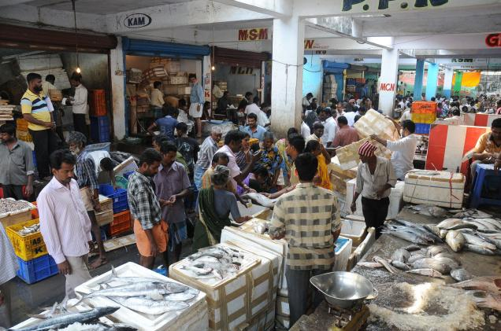

Figure 2.2 Fish market in Royapuram fishing harbour area

The boats are vital tool for fishing. It is type of boat that decides the fishing gear to be used and the fishing ground to be fished by the fishermen. In general different types of boats are used in a Harbour for fishing, such as large and small mechanized boats, fiber boats and catamarans. The fiber boats are brought from a manufactures, where as mechanized boats and catamarans made of wood are manufactured locally. Approximately hundreds of workers involved in the boat making activity (Figure 2.3) and it takes nearly 5 to 6 months to build a mechanized boat. Apart from boat making the retrofitting of old boats and boat repairing also important jobs around the Harbour area. Over all the boat making and repairing activities supports the livelihood of local peoples.

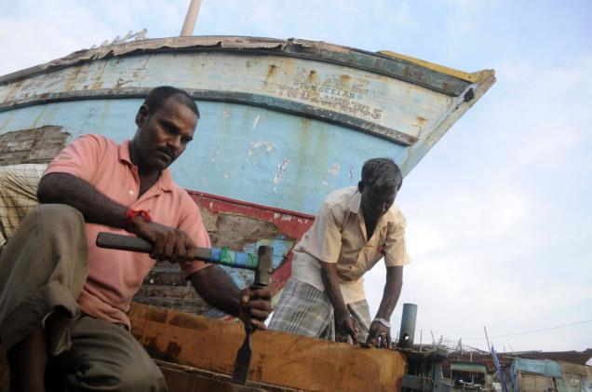

Figure 2.3 Boat making and retrofitting activities in harbour area

In general, different fishing gears and nets are used for fishing for a variety of fish catch. The variety and size of fishes is fully depends on fishing net type and their mesh size. The old men from the local communities involve in the net winding and cleaning of used nets.

- Impacts of Capital Dredging

- Environmental Impacts
The potential environmental impacts of capital dredging are generally in two-folds; i) As a result of the dredging process and ii) As a result of the disposal / dumping of the dredged material. During the dredging process effects may arise due to the excavation of sediments at the bed, loss material during transport to the surface, overflow from the dredger whilst loading and loss of material from the dredger and/or pipelines during transport.

The suspension of fine sediments (silts) in the water column creates turbidity, which scatters and attenuates light levels and potentially affects the growth of plants (phytoplankton) indirectly by reducing the availability of light and consequently the photosynthetic process in plants (Varghese et al. 2003). Also the turbidity causes oxygen deficiency and the result is degradation of marine plants and species.

The dredger has to dig particular depth of a sea bed, so it excavates a large amount of silts from a sea bottom to build an infrastructure for port activities. The disposal of dredge materials is important for any dredging activities; either the disposal may be in deep sea or shore areas and method of disposal also be an important criteria such as, by pipe lines, barge etc. The disposal of fine dredged materials at sea by the Total Hydraulic Suction Dredger (THSD) will cause turbidity in the water Column and it may be settled over deep-water benthic communities (Kudale 2010). That is not likely to be significant since the sediments are fine grained and will therefore become quickly and widely dispersed as compare to rocky and clay materials. The potential severity of the impact would be dependent on the location of the disposal site relative to valuable shallow water ecosystems (e.g. coral reefs, mangroves, recreational bathing waters).

- Social-Economical Impacts
The proposed capital dredging will change the social and economical status of the proposed project development area by taking over the adjacent Royapurama fishing Harbour area. Because, once Royapuram fishing Harbourarea is been taken due to dreding actitvy and port development of the Chennai port authorities, there would not be sufficient space for bearthing of fishing boats and navigational channels. An alternative place will be provided to fishing community to continue their fishing activities and to protect their livelihood. The alternative fishing harbour may be located 25 kms away from original harbour; which would cause significant social impacts on a local community.

- Impacts of fishing activities

The proposed capital dredging will remove all the berths and block the navigational channels; hence the community could not carry out their fishing activities. Apart from this, the dredging causes more noise and under water disturbances which may cause migration of fishes, and hence the local fishing ground would lose the potential fish stock (Addakanna 2006). The alternative fishing Harbour will not be a good solution to a local community, as the communities lives in and around area of Royapuram but a new fishing harbour will be located 25 kms away from their present residence and they have to travel longer distances to reach their working place( alternative harbour). Apart from the fish catch, the trading of fishes is also significant and the fish catch has to be converted to monetary terms before the catch gets spoil, as the fish catch have to be transported over a longer distances to the local markets.

- Impacts on child education and other livelihood
The fishermen and their family ought to migrate from Royapuram to new fishing harbour area for work convenience. As they mighrate to a new place, their children have to travel more distance to reaches the educational institutes, which would affect their education.
Apart from the children’s education, the shifting of fishing harbour also causes an negative impacts on other livelihood activities. For instance; more people are involved in the ice making and boat making activities on 24 hour basis, hence the people cannot engage their work at appropriate time and it will relatively affect the fishing and livelihood.

- Conclusion and Suggestions
Port development is an important ongoing activity over various time scales to carry out effective import and exports and to achieve the economical growth of the country. But on the other hand the social welfare and livelihood of local communities (stakeholders) also important to sustain their life. For the proper sustainable development of the proposed project, the present study will suggest the various recommendations given below.
- The effective Environmental Impact Assessment (EIA) is required for development of Port and environmental baseline studies including; Marine Water Quality, Ambient Air Quality, Sediment Characteristics and biological parameters (as a part of the marine ecological survey Includes the Chlorophyll, Phaeopigment, Phytoplankton, Zooplanktons, Mio and Macro benthos) are to be collected and analyzed in prior to the proposed capital dredging, to understand the environmental status of the proposed project location.
- Great focus to the given in involving public in each step of the decision making by conducting regular public participation and stakeholder analysis of all stakeholders of project development area. All results from a stakeholder analysis should be transparent and understandable by the local community. The beneficial and adverse impacts are categorized with the help of interaction matrix.
- The geomorphology and soil characteristics of the sea bed have to be studied and based on the study, the method of dredging and waste disposal should be effectively selected. The waste disposal area and their utilities should be studied.

Acknowledgements

We thank those who given an opportunity to travel on an education track.

References

1. Addakanna R (2006), Management of Environmental Issues Related to Capital Dredging Works at Port Klang, Malaysia, Shah Alam, Malaysia., pp.957-964.
2. Chartrand, Rasheed and Sankey (2008), Deepwater Sea grass Dynamics in Hay Point Measuring Variability and Monitoring Impacts of Capital Dredging, Department of Primary Industries and Fisheries, Australia.,pp.6-21.
3. Chennai port trust (2008), Port Profile accessed date: 27/12/2013,
URL: http://www.chennaiport.gov.in/Abt_PortProfile.html
4. Environmental Impact Assessment Study for development of Barge Handling Facility in Bharathi Dock, Chennai port (2013), Chennai port trust, India., pp.1-13.
URL:http://www.tnpcb.gov.in/pdf/ChennaiPort_TrustBargehandling191113.pdf
5. Environmental Impact Assessment Proposed Dredging Works at West Harbour, Port Antonio, (2002), Port Authority of Jamaica, Jamaica., pp.12-25.
URL: http://www.nepa.gov.jm/eias/ptantonio/finalreport_ptantonio_dredging.pdf
6. Gupta, Rashmi and Patil (2005), Environmental management plan for port and harbour projects, Indian Institute of Technology, Bombay, India., pp. 133–141.
7.Kudale D (2010), Impacts on Port Developments on Coastline and need for the Protection, Central Water and Power Research Station, Pune, India.,Vol.39(4).,pp.597-604.
8. Royapuram Fishing Harbour (2013), Basic Infrastructure accessed date: 23/12/2013,
URL: http://en.wikipedia.org/wiki/Royapuram_fishing_harbour
9. Varghese1et al. (2013), Biological Aspects of Swordfish, Xiphias gladius Linnaeus, 1758, caught during Tuna Long line Survey in the Indian Seas Chennai Base of Fishery Survey of India, Royapuram, Chennai., India.

