ROBOTIC HULL PROTECTION



Cdt V.ARUN^{*1} Cdt G.VIVEK^{#2} Cdt BINAYAK SHRESTHA^{*3}

*1. Final year marine cadet, Department of marine engineering, G.K.M college of engineering & technology, GKM Nager, New perungalathur, Chennai-600 063.
arun.v.mech@gmail.com ph:+918056141652

#2. Final year marine cadet, Department of marine engineering, G.K.M college of engineering & technology, GKM Nager, New perungalathur, Chennai-600 063.
vivek.gugraj@gmail.com ph:+919790565449

*3. G M E, Department of marine engineering, G.K.M college of engineering & technology, GKM Nager, New perungalathur, Chennai-600 063.
dreamtheatre.binayak@gmail.com ph:+919003248462

ABSTRACT:

This project will develop a fully automated self navigation, multi-functional platform Hull maintenance robot with an advanced navigation system for marine applications. The device developed will offer a means to undertake hull inspection and Maintenance in dry-dock, in port or at anchor thereby improving the potential safety and environmental impact of vessels. The robotic platform will have an innovative Navigational system that will be cost effective and be an economically viable product. Vessel safety has improved in recent years, however Structural failures continue to occur. Therefore any system which is capable of Hull identification system for marine autonomous robotics Funded under framework monitoring the integrity of the vessels hull will provide a valuable Operational tool.
Keywords: Underwater cleaning, Robotic system, Underwater inspection, Ship propulsion, Efficiency

Environmental and legal aspects
There is ongoing discussion at International Marine Organisation (IMO) with regard to Marpol Annex V (Regulations for the Prevention of Pollution by Garbage from Ships). IMO has already defined the residue from hull scrubbing as ships waste and it is therefore covered by the convention. As a consequence of this, it is likely that restrictions will be introduced as to where and how ship hulls may be scrubbed. The scrubbing of hulls by divers is forbidden within many European harbours. Fouling on a hull increases a ship’s drag through the water, thus increasing the amount of power required to maintain the same speed or reducing the speed of the vessel for a given power

INTRODUCTION
- For over 130 years people have thought about machines for cleaning ship hulls.
- Only few developments have found wider application, an example could be hydraulic brush system operated by diver.
- Diver(s) presence enhances the risk of diving accidents at work.
- The number of accidents in offshore and inshore diving is in a range 20-40 for 100000 dives.
- While fatal accidents occur in number of 6-7 for 100000 dives.
- Diver has limited time to be able to work underwater so a team of divers is required to perform cleaning task.
- An open issue is the cost of diver safety measures and environment protection requirements that must be taken into consideration discussing the cost benefits.
- Remotely controlled machines are not able to clean the whole wetted ship surface due to some hull features that restrict the robot operation.
- Ship bow and stern, due to hull shape are very difficult for automatic cleaning and that area will probably be cleaned by divers.
- We have used so many technologies to clean hull in olden days.
Some of the technologies are
- Brush technology
- grid blasting & Sand blasting
BRUSH TECHNOLOGY
- Most systems consist of one or more rotating brushes pneumatically, or hydraulically driven.
- The major problems in cleaning using heavy duty brushes could have damage hull paints.
- It can be used by manual operation.
GRID BLASTING & SAND BLASTING
- The grid blasting is used to remove the fouling only in ship at dry dock condition.
- It can also damage the hull paint.
- It can operate only in manual.

MULTIFUNCTIONAL ROBOTIC PLATFORM:

Robotic platform is to be deployed for the board of the ship, harbour service craft or from the pier using simple care or special launching and retrieval device. The control over the vehicle is provided via the special umbilical with power, control lines and hoses used for removal of cleaning wastes to the surface. Intervention with the use of robot needs some preparation before the vehicle is placed on the surface of the ship hull. The desired situation is the case when digital data of the ship hull construction are provided to the robot control computer. On the other hand, at start of the job a map of the hull is automatically charted, recording the location of every weld, thickness change, rivet and indentation on the ship’s surface. Adjustable jets of pressurised sea water blast the marine growth off the surface of the ship which is then sucked up into the main chamber. Here, ca 150 litres of water a minute is filtered and the bio-fouling removed and rendered harmless to the local environment. In this way, the ship’s robotic ‘vacuum’ can continuously roam the ship’s hull, preventing the build up the layer of slime.

Hull surveying is an important part of any vessel’s life span and a number of periodic inspections of the hull are required during the vessel’s life. Currently, the minimum requirement is for a visual inspection of the hull and with some thickness measurements being taken in specific areas of the hull, or where a probable defect might have occurred. These are usually performed using an ultrasonic sensory system that is placed on the plate’s surface. Due to the size of the detection head and the skill required to operate the equipment, only a small proportion of a vessel’s hull can be accurately measured. A full hull inspection is required to be performed in dry dock every five years, but up to 20% of the hull may not be inspected due to the vessel’s dock supports. Between these class renewal inspections, intermediate hull inspections are required. These are general visual underwater inspections performed by divers. However, in recent years a number of robots have been developed to improve the accuracy, coverage and reliability, while reducing the time and cost of the inspection. The current robotic systems available are limited to visual inspection and ultrasonic plate thickness measurements.

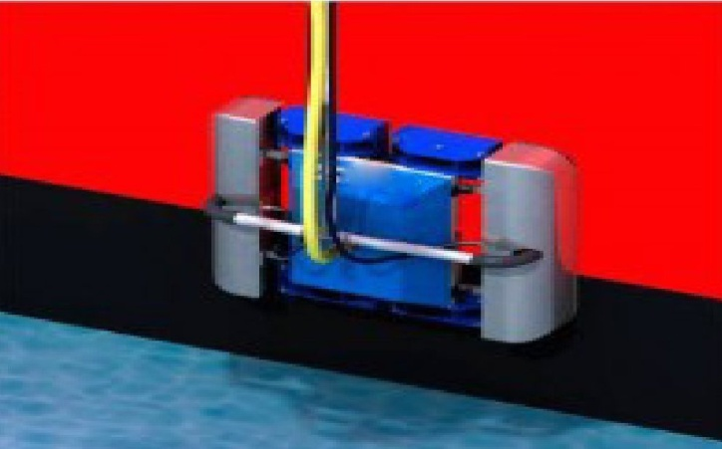

CONSTRUCTION:
- This robot having magnetic wheels for climbing the vertical walls.
- This robot work based on locomotive mechanism. Which consists of three pieces of magnet and two pieces of pure steel plates.
- The robot is powered by DC servo motor.
- Multifunctional robotic platform having ultrasonic sensory system that is placed on plate’s surface.

WORKING:
- Robot needs some preparation before the vehicle is placed on the surface of the ship hull.
- When digital data of the ship hull construction are provided to the robot control computer.
- Map of the hull is automatically charted, recording the location of every weld, thickness change, rivet and indentation on the ship’s surface.

WATER JETTING TECHNOLOGY
- The use of high pressure water jets has become an accepted alternative to brush cleaning systems.
- Water jets can be easily controlled by reducing or increasing the pressure from the pump.
- Adjustable jets of pressurized sea water blast the marine growth off the surface of the ship.
- Then removed bio-fouled are sucked by the vacuum pump.
- Here, 150 liters/m² of water a minute is filtered and the bio-fouling removed and rendered harmless to the local environment.
- Robot is that it is an autonomous system so it can continue cleaning with the ship remaining in service.

HULL SURVEYING
- Hull surveying is an important part of any vessel's life span.
- These are performed by using an ultrasonic sensory system that is placed on the plate's surface.
- When every manual hull inspection taken on once with in five years.
- But 20% of hull may not be inspected by visual. Due to the vessel’s dock support.
- In our robot ultrasonic plate thickness measurement is used measure the thickness of the hull plate.
- This waves are emitted by piezoelectric cell (or) EMAT sensors.
- The same sensor is used to record reflected waves.

ADVANTAGES:
- It will prevent the damage of the hull coating.
- This system improves the efficiency of the ship.
- This system works on totally independent.
- It is not only keeps the ship clean but also feeds back vital information about the hull’s condition.
- All other developed cleaning or inspection systems currently available are remotely
- Controlled during their operation, requiring highly skilled and experienced operators.
- The platform can be launched whenever the vessel is in port or at anchor.

CONCLUSION:
The use of remotely controlled technology for underwater cleaning is subject of numerous R&D activities. Commercially available devices are not cheap and the cleaning in dry dock is much more popular and usually coupled with class surveys. Prime target for robotic tool is to achieve performance and cost of operation at the competitive level. Hull cleaning by cost-effective robotic devices that are able to cope with slime will limit fouling and lower the fuel consumption. The use of intelligent crawling underwater robots will expand as there will be more comparable data available describing ship propulsion performance increase as a result of more frequent robotic cleaning. Collection of reliable data about the financial and technical benefits of the robotic cleaning technology will be important for independent assessment of ship propulsion system performance. Plate thickness measurements and other data describing ship hull condition that will be collected by robot during cleaning missions could be further used by classification societies for class renewal surveys. The hull surveying using innovative robotic technology is in development phase and needs additional founds to be recognized as mature technique recommended for wider use.

