Sky-Sail: Generation of Power from Wind
- Snehadri Banik,
Marine Engineering, Tolani Maritime Institute, Induri, banik.snehadritmi@gmail.com

Abstract: Sky-sail is the genre of engineering science that uses extensive utilization of wind energy to move a vessel in the sea water. The skysail engineering science incorporates the use of towing kites to make the vessel move forward rather than the traditional concept of sails or diesel or steam propulsion. And since the Sky-sails technology allows the towing kite to gain a height of anything between 100 metres – 300 metres, it becomes implied that this is the height where stronger winds tend to prevail. It will lead to immediate and prompt problem solving of the crisis of marine pollution.
Keywords- Sky-Sail, Wind Energy, Towing Kite, Control Pod.
- Introduction:
The shipping industry has witnessed some significant advancement since its advent. More than 90 percent of world trade is moved through the maritime commercial shipping industry. Subject to free market forces, this industry has achieved a high level of efficiency, which has contributed to the expanding global economy by enabling the low-cost movement of goods around the world. Worldwide seaborne trade has more than quadrupled in the last 40 years and now exceeds 6 billion tonnes per annum, with an annual growth rate of about 4 percent.
In order to drive this magnificent structure, generally 3 types of oil are used. Heavy Fuel Oil (HFO), Low Sulphur Fuel Oil (LSFO) and diesel oil. Different countries have different rules for burning fuel when the ship is at that place.
With the natural resources being depleted day by day, humans are in search of cleaner and sustainable sources of energy which can be used in the seaborne trade for the upcoming generation.
1.1 Wind:
Wind is the movement of gas. On the surface of the Earth, wind consists of the bulk movement of air. In outer space, solar wind is the movement of gases or charged particles from the Sun through space, while planetary wind is the out gassing of light elements from a planet's atmosphere into space. Wind moves from an area of high pressure to an area of low pressure.
1.2 Wind Energy:
Wind is one such source of energy which is available in abundant quantity in the seas, but this source of energy hasn’t been yet tapped by the human race. Wind happens to be one of the cheapest, most powerful, and greenest sources of energy on the high seas. If this source of energy can be made to use with the help of modern technology, then we can reduce the consumption of fossil fuels to a greater extent and can also help in creating a cleaner society.
Wind is caused by the uneven heating of the atmosphere by the sun, variations in the earth's surface, and rotation of the earth. Mountains, bodies of water, and vegetation all influence wind flow patterns. Wind turbines convert the energy in wind to electricity by rotating propeller-like blades around a rotor. The rotor turns the drive shaft, which turns an electric generator. Three key factors affect the amount of energy a turbine can harness from the wind: wind speed, air density, and swept area.

1.3.1Equation for Wind Power
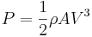
Where,
P= Power Generated
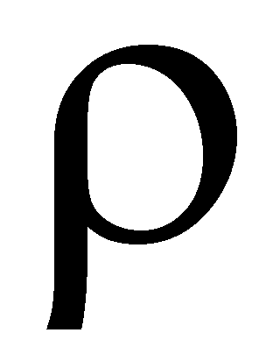= Density
A=Area
V=Volume
1.3.2 Wind speed
The amount of energy in the wind varies with the cube of the wind speed, in other words, if the wind speed doubles, there is eight times more energy in the wind. Small changes in wind speed have a large impact on the amount of power available in the wind.
1.3.4 Density of the air
The more dense the air, the more energy received by the turbine. Air density varies with elevation and temperature. Air is less dense at higher elevations than at sea level, and warm air is less dense than cold air. All else being equal, turbines will produce more power at lower elevations and in locations with cooler average temperatures.
1.3.5 Swept area of the turbine
The larger the swept area (the size of the area through which the rotor spins), the more power the turbine can capture from the wind. Since swept area is , where r = radius of the rotor, a small increase in blade length results in a larger increase in the power available to the turbine.

The mechanical energy which can be generated through wind energy can be used to drive the ship forward. This project deals with the method and technology through which wind energy can be used to drive the humongous engines present in ships.
The technical paper deals with the construction of a parafoil, which has been named as “Sky-Sail” and has been briefly described in the following diagram.
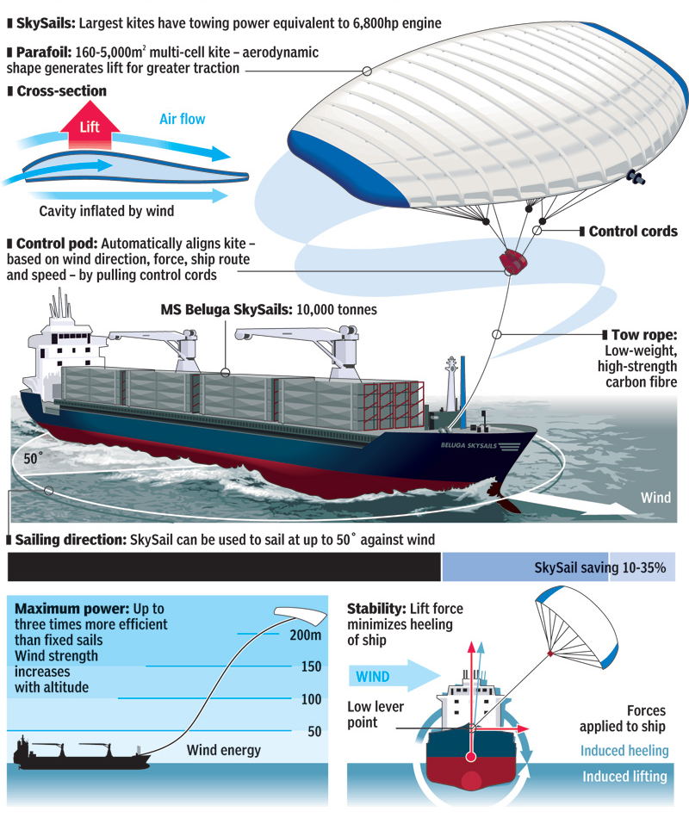
Fig 1: Representation of Sky-Sail
- Principle:
The basic principle is of the project is that of a kite. Kites are heavier-than-air flying structures controlled by three main forces: lift, gravity, and drag. Lift is the upward force created by wind pressure on the face of the kite, which makes the kite rise and keeps it in the air. Gravity is the downward force on the kite which works against lift. Drag is the air resistance acting on the kite as it travels forward. The kite flies most efficiently when the three forces are balanced at an imaginary point, known as the center of pressure. A kite is a heavier-than-air object that flies, just like an airplane. Most kites have three main components: the kite body (which comes in many different shapes and sizes), the bridle (or harness), and the control line (or tether). The kite body is made up of a framework and outer covering. The framework is usually made from a lightweight material like wood or plastic. Paper, fabric, or plastic is then stretched over the framework, turning it into a sort of wing. The bridle and the control line help the kite flyer control the kite. In flight, the kite is connected to the kite flyer by the control line, which is connected to the kite by the bridle. The kite pivots and dives about the point where the bridle connects to the control line.

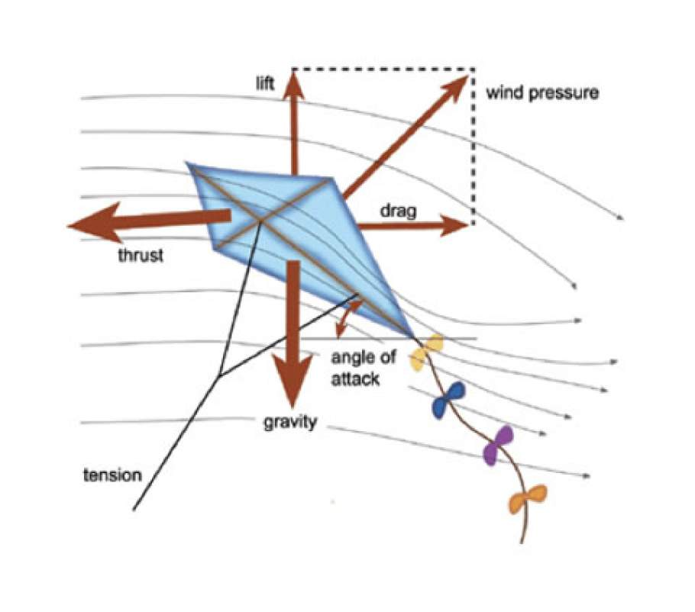
Fig 2: Working of a Kite
3. Components:
3.1 Flying System
The towing kite is the core of Sky Sails propulsion. Together with the control pod and towing rope it forms what is called the “flying system”. Steered by the control pod, the towing kite performs regular dynamic flight manoeuvres in the air in front of the ship to generate propulsion.
This force is transmitted to the ship through a towing rope made of high-strength synthetic fibre. A specialized cable integrated within this rope ensures the supply of power to the control pod and the communication with the control system on the ship.
3.1.1 Towing kite/Parafoil
The Parafoil is a multi-cell aircraft or glider which can be packed and deployed like a parachute. It is made of nylon cloth, and is completely non rigid. It’s aerodynamic shape generates lift for greater pulling power. The largest towing kite has towing power equivalent to a 6,800 hp engine.
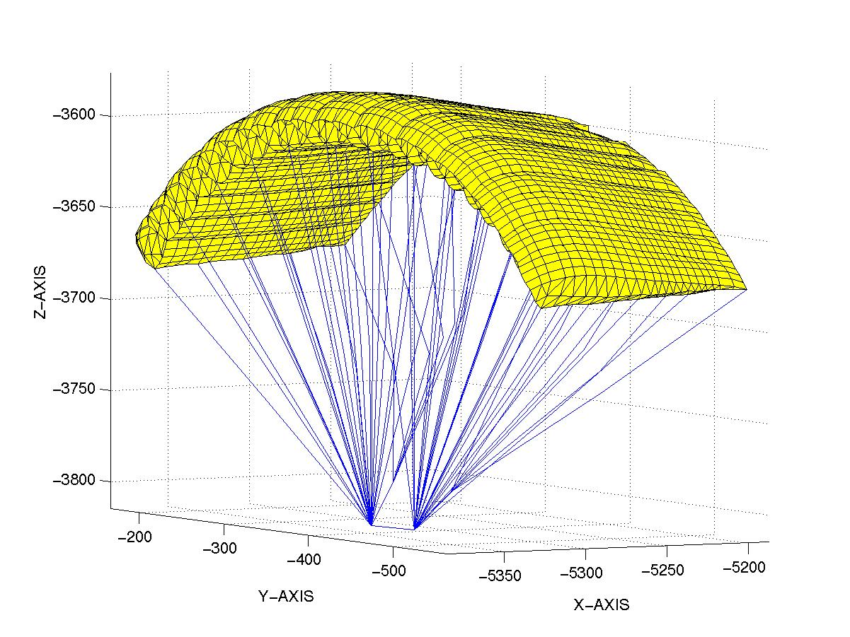
Fig 3: Geometrical representation of Towing Kite
3.1.2 Control Pod
The control pod automatically aligns the towing kite on wind direction, force, ship route and speed by pulling the control cords which can be controlled from the bridge. The system consists in a lightweight kite controlled by an airborne pod which allows the system to be elevated to high altitudes by the wind, negating the requirement for propulsion or a static tower. Implementation includes the choosing of the electronic parts/devices within the system, and also designing the software to allow the system meet the projects specifications. The control part of the system is provided by an FPGA and a microprocessor. These operate the airborne sensors and actuate two servo motors. This control kite’s orientation in order to get the system to the desired position or maintain it, based on some sensors inputs- primarily an inertial measurement unit, through the programming of an FPGA (A field-programmable gate array) and microprocessor. The proper positioning of the pod is achieved, either with a manual control, based on a joystick with a human pilot or an automatic one, based on sensors inputs.
3.1.3 Control Cords
The control cords are made up of high tensile material which is used to change direction and steer the ship to the desired direction by application of tension force.
3.1.4 Tow rope
The tow rope needs to be light weight, high strength carbon fibre which supports the entire flying system. The tow rope is wound in the winch which is present in the forecastle deck.
3.2 Launch and Recovery System
The launch and recovery system, along with the control system, are on-board components that are designed for easy integration and installed permanently onthe ship.
The components are designed according to the requirements of the main classification societies.
All deck components and the “flying system” are housed in the bow area so as not to reduce the ship’s cargo space.
The system does not impair the passage under bridges or loading and discharging operations in port since there are no obstructive superstructures and the towing kite is recovered as the ship approaches land.
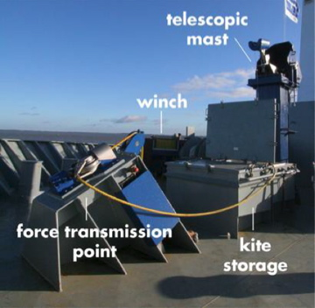
Fig 4: Storage area of the Flying System in the Forecastle Deck

4. Operation:
4.1 Safety and Easy
The ship’s officers can operate the Sky-Sails system using a control panel installed on the bridge. The launch and recovery process is partly automated and requires only a few simple actions by the crew on the forecastle deck.
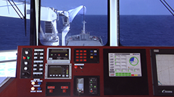
Fig 5: Bridge Control of Launch and Landing of Sky-Sail
4.2 Launching
First, the telescopic mast raises the towing kite, which is folded like an accordion, from its storage compartment. The mast then extends upwards after which the kite unfurls to its full size and is ready to be launched. The winch releases the towing rope until the kite has reached its operating altitude.

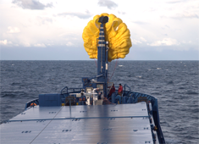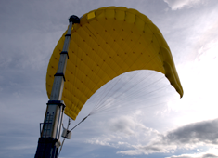
Fig 6: Launch of Towing Kite
4.3 Flying
The towing kite can be controlled automatically at all times while in flight mode. The Sky-Sails control panel on the bridge keeps the ship's officers informed at all times about the system’s operating status.

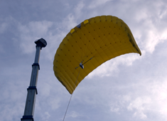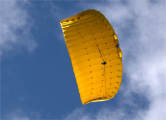
Fig 7: Sky Sail in operation
  - Landing
Recovery of the towing kite is performed in the reverse order as the launch: The winch retracts the towing rope and the kite is docked to the mast. The towing kite is then reefed, after which the telescopic mast retracts, and the kite and control pod are lowered into the storage compartment.
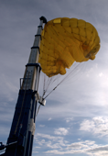
Fig 8: Landing wounding of Sky-Sail

5. Results and Discussions
The Sky-Sail technology has led to the following advantages:
5.1. Reduced Fuel Costs
The Sky-Sails system tows the ship using large, dynamically flying towing kites, which generate up to 25 times more energy per square meter than conventional sails propulsion systems. This equals up to 2,000 kW of propulsion power in good wind conditions. Experience has proven, one kilowatt hour of Sky-Sails power costs just 6 US-cents, or only about half as much as one kilowatt hour from the main engine. The Sky-Sail system is estimated to save fuel as much as to 20%.
5.2. Lower Emissions
Saving fuel also saves emissions. Sky-Sails can reduce ship borne CO₂ emissions while decreasing the output of such pollutants as sulphur and nitrogen oxides at the same time.
The international Maritime Organization (IMO) estimates that up to 100 million tons of climate-damaging carbon emissions can be eliminated worldwide every year with the help of Sky-Sails technology alone.
5.3. Sustainability
Consumers are increasingly calling for products that will not harm the climate, a trend that is strongly influencing the rising demand for environmentally friendly and low-emission logistics.
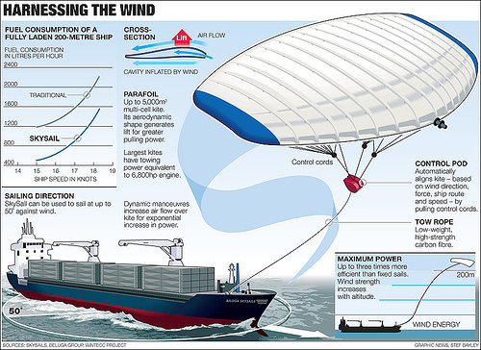
Fig 9

Thus, the Sky-Sail if implemented across the globe can help to conserve fuel and protect the eco system at the same time.
The Sky-System has been successfully in ‘MS Beluga’. With proper initiative this technology can eradicate the problem of fuel scarcity and marine pollution.
8. Acknowledgment:
I wish to express my sincere gratitude to Mr. Arun O. Mahajan for providing us with an opportunity to do a research project on “Sky-Sail: Generation of Power From Wind”.
I would also like to thank Ms. Puja Achawat and Ms. Vandana Shinde for their constant guidance and encouragement in carrying out this research project.
9. References
- http://windeis.anl.gov/guide/basics/
- http://en.openei.org/wiki/Wind_energy
- Parafoil Flight Performance, John D. Nicolaides And Michael A. Tragarz University Of Notre Dame, 1971.
- http://www.drachen.org/learn/kite-basics
- http://www.skysails.info/

