TRANSTECH ’14
Main Theme:
Socioeconomic Impact of Futuristic Technologies
Sub Themes:
High Voltage Applications in Industries and Transportation

TOPIC:
High-Voltage Shore Connections: Technology, Regulations, Standards and Business Cases
BY:
CADET ANUBHAV KUMAR¹, CADET ANKIT KUMAR SINGH², CADET SUDAMA KUMAR³
Marine Engineering & Research Institute, Indian Maritime University-Mumbai Campus, Mumbai, Maharashtra
E-MAIL:1- anubhavgotam@gmail.com
2- zxcankit2@gmail.com
3-sudama.kumar2001@gmail.com

ABSTRACT:

Commercial ships calling at more and more ports worldwide can now turn off their diesel engines and tap into cleaner energy sources provided by electrical connections from shore.

The technology to make this possible has been in place for over a decade. With a global technology standard due to be ratified by three technical bodies in 2010, high-voltage shore connections will soon get much more attention. Environmentally-minded ports, governments and ship owners are all tuning in to the benefits of supplying electricity to ships at berth. Here we present the challenge, the technical solution and the business case for all parties involved.

This paper will explore the case for connecting merchant ships to shore-based power, including the expected benefits, regulations, the technology on ships and on shore, shore based power standardization and a brief look at the business case as seen from the perspective of ship owners and port operators. Assertions related to technology for shore-side electrical connections of ships to shore are based on ABB’s experience delivering this technology to both ports and ship owners for approximately a decade.

- Shore connection technology
- Shore-side technology
The technology required to provide shore-based power to ships at berth is not novel equipment. Engineers today can use existing technology in order to develop a reliable infrastructure to transport the power. Shore-based power demands rigorous technical attention to issues such as safe cable-handling. Costs for the equipment range widely, depending on the specific needs of the port and the power it will provide. Additional investments stem from construction and installation at the quay and potential costs related to strengthening the port’s electricity grid.

The picture of shore-based power infrastructure from the perspective of the port or terminal operator can be broken down into seven basic elements:
1) Enabling the vessel’s power supply
2) A transformer for each ship’s power supply
3) Switchgear equipment such as breaker and dis connector for each ship’s power supply
4) An automated earthing switch for each ship’s power supply
5) A frequency converter, if power frequency needs to be stepped down from 50 Hz to 60 Hz or, vice-versa, stepped up
6) Communications equipment to link the ship and shore
7) Protection relays in order to assure safety for cable-handlers

Power supply in ports is typically equivalent to a small factory, with electricity needed to power shore-side loading and unloading infrastructure such as cranes, belts and gantries, cooling, heating and additional power for incidentals. Most ports have access to enough power to run these consumers, with an additional 2-3 megawatts for incidental needs.

Given that each vessel’s power needs while in port may be as high as 2 megawatts (and may be as much as 10 megawatts), the electrical infrastructure at many ports will be insufficient to handle significant ship-to-shore connections without a major improvement to their grid. This may involve investing in a new substation, or installing a new incoming power line with more power; both of these actions would involve a negotiation with the port’s power provider.

For each shore-based power connection point, the port or terminal must have a dedicated transformer. The transformer serves two purposes. First, it provides galvanic separation (a non-metallic direct connection between the onshore power supply grid and the ship’s internal system), so that an earthing fault in the ship will not endanger the land grid or vice-versa.

Galvanic separation is a requirement to shore-based power connections. Secondly, the transformer steps down the voltage supply from a voltage level optimized for distribution (20 kilovolts, for example) to one of the two voltage levels standardised for shore-based power connections: 11 or 6.6 kilovolts.

Each shore-based power connection point also requires switchgear equipment with an automated earthing switch. In essence, this switch ensures that there is no power in the cables between the ship and shore, while they are being handled and connected. As the highest area of risk associated with shore-based power connections is injury to personnel manipulating the cables and systems, this system is critical.

A static frequency converter is required for most shore-based power connections. The majority of ships operate with 60 Hz supply, whereas local power grids in many parts of the world use 50 Hz. As a result, most shore-based power connections will require a frequency conversion. Static frequency converters provide an economic solution to connect any ship to any grid independent of the required frequency. Depending on the port’s layout, a centralized solution with one converter may serve multiple ships and berths. Thanks to its small footprint the converters can fit into any substation building or container.

Finally, the shore-side infrastructure for a shore-based power connection must include a communications system allowing personnel on land to coordinate the connection of cables and synchronizing the electrical load to the ship and off again. This can be arranged by two computers – one on the ship and one on shore – with Ethernet communication and a fiber optic line incorporated in the cable connection.

As far as scarce quayside space is concerned, the shore-based power connection system need not take up very much space. The substation has a large footprint, but it can be located as far as 10 kilometers from the quayside transformer that will directly supply the vessel with electricity. Quayside there is only a small and secure container-sized room that contains the shore-based power transformer, the switchgear with an automated earthing switch and the operator’s interface. The major benefit of a small quayside infrastructure is that it can be
Made mobile.
- Ship-side technology
In order to use power from the shore-based electricity grid, ships must be either built or retrofitted with equipment that enables the connection to shore, synchronizes the power changeover from shore to ship and connects the incoming power supply to the ship’s auxiliary power system. Ships can be retrofitted over a period of weeks while in operation, or as quickly as a week at a shore-side berth.

First and foremost, the shore-based power needs to get onboard via cables. In some cases, particularly container ships and Roll-On/Roll-Off car carriers, the cable is installed on the ship, and lowered via a spool or drum to the quay, where it is connected. On cruise ships, the cables are always shore-side, and need to be lifted by a crane to make the connection onboard the ship.

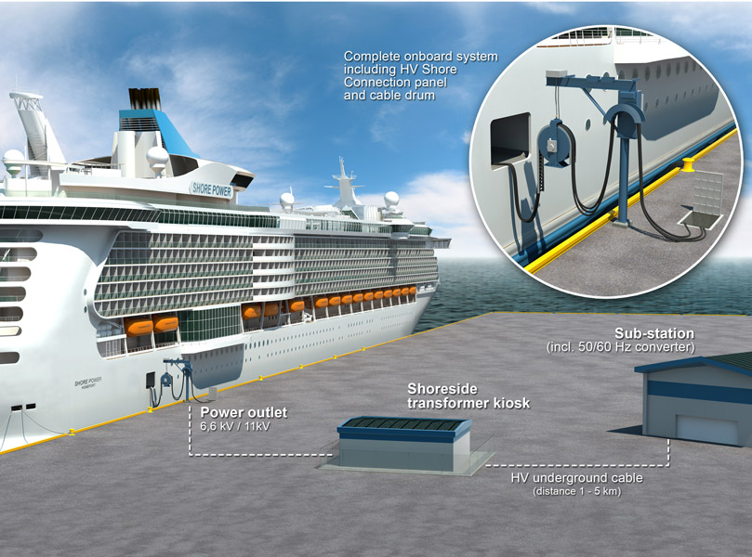
The cable to the shore side power supply is handled with a dedicated cable management system

When the cable-handling system is on shore, the electrical connection is received shipside by a shore connection panel. This panel must generally be located close to the hull and in convenient reach of the heavy shore-side cables. The shore connection panel contains a circuit breaker, a protection relay, the physical electrical connection (plugs and grounding cable) and a control interface with the ship’s integrated automation system, or power management system.

These systems allow the incoming power to be synchronized with the ship’s diesel auxiliary engines before the load is transferred. Shore connection panels provided by ABB include two cabinets, the dimensions of which vary depending on the power rating. This medium-voltage equipment needs to be installed in a dedicated room that can be locked.

On ships that use conventional mechanical propulsion (in which the diesel engines directly power the ship’s propellers, as opposed to diesel electric propulsion), the ship’s low-voltage auxiliary power system – typically 400 to 690 volts – requires a transformer to receive the 11 kV or 6.6 kV power supply from shore. This transformer is relatively large and bulky, but –unlike the shore connection panel – it can be installed in the engine room, or any other suitable location onboard.

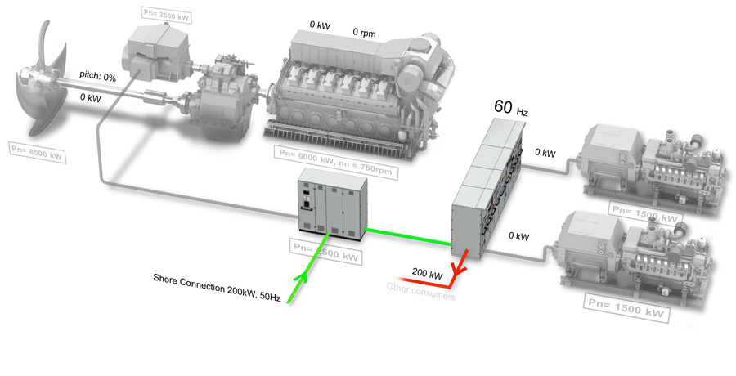
The Shore Connection System is arranged with the Shore Connection Panel located outside the main switchboard room with cable connectors mounted in the front. An onboard transformer steps down the power from high to low voltage.

The process of connecting and disconnecting a ship to the shore-based power supply takes half an hour at the most, and five minutes at the least. Onboard, the chief engineer or some other personnel familiar with the ship’s power management system handle the power transfer.

Cable-handling can be done either by ship personnel or shore personnel, with adequate training to prepare for handling medium-voltage equipment. At least one company has begun investigating an automated system for plugging the cables into the ship, for safety and timesaving reasons.

Today the majority of ships equipped with infrastructure to take shore-based power are container vessels, and many ship designers are either including this infrastructure in their designs or setting aside space for it. Ships in operation today with shore connection equipment have generally been retrofits (adding equipment to an existing vessel), rather than built with the equipment installed.

While little of the technology installed onboard ships for shore-based power supply is new, the entire system must generally be engineered on a case-by-case basis for each installation.

Even if the connection is standardised, ship design is not, meaning that questions of space, accessibility, interfacing with the power management system and the diesel engines all need to be surveyed and assessed prior to installation. ABB, however, has developed turnkey services covering the entire scope of delivery, with minimal interruption of ship operations.

- Pros and cons

For port operators and ship owners, the merits of shore-side connection versus competing emissions-abatement technologies are debatable, and it is difficult for investors to calculate long-term return on investment, as the regulatory picture changes. Fluctuations in the price of marine bunkers fuels compared to shore-based electricity also throw off calculations.

Advantages to shore-based power supply stem from the environmental profile of electricity generated by power plants on land versus ships’ diesel engines running on bunker fuels. Generally, when power production can be reduced to as few producers as possible, these producers can more easily and efficiently be optimized and made environmentally friendly.

Another argument for shore-based power supply is the advantage of jurisdiction. With shore based power arrangements, regulators can deal with a specific, local problem of pollution with a specific, local response. Efforts to capture emissions from auxiliary diesel engines can be used throughout a ship’s operations worldwide, but it takes away any scope of action by local or regional authorities. For ports, the ability to supply power to ships at berth enables them to establish a more efficient and powerful overall electrical supply as a utility. Where ports need to use frequency converters, these provide both a stabilizing effect on the local grid and an improved power factor.

Effectively, this means the local power system experiences lower losses. Shore-based power supply has an advantage to other emissions abatement technologies in that it reduces both noise and vibration in port areas. This is to the benefit of merchant mariners, port workers and the immediate community of ports, particularly large ones. Some ports have encountered growth constraints related to their environmental permits, as their operations’ emissions, noise or vibration levels get too high.

Finally, shore-based power supply is easily scalable; infrastructure investments last for decades with relatively little maintenance, and long-term revenues. For each new port that invests in high-voltage shore connections, the cumulative value of the technology increases by a factor, as more and more ships and sailing schedules are impacted. Arguments against shore-based power supply are related to the provenance of the shore-based power, the costs of investing in infrastructure and safety and efficiency concerns in port operations. Studies have shown that switching from ship-based diesel power generation to onshore coal-powered electricity has a negligible environmental benefit (with increases in particulate matter and, potentially, sulphur-oxides).

With any other kind of power supply, the benefits are considerable; renewable energy sources, in particular, improve port operations’ environmental footprint. The costs of investing in shore-based power infrastructure are considerable, and a template for how governments, port or terminal operators and ship-owners share these costs has not been established. At the port of Gothenburg, for example, a ship charterer determined to improve the environmental profile of its supply chain invested in the infrastructure. At the Port of Long Beach and Los Angeles, which are owned by the local government, port infrastructure is financed by taxpayer dollars. As the cost of emissions and regulations preventing them increase, however, funds will increasingly be made available from private and public sources.

Safety and efficiency concerns in port operations cannot be neglected in a study of shore based power supply. Particularly in the instance of container terminals, with large, rolling gantry cranes, there are issues about the placement of cables and shore-side infrastructure. In ports, space is at a premium. Additionally, both port operators and ship-owners are concerned with the possibility for injuries or deaths related to power connection. Hopefully, the introduction of strict shore connection standards and technical solutions that ensure safe cable-handling will allay these concerns.

- Standardization of high-voltage shore connection systems

In order for high-voltage shore connection systems to make sense for ports and ship-owners, the nature and arrangement of power connections must be standardised. Neither a port nor a ship-owner can justify investment in expensive equipment to enable high-voltage shore connection systems without assurance that such a system will be functional across many jurisdictions and for a defined period of time.

Work on a common standard for high-voltage shore connection systems for ships at berth began early in 2005. Major players in the effort for a common standard have included technology suppliers, governments, port authorities, ship-owners (particularly cruise lines, tanker and container ship companies), classification societies and others.

Work began under the auspices of the International Electro technical Commission (IEC), after a meeting in Delft in February 2005. The following year the International Organization for Standardization (ISO) began studying these standards as well, and – on the initiative of the IMO – these two groups were united in 2007. Early in 2009, the final authority – the Institute of Electrical and Electronics Engineers (IEEE) – joined the same standardization effort. With a joint IEC, ISO and IEEE standard, shore-based power connections would effectively have a water-tight global basis.

Work on a standard for high-voltage shore connection systems began by determining the limitations to such a standard. The standard applies to the specification, installation and testing of high-voltage shore connection systems and plants and addresses:
- The high-voltage shore distribution system,
- The shore-to-ship connection,
- Transformers/reactors,
- Semiconductor converters and rotating converters,
- Ship distribution systems, and
- Control, monitoring, interlocking and power management systems.

The intention of the standards work was to define requirements that “support, with the application of suitable operating practices, compliant ships to connect quickly to compliant high-voltage shore power supplies through a compatible shore to ship connection.” This will hopefully avoid the need for ships or port operators to adapt or adjust their infrastructure to enable connections.

Although work began with the goal of creating a single, global connection standard for all ships at all ports, this was abandoned out of necessity. The power needs and capacities of ships differ so much that a single standard would be unfeasible. As a result, the standards work eventually settled on four separate, but linked, standards – one for Ro-Ro ships, one for container ships, one for cruise ships and another for tankers. In addition, there are two main standard voltages for connection – 11 kilovolts and 6.6 kilovolts. System voltage is limited to 15 kilovolts.

Early in 2010, the three standardization bodies will conclude their work on the global standard and publish its work for final comments. A publicly-available specification (PAS), which is a recommendation of the true copy of the final standard, is available for a small sum from the web-sites of the ISO and IEC. The final standard is approved by the ISO and IEC, and is due for approval by the IEEE by summer 2010.

With a global standard in place, investment in shore-based power connection systems by ports and ship-owners is due to take off. Currently, there are many undertaking studies into such investments, in preparation for the day when a global standard is in place. This is confirmed both anecdotally by port operators and suppliers, and quantitatively by the purchase of the PAS via IEC and ISO.

