MIRACLE –A CONCEPT MODEL OF ECO SHIP ON BLUE HIGHWAYS
AUTHORS:-
- SUDARSHAN.V, SUMANTRA CHAKRABORTY & SOUNDAR.K OF COIMBATORE MARINE COLLEGE
Phn No:- 07598646507

KEYWORDS:

- : Introduction to MIRACLE
- : Ships running in
1: Solar energy
2: Wind energy
3: Diesel electric energy (hybrid)
4: LNG (liquefied natural gas) the best alternative.
- : Conclusion

Introduction
As the use of alternative fuels continues to grow to run heat engines, there is a growing need for technicians to be properly educated about alternative fuel sources as they relate to service issues.
Today, almost all of the fuel we use comes from petroleum. Diesel fuel account for almost 99 percent of our transportation fuel use. The remaining 1 percent is using eco friendly sources like solar, wind, electrical, LNG, etc.... Here are the different types of alternative sources:
MIRACLE aims to give a solution for the above problem by combining the three energy modes viz.
1: Solar Energy: Solar power is the conversion of sunlight to electricity. Sunlight can be converted directly into electricity using photovoltaics (PV), or indirectly with concentrating solar power (CSP), which normally focuses the sun's energy to boil water which is then used to provide power, and technologies such as the Stirling engine dishes which use a Stirling cycle engine to power a generator.
2: Wind Energy: Wind energy is the kinetic energy associated with the movement of atmospheric air. It has been used for hundreds of years for sailing, grinding grain, and for irrigation. Wind energy systems convert this kinetic energy to more useful forms of power. Wind energy systems for irrigation and milling have been in use since ancient times and since the beginning of the 20th century it is being used to generate electric power. Windmills for water pumping have been installed in many countries particularly in the rural areas.
3: Electrical Energy:-Electricity-stored batteries in electric vehicles have been around for a long time. It was also difficult to start the early engines by electricity. But nowadays ships are being run by diesel electric propulsion, which is pollution free and very much eco-friendly.

BUT when it comes to finding a perfect alternative LNG is the best and hopefully the silent fuel of all the time.
4: Liquefied Natural Gas (LNG): Natural gas comes in three forms. One is the low- pressure form you use to cook or heat a home. It comes to you in a pipe from the local gas company. Another form is compressed natural gas (CNG). This form is compressed into high-pressure cylinders to power a car or truck. It comes from special CNG fuel stations. The third form is liquefied natural gas. LNG is made by refrigerating natural gas to condense it to a liquid. The liquid form is much more dense that natural gas or CNG. It has more energy for the same amount of space it takes up. This makes LNG good for vehicles to travel long distances. LNG is cooled to minus 260 degrees Fahrenheit below zero! These LNG are used to run ships to makes the environment free from pollution.
As all these problems are concerned we are presenting our papers on how ships run on alternative sources of fuels & our concept ship
“Ship of the future”

THE MIRACLE

Think!!You and me and the entire shipping community enjoying the essence of true sea, its color, and its varied eco systems.
Ever since fuel oil has come into picture it has started introducing both development of mankind and destruction of our nature. Shipping being the veins and artery of the nations around the world and its development has contributed to nation’s development and destruction of marine resources around the region.
So let’s think of a new ship which can guide us through the dilemma into a future secured for our younger generations to know that what the real color of the ocean is.
Hence we introduce to you the future of ships THE MIRACLE.

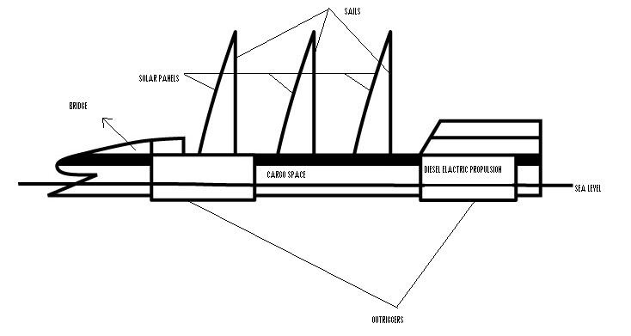

A cargo ship designed to run exclusively on renewable energy. Designed for a future with declining supplies of fossil fuels and increasing environmental responsibility, the concept vessel would use only renewable energy sources.
The ship's design.
Three giant rigid sails manufactured of special lightweight composite materials are covered in solar panels to help drive the ship at its cruising speed of 15 knots. The solar panels are fitted on the front part of the rigid sails. The fins double as propulsion units, driven either by diesel electric energy or other renewable energy sources onboard. Powered by two variable-speed electric propulsion systems known as PODS. This propulsion system eliminates the traditional stern propeller and rudder arrangement. Around half the energy on THE MIRACLE will be produced by combination of solar, wind and diesel electric systems to generate the electricity which will be used in the pod propulsion systems, while also producing electricity for other uses onboard. The only by-products from this process are water vapor and heat. The ship's hull is like a rock oval shaped a new design concept in trans-ocean shipping. The design consists of a wave-piercing slender hull fitted with four outriggers for added stability in heavy seas. Besides picking up wind energy, its large sails generate electricity using solar cells fitted to their entire surface. Eliminate the need for ballast water, another key environmental concern.

This increased level of efficiency has been achieved through the use of lightweight materials, including aluminum and thermoplastic composites, and also by eliminating the need for ballast water tanks and hence reducing any case of oil discharge through the discharge of ballast and bilge systems. The outriggers help the vessel to remain at a certain height thus relieving the entire stress on the ship’s hull. These out riggers are fitted with Propellers within them thus reducing or merely exempting the use of Standard rudders and propellers fitted at the stern. Thus reducing the extra appendages for the ship surface.
And want to change direction then your wind sail is enough to change the direction, i.e., change the sail in direction u want thus making a viable use of the system. The system is efficient and economic.
And rest if both the system fail then the rest propulsion and power system rests with the electric diesel propulsion and this is the one of the most the efficient system and has been successfully installed on cargo vessels in the pacific route.

Solar powered ships

“The Sun Always Shines on TV”, a famous Euro pop song in the 1980s, could be re-released for the 21st century, just slightly modified: nowadays, the sun always shines on PV.
Photovoltaic solar panels have become a symbol of renewable energy and a greener future – unfortunately, they still represent less than 0.1 percent of global energy production.
Solar technology must mature. That means squeezing more kilowatt hours out of each solar plant, at lower cost, in order to reach so-called grid parity. By around 2030 solar power will be produced at 5 to 10 cents per kilowatt hour and will be competitive with fossil fuels.
The various means of capturing the sun's energy - including concentrating solar power (CSV), photovoltaic (PV) power, and solar heating - also represent promising investment opportunities. Public solar firms - such as SolarWorld AG and Evergreen Solar Inc. - were some of the shooting stars on European and North American stock markets in Europe and North America.
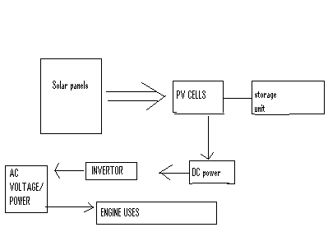
These days, it seems everything from rooftops to cell phones come equipped with solar panels. Now, huge cargo ships are the latest entities to join the solar power fray. The M/V Auriga Leader, recently unveiled an impressive array of 328 solar panels that will power the ship’s main electrical grid, making this the first ocean liner to be propelled in part by the sun’s rays.
The ship’s new solar array is part of a demonstration project organized by Toyota and Tokyo-based shipping company, NYK Line. The project aims to reduce ships’ dependence on diesel, a dirty fuel that releases significant amounts of greenhouse gas emissions even while crafts are docked and unloading cargo at port.

While other ships have used solar panels before to power small electronics like auxiliary lights, the Auriga Leader is the first craft to direct solar power into the ship’s main electrical grid. Energy from 328 panels is helping to power the ship’s thrusters, hydraulics and steering gear, providing about 10 percent of the ship’s total electricity usage hough 10 percent may seem a bit paltry, cargo ships suck up huge amounts of power. A boat the size of the Auriga Leader needs about 400 kilowatts of energy while at port, while a larger vessel like an oil supertanker needs about eight megawatts (enough juice to power 5,500 homes!) to pump its cargo of oil off the ship.The shipping business is extremely toxic to both the earth and human health because of its massive amounts of greenhouse gas emissions and harmful soot and particulate pollution. So while 328 panels on the Auriga Leader may be a small step, it’s certainly a step in the right direction.

Wind powered ships
Passion focused on a singular goal is often the driver of new ideas and technology. Today the focus for many is on saving our planet from the effects of global warming a goal magnified by a global, bipartisan desire to reduce our dependence on oil. For maritime interests the opportunity to participate in a solution is significant. A recent study by the American Geophysical Union confirms long held beliefs that marine transportation is among the most fuel-efficient methods for moving global resources but simultaneously acknowledges shipping as a significant factor contributing to global climate change. By improving on the efficiencies inherent in ocean transport great opportunity exists for this industry to make a significant and lasting impact on the environment. Leading the way in reducing emissions and fuel consumption.
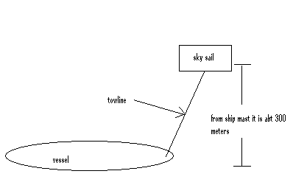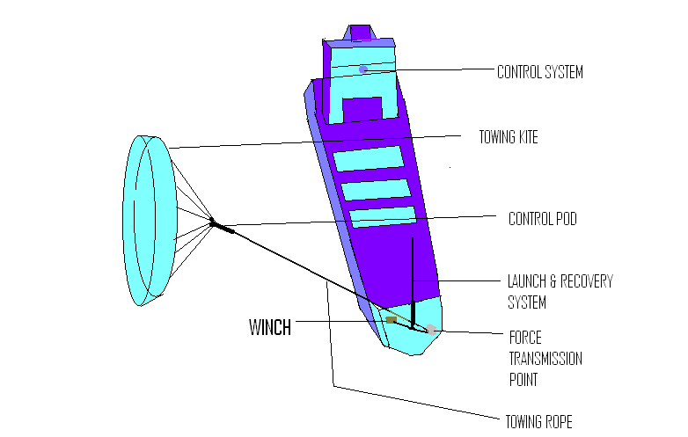

The innovative idea, in terms of both imaginative thought and probability of home run success, of using kites to tow large commercial ships was conceived by inventor Stephan Wrage.
This exciting product finds its origins in the kite surfing community but, unlike its cousin, was not developed in the backyards and garages of enthusiasts for personal enjoyment.

OPERATION OF SAILS:
One area with great potential for improving efficiencies is weather forecasting and routing. As an auxiliary wind propulsion system, the performance, and thus generated fuel & emission savings, of the SkySails system highly depends on the wind conditions prevailing along the routes traveled. In this regard, weather routing is a very important and useful tool as it allows shipping companies to guide their ships to their destinations on the most cost-effective routes while always adhering to schedule.
SkySails towing kites operate at altitudes between 100 and 300 m where stronger and more stable winds prevail. As to that, new forecasting products have to be developed which take these different wind conditions/altitudes into account.
In general, wind speeds on the world’s oceans and thus wind power generated by sailing propulsions depend greatly on the respective region. SkySails did a global analysis of the wind energy potential on the world’s ocean based on a comprehensive database of weather data of the past six years. The results of these computations demonstrate high wind energy potential on most of the main routes of the shipping industry, e.g. on the North Atlantic, the North Pacific or in Northern Europe and guess what this is the busiest sea route of the world.
Of further importance, the SkySails-System is designed for operation in predominantly prevailing wind forces of 3 to 8 Beaufort at sea. The system can be recovered, but not launched at wind forces below 3 Beaufort. Their double-wall profile gives the SkySails towing kites aerodynamic properties similar to the wing of an aircraft. Thus, the SkySails-System can operate not just downwind, but at courses of up to 50° to the wind as well. Test results show that in practice high propulsion power can be achieved on halfwind, reaching and downwind courses from 90° to 270°.

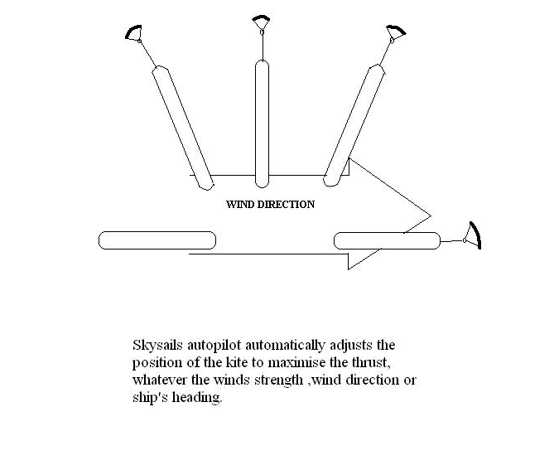
Why
The economic force driving the resurgence of interest in wind power is the rising cost of fuel oil, which has topped $100 a barrel in futures markets. A freighter’s fuel consumption can be cut by 10 percent to 15 percent if a kite is used to pull the ship.
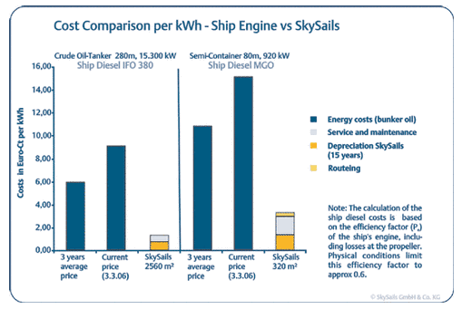
In addition to fuel costs, ship emissions are an important environmental topic for the shipping industry. In a 2007 report published by The Environmental Science and Technology Journal 60,000 deaths per year worldwide were attributed to vessel emissions.

The Competition
Skysail is not the only company looking to provide alternative energy solutions to power commercial ships. From solar sails to wing kites various companies worldwide are looking for solutions that will benefit the environment and cut down on high fuel costs.
Compared to more conventional wind propulsion by sails, there are some benefits involved with applying kites:
- A kite can be actively controlled inorder to create its own flying speed thus increasing its apparent wind speed and the traction force: more traction power can be created with less ‘sail’ area this way.
- Due to the fact that a kite can fly at higher altitudes, it is exposed to higher wind speed.
- Due to the low attachment point of the tow line, the row heeling moment is considerably smaller.
- There are no masts taking deck space
What challenges must be overcome?
Offshore wind projects must strike a viable balance between technological and economic challenges.
Offshore technology has had to adapt to operate successfully in a more challenging environment. Tough weather conditions, which can limit access for routine maintenance, and the saline environment, create the need for more robust turbine parts. This in turn means higher costs, which are not always offset by the higher productivity due to the higher offshore winds.
Continued operational R&D, and policy support that recognizes the value added from renewable energy projects like offshore and onshore wind, will go a long way toward resolving these challenges.
Pursuing ELECTRIC PROPULSION
Introduction:
Diesel electric propelled ships are good option as an alternate fuel. Unlike the conventional diesel engine ships it uses much purified fuel in less quantity. Electric propulsion systems are known to have superior feature in terms of
- Its low noise as well as good maneuverability in low operation.
- Reduced vibration.
Because electric powered ship will convert the power generated by the engine into electric power. The need for realizing diesel electric propelled vessel, providing both environment protection as well as economical solution has come increasingly strong, because environment protection is becoming a key issue in various industries including the shipping industry motivated by the general social interest surrounding the rational use of energy as Kyoto protocol which became effective in 2005.

Working:
Its working is no different from the conventional diesel engine, difference is that instead of using such a large engine as a main engine and a generator as an auxiliary engine, this system uses only generator as a main propelling engine.
CONVENTIONAL ENGINE
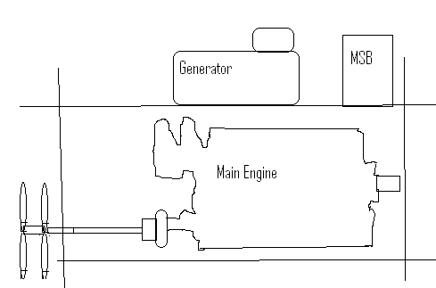
DIESEL ELECTRIC POWERED ENGINE
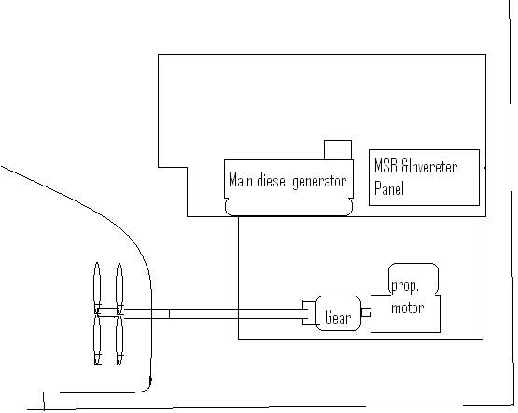

DIESEL ELECTRIC ENGINE ROOM LAYOUT
It consists generators, control panel (switch board), propulsion motor, and controlled pitch propeller (CPP). Contrary to the conventional arrangement where the main diesel engine provides propulsion power and the auxiliary engines provide electricity, the diesel electric propulsion system provides electricity for both propulsion and energy needs of the ship. The need for only auxiliary engines means lower purchasing and operating cost.
Here we have example of this type of ships which are already in existence.
First ship of this concept is shinei maru.
Second ship of this concept is Dai-go Nikkou Maru.

ADVANTAGES:
- These ships don’t have huge engine which means less noise in engine room .
- These small engines contribute in keeping less vibration, which gives more life to hull of the ship by reducing the stresses caused by the vibration.
- Provides good maneuverability in low operation.
- Environmental Solution and yet economical—
With the adoption of CRP(contra rotating propulsion) efficiency is improved so that cargo transporting fuel consumption per ton- kilometer become superior to that of the conventional ships of similar size.
- Improved flexibility of engine room-Since the propulsion system is driven by electric motors, there is no need to align the position of prime mover to the propulsion shaft. which will ensure more freedom to engine room in deciding the engine room arrangement . Required space of machinery reduces which increases the cargo spaces.
- Reduced maintenance work and cost.The power supply system for the electric powered ships are normally configured with 3 or 4 sets of electric generators of the same capacity, and this will leads to the possibility of using smaller spare parts which in turn reduces the cost of maintenance.
- Superior Compliance to change in propeller load-Change in propeller load has been one of the key causes of trouble for conventional ships with direct coupling of engine to the propeller, but electric powered ships are not affected by such change in load allowing continued fixed revolution operation. Further electric motors are inverter controlled and quickly responds to the changes in the propeller load.

- Improvement of Safety and operational stability-Diesel electric propulsion vessels source the electricity from a number of electric generators, while the CRP uses two sets of electric motors driving the two separately independent shafts, resulting in very high redundancy against risk of unexpected occurrences.
CRP can be operated using similar operating skills and sensitivity as the conventional ships. Moreover electric motors have the advantage of delivering high thrust in lower revolution range giving extra feeling of safety during port operations on arrival and departure.
LNG powered vessels
Switching from HFO to natural gas will significantly reduce all important exhaust Gas emissions from a ship, including a 30% reduction in CO2 emissions. The main reason for this reduction is the fact that the main component of natural gas (NG) is methane, which in turn is the most efficient hydrocarbon when measuring energy content against carbon
content.
By running on LNG instead of HFO, the main emissions can be reduced accordingly:
-.30% lower CO2(Thanks to low carbon to hydrogen ratio of fuel)
-85% lower NOX(high air-fuel ratio)
-.No SOX emissions(Sulphur is removed from LNG when)
-NG is liquefied
-Very low particulate emissions
-No visible smoke and sludge deposits.
LNG Propelled Ship – As part of its development work, Wärtsilä has developed a new coastal cruise ferry using liquefied natural gas (LNG) as fuel. LNG is an efficient way to cut emissions. All SOX emissions are eliminated and the NOX and CO2 emissions are reduced by about 80% and 20% respectively (see figure 1). LNG is not only an environmentally sound solution, but also economically interesting at today’s oil prices.
The new ferry is designed for cruising along the Norwegian coast between small coastal communities. As this still represents a relatively untouched natural landscape, an environmentally friendly ship solution is required. The same ship and machinery concept could also be applied easily to other passenger ship operations, such as short-route ferries and expedition cruise vessels
Wärtsilä has, together with Aker Yards, designed a cruise ship concept using LNG as fuel. How the gas will improve the performance of the vessel? The ship has a volume of 125,000 GT and almost 2800 lower beds.

Main particulars;
- Gross tonnage...............125,000 GT
- Length overall........................ 310 m
- Length, bp............................. 295 m
- Breadth.................................... 40 m
- Draught, design...................... 8,6 m
- Deadweight..................... 10,000 ton
- Service speed, max............21.0 knots
- Lower beds (no.)...................... 2780
- Pax cabins (no.)........................ 1390

As the IMO is also currently dealing with some draft rule proposals, the availability of governing rules is likely to improve LNG storage. However, the big challenge for LNG storage comes from the larger size of the tanks. In order to produce the same amount of energy, the volume of LNG is 1.8 times that of diesel. LNG has to be stored at -162°C for it to remain in liquid state, so this requires special tanks with good insulation. This means thicker walls that take up additional space. The most common LNG tank used in existing LNG ferries and supply vessels is a cylindrically shaped, double walled, stainless steel pressure vessel. Thus, the actual volume needed for the LNG storage compartment is about four times that of diesel tanks, taking into account the lost space around the a cylindrical tanks.
A new location for the LNG tanks has been developed for the LNG cruise ship concept. The tanks are located in the centre of the superstructure, inside the outer row of cabins and in front of the engine casing. The advantage of this location is free access to open air. This provides for an ultra safe storage location. Any possible leak, even though this is very unlikely, will evaporate and disperse directly into the air. No pressure build up is possible either, since the space has an open roof that cancels any pressure increase from fire. A stainless steel tray beneath the tanks prevents possible leaks of cold LNG to come in contact with the ship steel structure. Wärtsilä has also made an alternative design, with the LNG tanks in the conventional location on the tank top down in the hull. The idea in this case would be to use International Gas Carrier code B-type low-pressure stainless steel tanks. These would be cheaper to buy and would take up less space, as they can be rectangular in shape .The propulsion consists of twin FP (fixed pitch) propellers on shaft lines, each driven by a low-speed electric motor. The Wärtsilä 50DF engine has high efficiency and can run on either gas or diesel. It uses low-pressure gas and adopts a lean burning process. The air gas mix is ignited by a small pilot fuel injection of diesel oil. The Wärtsilä 50DF engine has already been ordered for more than 52 LNG carriers with a combined output of more than 2000 MW. The LNG is fed from the tanks down to one of two small compartments containing a heat exchanger, which evaporates the liquid to gas, and a gas valve unit for each engine. The gas is led from each valve unit through double wall pipes, directly to each engine. There are no pumps or compressors needed. The gas is fed by the pressure in the LNG tank, which makes for a very simple and reliable system. The pressure in the tank is maintained by evaporating some of the LNG in a separate heat exchanger located in the tank room. In order to heat the LNG, the heat exchangers use a glycol water mix. For improved energy efficiency, most of the heat is taken from the AC cold water circuit. This will actually provide chilling power for the HVAC system, thereby reducing the AC compressor power demand.
SAFETY:
- Gas is sometimes wrongly considered to be a dangerous explosive. This is, however, very far from the truth. Natural gas is actually a very safe fuel – especially if the installation is correctly designed. The LNG cruise ship concept represent one of the safest, and most reliable merchant ship designs .The engine rooms contain gas detectors that will detect even the tiniest gas leak.
- The ventilation is also increased to avoid any build up of gas. This is in fact, one of the more important features of gas safety principle. There will never be a build up of any large quantities of gas.
- All gas pipes are double walled or enclosed in a separate duct. The space between the pipes are ventilated and equipped with gas detectors. Any gas detection will lead to an automatic shutdown of the gas supply. The ship will then switch to diesel operation to allow for uninterrupted power supply. Only the amount of gas that is consumed will be evaporated and brought into the engine rooms. The rest will be in liquid form in the LNG tanks located in the separate tank compartment, isolated from any machinery.
- Safety is also enhanced by the location of the tanks, above the ship and with free access to open air .The nice thing with LNG storage is that in liquid form, natural gas cannot ignite. It is simply too cold. Also, when it has evaporated into gas form, it is still very difficult to find the right mixture of gas and air to allow it to burn.
- Furthermore, the ignition temperature of the air gas mix is much higher (600°C) than that of diesel. There are no surfaces in the engine room hot enough to ignite gas. Gas is also lighter than air, so it will quickly disperse upwards in case of a leak.
Availability of gas:
Natural gas is, nevertheless, available in many places. Access to LNG is easiest in areas relatively close to LNG receiving and export terminals Since a ship would be such a big LNG customer, most gas suppliers would certainly be ready to provide the gas needed.
Conclusion

An alternative fuel vehicle is a vehicle that runs on a fuel other than "traditional" petroleum fuels (petrol or diesel); and also refers to any technology of powering an engine that does not involve solely petroleum .Because of a combination of factors, such as environmental concerns, high oil prices and the potential for peak oil, development of cleaner alternative fuels and advanced power systems for vehicles has become a high priority for many governments and vehicle manufacturers around the world.

“GO GREEN”

