Reduction of Ship Weight using Aluminium Foam

Report submitted for
Transtech 2014

By
Eugene Fonseca (201137TP174)
Satej Joshi (201137TP198)
Amey Peshwe (201137TP130)

On
Dec 31, 2013



Tolani Maritime Institute, Induri

Acknowledgement

Any project idea requires authenticated inputs based on well-rounded research. This was provided to us by Fraunhofer Institute for Machine tools and Forming Technology, based in Chemnitz, Germany through their Head of the Department, Dr. Thomas Hipke. This invaluable support is greatly acknowledged.

We express our sincere gratitude and admiration for Mr. AYAZ KHAN for his extraordinary contribution towards this project and for guiding us throughout our work with finite element modelling (FEM).

We would like to thank Cdr. BHASKAR WALIMBE and Mr. SHISHIR DUTT for the key inputs provided which have been instrumental for our project.

We wish to acknowledge the help rendered by Dr. SANJEET KANUNGO and Dr. SANJAY POHEKAR for going through our project and giving us their valuable feedback.

We admire and respect Mr. INDRA BASU and Mr. ARUN MAHAJAN for encouraging us to work on this topic.

Finally we thank all the instructors in the fitting section for helping us prepare a model for our project.

Abstract

Maximising vessel utilization by improving cargo carrying capacity while adhering to safety and environmental standards has always been the aim of the shipping industry.
To achieve this aim, numerous projects have been done primarily centred on increasing the engine power, increasing the size of the ship, reducing the drag and so on, however the avenue of reduction in ship weight has been neglected.
This paper focuses on a new concept that is the reduction of ship weight by the use of an aluminium foam sandwich. Aluminium foam is a type of metal foam known for its interesting combinations of physical and mechanical properties such as high stiffness in conjunction with very low specific weight and high compression strengths combined with good energy absorption characteristics.

This paper will attempt to convince the reader by analysing a sample hatch cover for its strength, weight and deflection. This paper has been backed up with Finite Element Modelling (FEM) to prove that aluminium foam sandwich is a viable alternative to steel.

Contents
Acknowledgements 2
Abstract 3
Keywords 5
Introduction 5
Materials 6
Aluminium Foam 6
Open Cell 7
Closed Cell 8
Manufacturing 9
Liquid metal process: 9
Metal powder process: 10
Sandwich 11
Manufacturing 12
Precursor Method: 12
Advanced Pore Morphology (APM) Foam: 13
Bonding 14
Ex-Situ Bonding 14
In-Situ Bonding 14
Types 16
Results 18
Methods of Joining 19
Forging 19
Age Hardening 20
Welding 20
Application 21
Results: 24
Cost and Savings 25
Marine Environmental Impact 26
Conclusion 26
Appendix 27
References 31

Keywords
Aluminium Foam, Face Sheets, Sandwich, Hatch Cover

Introduction
Steel has always been the chosen material for ship construction owing to its excellent material properties. However, steel comes with some inherent drawbacks such as high mass density and low stiffness to weight ratio. Density is a factor which we cannot change but the stiffness can be increased by using stiffeners or by increasing its moment of inertia which would further result in additional weight. In the merchant industry, due to draft limitation, we need to limit the structural weight to carry more cargo.
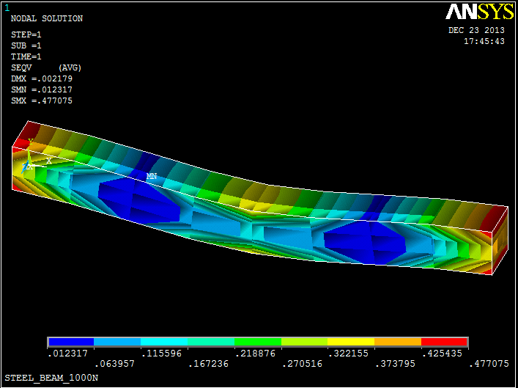
Figure 1: FEM analysis of 1kN point load acting on a simply supported steel beam
From figure 1, it can be observed that when a beam bends, maximum stress is induced in the uppermost, lowermost & extreme ends of the beam. The central core remains almost unaffected by the bending stress. The core does not really contribute to strength but results in additional weight which is not needed.
This core if replaced by a light weight material could reduce the overall weight of the beam and this is the thesis of the project.

Materials
Aluminium has emerged as the best alternative for replacing the core material of a steel beam due to its ease of availability and high strength to weight ratio. The properties of aluminium and steel are compared below.

Figure 2: Material properties of Aluminium and Steel
Aluminium properties can be further enhanced for weight reduction by replacing it with aluminium foam.

Aluminium Foam
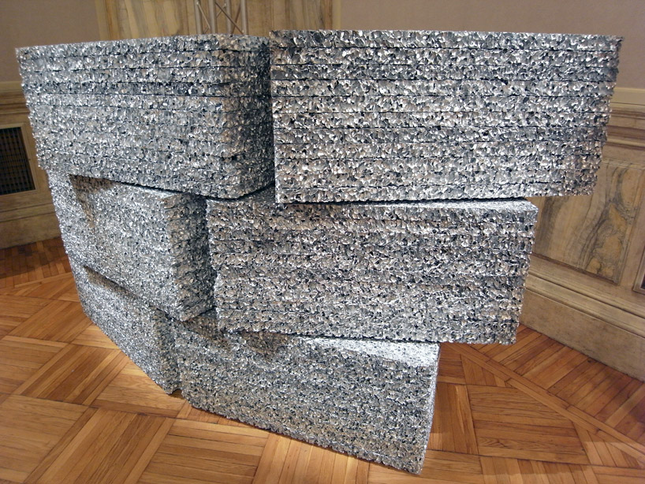
Figure 3: Aluminium Foam sheets stacked one above the other

Aluminium foam is a cellular material defined by solid material surrounded by a three-dimensional network of voids. As a lightweight, porous material, aluminium foam possesses a high strength and stiffness relative to its weight, making it an attractive option for a variety of applications. The properties of aluminium foams make them desirable materials for use in situations where high strength and stiffness to weight ratios are essential, as well as applications where energy absorption and permeability characteristics are valued. Aluminium foams are mainly being used in aerospace, filter and impact or insulation applications. Foamed materials are also useful due to their favourable sound absorption, fire retardation and heat dissipation properties.

The porous nature of these materials results in ultra-light weight materials having densities below 1000 kg/m3.

Figure 4: Density difference between the materials

The most basic classification of aluminium foams is the degree of interconnection between adjacent cells within the microstructure of the material.

Aluminium foam can be broadly categorized in two types:
- Open Cell
- Closed Cell

Open Cell
Open-cell foam is comprised of only cell edges, or ligaments, so that open spaces exist between adjoining cells.
Closed Cell
Closed-cell foams are defined by solid faces so that each cell is closed off from those adjacent to it.

Figure 5: Open-Cell Foam Figure 6 Closed-Cell Foam

Mechanical properties:

Structure | Open Cell | Closed Cell
Density, (g/cm³) | 0.16 | 0.3-1
Young’s modulus, (E) |  | 12
Shear modulus, (G) | 0.3 | 5.2
Comp. strength MPa | 3.0 | 14
Tensile strength MPa | 3.5 | 30
Figure 7: Comparison between Open and Closed Cell Foam

The mechanical properties of closed cell are far more suited for industrial applications and so in this paper, closed cell aluminium foam is dealt in greater details.

Manufacturing
The method of manufacturing aluminium foam can be classified into two types:
- Starts with liquid metal.
- Starts with metal powder.

Liquid metal process:

Alporas Process:

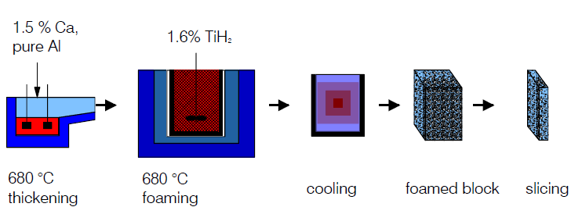
Figure 8: Alporas Process
Another process for production of Aluminium Foam has been developed by Shinko Wire Co. Ltd. based in Osaka, Japan. In this procedure, 1.5% calcium is added to the aluminium melt for adjusting its viscosity. Calcium is introduced to the molten aluminium at 680°C and stirred for 6 minutes in an ambient atmosphere. This results in a thickened aluminium melt which is poured into a casting mould and stirred with an addition of powdered TiH2 (foaming agent) by using a rotating impeller. If a sufficient amount of the hydride is added (usually 1.6%) the foaming agent decomposes under the influence of heat and releases hydrogen gas. Thereby, the foam expands and fills up the mould within 15 minutes. It is cooled by fans in the mould and solidifies as a block with porosity between 89% and 93%. A cast Alporas block is 450 x 2050 x 650 mm and weighs 160 kg. This block can be further cut into required sizes.

Metal powder process:
IFAM Process:

Fraunhofer Institute for Manufacturing Technology and Advanced Materials (IFAM) based in Bremen, Germany has developed the metal powder process.

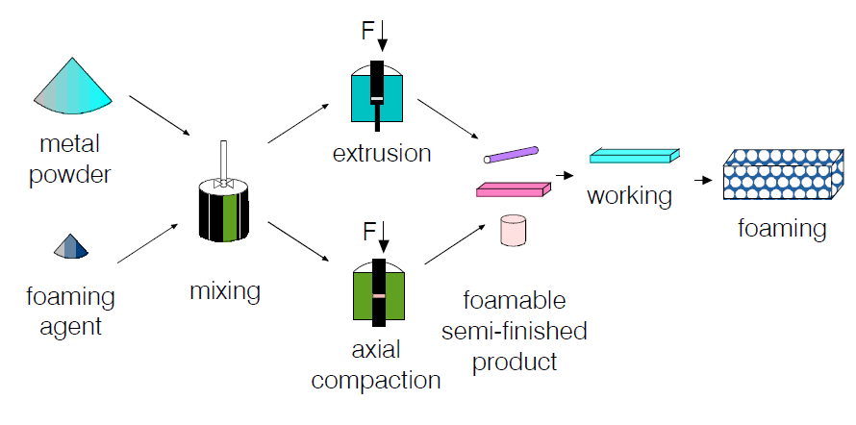
Figure 9: IFAM Process

Technologies based on the use of foaming agents start with the mixing of the metal powders (pure metal, alloy or powder blend) with a foaming agent (usually 0.4 – 0.6 wt.-% TiH₂). The most common alloy used are AlSi₁₂ due to its excellent foamability as a direct result of low melting point and good foaming properties. The mixture is compacted to a dense, semi-finished product by uniaxial compression, powder rolling or extrusion depending on the required shape. The next step is a heat treatment up to the melting point of the matrix metal and above the decomposition temperature of the blowing agent. At this temperature the foaming agent decomposes and releases hydrogen gas. This gas leads to an expansion of the material resulting in a highly porous structure with closed cells. By cooling under the melting point the foaming process is stopped. The porosities range from 60% to 85%.

Properties of Aluminium Foam:

Alloy | AlSi₁₂ | AlSi₁₂
Foaming Agent | TiH₂ | TiH₂
Density (g/cm³) | 0.54 | 0.84
Compression Strength (MPa) | 7 | 15
Energy Absorbed at 30% Compression (kJ/kg) | 3.7 | 4.8
Modulus of Elasticity  (GPa) | 5 | 14
Figure 10: Difference between two aluminium foams
As it is apparent from the above table that Aluminium Foam alone lacks strength. To increase its strength and to be able to use it in industrial and structural applications, it is necessary to sandwich it between two face sheets.
This will result in a stronger composite structure.

Sandwich
A sandwich-structured composite is a special class of composite material that is fabricated by attaching two thin but stiff skins to a lightweight but thick core. The core material is normally low strength material, but its higher thickness provides the sandwich composite with high bending stiffness with overall low density.
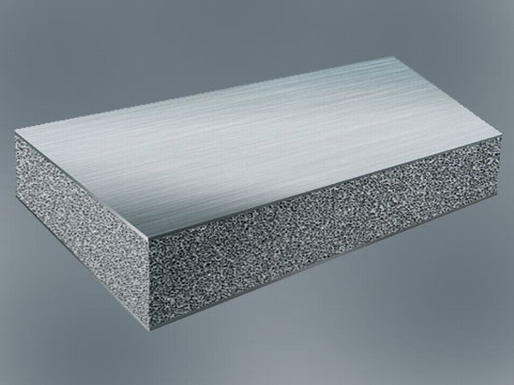
Figure 11: Aluminium Foam Sandwiched between face plates.

Importace of face sheets:

The question arises why even use face sheets?
As it has been discussed, the stiffness-to-mass ratio of a foam is higher than that of the corresponding dense material.
However, aluminium foam on its own is not able to handle excess load and tends to fail.

So it is necessary to cover it with metal sheets which would in turn handle the load. These metal sheets act as closed outer skins or a mould in which foam is expanded. On the other hand, using simple sheets is the worst thing one can do to optimise stiffness. A proper sandwich design based on dense face sheets can optimise compressional, tensional, torsional or flexural properties much more efficiently

In practice, materials selection of face sheets is guided by various aspects such as, 1) ability to produce 3D shapes, 2) costs, 3) elastic limit, 4) failure mode,
5) Damage tolerance, 6) available joining technologies, 7) damping behaviour, and other properties.

Manufacturing
Two widely used methods of manufacturing are available for aluminium foam sandwich:

Precursor Method:
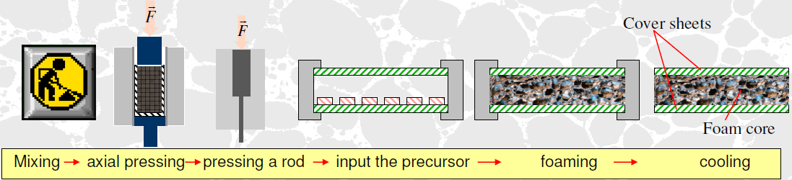
Figure 12: Precursor process

As in the IFAM process, the mixture of metal powder and foaming agent is compacted into a dense, semi-finished product. This semi-finished product is also known as “precursor”. The precursor method developed by Fraunhofer Institute uses a continuous extrusion technology for the compaction of the mixture. This precursor so formed can be then inserted into a hollow mould for attaining any desirable shape. The precursor so inserted into the hollow mould is then heated for initiating the foaming process. Foam and metal parts can be joined during the foaming process.
This process is most widely used for the production of sandwich panels consisting of foamed metal and face sheets.

Advanced Pore Morphology (APM) Foam:
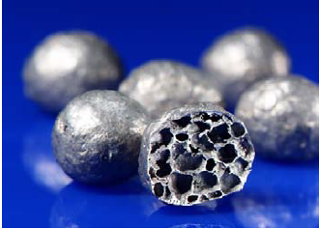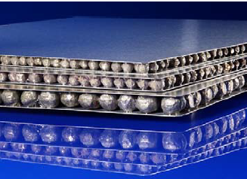
Figure 13: APM method developed by IFAM

In the APM method, the well established powder-metallurgical process for the production of foamed metals have been improved upon by separating the two main processes which are:

- Foam expansion.
- Foam part shaping.

APM foam parts consist of small volume metallic foam elements which are expanded while heating resulting in bulk prodcution. These elements are joined to each other in a separate process resulting in formation of APM foam.

APM Foam element:
- Material: Aluminium Silicate
- Density: 0.5 to 1.0 g/cm³
- Diameter: 5,10,15 mmr
- Shape: Spherical

The steps involved are:
- The APM foam elements are adhesive coated.
- These elements are placed between the face sheets.
- The structure is heated in a hot press. The adhesive is activated and cured for joining all layers to form the sandwich strucutre.

The material and thickness can be adjusted according to the desired application.

Bonding

There are two methods of bonding between the face sheets and the foam core:
- Ex-situ bonding
- In-situ bonding

Ex-Situ Bonding
Ex-situ bonding deals with gluing face sheets together with aluminium foam by means of adhesive bonding, brazing or diffusion bonding. Foams used can be both closed-cell as well as open-cell.
However the bond formed is quite weak in comparison to In-situ bonding.

In-Situ Bonding
In-situ bonding is only for closed-cell foam cores.
It results in a metallic bonding between the foam core and face sheets.

Three types of methods are available for achieving metallic bonding using In-situ bonding:

Rapid Solidification: This process is used where aluminium face sheets are required. In this it is necessary to rapidly solidify the surface of a foamable molten metal before it can foam into to a dense skin while the interior of the metal evolves to a foam structure. This process yields in an integral-type foam structure.
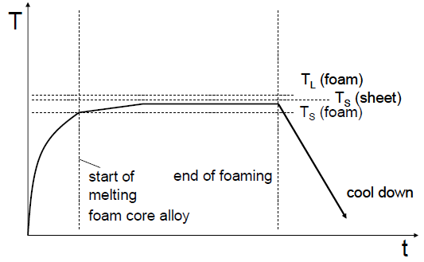
Figure 14: The graph shows the manufacturing process for aluminium face sheets
Liquid Foam: A foamable precursor is expanded between two face sheets. When the liquid foam comes in contact with the solid face sheets a metallic bond is established.
This method can only be used for steel face sheets as with aluminium face sheets there is a risk of oxidation which can prevent the forming of a sound bonding.

Rolling and heating: This process consists of compaction of metal powders together with face sheets. This sandwich-compact assembly goes through several rolling steps to attain desired precursor and face sheet thickness. After which this three-layer composite is heated to transform the core layer into foam.
The melting point of the face sheet material is above the melting point of the foamable precursor material. The face sheets used can be steel as well as 3xxx, 5xxx and 6xxx series aluminium alloys

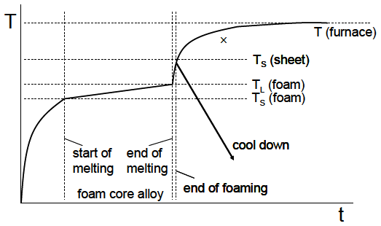
Figure 15: The graph shows the method of manufacture for steel face sheets

In-situ bonding is more preferred as compared to Ex-situ bonding due to the fact that in-situ bonding results in the formation of metallic bond.

Importance of metallic bond:

Metallic bonding constitutes the electrostatic attractive forces between the delocalized electrons resulting in an electric cloud and sharing of free electrons.
The atoms in metals have a strong attractive force between them. Much energy is required to overcome it. It is the sharing of a sea of delocalised electrons amongst a lattice of positive ions.
The electrons and the positive ions in the metal have a strong attractive force between them which results in the electrons acting as a "glue" giving the substance a definite structure.
Metallic bonding accounts for many physical properties of metals, such as strength, malleability, ductility, thermal and electrical conductivity and opacity.

Types
There are two types of sandwiches most widely used with aluminium foam:
- Steel-Aluminium Foam-Steel (SAS)
- Aluminium-Aluminium Foam-Aluminium (AFA)

Aluminium Face sheets v/s Steel face sheets:

Steel is an alloy of iron and a small amount of carbon. Carbon is the primary alloying element. Heavy material with specific gravity of 7.8. It is susceptible to atmospheric corrosion. Easily manufactured with properties which vary with changing concentration of alloying elements.

Aluminium is a silvery-white, tough, but lightweight metal (specific gravity 2.7). It is a good conductor of electricity and is very resistant to atmospheric corrosion. Aluminium alloys combine lightness with strength and as a result are used in a great variety of industries.

To choose between the two face sheets we compare both of them by using FEM analysis.
For the FEM analysis, we will consider equivalent thickness of both AFA and SAS plates.
The results are:

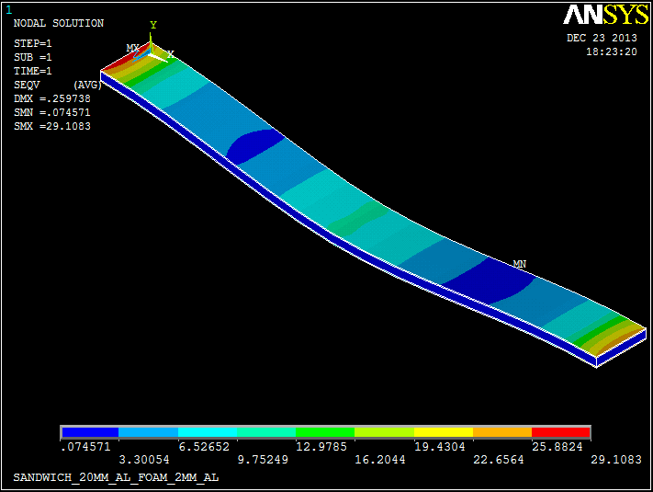
Figure 16: It shows 1000N load acting at the centre of a 24mm Aluminium-Aluminium Foam-Aluminium sandwich
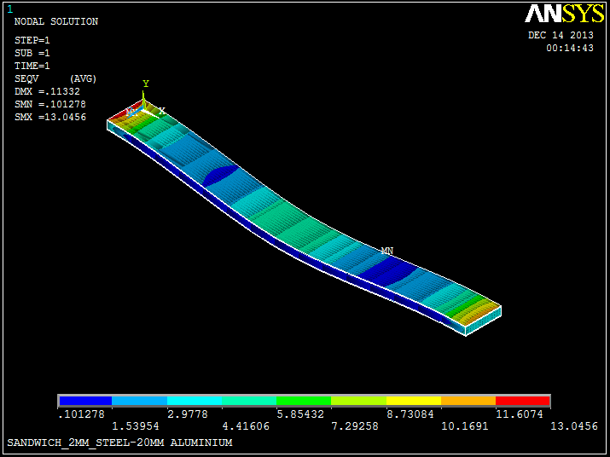
Figure 17: It shows 1kN load acting at the centre of a 24mm Steel-Aluminium-Steel sandwich

Results
Properties | Aluminium Face Sheets  (24 mm) | Steel Face Sheets  (24 mm)
Weight | 2.08 | 4.12
Stress | 29.10 | 13.04
Deflection | 0.2597 | 0.1133
Figure 18: Comparing the two face sheets

However while being lightweight, for the same thickness of both aluminium and steel, the aluminium’s stiffness falls short. Stiffness refers to how much a material will bend when a load is applied. Steel’s modulus of elasticity is 3 times that of aluminium.
So for high load applications, steel is preferred to aluminium.
Aluminium is also more expensive to manufacture than steel.

As a result, SAS sheets have been used for the remainder of the paper.

Steel v/s SAS:

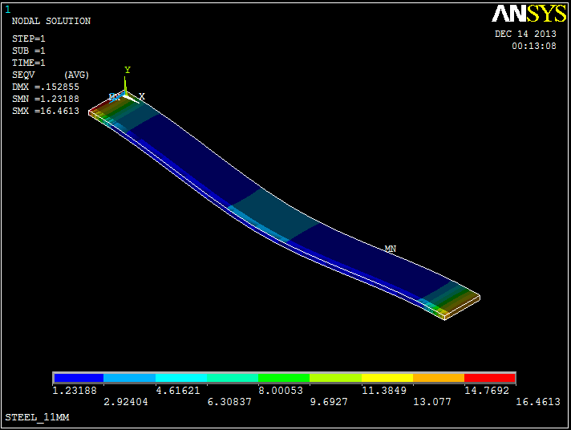
Figure 19: It shows 1000N load acting at the centre of the 11mm steel plate

The steel plate and the SAS sandwich both of equal weight were compared and there results were compared:

Properties | Steel Plate | SAS
Weight | 4.12 | 4.12
Stress | 16.46 | 13.04
Deflection | .1528 | 0.1133
Figure 20: Steel plate v/s SAS

Both the steel plate and the SAS sandwiches were compared and for the same load and stress, SAS sandwich triumphed over steel.

Methods of Joining

Forging
The manufacturing of aluminium foam sandwich (AFS) allows one to manufacture 3D-shaped sandwich panels. However, these structures have a nearly constant cross sections and open edges. Forging provides a unique opportunity to manufacture more complex-shaped parts while maintaining a porous core. For this, AFS panels are cut to a suitable size and are forged in a die. Although one might expect that forging largely destroys the foam structure, the image, shown below, shows that this is not the case.

Figure 21: It shows a forged AFS

The forging results in a very good densification of the foam core which facilitates fixture of the component in engineering systems.

Age Hardening
Age hardening is a type of heat treatment used in metallurgy to strengthen metal alloys. It is also called precipitation hardening, as it strengthens metal by creating solid impurities, or precipitates, in the alloy that prevents dislocations in the alloy's crystalline structure.
The metal is aged by keeping the metal heated for several hours. The temperature at which the aging process occurs affects how this precipitation occurs, and so influences the mechanical properties of the resulting metal.
These impurities created by the hardening process strengthen the metal by interfering with the movement of defects like dislocations, which result from misalignments in the atoms that form the metal's crystalline structure. This resistance to dislocations makes the metal more resistant to being irreversibly bent by outside forces. This resistance gives age-hardened alloys high yield strength and the ability to resist permanent deformation.

This treatment is used on malleable alloys such as the face sheets in AFS like aluminium and steel. Age hardening of the face sheets has been shown to improve the mechanical properties of AFS.

Welding
AFS structures are difficult to weld, due to inhomogeneity of the foam core, high stiffness, and the material thicknesses.
The method of welding which can be used to overcome these problems and can be used on foam structures is Laser Beam Welding
Laser beam welding (LBW) is a welding technique which can be used to join 2 AFS or AFS to another piece of metal through the use of a laser.

Welding results when materials are heated to a molten state and fused together. Lasers generate light energy that can be absorbed into materials and converted to heat energy. The light beam is transmitted in the visible or infrared portion of the electromagnetic spectrum, which transmits this energy from its source to the material using delivery optics which can focus and direct the energy to a very small, as small as a few thousandths of an inch or less and a very precise point.
The laser has minimal divergence without causing significant loss of beam quality or energy.

For the AFS panels, instead of a continuous laser beam, a pulsed laser beam will be used. Millisecond-long pulses are emitted which can be used to weld thin materials such as the face sheets of the AFS panels.

The weld quality is high and the speed of welding is proportional to the amount of power supplied but also depends on the type and thickness of the workpieces.
Considering the properties of aluminium foam sandwich described above, this composite structure can be used for various applications to replace steel and save weight.
One such application to be discussed in this paper is Hatch Cover of ships like bulk carriers or OBO’s.

Application
The vessel used for analysis in this paper is Derbyshire.

The vessel particulars are:

Length: 281.94 Meters.

Beam: 44.20 Meters.

Depth: 24.90 Meters.

Construction Date: 1976

Vessel Type: Oil/Bulk/Ore (OBO) Carrier

Number of Cargo Holds: Nine

The hatch cover used in the Derbyshire and later for consideration in the paper was of the Faulkner’s improved design single skin, transversely stiffened type

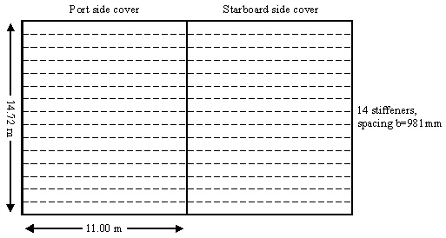
Figure 22: Single skin, transversely stiffened hatch cover.
The design of the hatch cover was based on the dimensions defined by Det Norske Veritas (DNV), a classification society based in Norway.

Faulkner’s Design
Transverse Stiffener | Input
Top flange breadth (b) | 63 cm
Top flange thickness (t) | 1.05 cm
Web height (h) | 63.5 cm
Web thickness (t) | 1.5 cm
Bottom flange breadth (b) | 28 cm
Bottom flange thickness(t) | 2.5 cm
Neutral Axis (z) | 33.4 cm
Design Load | 17.5 kN

Requirements are based on the class rules from
Det Norske Veritas

Figure 23: Stiffener Dimensions

This hatch cover was designed under specifications as stated by Faulkner and approved by the DNV using CAD software.

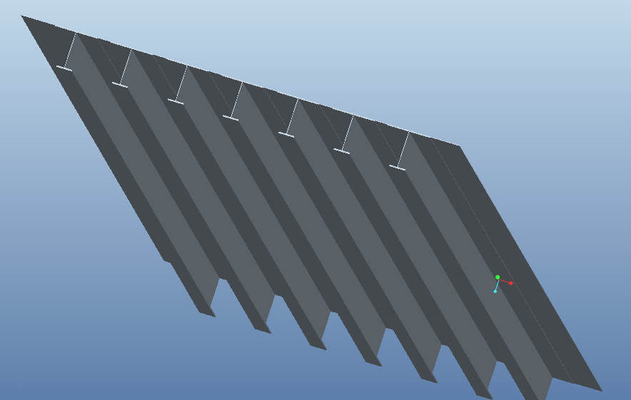
Figure 24: A small representation of the hatch cover under consideration.
The hatch cover under discussion a standard 15 x 14 plate with specifications as by Faulkner and the DNV was then analysed using the FEM software at the design load of 17.5 kN with the edges constrained at all degrees of freedom.

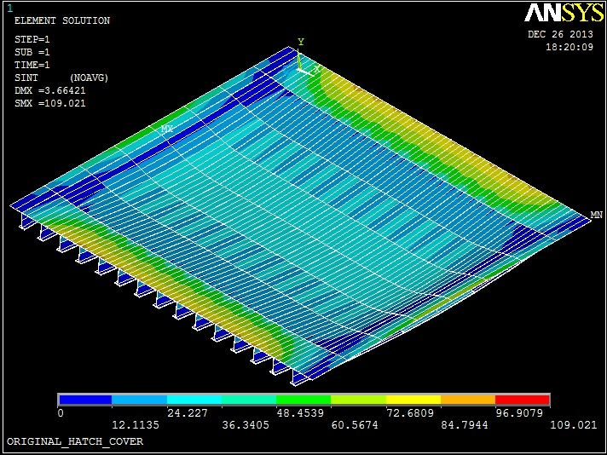
Figure 25: Hatch cover based on Faulkner’s design

- The steel plate would have buckled and failed if it had not been appropriately stiffened by the use of 14 stiffeners.
- The stiffeners used while necessary, lead to various problems like cumbersome design, additional weight, need of manpower and constructional difficulties leading to high costs.
- So instead of using a thinner plate with stiffeners, the author proposes using a thicker plate without stiffeners.

The plate used will be an SAS sandwich which will result in a higher stiffnes to weight ratio, lightweight, and easy to construct while still maintaining the requirements of the classification society.

The figure shown below is an SAS sandwich plate. Its construction consists of:

- Face sheets: Eight mm, two in number
- Core: Aluminium foam, 150mm

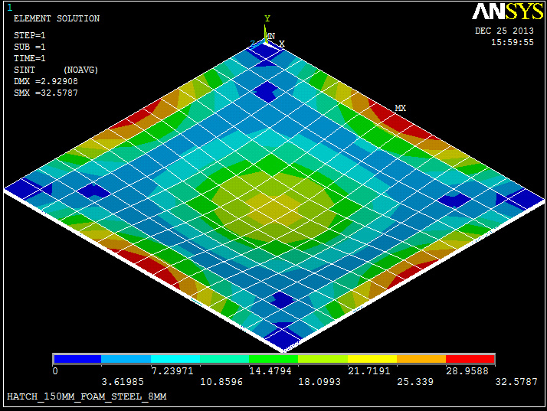
Figure 26: SAS Sandwich design of the hatch cover

Results:

Parameter | Faulkner’s Design | SAS Design
Thickness | 670 mm with 14 stiffeners | 150 mm Al Foam and 8 mm Face Steel Sheet
Weight | 76.887 MT | 41.958 MT
Deflection | 3.664 mm | 2.929 mm
Maximum Stress | 92.3609 MPa | 32.5787 MPa
Figure 27: Comparing the old and new design of a hatch cover

Cost and Savings

The current design of Faulkner weighs about 76.887 MT and the new SAS weighs about 41.958 MT.
The weight saving achieved by using SAS is 45%. Total weight saving for 9 hatch covers would be 315 MT.

- The freight charges for shipping iron ore from Australia to China :
$23/tonnes
- Thus the total profit achieved in every voyage is 315 x 23 =$ 7245

Though we have demonstrated application of Aluminium foam for hatch covers, this strong yet lightweight structure can be used for a variety of shipboard applications such as the superstructure, internal bulkheads and so much more.

Further research is being carried out on composite Metal foams which is essentially forming of hollow beads of one metal within a solid matrix of another, such as steel within Aluminium. It is expected that the resultant foam will be 5 to 6 times stronger than conventional metal foams.

Plate dimension uncut: 1,500 X 1,000 X sandwich thickness [mm³]

Foam – 1mm | 6 €
Steel | 475 €/T
Figure 28: Cost of sandwich

- Cost of steel hatch cover Faulkner’s design : 37,365 €
- Cost of hatch cover SAS Sandwich design : 90,160 €
- The cost of SAS sandwich design is approximately two and half times the cost of steel hatch covers.s

Worldwide steel has been used for decades. The mass production of steel components has resulted in cheaper construction.

Aluminium foam sandwich is a relatively new composite material and the current production cost of SAS is tremendous as compared to steel. However it is a material for the future and with time and various mass production it is expected the cost will decrease drastically.

Marine Environmental Impact

When considering the reduction of ship weight, it is necessary to consider the impact of marine environment on the material in the form of corrosion.

The steel face sheets will behave normally and can be protected by conventional means such as by paints or electroplating.

Corrosion behaviour of Aluminium Foam:

A Corrosion test was performed on aluminium foam having a closed cell structure. The sample was exposed to a Sodium Chloride (NaCl) spray (40g/cm3) for 1000 hours at 25°C.
Some of the pores were filled with NaCl, while others were empty.
The test was a success and the foam was quite unaffected by the corrosive medium and no structural defects were detected.

The core that is Aluminium foam by itself was found to be resistant to corrosion.

Conclusion
On comparing both the FEM results, the reduction in weight achieved of hatch covers using SAS is 45 %.
The FEM results match the assumption made and prove that Aluminium Foam Sandwiches can be a viable alternative as a smart material and can replace steel constructions in the future

Appendix
Various models of hatch covers were created and analysed. The optimum, depending on factors of strength in terms of stress, weight and deflection was chosen.
The various models -
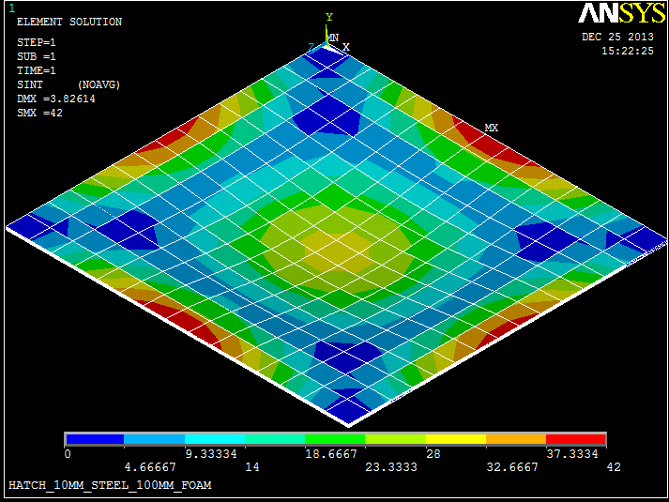
Figure 29: 100 mm Foam with 10mm steel face sheets
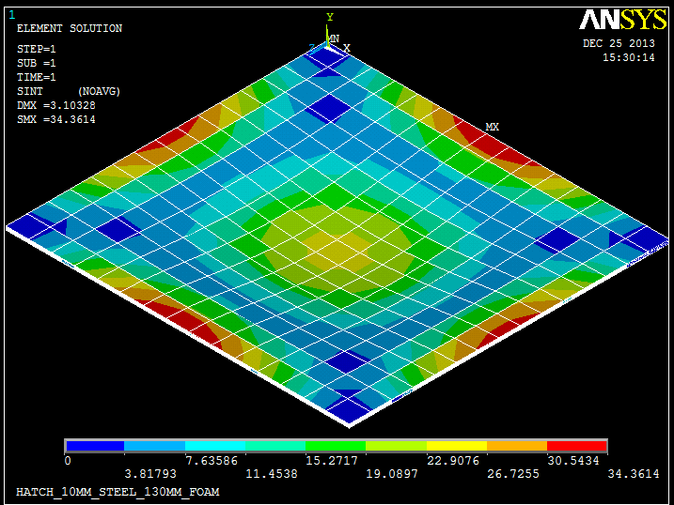
Figure 30: 130 mm Foam with 10mm Steel face sheets
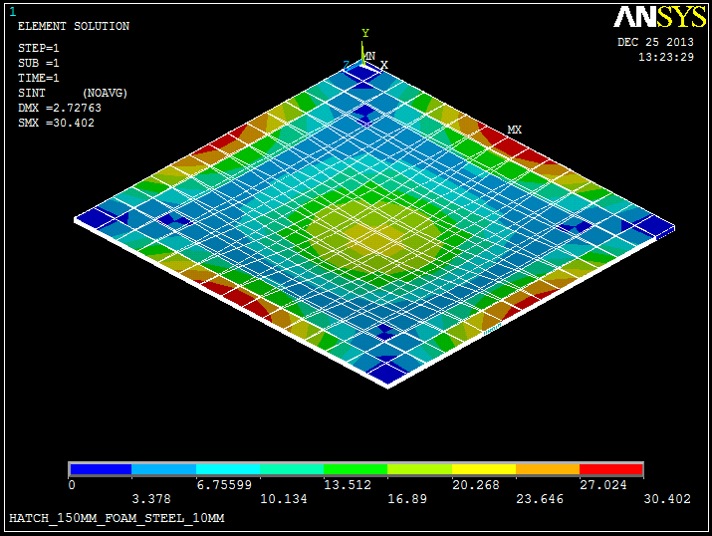
Figure 31: 150 mm Foam and 10mm Steel face sheets
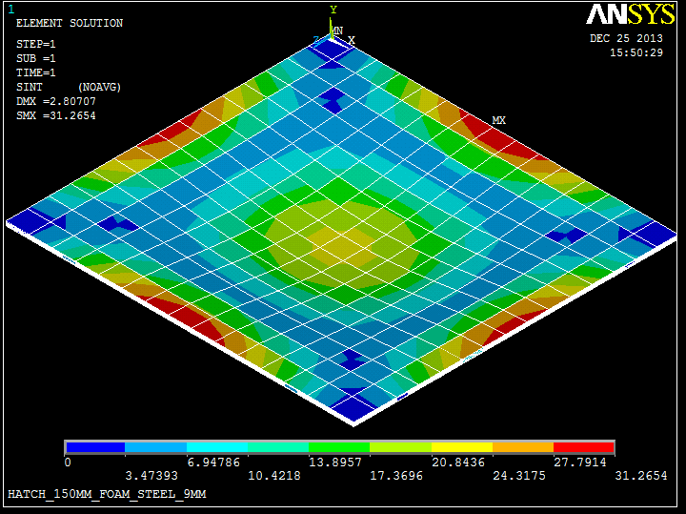
Figure 32: 150 mm Foam and 9 mm Steel face sheets
Figure 33: 150 mm Foam and 8 mm Steel face sheets
The results were obtained and the chosen sample based on low deflection, weight and stress was the one with 150mm Al. foam core and 8mm Steel face sheets.
Results – Based on a standard 1500 x 1000 x 1 mm³ sandwich.
 | CATEGORY 1 |  | CATEGORY 2
Thickness | STEEL : 10 MM | FOAM :  100 MM | STEEL : 10 MM | FOAM :  130 MM
Weight | 43.26 T |  | 46.41 T
Max Stress | 42 Mpa |  | 34.3614 MPa
Deflection | 3.8261 mm |  | 3.1032 mm
 | CATEGORY 3 |  | CATEGORY 4 |  | CATEGORY 5
Thickness | STEEL :  10 MM | FOAM :  150 MM | STEEL  9 MM | FOAM :  150 MM | STEEL  8 MM | FOAM :  150 MM
Weight | 48.51 |  | 45.23 |  | 41.95
Max Stress | 30.402 Mpa |  | 42 Mpa |  | 32.5787 Mpa
Deflection | 2.7263 mm |  | 2.80707 mm |  | 2.929 mm

Cost analysis calculation – Based on standard costs:

Sandwich standard 1.5 x 1 x sandwich thickness m³.
Steel is based on weight with current cost being 475 €/T
Foam costs is estimated taking into account present cost for various thicknesses.

Foam: 5mm – 20 € Steel: 1mm – 5.55 €
1mm – 6 €

Estimated cost:
150mm – 600 € 8mm – 44.4 €

Cost of one sheet – 600 + 44 = 644 €
We require 140 sheets to make the hatch cover.
Total cost - 644 x 140 = 90,160 €
Steel:
Weight of hatch cover - 78.667 MT
Price per T - 475
Total Cost - 37,364 €

References

- Dr. Thomas Hipke, Fraunhofer Institute for machine tools and Foaming Technology, IWU, METAL FOAM, Germany, 2011
- Preparation of Aluminium Foam Edges for Welding by S. Krajewski (2013)
- Dr. Catrin Kammer, TALAT, Aluminium foam , Goslar, Germany ,1999
- Prof . Dr – Ing. Matthias Busse, Advanced Pore Morphology , Bremen, 2011,www.ifam.fraunhofer.de
- IACS, Common Structural Rules, section 5, 2013
- LIGHT-WEIGHT ALUMINIUM FOAM STRUCTURES FOR SHIPS by J. Banhart, C. Schmoll, U. Neumann, Fraunhofer-Institute Bremen, Fr. Lürssen Werft Bremen, WIWEB Erding, Germany
- Derbyshire Manuals & Specification Sheets
- Wikipedia.com
- Scholar.Google.com
- http://www.tms.org/pubs/journals/JOM/0012/Banhart-0012.html
- http://www.makeitfrom.com/material-data/?for=Aluminum-Foam
- http://materials.iisc.ernet.in/~ramu/publications/paper33.pdf

